Exploring Bikaverin as Metal ion Biosensor: A Computational approach.

Supporting Information

Figure S1: Optimized ground state (S₀) geometries of receptor-analyte complexes at CAM-B3LYP/6-311G evel of theory.
Figure S2: Optimized first excited state (S₁) geometries of receptor-analyte complexes at CAM-B3LYP/6-311G level of theory. Figure S3.Chemical structure of Bikaverin compound isolated and its optimized form
Table S1: The energies of HOMO and LUMO frontier molecular orbitals in electron volts.
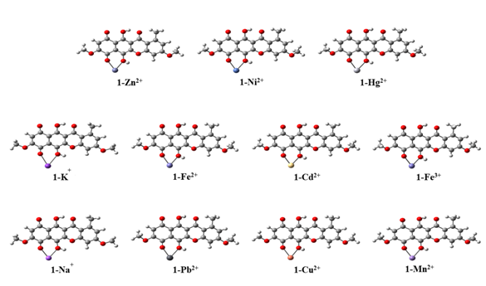
Figure S1: Optimized ground state (S₀) geometries of various receptor-analyte complexes at CAM-B3LYP/6-311Glevel of theory.
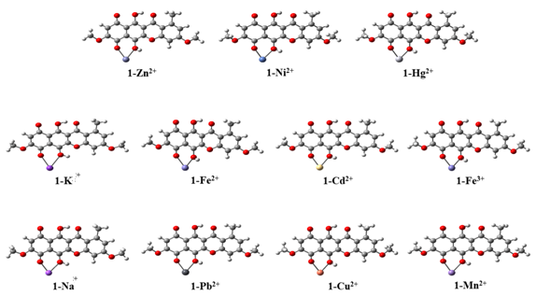
Figure S2: Optimized first excited state (S₁) geometries of various receptor-analyte complexes at CAM-B3LYP/6-311Glevel of theory.
Figure S3.Chemical structure of Bikaverin compound isolated.

Table S1 The energies of HOMO and LUMO frontier molecular orbitals in electron volts.
Molecule | HOMO (eV) | LUMO (eV) | HOMO-LUMO gap (eV)
1 | -2.371 | 0.149 | 2.52
1-Na⁺ | -1.580 | 1.430 | 3.01
1-K⁺ | -1.827 | 2.113 | 3.94
1-Ni²⁺ | -1.718 | 1.092 | 2.81
1-Hg²⁺ | -1.314 | 1.976 | 3.29
1-Cd²⁺ | -1.152 | 2.038 | 3.19
1-Mn²⁺ | -1.299 | 1.641 | 2.94
1-Fe²⁺ | -1.411 | 2.029 | 3.44
1-Zn²⁺ | -1.215 | 1.965 | 3.18
1-Cu²⁺ | -1.284 | 1.886 | 3.17
1-Fe³⁺ | -1.126 | 1.964 | 3.09
1-Pb²⁺ | -1.355 | 1.615 | 2.97

