Protein release from biodegradable poly(ε-caprolactone)-chitosan scaffolds prepared in scCO₂
Gregor Kravanja,1 Maja Globočnik,1 Mateja Primožič,1 Željko Knez1,2 and Maja Leitgeb1,2,*
1 University of Maribor; Faculty of Chemistry and Chemical Engineering; Laboratory of separation processes and product design; Smetanova ul. 17; 2000 Maribor; Slovenia
²University of Maribor, Faculty of Medicine, Taborska ulica 8, 2000 Maribor
* Corresponding author: E-mail: maja.leitgeb@um.si, Telephone: +386 2 2294 462

Abstract
Biodegradable porous poly(ε-caprolactone)-chitosan scaffolds containing incorporated protein bovine serum albumin (BSA) were prepared by using supercritical fluid base technology. Prior to supercritical processing, an emulsion, consisting of a polymer-solvent solution and buffer protein solution was saturated with supercritical CO₂ (scCO₂) at 12 MPa and 37 °C and then rapidly depressurized through a release valve causing bubble nucleation and precipitation of the composite material. The controlled total protein release from biodegradable poly(ε-caprolactone) with 5% chitosan (w/w) scaffolds was assessed by Bradford protein assay. After 16 to 20 days of protein release testing, 58.8% of the protein was released from composite with PCL (M_{w}=10,000 g/mol) and 43.9% from composite with PCL (M_{w}=60,000 g/mol). Preliminary studies for characterization of the prepared composite material using FTIR spectra, ESEM photo analysis and DSC analysis have been carried out.
Keywords: protein release; PCL polymer; chitosan; scaffold; supercritical CO₂

1. Introduction
Biodegradable porous polymer scaffolds are often required for reconstruction or regeneration of organ function in tissue engineering applications, alone or in combination with a bioactive agent. They mimic the extracellular matrix (ECM), so they must provide a sustainable template for cell attachment, proliferation, and differentiation. Biocompatibility, absorbability, appropriate mechanical strength, and porous structure are some of the basic requirements of scaffolds. Biodegradability is a very convenient feature of polyesters, and that is why they are so promising and extensively utilized, since ceramic and metal implants require a second surgical operation, to remove them from the body.¹⁻³ Furthermore, in bone tissue engineering, the material should form an osteoconductive structural support for the newly formed bone and consist of interconnected pores, which have an important role in supporting cell penetration, new tissue ingrowth, nutrient diffusion, and neovascularization.⁴⁻⁶
Poly(glycolic acid), poly(lactic acid), poly(hydroxyl butyrate), poly(ε-caprolactone) (PCL) and their copolymers are the most frequently used synthetic biodegradable polymers in tissue engineering. PCL is highly appealing because of its physical-chemical and mechanical characteristics. It has been broadly investigated on account of its soft- and hard-tissue compatibility. Its low melting point (ca. 60 °C) allows easy processing. Its non-toxic degradation products are easily metabolized or secreted from the body. PCL is approved by the Food and Drug Administration (FDA) for use in biomedical applications. However, as with other biodegradable polyesters, its use could be limited by some drawbacks. The absence of cell recognition sites on the surface of scaffolds can lead to poor cell affinity and adhesion. Its hydrophobicity can prevent the cells from penetrating into the porous structure. Neutral charge distribution can cause a lack of interaction with the ECM. Acidic degradation products are formed during hydrolysis of PCL and could possibly cause side effects. It has a very slow degradation rate, due to high crystallinity. Therefore, PCL is often mixed with natural polymers to enhance its bioactivity.^{1,5,7} Chitosan (CS) is a linear polysaccharide. Its numerous good features, such as biocompatibility, biodegradability, non-antigenicity, non-toxicity, antibacterial properties, and bio-adherence have induced its use in biomedical areas. When combined with PCL, hydrophilic chitosan can modulate the hydrophobicity of PCL, which increases the biocompatibility, cellular affinity, wettability and permeability of matrices.^{6,7}
Tissue engineering applications require scaffolds with high surface area to volume ratios. This is crucial for effective cell seeding onto the biomaterial support and for efficient nutrient acquisition, so that rapid proliferation and sufficient physiological activity can be achieved. Porous polyester scaffolds can be formed by many techniques, each of which results in different biomaterial characteristics, therefore, the most convenient method may depend on the application.⁸ In the last two decades, there has been significant progress in using scCO₂ for polymer foaming. This is a non-toxic, non-flammable, chemically inert and environmentally safe gas.⁹ Furthermore, it is inexpensive and offers a useful alternative to organic solvents that can be potentially harmful to cells. CO₂, dissolved in the polymer, decreases the viscosity, acts as a plasticizer and allows processing at lower temperatures. This foaming technique enables control of the size and distribution of pores by selecting suitable processing conditions, like temperature, depressurization rate and solubilisation pressure (gas concentration in the polymer). Good solubility of CO₂ in polymers can be additionally influenced by temperature, pressure and weak interactions with functional groups of polymers.^{5,10}
With the ability to control the morphology of the composite, supercritical fluid technology has also overcome the problem of incorporating biologically active species into polymeric composites without a change in activity. The combination of gas-like viscosity and liquid-like density makes scCO₂ an ideal medium for making polymer-based materials containing bioactive species. Interaction of scCO₂ with amorphous polymers leads to depression of the glass transition temperature (T_{g}); under these conditions, the polymer is plasticized, which significantly lowers the viscosity and allows incorporation of insoluble bioactive particles into the polymer. Additionally, no solvent residues remain in the material after processing.^{11,12}
To create new composite material scaffolds with specific physical-chemical properties PCL (M_{w}=10,000 and 60,000 g/mol) was mixed with 5% chitosan (w/w) and further, bovine serum albumin (BSA) was incorporated. We have used BSA as a model protein for preliminary studies of controlled release from prepared porous scaffolds. Measurement of total protein release was performed by Bradford protein assay. As a prior characterization of the prepared material, FTIR, ESEM and DSC analysis on clean PCL and CS and their composites were performed.

2. Experimental

2.1. Materials
Bovine serum albumin (BSA) (CAS: 9048-46-8) was provided by Sigma-Aldrich. Dimethyl chloride (CAS: 75-09-2), was purchased from Fluka Analytical. Poly(ε-caprolactone) (PCL) of molar weight 10,000 g/mol (CAS: 24980-41-4) and of 60,000 g/mol (CAS: 24980-41-4) and chitosan (CAS: 9012-76-4) were purchased from Sigma-Aldrich. The polymers were delivered as powders and were used without further purification. Moisture content in the polymers, determined gravimetrically by means of an HB43-S Compact Halogen Moisture Analyzer, was lower than 0.10 wt.% for each polymer. CO₂ (99.998%) was supplied by Messer (Slovenia).

2.2. Scaffold preparation in scCO₂
Before processing with scCO₂, an emulsion consisting of a water (aqueous) phase and an organic composite solution phase was prepared by sonicating the immiscible phases.
The water phase consisted of 20 mg BSA dissolved in 200 µL of phosphate buffer at pH 7.4. The organic phase consisted of 500 mg PCL + CS mixture dissolved in 1 mL of dimethyl chloride. Prior to supercritical processing, the emulsion was pipetted into the small cylindrical mold and then immediately placed into a high-pressure view equilibrium cell made of stainless steel (Sitec AG, Zurich, CH) (Figure 1).¹³ The high-pressure cell was pressurized to 12 MPa with CO₂ by a high-pressure pump (NWA PM-101). The pressure inside the cell was measured by an electronic pressure gauge (WIKA Alexander Wiegand GmbH & Co. KG, Alexander-Wiegand-Straße, Klingenberg, Germany). The temperature of the cell was kept constant using a heating jacket and was observed using calibrated thermocouple immersed in the cell. The pressure deviation was ± 0.01 MPa and the total temperature deviation was 0.1 °C. When the CO₂ reached the desired working pressure, a stable 20 mL/h flow-rate of CO₂ was produced through the pressure cell by a syringe pump manufactured by ISCO (Lincoln, NE) to fully extract the dimethyl chloride. The emulsion consisting of BSA and a biodegradable polymer was saturated with scCO₂ for 18 h to easily incorporate insoluble bioactive particles into the polymer by lowering the glass transition temperature (T_{g}) and eliminating all solvent residues from the material. In the last step, the high pressure cell was rapidly depressurized at a controlled depressurization rate of 0.1 MPa/s by opening the release valve in order to create a microporous composite scaffold. After the depressurization step, the composite scaffold was removed from the mold and sectioned into three parts for further protein release studies. Prior to material characterization, additional scaffolds were prepared without incorporating BSA protein.
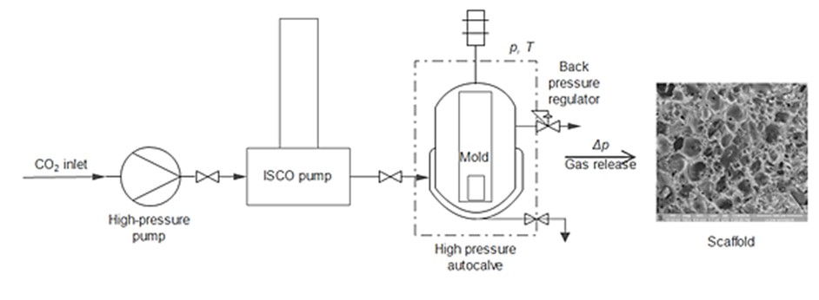
Figure 1: Diagram of the system used to generate biodegradable scaffolds with scCO₂.

2.3. Characterization of prepared scaffolds
The porosity of the prepared scaffolds was measured with a graduated cylinder.^{10,14} It was calculated as given in the equation (1):
$Porosity \left(\%\right)= \frac{(w_{2}-w_{3}-w_{s})/ρ_{e}}{(w_{1}-w_{3})/ρ_{e}}×100$ (1)
where $w_{1}$ is the weight of graduated cylinder filled with ethanol, $w_{2}$ the weight of the graduated cylinder, ethanol and scaffold, $w_{3}$ the weight of the graduated cylinder and ethanol after removing the scaffold, $w_{s}$ the weight of the scaffold and $ρ_{e}$ the density of absolute ethanol used in the analysis.

2.3.1. DSC analysis
Differential scanning calorimetry (HP DSC 1, Mettler Toledo) was performed on pure PCL (M_{w}=10 000, 60 000 g/mol) and on the prepared porous scaffolds to confirm the composition of PCL and CS and to define the percentage of crystallinity. Samples were placed in sealed aluminium pans. Measurements were held at ambient pressure at a temperature range from 25 °C to 600 °C with a temperature rate of 10 °C/min.
Based on the DSC curves, the melting temperature (T_{m}), heat of fusion (ΔH_{m}) and crystallinity of the samples were determined. The crystallinity of the PCL fracture (X_{c}) in the samples was calculated with equation (2) ¹⁵:
$X_{c}=\frac{∆H_{m}}{{∆H}_{m}^{°}∙w}×100$ (2)
where ΔH_{m} is the specific melting enthalpy of the sample, ΔH_{m}̊ is the melting enthalpy of 100% crystalline poly(ε-caprolactone) (76.9 J/g), and w is the weight fraction of PCL in the blend.¹⁶

2.3.2. FTIR spectra and ESEM analysis
The FTIR spectra were recorded on a Fourier Transform infrared instrument (Bruker Platinum-ATR) equipped with OPUS Optik GmBH software in the range from 400 to 4400 cm⁻¹ of wavelength.
Pores size for the resulting composite scaffolds generated in scCO₂ were determined using environmental scanning electron microscopy (ESEM) Quanta 200 3D (FEI Company, Hillsboro, OR), which allows observation of translation and non-sample without prior preparation (polymer materials, biological and medical samples).

2.4. Protein release studies
Each of the porous PCL-CS composites incorporated with BSA was divided into three smaller units of 50 mg, to verify the uniformity of protein release. Each section was placed into 2 mL microcentrifuge tubes, containing 1 mL of phosphate buffer (PBS) with pH 7.4. In order to simulate the conditions in the human body, the tubes were incubated at 37 °C. The amount of the released BSA was determined by the Bradford method.¹⁷ First measurement was performed after 3 hours and second after 24 hours from the start of the study. Then, Bradford assay was repeated every few days. After each measurement, fresh PBS was added to the microcentrifuges containing parts of the composites.

3. Results and discussion
Results for the characterization of prepared composite material using FTIR spectra, ESEM photo analysis, DSC analysis and finally protein release studies are presented in the following subsections.

3.1. DSC analysis
DSC analysis was performed on two pure PCLs with different molar masses (M_{w}=10,000 and 60,000 g/mol) and on porous scaffolds after processing with CO₂ to confirm the composition of the mixture between PCL and CS. As seen in Table 1, the melting point of both composites was lower than the melting point of pure PCL. Therefore, we have confirmed miscibility between PCL and CS.¹⁸ PCL 10,000 based composite material has a higher crystallinity (89.2%) than the PCL 60,000 based composite (75.3%). Degradation of materials was observed at a temperature of approximately 420 °C, and a slight decrease in decomposition temperature of the composites can be obtained, compared to pure PCL.
Table 1: Melting temperatures and specific melting enthalpies of the samples.
Material | T_{m} (°C) | $∆H_{m}$ (J/g)
PCL 10,000 | 67.58 | 71.31
PCL 10,000 + 5% CS | 62.88 | 65.17
PCL 60,000 | 73.04 | 66.62
PCL 60,000 + 5% CS | 66.23 | 55.04

3.2. FTIR analysis
The FTIR analysis for raw materials, pure PCL, CS, and other obtained composites was made. Figure 2 shows the spectra of raw materials, PCL (M_{w}=10,000 g/mol), CS and the composite material. Figure 3 shows the spectra of pure PCL (M_{w}=60,000 g/mol), CS and their composite. The characteristic peak of pure PCL that corresponds C=O stretching vibration of the carbonyl group in ester is at 1732 cm⁻¹ for PCL (M_{w}=10,000 g/mol) and at 1734 cm⁻¹ for PCL (M_{w}=60,000 g/mol). The spectra of pure CS shows a broad peak for the O-H stretch at 3408 cm⁻¹. The peak at 1656 cm⁻¹ represents N-H stretching. Another peak for 1˚ amine in CS at 1076 cm⁻¹ represents the C-N stretch. C=O stretching vibrations were detected in both composites, at 1735 cm⁻¹ for the composite with PCL (M_{w}=10,000 g/mol) and at 1734 cm⁻¹ for the composite with PCL (M_{w}=60,000 g/mol). In the blend of PCL and CS, interactions between the carbonyl groups of PCL and the hydroxyl and amine groups of CS can occur, which leads to the formation of ester and amide bonds. However, there are no major absorptions shifts of the characteristic functional groups to be seen when the spectra of pure PCL is compared to the spectra of the composites. This could indicate that no molecular interactions occurred between functional groups, a finding which corresponds to results from the previous studies.¹⁹ Peaks in the range from 2850 cm⁻¹ to 3000 cm⁻¹ represent alkyl (sp³ hybridization of C atoms) stretching vibrations in pure materials and in the composites.
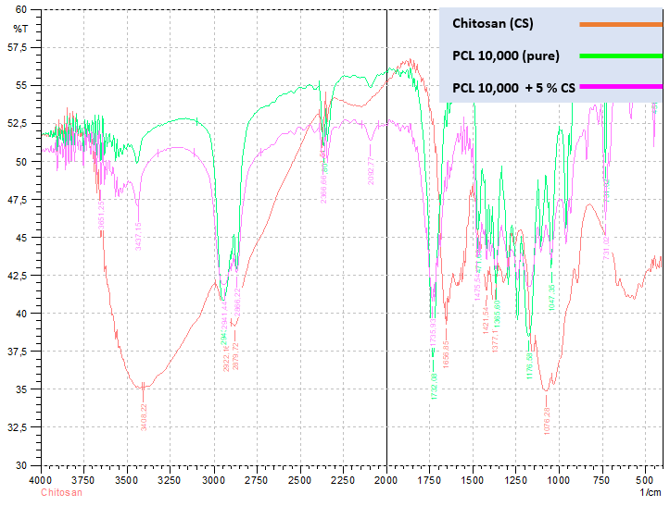
Figure 2: The FTIR spectra of raw materials (PCL (M_{w}=10,000 g/mol) and CS) and the composite material.
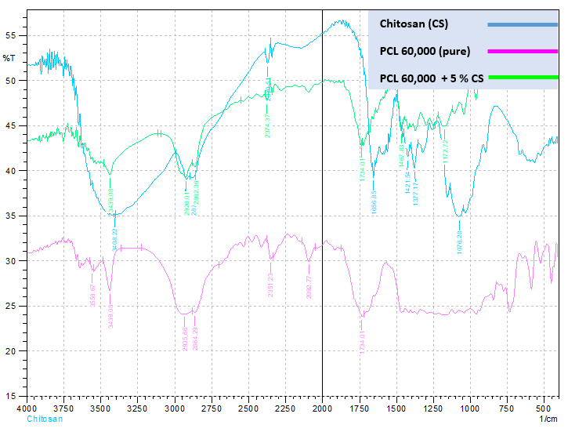
Figure 3: The FTIR spectra of raw materials (PCL (M_{w}=60,000 g/mol) and CS) and the composite material.

3.3. ESEM analysis
Figure 4 (a and b) shows an ESEM micrograph of PCL-CS scaffolds foamed with scCO₂ at 12 MPa and 37 °C. ESEM analysis showed that resulting porous scaffolds have a closed cell structure which enables better isolating properties because of its greater stiffness and toughness and lower permeability. The diameters of the pores vary from 50 to 130 µm when PCL 10,000 + 5% CS is used; and from 40 to 140 µm when PCL 60,000 + 5% CS is used, so they are considered to be micropores (Table 2). Porosity in both composites is relatively high, above 75%.
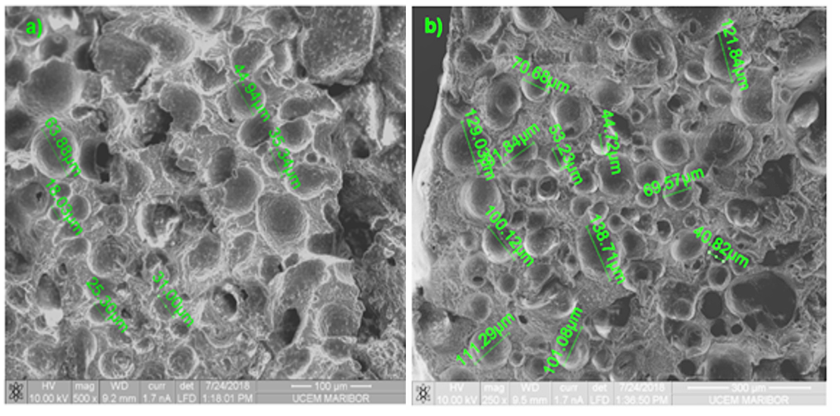

Figure 4: Environmental scanning electronic microscope image of a) PCL 10,000 + 5% CS and b) PCL 60,000 + 5% CS scaffolds.

Table 2: Preparation of biodegradable composite material at an applied pressure of 15 MPa and a temperature of 37 °C.
Composite | Molar mass (g/mol) | Depressurization rate (MPa/s) | Pore size interval (µm) | Porosity  (%)
PCL 10,000 + 5% CS | 10,000 | 0.1 | 50-130 | 80.1
PCL 60,000 + 5% CS | 60,000 | 0.1 | 40-140 | 75.1

3.4. Protein release monitoring
Total protein release monitoring was assessed for the PCL 10,000 + 5% CS and PCL 60,000 + 5% CS scaffolds by dividing each of them into three equal parts. The influence of molecular mass of PCL and time of protein release from composite polymers on total concentration of released BSA was studied. As presented in Figure 5, BSA loaded scaffolds showed two-stage release profiles. Larger concentrations of protein were released in the first few days from both investigated scaffolds, and then release of protein was constant, since the total protein concentration linearly increased with increase in release time. The main share of the protein from PCL–based scaffolds was released within the first 16 days. After that time, concentrations of protein in PBS solutions were zero or negligibly small, regardless of the tested composite. Higher total protein release was observed for the scaffold PCL 10,000 + 5% CS compared to the scaffold PCL 60,000 + 5% CS. This can be related to scaffold porosity, which is approximately 5% higher in the case of PCL 10,000 + 5% CS. With high porosity, the lightly trapped BSA in the micropores can be easily released.²⁰ Similar controlled release protein patterns were observed when BSA and basic fibroblast growth factor (bFGF) was encapsulated in poly(lactic-co-glycolic) acid (PLGA 65:35) generated in scCO.²¹ The overall release rates from the scaffolds foamed with CO₂ were up to twice as high compared to release patterns of PLGA 65:35 by the salt leaching method. This can be related to protein loss due to the distilled water required for salt leaching.²²

Table 3: Concentrations of protein, released from three equal parts of scaffolds (PCL 10,000 + 5% CS and PCL 60,000 + 5% CS).
Time (days) | Protein  concentration in scaffold part 1  (mg/mL) | Protein  concentration in scaffold part 2  (mg/mL) | Protein  concentration in scaffold part 3  (mg/mL | Average concentration (mg/mL) | Total protein release  (mg/mL)
PCL 10,000 + 5% CS
0 | 0 | 0 | 0 | 0 | 0
0.125 | 0.249 | 0.204 | 0.205 | 0.219 | 0.219
1 | 0.169 | 0.162 | 0.320 | 0.217 | 0.436
4 | 0.113 | 0.680 | 0.550 | 0.448 | 0.883
8 | 0.106 | 0.291 | 0.121 | 0.173 | 1.056
12 | 0.122 | 0.144 | 0.096 | 0.121 | 1.177
16 | 0 | 0 | 0 | 0 | 1.177
20 | 0 | 0 | 0 | 0 | 1.177
PCL 60,000 + 5% CS
0 | 0 | 0 | 0 | 0 | 0
0.125 | 0.385 | 0.118 | 0.302 | 0.268 | 0.268
1 | 0.090 | 0.103 | 0.281 | 0.158 | 0.426
4 | 0.123 | 0.398 | 0.152 | 0.225 | 0.651
8 | 0.108 | 0.115 | 0.121 | 0.115 | 0.765
12 | 0.018 | 0.079 | 0.080 | 0.113 | 0.878
16 | 0.060 | 0.068 | 0.083 | 0.070 | 0.949
20 | 0 | 0 | 0 | 0 | 0.949

Figure 5: Total concentration of released BSA from PCL 10,000 + 5% CS and PCL 60,000 + 5% CS scaffolds vs. time of release, compared to the literature data.²¹

The BSA release was normalized to the initial protein entrapped in the scaffold, as shown in Figure 6. At the beginning, the release of proteins follows the same curve for both tested scaffolds and after 4 days of protein release, the PCL 10,000 + 5% CS shows better release profile, which can be attributed to better porosity of the material. 58.8% of the protein was released from the composite with PCL (M_{w}=10,000 g/mol) and 43.9% from composite with PCL (M_{w}=60,000 g/mol) after 16 or 20 days of protein release testing.

Figure 6: Total protein release normalized to the initial protein entrapped in the scaffold (for PCL 10,000 + 5% CS and PCL 60,000 + 5% CS) vs. time of release.

4. Conclusion
Porous PCL-CS composite scaffolds with entrapped BSA were generated in scCO₂ as constructs for tissue engineering. Before the protein release studies, scaffolds were prepared for characterization of the composite material without incorporated BSA. DSC analysis confirmed the miscibility of the blend with a decrease in the melting points of the composites, compared to pure PCL. ESEM analysis showed that the resulting porous scaffolds have a closed cell structure that yields better isolating properties because of higher toughness and lower permeability.
When used as a model protein loaded into scaffolds, BSA showed two-stage release profiles. Larger concentrations of protein were released in the first few days in both investigated scaffolds. After 16 to 20 days of protein release testing, 58.8% of the protein was released from composite with PCL (M_{w}=10,000 g/mol) and 43.9% from composite with PCL (M_{w}=60,000 g/mol). The ability to simply incorporate and release thermolabile proteins at a controlled rate demonstrates the potential for using scCO₂ as a blowing agent for creating scaffolds and opens up the frontier for investigating encapsulation of healing agents and therapeutic enzymes for tissue engineering applications.

Acknowledgement

The authors would like to acknowledge the Slovenian Research Agency (ARRS) for financing this research within the frame of program P2-0046 (Separation Processes and Production Design).

5. References

- Y. Wan, H. Wu, X.Cao, S. Dalai, Polym. Degrad. Stab. 2008, 93, 1736–1741. DOI:10.1016/j.polymdegradstab.2008.08.001
- H.-Y. Cheung, K-T. Lau, T.-P. Lu, D. Hui, Composites, Part B. 2007, 38, 291–300. DOI:10.1016/j.compositesb.2006.06.014
- M. Leitgeb, K. Heržič, G. Hojnik Podrepšek, A. Hojski, A. Crnjac, Ž. Knez, Acta Chim. Slov. 2014, 61, 145–152.
- S. Kovačič, N. B. Matsko, G. Ferk, C. Slugovc, Acta Chim. Slov. 2014, 61, 208–214.
- B. Dariš, P. Ferk, E. Markočič, Ž. Knez, Acta Medi. Bio. 2016, 9, 42–48.
- R. M. Jin, N. Sultana, S. Baba, S. Hamdan, A. F. Ismail, J. Nanomater. 2015, 2015. DOI:10.1155/2015/357372
- S. C. Neves, L. S. Teixeira Moreira, L. Moroni, R. L. Reis, C. A. Van Blitterswijk, N. M. Alves, M. Karperien, J. F. Mano, Biomaterials. 2011, 32, 1068–1079. DOI:10.1016/j.biomaterials.2010.09.073
- M. Whitaker, R. Quirk, S. Howdle, K. Shakesheff, J. Pharm. Pharmacol. 2001, 53, 1427–1437. DOI:10.1211/0022357011777963
- M. Škerget, Ž. Knez, Acta Chim. Slov. 2007, 54, 688–692.
- E. Markočič, M. Škerget, Ž. Knez, Ind. Eng. Chem. Res. 2013, 52, 15594–15601. DOI:10.1021/ie402256a
- S. M. Howdle, M. S. Watson, M. J. Whitaker, V. K. Popov, M. C. Davies, F. S. Mandel, J. D. Wang, K. M. Shakesheff, Chem. Commun. 2001, 109–110. DOI:10.1039/b008188o
- A. Salerno, J. Saurina, C. Domingo, Int. J. Pharm. 2015, 496, 654–663. DOI:10.1016/j.ijpharm.2015.11.012
- G. Kravanja, M. K. Hrnčič, M. Škerget, Ž. Knez, J. Supercrit. Fluids. 2016, 108, 45–55. DOI:10.1016/j.supflu.2015.10.013
- J. Yang, G. Shi, J. Bei, S. Wang, Y. Cao, Q. Shang, G. Yang, W. Wang, J. Biomed. Mater. Res. 2002, 62, 438–446. DOI:10.1012/jbm.10318
- A. R. C. Duarte, J. F. Mano, R. L. Reis, Polym. Degrad. Stab. 2010, 95, 2110–2117. DOI:10.1016/j.polymdegradstab.2010.06.020
- E. de Paz, A. n. Martín, S. Rodríguez-Rojo, J.Herreras, M. a. J.Cocero, J. Chem. Eng. Data. 2010, 55, 2781–2785. DOI:10.1021/je900997t
- Kruger, N. J. in The protein protocols handbook, Springer, 2009, pp. 17–24.
- H. She, X. Xiao, R.Liu, J. Mater. Sci. 2007, 42, 8113–8119. DOI:10.1007/s10853-007-1706-7
- V. N. Malheiro, S. G. Caridade, N. M. Alves, J. F. Mano, Acta Biomater. 2010, 6, 418–428. DOI:10.1016/j.actbio.2009.07.012
- H. Nie, S. T. Khew, L. Y. Lee, K. L. Poh, Y. W. Tong, C.-H. Wang, J. Controlled Release. 2009, 138, 64–70. DOI:10.1016/j.jconrel.2009.04.027.
- D. D. Hile, M. L. Amirpour, A. Akgerman, M. V. Pishko, J. Controlled Release. 2000, 66, 177–185. DOI:10.1016/S0168-3659(99)00268-0
- S. B. Lee, Y. H. Kim, M. S. Chong, S. H. Hong, Y. M.Lee, Biomaterials. 2005, 26, 1961–1968. DOI:10.1016/j.biomaterials.2004.06.032

