SUPPLEMENTARY MATERIAL
to
Characterization and Atmospheric Implication of Hydrotrioxy Radical-Water-Methylamine-Formic Acid-Sulphuric Acid Complexes
Matjaž Dlouhy and Antonija Lesar*

Department of Physical and Organic Chemistry, Jožef Stefan Institute, Jamova c. 39, SI-1000 Ljubljana, Slovenia
* Corresponding Author: E-mail: antonija.lesar@ijs.si

Presented at the 24th Annual Meeting of the Slovenian Chemical Society

Table of contents

Figure S1: | Harmonic IR absorption spectra of cis-HOOO• radical calculated on B3LYP/6-311++G(3df,3pd) level of theory. | 3
Figure S2: | Harmonic IR absorption spectra of trans-HOOO• radical calculated on B3LYP/6-311++G(3df,3pd) level of theory. | 3
Figure S3: | Optimised strucures of the stable binary complexes with the B3LYP/6-311++G(3df,3pd) bond lenghts and the CBS-QB3 binging energies. Dotted lines represent intermolecular formation of H-bonds. | 5
Figure S4: | Optimised strucures of the stable ternary complexes with the B3LYP/6-311++G(3df,3pd) bond lenghts and the CBS-QB3 binging energies. Dotted lines represent intermolecular formation of H-bonds. | 6
Table S1: | B3LYP/6-311++G(3df,3pd) calculated harmonic and anharmonic frequencies (υ) in cm⁻¹ and IR absorption intensities (I) in km mol⁻¹ of c-HTO and T-HTO radicals and precursors (water, methylamine, formic acid and sulphuric acid) . Avaliable experimental values are given. | 3
Table S2 | Thermodynamic properties (∆H, T∆S and ∆G) in kcal mol⁻¹ and calculated K_{c} values in cm³ molecules⁻¹ at different altitude (h) [km], temperature (T) [K] and preassure (p) [atm]. Calculated values correspond to the reaction: x-HTO-PR + W → x-HTO-PR-W (where x stands for the corresponding conformation of HOOO• radical and RP for the corresponding precursor molecule). | 7

Figure S1: Harmonic IR absorption spectra of cis-HOOO• radical calculated on B3LYP/6-311++G(3df,3pd) level of theory.
Figure S2: Harmonic IR absorption spectra of trans-HOOO• radical calculated on B3LYP/6-311++G(3df,3pd) level of theory.

Table S1: B3LYP/6-311++G(3df,3pd) calculated harmonic and anharmonic frequencies (υ) in cm⁻¹ and IR absorption intensities (I) in km mol⁻¹ of c-HTO and T-HTO radicals and precursors (water, methylamine, formic acid and sulphuric acid) . Avaliable experimental values are given.
 |  | harmonic |  | anharmonic |  | experiment^{a, b}
 | Mode: | υ | I | υ | I | υ
t-HTO | 1 | 3742 | 70 | 3582 | 59 | 3569
 | 2 | 1389 | 22 | 1353 | 36 | -
 | 3 | 1239 | 136 | 1199 | 113 | 1202
 | 4 | 659 | 64 | 636 | 53 | 482
 | 5 | 460 | 76 | 445 | 74 | 244
 | 6 | 183 | 109 | 193 | 98 | 129
c-HTO | 1 | 3687 | 49 | 3521 | 42 | -
 | 2 | 1413 | 72 | 1362 | 72 | -
 | 3 | 1240 | 12 | 1219 | 8 | -
 | 4 | 715 | 150 | 691 | 138 | -
 | 5 | 463 | 19 | 450 | 22 | -
 | 6 | 230 | 106 | 163 | 93 | 148
H₂O | 1 | 3913 | 59 | 3728 | 55 | 3756
 | 2 | 3814 | 5 | 3641 | 3 | 3657
 | 3 | 1627 | 72 | 1573 | 74 | 1595
CH₃NH₂ | 1 | 3505 | 1 | 3355 | 1 | 3361
 | 2 | 3060 | 31 | 2957 | 16 | 2961
 | 3 | 2969 | 89 | 2791 | 49 | 2820
 | 4 | 1660 | 21 | 1630 | 15 | 1623
 | 5 | 1499 | 7 | 1461 | 5 | 1473
 | 6 | 1461 | 2 | 1425 | 3 | 1430
 | 7 | 1168 | 6 | 1123 | 5 | 1130
 | 8 | 1055 | 12 | 1029 | 14 | 1044
 | 9 | 823 | 149 | 760 | 152 | 780
 | 10 | 3578 | 2 | 3405 | 1 | 3427
 | 11 | 3096 | 28 | 2968 | 22 | 2985
 | 12 | 1519 | 5 | 1476 | 4 | 1485
 | 13 | 1344 | 0 | 1309 | 0 | 1419
 | 14 | 972 | 0 | 959 | 0 | 1195
 | 15 | 294 | 32 | 262 | 29 | 268
HCOOH | 1 | 3730 | 60 | 3540 | 50 | 3569
 | 2 | 3053 | 40 | 2896 | 38 | 2942
 | 3 | 1819 | 372 | 1786 | 353 | 1777
 | 4 | 1403 | 2 | 1375 | 3 | 1381
 | 5 | 1300 | 9 | 1294 | 2 | 1223
 | 6 | 1125 | 263 | 1092 | 260 | 1104
 | 7 | 631 | 42 | 624 | 40 | 625
 | 8 | 1052 | 2 | 1033 | 1 | 1033
 | 9 | 676 | 139 | 641 | 137 | 642
H₂SO₄ | 1 | 3768 | 49 | 3595 | 148 | 3609
 | 2 | 3764 | 201 | 3591 | 215 | -
 | 3 | 1467 | 297 | 1438 | 281 | 1465
 | 4 | 1221 | 170 | 1199 | 174 | 1220
 | 5 | 1162 | 91 | 1134 | 64 | 1157
 | 6 | 1145 | 73 | 1113 | 57 | 1138
 | 7 | 862 | 332 | 842 | 302 | 891
 | 8 | 811 | 110 | 793 | 94 | 834
 | 9 | 551 | 25 | 542 | 18 | 568
 | 10 | 538 | 40 | 533 | 32 | 550
 | 11 | 493 | 40 | 486 | 31 | -
 | 12 | 433 | 14 | 403 | 6 | -
 | 13 | 370 | 2 | 346 | 1 | 281
 | 14 | 326 | 60 | 291 | 59 | -
 | 15 | 248 | 101 | 229 | 111 | 216
ª Derro et al., values for isolated radical (cis- and trans-HOOO• radicals) in gas-phase¹; ^{b} Shimanouchi et. al., IR absorption spectra of gase-phase precursor molecules.²

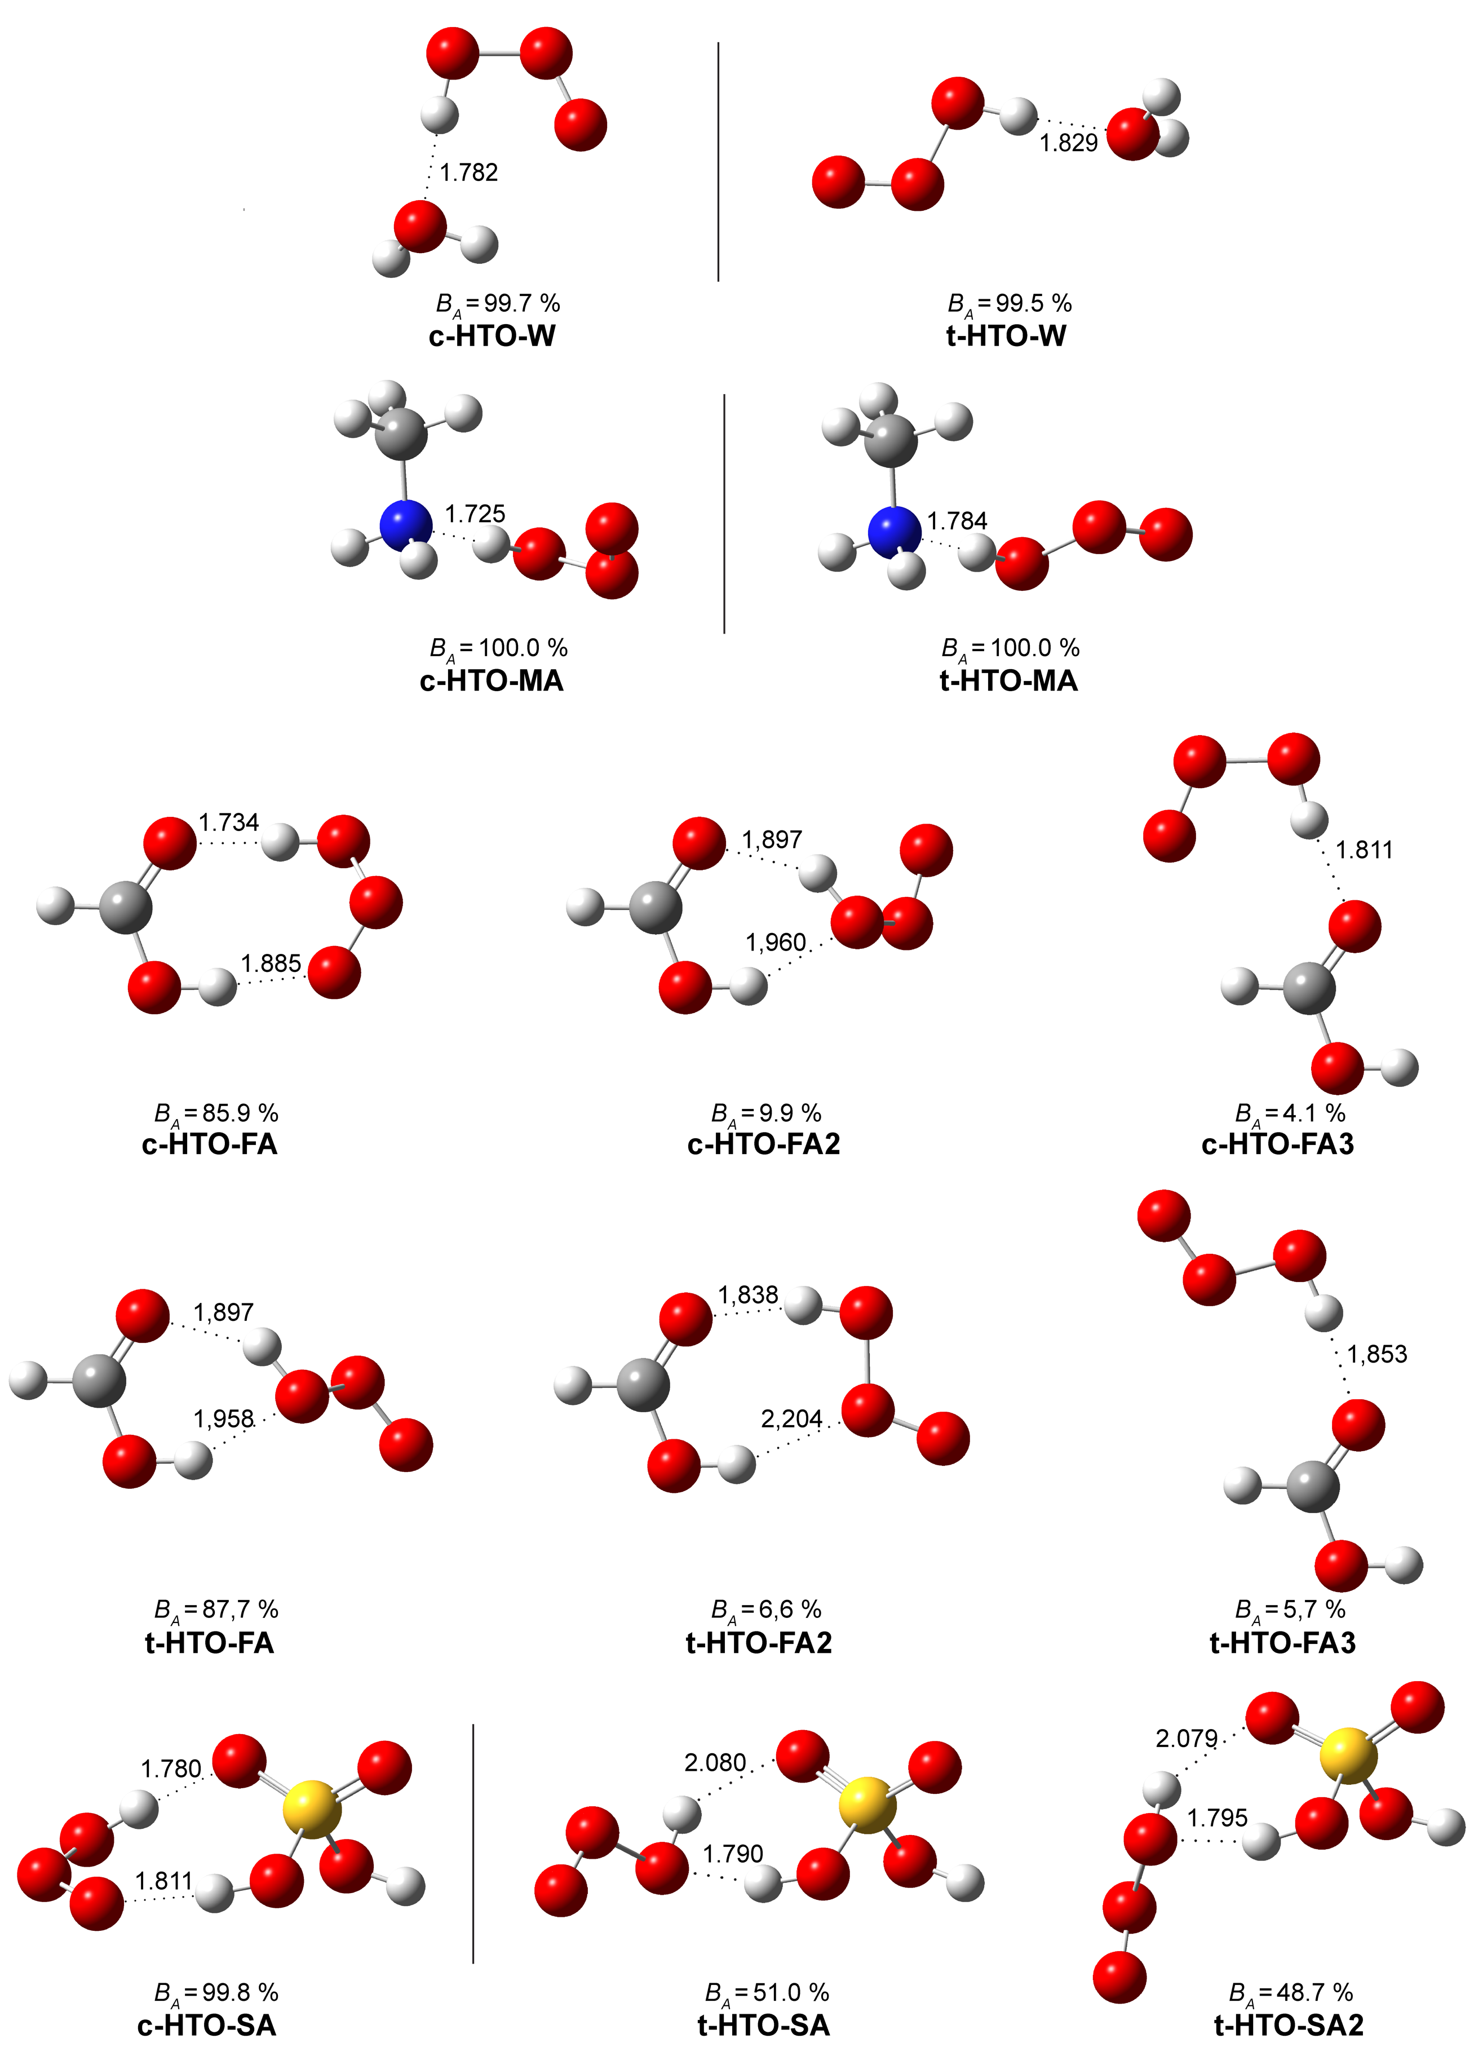

Figure S3: Optimised strucures of the stable binary complexes with the B3LYP/6-311++G(3df,3pd) bond lenghts and the CBS-QB3 binging energies. Dotted lines represent intermolecular formation of H-bonds.
Figure S4: Optimised strucures of the stable ternary complexes with the B3LYP/6-311++G(3df,3pd) bond lenghts and the CBS-QB3 binging energies. Dotted lines represent intermolecular formation of H-bonds.
Table S2: Thermodynamic properties (∆H, T∆S and ∆G) in kcal mol⁻¹ and calculated K_{c} values in cm³ molecules⁻¹ at different altitude (h) [km], temperature (T) [K] and preassure (p) [atm]. Calculated values correspond to the reaction: x-HTO-PR + W → x-HTO-PR-W (where x stands for the corresponding conformation of HOOO• radical and RP for the corresponding precursor molecule).
Complex | h | T | p | ∆H | T∆S | ∆G | K_{c}
Ternary Complexes
t-HTO-W-W | 0 | 298.15 | 1 | -7.73 | -10.78 | 3.05 | 5.7×10⁻²⁴
 | 0 | 278.15 | 1 | -7.74 | -10.09 | 2.35 | 1.3×10⁻²³
 | 5 | 255.15 | 0.533 | -7.73 | -9.57 | 1.84 | 2.3×10⁻²³
 | 8 | 236.15 | 0.351 | -7.71 | -9.03 | 1.32 | 4.7×10⁻²³
c-HTO-MA-W | 0 | 298.15 | 1 | -5.54 | -2.14 | -3.40 | 3.2×10⁻²⁴
 | 0 | 278.15 | 1 | -5.57 | -2.77 | -2.80 | 5.8×10⁻²⁴
 | 5 | 255.15 | 0.533 | -5.61 | -3.19 | -2.42 | 7.1×10⁻²⁴
 | 8 | 236.15 | 0.351 | -5.63 | -3.61 | -2.02 | 1.0×10⁻²³
t-HTO-FA-W | 0 | 298.15 | 1 | -10.64 | -10.22 | -0.42 | 2.0×10⁻²¹
 | 0 | 278.15 | 1 | -10.65 | -9.55 | -1.10 | 6.7×10⁻²¹
 | 5 | 255.15 | 0.533 | -10.66 | -9.09 | -1.57 | 1.9×10⁻²⁰
 | 8 | 236.15 | 0.351 | -10.66 | -8.61 | -2.05 | 6.2×10⁻²⁰
c-HTO-SA-W | 0 | 298.15 | 1 | -12.25 | -8.71 | -3.54 | 3.9×10⁻¹⁹
 | 0 | 278.15 | 1 | -12.26 | -8.13 | -4.13 | 1.6×10⁻¹⁹
 | 5 | 255.15 | 0.533 | -12.27 | -7.79 | -4.48 | 8.8×10⁻¹⁹
 | 8 | 236.15 | 0.351 | -12.28 | -7.41 | -4.87 | 2.7×10⁻¹⁸

References

- C. Murray, E. L. Derro, T. D. Sechler, M. I. Lester, J. Phys. Chem. A 2007, 111, 11592.
- T. Shimanouchi, Tables of Molecular Vibrational Frequencies Comsolidated. National Bureau of Standards, Washington, United States, 1972.

