Scientific paper
Application of Inverse QSAR/ QSPR Analysis
for Pesticides Structures Generation

Belgacem Souyei^{1,2}, Abdelkader Hadj Seyd^{3,*},Faouzi Zaiz⁴
and Abdelkrim Rebiai⁵

¹Faculty of Applied Sciences, University of Kasdi Merbah-Ouargla, 30000, Algeria
²Chemistry Department, Echahid Hamma Lakhdar University of El Oued.
³Faculty of Renewable Energy, Hydrocarbons, Earth and Universe Sciences, University of Kasdi Merbah- Ouargla
⁴Informatics department, Echahid Hamma Lakhdar University of El Oued.
⁵VTRS Laboratory, University of El Oued, P.O. Box 789, 39000, El-Oued, Algeria.

* Corresponding author: E-mail: seydtg@gmail.com
Tel: +213 662 726024
Received: 00-00-2018

Abstract
This present work has focused on the application of the inverse-QSAR/QSPR problem for generating new structures of pesticides, for this reason a quantitative structure–activity/property relationship study was performed to develop model that relate the structures of 190 pesticides compounds to their n-octanol–water partition coefficients. We used the unique atomic Signatures which represent the structures and acts as independent variables, while the property (logkow) as the dependent variable. Modeling of logkow as a function of the Signatures descriptors was established by multiple linear regression (MLR) using cross-validation (LOO).An equation with 14 atomic Signatures was hereby obtained with R² =0.659273,Q² =0.65617 and RMSE_{training}= 0.930192, for the training set and in leave-one-out (LOO) cross-validation experiment set value,q2 =0.605676, RMSE_{LOO}= 1.0936 respectively.

Keywords : n-Octanol–water partition coefficients; I-QSPR algorithm; Multiple linear regression (MLR); Atomic Signatures; Pesticides.

- Introduction
Pesticides are a large group of substances used to kill insects. These substances are mainly used to control pests that infest cultivated plants and crops or to eliminate disease-carrying insects in specific areas.¹ The definition of pesticides according to Food Agriculture Organization of the United Nations (FAO 1989), a pesticide is any substance or mixture of substances intended for preventing, destroying, or controlling any pest including vectors of human or animal diseases, unwanted species of plants or animals causing harm during, or otherwise interfering with, the production, processing, storage, or marketing of food, agricultural commodities, wood and wood products, or animal feedstuffs, or which may be administered to animals for the control of insects, arachnids or other pests in or on their bodies.²
Pesticides and agrochemicals, in general, became an important component of worldwide agriculture systems during the last century, allowing for a noticeable increase in crop yields and food production.³
Poisoning from pesticides is a global public health problem and accounts for nearly 300,000 deaths worldwide every year.⁴
Pesticides have numerous beneficial effects. These include crop protection, preservation of food and materials and prevention of vector-borne diseases. For example pesticides may be used in the prevention of malaria, which kills up to 1 million children per year,⁵ and for preventing other vector-borne diseases such as dengue, leishmaniasis and Japanese encephalitis .Sorption, volatilization, solubility in water, hydrolysis or oxidation, photo degradation and biodegradation are some of the important factors dealing with the fate of OPPs in the environment.⁶ Pesticides vary by source, structure and usage, for example, we find Botanical Ps and Neonicotinoid pesticides. Botanical Ps are naturally occurring chemical compounds extracted or derived from plants to manage field and storage crop pests.⁷ The BPs can easily degrade in the environment, and they are easily available, less toxic to human and non-targeted organisms and are compatible with different human cultures.^{8,9} Studies have shown that, plants are very good source of crop protectants against pests.^{10,11}
Neonicotinoid pesticides were first introduced in the mid-1990s and since then their use has grown rapidly so that they have become the most widely used class of insecticides in the world, with the majority being used as seed coatings.¹² As for the distribution of pesticides, it is concluded that lipophilicity is the chief determinant of pesticide distribution in sediment/water systems .¹³ Accordingly lipophilicity k_{ow} (n-octanol–water partition coefficients) is a physico-chemical property that characterizes the ability of a chemical compound to dissolve in fats (lipids) and non-polar solvents.¹³ Lipophilicity plays an important role in the development of drugs and pesticides, since this parameter affects the pharmacokinetic and pharmacodynamic behavior of a biologically active substance.^{15,16} According to IUPAC, lipophilicity reflects the affinity of a molecule or a fragment thereof with a lipophilic medium.¹⁷
Due to the importance of lipophilicity parameter k_{ow} in the distribution of these compounds (pesticides) between the water and organic phases in the organism. Numerous studies report k_{ow} values for ionisable compounds.¹⁸⁻²⁰
However, most of them determined a single k_{ow} value, reflecting the lipophilicity of the neutral species only. Lipophilicity is expressed by the octanol–water partition coefficient (k_{ow}), estimates the solubility in both aqueous and organic phases.²¹ The values of k_{ow} generated using these various methods may vary by several orders of magnitude hence k_{ow} is usually expressed in the logarithmic form (logk_{ow}).²² Given all the above mention of the logk_{ow} importance therefore it is necessary to study the shape and characteristics of the relationship between this important property (logk_{ow}) and the molecular structure of these compounds.
The aim of this work is that an Inverse-quantitative structure-property relationship (I-QSPR) study is performed, to develop a QSPR model that relate the structures of 190 pesticides compounds to their n-octanol–water partition coefficients using multiple linear regression technique and to generate new pesticides structures with novel physico-chemical and QSAR properties.

- Methodology
Inverse-QSAR/QSPR is known as the technical uses values for the independent variables of a particular compound in the QSAR /QSPR to solve for the activity /property of that compound (the dependent variable). In contrast, the goal of the inverse-QSAR/QSPR problem is to determine values for the independent variables given a desired activity /property.²³
An inverse-QSPR(I-QSPR) problem is a Signature-based CAMD (Computer Aided Molecular Design ) algorithm that identifies compounds possessing a certain performance (or property) of interest predicted using a developed QSPR model.²⁴ The I-QSPR technique is interchangeable with the molecular Signature descriptor CAMD algorithm. A general overview of the I-QSPR algorithm is provided in Figure 1, which explains that this algorithm is performed in nine fundamental stages:
(1) The selection of database compounds ; (2) Generation of the 2Dstructures; (3) Translation of the database compounds into signatures in addition to QSPR analysis; (4) Generation of constraint equations ; (5) Constraint equations solving then inverse solutions obtaining;(6) Check solutions for database; (7)Store solutions within desired range ; (8) New structure generation;(9) Focused database.
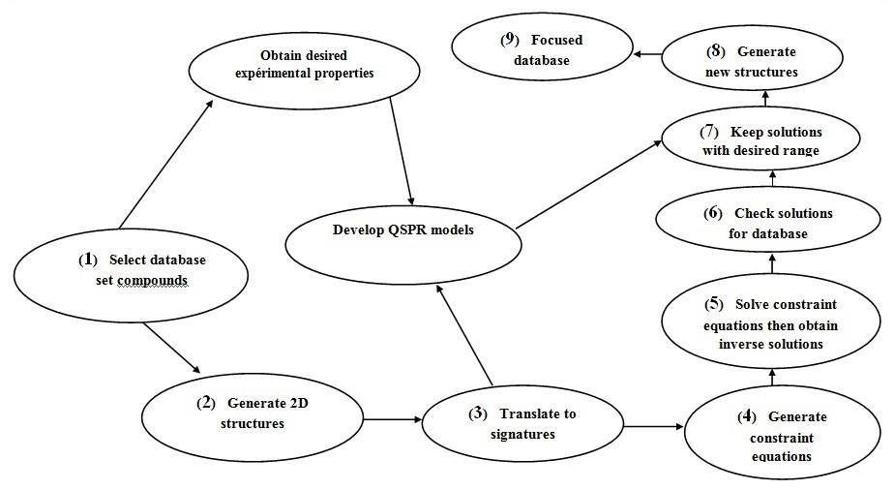

Figure 1. Outline of the I-QSPR Algorithm.²⁴

  - Step 1: Selection of database compounds
In this work the database contains 190 compounds (Pesticides) of deferent classes, which have important role in human life. The corresponding experimental data (n-octanol/water partition coefficients (logK_{OW}) were obtained from the literature (www.chemspider.com chemical structures and www.pubchem.com).
  - Step 2 : Generation of the 2D structures
We have developed a code that allows us to calculate the atomic signatures of molecules after generating 2D structures.
  - Step 3 : Translation of the database compounds into signatures in addition to QSPR analysis
The structural representation of the studied compounds is of great importance for describing, circulating and explaining the significant structural information on their characteristics. Based on this representation, the extent to which this structure is related to the activity /physiochemical properties of the studied molecule. The structural information of a molecule is evaluated by entities called molecular descriptors. The descriptor which is distinctive and in accordance with the applicable conditions to this technique (I-QSPR) is called signature.^{25,26}
- Signature
The Signature molecular descriptor is a fragment based descriptor that encodes the local topology of an atom in a molecule.²⁷ Degeneracy, when using Signature, is controlled by the height of the Signature, which represents the level of branching in a structure. Signature at height-1 or height-2 has lower degeneracy than height-0, and show high correlation ability for atomic Signatures of a molecule to its corresponding property of interest.²⁸
- Definition of the atomic signature
Signature, which has its origins in structural elucidation studies of Faulon, ²⁹ is based on the molecular graph of a molecule, G = (VG, EG), where the elements in VG denote the atoms in the molecule, and the edges of EG correspond to the bonds between those atoms. We define an atomic Signature, ^{h}σ_{G}(x),as the canonical sub-graph of G consisting of all atoms a distance h from the root x.²⁹
Once a Signature height is specified, the molecular Signature of each of the N compounds identified in Step 1 is calculated using an in-house translator program.
- Definition of the molecular signature descriptors
Descriptors encoding significant structural information are used to present the physicochemical characteristics of compounds to build the relationship between structure and property in this study. The molecular descriptor used in this project was the molecular descriptor called Signature due to its success to address the I-QSAR problem. The success of Signature is threefold, First, Signature performs the QSAR analysis as well as conventional molecular descriptors,^{30,31} Second, Signature has a lower degeneracy than other molecular descriptors and can be controlled by the user by a variable termed height. The molecular signature for a compound is the sum of each atomic signature multiplied by the occurrence vector of that atomic signature in the given compound and it can be calculated using the following equation.³²
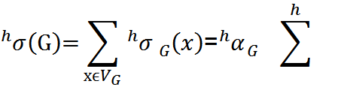
(1)
Where the elements of V_{G} (matrix of the vertices) are the atoms(X),$\sum^{h}{i}$is the basis set of all atomic signatures of height h and ^{h}α_{G} is the vector of occurrence number of atomic h-signatures of the graph G. Example of molecular signatures for Ethephon is given in Figure2.

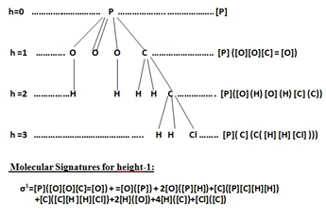
Figure 2. illustrates the atomic and molecular signatures of Ethephon (C₂H₆ClO₃P)

- QSAR/QSPR analysis :
The QSPR analysis was performed according to the organizational chart below:
Quantitative structure-activity / property relationship (QSAR/QSPR) as an important area of chemometrics has been the subject of a series of investigations.^{32,33} The main aim of (QSAR/QSPR) studies is to establish an empirical rule or function relating the structural descriptors of compounds under investigation to properties. This rule or function is then utilized to predict the same properties of the compounds not involved in the training set from their structural descriptors.
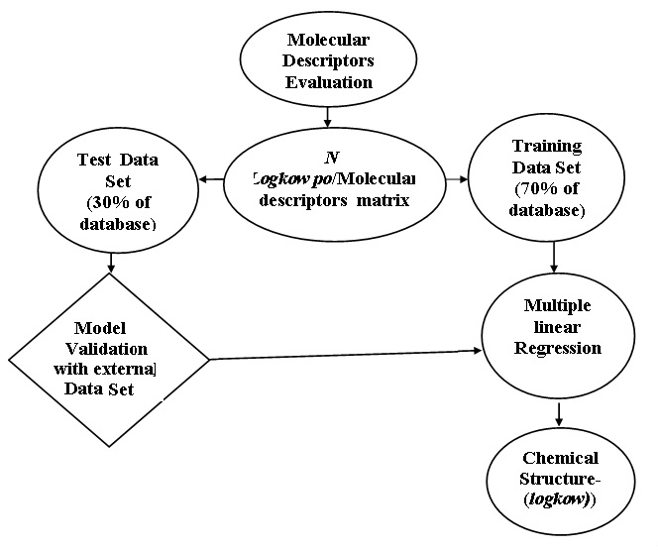

Figure 3: The Steps of QSPR Proposed Methodology

  - Step 4: Generation of constraint equations

The next step in the I-QSPR analysis is the construction of constraint equations, which serve in the construction of new compounds by reconnecting atomic Signatures into molecular Signatures with desired properties determined by the QSPR equation.³⁴ Constraint Equations are generated from the atomic Signature database. Graphicality Equation is developed from the height 0 atomic signatures, and is a necessary condition for a connected graph.³⁵

  - Step 5: Solve constraint equations
Since the space of solutions is infinite we limit the range that these solutions (independent variables) can take, based on their range in the original training set, minimum and maximum value (per atomic Signatures) provides the additional constraints necessary to solve the system. Due to the large number of equations , we have used the min/max values in the Particle Swarm Optimization algorithm called PSO .This algorithm looks to satisfy the constraint equations in an step-wise manner such that the iterations involving those variables which occur in the equations go from least to most iterations.
  - Step 6: Check solutions for database
Since the constraint equations are derived from the number of used compounds, this number of used compounds should represent solutions to the constraint equations.

  - Step 7 : Keep solutions with desired range
In this step the solutions must be scored for fitness relative to a desired property value. The solutions which have the desired fitness are kept, while the unsuitable atomic signature must be removed from the solution. At this stage where various heuristics can be applied to focus the solution space based on expert knowledge or other means.²⁶

  - Step 8: Generate new structures
The molecular Signatures (solutions) which emerge from Step 7 are the molecular Signatures from which structure generation will occur. Structure generation is performed using an algorithm developed by Faulon and Coworkers,³⁶ which is based on an earlier isomer enumeration algorithm developed by Faulon. In this step various filters can be employed to remove those undesirable candidate structures.

  - Step 9: Focused database
The structures which have survived until this point become part of the focused database. These are the high-quality structures which are worthy of further investigation. It is here where experiments run on a select number of compounds to verify the predictions of the algorithm would be employed. Often, the results of the experimentation can be used to refine the QSPRs and the focused database itself.²⁶
- Results and discussion
  - Atomic signatures calculation
The first step in the I-QSPR analysis is the translation of the 2D molecular structures into atomic Signatures, as illustrated in Table 1
Table 1. The unique height-1 atomic Signatures used in the QSPR analysis.
Variable | Height-1Atomic  Signature | Occurrence  [Min, max]
X₂ | [H]( [N]) | [0,5]
X₅ | [O](=[C]) | [0,3]
X₆ | [C]([C] [H] [H] H]) | [0,5]
X₈ | [S]([P] [C]) | [0,3]
X₉ | [O]([P][C]) | [0,4]
X₁₁ | [C] ([O] [H] [H ] [H]) | [0, 4]
X₁₂ | [H] ([C]) | [0,29]
X₁₄ | p[C] ([N] p[C] p[C]) | [0,4]
X₁₈ | p[C] ( p[C] p[C] [C]) | [0,5]
X₁₉ | [Cl] ([C]) | [0,4]
X₂₀ | p[C] ( p[C] p[C] [H]) | [0,10]
X₂₁ | [H](p[C]) | [0,11]
X₂₃ | pC( p[N] p[N] [N]) | [0,3]
X₂₄ | p[N] ( p[C] p[C]) | [0,3]
X₃₃ | [O] ( p[C] [C]) | [0,3]
X₃₅ | [O] (=[S]) | [0,4]
X₃₇ | C( N] H] H] H]) | [0,4]
X₃₉ | [N] ([C] [C] [C]) | [0,3]
X₄₃ | [C](p[C][H][H][H]) | [0,4]
X₄₄ | [pN] ( pC] pN]) | [0,4]
X₄₉ | [C]([C] H] [H]S]) | [0,3]
X₅₂ | p[C](p[C]p[C]Cl]) | [0,5]
X₅₃ | [Cl](p[C]) | [0,5]
X₅₇ | p[C]([pC] p[C][O]) | [0,3]
X₆₄ | [C]([O][C][H][H]) | [0,4]
X₇₄ | [C]([C][C][H][H]) | [0,7]
X₇₅ | [F] ([C]) | [0,6]
X₈₉ | [H] ([O]) | [0,3]
X₁₀₄ | [H](=[C]) | [0,3]

The QSPR analysis was calculated on the basis of a descriptor matrix. The descriptor matrix for the height -1 atomic Signature contained 190 rows and 253 columns, one column for the logkow and 252 columns for the unique atomic Signatures. The QSPR equation was however only calculated on the basis of 29 atomic signatures hereby removing 223 atomic Signatures in order to perform LOOCV.³⁷ Prior to performing the forward stepping MLR 223 unique atomic Signatures were removed leaving 29 with occurrence numbers greater than or equal to 3 for the LOOCV analysis. The most significant atomic Signatures were then added one at a time, on the basis of the R² and Q² values were calculated for each step resulting in Figure 4, which depicts the R² and Q² values as function of the number of independent variables, i.e. atomic Signatures.
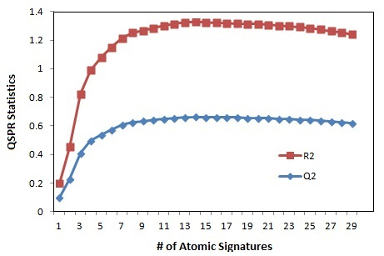

Figure 4. The impact of pesticides height-1 atomic Signatures on the QSPR statistics, which is plotted as function of the number of independent variables
As the figure illustrates the R² and Q² increased as a function of the independent variables. The calculations were terminated at 14 atomic signatures, thus the 15th atomic Signature was insignificant. Statistically QSPR model using MLR was obtained, the QSPR equation was chosen on the basis of the best predicting model, i.e. highest Q² value. A QSPR equation with 14 atomic Signatures was hereby obtained with a R² =0.659273, Q² =0.65617 and RMSE_{training} = 0.930192, for the training set ,and in leave-one-out (LOO) cross-validation experiment set value, q² =0.65617, RMSE_{LOO} = 1.0936 respectively.
  - The model equation
The model equation can be written as:
logk_{ow} = - 0.167497 + 0.444669 * X₅₂ + 0.417366 * X₆ + 0.785521 * X₂₀ + 0.461849 * X₇₅ + 0.0716288 * X₁₂ - 0.419674 * X₅ - 0.409265 * X₂₁ + 0.528737 * X₁₉ - 0.220096 * X₄₄ + 0.251859 * X₇₄ + 0.365269 * X₉ + 0.226272 * X₁₄ + 0.445708 * X₅₃ + 0.0357723 * X₂₄
The 14 atomic Signatures included in the QSPR equation are marked with bold in Table 1. Statistical results and significance of this final model, illustrate that the positive high value coefficient is for atomic signature X₂₀.It was also suggested from this model that the atomic signature X₂₄ was necessary contributor to logk_{ow,} the atomic signature X₅ was assigned as an effective variable on logk_{ow}, but with a negative coefficient. Using the QSPR equation to predict the logk_{ow} of the pesticides in the same training set and plotting these values against the experimental data, resulted in Figure 5.
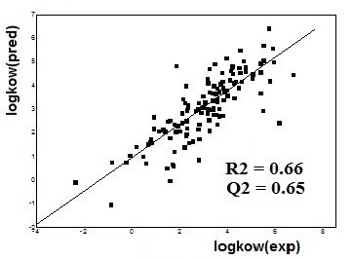
Figure 5: The experimental- versus predicted values for the QSPR equation based on the logk_{ow} with 29 height-1 atomic Signatures (logKow(Pred)=0.909412+0.704451.logKow(exp))
The plot shows the predicted logk_{ow} values based on the model equation which is validated to be statistically significant by the leave-one-out cross-validation versus experimental ones is shown in Figure 5. Obviously, the predicted logk_{ow} values are in a good agreement with experimental ones. The 14-parameters of model provide a high statistical quality: R² = 0,66 and Q² = 0.65 , and this shows that the condition of predictability according to the consideration of Golbraikh and Tropsha is satisfied,³⁸ the cross-validation test (leave-one-out ) confirm the capability of this model to predict the property of compounds not used for regression, but, also other novel compounds.
  - The constraint equations
The following constraint equations are written in the order of the smallest parameters number to the greatest, thus in the order they were solved: (i) Consistency equations which ensure the alignment of atoms in the construction of molecular Signatures. (ii) Graphicality equation which represents the valence of each atom. Solve these equations, a method was adopted which developed by Weis and Visco.²⁸ Given the large number of constraint equations and the wide database of pesticides, we have used a program based on PSO algorithm.

Table 2. Constraint Equations
N° | Constraint Equation
Eq.1 | Mod(+X₂₁₇,2) = 0
Eq.2 | Mod(+X₂₄₂,2) = 0
Eq.3 | +X₄₄+X₁₆₉ = 2
Eq.4 | -X₄₅+_{X48} = 0
Eq.5 | -X₉₁+X₉₂ = 0
Eq.6 | -2X₁₃₆+X₁₃₇ = 0
Eq.7 | -X₁₃₈+X₁₃₉ = 0
Eq.8 | -X₁₄₄+X₁₄₅ = 0
Eq.9 | -X₁₉₁+X₁₉₃ = 0
Eq.10 | Mod(+X₂₁₃+X₂₁₅,2) = 0
Eq.11 | -X₂₄₃+X₂₄₄ = 0
Eq.12 | -X₄₁+X₄₂-X₆₃ = 0
Eq.13 | -X₇₀+X₇₂-X₁₈₅ = 0
Eq.14 | -X₇₀+X₇₃-X₁₈₅ = 0
Eq.15 | -X₉₃+X₉₅+X₁₅₉ = 0
Eq.16 | -X₁₁₃+X₁₁₄-X₂₀₈ = 0
Eq.17 | -X₁₇₃+2X₁₇₄-X₁₇₅ = 0
Eq.18 | -X₂₀₆+X₂₀₇+X₂₀₉ = 0
Eq.19 | -X₅₂+X₅₃-X₁₁₉-X₁₈₇ = 0
Eq.20 | -X₈₈+X₈₉-X₁₅₃-X₁₉₅ = 0
Eq.21 | -X₁₄₉+X₁₅₀+X₂₂₆+X₂₅₀ = 0
Eq.22 | -X₁₆₈+X₁₆₉-X₁₈₆-X₂₄₆ = 0
Eq.23 | -X₁₂₁+2X₁₂₂-X₁₂₃-X₂₃₄-X₂₃₅ = 0
Eq.24 | -X₁₅₁+X₁₅₂+X₁₇₀-X₁₇₆-X₂₅₂ = 0
Eq.25 | -X₁+X₃+X₁₆₀-X₁₇₂+X₁₈₈-X₂₀₅ = 0
Eq.26 | -X₂₀+X₂₁-X₄₇-X₅₈-X₁₂₃-X₁₇₅ = 0
Eq.27 | -X₅₀+X₅₁-X₁₁₆-X₁₄₄-X₁₇₀-X₁₈₈ = 0
Eq.28 | -X₆₂+X₆₃+X₁₉₈-X₁₉₉-X₂₁₂-_{X247} = 0
Eq.29 | -X₁₀₁+X₁₀₄-X₁₅₀-2X₁₅₅-X₁₆₅-X₂₂₆ = 0
Eq.30 | -3X₇₁+X₇₅-X₁₃₃-3X₁₆₇-2X₂₁₉-X₂₂₀-2X₂₃₉ = 0
Eq.31 | -X₁₀₉+X₁₁₂-X₁₄₂-X₂₀₇-X₂₁₅-X₂₅₀+X₂₅₁ = 0
Eq.32 | -X₃+X₇-X₅₉-X₉₆-X₁₃₄-X₁₅₂-X₁₆₀-X₂₃₂ = 0
Eq.33 | -X₁₇+X₁₉-2X₈₀-3X₁₀₃-X₁₁₅-3X₁₁₇-2X₁₃₃-X₂₄₅ = 0
Eq.34 | -X₃₂+X₃₃-X₅₇+2X₈₅+X₉₃+X₁₁₈-X₁₂₄+X₁₉₅ = 0
Eq.35 | -X₃+X₈-X₅₀-X₅₉-2X₉₆+X₁₄₆-X₁₇₀-3X₂₃₂+X₂₄₁ = 0
Eq.36 | -X₂₇+X₂₈-X₆₇+X₁₂₀+X₁₄₆-X₂₁₈+X₂₃₀+2X₂₃₆+2X₂₄₀ = 0
Eq.37 | Mod(+X₆₀+X₆₂+X₁₄₀+X₁₄₁+X₁₈₄+X₁₈₅+X₂₀₁+X₂₀₂+X₂₃₈,2)= 0
Eq.38 | -2X₃₄+X₃₅-2X₃₈-2X₉₅-2X₁₂₀-2X₁₅₉-2X₂₂₃-X₂₂₄-2X₂₃₀-2X₂₄₀-2X₂₄₁ = 0
Eq.39 | -X₄+X₅-X₃₀-X₅₆-X₆₁-X₆₅-X₆₆-X₈₂-X₁₆₃-X₁₇₁-X₁₇₇-X₂₂₂ = 0
Eq. 40 | -X₃₁+2X₃₄-2X₃₆+X₃₈-X₈₃-X₈₄+X₉₅+X₉₉+2X₁₀₇+X₁₂₀-2X₁₃₂-X₂₂₁ =0
Eq.41 | -X₁+X₂-X₂₅-X₃₁-2X₄₆-X₆₉-X₇₉-X₈₃-X₁₆₂-X₁₈₄-2X₂₀₂-2X₂₀₅-2X₂₂₁-X₂₃₈ =0
Eq.42 | -X₁₃+X₁₄+X₂₃-X₂₅-X₄₆+X₅₅-X₇₀-X₇₆-X₇₇-X₈₃-X₁₃₂-X₁₄₀-2X₁₆₂+X₂₃₄-X₂₃₈ = 0
Eq.43 | -X₃+X₉-2X₅₀-2X₅₉-X₉₆-3X₁₁₆+X₁₁₈-3X₁₃₄-2X₁₄₄-2X₁₅₂+X₁₅₃-2X₁₆₀-X₁₇₀-2X₁₈₈+2X₂₃₁+X₂₅₁ = 0
Eq.44 | -2X₂₃+2X₂₄-2X₂₇-X₃₂+X₄₄+2X₄₅-2X₄₇-X₅₅-X₅₈-X₉₄-X₁₁₉-2X₁₂₄-2X₁₂₅-2X₁₂₆+X₁₆₉-2X₁₈₇-X₂₁₈-X₂₃₄-X₂₃₅ = 0
Eq.45 | -X₄₀+X₄₁-X₁₀₅+X₁₄₉-X₁₇₇+2X₁₇₈-X₁₈₁-X₁₈₂-X₁₈₃-X₁₉₂+X₁₉₃-X₁₉₆-X₁₉₇+X₁₉₈-X₂₁₀-X₂₁₆+X₂₁₇-X₂₂₈-2X₂₄₈-X₂₄₉ = 0
Eq.46 | -X₇₆-X₇₇+3X₇₈-X₇₉-X₁₄₁+X₁₄₂+X₁₅₀+X₁₆₅-2X₁₆₆-X₁₈₀+X₁₉₄-X₁₉₉+2X₂₀₀-X₂₀₁+X₂₀₇-X₂₀₈+X₂₀₉-X₂₁₁-X₂₁₂-2X₂₁₄+X₂₁₅+X₂₅₀ = 0
Eq.47 | +2X₁₄+2X₁₈+2X₂₀+X₃₂+2X₄₂+2X₅₂+X₅₅+2X₅₇+X₅₈+2X₆₇+3X₈₆+2X₉₁+X₉₄+X₁₁₉+X₁₂₁+X₁₂₃+X₁₂₆+2X₁₃₈+2X₁₄₅+X₁₇₃+X₁₇₅+X₂₁₈ = 2
Eq.48 | -X₁₈+X₂₂+X₄₃+X₆₁+X₇₁+X₈₁+X₈₂+2X₈₇-X₉₄-X₁₂₁-X₁₂₅+X₁₂₇+2X₁₃₀+X₁₃₁+X₁₄₇+X₁₄₈+X₁₅₇+3X₁₆₁+X₁₆₄-X₁₇₃+X₁₇₉+X₁₉₇-X₂₃₅= 0
Eq.49 | -X₈+X₁₀-X₂₈-X₃₈+X₄₉+X₅₄+X₆₆+X₈₁+X₉₇-X₉₉+X₁₀₃+X₁₀₈-2X₁₁₁+X₁₃₃+2X₁₅₆-X₁₅₉+X₁₇₉+X₁₈₂+X₁₉₆-X₂₀₆+X₂₁₀-2X₂₂₃-2X₂₂₄-X₂₃₀+X₂₃₇-X₂₄₁-X₂₄₂+X₂₄₃= 0
Eq.50 | -X₁₀₀+2X₁₀₁-X₁₀₂-X₁₀₈+2X₁₀₉-X₁₁₀-X₁₃₅+X₁₃₆+X₁₄₂-X₁₄₃-X₁₅₄+X₁₅₅-X₁₆₄+X₁₆₅-X₁₈₁-X₁₈₉+2X₁₉₀-X₁₉₂+2X₁₉₄+X₂₀₀-2X₂₀₄+X₂₀₉+X₂₁₃-X₂₂₂-X₂₂₅+X₂₂₆-X₂₂₇-X₂₂₈-2X₂₂₉-X₂₄₅ = 0
Eq. 51 | -X₉+X₁₁+X₁₅-2X₁₆-X₃₃+X₅₆+X₆₄+X₆₅+2X₆₈+X₈₂+X₈₇-X₈₈+X₉₀+X₁₀₆-X₁₁₂ X₁₁₄+X₁₁₅+X₁₃₅+X₁₄₇+X₁₄₈+2X₁₅₈+X₁₆₁+X₁₆₇+X₁₈₉-X₁₉₁+X₁₉₆+X₂₁₉+X₂₂₀+X₂₂₈+X₂₄₆+X₂₅₂ = 0
Eq.52 | -X₁+X₄-2X₁₃+X₁₅-X₂₅+X₂₆+X₂₉+2X₃₀-X₃₁₋X₃₆+X₃₇-3X₃₉+X₄₀+X₅₄+X₅₆-2X₆₀+X₆₁+X₆₆-2X₆₉-X₇₆-X₇₉-2X₈₄+2X₁₀₅-2X₁₁₃+X₁₂₇+X₁₂₉-X₁₄₀-X₁₆₆+X₁₇₁-2X₁₇₂+X₁₇₆+X₁₇₇-2X₁₈₀-X₁₈₄+X₁₈₉-X₂₀₁+2X₂₀₃+X₂₁₀-X₂₁₁-X₂₁₂+X₂₂₂+X₂₂₅+2X₂₂₇+X₂₃₃+X₂₄₃-2X₂₄₇+X₂₄₉ = 0
Eq.53 | -3X₆-3X₁₀-3X₁₁+X₁₂-2X₁₅-2X₁₇-2X₂₂-2X₂₆-X₂₉-3X₃₇-X₄₀-3X₄₃-2X₄₉-2X₅₄-2X₆₄-2X₇₄-X₈₀-2X₈₁-X₉₀-X₉₇-X₉₈-X₁₀₀-2X₁₀₂-3X₁₁₀-X₁₁₅-2X₁₂₇-X₁₃₀-X₁₃₁-X₁₃₅-X₁₄₈-2X₁₅₁-2X₁₅₆-X₁₅₈-2X₁₆₈-X₁₇₁-2X₁₇₆-X₁₇₉-X₁₈₁-2X₁₈₃-X₁₈₆-2X₂₀₃-X₂₀₄-X₂₂₀-X₂₂₅-X₂₃₉-X₂₄₆-2X₂₄₉-X₂₅₂ = 0
Eq.54 | +X₄+X₆+X₁₇+X₂₂+X₂₆+2X₂₉+X₄₉+X₆₄+X₆₅+2X₆₈+2X₇₄+X₈₀+X₈₇+2X₉₀+2X₉₇+3X₉₈+X₁₀₀+X₁₀₂+3X₁₀₆+X₁₀₈+X₁₁₅+X₁₁₇+4X₁₂₈+2X₁₂₉+X₁₃₀+2X₁₃₁+3X₁₄₃+2X₁₄₇+X₁₄₈+X₁₅₁+2X₁₅₄+3X₁₅₇+X₁₅₈+2X₁₆₃+X₁₆₄+X₁₆₈+X₁₇₉+X₁₈₂+X₁₈₃+2X₁₈₆+X₁₉₂+X₁₉₇+2X₂₁₆+X₂₁₉+X₂₂₀+X₂₂₉+3X₂₃₃+3X₂₃₇+X₂₃₉+X₂₄₅+X₂₄₆+X₂₄₈+X₂₅₂ = 2
Eq.55 | Mod( X₁-X₂+2X₃+X₄-X₅+2X₆-X₇+X₈+X₉+2X₁₀+2X₁₁-X₁₂+X₁₃+X₁₄+2X₁₅+X₁₆+2X₁₇+X₁₈-X₁₉+X20-X₂₁+2X₂₂+X₂₃+X₂₄+X₂₅+2X₂₆+X₂₇+X₂₈+2X₂₉+X₃₀+X₃₁+X₃₂+X₃₃+2X₃₄-X₃₅+X₃₆+2X₃₇+2X₃₈+X₃₉+X₄₀+X₄₁+X₄₂+2X₄₃+X₄₄+X₄₅+X₄₆+X₄₇-X₄₈+2X₄₉+2X₅₀-X₅₁+X₅₂ X₅₃+2X₅₄+X₅₅+X₅₆+X₅₇+X₅₈+2X₅₉+X₆₀+X₆₁+X₆₂+X₆₃+2X₆₄+X₆₅+X₆₆+X₆₇+2X₆₈+X₆₉+X₇₀+2X₇₁-X₇₂-X₇₃+2X₇₄-X₇₅+X₇₆+X₇₇+X₇₈+X₇₉+2X₈₀+2X₈₁+X₈₂+X₈₃+X₈₄+X₈₅+X₈₆+2X₈₇+X₈₈-1X₈₉+2X₉₀+X₉₁-X₉₂+X₉₃+X₉₄+2X₉₅+2X₉₆+2X₉₇+2X₉₈+X₉₉+X₁₀₀+X₁₀₁+2X₁₀₂+2X₁₀₃-X₁₀₄+X₁₀₅+2X₁₀₆+X₁₀₇+X₁₀₈+X₁₀₉+2X₁₁₀+X₁₁₁+X₁₁₂+X₁₁₃+X₁₁₄+2X₁₁₅+2X₁₁₆+2X₁₁₇+X₁₁₈+X₁₁₉+2X₁₂₀+X₁₂₁+X₁₂₂+X₁₂₃+X₁₂₄+X₁₂₅+X₁₂₆+2X₁₂₇+2X₁₂₈+X₁₂₉+2X₁₃₀+2X₁₃₁+X₁₃₂+2X₁₃₃+2X₁₃₄+X₁₃₅+X₁₃₆-X₁₃₇+X₁₃₈-X₁₃₉+X₁₄₀+X₁₄₁+X₁₄₂+2X₁₄₃+2X₁₄₄+X₁₄₅+X₁₄₆+2X₁₄₇+2X₁₄₈+X₁₄₉+X₁₅₀+2X₁₅₁+2X₁₅₂+X₁₅₃+X₁₅₄+X₁₅₅+2X₁₅₆+2X₁₅₇+2X₁₅₈+2X₁₅₉+2X₁₆₀+2X₁₆₁+X₁₆₂+X₁₆₃+X₁₆₄+X₁₆₅+X₁₆₆+2X₁₆₇+2X₁₆₈+X₁₆₉+2X₁₇₀+X₁₇₁+X₁₇₂+X₁₇₃+X₁₇₄+X₁₇₅+2X₁₇₆+X₁₇₇+X₁₇₈+2X₁₇₉+X₁₈₀+X₁₈₁+X₁₈₂+2X₁₈₃+X₁₈₄+X₁₈₅+2X₁₈₆+X₁₈₇+2X₁₈₈+X₁₈₉+X₁₉₀+X₁₉₁+X₁₉₂+X₁₉₃+X₁₉₄+X₁₉₅+X₁₉₆+X₁₉₇+X₁₉₈+X₁₉₉+X₂₀₀+X₂₀₁+X₂₀₂+2X₂₀₃+X₂₀₄+X₂₀₅+X₂₀₆+X₂₀₇+X₂₀₈+X₂₀₉+X₂₁₀+X₂₁₁+X₂₁₂+X₂₁₃+X₂₁₄+X₂₁₅+X₂₁₆+X₂₁₇+X₂₁₈+2X₂₁₉+2X₂₂₀+X₂₂₁+X₂₂₂+2X₂₂₃+X₂₂₄+X₂₂₅+X₂₂₆+X₂₂₇+X₂₂₈+X₂₂₉+2X₂₃₀+X₂₃₁+2X₂₃₂+2X₂₃₃+X₂₃₄+X₂₃₅+X₂₃₆+2X₂₃₇+X₂₃₈+2X₂₃₉+2X₂₄₀+2X₂₄₁+X₂₄₂+X₂₄₃-X₂₄₄+X₂₄₅+2X₂₄₆+X₂₄₇+X₂₄₈+2X₂₄₉+X₂₅₀+X₂₅₁+2X₂₅₂ ,2) = 0

  - Generating of new pesticides Structures
Base on the inverse solutions obtained from solving the system of constraint equations, new structures can be constructed from molecular Signatures. It is worth mentioning that for the same molecular Signature there are multiple structures.
Solving the constraint equations (Table 2) a total number of 5500 solutions (new molecular Signatures) which will be a new structures. Since it would be difficult to examine over 5500 structures, the newly generated structures were refined according to the different chemical structure of all existing pesticides. All newly generated structures were passed through the ChemSpider , PUB Chem and LookChem. ( structures search) which are reliable database to identify commercially available compounds. After all these steps, a set of 20 samples were obtained (Table 4).
The 20 identified compounds became part of the focused database. In order to assess the diversity level among the newly generated structures, they were compared to the training set structures.

Table 3. Example of a solved molecular Signature, note that only atomic Signatures with occurrence numbers greater than 0 are depicted.
Molecular Signature | X₆ X₈ X₉ X₁₀ X₁₁ X₁₂ X₄₉ X₅₀ X₅₁ X₆₄
no. 1 | 1 1 2 1 1 15 1 1 1 1

Table 4. Summarizes the 20 samples obtained with their QSAR properties like: Surface Area ,Volume , Mass, logk_{ow}, Refractivity in addition to molecular mechanic MM⁺ and semi-empirical PM3 simulations .

Formula | 3D Structure (*) | logK_{ow} | Surface area | Volume | Refractivity | Mass | MM+  (Kj/mol) | PM3  (Kj/mol)
C₇H₁₇O₂PS₄ | 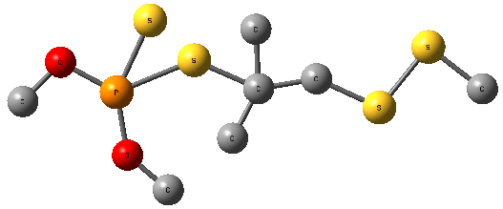 | 2.93 | 536.71 | 760.29 | 76.60 | 292.42 | 22.67 | -2641.14
C₆H₁₅O₂PS₃ | 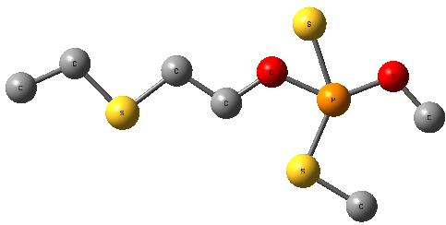 | 2.17 | 531.90 | 730.74 | 64.50 | 246.34 | 24.518 | -2302.97
C₇H₁₅ N₂O₄PS₃ | 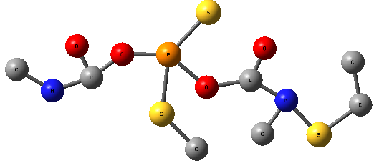 | 6.05 | 580.95 | 882.26 | 77.57 | 318.36 | 146.488 | -2905.23
C₈H₁₇N₂O₄PS₃ | 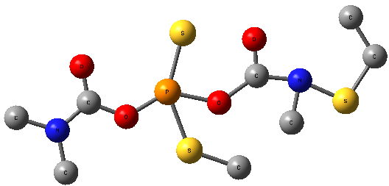 | 6.74 | 577.82 | 882.76 | 81.80 | 332.39 | 131.31 | -3174.98
C₉H₁₇Cl₂N₂O₃PS₂ | 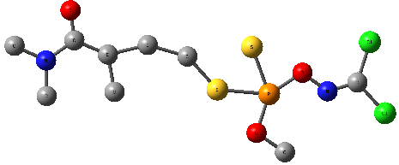 | 6.30 | 564.48 | 874.47 | 77.39 | 353.22 | 26.47 | -2922.12
C₇H₁₈NO₂PS₂ | 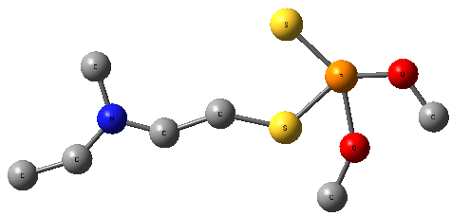 | 1.87 | 573.67 | 483.36 | 65.30 | 243.32 | 54.01 | -2703.03
C₅H₁₂NO₅PS | 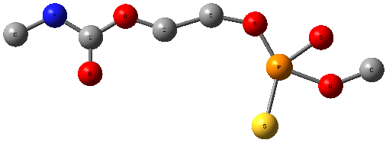 | 2.65 | 451.91 | 657.32 | 52.07 | 229.19 | 21.28 | -2288.44
C₇H₁₆NO₄PS | 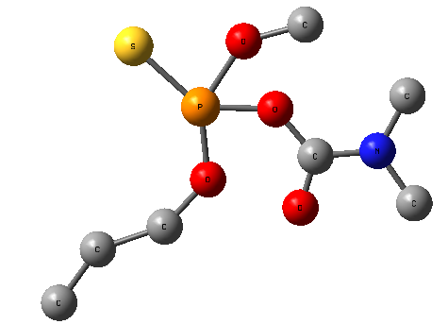 | 4.56 | 510.26 | 729.30 | 59.29 | 241.24 | 19.674 | -2737
C₆H₁₄OS₂ | 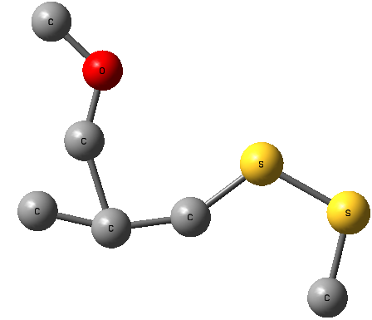 | 1.46 | 410.80 | 566.15 | 47.31 | 166.30 | -0.46 | -1997.52
C₉H₁₉N₂O₄PS₄ | 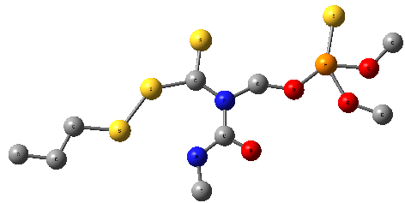 | 6.00 | 651.1 | 992.59 | 95.46 | 378.47 | 32.8 | -3488
C₁₃H₂₃N₄O₅PS₂ | 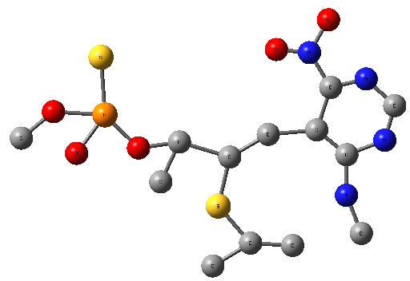 | 3.34 | 600.25 | 1074.63 | 106.29 |  | 44.67 | -4527.12
C₆H₁₆NO₂PS₂ | 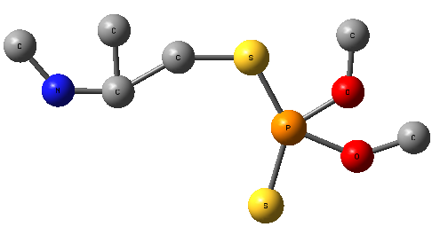 | 1.55 | 606.55 | 978.56 | 81.77 | 347.45 | 31.30 | 3549.116
C₉H₂₂N₃O₃PS₃ | 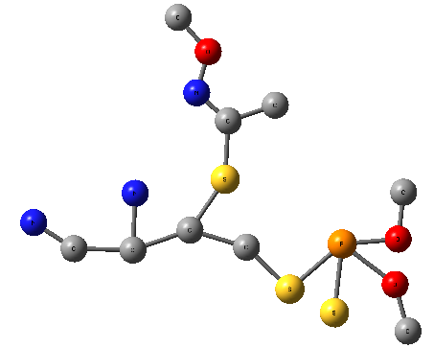 | 5.02 | 651.7 | 982.59 | 95.42 | 346.48 | 32.8 | -3458
C₆H₁₄NO₃PS₄ | 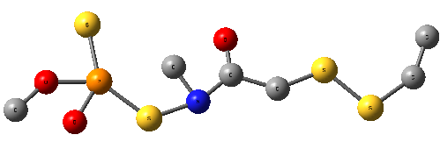 | 4.71 | 499.29 | 791.32 | 73.09 | 307.40 | 14.102 | 2539.87
C₁₀H₁₅N₂O₄PS₂ | 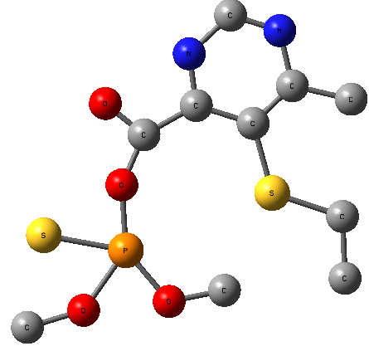 | 5.2 | 488.23 | 853.74 | 76.81 | 322.33 | 27.922 | -3329.07
C₆H₁₆NO₅PS₂ | 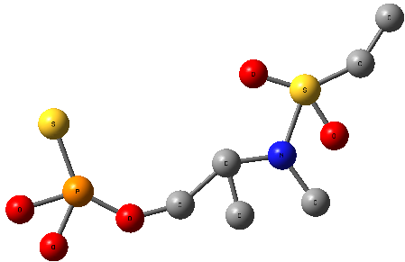 | 4.27 | 493.77 | 731. | 63.56 | 277.23 | 49.9 | -2743.26
C₁₆H₂₆N₃O₇PS₃ | 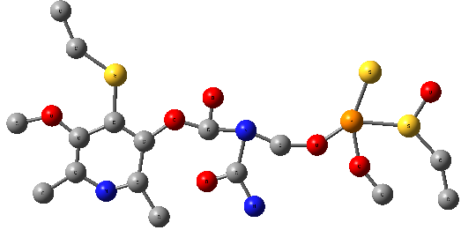 | 8.66 | 693 | 1249 | 115.85 | 499.5 | 46.36 | -5356.36
C8H18N3O2PS3 | 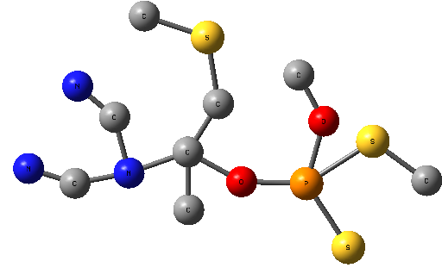 | 2.59 | 506.16 | 858.53 | 74.30 | 315.40 | 43.37 | -3075.79
C₈H₂₀NO₃PS₂ | 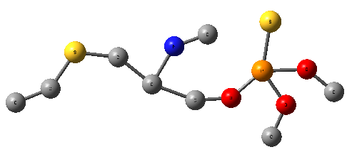 | 1.51 | 543.54 | 803.91 | 70.45 | 273.35 | 26.001 | -3074.00
C5H15N2O4PS | 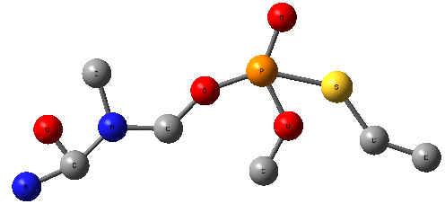 | 5 .52 | 492.04 | 72.69 | 57.54 | 242.23 | 40.15 | -26.21

- Conclusion

The high interest in pesticides and their uses in diverse fields, especially agricultural, requires us to study in depth and extensive to these pesticides and this is done by identification and focus on the characteristics including physico-chemical properties, then attempt to establish new chemical structures.
The identification of new pesticides with desired properties was done by developing an inverse-quantitative structure-property relationship on the basis of octanol-water partition coefficient (logk_{ow}).
We processed a database of 190 pesticide compounds, after developing molecular signatures calculated from atomic signatures and in order to perform LOOCV Only 29 atomic signatures from 252 are used as independent variables and logk_{ow} as a dependent variable in the QSPR realization, then the resolution of the constraint equations to the number of 55 by a computation code developed for this purpose, based on the successful PSO method to find 5500 solutions represent new structures.
We have presented and studied some examples of these new structures that do not yet exist in the databases of chemical compounds based on our search of reliable databases for this purpose.
Acknowledgments
We thank Dr. Labbi Yacine, Electrical Engineering Department , Echahid Hamma Lakhdar University of El Oued for the numeric analysis and calculating method assisting .
5. References
1. A. Sharma, P. J. Gadi , V. P. Reddy, Science of The Total Environment, 2018, 643,1522-1532

2. S. Knillmanna, P. Orlinskiyabc, O. Kaskea, K. Foita, M. Liessad, Science of The Total Environment, 2018, 630,1619-1627, https://doi.org/10.1016/j.scitotenv.2018.02.056

3. R. Münze, P. Orlinskiy, R. Gunold , A. Paschke, O. Kaske, M. A. Beketov, M. Hundt, C. Bauer, G. Schüürmann, M. Möder, M. Liess, Science of The Total Environment, 2015, 537,69-80.

4. A. Sabarwal, K. Kumar, R. P. Singh, Environmental Toxicology and Pharmacology, 2018, 63,103-114, https://doi.org/10.1016/j.etap.2018.08.018

5. V. Sujitha, K. Murugan, D. Dinesh, A. Pandiyan, R. Aruliah, J.Hwang, K. Kalimuthu, C. Panneerselvam, A. Higuchi, A. T. Aziz, S. Kumar, A. A. Alarfaj, B. Vaseeharan, A. Canale, G. Benelli, Aquatic Toxicology, 2017,188,100-108
6. K. V. Ragnarsdottir, Journal of the Geological Society, 2000,157,859 – 876.
7. N. E. El-Wakeil, Gesunde Pflanzen, 2013, 65,125–149

8. E. V.R. Campos, P. L.F.Proença, J. L. Oliveira, M. Bakshi, P.C. Abhilash, L. F. Fraceto , Ecological Indicators, (in press), Available online 27 April 2018, https://doi.org/10.1016/j.ecolind.2018.04.038

9. Y. Huang, L. Li , J. Liu, W. Lin, Algal Research, 2014, 4, 62-69, https://doi.org/10.1016/j.algal.2013.08.001

10. M. L. Umpiérrez, J. Paullier, M. Porrini, M. Garrido, E. Santos, C. Rossini, Industrial Crops and Products, 2017,109, 686-692, https://doi.org/10.1016/j.indcrop.2017.09.025
11. B. I. Murray, Pest Management Sci. 2008, 64, 8–11.

12. R. Potts, M. R. Clarke, S. E. Oldfield, K. L. Wood, N. H. de Ibarra, J. E. Cresswell, Journal of Insect Physiology , 2018,104,33-39, https://doi.org/10.1016/j.jinsphys.2017.11.006.

13. O. Ogbeide, A. Chukwuka, I. Tongo, L. Ezemonye, Journal of Environmental Management, 2018, 217,23-37

14. M. Kah, C. D. Brown, Chemosphere, 2008, 10,1401-1408, https: //doi.org/10.1016/j. chemosphere. 2008.04.074.
15. F.Tsopelas, C.Giaginis, A. Tsantili-Kakoulidou, Expert Opinion on Drug Discovery, 2017, 12,885‒896.
16. C. Vraka, L. Nics, K. Wagner, M. Hacker, W. Wadsak, M. Mitterhauser, Nuclear Medicine and Biology. 2017, 50, 1‒10.
17. V.S. Talismanov, S.V. Popkov, O.G. Karmanova, S.S. Zykova , A.P., Chernobrovkina, J. Pharm. Sci. & Res. 2017, 9, 2372-2375.
18. E. Benfenati, G. Gini, N. Piclin, A. Roncaglioni, M.R. Varı , Chemosphere , 2003,53, 1155–1164.

19. R. N. Waterhouse, Molecular Imaging & Biology, 2003, 5, 376-389, https: //doi.org/ 10.1016/ j.mibio. 2003.09.014
20. A. Finizio, M. Vighi, D. Sandroni, Chemosphere, 1997, 34,131-161.
21. S. G. Machatha, S. H. Yalkowsky, Int. J. Pharm, 2005, 294,185-192.

22. Y. P. Chin, W. J Weber, T. C. Voice, Water Research, 1986, 20, 1443-1450

23. T. Ferrari, A. Lombardo, E. Benfenati, Science of The Total Environment, 2018, 638, 1158-1165, https://doi.org/10.1016/j.scitotenv.2018.05.072
24. C. J. Churchwell, M. D. Rintoul, S. Martin, D. P. Jr Visco, A. Kotu, R. Slarson, L. O. Sillerud, D. C. Brown, J.L. Faulon, J Mol Graph Model, 2004, 22, 263-273.
25. J. L. Faulon, D. P. Jr.Visco, R.S.Pophale, J. Chem. Inf. Comput. Sci. 2003, 43, 707–720.
26. T. Miyao, H. Kaneko, K. Funatsu, J Chem Inf Model. 2016, 56, 286-299.
27. T. Miyao, M. Arakawa , K. Funatsu, Mol Inform. 2010, 29, 111-125.
28. C. D. Weis, D. P. Visco, Computers & Chemical Engineering, 2010, 34, 1018-1029.
29. J. L. Faulon, J. Chem. Info. Comput. Sci. 1994, 34, 1204- 1218.

30. V. A. Dev, N. G.Chemmangattuvalappil, M. R. Eden, Computer Aided Chemical Engineering, 2014, 33,151-156.
31. N. Brown, B. McKay , J. Gasteiger, J. Comput. Aided Mol. Des. 2006, 20, 333-341.
32. C.Hansch, R. M. Muir, T. Fujita, P. P. Maloney, F. Geiger, M. Streich, j. Am. Chem. Soc. 1963, 85, 2817-2825
33. E.X. Esposito, A. J. Hopfinger, J. D. Madura, Methods. Mol. Biol. 2004, 275,131-214.
34. W.M. Brown , S. Martin, M.D. Rintoul , J. L. Faulon , J. Chem. Inf. Model., 2006, 46, 826-835
35. P. Donald, J. R. Visco . R. S. Pophale, M. D. Rintoul, and J. L. Faulon, Journal of Molecular Graphics and Modelling, 2002, 20, 429–438.
36. J. L. Faulon, C. J. Churchwell, D. P. Jr. Visco, J. Chem. Inf. Comput. Sci. 2003, 43, 721-734.
37. R. Veerasamy, H. Rajak, A.Jain, S. Sivadasan, C. P. Varghese, R.K. Agrawal , International Journal of Drug Design and Discovery . 2011, 2, 511-519
38. A. Golbraikh , A. Tropsha, J. Mol. Graphics Mod. 2002, 20, 269-276.

