Evaluation of DNA/BSA Binding and Chemical Nuclease Activity of L-Tyrosine-Based Mn(III) and Fe(III) Metallo-Intercalators
R. Biju Bennie,¹ C. Joel,¹ S. Daniel Abraham,² S. Iyyam Pillai,³ S. Theodore David^{4,*}
¹PG. Department of Chemistry, St. John’s College, Tirunelveli-627002, Tamil Nadu, India.
²Department of Chemistry, Madras Christian College, Chennai-600059, Tamil Nadu, India.
³PG. and Research Department of Chemistry, Pachaiyappa’s College, Chennai-600030, Tamil Nadu, India.
⁴Department of Applied Chemistry, PSN College of Engineering and Technology, Tirunelveli-627152, Tamil Nadu, India.

Corresponding author: S. Theodore David Manickam
Contact information:
Mobile: +91 9366705118
E-mail: s.theodore.david@gmail.com
1 DNA binding and cleavage experiments
1.1 Absorption spectral studies
The binding affinity of the complexes to CT-DNA was studied using UV-visible spectra in a medium of 50 mM Tris-HCl buffer maintained at pH 7.5. The calf thymus (CT) DNA gave an absorption maximum at 260 nm with an ε_{max} value of 6600 M⁻¹ cm⁻¹ from which its concentration was calculated.¹ Maintaining constant complex concentration (10 µM), the absorption titrations were conducted at various CT-DNA concentrations (0-250 µM) from which the binding constant (K_{b}) values, were calculated from the equation provided as follows.²
$$\frac{[DNA]}{(ε_{a}-ε_{f} ) }=\frac{[DNA]}{(ε_{b}-ε_{f} ) }+ \frac{1}{K_{b}(ε_{b}-ε_{f} ) }$$
Where ε_{a} is the molar extinction coefficient for the charge transfer absorption of DNA at a given concentration, ε_{f} and ε_{b} is the extinction coefficients of the complex in free as well as bound states respectively and K_{b,} the equilibrium binding constant. The K_{b} value is the ratio of the slope to the intercept in the linear fitting plot of [DNA]/(ε_{a}-ε_{f}) versus [DNA]. In all the experiments, Origin lab (version 6.1) software was used to perform the least squares analysis.
1.2 Fluorescence spectral studies
The relative binding propensities of the complexes were studied using fluorescence spectral method employing ethidium bromide (EB) as reference. Fluorescence intensities of EB bound DNA was measured by varying the complex concentrations at 612 nm and was observed that the emission intensity was reduced gradually on addition of the complexes. The binding efficiency of the complexes MnL and FeL to the nucleic acid can be determined from the classical Stern-volmer equation;
$$\frac{I_{0}}{I}=1+ K_{sv }\left[Q\right]$$
Where, I₀ and I represent the intensities of emission maxima in the absence and presence of the quenchers respectively and [Q] the corresponding complex concentration; K_{sv} the Stern-Volmer quenching constant which is obtained from the slope in the linear plot of I₀/I vs [Q]. The following equation paves the route to calculate the apparent binding constant (K_{app}) values.
K_{app} = K_{EB}[EB]/K_{app}[complex]
The concentration of EB was 3.3 μM and the value of K_{EB} was found to be 1.0 x 10⁷ M⁻¹.³
1.3 Viscosity measurements
The mode through which the complexes could bind to DNA was found from the viscosity measurements. These experiments were performed with constant CT-DNA concentration (200µM) at various complex concentrations (0-120 µM). A graph is obtained by plotting (η/η_{o})^{1/3} versus binding ratio of concentration of complex to that of concentration of CT-DNA, where η being the viscosity of DNA/complex and η_{o} the viscosity of DNA.⁴
1.4 DNA Cleavage analysis
Agarose gel electrophoresis technique was employed to monitor the nuclease activity of the complexes on supercoiled plasmid DNA (pBR322). The plasmid pBR322 DNA (30 μM) was treated with each complexes of different concentrations (10, 20 & 30 μM). The complexes were incubated at 37 ºC for 5h in a loading buffer containing 50% glycerol, 0.5M EDTA and 0.5% bromophenol blue dye and packing onto an agarose gel. Electrophoresis of pBR322 was carried at 50 V in 1% slab gel for 30 minutes containing ethidium bromide (0.5 μg/mL) and TAE buffer (Tris base (40 mM), EDTA (2 mM) and acetic acid (20 mM) maintaining the pH to 8). The pBR322 bands were visualized by using the ALPHA IMAGERTM 2200 gel documentation system. A fraction of normal supercoiled (SC, Form I) DNA was changed to nicked circular (NC, Form II) DNA.
2. BSA binding experiments
2.1 Preparation of stock solutions
The concentrations of the BSA stock solutions (C_{BSA} ~ 2 x 10⁻⁶ molL⁻¹) were maintained in a medium of Tris buffer (0.05 molL⁻¹ Tris, 0.15 molL⁻¹ NaCl and the pH is maintained at 7.4 using con.HCl) and is determined by monitoring the absorption band of BSA at 280 nm and dividing by molar extinction coefficients of BSA (ε₂₈₀ = 44,300 M⁻¹cm⁻¹).⁵
2.2 Fluorescence Spectroscopy
The fluorescence experiments were performed at BSA emission range at 340 nm with an excitation wavelength set to 285 nm. A width of 15 nm and 4 nm was set to the excitation and emission slit respectively. About 2 ml of BSA solution was added to the quartz cell (1.0 x 1.0 cm) followed by titration on successive additions of varying concentrations of metal complex solutions using micro-injector.
2.3 UV-Vis Spectroscopy
The absorption spectra in the range of 250-310 nm were recorded for both the BSA and BSA-metal complexes system. A concentration of 2 x 10⁻⁶ molL⁻¹ was maintained for BSA and the metal complexes.
3. Molecular docking study
Molecular docking study is a computational tool utilised to determine the interaction between the synthesised metal complexes and target molecules. Docking studies were performed on AutoDock Tools and AutoDockvina software.⁶ The structure of the metal complexes were converted into PDB format using discovery studio software and the PDB format file of the macro molecules (DNA/BSA) were obtained from Protein Data Bank. The most stable binding site and binding affinity of the complexes with Human DNA Topoisomerase (PDB ID: 1SC7) and BSA protein (PDB ID: 4F5S) has been explored. The grid box dimensions of 60 x 60 x 60 points were created with in which almost the entire DNA/BSA molecules are involved.

Supplementary Information
Fig S1:(a) FT-IR spectra of Ligand (L), (b) FT-IR spectra of MnL, (c) FT-IR spectra of FeL
Fig S2: ¹³C-NMR spectrum of the Ligand
Fig S3 (a): EI mass spectrum of the Ligand, (b) ESI mass spectrum of MnL, (c): ESI mass spectrum of FeL
Fig S4: Absorption spectra of metal complexes with 1 x 10⁻⁵ M concentrations in the absence and presence of increasing amounts of CT-DNA (0-25 x 10⁻⁵ M) at room temperature in 50 mM Tris-HCl/NaCl buffer (pH = 7.5). Arrow shows the absorbance changing upon increasing DNA concentrations. (a) Absorption spectra of MnL complex (b) Absorption spectra of FeL complex.
Fig S5: Emission spectra of BSA in the presence of various concentrations of MnL in DMSO, c(BSA)=2.0 x 10⁻⁶ molL⁻¹, c(Metal complex) = 2, 4, 6, 8, 10 x 10⁻⁶ molL⁻¹. Insert: Stern-Volmer plot for quenching of BSA by metal complexes (a) Emission spectra of BSA with MnL complex at 304 K (b) Emission spectra of BSA with MnL complex at 310 K.
Fig S6: Emission spectra of BSA in the presence of various concentrations of FeL in DMSO, c(BSA)=2.0 x 10⁻⁶ molL⁻¹, c(Metal complex) = 2, 4, 6, 8, 10 x 10⁻⁶ molL⁻¹. Insert: Stern-Volmer plot for quenching of BSA by metal complexes (a) Emission spectra of BSA with FeL complex at 304 K (b) Emission spectra of BSA with FeL complex at 310 K.
Fig S7: (a) Double logarithm plot for BSA-MnL complex at 304 K, (b) Double logarithm plot for BSA-MnL complex at 310 K
Fig S8: (a) Double logarithm plot for BSA-FeL complex at 304 K, (b) Double logarithm plot for BSA-FeL complex at 310 K
Tables S1-S4

.

Fig S1:(a) FT-IR spectra of Ligand (L), (b) FT-IR spectra of MnL, (c) FT-IR spectra of FeL
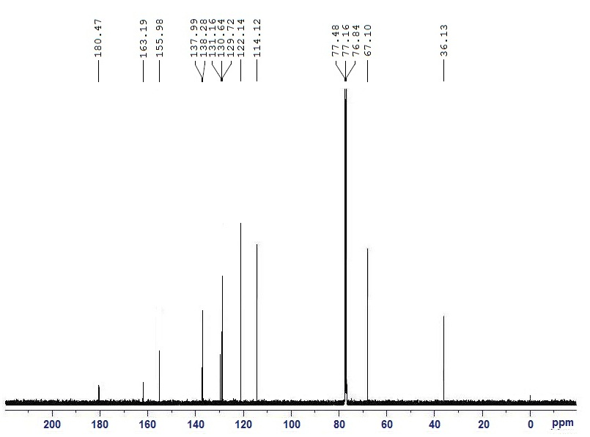
Fig S2: ¹³C-NMR spectrum of the Ligand

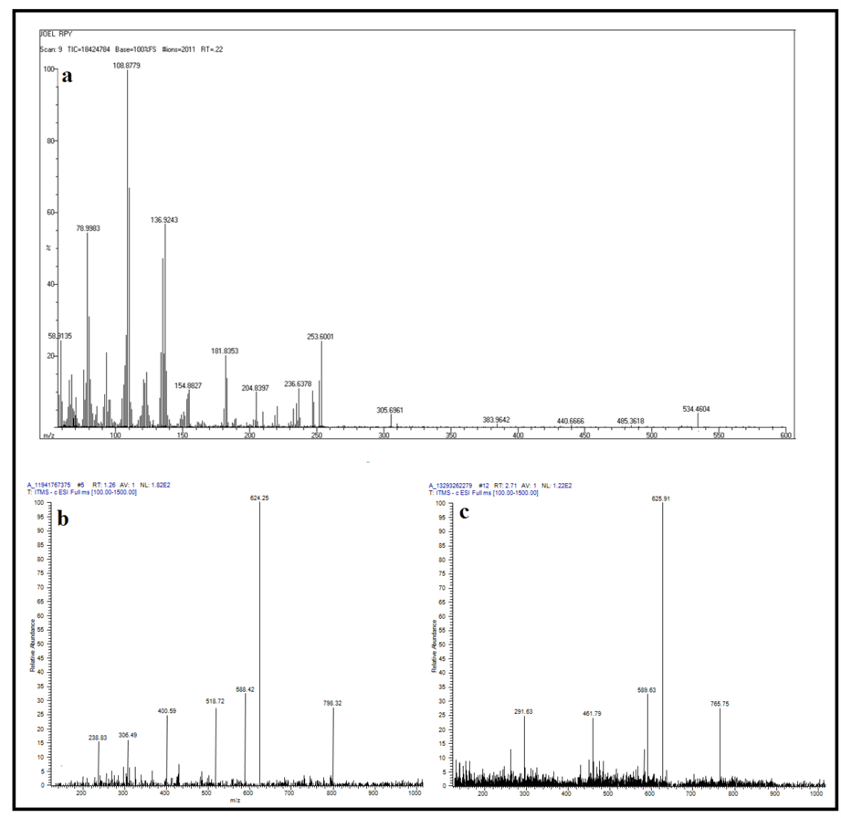

Fig S3 (a): EI mass spectrum of the Ligand, (b) ESI mass spectrum of MnL, (c): ESI mass spectrum of FeL

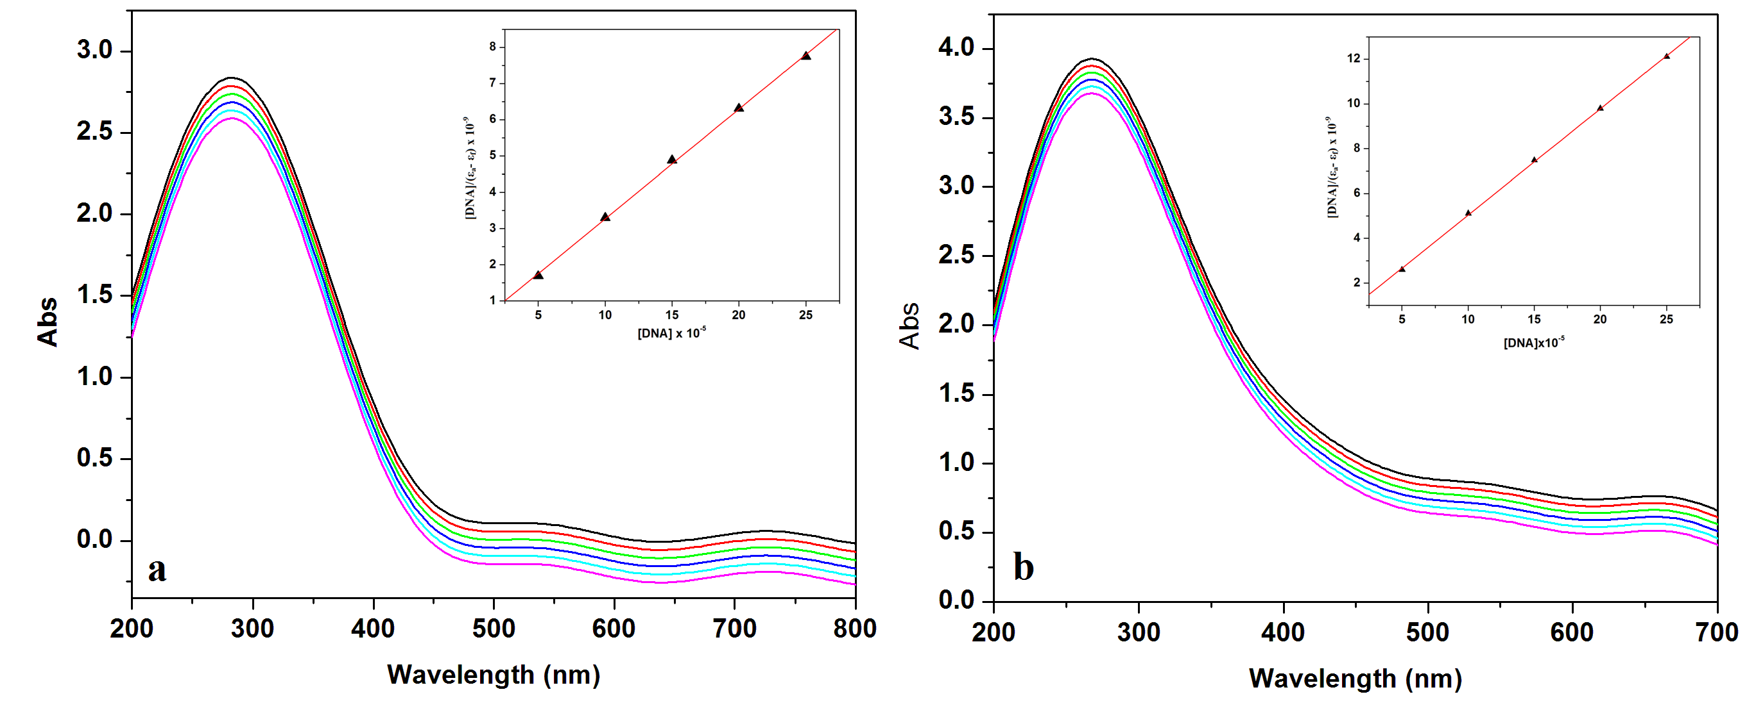
Fig S4: Absorption spectra of metal complexes with 1 x 10⁻⁵ M concentrations in the absence and presence of increasing amounts of CT-DNA (0-25 x 10⁻⁵ M) at room temperature in 50 mM Tris-HCl/NaCl buffer (pH = 7.5). Arrow shows the absorbance changing upon increasing DNA concentrations. (a) Absorption spectra of MnL complex (b) Absorption spectra of FeL complex.

Fig S5: Emission spectra of BSA in the presence of various concentrations of MnL in DMSO, c(BSA)=2.0 x 10⁻⁶ molL⁻¹, c(Metal complex) = 2, 4, 6, 8, 10 x 10⁻⁶ molL⁻¹. Insert: Stern-Volmer plot for quenching of BSA by metal complexes (a) Emission spectra of BSA with MnL complex at 304 K (b) Emission spectra of BSA with MnL complex at 310 K.

Fig S6: Emission spectra of BSA in the presence of various concentrations of FeL in DMSO, c(BSA)=2.0 x 10⁻⁶ molL⁻¹, c(Metal complex) = 2, 4, 6, 8, 10 x 10⁻⁶ molL⁻¹. Insert: Stern-Volmer plot for quenching of BSA by metal complexes (a) Emission spectra of BSA with FeL complex at 304 K (b) Emission spectra of BSA with FeL complex at 310 K

Fig S7: (a) Double logarithm plot for BSA-MnL complex at 304 K, (b) Double logarithm plot for BSA-MnL complex at 310 K

Fig S8: (a) Double logarithm plot for BSA-FeL complex at 304 K, (b) Double logarithm plot for BSA-FeL complex at 310 K

Table S1: Binding interactions of MnL complex with human DNA and BSA

Mode | Affinity (kcal/mol) |  | Dist from best mode
Mode |  |  | HDNA |  | BSA
Mode | HDNA | BSA | rmsdl.b. | rmsdu.b. | rmsdl.b. | rmsdu.b.
1 | -11.8 | -10.9 | 0 | 0 | 0 | 0
2 | -11.7 | -10.9 | 15.07 | 18.429 | 2.803 | 3.978
3 | -11.6 | -10.7 | 13.199 | 15.85 | 2.73 | 9.025
4 | -11.4 | -10.4 | 13.255 | 16.911 | 20.379 | 26.216
5 | -11.3 | -10.2 | 12.505 | 15.828 | 21.967 | 26.713
6 | -11.3 | -10.1 | 5.85 | 11.236 | 3.68 | 6.422
7 | -11.1 | -10 | 20.07 | 23.985 | 32.378 | 36.62
8 | -11 | -9.8 | 12.217 | 15.859 | 24.864 | 27.785
9 | -10.8 | -9.5 | 21.004 | 23.283 | 12.487 | 14.234

Table S2: MnL binds with different amino acid residues and nucleotide of receptors

Ligand | Receptor | Distance A° | Residue
MnL | HDNA | 2.15 | DT109-O41
MnL | HDNA | 3.57 | DT14-O41
MnL | HDNA | 2.78 | DA13-O41
MnL | HDNA | 2.42 | THR747-C3-C8
MnL | HDNA | 2.47 | ALA635-C29
MnL | HDNA | 2.18 | PRO636-C25
MnL | BSA | 4.21 | ASP111-c22-C28
MnL | BSA | 4.73 | LYS114-C4-C9
MnL | BSA | 3.84 | LUE112-C21-C26
MnL | BSA | 2.15 | ARG558-O40
MnL | BSA | 2.86 | GLU424-O40
MnL | BSA | 2.45 | LYS114-O40

Table S3: Binding interactions of FeL complex with human DNA and BSA

Mode | Affinity (kcal/mol) |  | Dist from best mode
Mode |  |  | HDNA |  | BSA
Mode | HDNA | BSA | rmsdl.b. | rmsdu.b. | rmsdl.b. | rmsdu.b.
1 | -11.7 | -10.8 | 0 | 0 | 0 | 0
2 | -11.7 | -10.6 | 10.208 | 15.983 | 21.955 | 25.053
3 | -11.7 | -10.3 | 12.721 | 14.87 | 2.526 | 3.144
4 | -11.7 | -10.3 | 13.195 | 15.847 | 3.284 | 5.491
5 | -11.4 | -10.1 | 15.285 | 17.689 | 22.793 | 26.563
6 | -11.4 | -10 | 13.244 | 16.915 | 22.581 | 26.381
7 | -11.4 | -9.9 | 9.634 | 13.559 | 17.889 | 22.082
8 | -11.3 | -9.8 | 15.364 | 17.652 | 24.559 | 26.444
9 | -11.3 | -9.7 | 15.535 | 18.169 | 13.24 | 17.041

Table S4: FeL binds with different amino acid residues and nucleotide of receptors

Ligand | Receptor | Distance A° | Residue
FeL | HDNA | 2.08 | THR747-C42
FeL | HDNA | 3.08 | DT109-O49
FeL | HDNA | 2.24 | DT14-O49
FeL | HDNA | 2.56 | DT13-O49
FeL | HDNA | 2.89 | DT109-O41
FeL | HDNA | 3.28 | ALA634-O43
FeL | BSA | 4.08 | PRO420-C27-C32
FeL | BSA | 3.51 | LUE189-C20-C25
FeL | BSA | 4.76 | GLU-424-C20-C25
FeL | BSA | 2.09 | ASP111-O36
FeL | BSA | 4.86 | ILE522-C5-C10
FeL | BSA | 4.12 | GLU424-C5-C10

References
1. M. E. Reichmann, S. A. Rice, C. A. Thomas, P. Doty, J. Am. Chem. Soc. 1954, 76, 3047-3053.
DOI: 10.1021/ja01640a067.
2. A.Wolfe, G. H. Shimer, T. Mechan, Biochem.1987, 26, 6392-6396.
DOI: 10.1021/bi00394a013.
3. Ashis K. Patra, Munirathinam Nethaji, Akhil R. Chakravarty, J. Inorg. Biochem. 2007, 101, 233-244.
DOI: 10.1016/j.jinorgbio.2006.09.018.
4. Jiazheng Lu, Haiwei Guo, Xiandong Zeng, Yongli Zhang, Ping Zhao, Jing Jiang, Linquan Zang, J. Inorg. Biochem. 2012, 112, 39-48.
DOI: 10.1016/j.jinorgbio.2012.02.034.
5. E. Alarcon, A. Aspee, M. Gonzalez-Bejar, A.M. Edwards, E. Lissi, J.C. Scaiano, Photo chem. Photobiol. Sci., 2010, 9, 861-869.
DOI: 10.1039/C0PP00079E.
6. O. Trott, A. J. Olson, J. Comput. Chem., 2010, 31, 455-61.
DOI: 10.1002/jcc.21334.

