Autofermentation of Chamomile Ligulate Flowers Increases Antitumor Effects in vitro

Marijana Jukić^{a#}, Aleksandra Cvetanović^{b#}, Katarina Mišković Špoljarićª, Saša Savić^{c}, Jaroslava Švarc-Gajić^{b}, Zoran Zeković^{b}, Ljubica Glavaš-Obrovacª*
ª Department of Medicinal Chemistry, Biochemistry and Clinical Chemistry, Faculty of Medicine, J.J. Strossmayer University of Osijek, J. Huttlera 4, HR-31000 Osijek, Croatia
^{b} Department of Pharmaceutical Engineering and Biotechnology, Faculty of Technology, University of Novi Sad, Bulevar cara Lazara 1, 21 000 Novi Sad, Serbia
^{c} Faculty of Technology, Bulevar Oslobođenja 124, 16000 Leskovac, Serbia

#These authors contributed equally to this work.

*Correspondence to:
Author to whom correspondence should be addressed: Ljubica Glavaš-Obrovac, e-mail: lgobrovac@mefos.hr; Tel.: +385-91-224-1446; Fax: +385-31-399-613.

Autofermentation of Chamomile Ligulate Flowers Increases Antitumor Effects in vitro

Abstract
The scope of the paper was an apigenin in chamomile flowers and it is biological activity. Both nonfermented-native (N-CLF) and auto fermented chamomile flowers (A-CLF) were extracted by different extraction techniques (ultrasound-UE, Soxhlet-SE) and different solvents. Obtained extracts were compared in terms to their chemical composition as well as bio-potential. Biological activity (antiproliferative effect, apoptosis) of chamomile extracts were investigated on a MDCK I, HeLa, NCI-H358 and K562 cell lines. Compared to the native extracts, autofermented extracts were characterized with higher apigenin content, higher extraction yield, as well as higher amount of total phenols and flavonoids. All evaluated extracts exerted significant antiproliferative activity against a tumour cell lines. The most sensitive were a K562 cells, which were reduced by 80% after 48 h of exposure. Morphological changes and apoptosis were detected in the HeLa cells exposed to A-UE (0.098 mg/mL) and A-SE (0.079 mg/mL) extracts.

Keywords: chamomile flowers, extraction, apigenin, antiproliferative activity, apoptosis.

- Introduction
It is well known that some natural plant compounds exhibit positive impact on human health demonstrating additive or synergistic diseases-fighting activities¹. Flavonoids, especially flavons, flavonols and flavanons, are often key bioactive compounds for antioxidant and anticancer effects.
Apigenin (4',5,7-trihydroxyflavone) is a flavon with relatively low molecular weight. Different studies have shown that apigenin demonstrates broad spectrum of beneficial effects being considered as a molecule with promising pharmacological and biological characteristics. Studies have shown that apigenin is a potent antioxidant, antiviral and antimicrobial agent ^{2,3}. In the structure of this compound three hydroxyl groups together with double bonds at C2 and C3 are present. Such chemical structure provides that apigenin can acts as a phytoestrogen. Furthermore, high cytotoxic activity of apigenin was proved in numerous studies. It is capable to induce apoptosis in different tumour cells like monocytic and lymphocytic leukemia cells, cervical, lung, breast, and colon carcinoma cells as well⁴. Conducted studies have provided data related to its chemoprotective effects. It was demonstrated that apigenin are able to block signal transduction pathways in different models of prostate cancer ⁵. Further, treatment of prostate cancer with apigenin can stop the cell cycle in the GO-G1 phase ⁶. It can inhibit growth of cancer cells and induce apoptosis in them; however it does not influence the growth of normal cells ⁷. Thus, it is considered as high-selective molecule. Low toxicity of apigenin was also proven. In fact, it shows lower toxicity in comparison to some other structurally similar molecules (quercetin, kaempferol, luteolin, and others) ⁸ .
Apigenin is common constituent of different fruits, vegetables, medicinal plant, teas or other plants’ beverages. However, one of the most common dietary sources of apigenin is herbal tea prepared from chamomile (Matricaria chamomilla L.). The chamomile inflorescences (so-called anthodia), consisting of white (ligulate) and yellow (tubulare) flowers, contain different chemical constituents. Apigenin is present only in ligulate flowers (CLF) where it can be accumulated in a different form: (1) form of free aglycone; (2) form of glycoside - apigenin-7-O-β-glycoside (Ap-7-Glc); (3) form of different acetylated derivatives of Ap-7-Glc ⁹. Earlier research has shown content of free apigenin is much lower than content of its bound forms¹⁰. However, from the point of view of biological activity, high concentration of free apigenin in chamomile extracts is of great importance. An increase of its content in starting plant material and further in extracts is very notability task and different hydrolysis of apigenin glycosides into aglycone have been reported in the literature.
In this study, apigenin was liberated from its glycosides by enzymatic biotransformation, i.e. autofermentation. The conducted process was based on activation of β-glucosidase, an enzyme which is naturally present in chamomile and which is able to hydrolysed apigenin glycosides into apigenin. Autofermented chamomile ligulate flowers (A-CLF) together with native ones (N-CLF) were used for the extracts preparation. Detailed chemical profiles of such extracts were defined by UHPLC-MS-MS analysis. The bio-potentials of native (N-CLF) and autofermented (A-CLF) extracts were compared, including evaluation of apoptosis and morphological changes which had been influenced by extracts.
- Exsperimental
  - Sample preparation
Dry plant material (CLF) was purchased from the Institute of Field and Vegetable Crops, Bački Petrovac, Serbia. The autofermentation of CLF was performed in the manner previously described elsewhere¹¹. Obtained autofermented (A-CLF) as well as native (N-CLF) flowers were used for extraction process.

  - Ultrasound-assisted (UE) extraction
The UE was carried out in an ultrasonic bath (Branson, USA) at a frequency of 55 Hz. N-CLF and A-CLF were extracted by both ethanol and water. A mass of plant material used for the extraction was 5 g, while volume of the solvent was 250 mL. UE was performed within 40 minutes. Obtained extracts were filtered and dried at 40°C. Extraction runs were performed in triplicates.
  - Soxhlet extraction (SE)
Plant samples (N-CLF or A-CLF) were extracted in a Soxhlet extractor by using ethanol as a solvent. Extraction process was carried out for eight hours, i.e. until the solvent discoloration. After cooling, the solvent was removed from obtained extracts by evaporation and the extracts were dried at 40°C. Thus obtained SE extracts were kept in a glass vessel and stored at 4°C until analysis. Extraction runs were performed in triplicates.
  - Determination of the total extraction yield, total phenols (TP) and flavonoids (TF) content
Determination of the total extraction yield was carried out according to the method previously described in Ph. Jug. IV¹². Yield of each extract was expressed as mass of dry extract per 100 g of dry plant material (g/100 g DP).
Total phenols (TP) and flavonoids (TF) content was determined according to the methods previously described by Singleton and Rossi¹³ and Markham¹⁴, respectively. In case of phenols content, the obtained results were expressed as a mass of chlorogenic acid equivalents (CAE) per g of dry extract (mg CAE/g). The content of total flavonoids in examined extracts were expressed as a mass of rutin equivalents (RE) per g of dry extract (mg RE/g). All measurements were done in triplicates.
  - TLC-UV determination of apigenin and apigenin-7-O-glucoside content
TLC-UV measurement of apigenin and Ap-7-Glc content was done according to the procedure previously described elsewhere¹⁵. Mobile phase was made by mixing toluene, methyl ethyl ketone and methanol in the ratio of 55:30:15 (v/v/v), while stationary phase was silica gel GF₂₅₄ (thickness of the layer was 0.5 mm). Standard compounds (apigenin and Ap-7-Glc; analytical grade of purity ≥ 99%) were dissolved in ethanol and used for calibration curve preparation. Calibration curve for apigenin was defined for the concentration range 0.02–0.1 mg/mL ($C_{Apigenin}=\frac{A-0.03}{6.91}$, R² = 0.9981). For Ap-7-Glc this concentration range was 0.01-0.09 mg/mL, and the curve had the following expression: $C_{Ap-7-Glc}=\frac{A-0.03}{2.43},$ (R² = 0.9978).
  - UHPLC-DAD-HESI-MS/MS analysis
The analysis was performed by using Thermo Scientific liquid chromatography system (UHPLC) (Thermo Fisher Scientific, San Jose, California, USA). Xcalibur (version 2.2 SP1.48) and LCQ Fleet (version 2.7.0.1103 SP1) software were used for instrument control, data acquisition and data analysis. Separations were performed on a Hypersil gold C18 column (50 × 2.1 mm, 1.9 µm). The used mobile phase was consisted of (A) water + 0.2% formic acid and (B) acetonitrile. The volume of 5 µL of each extract was injected into the system. The column was termostated at 25ºC and the analysis was performed according to the method previously described in the literature ^{11,16}. Detected compounds were identified according to corresponding spectral characteristics: mass spectra, accurate mass and characteristic fragmentation. Quantification of apigenin and Ap-7-Glc was made by using the external standard method.
  - Antioxidant activity
The ability of the extracts to act as antioxidants was determined by two different assays: DPPH and reducing power methods. DPPH test was done followed the method of Espín¹⁷ while reducing powers ability was measured according to the Oyaizu¹⁸ method. The obtained results were expressed as IC₅₀ (mg/mL) and EC₅₀ (mg/mL) values, respectively (Table 1).
  - Cell lines and culturing
The experiments were carried out on cervix adenocarcinoma (HeLa), bronhoalveolar carcinoma (NCI-H358), chronic myeloid leukemia in blast crisis (K562), and normal Madin-Darby canine kidney fibroblast like cells (MDCK I; p = 33-35). HeLa and MDCK I cells were cultured in DMEM supplemented with 10% heat-inactivated FBS and 2 mM glutamine. NCI-H358 and K562, were grown in RPMI 1640 medium supplemented with 10% FBS, 2 mM glutamine, 10 mM sodium pyruvate and 2 mM HEPES. The cells were grown as monolayers or suspensions in tissue culture flasks (BD Falcon, Germany) in the humidified atmosphere under the conditions of 37°C/5% of CO₂ gas in the CO₂ incubator (IGO 150 CELLlifeTM, JOUAN, ThermoFisher Scientific, Waltham, MA, USA). The trypan blue dye exclusion method was used to assess cell viability.
  - Preparation of test compounds for biological tests
N-CLF and A-CLF extracts were dissolved in DMSO (25 mg/mL). Working solutions were prepared prior testing in the sterile water and added to the test plates reaching final concentration from 0.0001 mg/mL to 0.5 mg/mL. For detection of apoptosis and evaluation of morphological changes, samples were added at concentration that reached 50% inhibition of treated cells’ growth (GI₅₀). Apigenin was prepared as the stock solution (5 mg/mL) and used as matching and differing parameter for CLF extracts.
  - Cytotoxicity evaluation
The effects of observed CLF and A-CLF extracts on the growth of normal and tumor cells were determined using the MTT assay. The adherent cells, MDCK I, HeLa, and NCI-H358, were seeded in 96 micro-well plates at concentration of 2×10⁴ cells/mL. The cells were incubated during the night in the CO₂ incubator (IGO 150 CELLlifeTM, JOUAN, Thermo Fisher Scientific, Waltham, MA, USA). Afterwards, the cells were treated with extracts and incubated for 48 and 72 h. Immediately after, medium was replaced with MTT solution (5 mg/mL) and the resulting formazane crystals were dissolved in DMSO. In case of leukemia cells, the cells were seeded at the plates in the concentration of 1x10⁵ cells ⁄mL, and incubated for 72 h. After that, MTT solution (5 mg/mL) was added to the each well and incubation was performed for 4 h in CO₂ humidified atmosphere. In order to dissolve water-insoluble MTT-formazane crystals, 10% SDS with 0.01 M HCl was added to each well. The absorbance was read at 595 nm on ELISA microplate reader (iMark, BIO RAD, Hercules, CA, USA).
All experiments were performed at least three times in triplicates. The percentage of cell growth (PG) was calculated in the manner given in the literature ¹⁹.
The results were expressed as GI₅₀ value, i.e. as a concentration of the extract which are able to reduce the cell growth by 50%.
  - Detection of apoptosis
The ApoAlert Annexin V-FITC staining kit was used to detect apoptosis at the single cell level. Experiments were performed according to manufacturer’s instructions, with modification in propidium iodide concentration (reduced 1.5 x). Briefly, 1x10⁵ cells/mL HeLa cells were seeded on 8-wells chamber slides with silicon borders and incubated in DMEM overnight. Growing medium was replaced with a fresh medium containing GI₅₀ concentration of A-UE (0.098 mg/mL) and A-SE extracts (0.079 mg/mL) for 24 and 48 hrs, respectively. The GI₅₀ concentration (0.008 mg/mL) for commercially available apigenin was determined on HeLa cell line by MTT test.
The cells were analysed by fluorescent microscope (Axioskop 2 MOT, Carl Zeiss Jena GmbH, Jena, Germany) in a combination with appropriate filters (λ_{exc} = 450–490 nm; λ_{em} = 520 nm (f3); λ_{exc} = 530–585 nm; λ_{em} = 615 nm (f2)).
  - Morphological changes
The HeLa cells were seeded in 6-wells plate at a concentration 1 x 10⁵ cells/mL and incubated overnight in CO₂ incubator. The cells were exposed to the GI₅₀ concentration of A-UE (0.098 mg/mL) and A-SE extracts (0.079 mg/mL) for 48 and 72 hrs and monitored by inverted microscope (Olympus 1 x 51 with Olympus SP-500 UZ camera, Tokyo, Japan).
  - Statistical analysis
Statistical analysis was performed by Statistic 11.0 software for Windows. Data are expressed as a mean value (X) and standard deviation (SD) of three dependent experiments done in triplicate. A nonparametric Mann-Whitney test was applied and statistical significance was set at the p < 0.05.

- Results and discussion

  - Content of apigenin and apigenin-7-O-glucoside (Ap-7-Glc) in the obtained extracts
Due to the considerable bioactivity of apigenin we perform the bioconversion of Ap-7-Glc in the plant material prior to extraction process to increase concentration of its free form. In order to define extraction method that would provide the highest yield of apigenin, both, native and autofermented chamomile ligulate flowers, were extracted by applying ultrasound-assisted and Soxhlet extractions. The ultrasound extraction represents a modern technique in which desorption of the analytes from the matrix is enhances due to cavitation phenomenon. However, cavitation can provoke the destruction of the target analytes. From this reason, scrutiny of the polyphenols’ behaviour in different extraction systems is necessary. For this purpose, the Soxhlet extraction, as a reference technique, was used. Apart of the technique, used solvent has multiple influence on extraction efficiency, and choosing the optimal solvent or their mixture is one of the most important task in the extraction process of bioactive molecules.
Ethanol and water, as well as their mixture are classified as GRAS (generally recognized as safe) and suitable for the recovery of nutraceuticals. Even ethanol is not highly selective for phenols, its use is preferable in comparison to other organic solvents, especially for food and pharmaceutical products. For these reasons, ethanol was used for sonification of native (N-UE) and autofermented (A-UE) CLF. The same solvent was used for the Soxhlet extraction of nonfermented (N-SE) and autofermented (A-SE) samples. Additionally, water was used as a solvent for ultrasound extraction of native (N-UE_{W}), as well as autofermented (A-UE_{W}) CLF.
The first step in our research was to determine the success of the fermentation process. For that reason, N-CLF and A-CLF extracts were subjected to TLC-UV analysis. Appearance of obtained TLC chromatogram suggested that apigenin was present in all samples and the intensity of its spots was stronger in autofermented samples than in native ones. The Ap-7-Glc was also present in all extracts, but on contrary to the apigenin, the intensity of Ap-7-Glc spots in A-CLF samples was lower. Although literature data suggest that apigenin is poorly soluble in water ⁵, apigenin was present in CLF water extracts. Presence of the apigenin in water extracts was previously reported in the literature ⁵. Taking into account that concentration of apigenin in hot water tea could be up to 1.2% it can be assumed, that specific experimental condition could isolate this flavon. Taking into account that physico-chemical properties of solvents are altered in the ultrasonic field and very often the solvating properties are enhanced, we suppose that the ultrasound modified solvating properties of water. Nevertheless, the concentration of both flavonoid forms was higher in ethanolic samples. As presented in Table 1, results of quantifications of Ap-7-Glc and apigenin show increased concentration of apigenin after fermentation process.
Table 1. Content of apigenin and apigenin-7-O-glucoside in obtained extracts.
Extracts | Apigenin (mg/g) | Ap-7-Glc (mg/g)
A-UE¹ | 2.51 ± 0.18 | 1.35 ± 0.05
N-UE² | 0.39 ± 0.07 | 0.89 ± 0.13
A-SE³ | 2.42 ± 0.02 | 1.31 ± 0.09
N-SE⁴ | 0.02 ± 0.00 | 0.06 ± 0.02
A-UE_{W}⁵ | 1.37 ± 0.07 | 0.91 ± 0.06
N-UE_{W}⁶ | 0.18 ± 0.01 | 0.53 ± 0.02
Data represent mean value of three independent experiments done in triplicate.
¹A-UE ethanol extract of autofermented flowers prepared by ultrasound extraction; ²N-UE ethanol extract of native flowers prepared by ultrasound extraction; ³A-SE ethanol extract of autofermented flowers prepared by Soxhlet extraction; ⁴N-SE ethanol extract prepared from native flowers by Soxhlet extraction; ⁵A-UE_{W} aqueous extract prepared from autofermented flowers by ultrasound extraction; ⁶N-UE_{W} aqueous extract prepared from native flowers by ultrasound extraction

However, the transformation of Ap-7-Glc was not complete, possibly due to the presence of other apigenin derivatives. Namely, according to the literature data, chamomile may contain up to 12 different derivatives of Ap-7-Glc ⁹, thus it can be assumed that during the fermentation those derivatives, in first place mono- and diacetylated, were transformed into Ap-7-Glc. In this way, during the fermentation a particular amount of Ap-7-Glc was transformed into apigenin.
Toward to the results presented in the Table 1, it is evident that the content of apigenin was much higher in A-CLF. This confirmed successful hydrolysis of apigenin glucosides in chamomile by the plants' own enzymes. Although, TLC was performed for fast screening of target substances, there was need for more relevant analysis like an UHPLC-MS-MS analysis which was performed with two selected samples (A-UE and N-UE). The content of target compounds in these samples was previously reported¹¹, and its chromatograms are presented in the Fig. 1. Quantification of apigenin and Ap-7-Glc was made by using the external standard method. Obtained results were in accordance with those obtained by the TLC (Table 1).
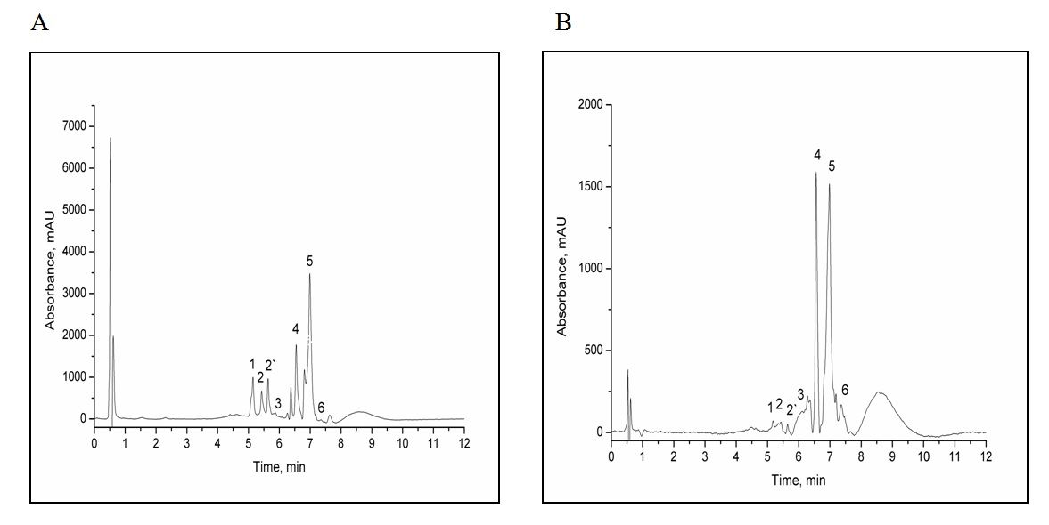

Figure 1. HPLC chromatograms of native (A) and fermented (B) chamomile extract obtained by UE technique. Identified compounds are labelled as peaks 1–6: 1- apigenin-7-O-glucoside; 2, 2'- derivate of apigenin-7-O-glucoside; 3-apigenin; 4, 5- derivate of flavonoids; 6-chlorogenic acid

  - Extraction yield, total phenols (TP) and flavonoids (TF) content
In order to get the highest yields of biologically active compounds in observed extracts the comparison of solvents and extraction techniques for their isolation was done. The total extraction yields, TP and TF contents in different extracts are shown in the Table 2.
Table 2. Total extraction yield, total phenols and flavonoids contents in the obtained extracts
Extracts | Total extraction yield (%; w/w) | Total phenols content (mg CAE/g) | Total flavonoids content (mg RE/g)
A-UE | 31.00 ± 1.56 | 198.64 ± 0.93 | 39.10 ± 0.26
N-UE | 27.80 ± 0.17 | 133.26 ± 1.24 | 31.27 ± 0.11
A-SE | 28.93 ± 0.18 | 198.07 ± 1.10 | 38.98 ± 0.09
N-SE | 27.62 ± 0.81 | 132.04 ± 1.04 | 32.35 ± 0.21
A-UE_{W} | 30.50 ± 0.57 | 135.09 ± 0.45 | 35.63 ± 1.59
N-UE_{W} | 31.70 ± 0.27 | 130.82 ± 0.96 | 29.80 ± 0.17
Data represent mean value of three independent experiments done in triplicate.

Total extraction yield was between 27.62% (in case of N-SE) and 31.70% (in case of N-UE_{W}). Ethanol extracts of autofermented samples had higher total extraction yield than native, while in the case of water extracts, autofermented samples had lower total extraction yield. In general, UE has proved to be more efficient for the recovery of chamomile compounds. Those results were in correlation with literature data²⁰.
The yield of TP in explored samples was determined by using previously described Folin-Ciocalteu method and different yields of phenols were noticed for different solvents and techniques used (Table 2).
Autofermented samples proved to be much better sources of phenols independently on the extraction technique and solvent used (Table 2). Contents of the total phenolic compounds in A-UE (198.64 mg CAE/g) and A-SE (198.07 mg CAE/g) extracts were very similar, while total phenols content in autofermented sonificated water sample (A-UE_{W}) was about 1.5 times lower than in the autofermented sonificated ethanol (A-UE) sample (135.09 mg CAE/g). In the case of native samples, the situation was the same, i.e. the total phenols content for the N-UE (133.26 mg CAE/g) was close to that of the N-SE (133.04 mg CAE/g). Phenolic content in water extracts was the lowest (130.82 mg CAE/g). By comparing water and ethanol extracts obtained by ultrasonic extraction, water extracts were characterized with lower phenols content. The significant difference in phenols content was observed in autofermented sample, whereas this difference in the case of native samples was not so pronounced.
As a part of chemical composition analysis, the TF content in the native and in the autofermented CLF extracts was determined, as well. Flavonoids are important biomolecules which are present in surprisingly high concentrations in the plants. In this study their content was between 29.80 mg RE/g (N-UE_{W}) and 39.10 mg RE/mL (A-UE). As well as in the case of phenols, all autofermented samples exhibited higher contents of flavonoid compounds. Results, presented in the Table 2, indicate the highest flavonoids content in ethanolic A-UE extract followed by A-SE and A-UE_{W} extracts. In case of native samples, flavonoids content decreased as follows: N-SE > N-UE > N-UE_{W}.
According to obtained results, it can be concluded that ultrasonic extraction technique was more efficient in comparison to Soxhlet extraction. This is certainly a consequence of increased liberation of the solutes from sample matrix due to the cavitation phenomenon. Presented results show that regardless on the applied extraction technique or used solvent the autofermented samples have more phenolic bioactive compounds than the native ones.
  - The antioxidant activity
Polyphenols are well recognized for their health-promoting properties. Different studies indicated their wide spectrum of biological activities^{21,22}. Reducing properties of polyphenols as hydrogen or electron-donating agents predict their free-radical scavenging as well as antioxidant ability. The free-radical scavenging ability of obtained extracts (N-CLF and A-CLF) was tested using stable radical DPPH. Reducing power of tested extracts served as an indicator of their antioxidant ability. As shown in Table 3, all tested extracts showed an antioxidant potential in accordance with their total polyphenols content. Autofermented extracts exhibited better antioxidant capacity that could be linked to previously discussed polyphenols content. The most potent extract in this respect was found to be the A-UE extract (IC₅₀ = 0.0270 mg/mL). On the other hand, the N-UE_{W} showed the highest IC₅₀ value (0.0601 mg/mL) indicating the lowest antioxidant ability. However, significant differences among the extracts in this respect were not observed. The IC₅₀ values increased in the following sequence: A-UE (0.0270 mg/mL) > A-SE (0.0341 mg/mL) > A-UE_{W} (0.0418 mg/mL) > N-UE (0.0528 mg/mL) > N-SE (0.0595 mg/mL) > N-UE_{W} (0.0601 mg/mL).
The potential of the obtained extracts to fight against free radicals was also examined by determination of their reduction power. In the conducted analysis the electron-donating capacity of antioxidants was measured through the change of yellow colour of the test solutions to various shades of green and blue, depending on the reducing power of each sample²³. The presence of reducing agent causes a reduction of the Fe³⁺/ferricyanide complex to the ferrous form. The reducing power of extracts is a function of their concentration. All investigated N-CLF and A-CLF extracts showed good reducing power but as it could be expected, the highest reduction potential was detected in A-UE extracts with EC₅₀ value of 0.520 mg/mL, which represented the lowest value in all examined extracts.
Table 3. Antioxidative activity of chamomile extracts obtained by a different extraction technique
Extracts | A-UE | N-UE | A-SE | N-SE | A-UEw | N-UEw
DPPH  IC₅₀ (mg/mL) | 0.027 | 0.053 | 0.034 | 0.060 | 0.042 | 0.060
Reducing power  EC₅₀ (mg/mL) | 0.520 | 0.770 | 0.523 | 0.840 | 0.550 | 0.570

The differences between EC₅₀ values of A-UE (0.520 mg/mL) and A-SE (0.523 mg/mL) was insignificant, indicating similar reducing powers for those extracts. A-UE_{W} extracts had slightly higher EC₅₀ value (0.550 mg/mL). Scavenging ability of native samples decreased in the following order: N-UE_{W} > N-UE > N-SE. Focusing on the solvent influence it was evident that in the case of autofermented UE samples ethanol was superior, while in the case of native UE samples water was better solvent for extracting components with good reducing capacity. Autofermented samples again proved to be a better source of antioxidants in comparison to extracts obtained from the native CLF. Accordingly, it could be assumed that autofermented samples contain higher concentrations of reductones, which could react with free radicals to stabilize and block radical chain reactions.
  - The antiproliferative activity of the CLF extracts
Chamomile flavonoids, the most important of which are apigenin conjugates, are recognized as natural compounds which exhibit broad biological activities²⁴. Apigenin acts by scavenging of free radicals and has significant antitumor activity in vivo and in vitro^{3,25}. Taking into account considerable biological potential of the apigenin ^{5,11,20} its free form was increased in this study by bioconversion of the Ap-7-Glc before extraction processes. Antiproliferative capacity of obtained extracts was evaluated on normal and tumour cells during 48 and 72 h, respectively. The statistically significant difference in the antiproliferative activity between autofermented and native extracts, and between treated and non-treated cells’ growth were observed (Fig. 4). The observed effects were various and depended on the applied concentration and treated cells type as well. The obtained results show that all analysed extracts in two highest applied concentrations of 0.2 and 0.5 mg/mL reduced cells’ viability, particularly after 72 h of exposure. More potent extracts proved to be the autofermented extracts with highest content of apigenin, A-UE and A-SE, which exhibited better antioxidant capacity and the highest reduction potential as well. Extracts A-UE and A-SE, applied in the concentration of 0.1 mg/mL during 48 and 72 h, inhibited cells’ growth for near 60%. The most sensible were treated leukemia cells K562, whose growth was significantly reduced (up to 80%) after 48 h of exposure. Observed results correlate with published data obtained on the cytotoxic effect of apigenin on leukemia cells where was described significant influence of apigenin on the growth of myeloid (HL-60 and K562) compared to the erythroid (TF1) leukemia cells²⁶. Lower tested concentrations (0.01, 0.001 and 0.0001 mg/mL) only slightly affected the growth of treated cells (data not shown). All tested extracts had less inhibitory potential on normal cells in comparison with effect on tumour cells after 48 h of exposure. That is in a good correlation with literature data where was described selectivity in the antiproliferative activity of apigenin ^{6,27}.
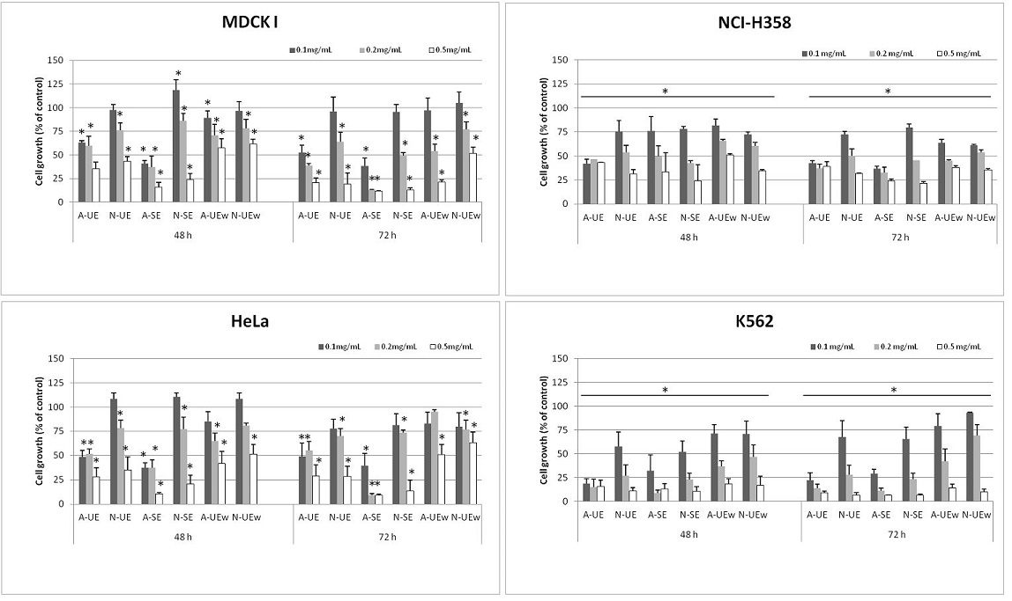
Figure 2. Cytotoxic effect of autofermented and native extracts in different cell lines. MDCK I, HeLa, NCI-H358 and K562 cells were treated with 0.5, 0.2 and 0.1 mg/mL of extract respectively. Cytotoxicity was assessed after 48 and 72 h by the MTT survival assay. Data represent mean value of three independent experiments done in triplicate. *Statistically significant change (p < 0.05).

Noticed morphological changes support observed cytotoxic results. A-UE and A-SE extracts applied at GI₅₀ concentration evidently reduced the number of treated HeLa cells (Fig. 5) after 48 and 72 h of exposition.
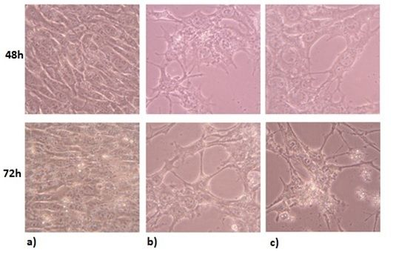
Figure 3. Morphological changes in the HeLa cells. HeLa cells were treated with A-UE (0.098 mg/mL) and A-SE (0.079 mg/mL) for 48 and 72 h. Native photographs are taken by the inverted microscope Olympus 1X51 with Olympus SP-500 UZ camera. Follows: a) control cells; b) A-UE extract and c) A-SE extract. Magnification 400 x.

  - Proapoptotic effects of the autofermented CLF extracts
Among six different samples, ethanolic extracts of A-CLF, A-UE and A-SE, had the highest antiproliferative activity, thus those extracts were further subjected for testing on proapoptotic potential. In the GI₅₀ concentrations, A-UE (0.098 mg/mL) and A-SE (0.079 mg/mL) extracts, applied on HeLa cells for 24 and 48 h, induced time depended apoptotic features. The exposure of phosphatidylserine (PS) on the external leaflet of the plasma membrane as an early marker of apoptosis²⁸, is visible in the HeLa cells with preserved cell shape (Fig. 6). The blebbing of the cell membrane was seen after 48 h of treatment with the A-UE extract. The standard compound apigenin in the applied concentration evoked less proapoptotic effect in comparison with tested extracts. The obtained results suggest that although apigenin has been proved as the compound able to inhibit tumour cell growth through apoptosis induction^{29,30}, the treatment with autofermented CLF ethanolic extracts, which are mixtures of apigenin, its derivatives, and polyphenols as well, have improved proapoptotic efficacy.
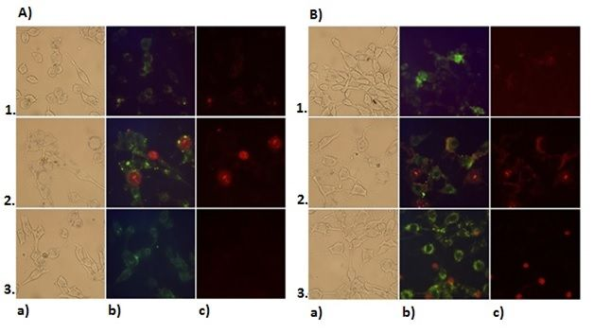

Figure 4. The fluorescent microscopy analysis of apoptosis caused by CLF extracts in the HeLa cells. HeLa cells were treated with A-UE (0.098 mg/mL) and A-SE (0.079 mg/mL) for 24 h (A) and 48 h (B). The cells were subsequently analyzed by the Carl Zeiss fluorescent microscope: a) visible light b) Annexin V-FITC (green fluorescence) and c) PI (red fluorescence); 1. apigenin standard (positive control), 2. A-UE extract and 3. A-SE extract. Magnification 400 x.

- Conclusions:
Results of this study indicated that the autofermented CLF extracts had higher total yield of extraction and increased phenols, apigenin, and flavonoids content than the native CLF extracts. Ethanol provides to be better solvent than water. The autofermented extracts showed better antioxidant activity in comparison to native CLF extracts. The antiproliferative potential of CLF extracts enhanced proportionally with increasing applied concentrations and prolonged time of exposure, but autofermented CLF extracts had significantly stronger impact on the treated tumour cells’ growth reduction in comparison to the native CLF extracts. Leukemia cells showed to be more sensitive to all tested CLF extracts. The CLF extracts with highest antiproliferative efficacy induced morphological changes and apoptosis in the HeLa. Based on these results regarding the antiproliferative capacity of tested extracts, further research may be carried out to investigate the biological mechanisms of action of observed extracts and apigenin.
Acknowledgment
The present work was carried out within the project of the Serbian Ministry of Education, Science and Technological Development, (Project No. TR 31013). Research was also supported by J.J. Strossmayer University of Osijek internal fund VIF-2015-MEFOS-2. The authors are grateful to Dr Dušan Adamović, Institute of Field and Vegetable Crops, Bački Petrovac, Serbia, for his support in supplying plant material.

Conflict of interest
The authors declare that there are no conflicts of interest.
Reference:
- R. H. Liu, Am. J. Clin. Nutr. 2003, 78, 3–6.
- D. Patel, S. Shukla, S. Gupta, Int. J. Oncol., 2007, 30, 233-245.
- S. Shukla, S. Gupta. Pharm. Res., 2010, 27, 962-978.
- T. D. Way, M.C. Kao, J.K. Lin, J. Biol. Chem., 2004, 279, 4479–4489.
- S. Shukla, S. Gupta, Shukla S, Gupta S, Bioactive Foods in Promoting Health, Fruits and Vegetables: Apigenin and cancer chemoprevention, London, Elsevier Ltd, 2009, pp. 663-689.
- S. Shukla, S. Gupta, Cell Cycle, 2007, 6,1102–1114.
- T. C. Hsia, J.S. Yang, G. W. Chen, T. H. Chiu, H.F. Lu, M.D. Yang, F.S. Yu, K.C. Liu, K.C. Lai, C. C. Lin, J.G. Chung, Anticancer Res, 2009, 29,309–318.
- S. Gupta, F. Afaq, H. Mukhtar, Biochem. Biophys. Res. Commun, 2001, 287, 914–920.
- V. Švehlíková,R. N. Bennett, F.A. Mellon, P. W. Needs, S. Piacente, P.A. Kroon, Y. Bao, Phytochem, 2004, 65, 2323–2332.
- J. K. Srivastava, E. Shankar, S. Gupta, Mol. Med. Rep., 2010, 3, 895–901.
- A. Cvetanović, J. Švarc-Gajić, Z. Zeković, S. Savić, J. Vulić, P. Mašković,G. Ćetković, Planta, 2015, 242, 721–732.
- Federal Office of Public Health (Beograd): Pharmacopoeia Jugoslavica editio quarta, (Ph. Jug. IV), 1984.
- V.L. Singleton,J.A.J. Rossi, Am. J. Enology Vitic., 1965, 16, 144–158.
- K. R. Markham, Methods in Plant Biochemistry: Flavones, flavonoids, and their glycosides, London: Academic Press Ltd.,1989, pp. 197–235.
- A. Cvetanović, J. Švarc-Gajić, U. Gašić, Ž. Tešić, G. Zengin, Z. Zeković, S. Đurović, J. Supercrit. Fluids., 2017, 120, 32-42.
- S. Kečkeš, U. Gašić, T. Ćirković-Veličković, D. Milojković-Opsenica, M. Natić, Ž. Tešic, Food Chem, 2013, 138, 32–40.
- J.C. Espín, C. Soler-Rivas, H.J. Wichers, J. Agric. Food Chem., 2000, 48, 648–656.
- M. Oyaizu, J. Hum. Nutr. Diet., 1986, 44, 307–315.
- J. Kašnar-Šamprec, I. Ratkaj, K. Mišković, M. Pavlak, M. Baus-Lončar, S. Kraljević Pavelić, Lj. Glavaš-Obrovacj, B. Žinić, Invest. New Drugs, 2012, 30, 981–990.
- P.C. Roy. Optimizing the Ultrasound Assisted Extraction of Phenolic Antioxidant Compounds from Centella Asiatica Leaves [Master’s thesis], Kolkata (India): Jadavpur University, 2014.
- D.R. Pavlović, S. Branković, N. Kovačević, D. Kitić, S. Veljković, Phytothe Res., 2011, 25, 749–754.
- P.H. Li, Y.W. Lin, W.C. Lu, J.m. Hu, D.W. Huang, Int. J. Food Prop., 2015, 19, 1786-1797.
- I.C.F.R. Ferreira, P. Baptista, M. Vilas-Boas, L. Barros, Food Chem., 2007, 100, 1511–1516.
- S. Shukla, S. Gupta, Free Radic. Biol. Med., 2008, 44, 1833-1845.
- Y. Liao, W. Shen, G. Kong, H. Lv, W. Tao, P. Bo, PloS One, 2014, 9, e92007.
- R.R. Ruela-de-Sousa, G.M. Fuhler, N. Blom, C.V. Ferreira, H. Aoyama, M.P. Peppelenbosch, Cell Death Dis, 2010, 1, e19.
- X. Cao, B. Liu, W. Cao, W. Zhang, F. Zhang, H. Zhao, R. Meng, L. Zhang, R. Niu, X. Hao, B. Zhang, Chin. J. Cancer Res, 2013, 25, 212-222.
- S.H. Lee, X.W. Meng, K.S. Flatten, D.A. Loegering, S.H. Kaufmann, Cell Death Differ., 2013, 20, 64–76.
- P. W. Zheng, L.C. Chiang, C.C. Lin, Life Sci., 2005, 76, 1367-1379.
- F. Papachristou, E. Chatzaki, A. Petrou, I. Kougioumtzi, N. Katsikogiannis, A. Papalambros, G. Tripsianis, C. Simopoulosand, A.K. Tsaroucha, Chin. Med., 2013, 8, 1-9.

