A simple and highly sensitive turn-on Schiff base type naked-eye fluorescent sensor for aluminum ion in living cells
Sedat Keskin and Mevlut Bayrakci
Karamanoglu Mehmetbey University, Faculty of Engineering, Department of Bioengineering 70200, Karaman/TURKEY
Abstract
Six different Schiff base compounds (SK-1, SK-2, SK-3, MK-2, MK-3, and MK-4) to be possible turn-on fluorescent probes based on photoinduced electron transfer (PET) mechanism for the recognition of aluminum ions were successfully synthesized and characterized. The binding abilities of synthesized compounds with different metal cations was investigated by absorption and emission spectra. From the spectrophotometric experiments, it was seen that compound SK-1 having suitable chelating structure modified with ortho hydroxyl groups coming from both aldehyde and amine derivatives displayed an excellent fluorescence response towards targeted aluminum ions. Furthermore, such compound SK-1 showed high sensitivity and selectivity response towards aluminum ions over other competing. The potential biological applications of SK-1 to detect aluminum ions in living cells were also investigated and results showed that fluorescence sensor SK-1 could be a promising probe for determining and/or monitoring aluminum ions in both biological and/or chemical samples.
Keywords: Schiff Base, Fluorescent probe, Cell imaging, Aluminum, PET.
1. Introduction
Aluminum is one of the most abundant metal elements in the Earth's crust and has an important place in our live. ¹ Due to different reasons such as both ecological system and human activities, high quantities of aluminum are found in the environment.² The presence of excess amount of aluminum in nature life affects the living beings. Consequently, some natural products containing large amount of aluminum in food chain are slowly consumed by human beings and this consumption causes many toxic effects towards human health and this toxicity leads to different diseases such as cancer, neurotoxicity, dialysis disease, Alzheimer’s and Parkinson’s diseases.³⁻⁶ With respect to the World Health Organization, desired concentration of aluminum in drinking water must be limited to 7.4 μM.⁷ Therefore, it is important topic to design and develop effective analytical methods or instruments for detection of aluminum ions in environmental and/or biological systems. Although many different and sophisticated analytical techniques including inductively coupled plasma emission (ICP-OES) or mass spectrometry (ICP-MS), and atomic absorption spectrometry have been used extensively for the detection of aluminum ions,^{8,9} most of these techniques have some disadvantages such as time consuming, qualified personal and high cost.¹⁰ But among them, fluorescence spectroscopy is most popular analytical instrument for the detection of metal ions and it is preferred intensively by scientists in analytical applications owing to its easy operation, comparatively low cost, and high sensitivity, etc.¹¹ Thus, many different fluorescence based chemosensors specific for metal ions have been designed and developed. Compared to these metal ions, just a few fluorescent probes have been reported for detection of trace amount of aluminum ions. Some limitations such as poor coordination ability and lack of spectroscopic characteristics has always been problematic for the detection of aluminum ions.¹² In addition to these limitations, both complicated synthesis and solubility properties of new fluorescent probes are also other restrictions in the point of design of aluminum sensors.¹³ Therefore, it is necessary to design and synthesis facile aluminum sensors that can be easily prepared and soluble. Many sensitive and selective fluorescent sensors for metal cations have been reported based on fluorescence resonance energy transfer (FRET),¹⁴ chelation- enhanced fluorescence (CHEF),¹⁵ internal charge transfer (ICT),¹⁶ photoinduced electron transfer (PET),¹⁷ and excimer/exciplex formation mechanisms.¹⁸ However, although photoinduced electron transfer (PET)-based fluorogenic sensors have many advantages,¹⁹ their synthesis and application are not common in the literature. Though there are very interesting literature reports about photoinduced electron transfer (PET)-based fluorogenic sensors for different analytes,²⁰⁻²² Schiff base type probes are very inspirational owing to their easily preparation, faster response and high selectivity towards specific analytes of interest. Schiff-bases are the most popular class of synthetic compounds in organic, medicinal and pharmaceutical chemistry because of their unique biochemical properties such as antitumor, anti-HIV, antibacterial, antioxidant, anti-inflammatory, antifungal, pesticidal, anthelmintic and antihypertensive, activitie.²³⁻²⁵ Although, there are appropriate literature reports showing their biological applications of Schiff base compounds, recently, a considerable number of literature results which are used synthetic Schiff base derivatives as fluorescent probe for the detection of some organic or inorganic analyte have been also reported.²⁶⁻³⁰ In the light of these literature data and as a part of our interest in fluorescent sensor applications, here, we present the design and synthesis of a series of Schiff base based fluorescent sensors containing ortho, meta and para hydroxy units which could detect aluminum ions by the ‘naked eye’ with fluorescent ‘off–on’ responses.
2. Experimental
2.1. General
2,3-dihydroxybenzaldehyde, 3,4-dihydroxybenzaldehyde, ortho, meta and para aminophenol and all metal salts were of analytical grade and purchased from Sigma-Aldrich or Merck and was further used without any purification. ¹H NMR spectra was recorded on Agilent Premium Compact spectrometer operating at 600 MHz. Chemical shifts are reported as δ values (ppm). Peak multiplicities are expressed as follows: s, singlet; bs, broad singlet; d, doublet; t, triplet and m, multiplet. Bruker Vertex FT-IR spectrometer (ATR) was used for FT-IR spectra. UV-vis absorbance spectra were collected by a Shimadzu UV-1800 and the fluorescence measurements were obtained by Hitachi F-7100.
2.2. General procedure for the synthesis of Schiff base probes
To a stirred solution of corresponding ortho, meta or para aminophenol compounds (1.5 mmol) in 20 mL absolute ethanol was added 1.5 mmol of 2,3-dihydroxybenzaldehyde (for SK-1, SK-2 and SK-3, respectively) or 1.5 mmol of 3,4-dihydroxybenzaldehyde (for MK-2, MK-3 and MK-4, respectively); the reaction mixture was stirred under reflux for 18 h. After completion of the reaction, excess amount of solvent was removed under reduced pressure and the solid residue was washed with 1 N HCl, brine and excess amount of water. The crude product was crystallized from CH₂Cl₂-C₂H₅OH (1:1) solvent system (Scheme 1).
Scheme 1. The synthetic route of Schiff base compounds (SK-1, SK-2, SK-3, MK-2, MK-3, and MK-4)
SK-1: Red solid with 68% yields, FT-IR (ATR cm⁻¹): 1616 (C=N stretching). ¹H NMR (600 MHz DMSO): δ 14.21 (bs, 1H, OH) 9.88 (bs, 1H, OH), 9.02 (bs, 1H, OH), 8.91 (s, 1H, CH=N), 7.38 (d, J= 8.3 Hz, 1H, Ar-H), 7.10 (m, 1H, Ar-H), 7.02 (m, 1H, Ar-H), 6.95 (m, 1H, Ar-H), 6.87 (m, 1H, Ar-H), 6.77 (m, 1H, Ar-H), 6.69 (m, 1H, Ar-H). Anal. calcd. For C₁₃H₁₁O₃N: C, 68.11; H, 4.84; N, 6.11. Found: C, 68.09; H, 4.90; N, 6.19%.
SK-2: Dark red solid with 70% yields, FT-IR (ATR cm⁻¹): 1623 (C=N stretching). ¹H NMR (600 MHz DMSO): δ 14.18 (bs, 1H, OH) 9.87 (bs, 1H, OH), 9.03 (bs, 1H, OH), 8.89 (s, 1H, CH=N), 7.35 (d, J= 8.4 Hz, 1H, Ar-H), 7.13 (m, 1H, Ar-H), 7.03 (m, 1H, Ar-H), 6.92 (m, 1H, Ar-H), 6.85 (m, 1H, Ar-H), 6.74 (m, 1H, Ar-H), 6.65 (s, 1H, Ar-H). Anal. calcd. For C₁₃H₁₁O₃N: C, 68.11; H, 4.84; N, 6.11. Found: C, 68.03; H, 4.80; N, 6.07%.
SK-3: Dark red solid with 70% yields, FT-IR (ATR cm⁻¹): 1621 (C=N stretching). ¹H NMR (600 MHz DMSO): δ 14.17 (bs, 1H, OH) 9.88 (bs, 1H, OH), 9.06 (bs, 1H, OH), 8.91 (s, 1H, CH=N), 7.34 (d, J= 8.4 Hz, 1H, Ar-H), 7.17-7.11 (m, 3H, Ar-H), 6.83 (m, 1H, Ar-H), 6.34 (m, 1H, Ar-H), 6.21 (m, 1H, Ar-H). Anal. calcd. For C₁₃H₁₁O₃N: C, 68.11; H, 4.84; N, 6.11. Found: C, 68.03; H, 4.88; N, 6.15%.
MK-2: Red solid with 71% yields, FT-IR (ATR cm⁻¹): 1635 (C=N stretching). ¹H NMR (600 MHz DMSO): δ 9.84 (bs, 1H, OH) 9.48 (bs, 1H, OH), 9.03 (bs, 1H, OH), 8.87 (s, 1H, CH=N), 7.27 (m, 2H, Ar-H), 7.18 (m, 2H, Ar-H), 7.10-7.04 (m, 3H, Ar-H). Anal. calcd. For C₁₃H₁₁O₃N: C, 68.11; H, 4.84; N, 6.11. Found: C, 68.09; H, 4.90; N, 6.19%.
MK-3: Red solid with 65% yields, FT-IR (ATR cm⁻¹): 1634 (C=N stretching). ¹H NMR (600 MHz DMSO): δ 9.81 (bs, 1H, OH) 9.52 (bs, 1H, OH), 9.11 (bs, 1H, OH), 8.91 (s, 1H, CH=N), 7.33 (m, 2H, Ar-H), 7.25 (m, 1H, Ar-H), 7.09 (m, 1H, Ar-H), 6.88 (m, 2H, Ar-H), 6.57 (m, 1H, Ar-H). Anal. calcd. For C₁₃H₁₁O₃N: C, 68.11; H, 4.84; N, 6.11. Found: C, 68.03; H, 4.80; N, 6.07%.
MK-4: Dark red solid with 58% yields, FT-IR (ATR cm⁻¹): 1620 (C=N stretching). ¹H NMR (600 MHz DMSO): δ 9.81 (bs, 1H, OH) 9.47 (bs, 1H, OH), 9.16 (bs, 1H, OH), 8.90 (s, 1H, CH=N), 7.34-7.29 (m, 2H, Ar-H), 7.17 (m, 2H, Ar-H), 7.03 (m, 3H, Ar-H). Anal. calcd. For C₁₃H₁₁O₃N: C, 68.11; H, 4.84; N, 6.11. Found: C, 68.03; H, 4.88; N, 6.15%.
2.3. Uv–vis and fluorescence studies
The stock solutions of SK-1, SK-2, SK-3, MK-2, MK-3 and MK-4 (1 mM), the guest nitrate salts of metal cations (Li⁺, Na⁺, Ag⁺, Ca²⁺, Ba²⁺, Co²⁺, Cs⁺, Cu²⁺, Mg²⁺, Hg²⁺, Mn²⁺, Pb²⁺, Ni²⁺, Sr²⁺, Zn²⁺ and Al³⁺) (1 mM) in DMF were prepared. In absorption and emission experiments, the volume of studied solutions was adjusted as 2.0 mL. Titration experiments were performed by addition of corresponding amount of metal cation solutions to a DMF solution of targeted fluorescent probe (SK-1). The absorption spectra of SK-1, SK-2, SK-3, MK-2, MK-3 and MK-4 in the presence and absence of metal cations were recorded in the range of 200–600 nm in a UV-Vis spectrophotometer. All emission spectra were obtained at room temperature under the excitation of 400-430 nm. The solutions were scanned (1200 nm/min) with 400 watt of PMT voltage in a spectrofluorometer with the range of 400-750 nm. The widths of the slit for the both excitation and emission were adjusted at 10 nm. The best fluorescence intensity at 530 nm was determined under the excitation at the wavelength of 430 nm.
2.4. Biological applications
The living MCF7 cells were provided by ATCC (American Type Culture Collection, Rockville, MD, USA). MCF7 cells were incubated with 10 μM of Al³⁺ ions in the culture medium at 37 ^{ο}C for 1 h and washed with phosphate buffered saline (PBS) followed by the addition of 10 μM of SK-1. Bright field and fluorescent images were taken from Leica DM3000 fluorescence microscopy.
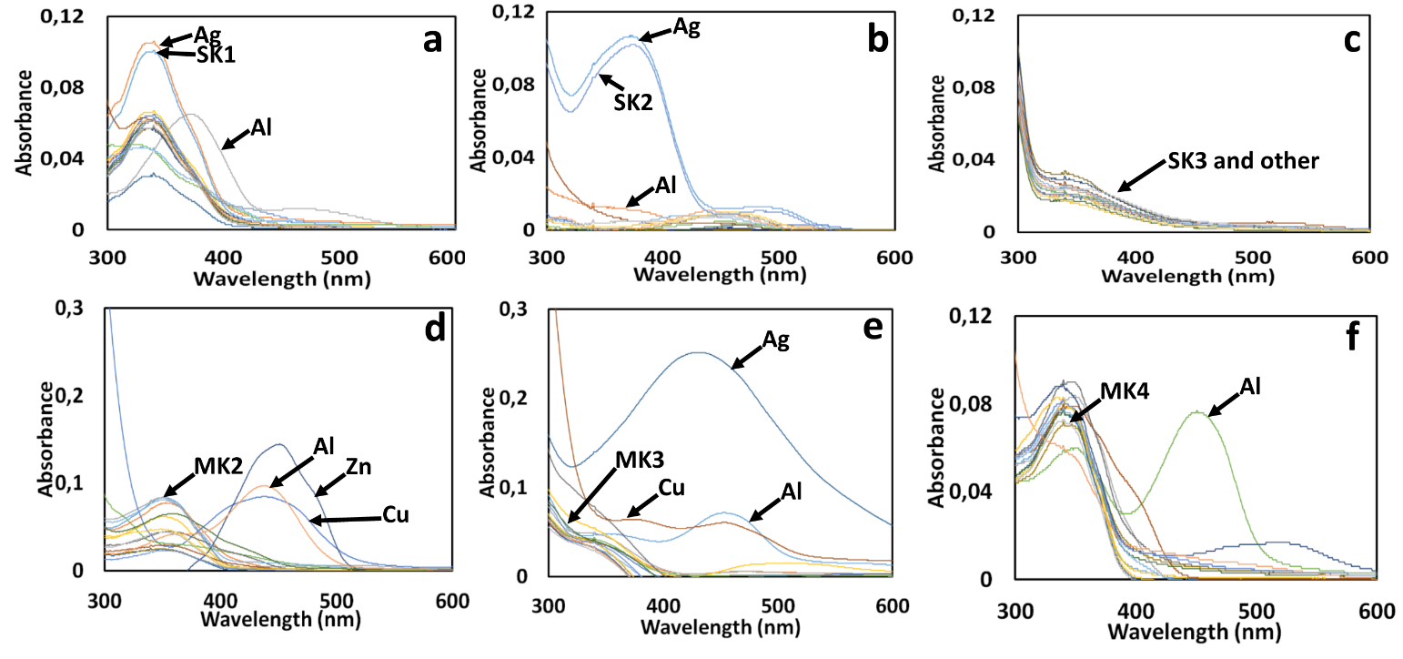
Fig. 1. UV–vis absorption spectra of (1µM); (a) SK-1, (b) SK-2, (c) SK-3, (d) MK-2, (e) MK-3, and (f) MK-4 in the presence of several metal ions such as Li⁺, Na⁺, Ag⁺, Ca²⁺, Ba²⁺, Co²⁺, Cs⁺, Cu²⁺, Mg²⁺, Hg²⁺, Mn²⁺, Pb²⁺, Ni²⁺, Sr²⁺, Zn²⁺ and Al³⁺ (10 eq. for each metal ion).

3. Results and discussion
3.1. UV–vis absorption studies
The absorption spectrum of the Schiff bases SK-1, SK-2, SK-3, MK-2, MK-3 and MK-4 was investigated by the absence and/or presence of 10 equiv. of metal cations such as Li⁺, Na⁺, Ag⁺, Ca²⁺, Ba²⁺, Co²⁺, Cs⁺, Cu²⁺, Mg²⁺, Hg²⁺, Mn²⁺, Pb²⁺, Ni²⁺, Sr²⁺, Zn²⁺ and Al³⁺. As seen in Fig. 1, the absorption spectrum of all Schiff bases, exhibited a broad absorption band attributable to π-π* transition of the imine moiety at around 342 nm. The absorption band positions generally remained unchanged over the various metal ions except Al³⁺ ions. The appreciable bathochromic or hypochromic changes for the position of absorption bands at 342 nm for SK-1, SK-2, MK-2, MK-3 and MK-4 was observed after the addition of Al³⁺ owing to the imine nitrogen (CH=N) was involved in coordination with Al³⁺ ion. However, considerable changes in the absorption spectra of the SK-3 was not observed over the various metal ions (Fig. 1c). Furthermore, new absorption bands at around 470 nm for SK-1, and SK-2 except SK3, 450 nm for MK-2, MK-3 and MK-4 were formed due to the complexation capabilities of these molecules with Al³⁺ ions. Owing to absorption spectroscopy is a complementary part of emission spectroscopy, thus fluorescence emission studies were also applied for the getting more information about the spectrophotometric results.
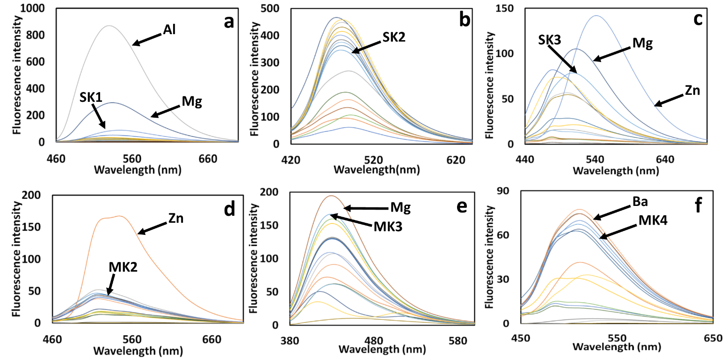
Fig. 2. Fluorescent emission spectra of (1µM); (a) SK-1, (b) SK-2, (c) SK-3, (d) MK-2, (e) MK-3, and (f) MK-4 in the presence of several metal ions such as Li⁺, Na⁺, Ag⁺, Ca²⁺, Ba²⁺, Co²⁺, Cs⁺, Cu²⁺, Mg²⁺, Hg²⁺, Mn²⁺, Pb²⁺, Ni²⁺, Sr²⁺, Zn²⁺ and Al³⁺ (10 eq. for each metal ion).

3.2. Fluorescence emission analysis
High selectivity is necessary to define the excellent chemosensor. Therefore, to evidence the usability of the synthesized Schiff bases as a selective sensor, the fluorescence behavior of Schiff bases SK-1, SK-2, SK-3, MK-2, MK-3 and MK-4 was investigated by using Hitachi F-7100 Spectrofluorometer upon the addition of selected metal ions such as Li⁺, Na⁺, Ag⁺, Ca²⁺, Ba²⁺, Co²⁺, Cs⁺, Cu²⁺, Mg²⁺, Hg²⁺, Mn²⁺, Pb²⁺, Ni²⁺, Sr²⁺, Zn²⁺ and Al³⁺. The reported Schiff base probes (1 µM) shows a weak fluorescence emission spectrum at around 530 nm (for SK-1), 480 nm (for SK-2), 508 nm (for SK-3), 518 nm (for MK-2), 430 nm (for MK-3) and 518 nm (for MK-4) with an excitation of 430 (for SK-1), 400 nm (for SK-2 and SK-3,), 380 nm (for MK-3,) and 430 nm (for MK-2 and MK-4) whereas when other metal ions (10 µM) such as Li⁺, Na⁺, Ag⁺, Ca²⁺, Ba²⁺, Co²⁺, Cs⁺, Cu²⁺, Mg²⁺, Hg²⁺, Mn²⁺, Pb²⁺, Ni²⁺, Sr²⁺, and Zn²⁺ were added to the solution of Schiff base probes, considerable decrease or increase in fluorescent intensity of probes were not observed in Fig. 2. Whereas, upon addition of Al³⁺ (10 µM) remarkable fluorescence increase accompanied by a red shift of 24 nm from 530 nm to 554 nm was noticed just for the Schiff base probe SK-1 when compared the other probes (Fig. 2a). Only, Schiff base probe SK-1 exhibited a more than 37-fold fluorescent enhancement in the presence of Al³⁺ ions. This increase in fluorescence intensity is such that the Schiff base probe SK-1 shows “OFF-ON” mode of high sensitivity for Al³⁺ ions. Furthermore, the Schiff base probe SK-1 showed considerable color change from colorless to brilliant turquoise fluorescence in the presence of Al³⁺ ions under UV light, and this color change is also easily detected by the naked eye (Fig. 3). Thus, this Schiff base probe SK-1 can be evaluated to determine Al³⁺ ions in solution visually.
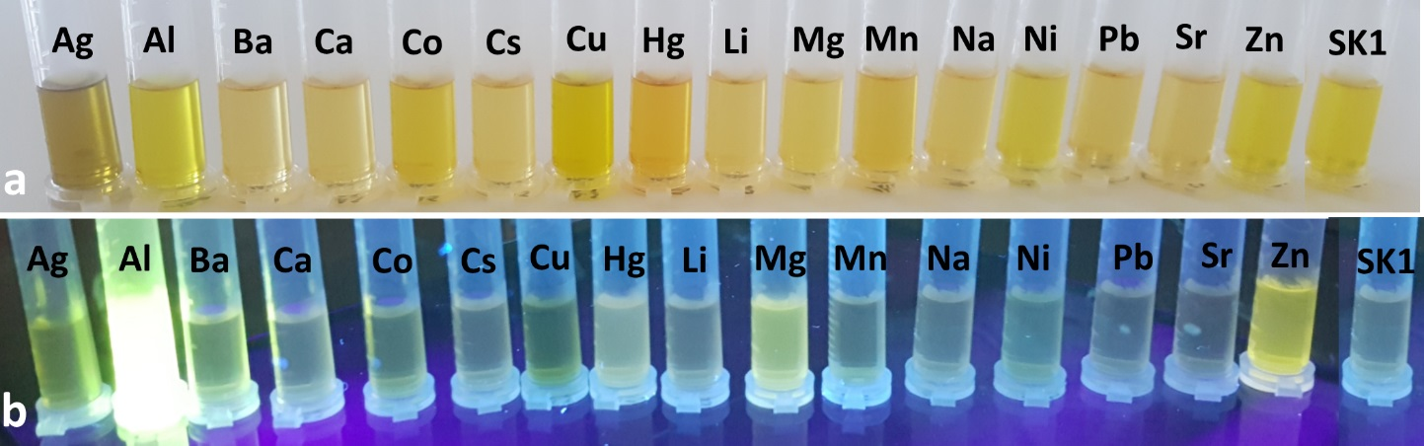

Fig. 3. Images showing the corresponding (a) visible color and (b) fluorescence color changes of SK-1 with and without metal cations (10 equiv. of Li⁺, Na⁺, Ag⁺, Ca²⁺, Ba²⁺, Co²⁺, Cs⁺, Cu²⁺, Mg²⁺, Hg²⁺, Mn²⁺, Pb²⁺, Ni²⁺, Sr²⁺, Zn²⁺ and Al³⁺) under day light and UV light.

Photoinduced electron transfer (PET) mechanism includes the deactivation of the excited-state of fluorescent compounds by adding an electron to its frontier orbital. This electron addition to one of frontier orbital of excited-state causes a non-emissive state for fluorophore structures. For instance, the presence of one or more functional groups having free pair of electrons attached to the fluorescent molecule may quench its fluorescent intensity intramolecularly due to photoinduced electron transfer (PET) mechanism. However, a possible interaction of these electron donor groups with electron acceptor metal ions reduces efficient electron donor capabilities of these groups, thereby disconnecting the photoinduced electron transfer (PET) mechanism and increase the fluorescence output via chelation-enhanced fluorescence (CHEF).^{31,32} Herein, the emission intensity of SK-1 is very low because of the quenching by the lone pair electrons of imine group through a PET mechanism. However, with increasing of Al³⁺ (0–10 equiv.), the fluorescence emission intensity of SK-1 (1.0 µM) at 530 nm increased gradually (Fig. 4b). The complexation of the imine group (-C=N) with Al³⁺ ion given rise to the PET mechanism was suppressed, the fluorescence of the complex structure was restored.^{33,34}

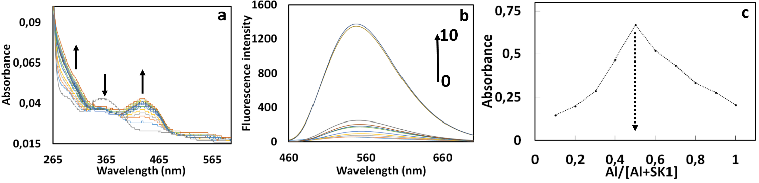
Fig. 4. (a) UV-Vis, (b) fluorescence titration spectra of compound SK-1 (1µM) respectively, upon addition of Al³⁺ (from 0 to 10 equiv.) at room temperature (λ_{ex} = 430 nm; λ_{em} = 530 nm) and (c) Job’s plot for the determination of stoichiometry of SK-1-Al³⁺ system.

3.3. Titration and competition studies
The binding properties of SK-1 with Al³⁺ ions were studied by both UV–vis and fluorescent titration experiments (Fig. 4a and 4b). Firstly, we explored the UV-vis titration spectra of SK-1 with increasing concentrations of Al³⁺ in DMF. As shown in Fig. 4a, upon addition of increasing amounts of Al³⁺ (0.0 to 2.0 equiv.), absorption bands of SK-1 appeared at around 360 nm was gradually decreased with increasing amount of Al³⁺, while the intensities of absorption SK-1 at around 434 nm increased. Furthermore, the absorbance at around 434 nm reached maximum in the presence of 1.0 equiv. of Al³⁺ and showed nearly no change with further addition of metal ion. The titration configuration of SK-1 with Al³⁺ in Fig. 4a indicated 1 equiv. of Al³⁺ reacting with same equiv. of SK-1 could quickly reached an equilibrium, showing complex formation between SK-1 and Al³⁺ with 1:1 stoichiometry. To further examine the sensing properties of SK-1, sensitivity of SK-1 as a probe toward Al³⁺ ions was investigated by the fluorescence titration experiments by increasing concentration of Al³⁺ ions (0-10 equiv.) at 530 nm (Fig. 4b). Upon excitation at 430 nm, SK-1 in the absence of any Al³⁺ showed practically no emission signal between the range of 460 and 700 nm which is probably due to PET process.³⁵ However, a clear enhancement in fluorescence intensity of SK-1 was observed gradually at around 530 nm with increasing concentrations of Al³⁺ as shown in Fig 4b. This increase in fluorescent intensity is probably due to the chelation-enhanced fluorescence (CHEF) effect that inhibiting the PET process by complexation of SK-1 with Al³⁺.³⁶ Furthermore, the detection limit of Al³⁺ was estimated based on the fluorescence titration profile (Fig. 5c). The detection limit of SK-1 in recognizing Al³⁺ was found to be 4.85·10⁻⁷ M which was lower than some reported literature results regarding Al³⁺ selective chemosensors.^{37,38} This result has shown that this sensor could be used for both detection and monitoring of sub-micromolar concentration of aluminum ions in biological and environmental systems. To verify the practical application of SK-1 as an Al³⁺ selective and sensitive fluorescent sensor, competition experiments were performed by adding of Al³⁺ into SK-1 solution mixed with other coexisting metal ions such as Li⁺, Na⁺, Ag⁺, Ca²⁺, Ba²⁺, Co²⁺, Cs⁺, Cu²⁺, Mg²⁺, Hg²⁺, Mn²⁺, Pb²⁺, Ni²⁺, Sr²⁺, and Zn²⁺. As depicted in Fig. 5a, relatively low interference was seen for the detection of Al³⁺ in the presence of other competing metal ions. Although, the slightly decreasing in emission intensity of SK-1 at around 530 nm was observed in the presence of Zn²⁺, and Mg²⁺, fluorescent response was relatively detectable. However, upon addition of other competing metal ions under same conditions, it was seen that the fluorescence emission intensity at around 530 nm did not change considerably and SK-1 still have an efficient “turn-on” rate for the detection of Al³⁺. Consequently, it was concluded that SK-1 could be a promising selective and sensitive fluorescent sensor for the detection of Al³⁺ in the presence of competing metal ions.
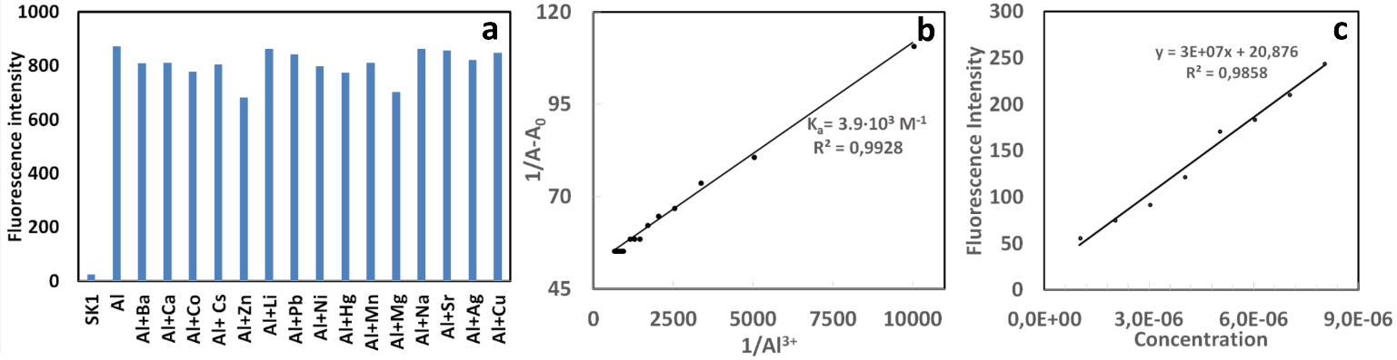
Fig. 5. Fluorescent selectivity of SK-1 (1µM) at 530 nm upon addition of various metal ions (10µM) Li⁺, Na⁺, Ag⁺, Ca²⁺, Ba²⁺, Co²⁺, Cs⁺, Cu²⁺, Mg²⁺, Hg²⁺, Mn²⁺, Pb²⁺, Ni²⁺, Sr²⁺, and Zn²⁺, λ_{ex} = 430 nm. (b) Calculation of binding constant between SK-1 and Al³⁺. A₀ is the absorbance of free SK-1 solution (1µM); A is the absorbance of compound SK-1 solution (1µM) upon addition of different amounts of Al³, (c) Calculation of detection limit of SK-1 for Al³⁺ with excitation at 430 nm and emission at 530 nm by addition of different amounts of Al³⁺ to SK-1 solution (1µM)

3.4. Binding studies
To determine the binding stoichiometry of SK-1 with Al³⁺, the method of continuous variations known as Job’s plot was used.³⁹ In this method, each experiment performed with different concentrations of SK-1 and Al³⁺ with maintaining the total concentration at 10 μM. The plot obtained by measuring the fluorescence intensity at 530 nm for nine experiments with molar fraction of SK-1 (0.1 to 0.9). In this experiment, the maximum absorbance value was observed when the molar fraction was 0.5 (Fig. 4c) and it was consistent well with the UV-vis titration spectra (Fig. 4a). This data showed that 1 mole of SK-1 and Al³⁺ participated in the complex formation and binding mode was determined as 1:1 stoichiometry. Furthermore, the binding constant of the probe SK-1 with Al³⁺ were calculated by the Benesi–Hildebrand method.⁴⁰ From curve fitting of absorbance values of probe SK-1 against the reciprocal of the Al³⁺ concentration, this plot yielded a linear fit as seen in Fig. 5b. The value of the binding constant was calculated as 3.9·10³ M⁻¹ which was within the range of those (10³-10⁹ M⁻¹) previously reported Al³⁺ sensors.⁴¹ In addition, the linear plot also proved the 1:1 complexation behavior of SK-1 to Al³⁺. Because, if a 1:1 metal-probe complex is formed between receptor and metal ions, Benesi-Hildebrand plot should be linear.⁴² In related to stoichiometry, the binding site participated in complexation was clarified by FT-IR (ATR) and ¹H NMR experiments along with stoichiometry confirmation as presented in Fig. 6 and 7.
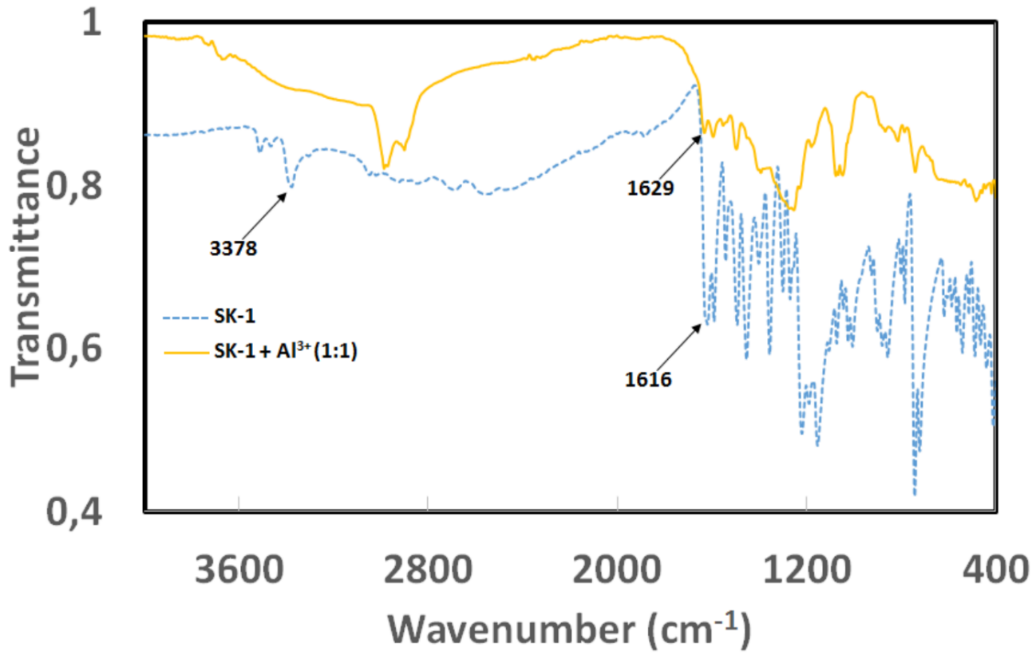
Fig. 6. The FT-IR (ATR) spectra of SK-1 with (1.0 equiv of Al³⁺) and without Al³⁺.

The IR spectra of free SK-1 and SK-1-Al³⁺ complex structure showed that the characteristics frequencies of SK-1 with 1.0 equiv. of Al³⁺ exhibited significant changes as compared with those of free the SK-1 (Fig. 6). The IR spectra of the free SK-1 showed the absence of bands at around 1735 and 3300 cm⁻¹ attributable to the carbonyl ν(C=O) and ν(NH₂) stretching vibrations and a clear strong new band at around 1616 cm⁻¹ due to azomethine ν(HC=N) linkage [43]. All these existing and disappearing signals in IR indicated that amino and aldehyde groups in starting reactants (Scheme 1) were converted into the SK-1 and synthesis of the SK-1 was successfully carried out. The comparison of IR spectra of free SK-1 and its Al³⁺ complex (Fig. 6) demonstrated that SK-1 probe was principally coordinated to the Al³⁺ ion. The strong band appearing at around 1616 cm⁻¹ due to azomethine group shifted to a higher frequency at 1629 cm⁻¹ in Al³⁺ complex, indicating participation of azomethine group in the complexation with the Al³⁺ ion. On the other hand, the free OH group at 3378 cm⁻¹ was completely disappeared at 1 equiv. of Al³⁺. In addition, disappearing of strong band at around 3378 cm⁻¹ indicated that phenolic hydroxy group of SK-1 participated in the complex formation with Al³⁺.
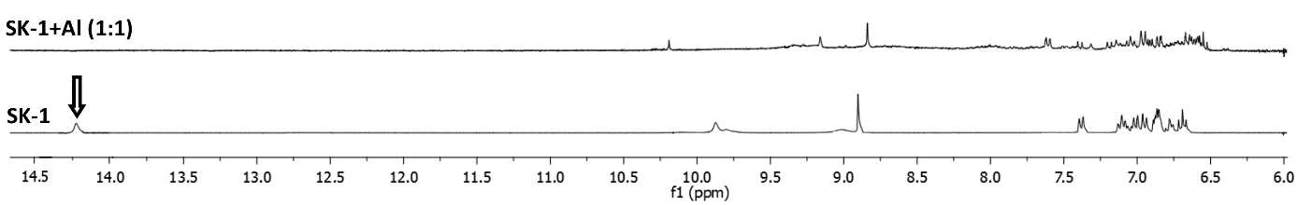
Fig. 7. ¹H NMR spectra in DMSO-d₆ of SK-1 with (1.0 equiv of Al³⁺) and without Al³⁺.

To better understand the complexation between the probe SK-1 and Al³⁺, ¹H NMR experiment of SK-1 in DMSO-d₆ were examined by addition of 1 equiv. of Al³⁺. As seen in Fig. 7, three phenolic -OH signals belonging to SK-1 was observed at around 9.88, 9.02 and 14.21 ppm. Compared the phenolic -OH signals, appearing signal at around 14.21 ppm attributed the ortho position of SK-1 is probably due to the intramolecular hydrogen bonding (Fig. 7). While the phenolic OH proton at 14.21 ppm disappeared when added of 1.0 equiv. of Al³⁺ to SK-1 solution, the other signal at around 9.88 and 9.02 ppm shifted to downfield. Also, it was seen that the imine (CH=N) proton of SK-1 at 8.91 ppm was slightly shifted to some extent. This shift for the imine proton was probably due to complexation ability of the azomethine group after coordination of SK-1 with Al³⁺. All these shifting and/or disappearing of signals showed that both phenolic OH group located in ortho position and imine group of SK-1 were efficient on complex formation between SK-1 and Al³⁺. In the light of obtained spectroscopic data, possible complex formation mechanism was given in Fig. 8.

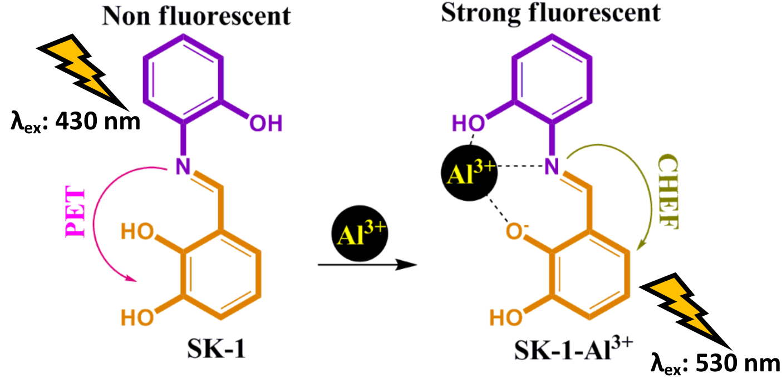
Fig. 8. Proposed binding mechanism between the compound SK-1 and Al³⁺.

3.5. Biological Applications
SK-1 was successfully applied for imaging of Al³⁺ ions in human breast cancer cells, MCF7 under fluorescence microscope. Cells treated with free SK-1 were used as controls. When MCF7 cells were incubated with SK-1 (10 µM), it was not seen any fluorescence response (Fig. 9e). However, after addition of Al³⁺ ions, a brilliant red fluorescence was sighted in the MCF7 cells (Fig. 9b). Merged images of fluorescence and bright-field showed that fluorescence signals were detected in the intra-cellular zone, showing the distribution of Al³⁺ and cell membrane permeabilities of SK-1 molecules (Fig 9c). On the other hand, Fig. 9 indicated that SK-1 could stain Al³⁺ ions in living cells without any harm (cells remain alive even after several hours of exposure to 10 µM of SK-1), making it useful to monitor Al³⁺ in biological systems.

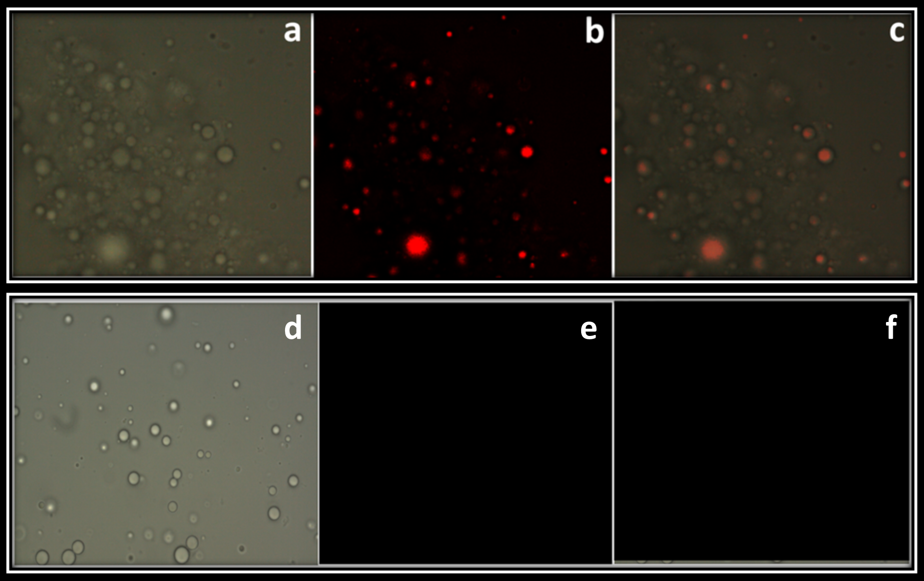
Fig. 9. Fluorescence images of Al³⁺ using probe SK-1 in MCF7: (a) bright field image of MCF7 cells treated with probe SK-1; (b) fluorescence image of MCF7 cells treated with probe SK-1; (c) merged image of (a) and (b); (d) bright field image of MCF7 cells treated with probe SK-1 without Al³⁺; (e) fluorescence image of MCF7 cells treated with probe SK-1 without Al³⁺; (d); (f) merged image of (d) and (e).

4. Conclusion
In conclusion, this study was presented for visual detection of highly selective and sensitive Al³⁺ ions by a very simple and low-cost fluorescence sensor (SK-1) based on the blocking PET process. SK-1 showed high sensitivity with the detection limit at around 4.8×10⁻⁷ M in the micromolar scale and selectivity response towards Al³⁺ over other metal ions with 37-fold fluorescence enhancement. The predicted configuration of the SK-1–Al³⁺ complex formation was well-characterized to be 1:1 by spectroscopic analyses. Beyond that, SK-1 was utilized to detect sensitively the Al³⁺ ions in living cells by emitting visible fluorescence. Cell applications indicated that SK-1 could be used as an excellent fluorescence probe for visualizing of Al³⁺ ions in cell lines.

5. Acknowledgments
The authors declare that there is no conflict of interest. This study is part of master thesis of Sedat Keskin and authors of this paper gratefully would like to thank Karamanoglu Mehmetbey University Research Foundation (BAP) and The Scientific and Technological Research Application Center (BILTEM) for the financial and technical supports.

6. References
1. J. Zhu, Y. Zhang, L. Wang, T. Sun, M. Wang, Y. Wang, D. Ma, Q. Yang, Y. Tang. Tetrahedron Lett., 2016, 57, 3535–3539. DOI:10.1016/j.tetlet.2016.06.112
2. X. Yan, H. Yang, F. Tian. RSC Adv., 2015, 107012–107019. DOI:10.1039/C5RA17557G
3. V.K. Gupta, S.K. Shoora, L.K. Kumawat, A.K. Jain. Sensors Actuators, B Chem., 2015, 209, 15–24. DOI:10.1016/j.snb.2014.10.143
4. K. Kaur, V.K. Bhardwaj, N. Kaur, N. Singh. Inorg. Chem. Commun., 2012, 18, 79–82. DOI:10.1016/j.inoche.2012.01.018
5. Y. Xu, S. Mao, H. Peng, F. Wang, H. Zhang, S.O. Aderinto, H. Wu. J. Lumin., 2017, 192, 56–63. https DOI:10.1016/J.JLUMIN.2017.06.023
6. L. Kang, Y.T. Liu, N.N. Li, Q.X. Dang, Z.Y. Xing, J.L. Li, Y. Zhang. J. Lumin., 2017, 186, 48–52. DOI:10.1016/j.jlumin.2016.12.056
7. T. Han, X. Feng, B. Tong, J. Shi, L. Chen, J. Zhi, Y. Dong. Chem. Commun., 2012, 48, 416–418. DOI:10.1039/C1CC15681K
8. M.H. Nagaoka, T. Maitani. Analyst, 2000, 125, 1962–1965. DOI:10.1039/b006590k
9. M. Shellaiah, Y.H. Wu, H.C. Lin. Analyst, 2013, 138, 2931–2942. DOI:10.1039/c3an36840h
10. S. Mukherjee, P. Mal, H. Stoeckli-Evans. J. Lumin., 2016, 172, 124–130. DOI: 10.1016/J.JLUMIN.2015.11.014
11. S. Das, D. Karak, S. Lohar, A. Banerjee, A. Sahana, D. Das. Anal. Methods., 2012, 4, 3620-3624. DOI:10.1039/c2ay25825k
12. X. Sun, Y.-W. Wang, Y. Peng. Org. Lett., 2012, 14, 3420–3423. DOI:10.1021/ol301390g
13. C.-Y. Huang, Y. Jhong, J.-L. Chir, A.-T. Wu. J. Fluoresc., 2014, 24, 991–994. DOI:10.1007/s10895-014-1404-1
14. H. Cheng, Y. Qian. RSC Adv., 2015, 5, 82887–82893. DOI:10.1039/C5RA15546K
15. M. Shellaiah, Y.C. Rajan, P. Balu, A. Murugan. New J. Chem., 2015, 39, 2523–2531. DOI:10.1039/C4NJ02367F
16. S. Jana, S. Dalapati, N. Guchhait. J. Phys. Chem. A, 2013, 117, 4367–4376. DOI:10.1021/jp3120463
17. G.Q. Wang, J.C. Qin, L. Fan, C.R. Li, Z.Y. Yang. J. Photochem. Photobiol. A Chem., 2016, 314, 29–34. DOI:10.1016/j.jphotochem.2015.08.005
18. L. Wang, W. Qin, X. Tang, W. Dou, W. Liu. J. Phys. Chem. A., 2011, 115, 1609–1616. DOI:10.1021/jp110305k
19. J. Shao, H. Lin, Z.-S. Cai, H. Lin. J. Photochem. Photobiol. B Biol., 2009, 95, 1–5. DOI:10.1016/J.JPHOTOBIOL.2008.12.007
20. J. Kumar, M.J. Sarma, P. Phukan, D.K. Das. Dalt. Trans., 2015, 44, 4576–4581. DOI:10.1039/C4DT03932G
21. J. Wu, W. Liu, J. Ge, H. Zhang, P. Wang. Chem. Soc. Rev., 2011, 40, 3483–3495. DOI:10.1039/c0cs00224k
22. T. Gunnlaugsson, H.D.P. Ali, M. Glynn, P.E. Kruger, G.M. Hussey, F.M. Pfeffer, C.M.G. Dos Santos, J. Tierney. J. Fluoresc., 2005, 15, 287–299. DOI:10.1007/s10895-005-2627-y
23. M.H. Yan, T.R. Li, Z.Y. Yang. Inorg. Chem. Commun., 2011, 14, 463–465. DOI:10.1016/j.inoche.2010.12.027
24. S. Sen, T. Mukherjee, B. Chattopadhyay, A. Moirangthem, A. Basu, J. Marek, P. Chattopadhyay. Analyst, 2012, 137, 3975–3981. DOI:10.1039/c2an35560d
25. C. Dohno, A. Okamoto, I. Saito. J. Am. Chem. Soc., 2005, 127, 16681–16684. DOI:10.1021/ja054618q
26. L. Fan, T.R. Li, B.D. Wang, Z.Y. Yang, C.J. Liu. Spectrochim. Acta - Part A Mol. Biomol. Spectrosc., 2014, 118, 760–764. DOI:10.1016/j.saa.2013.09.062
27. Y.J. Lee, C. Lim, H. Suh, E.J. Song, C. Kim. Sensors Actuators B Chem., 2014, 201, 535–544. DOI:1016/J.SNB.2014.05.035
28. S. Guha, S. Lohar, A. Sahana, A. Banerjee, D.A. Safin, M.G. Babashkina, M.P. Mitoraj, M. Bolte, Y. Garcia, S.K. Mukhopadhyay, D. Das. Dalt. Trans., 2013, 42, 10198-10207. DOI:10.1039/c3dt51045j
29. S.K. Shoora, A.K. Jain, V.K. Gupta. Sensors Actuators, B Chem., 2015, 216, 86–104. DOI:10.1016/j.snb.2015.04.038
30. M. Tajbakhsh, G.B. Chalmardi, A. Bekhradnia, R. Hosseinzadeh, N. Hasani, M.A. Amiri. Spectrochim. Acta Part A Mol. Biomol. Spectrosc., 2018, 189, 22–31. DOI:10.1016/J.SAA.2017.08.007
31. P. Alaei, S. Rouhani, K. Gharanjig, J. Ghasemi. Spectrochim. Acta - Part A Mol. Biomol. Spectrosc., 2012, 90, 85–92. DOI:10.1016/j.saa.2012.01.008
32. N.C. Lim, S. V. Pavlova, C. Brückner. Inorg. Chem., 2009, 48, 1173–1182. DOI:10.1021/ic801322x
33. J.M. An, Z.Y. Yang, M.H. Yan, T.R. Li. J. Lumin., 2013, 139, 79–83. DOI:10.1016/j.jlumin.2013.02.019
34. T. Gunnlaugsson, A.P. Davis, J.E. O’Brien, M. Glynn. Org. Lett., 2002, 4, 2449–2452. DOI:10.1021/ol026004l
35. G. Zhu, Y. Wang, H. Fu, X. Xu, Z. Cui, X. Ji, G. Wu. Spectrochim. Acta Part A Mol. Biomol. Spectrosc., 2015, 137, 148–153. DOI:10.1016/J.SAA.2014.08.021
36. F. Karagöz, O. Güney, M. Kandaz, A.T. Bilgiçli. J. Lumin., 2012, 132, 2736–2740. DOI:10.1016/J.JLUMIN.2012.05.005
37. D. Zhou, C. Sun, C. Chen, X. Cui, W. Li. J. Mol. Struct., 2015, 1079, 315–320. DOI:10.1016/J.MOLSTRUC.2014.09.050
38. W.-H. Ding, D. Wang, X.-J. Zheng, W.-J. Ding, J.-Q. Zheng, W.-H. Mu, W. Cao, L.-P. Jin. Sensors Actuators B Chem., 2015, 209, 359–367. DOI:10.1016/J.SNB.2014.11.144
39. J.S. Renny, L.L. Tomasevich, E.H. Tallmadge, D.B. Collum. Angew. Chem. Int. Ed. Engl., 2013, 52, 11998–2013. DOI:10.1002/anie.201304157
40. H.A. Benesi, J.H. Hildebrand. J. Am. Chem. Soc., 1949, 71, 2703–2707. DOI: 10.1021/ja01176a030
41. C. Kim, T.G. Jo, J. Lee, E. Nam, K.H. Bok, M.H. Lim. New J. Chem., 2016, 40, 8918–8927. DOI:10.1039/C6NJ01544A
42. H.M. Kim, C. Jung, B.R. Kim, S.-Y. Jung, J.H. Hong, Y.-G. Ko, K.J. Lee, B.R. Cho. Angew. Chemie Int. Ed., 2007, 46, 3460–3463. DOI:10.1002/anie.200700169
43. İ. Kaya, E. Kartal, D. Şenol. Des. Monomers Polym., 2015, 18, 524–535. DOI:10.1080/15685551.2015.1041084

Corresponding author: Karamanoglu Mehmetbey University, Department of Bioengineering, Karaman/TURKEY. Tel.: +90 338 2262200 fax: +90 338 2262214; e-mail: mevlutbayrakci@gmail.com

