Synthesis of New Di- and Triamides as Potential Organocatalysts for Asymmetric Aldol Reaction in Water
Elif Keskin, Cigdem Yolacan, Feray Aydogan*

Supporting Information

No  Chromatographic conditions of aldol products | Structureª | Column chromatgraphy Eluent  AcOH/n-Hexane | HPLC
No  Chromatographic conditions of aldol products | Structureª | Column chromatgraphy Eluent  AcOH/n-Hexane | Column  (CHIRALPAK) | Eluent  (i-PrOH/Hexane) | Flow rate  (mL/min) | Wave lenght (nm) | T (min) (anti)
 |  |  |  |  |  |  | major | minor | Ref.
8a |  | 1/3 | AD | 10/90 | 1.5 | 254 | 25.8 (2S,1’R) | 19.4  (2R, 1’S) | 40, 49
8b |  | 1/3 | AD | 10/90 | 0.6 | 254 | 20.6 (2S,1’R) | 23.4  (2R, 1’S) | 49
8c |  | 1/2 | AD | 10/90 | 1.0 | 254 | 20.2 (2S,1’R) | 25.3  (2R, 1’S) | 40
8d |  | 2/3 | AD | 10/90 | 1.0 | 254 | 18.8 (2S,1’R) | 15.1  (2R, 1’S) | 40, 49
8e |  | 1/3 | AD | 10/90 | 1.0 | 254 | 16.9  (2R, 1’S) | 28.2 (2S,1’R) | 40
8f |  | 2/3 | AD | 10/90 | 0.5 | 254 | 27.3  (2R, 1’S) | 24.7 (2S,1’R) | 40, 49
8g |  | 1/2 | AD-H | 10/90 | 0.8 | 254 | 16.6 (syn) (2R, 1’R) | 21.8  (syn) (2S,1’S) | 50
8h |  | 1/2 | AD-H | 10/90 | 0.5 | 254 | 27.3 (R) | 14.9 (S) | 51
ªFor major enantiomer

HPLC Chromatograms of Aldol Products
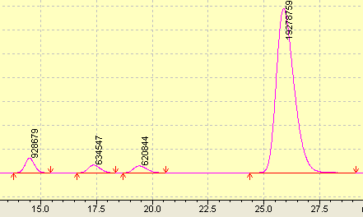
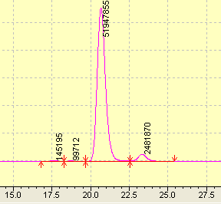
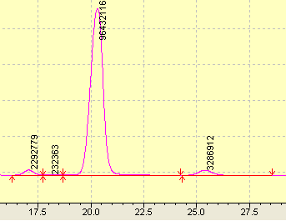

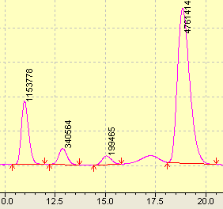
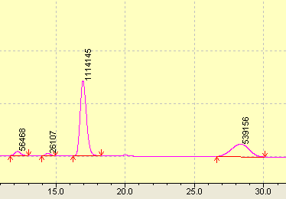
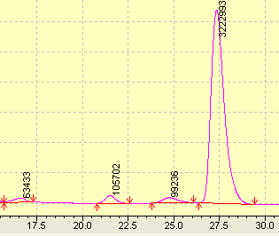
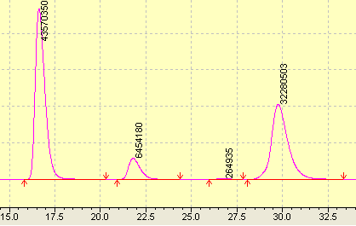
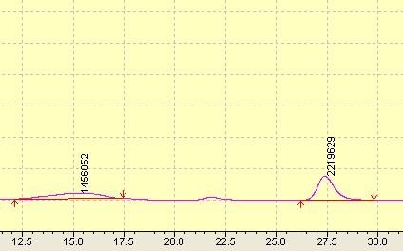

References

- S.-d. Fu, X.-k. Fu, S.-p. Zhang, X.-c. Zou, X.-j. Wu, Tetrahedron:Asymm., 2009, 20, 2390-2396.
- A. Russo, G. Botta, A. Lattanzi, Tetrahedron. 2007, 63, 11886-11892.
- S. Itoh, T. Tokunaga, M. Kurihara, S. Aoki, Tetrahedron:Asymm., 2013, 24, 1583-1590.
- T. Kanger, K. Kriis, M. Laars, T. Kailas, A. M. Müürisepp, T. Pehk, M. Lopp, J.Org.Chem. 2007, 72, 5168-5173.

