INVESTIGATION OF THE ELECTROCHEMICAL REDUCTION PROCESS OF THE MOLYBDATE IONS IN THE TARTARIC ELECTROLYTES
Vusala Asim Majidzade^{1, *}, Akif Shikhan Aliyev¹, Dunya Mahammad Babanly^{1, 3}, Mahmood Elrouby², Dilgam Babir Tagiyev¹

¹Institute of Catalysis and Inorganic Chemistry named after acad.M.Nagiyev,
Azerbaijan National Academy of Sciences, H.Javid ave., 113, AZ 1143, Baku, Azerbaijan
²Chemistry Department, Faculty of Science, Sohag University, 82524 Sohag, Egypt

³Azerbaijan State Oil and Industry University (Ufaz), Baku, Azerbaijan

Vusala Asim Majidzade – corresponding author, E-mail: vuska_80@mail.ru
Abstract
The electrochemical reduction of molybdate ions in tartaric electrolyte has been investigated in this work. Kinetics and mechanism of the electrochemical process have been studied by cyclic and linear voltammetric polarization methods. The effect of the temperature, the rate of potential-scanning and the concentration of the molybdate ions on the electrochemical process has been also studied. By estimating effective activation energy, it was revealed that the electroreduction is accompanied by mixing kinetics control.
Keywords: Molybdate ions; electroreduction; tartaric acid; polarization curves; chronoamperometry.

- INTRODUCTION
As is known, semiconductors are one of the important materials that differ from each other by their great manifold of the physical and electrical properties, also of the chemical composition.¹⁻⁴ The need for the chalcogenide semiconductor films increases with the development of the application of the new generation of the solar cells.⁵ Today, the using of ecologically waste free solar energy is very actual connecting with decreasing of the natural resources of the energy. Thin films of chalcogenide can be used as photo-anodes for obtaining of the electrical energy in the solar cells. The obtaining of these films can be carried out using various methods.^{1, 6}
The main aim of our investigation was to obtain the thin films of Molybdenum chalcogenides (MoS₂ and MoSe₂) by the electrochemical deposition method. Molybdenum as a transitive element has a stronger interatomic bond that increases its stability, and hardness at high temperatures. It is one of the most important industrial metals. This due to its successful suitability of complexes, valuable physicomechanical and corrosion properties, which make this metal one of the basic constructive materials for new technology.
Molybdenum and its alloys have a great importance due to its high corrosion resistance⁷ and low hydrogen overpotential.⁸ The obtaining of molybdenum alloys by metallurgical methods gets hard due to the oxidation in the crystallization stage and due to a high melting temperature of molybdenum. Therefore, the most suitable method of obtaining molybdenum alloys is an electrochemical method. There are a lot of works dedicated to the electrochemical deposition of thin films of these compounds. To well study the simultaneous electrodeposition process of these compounds, at first, these components should be deposited individually.
In our previous studies, we have investigated electroreduction and co-electrodeposition of various metals together with chalcogenides.⁹⁻¹³
Many works were dedicated to the electrochemical reduction of molybdate ions. Some researchers¹⁴ have investigated the electrochemical reduction of the hexavalent molybdenum ions in a solution containing tartaric acid. The formed complexes of Mo-tartarate ions were examined by spectroscopic and electrochemical methods. The resulted electrochemical peak was under kinetic control at relatively high pH values or at a relatively low concentration of the tartaric ions. But, the electrochemical reaction occurred by protonation reaction. Moreover, some researchers¹⁵ studied the reduction of molybdenum (VI) on a previously hydrated platinum electrode in acidic solutions. Reduction of molybdenum (VI) in 0.8-1.6 M H₂SO₄ occurs via two main steps. The first step is a relatively high cathodic wave attributes to the reduction of Mo (V) tо Mo (III), which is accompanied with the decomposition of the solvent. The second step is a relatively low cathodic wave and attributed to the reduction of Mo (VI) to Mo (V), which takes place at +0.07 V. The second peak seems to be controlled by a diffusion and can be used for the determination of molybdenum up to 4×10⁻⁵ M or 6×10⁻⁵ M. Incomplete reduction of molybdate ions from weak acidic and alkaline solutions within pH 3.0-9.0 interval has been investigated.¹⁶ It was indicated that the presence of ammonium ions accelerating the incomplete reduction process of the molybdate ions. A film consists of hydrated oxides of molybdenum with the low oxidation states is formed on the cathode when the ammonium ions were added to the solution. Adsorption of the products of the incomplete reduced molybdate ions on the surface of the cathode makes blocking to its working surface during electrolysis process of molybdate ions. The conditions of the electrochemical deposition of molybdenum oxide in aqueous solutions at the ambient temperature have been studied and the optimal parameters that provide to obtain oxides with certain physical and structural properties have been selected.¹⁷
The following up of the electroreduction process of the molybdate ions in an aqueous medium under different conditions is achieved to obtain metallic molybdenum.¹⁸ Kinetics and the mechanism of the electroreduction process were studied by the cathodic polarization. It was observed that the rate of the electrochemical process depends on the scan rate of potential, also on the temperature of the electrolyte. On the other hand, it can be concluded that the electrochemical reduction occurs in two stages. It was indicated that after -0.7 V, the electroreduction process of the molybdate ions is accompanied by releasing of hydrogen.
The effect of hydrogen fluoride on the cathodic reduction of molybdate ions has been investigated.¹⁹ It was indicated that the mechanism of the process is controlled by its concentration. It was found that in the region of concentration values less than 25 g/L, the intermediate products of electroreduction process of the molybdate ions are black or colorful precipitations. These precipitates were formed on the cathode, here the average valent of molybdenum was detected to be 3.6 - 4.0. In the concentration, more than 50 g/L molybdate ions are completely reduced forming on the cathode a dense light metallic coating of thickness 3-5µm with a great adhesion to the substrate. Addition of hydrogen fluoric acid prevents the polymerization and aggregation of the molybdate ions.
The bright, smooth metallic coating of molybdenum with 25 µm thickness is successfully deposited from aqueous electrolyte consisting high concentration of acetate.²⁰⁻²² The optimal conditions for deposition of metallic molybdenum have been detected to be as follow: the current density 200 – 450 mA/cm² and temperature 30 ⸰ С ± 2. The obtained coatings are amorphous, but after vacuum annealing at the high temperature, they converted into crystalline films. In the reference,²² it was concluded that the current density is a major effective factor for precipitation of a refractory metal. The results have indicated that the metallic molybdenum is deposited through two stages through electroreduction with obtaining intermediate coating from molybdenum oxide. According to the previous studies, kinetics and mechanism of electrochemical reduction have been investigated differently. Therefore, the main aim of our work is the determination of kinetics and mechanism of electrochemical reduction process together of the molybdate ions in the presence of tartaric acidic medium by detecting of the reduction potential range of the molybdate ions at the optimized conditions.

- EXPERIMENTAL PART
The electrochemical reduction process of the molybdate ions was carried out as follows. At first, tartaric acid was dissolved in distilled water to prepare the electrolyte. Then this prepared aqueous solution of tartaric acid was added to sodium molybdate (Na₂MoO₄⋅2H₂O) of AR grade. 0,007 mol/L C₄H₆O₆ (tartaric acid) was added to the resulting electrolyte of Na₂MoO₄⋅2H₂O. The polarization and chronoamperometric experiments were performed by potentiometer of IVIUMSTAT Electrochemical Interface. In that case, three electrode electrochemical triode cell of 100 mL volume was used. Pt and Ni sheets with an area of 2.2×10⁻³ dm² were used as working electrodes. Silver chloride electrode was used as a reference electrode, whereas, a platinum sheet with an area of 4 cm² was used as counter electrode. The universal ultra-thermostate UTU – 4 was utilized for regulation of the temperature of the electrochemical reaction cell.

- RESULTS AND DISCUSSION
As is known, to obtain thin semiconductive films from two or more components, the first required step was to study the electrochemical reduction processes of these components
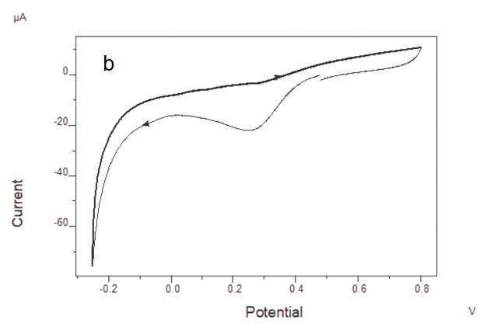
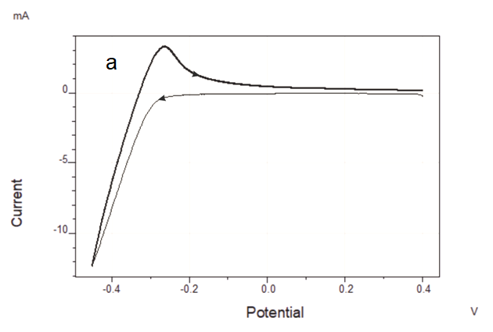

Fig. 1. Cyclic voltamperometric curves of the electroreduction process of the molybdate ions in the presence of tartaric acid on the Pt electrode. The electrolyte consists of: 0.1 M Na₂MoO₄⋅2H₂O + 0.007 M C₄H₆O₆. Т = 293 К, Е_{V}=0.02 V/s. а –the general process, b- the initial stage

In the presented work, full data about the electroreduction of the molybdate ions in tartaric electrolyte were given. The cyclic polarization curves were recorded by the potentiodynamic method for finding out kinetics and the mechanism of the electroreduction process of the molybdate ions. As seen from Fig. 1, the electrochemical reduction of the molybdate ions on the cathode occurs through two stages within 0.47 – (-0.25)V potential values. In our opinion, within 0.47- 0.27 V interval of potential values the process occurs with respect to reaction (1), whereas within 0.27-0.00 V with respect to reaction (2) (Fig.1)
MoO₄²⁻ + 4H⁺ + 2e = MoO₂ + 2H₂O (1)
MoO₂ + 4H⁺ + e = Mo³⁺ + 2H₂O (2)
After that, starting from 0.0 V potential value the full reduction process of Мо³⁺ ions to metallic Mo as (3) reaction occurred:
Mo³⁺ + 3e = Mo (3)
Starting from -0.45 V potential value along with electroreduction of the molybdate ions the releasing of hydrogen also occurs. Consequently, electroreduction process was carried out up to this potential (Fig. 1 а).
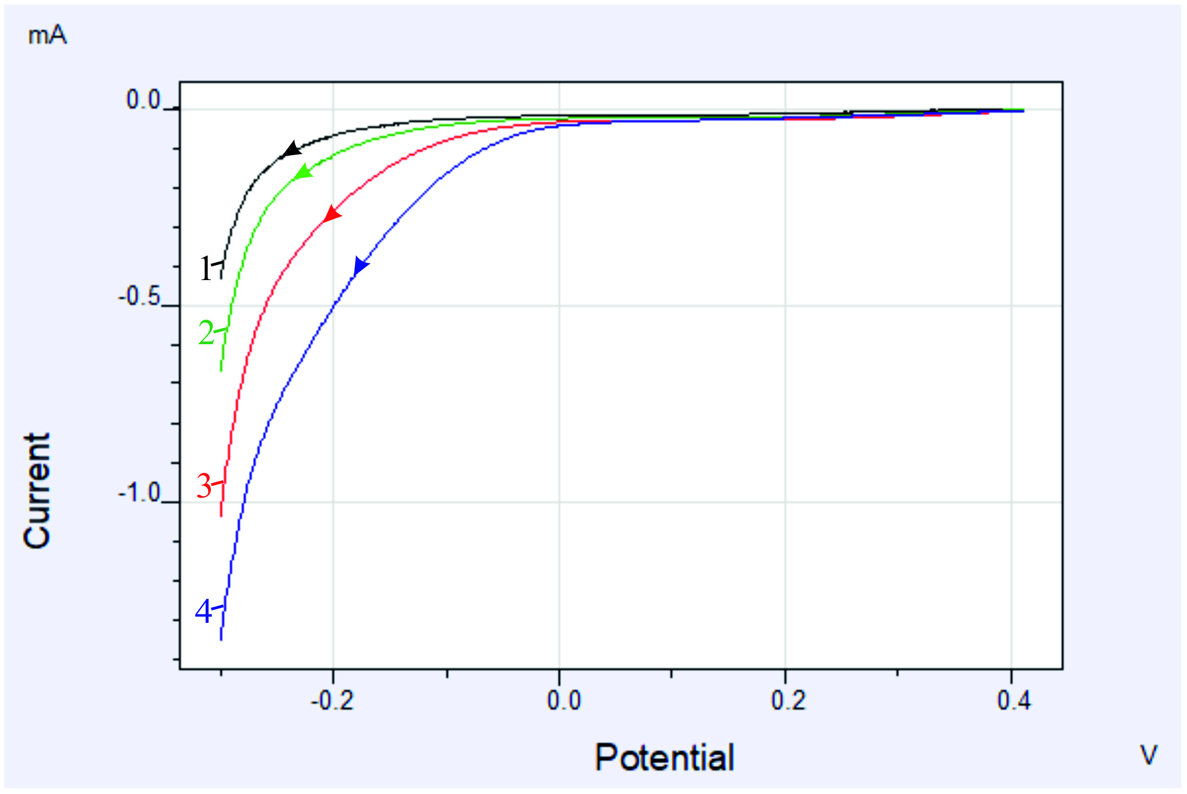

Fig. 2. The effect of temperature on the electroreduction process of the molybdate ions. Electrolyte composition in (М): Na₂MoO₄⋅2H₂O + 0.007 C₄H₆O₆. Т (К): 1- 293; 2- 313; 3- 333; 4- 353. At a scan rate of Е_{V}=0.02 V/s

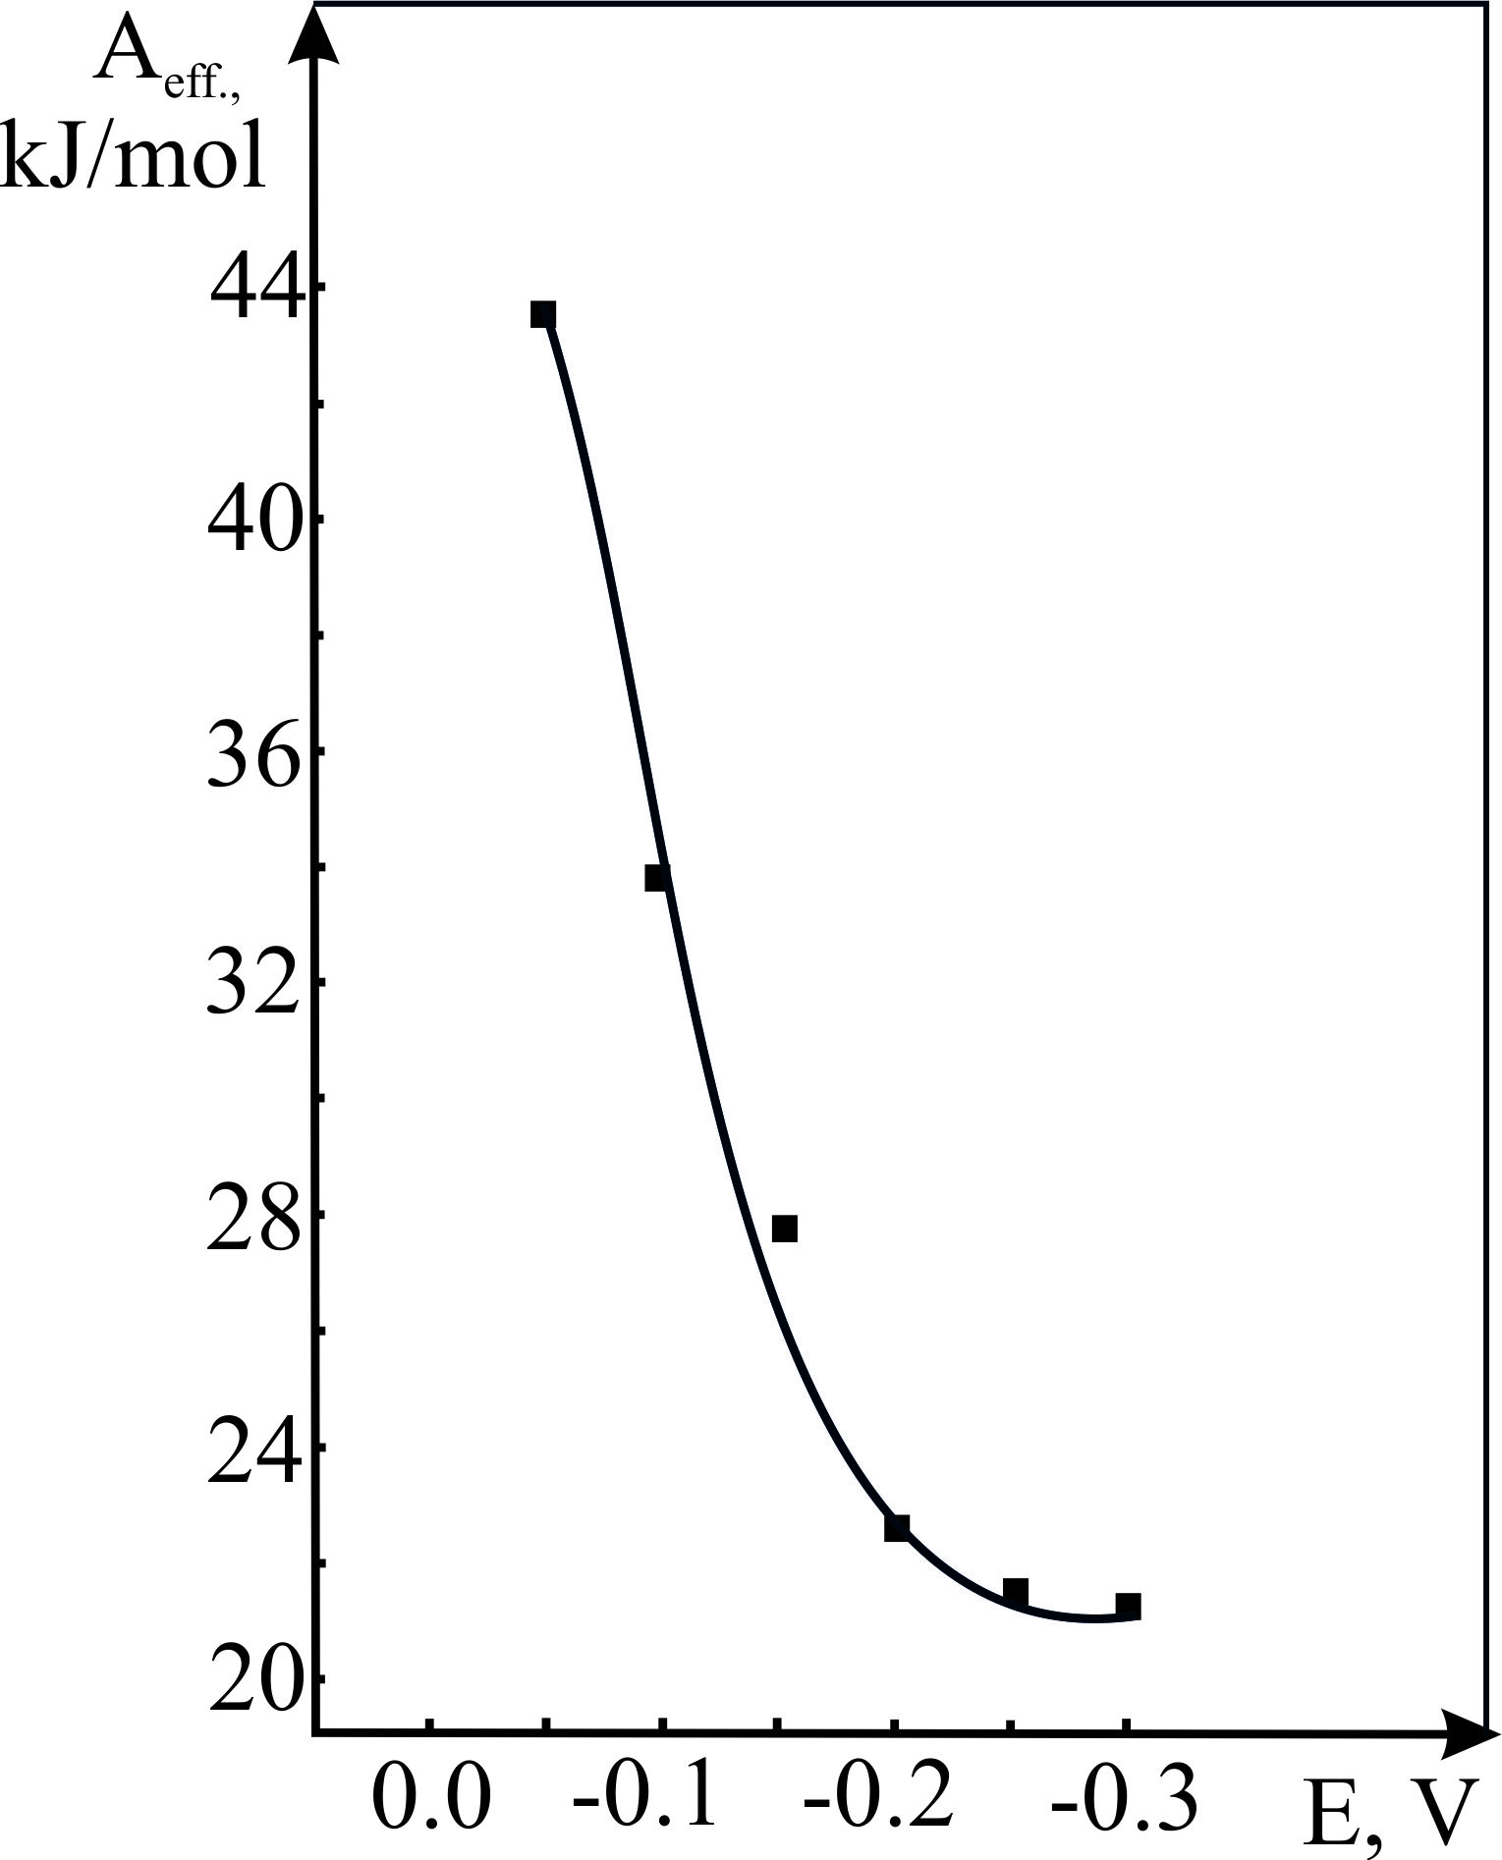
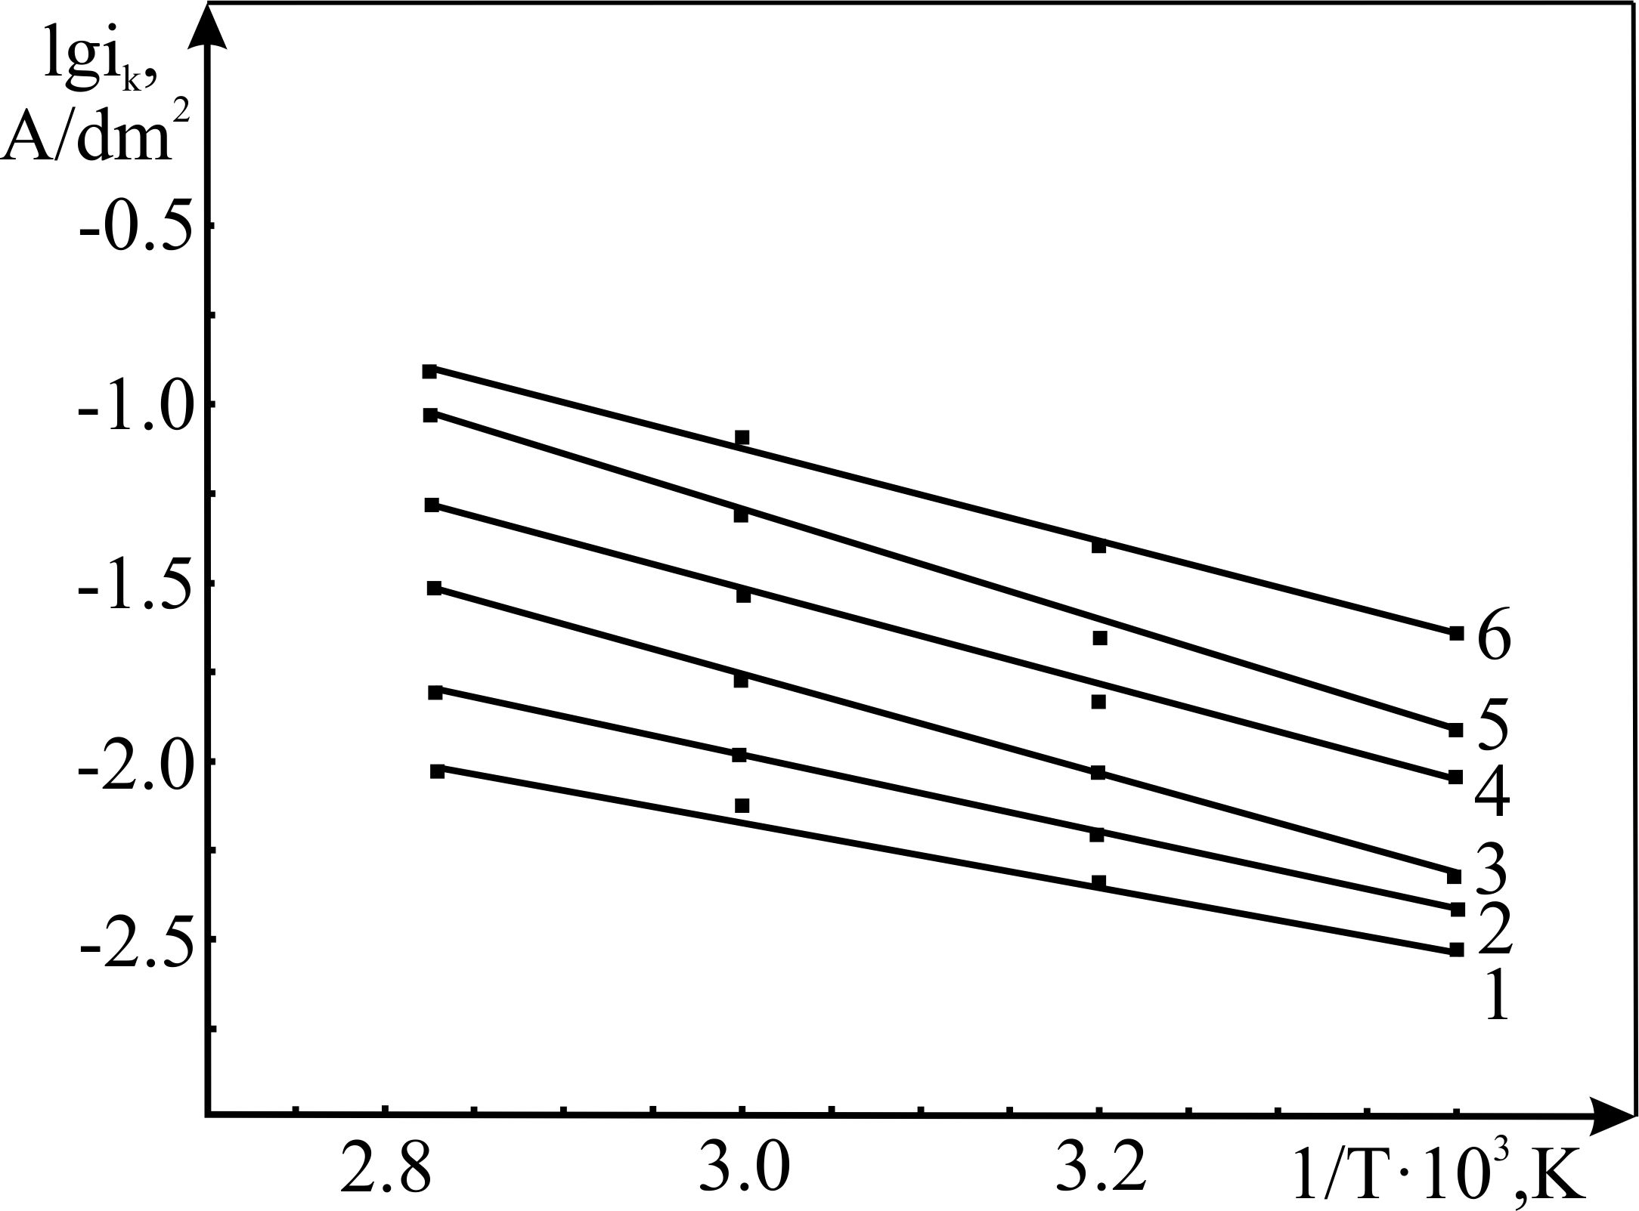

(a) (b)

Fig. 3. (a) lgi_{k} as a function of 1/T, (b) Activation energy as a function of potential.
The linear polarization experiments were performed as a function of temperature for determination of the kinetics of the process. The effect of temperature was investigated within the 293-353⁰С temperature range. As observed from Fig. 2, the electroreduction potential of the molybdate ions skids into the positive side with increasing of temperature, and the current also increased (the peaks of the polarization curves of step I and step II were disappeared with increasing of the current scale).
At a temperature of 293 K the reduction occurs at -0.094 V, but at 353 К it occurs at a potential of 0.0 V. The lgi_{k} – 1/T relation was plotted within 0.0 - (-0.3) V potential range taken from the polarization curves of Fig. 2 as shown in Fig. 3 (a). tgα is calculated according to the obtained lines. The value of effective activation energy obtained by the aid of equation А_{эф.} = -2.3Rtgα, which indicates that electrochemical reduction of the molybdate ions from tartaric electrolytes is accompanied by mixed kinetics. In other words, within the potential range of -0.2 – (-0.3) V, the process as under the control of concentration polarization, before -0.2 V value it takes place as electrochemical polarization (Fig.3 (b)).
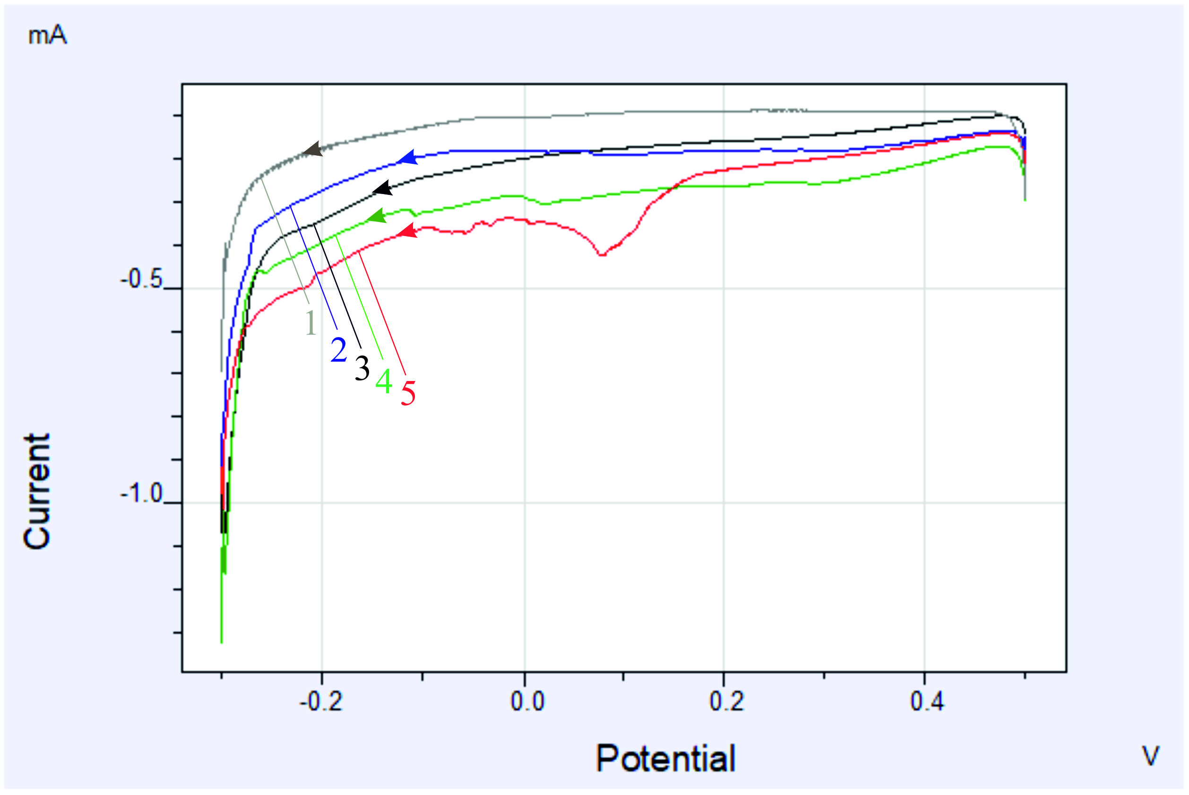

Fig. 4. The effect of concentaration of the molybdate ions to electroreduction process. The electrolyte consists of 0.007 C₄H₆O₆ + (M) Na₂MoO₄⋅2H₂O. M= 1-0.1; 2- 0.2; 3- 0.3; 4- 0.4; 5- 0.5, at Т = 293 К, and Е_{V}=0.02 V/s.

Subsequent to investigating of kinetics and mechanism, the effect of some factors on the electroreduction process of the molybdate ions has been studied. The effect of concentration of the molybdate ions on electroreduction process has been studied within the 0.1 – 0.5 mol/L interval (Fig. 4). At concentrations range of 0.1-0.3 М, the effect of concentration is regular, more precisely, with increasing of concentration of the ions the electrochemical reduction takes place in more positive potentials. Within these intervals (0.3-0.5 М) the displacement of reduction potential to the negative side is observed.
In our invistigation, with increasing of the concentration of the molybdate ions their mobilities in the electrolyte decrease, and then the electroreduction process becomes hard. Furthermore, in the high concentration, the molybdate ions form a stable complex with tartaric acid.

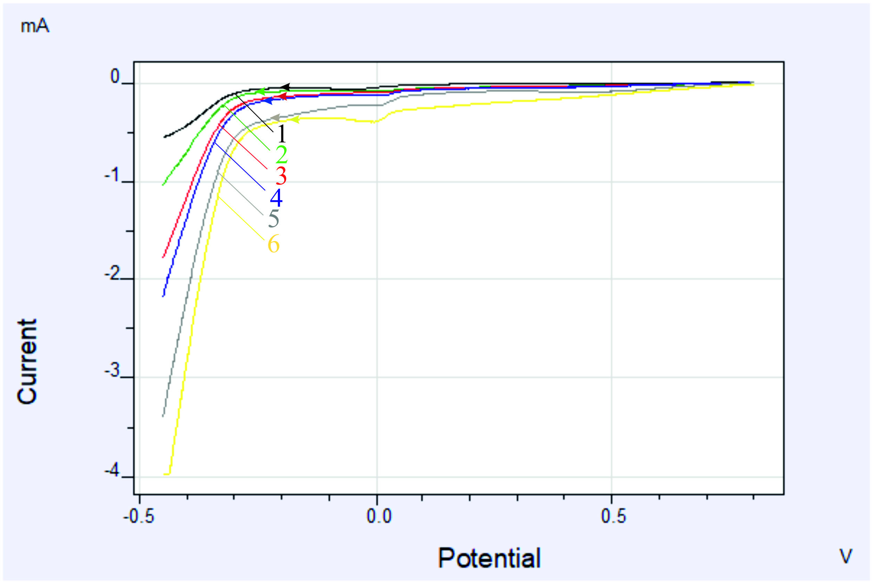

Fig. 5. The effect of potential-scanning to the electroreduction process of the molybdate ions. Electrolyte (М): 0,1 Na₂MoO₄⋅2H₂O + 0,007 C₄H₆O₆. Potential-scanning (V/s): 1-0,005; 2- 0,01; 3- 0,03; 4- 0,06; 5- 0,09; 6- 0,12. Т = 293 К.

Therefore, their subsequent dissociation becomes difficult. As a result of the investigation, the optimal conditions habe been detected, then we selected the optimal concentration of the molybdate ions up to 0.2 mol/L. After that, the effect of potential scanning onto the electroreduction process of the molybdate ions has been studied. In Fig. 5, the cathodic potentiodynamic polarization curves have been showed.
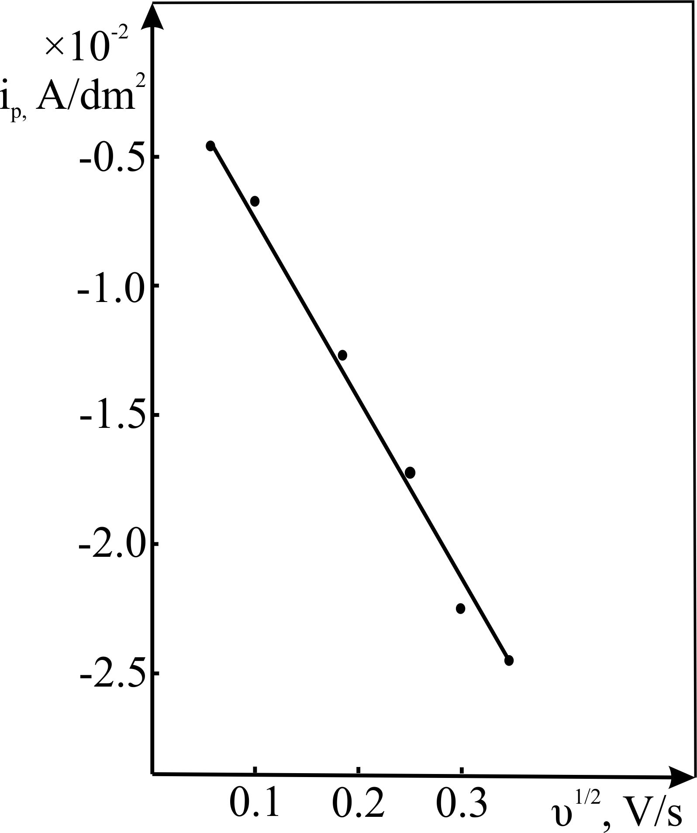

Fig. 6. i_{p} as a function of υ^{1/2} for electroreduction of the molybdate ions. Electrolyte (М): 0,1 Na₂MoO₄⋅2H₂O + 0,007 C₄H₆O₆, Т = 293 К.

Рис. 1. Циклическая поляризационная кривая электровосстановления тиосульфат ионов из виннокислого электролита. Электролит (моль/л): 0,01 Na₂S₂O₃ + 0,007 C₄H₆O₆. Т = 296К, Е_{V}=0,02 В/сек. I – начальная стадия; II – продолжение процесса

Рис. 1. Циклическая поляризационная кривая электровосстановления тиосульфат ионов из виннокислого электролита. Электролит (моль/л): 0,01 Na₂S₂O₃ + 0,007 C₄H₆O₆. Т = 296К, Е_{V}=0,02 В/сек. I – начальная стадия; II – продолжение процесса

As seen from Fig. 5, with increasing of potential scanning, the consumed current for electroreduction process of the moybdate ions is increased. Where, current at 0.005 V/sec is 5.53×10⁻⁴ А, whereas at 0.12 V/sec is 3.97×10⁻³ А.
Fig. 6 indicates that the relationship between i_{p} and υ^{1/2} is linear. It also demonstrates that the electroreduction process of the molybdate ions occurs under the cortol of concentration polarization overpotential.
The chronoamperometric method can be easily used for giving more precise information about the electrochemical deposition process, at which the potential can be stopped at the deposition potential (from CV), such as studying the mechanisms of the nucleation and growth of the electrodeposited particles.
Current-time curves were observed at different applied potentials of 0.047; 0.03; -0.06; -0.09; and -0.1 V at room temperature as shown in Fig. 7. It seems from the shown figure that the initial regime of the current-time curve is characterized by a sudden decrease in the current under application of the deposition potential. This can be attributed to the presence of the double-layer between the surface of the substrate and the ions of the solution which lead to an immediate nucleation of molybdenum in all cases as shown in Fig. 7.

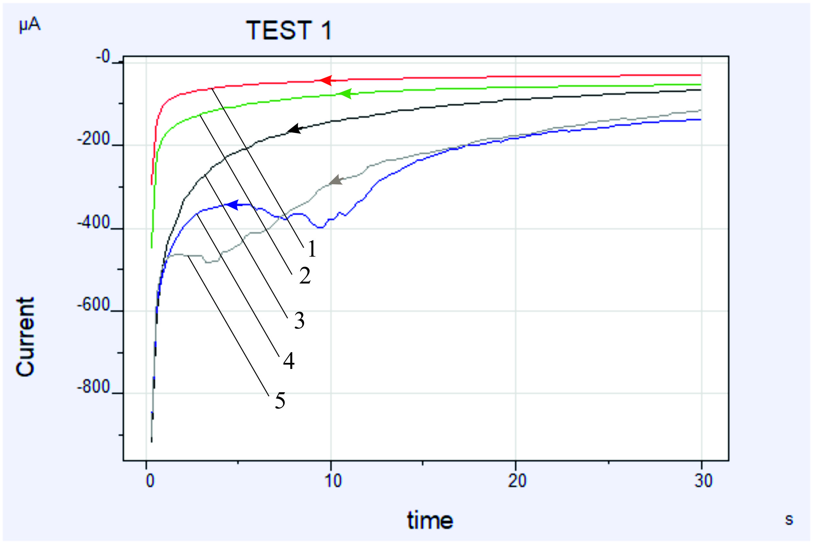

Fig. 7. Current-time curves of the electrodeposition of molybdenum on Pt in electrolyte consists of 0.1 M Na₂MoO₄⋅2H₂O+0.007M C₄H₆O₆ at T=295 K at room temperature and at different deposition potentials; 0,047; 0.03; -0.06; -0.09; and -0.1 V vs. Ag/AgCl.

This sudden decrease is followed by a little increase in the resultant current. This due to an increase in the electroactive surface area associated with the crystal growth. Moreover, it can be noted that the current density during the electrodeposition increases in all cases by increasing the deposition potential. The mechanism of crystal nucleation and growth the can be determined by the analysis of the resulted current-time curves. The analysis of these curves can be achieved by applying the equations of Scharifker-Hills model,²³ comparing with the experimental calculated data as shown in Fig. 8 (a-e). The models of the theoretical transients for the instantaneous and the progressive 3D nucleation are given by equations (4) and (5), respectively:
$$\frac{I{\left(t\right)}^{2}}{I_{max}}= \frac{1.9542}{t/{t_{max}}} {\left\{1-exp\left[-1.2564\left[\frac{t}{t_{max}}\right]\right]\right\}}^{2} (4)$$
$$\frac{I{\left(t\right)}^{2}}{I_{max}}= \frac{1.2254}{t/{t_{max}}} {\left\{1-exp\left[-2.3367{\left[\frac{t}{t_{max}}\right]}^{2}\right]\right\}}^{2} (5)$$
Fig. 8 (a-e) shows the nondimensional I².I² _{max} vs. t.t_{max} plots of the CA data at the different condition as in Fig. 8. The solid lines of black and red color are the theoretical transients of the instantaneous and the progressive nucleation, respectively as in the figure, and dotted lines for the experimental data. The nucleation and growth processes of molybdenum at these conditions can be predicted from Fig. 8 (a-e). At an early stage, the experimental curve well fits the curve of the progressive nucleation model by which the molybdenum nucleation occurred on many active sites of Pt surface substrates. Subsequently, the deposition deviates also out of the instantaneous nucleation as in Fig. 8 (a, b, c, and d). The deviation from the ideal assumption of the Scharifker model may be attributed to that the nuclei grow under diffusion control at these conditions.
Where, I_{max} and t_{max} are the coordinates of the chronoamperometric peak.

Fig. 8. Comparison of theoretical non-dimensional plots of (I/I_{max})² vs (t/t_{max}), for instantaneous and progressive nucleation with the experimental data derived from Fig. 7.

In fact, through time the nuclei growth and the electrodeposition of molybdenum will be under mixed control (diffusion and charge transfer). The deviation can be also interpreted as due to the hydrogen reduction during the formation of nuclei or the morphology change of the nucleus. But, the experimental data for the rest data (Fig. 8 e) are in a good agreement with the theoretical model of the progressive nucleation and growth where the deposition potential of 0.1 V.
Further information for the growth mechanism can be obtained by calculating the density of actives sites (N₀);
$N_{0}$=0.065${\left(\frac{8CM}{}\right)}^{-1/2}{\left(\frac{zfC}{t_{max}i_{max}}\right)}^{2} (6)$
where, C the bulk concentration in mol cm⁻³, zf the molar charge of electrodepositing species, M and ρ in g cm⁻³ are the molecular weight and the density of the deposited material, respectively. Further information of the growth mechanism can be obtained by determining the diffusion coefficient D via the chronoamperometric method. According to the theoritical nucleation model, the D is related to the i_{max} and the t_{max}^{23, 24} by the following equation;

D=$\frac{{ i_{max}}^{2}t_{max}}{0.1629(zfC)} (7)$

E_{d}, V vs. Ag/AgCl | D, cm² s⁻¹ | N₀, cm⁻²
0.047 | 1.89×10⁻⁹ | 25.10×10⁶
0.030 | 3.54×10⁻⁹ | 8.51×10⁶
−0.06 | 5.61×10⁻⁹ | 5.38×10⁶
−0.09 | 8.24×10⁻⁹ | 1.26×10⁶
−0.10 | 10.17×10⁻⁹ | 1.07×10⁶
The values of i_{max}, t_{max}, D, and N₀ at different deposition potentials and temperatures are shown in Table 1. From these values, it is clear that by increasing the deposition potential, the i_{max}.t_{max} value slightly increases. This characteristic is typical for 3D electrochemical nucleation and growth of a new phase under the mixed diffusion and adsorption control.

Table 1. The experimental data of the CA electrodeposition of Mo onto Pt substrate

Moreover, the D values at these conditions of the electroactive species are very small due to the high relative density of the electrolyte and the high relative volume of molybade ions. The D value is affected by the polarization potential as seen in Table 1.
It is noted from the table that nuclei densities N₀ decrease significantly with the increase of the deposition potential. This decrease with the applied deposition potential is generally understood as the decreased activation of nucleation sites at higher potentials, which deviates from the classical nucleation models as confirmed by Fig. 8.
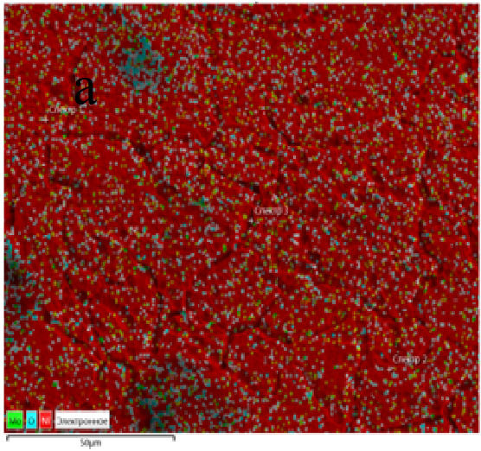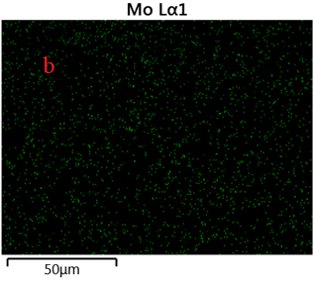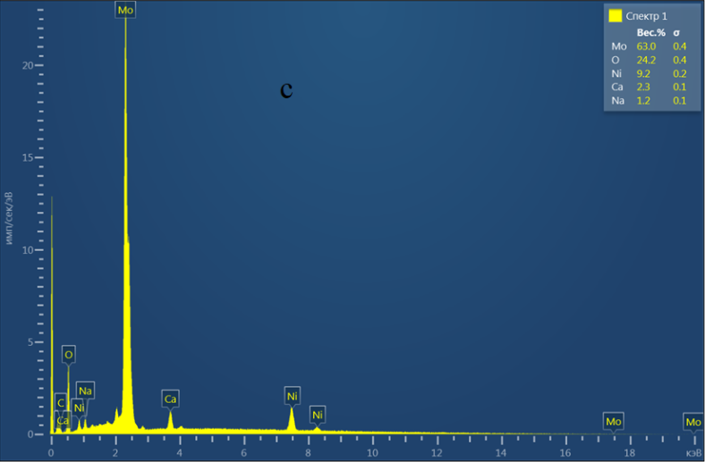

Fig. 9. SEM (a, b ) and EDAX (c) of the electrodeposited Mo from a solution consists of 0,1 M Na₂MoO₄⋅2H₂O + 0.007M C₄H₆O₆ at scan rate = 0.02 Vs⁻¹ on Ni sheet at T=295 K

This deviation may be also explained as by increasing the deposition potential the polarization of the working electrodes increases but the diffusion of the active species is still slow because of the high density of surrounding media which hinder the diffusion of the active species.
Fig. 9. shows the morphology of electrodeposits of the metallic Mo films investigated by SEM. Mapping SEM images and EDX analysis show that the quantity of metallic molybdenium more that of oxygen. The presence of oxygen may be returned to that there are some adsorbed molybdate ions on the electrode surface come from the electrolyte. As a result of the conducted experiments, the electroreduction of the molybdate ions has been implemented from electrolyte consisting of 0.05 М Na₂MoO₄,+ 0.007 М C₄H₆O₆ and with potential scan rate of 0.02 Vs⁻¹ and at 293 K temperature. EDX analysis shows a good During the electroreduction studies process, Pt electrode was used, but during galvanostatic electrodepositing process, Ni substrate with high purity was used.

CONCLUSIONS
The electroreduction process of the molybdate ions from tartaric acid solutions has been investigated on the Pt electrode. kinetics and mechanism of the process have been studied, using the data of cyclic and linear polarization curves. The nature of polarization process in this case is accompanied by mixing kinetics.
The results of all performed experiments indicate that the concentration of the molybdate ions, temperature and potential scanning have a great effect on the electroreduction process of the molybdate ions in the tartaric acidic electrolytes. The optimal conditions and the composition of electrodeposition bath electrolyte for electroreduction process of the molybdate ions was peciousely detected.

REFERENCE

АSh Aliyev, ShО Eminov, ТSh Sultanova, VА Mejidzadeh, DА Kuliyev, D Jalilova, DB Tagiyev, Chemical Problems. 2016, 2, 139-145.
- M Duda, R Kowalik, K Mech, PR Zabinski, Rudy Met. Niezel. 2012, 9, 586-591.
- ASh Aliyev, M Elrouby, SF Cafarova, Mat. Sci. Semicon. Proc. 2015, 32, 31-39.
- F Golgovici, T Visan, M Buda, Chalcogenide Lett. 2013, 6, 197 – 207.
- MR Palacín, P Simon, JM Tarascon, Acta Chim. Slov. 2016, 63, 417-423.
- GM Huseynov , NA Mammadova, HA Imanov, Chemical Problems. 2017, 3, 329-334.
- ASh Aliyev, HM Tahirli, M Elrouby, NSh Soltanova, DB Tagiev, Metall. Mater. Trans. B. 2016, 3, 2072-2078.
- R Abdel-Karim, J Halim, S El-Raghy, M Nabil, A Waheed, J. Alloys Compd. 2012, 530, 85-90.
- VA Majidzade, PH Guliyev, ASh Aliyev, M Elrouby, DB Tagiyev, J. Mol. Struct. 2017, 1136, 7-13.

VA Majidzade, ShE Alizade, ASh Aliyev, Nakhchivan State University Scientific works. 2018, 80, (in press)

ASh Aliyev, VA Majidzade, NSh Soltanova, DB Tagiyev, VN Fateev, Chemical Problems. 2018, 2, 178-185.

VA Majidzade, Chemical Problems. 2018, 3, 331-336.
- VA Majidzade, SF Cafarova, ASh Aliyev, DB Tagiyev, Azerbaijan Chemical Journal. 2018, 3, (in press)
- K Ogura, Y Enaka, T Yosino, Electrochim. Acta. 1977, 5, 509-512.

Р Zanello, G Raspi, А Cinquantini, Talanta. 1977, 1, 25-30.
- VV Kuznetsov, DI Zimakov, SA Chepeleva, VN Kudryavtsev, Russ. J. Electrochem. 2004, 7, 711–715.

VM Nagirnyi, RD Apostolova, AS Baskevich, EM Shembel, Russ. J. Appl. Chem. 2004, 1, 71-73.

SF Cafarova, ASh Aliyev, M Elrouby, NSh Soltanova, DB Tagiyev, J. Electrochem. Sci. Eng. 2015, 4, 231-235.
- ND Ivanova, SV Ivanov, EI Boldyrev, OA Stadnik, Prot. Met. Phys. Chem. 2006, 4, 388-392.
- S Rajak, SK Ghosh, PU Sastry, G Sharma, RC Hubli, JK Chakravartty, Surf. Coat. Tech. 2015, 261, 15–20.
- SM Deambrosis, E Miorin, F Montagner, V Zin, M Fabrizio, M Sebastiani, F Massimi, E Bemporad, Surf. Coat. Tech. 2015, 266, 14–21.

TJ Morley, L Penner, P Schaffer, TJ Ruth, F Bénard, E Asselin, Electrochem. Commun. 2012, 1, 78–80.
- B Scharifker, G Hills, Electrochim. Acta. 1983, 28, 879-889.
- MR Khelladi, L Mentar, A Azizi, A Sahari, A Kahoul, Mater. Chem. Phys. 2009, 115, 385-390.

