Fabrication of silver-modified halloysite nanotubes and their catalytic performance in Rhodamine 6G and Methyl orange reduction
ª Maryam. Akhondi, Effat. Jamalizadeh ^{b}
Department of Chemistry, Faculty of science, Shahid Bahonar University of Kerman, Kerman, Iran.
Abstract
In this paper, halloysite nanotube supported Ag nanoparticles (Ag/HNT) were synthesized and tested as a heterogeneous catalyst for the reduction of Rhodamine 6G and Methyl orange. Thus, the surface of HNTs modified with 3-glycidyloxyproyltrimethoxysilane and Triethylene tetramine as two new compounds, then Ag⁺ ions were reduced to AgNPs on the functionalized HNTs surface. The structure of AgNPs-modified HNTs was characterized by FTIR, XRD, TEM and FE-SEM with EDX analysis. The structural characterization revealed that the size of AgNPs was from 10-15 nm, which immobilized on the surface of HNTs. The catalytic activity of Ag/HNTs on reduction of Rh6G and MO were investigated by UV-vis spectroscopy and rate constants for the catalyzed and uncatalyzed reaction were determined. The catalyzed reaction spectrums show a sudden fall in absorbance value, confirming catalytic effect of Ag/HNTs. Furthermore, the Ag/HNT could be easily recycled several times without appreciable loss of activity. Results indicate that there is a possibility of supporting AgNPs on surface of HNT functionalized with new compounds to increase their performance to reduce Rh6G and MO dyes.
Keywords: Catalyst; Ag nanoparticles; Functionalized halloysite; GPTMS; TETA

1. Introduction
Removal of organic dyes from industrial wastewaters is very necessary, in order to have pollution free environment. Dyes affect the growth of plants, and having carcinogenic potential toward humans and animals by producing toxic and non-biodegradable wastes.^{1, 2}
There are various techniques employed to remove the dye molecules from wastewater such as coagulation, flocculation, ozonation, membrane filtration, Fentons reagent, ion exchange and
biological treatment.³⁻⁷ The coagulation–flocculation process is widely used, due to its simplicity and cost-effectiveness.³ This method is inefficient since it just transfers the dye molecules from liquid to solid.⁸ In the past few years, catalysis attracted much interest as an efficient method to treat wastewater containing colorants.⁹
In recent years, great achievements have been made in the metal nanomaterials as heterogeneous catalysts.¹⁰⁻¹² Nanomaterials have some special properties such as the surface and interface effect which arise from the damage of a boundary between a material and its surrounding environment, small size effect which is due to the decrease of the atom’s density of amorphous nanoparticles near the surface layer, quantum size effect that arise from confinement of electrons to small regions of space in one, two, or three dimensions and also macroscopic quantum tunnelling effect, as well as, some potential applications, such as catalysis, biology, medicine and so on.¹³⁻¹⁵
Among different type of metal nanoparticles, noble metal nanoparticles (Au, Ag, Pt, Pd, etc) have attracted extensive attention as catalyst.¹⁶⁻¹⁸ Among these noble metallic nanoparticles, Ag is particularly attractive due to its remarkable catalytic activity and much lower cost. A significant number of studies on the catalytic reactions of Ag nanoparticles (AgNPs) have been reported, such as alcohol dehydrogenation,¹⁹ oxidation of phenylsilanes,²⁰ reduction of aromatic compounds,²¹ and Diels-Alder cycloadditions.²² Since during a reaction, the highly active surface atoms destabilize the AgNPs,²²⁻²⁷ AgNPs have been immobilized onto the various supports such as polymeric ^{28, 29} and inorganic materials, including silica,^{30, 31} zeolite,^{32, 33} alumina,^{34, 35} ceria,³⁶ titania,^{37, 38} Zirconia,³⁹ activated carbon,^{40, 41} Carbon nanotubes (CNTs) ,^{42, 43} and halloysite nanotubes (HNTs) ^{44, 45} and so on.
Halloysite nanotubes with nanotubular structures of about 15 nm lumen, 50 nm external diameter and1000–2000 nm length are abundant deposited natural silicate resources. HNTs are important due to their biocompatibility,^{46, 47} chemical stability,⁴⁸ high absorption ability¹⁰ and ability to settle down quickly. HNTs (Al₂Si₂O₅(OH)₄.nH₂O) have two-layered (1:1) aluminosilicate with aluminol (Al–OH) groups in the internal surface and Si–OH groups on the external surface. Thus an amount of hydroxyl groups existing on the surface, which allows them to achieve surface functionalization easily.⁴⁹⁻⁵²
The purpose of this paper is to enhance the catalytic effect of Ag nanoparticles as a heterogeneous catalyst by supporting them on the surface of halloysite modified with new compounds to reduce 6G Rh6G and MO dyes. Here we report modification of the external surface of HNTs by a new compound, and then in situ reduction of Ag⁺ to Ag nanoparticles on the functionalized HNTs surface. The synthetized Ag/HNTs applied as a heterogeneous catalyst in the degradation of Methyl orange and Rhodamine 6G in aqueous solution (Scheme 1). The recyclability of the Ag/HNTs catalyst was tested by carrying out repeated runs of the same reaction system.

Scheme 1. Reduction of Rh6G and MO by NaBH₄ catalyzed by the Ag/HNT.

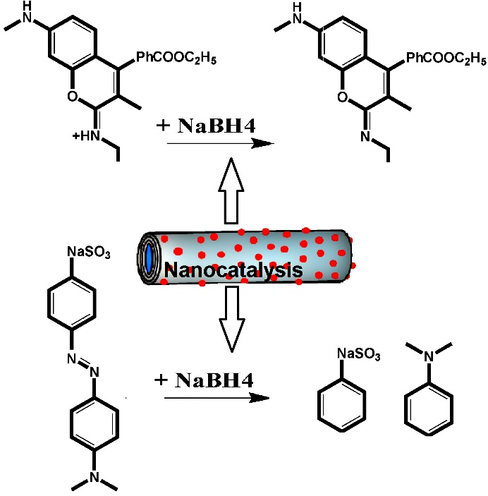

2. Methods
2.1 Materials
The halloysite nanotube powder was provided by New Zealand China Clays Ltd., Auckland, New Zealand. The Sodium borohydride (NaBH₄ ≥ 99.99%) was acquired from the Sigma Aldrich. The silver nitrate (AgNO₃ ≥ 99%), 3-glycidyloxyproyltrimethoxysilane (GPTMS ≥ 98%), Triethylene tetramine (TETA), Ethanol, MO and Rh6G were purchased from Merck.
2.2 Instruments
UV-vis spectra were recorded on a spectrophotometer (Varian, Cary50), with a quartz cuvette (1.0 cm path length, and 4 mL volume). Scanning electron microscope images were obtained with a field-emission scanning electron microscope (FE-SEM) KYKT, EM-3200. Transmission Electron Microscope (TEM) images were recorded from JEOL 2100F TEM. XRD patterns were obtained in reflection mode using a powder X-ray diffractometer (X′Pert Pro MPD Philips X‐ray diffractometer (Ni‐filtered Cu‐Kα radiation, λ = 0.154 nm). FT-IR spectra were recorded on a FT-IR 8400-Shimadzu as KBr discs in the range 400-4000 cm⁻¹.
2.3 Functionalization of HNTs
Functionalization of HNTs were performed in two steps as follows: Firstly, GPTMS containing epoxy groups were grafted on the surface of HNTs via silanization. 0.5g of HNTs were dispersed in 7mL of ethanol and then, 1mL of GPTMS added into the solution. Following that, the mixture was stirred at 65℃ for 24 h. Then, the suspension was collected by centrifugation. The precipitated products (GPTMS/HNT) were washed with pure ethanol five times and dried at 60℃ for 10 h. Secondly, TETA was grafted via ring opening reaction of epoxy groups. 0.5g of GPTMS/HNTs and 6mL of pure ethanol containing TETA (0.1mg L⁻¹) were stirred together and refluxed it for 24h at 70℃. The mixture was centrifuged and the precipitate (TETA/HNT) was washed with ethanol five times, dried at 70℃ for 10h. The process is demonstrated in Scheme 2.

Scheme 2. Schematic Illustration of the role of GPTMS and TETA in the formation of the TETA/HNTs.

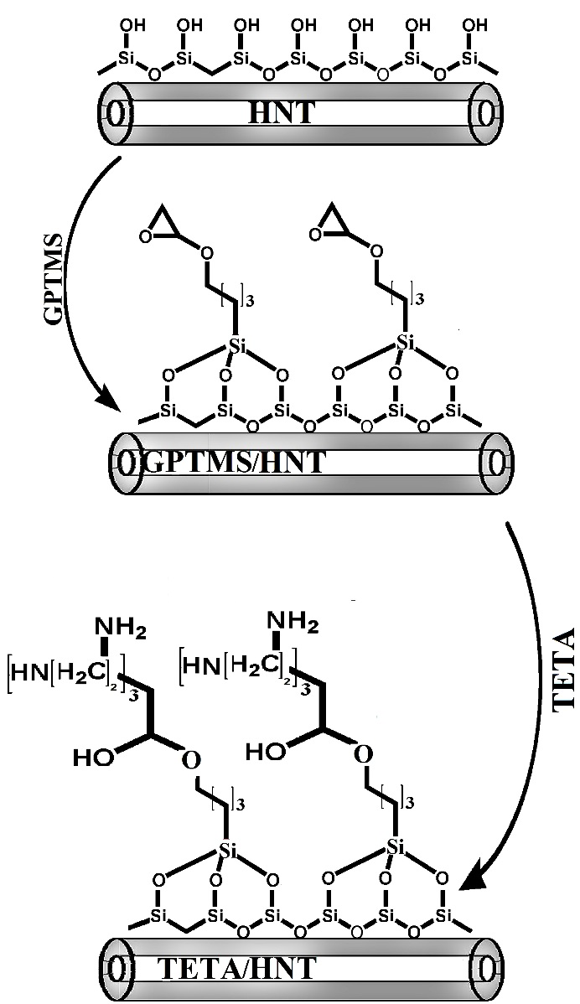

2.4 Synthesis of Ag/HNTs nanocomposite
The Ag/HNTs composite were prepared using AgNO₃ as silver precursor. Silver ions were in situ reduced to silver nanoparticles on the functional groups of amine on the surface of TETA/HNTs. In a typical synthesis process, 0.5 g of TETA/HNTs was first added to 10 ml of deionized water under severe stirring for 1h. Then, 1 mL of AgNO₃ solution (0.2 M) was added dropwise to the reaction mixture and magnetically stirred for 30 min to obtain Ag⁺/HNTs ions mixtures. The solution was reduced by addition of 2 mL of freshly prepared aqueous NaBH₄ solution (0.1 M) under stirring. The color of the reaction mixture turned from white to dark green, indicates the formation of Ag NPs on the surface of HNTs (Ag/HNTs). The final product was washed several times with water to remove unreacted Ag⁺ ions and byproducts. All experiments were performed at room temperature.
2.5 Catalytic reduction of dyes by Ag/HNTs nanocomposite
In order to investigate the catalytic activity of Ag/HNTs nanocomposite, the Rh6G and MO dyes were reacted with the NaBH₄ in the presence and absence of nanocomposite. The reduction of dyes was carried out in the quartz cell and monitored by a UV–vis spectroscopy at room temperature. 1 mg of Ag/HNTs nanocomposite was mixed with 2 mL of aqueous dye solution. Then 1.0 mL of NaBH₄ solution as reducing agent (1mM) was added to the mixture and continuously stirred. After the addition of NaBH₄ solution, the progress of the reaction was studied with time by UV-vis spectroscopy. After the reaction was over, the Ag/HNT catalyst was centrifuged and washed with deionized water for two times, and dried in vacuum for 24 h at 50 °C, and subjected again to dye degradation processes in order to determine its reusability. The catalyst reusability was tested in six successive runs.
The reduction of Rh6G and MO with an excess amount of NaBH₄ has been used as a model reaction to examine the catalytic performance of the fabricated Ag/HNTs.
The reaction kinetics can be described as Eq. (1): ⁴⁰
ln(C/C₀) = - kt (1)
where C₀ is the initial concentration of dye, C is the concentration of dye at time t, k is the apparent first-order rate constant (min⁻¹), and t is the time. Since the concentration of a solution is proportional to its adsorption, Eq. (1) can be written as follow:
ln(A/A₀) = - kt (2)
A₀ and A are the adsorption of dye at initial and time t, respectively.
Degradation efficiency (%D) of Ag/HNT is calculated according to the following Eq. (3):
%D = $\frac{A_{0} -A}{A_{0}}×100$ (3)

3. Results and Discussion
3.1 FTIR spectra
The FTIR spectroscopy was used to determine the chemical structure of the HNTs during the functionalization process. As shown in Figure 1, the characteristic peaks of HNTs occurred at 3698 cm⁻¹ and 3623 cm⁻¹ are attributed to O–H stretching of inner-surface hydroxyl groups and O–H stretching of inner hydroxyl groups, respectively.⁵³ As well as, the peaks observed at 1109 cm⁻¹ and 1034 cm⁻¹ ascribed to in-plane stretching of Si–O bond.⁵³ FTIR of the modified halloysite with GPTMS (GPTMS/HNT) shows new peaks at 2925 and 2854 cm⁻¹, which is assigned to the asymmetric and symmetric stretching vibration of aliphatic -CH₂ groups, which can also imply the existence of GPTMS grafted on the HNTs.⁵⁴ For GPTM/halloysite grafted by TETA (TETA/HNT), in addition to the presense of CH₂ bands at 2946cm⁻¹ and 2871cm⁻¹, there are two new peaks at 1200 and1600 cm⁻¹, attributing to the C-N and NH₂ groups, respectively.⁵⁵ The obtained results can also imply the interaction between TETA and epoxide ring of GPTMS grafted on the HNTs. In general, compare with the FTIR spectra of HNTs, the positions of the most of the peaks for HNTs do not changed, which demonstrates that the main crystal structures of HNTs are preserved in GPTMS/HNTs and TETA/HNTs. Also, from the above information, it can confirm that the HNTs have been successfully functionalized with amine groups.

Figure 1. FT-IR spectra of HNTs, GPTMS/HNTs and TETA/HNTs.

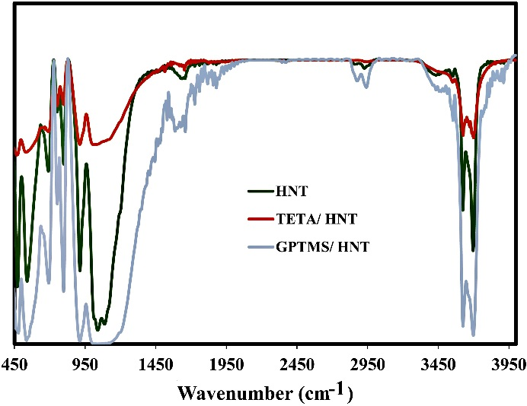

3.2 UV-vis spectra
Figure. 2 shows the UV-vis optical absorption spectra of the HNTs and Ag/HNTs in the 200-800 nm spectral range. The UV-vis spectra of HNTs dispersed in water revealed no absorption band, while the Ag/HNTs sample revealed an absorption band in 427 nm, corresponding to the surface plasmon resonance (SPR) of Ag nanoparticles.

Figure 2. UV–vis spectra of HNTs and Ag/HNTs.
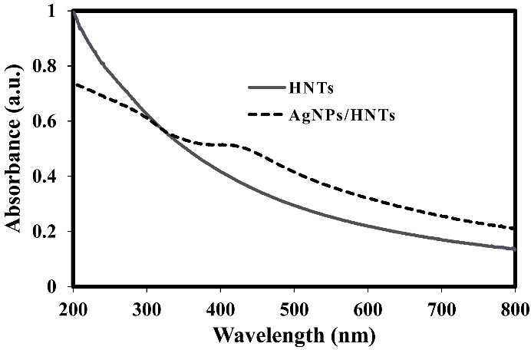

3.3 FE-SEM and EDX analysis
The FE-SEM image of HNTs and Ag/HNTs are shown in Figure 3(a) and Figure 3(b), respectively. The diameter of the HNTs particles are about 123 nm with random length. Fig 3 shows the halloysite nanotubes along with some non-tubolar structures. The particles of halloysite can adopt a multifariousness of morphologies, the most common of which is the elongated tubule. However, short tubular, spheroidal and platy particle shapes have all been widely described.⁵⁶ ⁻⁵⁸ The Ag nanoparticles are almost not observed in Figure 3(b) but EDX analysis confirms the existence of Ag element on the surface of halloysites, Figure 3(b).

Figure 3. EDX spectra and FE-SEM images of (a) HNTs and (b) Ag/HNTs.
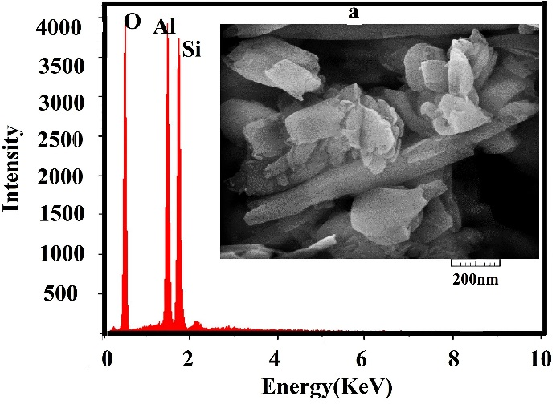

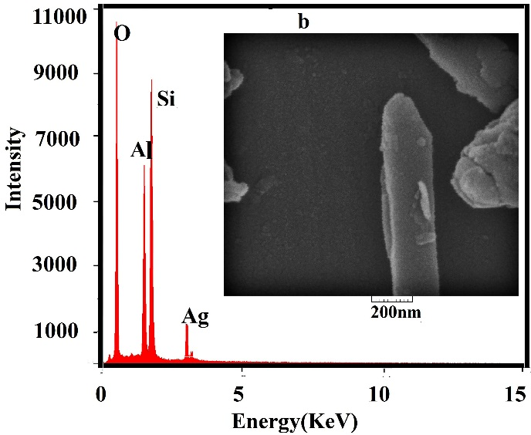
3.4 TEM analysis
The structure and morphology of Ag/HNTs are shown in Figure 4. The TEM image reveals the hollow tubular morphology of HNTs and with open ends (with the inner and outer diameters about 15-40 nm and 50-140 nm, respectively). The TEM image reveals that the particles are highly mono-dispersed with average size about 10 nm and are spherical in shape. Thus it can be concluded that amine terminated group adsorb Ag⁺ ions from solution. Thus, Ag⁺ ions reduced on the halloysites surface.

Figure 4. TEM image of Ag/HNTs.
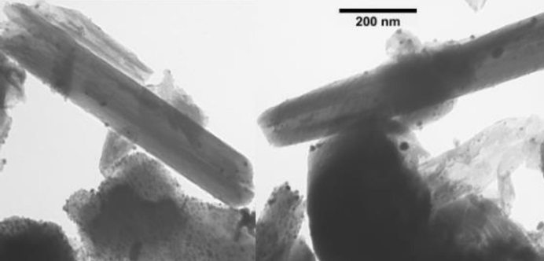

3.5 X-ray Diffraction analysis
The X-ray diffraction (XRD) pattern of HNTs and Ag/HNTs are shown in Figure 5. The XRD patterns of the functionalized HNT reveal well defined diffraction peaks all corresponding to the HNT, which show that modification with GPTMS and TETA does not affect the structure of the HNT. However, in the XRD pattern of the Ag/HNTs nanocomposite, four new peaks emerging at
2θ value of 37.7◦, 43.5◦, 64.2◦ and 77.4◦are ascribed to (1 1 1), (2 0 0), (2 2 0) and (3 1 1) reflections of fcc structure of metallic silver;^{59, 60} so this further demonstrates that the AgNPs were successfully synthesized onto the surface of the HNTs.

Figure 5. XRD pattern of HNTs and Ag/HNTs.
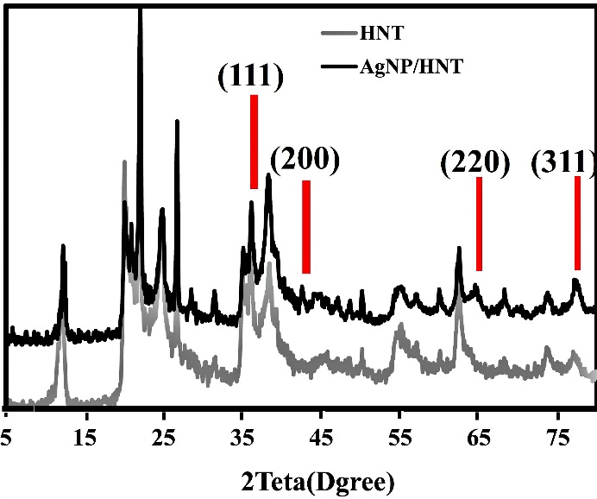

3.6 Catalytic reduction of Rh6G and MO
The catalytic activity of synthesize Ag/HNTs in the reduction of Rhodamine 6G and methyl orange was studied by UV–visible spectrophotometer, Figures 6 and 7, respectively. Time dependent reduction of Rh6G and MO with NaBH₄ in presence and absence of Ag/HNTs was observed by the successive decrease in the absorbance value at 516 and 467 nm, respectively.
The Figures show that the reduction of Rh6G and MO in absence of catalyst at room temperature occurs at a slow rate. But on the addition of Ag/HNTs degradation of the dyes Rh6G and MO is greatly enhanced. From Figure 6, we observed that there is a rapid decay in concentration of Rh6G in the presence of Ag/HNTs in 12 min (ΔOD_{12 min} = 0.4), as compared to the uncatalyzed reaction (ΔOD_{30 min} = 0.4) in 30 min, and from Figure, it is observed that there is a rapid decay in concentration of MO in the presence of Ag/HNTs in just 12 min (ΔOD_{12 min} = 0.8), whereas there is slow degradation for the uncatalyzed reaction (ΔOD_{30 min} = 0.34) in 30 min. The degradation efficiency for Rh6G and MO is found to be 87% and 85.5%, respectively, that occurred in 30 min in presence of Ag/HNT as catalyst. It is observed that degradation of methyl orange is classically enhanced in presence of silver nanoparticles due to electron relay effect.^{25, 26} Silver nanoparticles act as an electron relay, aiding in the transfer of electrons from the ${BH}_{4}^{-}$ ions to the dyes and thereby causing reduction in the absorption of the dyes.²⁵ Here AgNPs on the halloysites act as an electron transfer mediator; acceptsthe electrons from ${BH}_{4}^{-}$ and donate to organic dyes by acting as redox catalyst which show electron relay effect ⁴⁹.

Figure 6. Time-dependent UV-vis absorption spectra for the reduction of Rh6G with NaBH₄ (a) in the presence and (b) absence of
Ag/HNTs at room temperature.
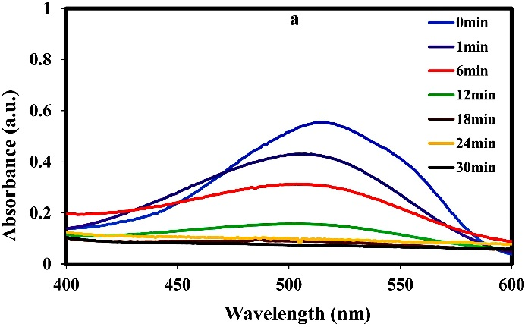
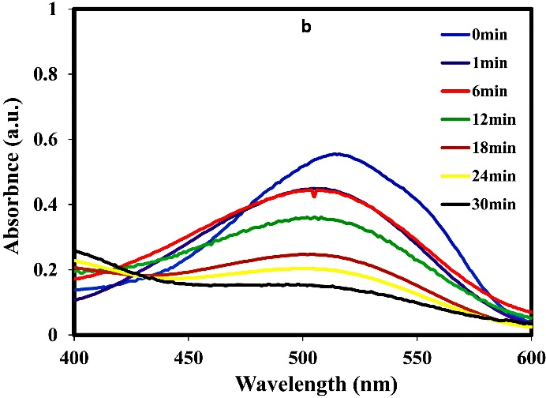

Figure 7. Time-dependent UV-vis absorption spectra for the reduction of MO with NaBH₄ (a) in presence and (b) absence of Ag/HNTs at room temperature.

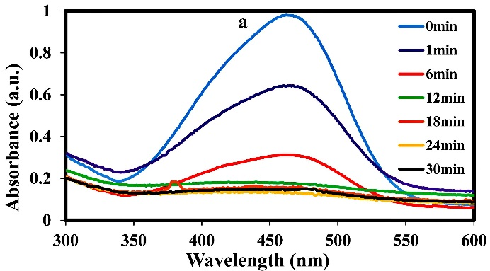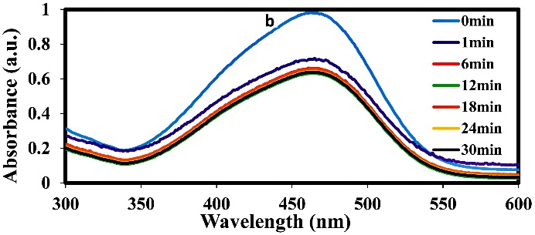

The rate constant (k) of Rh6G and MO degradation has been calculated for catalyzed reactions as 0.224 min⁻¹ and 0.222 min⁻¹, respectively, and for uncatalyzed reaction as 0.049 min⁻¹ and 0.014 min⁻¹, respectively, as presented in Table 1.

Table 1 Comparison of rate constant (k) for the catalyzed and uncatalyzed degradation of Rh6G
and MO.

Rate constant (catalysis)(min-1) | Rate constant (uncatalysis)(min-1) | Dye | Entry
0.126 | 0.049 | Rhodamine 6G | 1
0.222 | 0.014 | Methyl Orange | 2

3.7 Effect of amount of catalyst
The amount of catalysts is one of the important factor which affects the catalytic degradation reactions. Tables 2 and 3 present the optimization of degradation conditions for Rh6G and MO in the early Minutes, respectively. As Tables show, the amount of the Ag/HNTs catalyst was varied in the range of 0.0002 g L⁻¹ to 0.0025 g L⁻¹ while holding the other conditions constant (NaBH₄ concentration = 4 mg L⁻¹, dye concentration = 10 mg L⁻¹). According to the results, the rate of catalytic degradation reaction of both dyes increased by increasing the amount of catalyst. This may probably be due to the increase in the number of surface active sites and the extent of dye adsorption molecules on the catalyst surface.²⁵

Table 2 Optimization of degradation conditions for Rh6G at room temperature.
Rate constant  (min⁻¹) | NaBH₄  (mg L⁻¹) | Ag/HNT  (g l⁻¹) | Entry
0.010 | 4 | 0.0002 | 1
0.083 | 4 | 0.0005 | 2
0.126 | 4 | 0.0010 | 3
0.234 | 4 | 0.0250 | 4
0.014 | 1.5 | 0.0250 | 5
0.083 | 4 | 0.0250 | 6
0.207 | 8 | 0.0250 | 7
0.184 | 16 | 0.0250 | 8

Table 3 Optimization of degradation conditions for MO at room temperature.
Rate constant  (min⁻¹) | NaBH₄  (mg L⁻¹) | Ag/HNT  (g l⁻¹) | Entry
0.085 | 4 | 0.0002 | 1
0.188 | 4 | 0.0005 | 2
0.222 | 4 | 0.0010 | 3
0.229 | 4 | 0.0250 | 4
0.061 | 1.5 | 0.0250 | 5
0.221 | 4 | 0.0250 | 6
0.236 | 8 | 0.0250 | 7
0.330 | 16 | 0.0250 | 8

3.8 Effect of amount of NaBH₄
In order to evaluate the effect of NaBH₄ amount, the degradation of dyes was carried out by varying the concentration of NaBH₄ in in the range of 1.5 to 16 g L⁻¹, while holding the other conditions constant (dye concentration = 10 mg L⁻¹, Ag/HNT concentration = 0.001 g L⁻¹ ), Tables 2 and 3. The results show that by increasing the concentration of the NaBH₄, almost the rate of degradation of both dyes increases, which is because the higher number of electrons promotes the simultaneous reduction of the Ag particles from its oxide and the reduction of dyes (MO and Rh6G) .²⁵ However, the rate constant for the 8 g L⁻¹ concentration of NaBH₄ is observed to decrease. This is caused by the incapability of AgNPs to relay the electrons, owing to the higher production of electrons from the BH4⁻ ion. Saturation of electrons
occurs in this case.⁶¹
The dye reduction studies reported in literature are compared with the present study, Table 4. The synthesized Ag/HNTs performs as well as other Ag catalysts reported elsewhere for the degradation of MO and Rh6G.^{25, 62-64} This work reports the use of finite amounts of Ag than the other researches which are with Ag nanoparticles alone as catalyst. As shown in Table 4, the K value in this work is 0.21 min⁻¹. This is slightly lower when compared to the Ag supported on zeolite (0.30 min-1).⁶² In the present work, amount of used Ag/HNTs as catalyst is 2.4 times less than the AgNPs/Zeolite X.

Table 4 Rate constant (k) for the reduction of Rh5G and MO involving various nanocatalysts.
Refs | Time (min) | Rate constant (min⁻¹) | NaBH₄  (µmol) |  | Dye  (µmol) |  | Catalyst  (mg L⁻¹) | Entry
²⁵ | 1.5 | 0.33 | 7 |  | Rh6G  0.18 |  | silver-nanoshells  0.001 | 1
⁵⁹ | 35 | 0.09 | 0.27 |  | MO  2.40 |  | Ag/tannic acid  0.004 | 2
⁶⁰ | 15 | 0.19 | 30 |  | MO  0.20 |  | AgNPs  0.0001 | 3
⁶¹ | 8 | 0.30 | 550 |  | MO  0.76 |  | Ag/ZeoliteX  0.060 | 4
This work | 30 | 0.21 | 10 |  | Rh6G  0.02 |  | Ag/HNT  0.025 | 5
This work | 30 | 0.222 | 10 |  | MO  0.03 |  | Ag/HNT  0.025 | 6

3.9 Recycling process
Heavy metals have an impact on the environment and so it is important to investigate the issue of catalyst recovery and recycling.⁶⁵ Thus, we have used Ag/HTNs as recyclable and reusable catalysts. The catalyst was easily recovered from the reaction mixture by simple filtration after washing with water (which is due to the one-dimensional nanostructural nature of the Ag/HNTs). The recycling experiments involving synthesized Ag/HNTs for the reduction of MO and Rh6G are shown in Figure 8. The data show that the Ag/HNT catalyst could be used for six times and still maintained the percentage of degradation over 85%. As a result, the Ag/HNT catalyst has a high operational stability with no appreciable loss in catalytic activity even after six successive cycles and performs a good reusability.

Figure 8. Recyclability and reusability of the synthesized Ag/HNTs for the reduction of
Rh6G and MO.

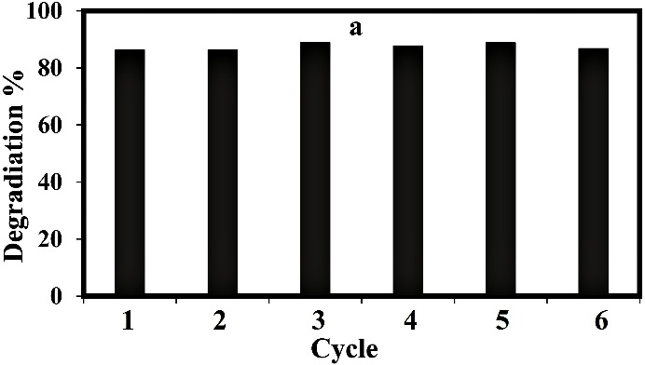

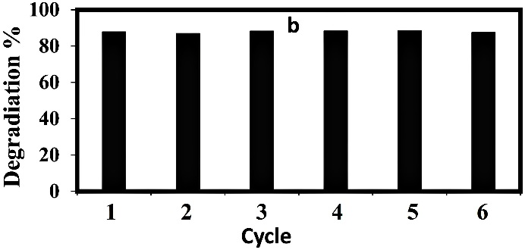

4. Conclusion
In summary, halloysite nanotube supported Ag nanoparticles were synthesized by in situ reduction of silver ions to silver nanoparticles on the functional groups of amine on the surface of TETA/HNTs. HNTs functionalized by TETA greatly improves dispersion of the Ag nanoparticles on HNT surfaces. Further investigation showed that the Ag/HNTs exhibited good catalytic activity in the reduction of MO and Rh6G using NaBH₄ as the reducing agent. And, the catalytic efficiency was enhanced with the increasing amount of Ag/HNTs. Notably, the Ag/HNTs could be easily recycled due to their one-dimensional nanostructural property. These results indicate that there is a possibility to immobilize Ag nanoparticles on the surface of halloysite modified with GPTMS and TETA to increase their performance to reduce Rh6G and MO dyes.

References
- P. Velusamy, S. Pitchaimuthu, S. Rajalakshmi and N. Kannan, J. Adv. Res. 2014, 5, 19-25.
- H. R. Pouretedal, H. Eskandari, M. H. Keshavarz and A. Semnani, Acta Chim. Slov. 2009, 56.
- A. K. Verma, R. R. Dash and P. Bhunia, J. Environ. Manage. 2012, 93, 154-168.
- T. Poznyak, P. Colindres and I. Chairez, J. Mex. Chem. Soc. 2007, 51, 81-86.
- C. Thamaraiselvan and M. Noel, Crit Rev Env Sci Tec. 2015, 45, 1007-1040.
- P. Palaniandy and S. F. AHBA, Int. j. innov. eng. 2014, 2.
- S. Karcher, A. Kornmüller and M. Jekel, Water Res. 2002, 36, 4717-4724.
- S. Rajalakshmi, S. Pitchaimuthu, N. Kannan and P. Velusamy, Appl Water Sci. 2017, 7, 115-127.
- B. K. Ghosh and N. N. Ghosh, J. Nanosci. Nanotechnol. 2018, 18, 3735-3758.
- D. Kumar Dutta, B. Jyoti Borah and P. Pollov Sarmah, Catal Rev. 2015, 57, 257-305.
- T. Yasukawa, A. Suzuki, H. Miyamura, K. Nishino and S. Kobayashi, J. Am. Chem. Soc. 2015, 137, 6616-6623.
- S. Zhang, X. Shen, Z. Zheng, Y. Ma and Y. Qu, J. Mater. Chem. A. 2015, 3, 10504-10511.
- J. Wang and H. Gu, Molecules. 2015, 20, 17070-17092.
- V. Pareek, A. Bhargava, R. Gupta, N. Jain and J. Panwar, Adv. Sci. Eng. Med. 2017, 9, 527-544.
- K. W. Choi, D. Y. Kim, S. J. Ye and O. O. Park, Adv. Mater. Res. 2014, 3, 199-216.
- B. Hvolbæk, T. V. Janssens, B. S. Clausen, H. Falsig, C. H. Christensen and J. K. Nørskov, Nano Today. 2007, 2, 14-18.
- F. P. da Silva, J. L. Fiorio and L. M. Rossi, ACS Omega. 2017, 2, 6014-6022.
- S. Mostafa, F. Behafarid, J. R. Croy, L. K. Ono, L. Li, J. C. Yang, A. I. Frenkel and B. R. Cuenya, J. Am. Chem. Soc. 2010, 132, 15714-15719.
- T. Mitsudome, Y. Mikami, H. Funai, T. Mizugaki, K. Jitsukawa and K. Kaneda, Angew. Chem. Int. Ed. 2008, 120, 144-147.
- T. Mitsudome, S. Arita, H. Mori, T. Mizugaki, K. Jitsukawa and K. Kaneda, Angew. Chem. Int. Ed. 2008, 120, 8056-8058.
- P. Zhang, C. Shao, Z. Zhang, M. Zhang, J. Mu, Z. Guo and Y. Liu, Nanoscale. 2011, 3, 3357-3363.
- N. Pradhan, A. Pal and T. Pal, Colloids Surf. A: Physicochem. Eng. Asp. 2002, 196, 247-257.
- L.-Q. Zheng, X.-D. Yu, J.-J. Xu and H.-Y. Chen, Chem. Commun. 2015, 51, 1050-1053.
- V. Vidhu and D. Philip, Spectrochim. Acta A. 2014, 117, 102-108.
- B. Vellaichamy and P. Periakaruppan, RSC Adv. 2016, 6, 31653-31660.
- N. Isa, S. H. Sarijo, A. Aziz and Z. Lockman: AIP Conference Proceedings, AIP Publishing, 2017, pp. 070001.
- A. Rajan, V. Vilas and D. Philip, J. Mol. Liq. 2015, 207, 231-236.
- S. Patra, A. N. Naik, A. K. Pandey, D. Sen, S. Mazumder and A. Goswami, Appl Catal A-Gen. 2016, 524, 214-222.
- N. P. B. Tan, C. H. Lee and P. Li, J. Polym. 2016, 8, 105.
- Z.-J. Jiang, C.-Y. Liu and L.-W. Sun, J. PHYS. CHEM. B. 2005, 109, 1730-1735.
- Z. Qu, W. Huang, M. Cheng and X. Bao, J. PHYS. CHEM. B. 2005, 109, 15842-15848.
- Y. Wu, C. Li, J. Bai and J. Wang, Results in physics. 2017, 7, 1616-1622.
- M. Choi, Z. Wu and E. Iglesia, J. Am. Chem. Soc. 2010, 132, 9129-9137.
- R. Poreddy, E. J. García-Suárez, A. Riisager and S. Kegnæs, Dalton Trans. 2014, 43, 4255-4259.
- B. Naik, V. S. Prasad and N. N. Ghosh, Powder Technol. 2012, 232, 1-6.
- M. J. Beier, T. W. Hansen and J.-D. Grunwaldt, J. Catal. 2009, 266, 320-330.
- S. Deshmukh, R. Dhokale, H. Yadav, S. Achary and S. Delekar, Appl Surf Sci. 2013, 273, 676-683.
- H. Sakai, T. Kanda, H. Shibata, T. Ohkubo and M. Abe, J. Am. Chem. Soc. 2006, 128, 4944-4945.
- L. Kundakovic and M. Flytzani-Stephanopoulos, Appl Catal A-Gen. 1999, 183, 35-51.
- L. Ai and J. Jiang, Bioresour Technol. 2013, 132, 374-377.
- H. Le Pape, F. Solano-Serena, P. Contini, C. Devillers, A. Maftah and P. Leprat, Carbon. 2002, 40, 2947-2954.
- S. Ma, R. Luo, J. I. Gold, Z. Y. Aaron, B. Kim and P. J. Kenis, J. Mater. Chem. A. 2016, 4, 8573-8578.
- Y. Liu, G. Wu and Y. Cui, Appl. Organomet. Chem. 2013, 27, 206-208.
- Y. Zhang, X. He, J. Ouyang and H. Yang, Sci Rep. 2013, 3.
- X. Tang, L. Li, B. Shen and C. Wang, Chemosphere. 2013, 91, 1368-1373.
- V. Vergaro, E. Abdullayev, A. Zeitoun, G. Giovinazzo, A. Santino, R. Cingolani, Y. M. Lvov and S. Leporatti, J. Microencapsul. 2008, 25, 376.
- D. Mills, Faseb J. 2014, 28, 87.4.
- R. D. White, D. V. Bavykin and F. C. Walsh, Nanotech. 2012, 23, 065705.
- P. Sudhakar and H. Soni, J Environ Chem Eng. 2018, 6, 28-36.
- E. Abdullayev and Y. Lvov, J. Nanosci. Nanotechnol. 2011, 11, 10007-10026.
- P. Sun, G. Liu, D. Lv, X. Dong, J. Wu and D. Wang, J. Appl Polym Sci. 2016, 133.
- J. Zhang, Y. Zhang, Y. Chen, L. Du, B. Zhang, H. Zhang, J. Liu and K. Wang, Ind Eng Chem Res. 2012, 51, 3081-3090.
- H. Zhu, M. Du, M. Zou, C. Xu and Y. Fu, Dalton Trans. 2012, 41, 10465-10471.
- E. K. Kim, J. Won, J.-y. Do, S. D. Kim and Y. S. Kang, J. Cult Herit. 2009, 10, 214-221.
- H.-T. Lu, Colloid J. 2013, 75, 311-318.
- E. Joussein, S. Petit, J. Churchman, B. Theng, D. Righi and B. Delvaux, De Gruyter, 2005.
- S. Levis and P. Deasy, Int J Pharm. 2002, 243, 125-134.
- B. Theng, M. Russell, G. Churchman and R. Parfitt, Clays Clay Miner. 1982, 30, 143-149.
- M. Zou, M. Du, H. Zhu, C. Xu and Y. Fu, J. Phys D Appl Phys. 2012, 45, 325302.
- J. Ellison, G. Wykoff, A. Paul, R. Mohseni and A. Vasiliev, Colloid Surface A. 2014, 447, 67-70.
- A. A. J. Ranchani, V. Parthasarathy, A. A. Devi, B. Meenarathi and R. Anbarasan, Appl Nanosci. 2017, 7, 577-588.
- S. Joseph and B. Mathew, Journal of Molecular Liquids 2015, 204, 184-191.
- X. Liu, M. Liang, M. Liu, R. Su, M. Wang, W. Qi and Z. He, Nanoscale Res Lett. 2016, 11, 440.
- A. Z. Abidin, N. A. Bakar, E. Ng and W. Tan, J. Taibah. Univ. Sci. 2017, 11, 1070-1079.
- N. Basavegowda, K. Mishra and Y. R. Lee, J. Alloy Compd. 2017, 701, 456-464.

ª m.akhondi@sci.uk.ac.ir ^{b*} Corresponding author: jamalizadeh@uk.ac.ir, jamalizadeheffat@yahoo.com. Tel./fax: +98 34 33257433.

