Synthesis, characterization of novel five-membered heterocycles and their anti-candidal activity

ABSTRACT
This research includes synthesis of new heterocyclic containing disubstituted tetrazol derivatives. Imine compounds were synthesized by reaction of aromatic aldehydes with primary aromatic amines, which reacted with various substituted benzaldehydes in the presence of a glacial acetic acid as catalyst in absolute ethanol to obtain new imine compounds O₁-O₅. The new tetrazol derivatives O₆-O₁₀ were obtained from treatment of each new imine compounds with sodium azide compound. Newly synthesized compounds were identified via spectral methods (FT-IR, ¹H-NMR and ¹³C-NMR) and some physical properties. O₆ is the best derivative that has significantly (p<0.01) recorded a stronger influence to inhibit the growth of Candida guilliermondii at an average of the zone of inhibition 14.0 mm. While, O₉ derivative recorded the lowest zone of inhibition 7.3 mm toward the same clinical fungal pathogen. The present work may be helpful in designing more potential antibacterial and antifungal agents for therapeutic use in the future.
Keywords: tetrazol, Candida sp., anti-Candidal, imine compounds, pharmaceutical, sodium azide.

1. Introduction

Imine compounds are class of the compounds which contain the group (-HC=N-) (Scheme 1), They are usually synthesizing by the condensation of a primary aromatic amino group with an active carbonyl aromatic aldehyde, they are versatile precursors in the synthesis of organic, bio-organic, organometallic and industrial compounds via ring closure, cycloaddition and replacement reactions.¹⁻⁴ Imine compounds were discovered by a German chemist, Nobel prize winner, Hugo Schiff in 1864.⁵ Imine compounds produced from the reaction between ketone or aldehyde compounds with amine compounds.⁶
Scheme 1. Structure of imine compounds
In the presence of perchloric acid (Scheme 2) the reaction of 4-fluorobenzaldehyde with 1-benzylpiperidin-4-amine gave the next product.⁷
Scheme 2. The effect of perchloric acid on imine compound formation

The reaction of pyridine-2-amine with 4-(dimethyl amino) benzaldehyde (Scheme 3) produces the imine compound.⁸
Scheme 3. Using glacial acetic acid to prepare the imine compound

One of the most important chemical compounds is sodium azide, which has been used in many fields including its effect on germination.⁹ Due to its great importance, it was used in the preparation of compounds called tetrazoles. Tetrazoles are a class of synthetic organic heterocyclic compounds consist of five-member ring of four nitrogen atoms and one carbon atom (Scheme 4).¹⁰
Scheme 4. Structure of tetrazol ring

Synthesis of tetrazol derivatives is an important task in modern medicinal chemistry.¹¹ Tetrazoles are class of heterocycles that have received attention due to their wide range of applications.¹² Pharmacologically, because of the effect of gram-negative or positive bacteria on the health of human. Then they must synthesize some products which have anti-activity against bacteria.^{13,14} Tetrazole contains compounds reported to possess diverse chemotherapeutic activities as antibacterial,¹⁵ and antifungal.¹⁶ Example of one of tetrazol derivatives is the product from the reaction between imine compound (N,N'-([1,1'-biphenyl]-4,4'- diyl) bis (1- (pyridine - 4 - yl) methanimine)) and sodium azide (Scheme 5).¹⁷
Scheme 5. Synthesized of 2,5-dihydro-1H-tetrazol derivative

Tetrazol derivatives of type of 5-phenyl-1H-tetrazol-1-yl) thiazetidine dioxide prepared from the next reaction (Scheme 6),¹⁸ below:
Scheme 6. Potassium carbonate in tetrazol derivatives synthesis

2. Experimental

2. 1. General procedure for the synthesis of imine compounds O₁-O₅

Equimolar mixtures 0.02 mol, of aldehydes and aromatic amines and trace of glacial acetic acid dissolved in 25 ml absolute ethanol was placed in a 100-ml round-bottom flask equipped with condenser and stirrer bar. The mixture was allowed to react at reflux temperature for 4hr, then allowed to cool down to the room temperature, whereby a crystalline solid was separated out. The solid product was recrystallized twice from ethanol.¹⁹⁻²¹ The structural formulae, names, melting points, colors, and percentage of yields for the synthesized imine compounds are recorded in table 1.

Table 1. Structural formula, nomenclature, melting points, percentages of yield and colors of imine compounds O₁-O₅
Comp. Code | Structural formula | Nomenclature | Yield  % | m.p.  °C | Color
O₁ |  | (E)-5-((4,6-dimethyl pyrimidin-2-ylimino)methyl)-2-methoxyphenol | 68% | 78-80 | Tan
O₂ |  | (E)-1-(2,4-dinitrophenyl)-2-(4-nitrobenzylidene) hydrazine | 81% | 291-293 | Orange
O₃ |  | (E)-4-(4-ethoxybenzylidene amino)-1,5-dimethyl-2-ph enyl-1H-pyrazol-3(2H)-one | 90% | 212-214 | Bright yellow
O₄ |  | 4-(5-chloro-2-hydroxy benzyl ideneamino)-1,5-dimethyl -2-phenyl-1H-pyrazol-3(2H)-one | 89% | 138-140 | Bright pale yellow
O₅ |  | (E)-2-((p-tolylimino) methyl) phenol | 87% | 94-96 | Bright yellow

2. 2. General procedure for the synthesis of tetrazol derivatives O₆-O₁₀

Equimolar mixtures 0.01 mol, of imine compounds and sodium azide dissolved in 20 ml of tetrahydrofuran and 2 ml of distilled water and refluxed the mixture for 4hr and left to stand for 24hr. The solid product was precipitated, filtered off and recrystallized from ethanol.^{22,23} The structural formulae, names, melting points, colors, and percentage yields for the synthesized tetrazol derivatives are presented in table 2. Melting points were recorded on electrothermal melting point apparatus (uncorrected). FT-IR spectra were recorded at the room temperature from (4000-400) cm⁻¹ with KBr disc by infrared spectrophotometer model tensor 27 Bruker Co., Germany. The ¹H-NMR and ¹³C-NMR spectra were recorded by Bruker Ac-300MHz spectrometer, see table 2.

Table 2. Structural formula, nomenclature, melting points, percentages of yield and colors of tetrazol derivatives O₆-O₁₀
Comp.  code | Structural formula | Nomenclature | Yield  % | m.p.  °C | Color
O₆ |  | 5-(1-(4,6-dimethylpyrimi din-2-yl)-4,5-dihydro-1H-tetrazol -5-yl)-2-methoxy phenol | 81% | 107-109 | Bright Pale yellow
O₇ |  | N-(2,4-dinitrophenyl)-5-(4-nitrophenyl)-4,5-di hydro-1H-tetrazol-1-amine | 89% | > 300 | Pale Orange
O₈ |  | 5-(4-chlorophenyl)-4-(1,5-dimethyl-3-oxo-2-phenyl-2,3-dihydro-1H-pyrazol-4-yl)-4,5-dihydrotetrazol-1-ide | 93% | 242-244 | Pale yellow
O₉ |  | 4-(5-(5-chloro-2-hydroxy phe nyl)-4,5-dihydro-1H-tetrazol-1-yl)-1,5-dimethyl -2-phenyl-1H-pyrazol-3(2H)-one | 85% | 169-171 | Pale yellow
O₁₀ |  | R)-2-(1-p-tolyl-4,5-di hydro-1H-tetrazol-5-yl)phenol | 84% | 119-120 | Bright Golden

2. 3. Anti-Candidal activity

This test was archived in vitro to investigate inhibitory effects of the synthesized tetrazol derivatives using well diffusion method on Muller-Hinton agar. This experiment was done as mentioned by Owaid et al.²⁴ Four milligrams of the synthesized tetrazol derivatives were applied separately in 6 mm-well. After 18 hr of incubation at 37 °C, the zone of inhibition was taken using the ruler in millimeters.
2. 4. Statistical Analysis
The data (triplicates) were analyzed by one-way analysis of variance using ANOVA table by SAS program for Windows, version 9.0, SAS Institute Inc., USA. The significance of differences was calculated using Duncan’s Multiple Range Test (DMRT). Probability value least than 1% was considered to be statistically significant.
3. Results and discussion

3. 1. Imine compounds

Imine compounds (Scheme 7) were synthesized from commercially available aromatic aldehydes and primary amines and identified by their melting points, and FT-IR. The FT-IR spectra showed the appearance of the stretching absorption bands of azomethine (C=N) at 1591-1669 cm⁻¹,^{25,26} beside the characteristic bands of the residual groups in the structure table 3. See Figs. 1 and 2.

Scheme 7. Structure of the synthesized imine compounds

Table 3. FT-IR spectra of imine compounds O₁-O₅
FT-IR, ν(cm⁻¹)
Others | C-H Ali. |  | C-H |  | C=C  Aromatic | C=N | Comp. Code
Others | symmetric | Asymmetric | Alkene | Aromatic | C=C  Aromatic | C=N | Comp. Code
O-H b3309,  C=N yrimidine1547 | 2941 | 2974 | 3045 | 3000 | 1510 | 1669 | O₁
NO₂ 1505, 1322  N-H 3277 | -- | -- | 3089 | 3042 | 1572 | 1610 | O₂
C=O 1645, C-Cl 829 | 2875 | 2983 | 3067 | 3044 | 1569 | 1591 | O₃
C=O 1634, C-Cl 815  O-H b3450 | 2874 | 2983 | 3075 | 3044 | 1559 | 1594 | O₄
O-H b3375 | 2867 | 2980 | 3079 | 3046 | 1566 | 1614 | O₅

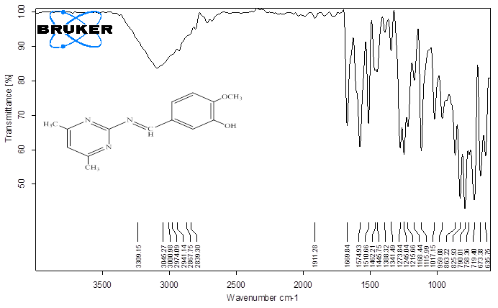
Fig. 1. FT-IR spectra of O₁
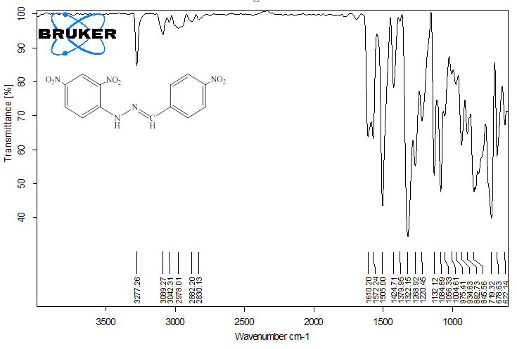
Fig. 2. FT-IR spectra of O₂
Mechanism of imine compounds formation represented in the following reaction.^{27,28} See scheme 8.
Scheme 8. Mechanism of imine compounds formation

3. 2. Tetrazol derivatives
The synthesis of tetrazol derivatives was achieved by the reaction of imine and sodium azide. Their melting points identified the resulted products. FT-IR spectra of the products (table 4) showed characteristic absorption band at 1272-1301, 1022-1089 and 1484-1509 cm⁻¹ as an indicative of C-N, N-N and N=N bonds of tetrazol rings formation beside the characteristic bands of the residual groups in the structure as presented in Figs. 3 and 4.²⁶

Table 4. FT-IR spectra of tetrazol derivatives O₆-O₁₀
FT-IR ν(cm⁻¹)
Others | C-H Ali. |  | C-H Aromatic | C=C  Aromatic | C-N | N=N | N-N | N-H | Comp. code
Others | Symmetric | Asymmetric
O-H b 3627 | 2875 | 2937 | 3082 | 1578 | 1278 | 1512 | 1022 | 3229 | O₆
NO₂1575,1331 | 2877 | 2968 | 3091 | 1594 | 1272 | 1509 | 1089 | 3279 | O₇
C=O 1650  C-Cl 768 | 2865 | 2941 | 3060 | 1594 | 1301 | 1484 | 1086 | -- | O₈
O-H b 3491  C=O1638  C-Cl 772 | 2874 | 2954 | 3055 | 1564 | 1273 | 1484 | 1087 | 3280 | O₉
O-H b 3446 | 2855 | 2920 | 3053 | 1598 | 1283 | 1499 | 1033 | 3320 | O₁₀

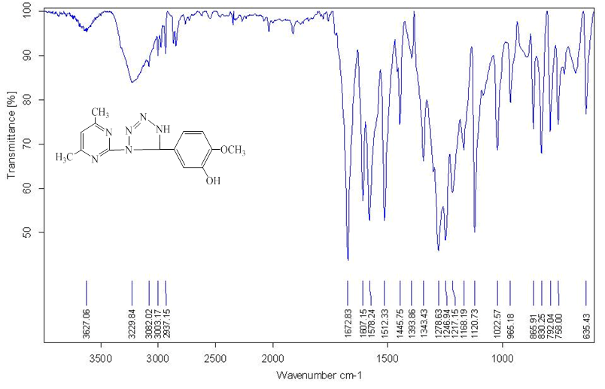
Fig. 3. FT-IR spectra of O₆
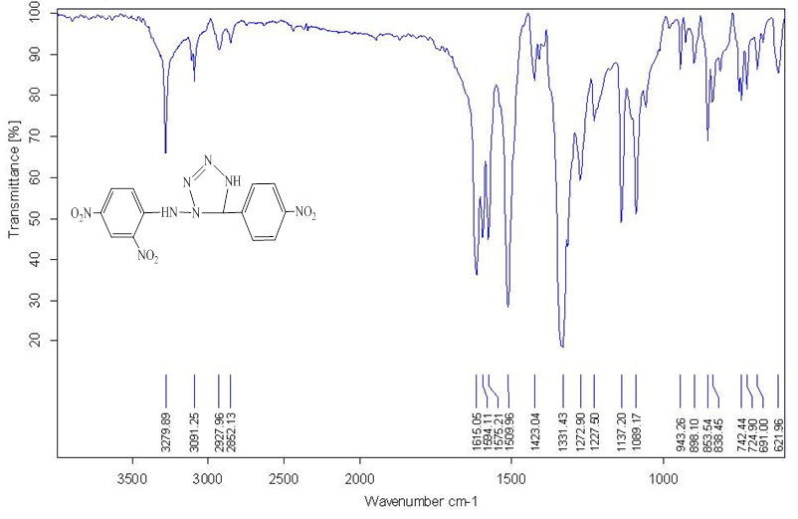
Fig. 4. FT-IR spectra of O₇
The ¹H-NMR spectrum of compound O₈ in DMSO solvent (Fig. 5) showed chemical shifts, δ(ppm), singlet in 2.46 (3H, N-CH₃), singlet in 3.20 (3H, =C-CH₃), singlet in 9.57 (1H, N-CH), multiplet and doublet of doublet in 7.85-7.36 (9H, aromatic protons). Spectrum of compound O₉ (Fig. 6) showed chemical shifts, δ(ppm) at: singlet in 2.42 (3H, N-CH₃), singlet in 3.23 (3H, =C-CH₃), singlet in 6.78 (1H, -NH), singlet in 9.67 (1H, N-CH), singlet in 12.73 (1H, -OH), multiplet in 7.64-6.93 (8H, aromatic protons).²⁹ Other chemical shifts of O₆, O₇ and O₁₀, δ(ppm) are presented in table 5.
Table 5. The ¹H-NMR Spectra of tetrazol derivatives O₆-O₁₀ in DMSO
Comp. code | Chemical Shift δ ppm
O₆ | Singlet in 2.40 (6H, 2 CH₃), singlet in 3.34 (3H, O-CH₃), singlet in 7.11 (1H, -NH), singlet in 9.58 (1H, N-CH), singlet in 9.77 (1H, -OH), multiplet and singlet in 7.42-7.11 (4H, aromatic protons)
O₇ | Singlet in 3.57 (1H, NH out), singlet in 8.89 (1H, NH in), singlet in 11.86 (1H, N-CH) and multiplet and doublet of doublet in 8.82-8.05 (7H,aromatic protons)
O₈ | Singlet in 2.46 (3H, N-CH₃), singlet in 3.20 (3H, =C-CH₃), singlet in 9.57 (1H, N-CH), multiplet and doublet of doublet in 7.85-7.36 (9H, aromatic protons)
O₉ | Singlet in 2.42 (3H, N-CH₃), singlet in 3.23 (3H, =C-CH₃), singlet in 6.78 (1H, -NH), singlet in 9.67 (1H, N-CH), singlet in 12.73 (1H, -OH), multiplet in 7.64-6.93 (8H, aromatic protons)
O₁₀ | Singlet in 2.34 (3H, CH₃), singlet in 6.80 (1H, -NH), singlet in 8.67 (H, N-CH), singlet in 13.25 (1H, -OH), multiplet and doublet of doublet in 7.66-6.95 (8H, aromatic protons)

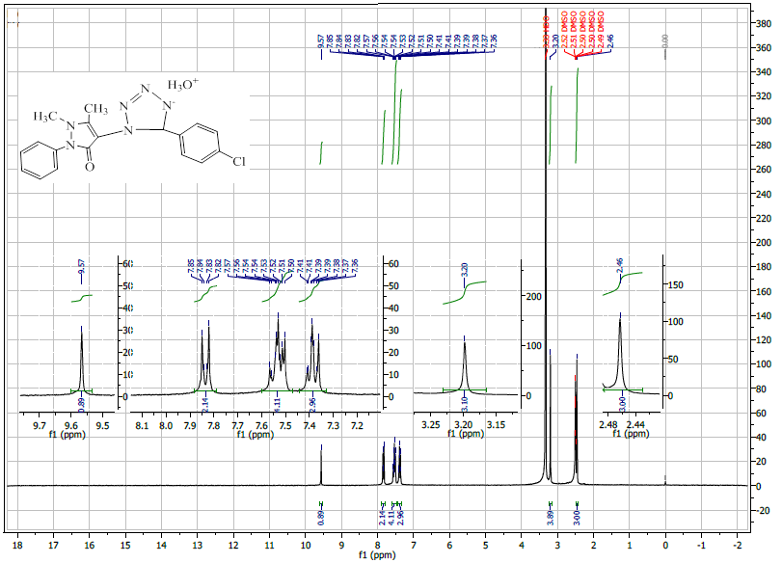
Fig. 5. ¹H-NMR Spectra of O₈
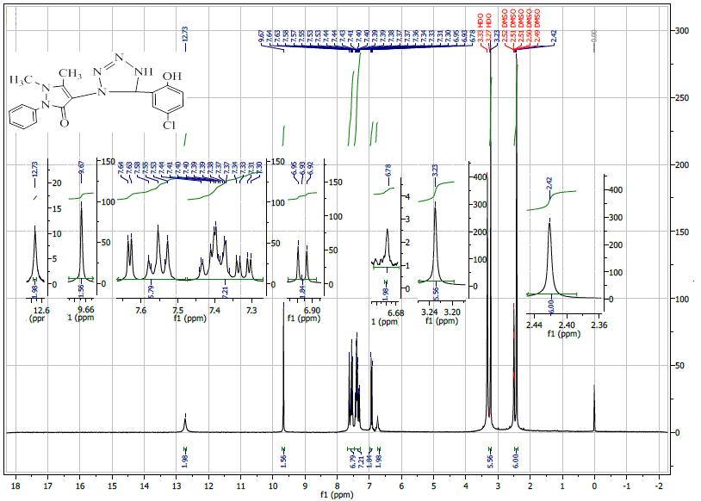
Fig. 6. ¹H-NMR Spectra of O₉

The ¹³C-NMR spectrum of compound O₆ in DMSO solvent (Fig. 7) showed chemical shifts, δ(ppm), 37.47 (2 CH₃), 56.27 (O-CH₃), 191.91 (N-CH), 112.04-124.94 (Aromatic Carbons), 130.29-153.80 (Pyrimidine Carbons). While the spectrum of compound O₉ (Fig. 8) exhibited chemical shifts, δ(ppm), 9.79 (N-CH₃), 35.01 (=C-CH₃), 150.46 (CH₃-C=), 154.78 (CO-C=), 157.80 (N-CH), 158.59 (N-CO), 113.96-134.10 (Aromatic Carbons).³⁰ Other chemical Shifts of O₇, O₈, O₁₀, δ(ppm) are displayed in table 6.
Table 6. The ¹³C-NMR spectra of tetrazol derivatives O₆-O₁₀ in DMSO
Comp. code | Chemical Shift δ ppm
O₆ | 37.47 (2 CH₃), 56.27 (O-CH₃), 191.91 (N-CH), 112.04-124.94 (Aromatic Carbons), 130.29-153.80 (Pyrimidine Carbons)
O₇ | 182.49 (N-CH), 118.96-125.56 (Aromatic Carbons)
O₈ | 10.33 (N-CH₃), 35.83 (=C-CH₃), 144.11 (CH₃-C=), 152.34 (CO-C=), 159.99 (N-CH), 162.47 (N-CO), 115.08-128.22 (Aromatic Carbons)
O₉ | 9.79 (N-CH₃), 35.01 (=C-CH₃), 150.46 (CH₃-C=), 154.78 (CO-C=), 157.80 (N-CH), 158.59 (N-CO), 113.96-134.10 (Aromatic Carbons)
O₁₀ | 21.07 (CH₃), 163.00 (N-CH), 117.00-136.95 (Aromatic Carbons)

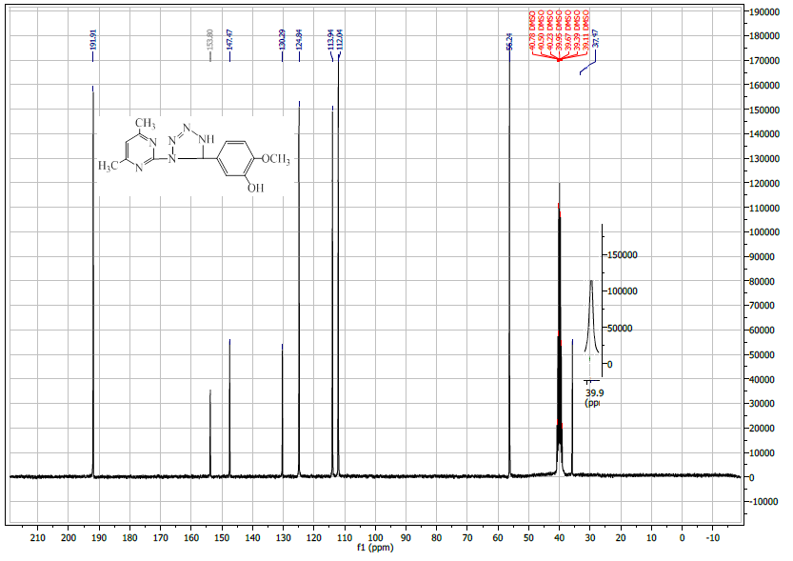
Fig. 7. ¹³C-NMR Spectra of O₆

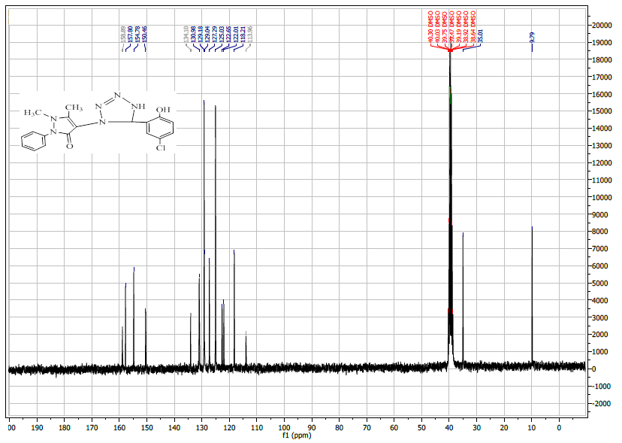
Fig. 8. ¹³C-NMR Spectra of O₉
Products of the reaction of the synthesized imine compounds with sodium azide are given in the following equation (Scheme 9):
Scheme 9. Structure of the synthesized tetrazol derivatives
It may be concluded that the reaction takes place via the concerted mechanism of the Huisgen 1,3-dipolar cycloaddition mechanism as represented in the following reaction.³¹ See scheme 10.
Scheme 10. Mechanism of tetrazol derivatives formation

The results of FT-IR ¹³C-NMR and ¹H-NMR showed that the five-ringed compounds were the least obstructed in all preparation processes. Because of the complete clarity in infrared beams and clear signals separated from each another by the resonance spectrum nuclear magnetic of hydrogen and carbon, this is the basis of organic preparation processes.

3. 3. Anti-Candidal activity

Zone of inhibition of some human pathogenic fungi was done well-diffusion method to test the potential of the tetrazol derivatives O₆-O₁₀ as shown in Figs. 8 and 9. O₆ is the best derivative that has significantly (p<0.01) recorded a stronger influence to inhibit the growth of Candida guilliermondii at an average of the zone of inhibition 14.0 mm. While, O₉ derivative recorded the lowest zone of inhibition 7.3 mm toward the same clinical fungal pathogen. From another hand, O₆ showed zone of inhibition 12.0 mm against Candida zeylanoides. Furthermore, O₆ derivative recorded zone of inhibition 11.3 mm against Candida krusei and Candida abicans. O₁₀ did not inhibit the growth of Candida albicans as shown in Fig. 9. The resistance mechanisms depend on which specific pathways are inhibited by the drugs and the alternative ways available for those pathways that the organisms can modify to get a way around to survive.³² Also, the synthesis heterocyclic compounds is useful against various pathogens such asviruses.^{33,34} Many new metal complexes and new 1,3-oxazepine derivatives had good antibacterial activity.^{35,36} Tetrazol derivatives are important to synthesize inflammatory agents. ³⁷

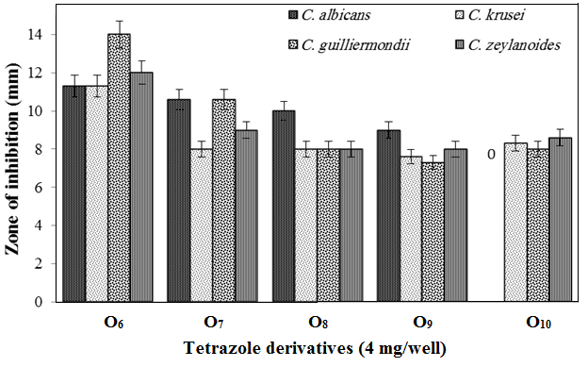
Fig. 8. Zone of inhibition of Candida sp. using the synthesized tetrazole derivatives O₆-O₁₀

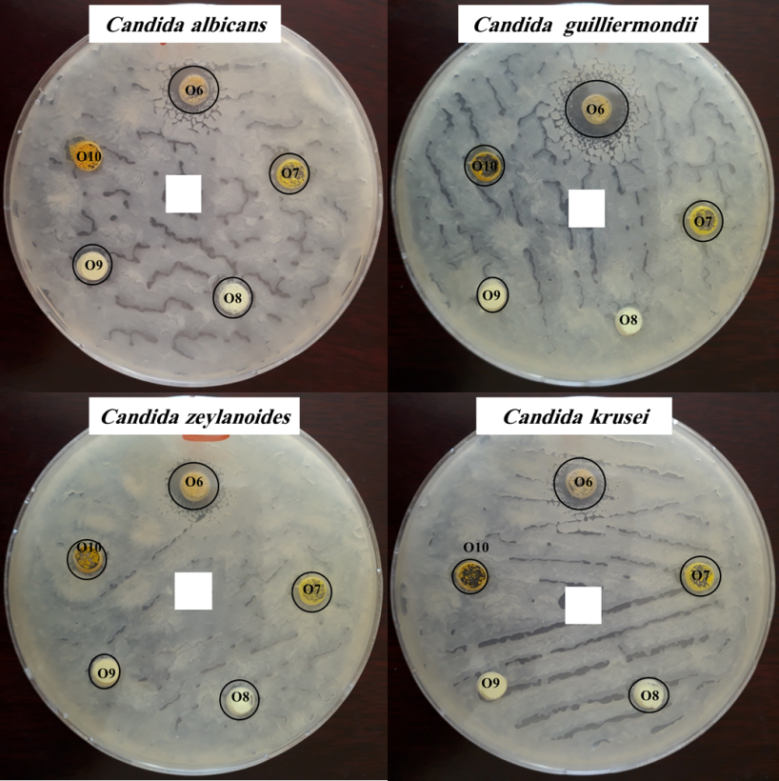
Fig. 9. Anti-Candidal activity of the synthesized tetrazole derivatives O₆-O₁₀
4. Conclusion
Preparing derivatives of tetrazol was possible. The results of FT-IR, ¹³C-NMR and ¹H-NMR showed that the five-ringed compounds were the least obstructed in all preparation processes. Because of the complete clarity in infrared beams and clear signals separated from each another by the resonance spectrum nuclear magnetic of hydrogen and carbon, this is the basis of organic preparation processes. O₆ is the best derivative that has significantly (p<0.01) recorded a stronger influence to inhibit the growth of Candida guilliermondii at an average of the zone of inhibition 14.0 mm. While, O₉ derivative recorded the lowest zone of inhibition 7.3 mm toward the same clinical fungal pathogen. The present work may be helpful in designing more potential antibacterial and antifungal agents for therapeutic use in the future.

5. Acknowledgment
Special thanks to Anbar University's President Professor Dr. Khalid Battal Najim for his continuous support to publishing the research in certified international journals. Also, grateful is for Dr. Abdullah Hussein Kshash, Department of Chemistry, College of Education for Pure Sciences, University Of Anbar for helping to measurement the FT-IR spectra.

6. REFERENCES
1. A. Adabiardakani. M. Hakimi, H. Kargar, WA P journal. 2012, 2, 472–476.
2. K. Brodowska, E. Chruścińska, CHEMIK. 2014, 68, 129–134.
3. W. Qin, S. Long, M. Panunzio, S. Biondi, Molecules. 2013, 18, 12264–12289.
4. O. Abid. R. Muslim, K. Mohammed, J. Uni. Al-Anbar Pure Sci. 2016, 10, 8–18.
5. M. Ashraf, K. Mahmood, A. Wajid, IPCBEE. 2011, 10, 1-7.
6. Z. Hussain, Z. Fadhil, H. Adil, M. Khalaf, B. Abdullah, E. Yousif, RJPBCS. 2016, 7, 1500–1510.
7. P. Mayavel, K. Thirumurthy, S. Dineshkumar, G. Thirunarayanan, Umcschem. lxix 2014, 159–179.
8. N. Al-Jamali, M. Jameel, A. Al-Haidari, Innovare Journal of Science. 2013, 1, 13–15.
9. M. Dahot, E. Rind and M. Rafiq, Pak. J. Biotechnol. 2011, 8, 67–72.
10. J. Mohammed, DRJI. 2016, 3, 12796–12804.
11. D. Varadarasi, S. Suban, V. Ramasamy, K. Kubendirran J. Raguraman, S. Nalilu, H. Pati, Organic Communications. 2010, 3, 45–56.
12. K. Babu, V. Prabhakar, L. Ravindranath, N. Kishore, J. Latha, Res. J. Chem. Environ. Sci. 2016, 4, 51–63.
13. Z. Al-Hakak, Pak. J. Biotechnol. 2017, 14, 417–422.
14. N. Sial, S. Abro, J. Shah, M. Memon, Pak. J. Biotechnol. 2016, 1, 67–71.
15. W. El-Sayed, R. Abdel Megeid, H. Abbas, Arch. Pharm. Res., 2011, 34, 1085–1096.
16. M. Malik and S. Al-Thabaiti, Int. J. Mol. Sci. 2012, 13, 10880–10898.
17. R. Al-Juburi, Journal of Al-Nahrain University. 2012, 15, 60–67.
18. P. Babu, L. Ravindranath, D. Rajesh, B. Saritha, World Journal of Pharmacy and Pharmaceutical Sciences. 2016, 5, 929–940.
19. O. Abid, H. Tawfeeq, R. Muslim, Acta Pharm. Sci. 2017, 55, 43–55. DOI: 10.23893/1307-2080.APS.05525
20. M. Murhekar and R. Khadsan, J. Chem. Pharm. Res. 2011, 3, 846–849.
21. H. Sabah, Der Pharma Chemica. 2014, 6, 38–41.
22. B. Srinivas, B. Prasanna, M. Ravinder, Der Pharma Chemica. 2016, 8, 84–93.
23. P. Ravula, H. Vamaraju, M. Paturi, N. Chandra, S. Kolli, EXCLI Journal. 2016, 15, 187–202.
24. M. Owaid, J. Raman, H. Lakshmanan, S. Al-Saeedi, V. Sabaratnam, I. Al-Assaffii, Mater. Lett. 2015, 153, 186–190. DOI: 10.1016/j.matlet.2015.04.023
25. R. Muslim, H. Tawfeeq, M.N. Owaid, O. Abid, Acta Pharmaceutica Sciencia 2018, 56, 39–57. DOI: 10.1248/bpb.b15-00698
26. R. Silverstein, F. Webster, D. Kiemle, Spectrometric identification of organic compounds, 7th edition, John Wiley and sons, Inc., 2005, 72–126.
27. J. Simek, Organic Chemistry, 8th edition, Pearson education, Inc., 2013, 412–414.
28. O. Abid, R. Muslim, K. Mohammed, J. Uni. Anbar Pure Sci. 2016, 10, 1–9.
29. R. Silverstein, F. Webster, D. Kiemle, Spectrometric identification of organic compounds, 7th edition, John Wiley and sons, Inc., 2005, 127–202.
30. B. Mistry, A Handbook of spectroscopic Data chemistry, edition 2009, Oxford book company Jaipor India, Mehra Offset Printers, Delhi, 2009, 99–127.
31. R. Das, N. Majumdar, A. Lahiri, IJRPC. 2014, 4, 467–472.
32. F. Tenover, Am. J. Med. 2006, 119, 3–10.
33. M. F. El Shehry, J. Balzarini, C. Meier, Synthesis. 2009, 5, 841–847. DOI:10.1055/s-0028-1083369
34. M. F. El Shehry, E. M. El Telbani, M. I. Hegab, Acta Chim. Slov. 2018, 65, 401–406. DOI: 10.17344/acsi.2017.4144
35. R. Ahmed, I. Majeed, A. Ahmed, E. Yousif., M. Al-Jeboori, Chem Xpress. 2016, 9(1), 61-68.
36. I. Jassim, I. Majeed, G. Al-Somaidaie, Tikrit Journal of pharmaceutical Sciences. 2009, 5(2), 147-155.
37. M. F. El Shehry, A. A. Abu-Hashem, E. M. El-Telbani. European Journal of Medicinal Chemistry 2010, 45(5), 1906-1911.

