Design, Synthesis, Biological Evaluation and Molecular Docking Studies of Some New Sulfonamides Possessing 1,4-Benzodioxane Nucleus
Misbah Irshad,^{1,}* Muhammad Athar Abbasi,² Aziz-Ur-Rehman,² Qamar Ali,¹ Sabahat Zahra Siddiqui,² Muhammad Shahid,³ Muhammad Ashraf,⁴ Muhammad Arif Lodhi⁵ and Syed Babar Jamal⁶

¹Department of Chemistry, Division of Science & Technology, University of Education, Lahore-54600, Pakistan.
²Department of Chemistry, Government College University, Lahore-54000, Pakistan.
³Department of Biochemistry, University of Agriculture, Faisalabad-38040, Pakistan.
⁴Department of Pharmacy; The Islamia University of Bahawalpur, Bahawalpur-63100, Pakistan.
⁵Department of Biochemistry, Abdul Wali Khan University, Mardan-23200, Pakistan.
⁶Department of Bioinformatics, Islamic International University, Islamabad, Pakistan.

*Corresponding author: E-mail: misbahchatha@hotmail.com; misbahirshad@ue.edu.pk
Tel: (+92)-42-99262232

ABSTRACT
In the current research work we have reported, a series of N-aryl-2,3-dihydro- benzo[1,4]dioxine-6-sulfonamide and its N-substituted derivatives with benzyl chloride and ethyl iodide. The synthesis was accomplished in multistep sequence. The structural confirmations were established by ¹H-NMR, IR and EIMS spectral techniques. Butyrylcholinesterase (BChE), acetylcholinesterase (AChE) and lipoxygenase (LOX) enzymes were used in this study. It was observed that most of these compounds exhibited moderate activity against BChE and AChE but promisingly good activity against lipoxygenase. Among the parent sulfonamides 3a, 3b, 3c and 3e showed the proficient antimicrobial activities, while from the derivatives 6a, 6c, 7a, 7b and 7c were found active against the selected panel of bacterial and fungal species. Hemolytic activity was also conducted to check their therapeutic utility. All the compounds were computationally docked against LOX, BChE and AChE enzymes.
Keywords: 2,3-Dihydrobenzo[1,4]dioxine-6-sulfonyl chloride; Lipoxygenase enzyme; Antimicrobial and hemolytic activities; Molecular docking.
- Introduction
Very first prepared antimicrobial agents are sulfonamides, which are bacteriostatic agents and active against gram negative and gram positive bacteria. Basically sulfonamides contain a benzene ring with sulfonyl and amino group at para position and have general formula ASO₂NHR. The nature of A and R varies from simple hydrogen to aliphatic carboaromatic, heterocyclic, OH, NH₂ or sugar scaffold. SAR studies revealed that liberated NH₂ group of sulfonamides is responsible for their activity. Low activity was observed in case of attached substituents at ortho and meta positions.¹⁻⁵ Sulfonamides restrain folic acid in bacteria which facilitates the production of bacterial DNA and RNA. Dihydropteroic acid is precursor of folic acid. Dihydropteroate synthase is responsible for the transformation of dihydropteroate diphosphate and P-amino-benzoic acid into dihydropteroic acid; while sulfonamides hinder this enzyme.^{6,7} These sulfonamide drugs are classified as: oral (absorbed and unabsorbed) and topical. Depending on the action absorbable sulfonamides can be short, intermediate and long acting. Their absorption takes place through stomach and small intestine.⁸ Commonly these sulfa drugs are synthesized by treating substituted sulfonyl chloride with suitable amine supply. Sulfonamides are used to cure membrane infections, enteritis, ulcerative colitis and for skin treatment. In agriculture sulfonamides have antiherbicidal and antifungal uses. They have wide applications as antibacterial,⁴ antiobesity,⁹ anticancer, antiviral,³ protease inhibitor,¹⁰ diuretic,^{11,12} hypoglycemic,¹³ antithyroid,¹⁴antitumor,¹⁵⁻¹⁷anti-neuropathic pain,¹⁸ cyclooxygenase¹⁹ and carbonic anhydrase inhibitory agents.²⁰
Compounds containing a 1,4-benzodioxane skeleton displayed wider range of biological activities,²¹ such as anticancer,^{22,23} immunosuppressive,²⁴ antiinflammatory,²⁵ antibacterial²⁶ and some others.^{27,28}
Additionally, interaction modes of the synthesized compounds were examined by molecular docking approach. The purpose of docking methodologies was to forecast the ligand and target complex and to align the molecular database (designed inhibitors) on the basis of binding affinity to that of target. The MOE-Dock was used for docking of all the synthesized inhibitors with the binding site of target enzymes. The eventual objective of molecular docking was to get ligands with better characteristics and have good inhibition potential.²⁹ This research work is a productive effort to bring in close proximity the pharmacologically significant moieties. Keeping continuity in connection with research work on sulfonamide molecules,³⁰ the different N-substituted sulfonamides derived from 1,4-benzodioxine-6-sulfonyl chloride were synthesized. It was aimed that the new drugs bearing sulfamoyl functionality would have striking activity and be able to cope with the challenges.
- Experimental
2.1. General
2,3-Dihydrobenzo[1,4]dioxine-6-sulfonyl chloride, different aryl amines and the other electrophilic reagents were purchased from local dealers providing consumables. All the solvents were used after distillation and purification. Griffin and George m.p instrument was employed to record m.p of the targets. The open capillary tube was used for it and were reported uncorrected. The TLC was utilized to check the purity and reaction progress. TLC plates were finished from pre-coated silica gel G-25-UV_{254.}The gradient solvent systems of C₄H₈O₂ (ethyl ethanoate) and C₆H₁₄ (n-hexane) were exercised. The detection was carried out at 254 nm and TLC plates developed from ceric sulphate reagent. On a Jasco-320-A spectrophotometer the IR spectra were recorded. The pallet of sample was made from KBr and functional group stretching was reported in wave number (cm⁻¹). NMR spectra were recorded on Bruker spectrometers. The deutrated methanol and chloroform were running solvents. The operating frequencies thus utilized were 300 and 400MHz and chemical shifts were given in ppm. On a JMS-HX-110 spectrometer the mass spectra (EIMS) were traced, with a data system.
2.2. Synthesis
2.2.1. General procedure for the synthesis of N-aryl-2,3-dihydrobenzo[1,4]dioxine-6-sulfonamides in aqueous medium (3a-e)
0.85 mmol of various substituted aryl amines (2a-e) were dispensed in 50 mL of distilled water contained in 250 mL RB flask. The pH of reacting medium was maintained at 9.0-10.0. The aqueous solution of Na₂CO₃ was added drop wise at 25ºC. Subsequently 0.85 mmol or 0.2 g of 2,3-dihydrobenzo[1,4]dioxine-6-sulfonyl chloride (1) was put in slowly over 10-15 min in the reaction mass. The reaction mixture was kept on stirring at RT till the TLC confirmation indicating the completion of reaction. The workup was done by slowly adding conc. HCl (2 mL) and dropping pH to 2.0. The title compounds (3a-e) were collected as solid precipitates on filtration and washed with immense volume of distilled water.
2.2.1.1. N-(2,3-Dimethylphenyl)-2,3-dihydrobenzo[1,4]dioxine-6-sulfonamide (3a)
HR-MS: [M]⁺ 319.3772 (Calcd. for C₁₆H₁₇NO₄S; 319.3854); IR (KBr, cm⁻¹): v_{max} stretching: 3419 (N-H), 3026 (C-H Ar ring), 2914 (CH₂), 1613 (C=C Ar ring), 1325 (SO₂),1125 (C-O-C of ether); ¹H-NMR (400 MHz,CDCl₃-d): δ (ppm) 1.99 (s, 3H, CH₃-2''), 2.27 (s, 3H, CH₃-1''), 4.24-4.27 (m, 4H, CH₂-2 & CH₂-3), 6.73 (brd, J = 7.6 Hz, 1H, H-4'), 6.78 (t, J = 7.6 Hz, 1H, H-5'), 6.80 (d, J = 8.0 Hz, 1H, H-6'), 6.95 (d, J = 8.4 Hz, 1H, H-8), 7.18 (dd, J = 8.4, 2.0Hz, 1H, H-7), 7.25 (d, J = 2.0 Hz, 1H, H-5); EIMS: m/z 319 [M]⁺, 255 [M-SO₂]⁺, 214 [C₆H₃C₂H₄O₂SO₂NH]⁺, 199 [C₆H₃C₂H₄O₂SO₂]⁺, 135 [C₆H₃C₂H₄O₂]⁺, 107 [C₆H₃O₂]⁺, 105 [C₆H₃(CH₃)₂]⁺ , 90 [C₆H₃CH₃]⁺ , 79 [C₄H(CH₃)₂]⁺, 75 [C₆H₃]⁺, 64 [C₄HCH₃]⁺.
2.2.1.2. N-(2,4-Dimethylphenyl)-2,3-dihydrobenzo[1,4]dioxine-6-sulfonamide (3b)
HR-MS: [M]⁺ 319.3772 (Calcd. for C₁₆H₁₇NO₄S; 319.3854); IR (KBr, cm⁻¹): v_{max} stretching: 3435 (N-H), 3021 (C-H Ar ring), 2917 (-CH₂-), 1615 (C=C Ar ring), 1324 (-SO₂-), 1140 (C-O-C of ether); ¹H-NMR (400 MHz, CDCl₃-d): δ (ppm) 1.99 (s, 3H, CH₃-2''), 2.24 (s, 3H, CH₃-1''), 4.24-4.26 (m, 4H, CH₂-2 & CH₂-3), 6.80 (s, 1H, H-3'), 6.84 (d, J = 8.0 Hz, 1H, H-5'), 6.92 (d, J = 8.4 Hz, 1H, H-6'), 7.12 (d, J = 8.0 Hz, 1H, H-8), 7.17 (dd, J = 8.4, 2.0 Hz, 1H, H-7), 7.26 (d, J = 2.0 Hz, 1H, H-5); EIMS: m/z 319 [M]⁺, 255 [M-SO₂]⁺, 214 [C₆H₃C₂H₄O₂SO₂NH]⁺, 199 [C₆H₃C₂H₄O₂SO₂]⁺, 135 [C₆H₃C₂H₄O₂]⁺, 107 [C₆H₃O₂]⁺, 105 [C₆H₃(CH₃)₂]⁺ , 90 [C₆H₃CH₃]⁺ , 79 [C₄H(CH₃)₂]⁺, 75 [C₆H₃]⁺, 64 [C₄HCH₃]⁺.
2.2.1.3. N-(2,5-Dimethylphenyl)-2,3-dihydrobenzo[1,4]dioxine-6-sulfonamide (3c)
HR-MS: [M]⁺ 319.3772 (Calcd. for C₁₆H₁₇NO₄S; 319.3854); IR (KBr, cm⁻¹): v_{max} stretching: 3415 (N-H), 3024 (C-H Ar ring), 2912 (-CH₂-), 1619 (C=C Ar ring), 1325 (-SO₂-), 1122 (C-O-C of ether); ¹H-NMR (300 MHz, CD₃OD-d₄): δ (ppm) 1.96 (s, 3H, CH₃-2''), 2.20 (s, 3H, CH₃-1''), 4.22-4.30 (m, 4H, CH₂-2 & CH₂-3), 6.85 (d, J = 7.6 Hz, 1H, H-4'), 6.89 (d, J = 7.5 Hz, 1H, H-3'), 6.91 (s, 1H, H-6'), 6.99 (d, J = 8.1 Hz, 1H, H-8), 7.09 (d, J = 2.1 Hz, 1H, H-5), 7.13 (dd, J = 7.8, 2.1 Hz, 1H, H-7); EIMS: m/z 319 [M]⁺, 255 [M-SO₂]⁺, 214 [C₆H₃C₂H₄O₂SO₂NH]⁺, 199 [C₆H₃C₂H₄O₂SO₂]⁺, 135 [C₆H₃C₂H₄O₂]⁺, 107 [C₆H₃O₂]⁺, 105 [C₆H₃(CH₃)₂]⁺ , 90 [C₆H₃CH₃]⁺ , 79 [C₄H(CH₃)₂]⁺, 75 [C₆H₃]⁺, 64 [C₄HCH₃]⁺.
2.2.1.4. N-(2,6-Dimethylphenyl)-2,3-dihydrobenzo[1,4]dioxine-6-sulfonamide (3d)
HR-MS: [M]⁺ 319.3772 (Calcd. for C₁₆H₁₇NO₄S; 319.3854); IR (KBr, cm⁻¹): v_{max} stretching: 3410 (N-H), 3045 (C-H Ar ring), 2909 (-CH₂-), 1614 (C=C), 1326 (-SO₂-), 1125 (C-O-C of ether); ¹H-NMR (300 MHz, CDCl₃-d): δ (ppm) 2.02 (s, 6H, CH₃-1''& CH₃-2''), 4.25-4.30 (m, 4H, CH₂-2 & CH₂-3), 6.93 (brd, J = 7.8 Hz, 1H, H-4'), 7.01 (d, J = 8.4 Hz, 2H, H-3' & H-5'),
7.03 (d, J = 8.4 Hz, 1H, H-8), 7.38 (d, J = 2.4 Hz, 1H, H-5), 7.48 (dd, J = 8.4, 2.4Hz, 1H, H-7);
EIMS: m/z 319 [M]⁺, 255 [M-SO₂]⁺, 214 [C₆H₃C₂H₄O₂SO₂NH]⁺, 199 [C₆H₃C₂H₄O₂SO₂]⁺, 135 [C₆H₃C₂H₄O₂]⁺, 107 [C₆H₃O₂]⁺, 105 [C₆H₃(CH₃)₂]⁺ , 90 [C₆H₃CH₃]⁺ , 79 [C₄H(CH₃)₂]⁺, 75 [C₆H₃]⁺, 64 [C₄HCH₃]⁺.
2.2.1.5. N-(3,4-Dimethylphenyl)-2,3-dihydrobenzo[1,4]dioxine-6-sulfonamide (3e)
HR-MS: [M]⁺ 319.3772 (Calcd. for C₁₆H₁₇NO₄S; 319.3854); IR (KBr, cm⁻¹): v_{max} stretching: 3422 (N-H), 3018 (C-H Ar ring), 2919 (-CH₂-), 1615 (C=C Ar ring), 1323 (-SO₂), 1118 (C-O-C of ether); ¹H-NMR (400 MHz,CDCl₃-d): δ (ppm) 2.15 (s, 6H, CH₃-1''& CH₃-2''), 4.23-4.25 (m, 4H, CH₂-2 & CH₂-3), 6.76 (d, J = 7.6 Hz, 1H, H-5'), 6.81 (s, 1H, H-2'), 6.84 (d, J = 8.0 Hz, 1H, H-6'), 6.96 (d, J = 8.0 Hz, 1H, H-8), 7.22 (dd, J = 8.4, 2.0 Hz, 1H, H-7), 7.28 (d, J = 2.0 Hz, 1H, H-5); EIMS: m/z 319 [M]⁺, 255 [M-SO₂]⁺, 214 [C₆H₃C₂H₄O₂SO₂NH]⁺, 199 [C₆H₃C₂H₄O₂SO₂]⁺, 135 [C₆H₃C₂H₄O₂]⁺, 107 [C₆H₃O₂]⁺, 105 [C₆H₃(CH₃)₂]⁺ , 90 [C₆H₃CH₃]⁺ , 79 [C₄H(CH₃)₂]⁺, 75 [C₆H₃]⁺, 64 [C₄HCH₃]⁺.
2.2.2. General procedure for the synthesis of compounds 6a-e and 7a-e:
0.40 mmol (0.01 g) of lithum hydride was added to a solution containing of 0.1 g of compounds (3a-e) in 5 mL of aprotic solvent (DMF) and kept in RB at 25 °C. On complete addition the reaction mixture was stirred for half an hour. The benzyl chloride (4) and ethyl iodide (5) were added into the reaction mixture to establish 6a-e & 7a-j series respectively. The stirring lasts for 1-2 hr. The monitoring of reaction completion was done by TLC. The reaction contents were quenched with cold distilled water after ensuring the complete conversion of mass. The corresponding N-benzyl/ethyl derivatives of N-aryl-2,3-dihydrobenzo[1,4]dioxine-6-sulfonamides (6a-e & 7a-j) were obtained as solid ppts on filtration. The subsequent washing with distilled water and drying yielded our target molecules. The greasy & sticky compounds were taken out through solvent extraction by using chloroform.
2.2.2.1. N-Benzyl-N-(2,3-dimethylphenyl)-2,3-dihydrobenzo[1,4]dioxine-6-sulfonamide (6a)
HR-MS: [M]⁺ 409.4991 (Calcd. for C₂₃H₂₃NO₄S; 409.5187); IR (KBr, cm⁻¹): v_{max} stretching: 3416 (N-H), 3015 (C-H Ar ring), 2918 (-CH₂-), 1617 (C=C Ar ring), 1329 (-SO₂-), 1135 (C-O-C of ether); ¹H-NMR (400 MHz, CD₃OD-d₄): δ (ppm) 2.00 (s, 3H, CH₃-2'''), 2.06 (s, 3H, CH₃-1'''), 4.25-4.29 (m, 4H, CH₂-2 & CH₂-3), 4.63 (s, 2H, CH₂-7''), 6.81 (d, J = 7.6 Hz, 1H, H-4'), 6.87-6.95 (m, 5H, H-2'' to H-6''), 7.02 (d, J = 7.2 Hz, 1H, H-6'), 7.10 (t, J = 7.6 Hz, 1H, H-5'), 7.31 (d, J = 8.4 Hz, 1H, H-8), 7.34 (d, J = 2.0 Hz, 1H, H-5), 7.38 (dd, J = 8.4, 2.0 Hz, 1H, H-7); EIMS: m/z 409 [M]⁺, 345 [M-SO₂]⁺, 304 [C₆H₃C₂H₄O₂SO₂NCH₂C₆H₅]⁺, 199 [C₆H₃C₂H₄O₂SO₂]⁺, 135 [C₆H₃C₂H₄O₂]⁺, 107 [C₆H₃O₂]⁺,105 [C₆H₃(CH₃)₂]⁺, 91 [C₇H₇]⁺, 90 [C₆H₃CH₃]⁺, 79 [C₄H(CH₃)₂]⁺, 75 [C₆H₃]⁺, 65 [C₅H₅]⁺, 64 [C₄HCH₃]⁺.
2.2.2.2. N-Benzyl-N-(2,4-dimethylphenyl)-2,3-dihydrobenzo[1,4]dioxine-6-sulfonamide (6b)
HR-MS: [M]⁺ 409.4991 (Calcd. for C₂₃H₂₃NO₄S; 409.5187); IR (KBr, cm⁻¹): v_{max} stretching: 3423 (N-H), 3067 (C-H Ar ring), 2932 (-CH₂-), 1617 (C=C Ar ring), 1326 (-SO₂), 1145 (C-O-C of ether); ¹H-NMR (300 MHz,CD₃OD-d₄): δ (ppm) 1.90 (s, 3H, CH₃-2'''), 2.22 (s, 3H, CH₃-1'''), 4.19 (s, 2H, CH₂-7''), 4.32-4.34 (m, 4H, CH₂-2 & CH₂-3), 6.55 (d, J = 8.1 Hz, 1H, H-5'), 6.86 (d, J = 7.8 Hz, 1H, H-6'), 6.90 (s, 1H, H-3'), 6.92-7.01 (m, 5H, H-2'' to H-6''), 7.10 (d, J = 8.1 Hz, 1H, H-8), 7.17 (d, J = 2.1 Hz, 1H, H-5), 7.19 (dd, J = 8.1, 2.1Hz, 1H, H-7); EIMS: m/z 409 [M]⁺, 345 [M-SO₂]⁺, 304 [C₆H₃C₂H₄O₂SO₂NCH₂C₆H₅]⁺, 199 [C₆H₃C₂H₄O₂SO₂]⁺, 135 [C₆H₃C₂H₄O₂]⁺, 107 [C₆H₃O₂]⁺,105 [C₆H₃(CH₃)₂]⁺, 91 [C₇H₇]⁺, 90 [C₆H₃CH₃]⁺ , 79 [C₄H(CH₃)₂]⁺, 75 [C₆H₃]⁺, 65 [C₅H₅]⁺, 64 [C₄HCH₃]⁺.
2.2.2.3. N-Benzyl-N-(2,5-dimethylphenyl)-2,3-dihydrobenzo[1,4]dioxine-6-sulfonamide (6c)
HR-MS: [M]⁺ 409.4991 (Calcd. for C₂₃H₂₃NO₄S; 409.5187); IR (KBr, cm⁻¹): v_{max} stretching: 3431 (N-H), 3041 (C-H Ar ring), 2922 (-CH₂-), 1612 (C=C Ar ring), 1328 (-SO₂-), 1131 (C-O-C of ether); ¹H-NMR (300 MHz, CD₃OD-d₄): δ (ppm) 1.89 (s, 3H, CH₃-2'''), 2.14 (s, 3H, CH₃-1'''), 4.30-4.36 (m, 4H, CH₂-2 & CH₂-3), 4.56 (s, 2H, CH₂-7''), 6.95 (dd, J = 8.4, 2.1 Hz, 1H, H-4'), 7.00 (d, J = 8.4 Hz, 1H, H-3'), 7.03 (s, 1H, H-6'), 7.09-7.20 (m, 5H, H-2'' to H-6''), 7.56 (d, J = 8.4 Hz, 1H, H-8), 7.62 (d, J = 2.1 Hz, 1H, H-5), 7.71 (dd, J = 8.4, 2.4 Hz, 1H, H-7);
EIMS: m/z 409 [M]⁺, 345 [M-SO₂]⁺, 304 [C₆H₃C₂H₄O₂SO₂NCH₂C₆H₅]⁺, 199 [C₆H₃C₂H₄O₂SO₂]⁺, 135 [C₆H₃C₂H₄O₂]⁺, 107 [C₆H₃O₂]⁺,105 [C₆H₃(CH₃)₂]⁺, 91 [C₇H₇]⁺, 90 [C₆H₃CH₃]⁺ , 79 [C₄H(CH₃)₂]⁺, 75 [C₆H₃]⁺, 65 [C₅H₅]⁺, 64 [C₄HCH₃]⁺.
2.2.2.4. N-Benzyl-N-(2,6-dimethylphenyl)-2,3-dihydrobenzo[1,4]dioxine-6-sulfonamide (6d)
HR-MS: [M]⁺ 409.4991 (Calcd. for C₂₃H₂₃NO₄S; 409.5187); IR (KBr, cm⁻¹): v_{max} stretching: 3422 (N-H), 3013 (C-H Ar ring), 2927 (-CH₂-), 1643 (C=C Ar ring), 1325 (-SO₂-), 1126 (C-O-C of ether); ¹H-NMR (400 MHz, CD₃OD-d₄): δ (ppm) 2.68 (s, 6H, CH₃-1'''& CH₃-2'''), 4.23-4.33 (m, 4H, CH₂-2 & CH₂-3), 4.61 (s, 2H, CH₂-7''), 6.14-6.94 (m, 5H, H-2'' to H-6''), 6.96 (brd, J = 8.8 Hz, 2H, H-3' & H-5'), 7.01 (brd, J = 8.8 Hz, 1H, H-4'), 7.27 (d, J = 8.0 Hz, 1H, H-8), 7.32 (d, J = 2.0 Hz, 1H, H-5), 7.58 (dd, J = 8.4, 2.0 Hz, 1H, H-7), EIMS: m/z 409 [M]⁺, 345 [M-SO₂]⁺, 304 [C₆H₃C₂H₄O₂SO₂NCH₂C₆H₅]⁺, 199 [C₆H₃C₂H₄O₂SO₂]⁺, 135 [C₆H₃C₂H₄O₂]⁺, 107 [C₆H₃O₂]⁺,105 [C₆H₃(CH₃)₂]⁺, 91 [C₇H₇]⁺, 90 [C₆H₃CH₃]⁺ , 79 [C₄H(CH₃)₂]⁺, 75 [C₆H₃]⁺, 65 [C₅H₅]⁺, 64 [C₄HCH₃]⁺.
2.2.2.5.N-Benzyl-N-(3,4-dimethylphenyl)-2,3-dihydrobenzo[1,4]dioxine-6-sulfonamide (6e)
HR-MS: [M]⁺ 409.4991 (Calcd. for C₂₃H₂₃NO₄S; 409.5187); IR (KBr, cm⁻¹): v_{max} stretching: 3416 (N-H), 3055 (C-H Ar ring), 2943 (-CH₂-), 1622 (C=C Ar ring), 1322 (-SO₂), 1134 (C-O-C of ether); ¹H-NMR (400 MHz,CDCl₃-d): δ (ppm) 2.10 (s, 3H, CH₃-2'''), 2.14 (s, 3H, CH₃-1'''), 4.28-4.31 (m, 4H, CH₂-2 & CH₂-3), 4.65 (s, 2H, CH₂-7''), 6.66 (d, J = 7.2 Hz, 1H, H-5'), 6.78 (s, 1H, H-2'), 6.81 (d, J = 7.2 Hz, 1H, H-6'), 6.88-6.90 (m, 5H, H-2'' to H-6''), 6.92 (d, J = 8.4 Hz, 1H, H-8), 7.12 (dd, J = 8.4, 2.0 Hz, 1H, H-7), 7.21 (d, J = 2.0 Hz, 1H, H-5); EIMS: m/z 409 [M]⁺, 345 [M-SO₂]⁺, 304 [C₆H₃C₂H₄O₂SO₂NCH₂C₆H₅]⁺, 199 [C₆H₃C₂H₄O₂SO₂]⁺, 135 [C₆H₃C₂H₄O₂]⁺, 107 [C₆H₃O₂]⁺,105 [C₆H₃(CH₃)₂]⁺, 91 [C₇H₇]⁺, 90 [C₆H₃CH₃]⁺ , 79 [C₄H(CH₃)₂]⁺, 75 [C₆H₃]⁺, 65 [C₅H₅]⁺, 64 [C₄HCH₃]⁺.
2.2.2.6. N-(2,3-Dimethylphenyl)-N-ethyl-2,3-dihydrobenzo[1,4]dioxine-6-sulfonamide (7a)
HR-MS: [M]⁺ 347.4302 (Calcd. for C₁₈H₂₁NO₄S;347.4587);IR (KBr, cm⁻¹): v_{max} stretching: 3435 (N-H), 3032 (C-H Ar ring), 2929 (-CH₂-), 1625 (C=C Ar ring), 1320 (-SO₂), 1123 (C-O-C of ether); ¹H-NMR (400 MHz, CD₃OD-d₄): δ (ppm) 0.96 (t, J = 7.2 Hz, 3H, CH₃-2''), 2.00 (s, 3H, CH₃-2'''), 2.06 (s, 3H, CH₃-1'''), 3.63 ( q, J = 7.2 Hz, 2H, CH₂-1''), 4.20-4.29 (m, 4H, CH₂-2 & CH₂-3), 6.81 (d, J = 7.6 Hz, 1H, H-4'), 6.93 (t, J = 7.6 Hz, 1H, H-5'), 7.02 (d, J = 7.2 Hz, 1H, H-6'), 7.21 (d, J = 8.0 Hz, 1H, H-8), 7.63 (d, J = 2.4 Hz, 1H, H-5), 7.75 (dd, J = 8.0, 2.0 Hz, 1H, H-7); EIMS: m/z 347 [M]⁺, 283 [M-SO₂]⁺, 268 [C₆H₃C₂H₄O₂NCH₂C₆H₃(CH₃)₂]⁺, 242 [C₆H₃C₂H₄O₂SO₂NC₂H₅]⁺, 240 [C₆H₃O₂NCH₂C₆H₃(CH₃)₂]⁺, 227 [C₆H₃C₂H₄O₂SO₂NCH₂]⁺, 199 [C₆H₃C₂H₄O₂SO₂]⁺, 135 [C₆H₃C₂H₄O₂]⁺, 107 [C₆H₃O₂]⁺, 105 [C₆H₃(CH₃)₂]⁺, 90 [C₆H₃CH₃]⁺, 79 [C₄H(CH₃)₂]⁺, 75 [C₆H₃]⁺, 64 [C₄HCH₃]⁺.
2.2.2.7 N-(2,4-Dimethylphenyl)-N-ethyl-2,3-dihydrobenzo[1,4]dioxine-6-sulfonamide (7b)
HR-MS: [M]⁺ 347.4302 (Calcd. for C₁₈H₂₁NO₄S; 347.4587); IR (KBr, cm⁻¹): v_{max} stretching: 3430 (N-H), 3044 (C-H Ar ring), 2918 (-CH₂-), 1629 (C=C Ar ring), 1328 (-SO₂-), 1120 (C-O-C of ether); ¹H-NMR (400 MHz, CD₃OD-d₄): δ (ppm) 1.00 (t, J = 7.2 Hz, 2H, CH₃-2''), 2.20 (s, 3H, CH₃-2'''), 2.27 (s, 3H, CH₃-1'''), 3.77 (q, J = 7.6 Hz, 2H, CH₂-1''), 4.28-4.33 (m, 4H, CH₂-2 & CH₂-3), 6.48 (s, 1H, H-3'), 6.50 (d, J = 7.6Hz, 1H, H-5'), 6.90 (d, J =7.6 Hz, 1H, H-6'), 6.97 (d, J = 8.0 Hz, 1H, H-8), 7.10 (d, J = 2.4 Hz, 1H, H-5), 7.12 (dd, J = 8.2, 2.0 Hz, 1H, H-7); EIMS: m/z 347 [M]⁺, 283 [M-SO₂]⁺, 268 [C₆H₃C₂H₄O₂NCH₂C₆H₃(CH₃)₂]⁺, 242 [C₆H₃C₂H₄O₂SO₂NC₂H₅]⁺, 240 [C₆H₃O₂NCH₂C₆H₃(CH₃)₂]⁺, 227 [C₆H₃C₂H₄O₂SO₂NCH₂]⁺, 199 [C₆H₃C₂H₄O₂SO₂]⁺, 135 [C₆H₃C₂H₄O₂]⁺, 107 [C₆H₃O₂]⁺, 105 [C₆H₃(CH₃)₂]⁺, 90 [C₆H₃CH₃]⁺, 79 [C₄H(CH₃)₂]⁺, 75 [C₆H₃]⁺, 64 [C₄HCH₃]⁺.
2.2.2.8 N-(2,5-Dimethylphenyl)-N-ethyl-2,3-dihydrobenzo[1,4]dioxine-6-sulfonamide (7c) HR-MS: [M]⁺ 347.4302 (Calcd. for C₁₈H₂₁NO₄S; 347.4587); IR (KBr, cm⁻¹): v_{max} stretching: 3438 (N-H), 3021 (C-H Ar ring), 2927 (-CH₂-), 1618 (C=C Ar ring), 1326 (-SO₂-), 1129 (C-O-C of ether); ¹H-NMR (500 MHz, CD₃OD-d₄): δ (ppm) 0.99 (t, J =7.0 Hz, 3H, CH₃-2''); 2.16 (s, 3H, CH₃-2'''), 2.27 (s, 3H, CH₃-1'''), 3.60 (q, J = 7.5 Hz, 2H, CH₂-1''), 4.28-4.34 (m, 4H, CH₂-2 & CH₂-3), 6.39 (s, 1H, H-6'), 6.99 (d, J = 8.5 Hz, 1H, H-3'), 7.04 (dd, J = 2.0, 8.0 Hz, 1H, H-4'), 7.09 (d, J = 2.5 Hz, 1H, H-5), 7.13 (dd, J = 8.5, 2.0 Hz, 1H, H-7), 7.16 (d, J = 7.5 Hz, 1H, H-8); EIMS: m/z 347 [M]⁺, 283 [M-SO₂]⁺, 268 [C₆H₃C₂H₄O₂NCH₂C₆H₃(CH₃)₂]⁺, 242 [C₆H₃C₂H₄O₂SO₂NC₂H₅]⁺, 240 [C₆H₃O₂NCH₂C₆H₃(CH₃)₂]⁺, 227 [C₆H₃C₂H₄O₂SO₂NCH₂]⁺, 199 [C₆H₃C₂H₄O₂SO₂]⁺, 135 [C₆H₃C₂H₄O₂]⁺, 107 [C₆H₃O₂]⁺, 105 [C₆H₃(CH₃)₂]⁺, 90 [C₆H₃CH₃]⁺, 79 [C₄H(CH₃)₂]⁺, 75 [C₆H₃]⁺, 64 [C₄HCH₃]⁺.
2.2.2.9 N-(2,6-Dimethylphenyl)-N-ethyl-2,3-dihydrobenzo[1,4]dioxine-6-sulfonamide (7d)
HR-MS: [M]⁺ 347.4302 (Calcd. for C₁₈H₂₁NO₄S; 347.4587); IR (KBr, cm⁻¹): v_{max} stretching: 3445 (N-H), 3017 (C-H Ar ring), 2921 (-CH₂-), 1612 (C=C Ar ring), 1325 (-SO₂), 1134 (C-O-C of ether); ¹H-NMR (300 MHz, CD₃OD-d₄): δ (ppm) 1.07 (t, J = 7.2 Hz, 3H, CH₃-2''), 2.06 (s, 6H, CH₃-1'''& CH₃-2'''), 3.56 (q, J = 7.2 Hz, 2H, CH₂-1''), 4.28-4.32 (m, 4H, CH₂-2 & CH₂-3), 6.99 (d, J = 8.4 Hz, 2H, H-3' & H-5'), 7.02 (d, J = 8.4 Hz, 1H, H-4'), 7.06 (d, J = 8.4 Hz, 1H, H-8), 7.12 (d, J = 2.1 Hz, 1H, H-5), 7.24 (dd, J = 8.4, 2.1 Hz, 1H, H-7); EIMS: m/z 347 [M]⁺, 283 [M-SO₂]⁺, 268 [C₆H₃C₂H₄O₂NCH₂C₆H₃(CH₃)₂]⁺, 242 [C₆H₃C₂H₄O₂SO₂NC₂H₅]⁺, 240 [C₆H₃O₂NCH₂C₆H₃(CH₃)₂]⁺, 227 [C₆H₃C₂H₄O₂SO₂NCH₂]⁺, 199 [C₆H₃C₂H₄O₂SO₂]⁺, 135 [C₆H₃C₂H₄O₂]⁺, 107 [C₆H₃O₂]⁺, 105 [C₆H₃(CH₃)₂]⁺, 90 [C₆H₃CH₃]⁺, 79 [C₄H(CH₃)₂]⁺, 75 [C₆H₃]⁺, 64 [C₄HCH₃]⁺.
2.2.2.10 N-(3,4-Dimethylphenyl)-N-ethyl-2,3-dihydrobenzo[1,4]dioxine-6-sulfonamide (7e)
HR-MS: [M]⁺ 347.4302 (Calcd. for C₁₈H₂₁NO₄S; 347.4587); IR (KBr, cm⁻¹): v_{max} stretching: 3432 (N-H), 3017 (C-H Ar ring), 2923 (-CH₂-), 1612 (C=C Ar ring), 1325 (-SO₂-), 1134 (C-O-C of ether); ¹H-NMR (400 MHz, CD₃OD-d₄): δ (ppm) 1.02 (t, J = 7.2 Hz, 3H, CH₃-2''), 2.19 (s, 3H, CH₃-2'''), 2.24 (s, 3H, CH₃-1'''), 3.55 (q, J = 7.2 Hz, 2H, CH₂-1''), 4.26-4.36 (m, 4H, CH₂-2 & CH₂-3), 6.62 (d, J = 8.4 Hz, 1H, H-5'), 6.71 (dd, J = 8.0, 2.0 Hz, 1H, H-6'), 6.81 (d, J = 2.0 Hz, 1H, H-2'), 6.94 (d, J = 8.4 Hz, 1H, H-8), 7.01 (d, J = 2.0 Hz, 1H, H-5), 7.06 (dd, J = 8.4, 2.4 Hz, 1H, H-7); EIMS: m/z 347 [M]⁺, 283 [M-SO₂]⁺, 268 [C₆H₃C₂H₄O₂NCH₂C₆H₃(CH₃)₂]⁺, 242 [C₆H₃C₂H₄O₂SO₂NC₂H₅]⁺, 240 [C₆H₃O₂NCH₂ C₆H₃(CH₃)₂]⁺, 227 [C₆H₃C₂H₄O₂SO₂NCH₂]⁺, 199 [C₆H₃C₂H₄O₂SO₂]⁺, 135 [C₆H₃C₂H₄O₂]⁺, 107 [C₆H₃O₂]⁺, 105 [C₆H₃(CH₃)₂]⁺, 90 [C₆H₃CH₃]⁺, 79 [C₄H(CH₃)₂]⁺, 75 [C₆H₃]⁺, 64 [C₄HCH₃]⁺.
2.3. Enzyme Inhibition Studies
2.3.1. Cholinesterase Assay
The BChE & AChE inhibition activities were assayed in concurrence with the reported method after making minor changes.³¹ Overall total volume of 100 µL was pertained to reaction mixture; made by mixing 60 µL of Na₂HPO₄ buffer (pH 7.7), 10 µL of each test sample and enzyme. The sample and buffer strength was kept at 0.5 mM well⁻¹. BChE was added 0.5 unit well⁻¹ and a quantity of 0.005 units was made constant for AChE in each well. After mixing the contents, the reading was recorded at 405 nm. Before this incubation of 10 min at 37 ºC was ensured. On adding 10 µL of both substrate (0.5 mM well⁻¹) and DTNB (0.5 mM well⁻¹) the reaction was allowed to start. The substrate for BChE and AChE were butyrylthiocholine chloride & acetylthiocholine iodide respectively. Again the incubation was done for 15 min at 37 ºC. Later on the absorbance was measured at 405 nm. The instrument used was 96-well plate reader Synergy HT, Biotek, USA. 0.5 mM well⁻¹of Eserine was exploited as a positive control. The experiments were employed in triplicate. The % inhibition was found as.
$$Inhibition \left(\%\right)=\frac{Control-Test}{Control}×100$$
Here total enzyme activity without inhibitor describes as control and test for its activity in the presence of our synthesized molecules. EZ–Fit Enzyme Kinetics software was employed to find IC₅₀ values. The software was provided by Perrella Scientific Inc. Amherst, USA.
2.3.2. Lipoxygenase Assay
For lipoxygenase assay total volume of mixture was maintained at 200 µL. It contained 150 µL of 100 mM Na₃PO₄ buffer having pH 8.0, 10 µL of 0.5mM well⁻¹ of test compound and 15 µL of enzyme. The lipoxygenase was added in 600 units in each well. After mixing and pre-incubation (10 mins; 25 °C) the contents were pre-read at 234 nm. On adding 25 µL of substrate solution the reaction was made to initiate. The absorbance was observed at 234 nm using 96-well plate reader Synergy HT, Biotek, USA. Baicalein was used as a positive control having 0.5 mM well⁻¹ in the assay. The % inhibition and rest of calculation was executed by the same method as described above.³²⁻³⁴
2.3.3. Statistical Analysis
All experimental measurements were recorded three folds. The statistical analysis was achieved by Microsoft excel 2010.
2.4. Antimicrobial Activity
2.4.1. Microbial Strains
A set of microorganisms were used to conduct antimicrobial activity. All the synthesized samples were tested against fungal, gram negative and positive bacterial strains. In this study Bacillus subtilis (B. subtilis) JS 2004 and Staphylococcus aureus (S. aureus) API Staph TAC 6736152 were used as gram-positive bacteria. Whereas Pasteurellamultocida (P. multocida) and Escherichia coli (E. coli) ATCC 25922 were among gram-negative bacteriae. The four pathogenic fungi: Microsporumcanis (M. canis), Candida albicans (C. albican), Aspergillusflavus (A. flavus) and Fusariumsolani (F.solani) were also the constituents of assay. All the pure strains were provided by CMS department of UAF, Faisalabad. The department of microbiology checked their purity and confirmed their identification. In nutrient agar (NA, Oxoid) bacterial strains were cultured overnight at 37 ºC. For fungal strains Potato Dextrose Agar (PDA, Oxoid) was chosen and subject to culture at 28 ºC for overnight.³⁵
2.4.2. Disc Diffusion Method
Disc diffusion method was used to determine antimicrobial activity of synthesized compounds. Suspension of tested microorganisms (100 µL) comprised 10⁷ colony-forming units (CFU)/mL of bacterial cells. They were expanded on NA medium. The suspension with 10⁶ spores/mL of fungi were expended on PDA medium. The solution of compound was applied to saturate filter discs. Sample free discs were used for negative control. For the comparison of sensitivity of strain/isolate in analyzed microbial species, positive reference used for fungi and bacteria were Flumequine (30 µg/disk) (Oxoid, UK) and Amoxycillin (30 µg/dish) (Oxoid, UK) respectively. After keeping it at 4 ºC for 2 hours, plates were incubated for 24 hours at 28 ºCfor fungal strains and for 18hours at 37 ºC for bacteria. Antimicrobial activity was assessed by calculating the diameter (mm of growth) of inhibition zones using zone reader. Later on it was compared with the controls.³⁵
2.4.3. Hemolytic Activity
To study hemolytic activity of the compounds 3 mL fresh blood of heparinized human was collected. After consent the bovine from volunteers of the Department of Clinical Medicine and Surgery, University of Agriculture, Faisalabad, Pakistan was bleeded. Centrifugation of blood was done at 1000 xg for 5 min. Plasma was discarded. 5 mL of chilled (4 ºC) sterile isotonic Phosphate Buffered Saline (PBS) with pH 7.4 was used to wash the cells. This task was performed for three times. For each assay erythrocytes were maintained 10⁸ cells per mL. 100 μL of each compound was taken and mixed with 10⁸ cells/mL of human separately. The incubation of samples was done at 37 ºC for 35 min. After incubation these samples were settled for 10 min and later on kept on agitation. The samples were placed on ice for 5 min immediately after incubation then centrifuged at 1000 xg for 5 min. From each tube 100 μL of supernatant were taken and then diluted with chilled (4ºC) PBS 10 times. As positive control, Triton X-100 (0.1% v/v) was used; while phosphate buffer saline (PBS) acted as negative control. The μQuant’s life science instrument licensed by Bioteck, USA was used to record the absorbance. The absorbance was taken at 576 nm. The % RBCs lysis for each sample was measured.^{36,37}

2.5. Molecular Docking
The structures of all the synthesized inhibitors were constructed using MOE-Builder tool. The default parameters of MOE-Dock program were used for the molecular docking of the ligands. Ligands were allowed to be flexible in order to find the accurate conformations of the ligands and to obtain minimum energy structures. At the end of docking, the best conformations of the ligands were analyzed for their binding interactions.³⁸
- Results and Discussion
  - Chemistry
We report herein the synthesis of series of heterocyclic compounds containing 1,4-benzodioxane nucleus. The precursor molecules N-aryl-2,3-dihydrobenzo[1,4]dioxine-6-sulfonamide (3a-e), were made by condensing 1,4-benzodioxane-6-sulfonyl chloride (1) and aryl amines (2a) in basic aqueous medium. Two series of N-substituted derivatives (6a-e and 7a-e) were formulated by the reactions of 3a-e with two different electrophiles. The substitution reactions yielded N-benzyl/ethyl-N-aryl-2,3-dihydrobenzo[1,4]dioxine-6-sulfonamides as well represented from Scheme 1. The derivatives 6a-e and 7a-e were obtained in DMF solvent and LiH as the base & activator. The reaction products were obtained within 30 to 70 min of stirring at room temperature. By adding cold distilled water along with vigorous shaking of reaction mixture, the products were precipitated out; isolation through filtration yielded pure solid targets. While some sticky & greasy compounds were recovered through solvent extraction method using chloroform as extracting solvent. Here the description of parent compound 3a is given for elaborating the spectral data. It was synthesized as white powder with good yield (80 %) and m.p was recorded as 102-104 ºC. High Resolution Mass Spectrometry (HR-MS) showed M˙⁺ (molecular ion peak) at m/z 319.3772. Therefore molecular formula of compound was established as C₁₆H₁₇NO₄S. The total number of protons counts was confirmed from ¹H-NMR spectrum. The IR spectrum of 3a confirmed the presence of different functionalities. Like the absorption bands were observed at 3419 cm⁻¹ for N-H stretching of sulfamoyl group and at 3026 cm⁻¹ for aromatic C-H stretching. A peak at 1613 cm⁻¹ depicted the presence of C=C stretching of Ar ring. A stretching band at 1325 cm⁻¹ confirmed the SO₂ stretching of sulfonyl group in the molecule. A characteristic band at 1125 cm^{–1} was assigned to C-O-C stretching of ether respectively. The EI-MS gave characteristic peaks at m/z 199 and 90. These were attributed due to the formation of C₆H₃C₂H₄O₂SO₂⁺ and C₆H₃CH₃⁺ cations respectively. In the aromatic region of the ¹H-NMR spectrum signals appeared at δ 7.25 as doublet (small coupling constant) confirmed H-5, doublet of doublet at chemical shift value of 7.18 showed presence of H-7 and again a doublet at δ 6.95 (large coupling constant) indicated H-8 of phenyl ring attached to sulfonyl group. Whereas three aromatic signals at δ 6.80 (brd), 6.78 (t) and 6.73 (brd) were assigned to the benzene ring of 2,3-dimethylphenyl group. In the shielded, upfield and aliphatic region of the spectrum three distinct signals were appeared. The multiplet ranging from 4.24-4.27 (CH₂-2 & CH₂-3), singlet at 2.27 (CH₃-1'') and relatively higher upfield singlet at 1.99 (CH₃-2'') indicated the presence of 1,4-dioxane nucleus and two methyl groups attached to second & third position of aniline in the molecule. The structure of 3a was established as (2,3-dimethylphenyl)-2,3-dihydrobenzo[1,4]dioxine-6-sulfonamide on these collective confirmations. The structures of other derivatives were also ascertained on the similar pattern. The physical data of all the synthesized compounds has been shown in Table 1. The ¹H-NMR spectrum of molecule 7c is shown in Figure 1. The mass fragmentation pattern of parent sulfonamides (3a-e) and their N-ethyl derivatives (7a-e) have been illuminated in Figure 2 & 3.

Reagents and conditions: (I) Na₂CO₃ (aq), pH= 9-10, stir, 3-4h, rt, (II) C₆H₅CH₂Cl (4), DMF, LiH, stir, 4-5 h, rt (III) CH₃CH₂I (5), DMF, LiH, stir, 4-5 h, rt
3a | 6a | 7a
3b | 6b | 7b
3c | 6c | 7c
3d | 6d | 7d
3e | 6e | 7e
Scheme 1: Synthetic scheme and sulfonamide compounds bearing benzodioxane nucleus.
Table 1: Physical data of synthesized compounds.

Compound | Physical state | Color | Mol. formula | Mol. Wt. | M.P.ºC | % yield
3a | Solid | White | C₁₆H₁₇NO₄S | 319 | 102-104 | 80
3b | Solid | White | C₁₆H₁₇NO₄S | 319 | 108-110 | 89
3c | Solid | White | C₁₆H₁₇NO₄S | 319 | 124-126 | 82
3d | Solid | White | C₁₆H₁₇NO₄S | 319 | 151-153 | 71
3e | Solid | White | C₁₆H₁₇NO₄S | 319 | 124-126 | 86
6a | Sticky solid | Yellow | C₂₃H₂₃NO₄S | 409 | - | 84
6b | Sticky solid | Light grey | C₂₃H₂₃NO₄S | 409 | - | 78
6c | Sticky solid | Yellow | C₂₃H₂₃NO₄S | 409 | - | 76
6d | Crystalline Solid | Creamy white | C₂₃H₂₃NO₄S | 409 | 156-158 | 72
6e | Solid | White | C₂₃H₂₃NO₄S | 409 | 118-120 | 90
7a | Sticky solid | Yellow | C₁₈H₂₁NO₄S | 347 | - | 82
7b | Sticky solid | Greenish brown | C₁₈H₂₁NO₄S | 347 | - | 73
7c | Sticky solid | Light yellow | C₁₈H₂₁NO₄S | 347 | - | 69
7d | Solid | White | C₁₈H₂₁NO₄S | 347 | 109-111 | 78
7e | Sticky solid | Yellowish brown | C₁₈H₂₁NO₄S | 347 | - | 86

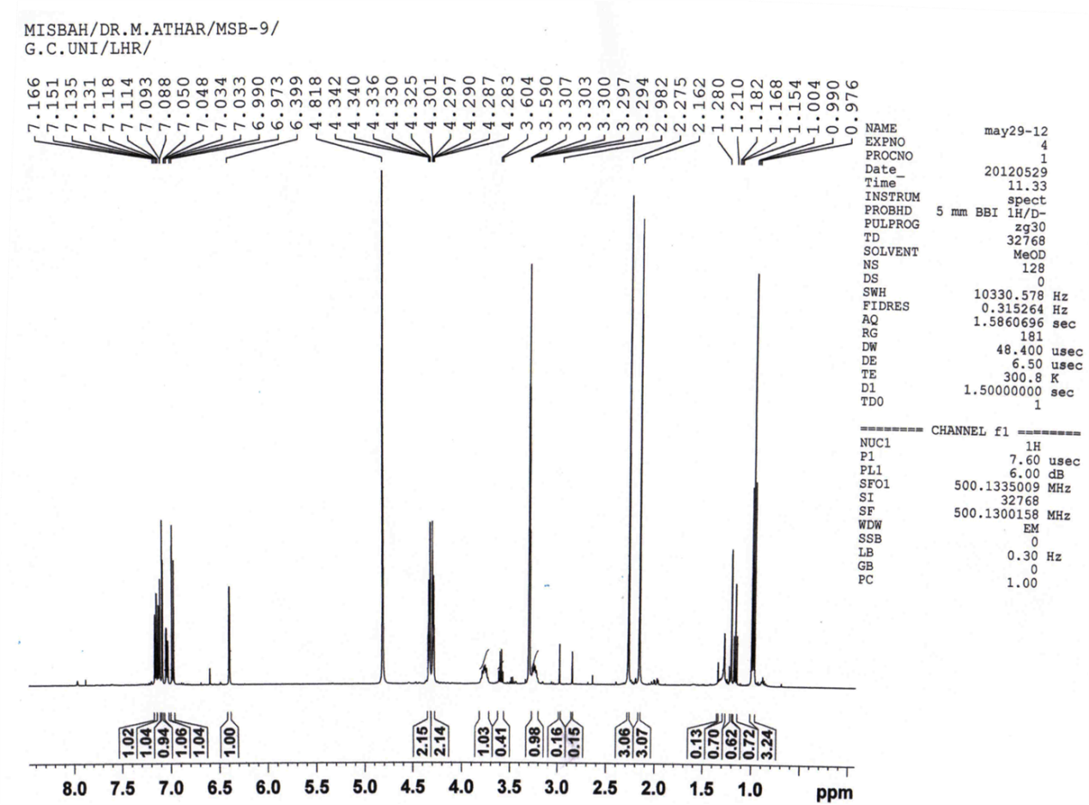
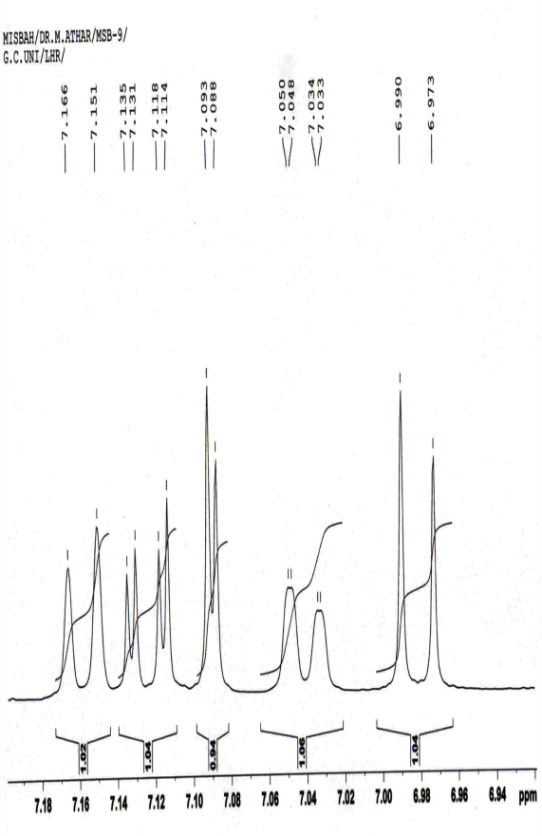
Figure 1a: ¹H-NMR spectrum of compound 7c (Aromatic Region)
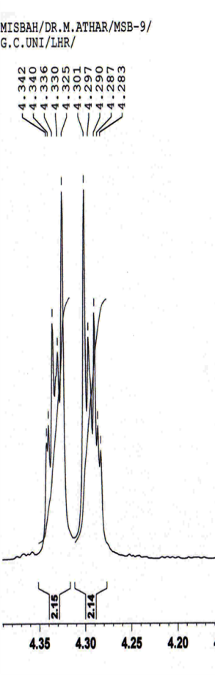 | 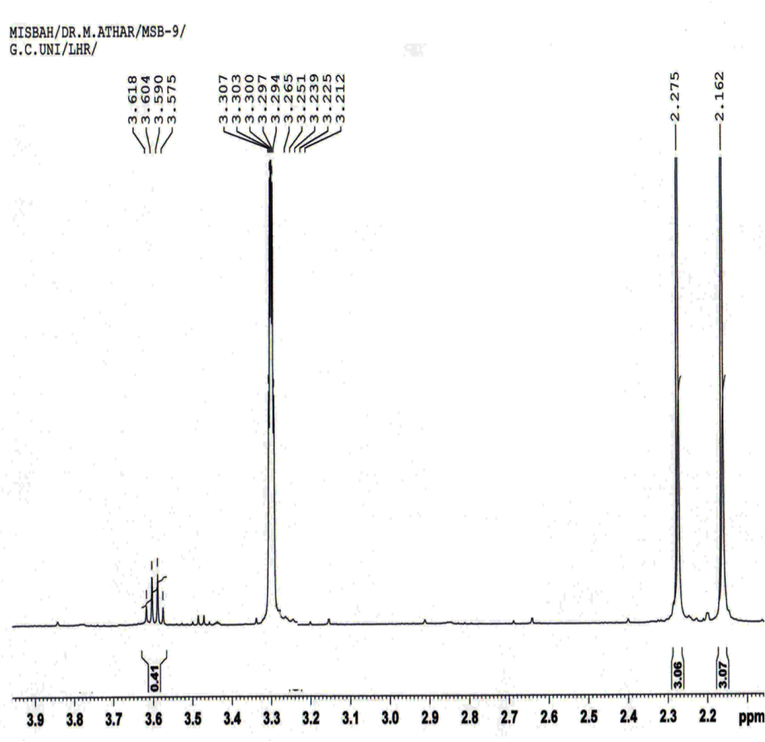

Figure 1b: ¹H-NMR spectrum of compound 7c (Aliphatic Region)
Figure 2: Mass Fragmentation pattern of N-aryl-2,3-dihydrobenzo[1,4]dioxine-6-sulfonamides (3a-e).Figure 3: Mass Fragmentation pattern of N-ethyl-N-(dimethylphenyl)-2,3-dihydro- benzo[1,4]dioxine-6-sulfonamide (7a-e)
3.2 Enzyme Inhibition
The screening of all the synthesized compounds against butyrylcholinesterase enzyme revealed that only three compounds showed better activity; N-(2,3-Dimethylphenyl)-2,3-dihydrobenzo[1,4]dioxine-6-sulfonamide (3a), N-benzyl-(2,5-Dimethylphenyl)-2,3-dihydro- benzo[1,4]dioxine-6-sulfonamide (6c), N-ethyl-(2,4-Dimethylphenyl)-2,3-dihydro- benzo[1,4]dioxine-6-sulfonamide (7b) having IC₅₀ values of 374.11±0.01, 387.51±0.48 and 353.13±0.86 µmoles/L respectively, relative to eserine, a reference standard with IC₅₀ value of 0.85±0.0001 µmoles/L (Table 2). The activity of the these compound was the most probably due to presence of methyl groups at different positions of phenyl ring in 3a, benzyl group in 6c along with alkyl groups and in additional ethyl group for 7b attached to nitrogen of sulfonamide. The screening, against acetylcholinesterase enzyme, of all the synthesized compounds showed that only four compounds were moderately active against it i.e.N-(3,4dimethylphenyl)-2,3-dihydrobenzo[1,4]dioxine-6-sulfonamide (3e), N-benzyl-N-(2,4-dimethylphenyl)-2,3-dihydro-benzo[1,4]dioxine-6-sulfonamide (6b), N-ethyl-N-(2,4-dimethylphenyl)-2,3-dihydro benzo[1,4]dioxine-6-sulfonamide (7b) and N-ethyl-N-(2,6-dimethylphenyl)-2,3-dihydro benzo[1,4]dioxine-6-sulfonamide (7d) having IC₅₀ values ranging from 178.51±0.14 to 364.27±0.54 µmoles/L. The relative reference standard was eserine, with IC₅₀ value of 0.04±0.0001 µmoles/L. The % age inhibition associated with these compounds arrayed from 59.91±0.96 to 76.56±0.19 µmoles/L respectively. The proficient activity was observed for 7b & 7d; which was most likely due to occurrence of N-ethyl group in these compounds in comparison to the other series members. Against lipoxygenase enzyme, all the synthesized compounds showed beneficially good activity but the most active were N-(2,6-dimethylphenyl)-2,3-dihydrobenzo[1,4]dioxine-6-sulfonamide (3d), N-(2,4-dimethylphenyl)-2,3-dihydrobenzo [1,4]dioxine-6-sulfonamide (3b), N-benzyl-N-(2,6-dimethylphenyl)-2,3-dihydrobenzo [1,4]dioxine-6-sulfonamide (6d), N-(3,4-dimethylphenyl)-2,3-dihydrobenzo[1,4]dioxine-6-sulfonamide (3e) having IC₅₀ values of 34.21±0.12, 64.21±0.05, 84.61±0.11 and 87.61±0.14 µmoles/L respectively, relative to baicalein, a reference standard with IC₅₀ value of 22.4±1.3 µmoles/L. The proficient activity of first & second compounds were most probably due to occurrence of two alkyl groups, one at 2nd position and other one at sixth and fourth positions of aniline ring respectively. In 3e these two alkyl groups were situated at third & fourth positions and resulted in less inhibition in comparison to 3d and 3b. For 6d the credibly was due to the presence of two alkyl groups at 2nd/6th of position of aniline ring along with benzyl group attached to nitrogen of sulfonamide. From the activity of molecules against LOX it might be concluded that free nitrogen of sulfamoyl group could be more effective in blocking the active site of enzyme; instead when we substitute it with ethyl or benzyl groups. All the parent compounds (3a-e) can be further utilized for the synthesis of new derivatives with other different electrophiles to enhance their biological, antimicrobial and other activities.

C. No. | BChE |  |  | AChE |  |  | LOX
C. No. | Conc./well  (mM) | Inhibition (%) | IC₅₀  µM | Conc.  (mM) | Inhibition (%) | IC₅₀  (µmol.) | Conc./well  (mM) | Inhibition (%) | IC₅₀  µM
3a | 0.5 | 59.98±0.45 | 374.11±0.07 | 0.5 | 34.68±0.68 | - | 0.5 | 81.34±0.33 | 89.25±0.17
3b | 0.5 | 36.56±0.66 | - | 0.5 | 18.34±0.25 | - | 0.5 | 89.11±0.22 | 64.21±0.05
3c | 0.5 | 36.44±0.22 | - | 0.5 | 16.91±0.11 | - | 0.5 | 88.45±0.82 | 92.25±0.11
3d | 0.5 | 29.12±0.55 | - | 0.5 | 30.39±0.85 | - | 0.5 | 96.86±0.36 | 34.21±0.12
3e | 0.5 | 56.85±0.91 | >400 | 0.5 | 59.91±0.96 | 302.11±0.14 | 0.5 | 82.22±0.67 | 87.61±0.14
6a | 0.5 | 32.32±0.19 | >500 | 0.5 | 4.37±0.15 | >500 | 0.5 | 1.04±0.22 | -
6b | 0.5 | 54.10±0.17 | >500 | 0.5 | 76.56±0.19 | 267.17±0.21 | 0.25 | 35.55±0.35 | -
6c | 0.5 | 58.72±0.13 | 387.51±0.48 | 0.5 | 64.77±0.36 | 364.27±0.54 | 0.25 | 43.01±0.64 | -
6d | 0.5 | 43.41±0.82 | - | 0.5 | 15.85±0.55 | - | 0.5 | 82.11±0.14 | 84.61±0.11
6e | 0.5 | 46.26±0.62 | - | 0.5 | 46.99±0.38 | - | 0.5 | 63.26±0.55 | 238.71±0.14
7a | 0.5 | 28.85±0.14 | >500 | 0.5 | 1.97±0.25 | >500 | 0.5 | 13.79±0.15 | -
7b | 0.5 | 67.69±0.18 | 353.13±0.86 | 0.5 | 73.08±0.76 | 223.1±0.18 | 0.25 | 53.44±0.66 | >400
7c | 0.5 | 54.09±0.15 | >500 | 0.5 | 46.67±0.23 | >500 | 0.5 | 5.21±0.11 | -
7d | 0.5 | 42.65±0.61 | - | 0.5 | 70.52±0.61 | 178.51±0.14 | 0.5 | 48.46±0.19 | -
7e | 0.5 | 42.03±0.58 | - | 0.5 | 32.36±0.14 | - | 0.5 | 43.84±0.19 | -
Control | Eserine | 82.82±1.09 | 0.85±0.0001 | Eserine | 91.29±1.17 | 0.04±0.0001 | Baicalein | 93.79±1.27 | 22.4±1.3
Table 2: Enzyme inhibition studies of synthesized compounds.

3.3 Antimicrobial Activity
The in vitro antimicrobial properties of the parent compounds and their derivatives were tested. Against the selected panel of both bacterial and fungal species; parent compounds 3a, 3b, 3c and 3e exhibited moderate antimicrobial activity; and 3c showed only antibacterial activity as evident from Table 3. Regarding these parent sulfonamides, the compound 3e showed relatively higher activity but lower than that of the standard compound. Among the derivatives of 6a-e series; 6aand 6c have shown both the antibacterial and antifungal activities; and 6a demonstrated higher activities in contrast to the other series members. 7a, 7b and7c are the members of 7a-e series which were active against both bacterial and fungal strains; among these 7b exhibited relatively better results against both microbes. The remaining compounds possess very low or no activity against the assessed microorganisms. The highest hemolytic activity was shown by 3b (92 %) but lower than the positive control (Triton-X-100). The lowest hemolytic activity was shown by 7b & 7c (2.1 % and 0.7 % respectively) but higher than the negative controls (PBS). Overall it can be concluded here that 7b & 7c were the better members overall from all these compounds and ligands; because they have displayed better antimicrobial potential and less hemolytic activity. On the basis of the presented results we may assume that the synthesized sulfonamides may be suitable leads for further improvement to address different targets.

Table 3: Antibacterial and antifungal studies on synthesized compounds.

Compound | Antibacterial activity |  |  |  |  | Antifungal activity
 | Staphylococcsaureus | Bacillus subtilis | Pasturellamultocida | Escherichia coli | Hemolytic activity (Mean) % ± S.D | Candida albicans | Microsporum canis | Aspergillus flavus | Fusarium solani
 | Zone of inhibition (mm) |  |  |  |  | Zone of inhibition (mm)
3a | 14 | 14 | 16 | 16 | 71.847±0.093 | 14 | 14 | 16 | 16
3b | 16 | 16 | 12 | 14 | 91.721±1.121 | 16 | 16 | 12 | 14
3c | 14 | 14 | 12 | 14 | 88.162±0.278 | - | - | - | -
3d | - | - | - | - | 88.328±3.122 | - | - | - | -
3e | 18 | 16 | 14 | 14 | 86.918±0.226 | 19 | 16 | 14 | 14
6a | 16 | 12 | 14 | 16 | 91.684±3.221 | 16 | 18 | 14 | 14
6b | - | - | - | - | 88.372±0.192 | - | - | - | -
6c | 14 | 16 | 12 | 14 | 73.814±0.464 | 13 | 18 | 11 | 12
6d | - | - | - | - | 81.770±3.060 | - | - | - | -
6e | - | - | - | - | 88.481±0.309 | - | - | - | -
7a | 14 | 14 | 16 | 12 | 71.472±0.087 | 16 | 14 | 18 | 16
7b | 16 | 18 | 14 | 14 | 2.186±0.124 | 19 | 17 | 18 | 16
7c | 16 | 14 | 14 | 16 | 0.743±0.062 | 17 | 12 | 15 | 18
7d | - | - | - | - | 72.372±0.526 | - | - | - | -
7e | - | - | - | - | 91.668±5.508 | - | - | - | -
Streptomycin | 30 | 28 | 28 | 30 | Flumequine | 29 | 27 | 26 | 31
PBS |  |  |  |  | 0.00±0.0
Triton  (toxicity) |  |  |  |  | 100±0.0

4. Molecular Docking
The results obtained from in silico approach were also favoring the fact that synthesized sulfonamides have shown good interaction with the target site. The interaction analysis shown that in every compound, the sulfonamide group is contributing in the interactions. The interaction of compound 3b and 7d with the active site of lipoxygenase (LOX) and acetylcholinesterase (AChE) is shown here in Figure 4 and Figure 5 respectively.
The interaction analysis of compound 7d against acetylcholinesterase depicted that residues of binding pocket interacted with two functionalities of compound. Tyr121 developed linked with the one oxygen of SO₂ group in sulfonamide moiety and Ser122 interacted with the one oxygen atom (at 4th position) of 1,4-dioxane ring (Figure 5). Whereas in compound 3b His518 have developed interactions with oxygen of sulfamoyl group and Ser122 have interacted with oxygen of dioxane functionality (Figure 4).
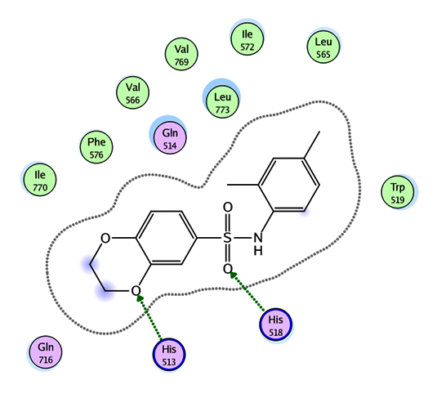
Figure 4: 2D interaction of N-(2,4-dimethylphenyl)-2,3-dihydrobenzo[1,4]dioxine-6-sulfonamide (3b) against lipoxygenase.

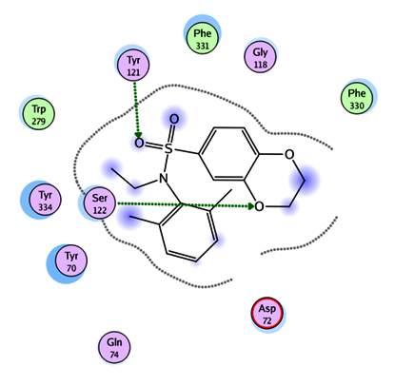
Figure 5: 2D image of compound N-(2,6-dimethylphenyl)-N-ethyl-2,3-dihydro- benzo[1,4]dioxine-6-sulfonamide (7d) against acetylcholinesterase.
- Conclusion
A new series of sulfonamide bearing 1,4-benzodioxane ring systems were synthesized. These were characterized by IR, ¹H-NMR and EIMS. All the compounds were screened for their antibacterial and antifungal activity by disc diffusion method. Compounds 3e, 7b & 7c exhibited good antimicrobial activity among all the synthesized compounds but lower than that of the standard drug streptomycin. Compound 7b was better inhibitor against BchE and 7d for AchE, while 3d exhibited good inhibition potential against LOX. Most of the synthesized compounds exhibited an overall bearable toxicity level and could be utilized as possible therapeutic entrants after making structural modifications.
- Acknowledgements
The authors extend their appreciation to the Higher Education Commission of Pakistan for financial support.
Conflict of Interest:
Authors declare no conflict of interest.

- References
- C. T. Supuran, Expert Opin. Drug Discov. 2017, 12, 61-88.
https://doi.org/10.1080/17460441.2017.1253677.
- F. Carta, C. T. Supuran, A. Scozzafava, Future Med. Chem. 2014, 6, 1149-1165. https://doi.org/0.4155/fmc.14.68.
- A. Scozzafava, T. Owa, A. Mastrolorenzo, C. T. Supuran, Curr. Med. Chem. 2003, 10, 925-953.
https://doi.org/10.2174/0929867033457647.
- C. Capasso, C. T. Supuran, J. Enzym. Inhib. Med. Chem. 2014, 29, 379-387. https://doi.org/10.3109/14756366.2013.787422.
- F. Carta, A. Scozzafava, C. T. Supuran, Expert Opin. Ther. Pat. 2012, 22, 747-758. https://doi.org/10.1517/13543776.2012.698264.
- C. Capasso, C. T. Supuran, J. Enzym. Inhib. Med. Chem. 2015, 30, 325-332. https://doi.org/10.3109/14756366.2014.910202.
- C. Capasso, C. T. Supuran, Expert Opin. Ther. Targets. 2015, 19, 1689-1704. https://doi.org/10.1517/14728222.2014.991312.
- V. M. Varagic, M. P. Milosevic, Farmakologija, Elitmedica, Beograd. 2009, 622-627.
- A. Scozzafava, C. T. Supuran, F. Carta, Expert Opin. Ther. Pat. 2013, 23, 725-735. https://doi.org/10.1517/13543776.2013.790957.
- A. Casini, A. Scozzafava, C. T. Supuran, Expert Opin. Ther. Pat. 2002, 12, 1307-27. https://doi.org/10.1517/13543776.12.2.217.
- F. Carta, C. T. Supuran, Expert Opin. Ther. Pat. 2013, 23, 681-691. https://doi.org/10.1517/13543776.2013.780598.
- C. T. Supuran, J. Enzym. Inhib. Med. Chem. 2016, 31, 345-360. https://doi.org/10.3109/14756366.2015.1122001.
- A. E. Boyd, Diabetes. 1988, 37, 847-850.
https://doi.org/10.2337/diab.37.7.847.
- T. H. Maren, Annu. Rev. Pharmacol. Toxicol. 1976, 16, 309-327. https://doi.org/10.1146/annurev.pa.16.040176.001521.
- C. T. Supuran, Metabolites. 2017, 7, 48-61.
https://doi.org/10.3390/metabo7040056.
- F. Abbate, J. Y. Winum, B. V. L. Potter, A. Casini, J. L. Montero, A. Scozzafava, C. T. Supuran, Bioorg. Med. Chem. Lett. 2004, 14, 231-234. https://doi.org/10.1016/j.bmcl.2004.07.087.
- L. Puccetti, G. Fasolis, D. Vullo, Z. H. Chohan, A. Scozzafava, C. T. Supuran, Bioorg. Med. Chem. Lett. 2005, 15, 3096-3101.
https://doi.org/10.1016/j.bmcl.2005.04.055.
- F. Carta, L. D. C. Mannelli, M. Pinard, C. Ghelardini, A. Scozzafava, R. McKenna, C. T. Supuran, Bioorg. Med. Chem. 2015, 23, 1828-1840. https://doi.org/10.1016/j.bmc.2015.02.027.
- A. Weber, A. Casini, A. Heine, D. Kuhn, C. T Suparan, A. Scozzafava, G. Kelebe, J. Med. Chem. 2004, 47, 550-557.
https://doi.org/10.1021/jm030912m.
- C. T. Suparan, F. Brigani, S. Tilli, W.R.Chegwidden,A. Scozzafava, Bioorg. Med. Chem.2001, 9, 703-714.
https://doi.org/10.1016/S0968-0896(00)00288-1.
- M. A. R. Matos, C. C. S. Sousa, V. M. F. Morais, J. Phys. Chem. A. 2008, 112, 7961-7968.
- Y. Luo, S. Zhang, K. M. Qiu, Z. J. Liu, Y. S. Yang, J. Fu, W. Q. Zhong, H. L. Zhu, Bioorg. Med. Chem. Lett. 2013, 23, 1091-1095.
https://doi.org/10.1016/j.bmcl.2012.12.010.
- J. Sun, Y. S. Yang, W. Li, Y. B. Zhang, X. L. Wang, J. F. Tang, H. L. Zhu, Bioorg. Med. Chem. Lett. 2011, 21, 6116-6121.
https://doi.org/10.1016/j.bmcl.2011.08.039.
- J. Sun, N. Cao, X. M. Zhang, Y. S. Yang, Y. B. Zhang, X. M. Wang, H. L. Zhu, Bioorg. Med. Chem. 2011, 19, 4895-4902.
https://doi.org/10.1016/j.bmc.2011.06.061.
- Y. Harrak, G. Rosell, G. Daidone, S. Plescia, D. Schillaci, M. D. Pujol,Bioorg. Med. Chem. 2007, 15, 4876-4890.
https://doi.org/10.1016/j.bmc.2007.04.050.
- Y. Aiba, D. Hasegawa, T. Marunouchi, K. Nagasawa, H. Uchiro, S. Kobayashi, Bioorg. Med. Chem. Lett. 2001, 11, 2783-2786.
https://doi.org/10.1016/S0960-894X(01)00561-3.
- M. Z. Xu, W. S. Lee, J. M. Han, H.W. Oh, D.S. Park, G.R. Tian, T.S. Jeong, H.Y. Park, Bioorg. Med. Chem. 2006, 14, 7826-7834.
https://doi.org/10.1016/j.bmc.2006.07.063.
- M. T. Vazquez, G. Rosell, M. D. Pujol, Eur. J. Med. Chem. 1997, 32, 529-534. https://doi.org/10.1016/S0223-5234(97)84016-0.
- I. A. Guedes, C. S. Magalhaes, L. E. Dardenne, Biophys. Rev. 2014, 6, 75-87. https://doi.org/10.1007/s12551-013-0130-2.
- M. Irshad, M. A. Abbasi, Aziz-ur-Rehman, S. Z. Siddiqui, M. S. Ali, M. Ashraf, T. Ismail, I. Ahmad, S. Hassan, M. A. Lodhi, S. B. Jamal, Pak. J. Pharm. Sci. 2016, 29, 1913-1925.
- G. L. Ellman, K. D. Courtney, V. Andres, R. M. Featherstone, Bio. Pharm. 1961, 7, 88-95. https://doi.org/10.1016/0006-2952(61)90145-9.
- A. L. Tappel, Arch. Biochem. Biophys. 1953, 44, 378-395.
- S. Baylac, P. Racine, Int. J. Aromather. 2003, 13, 138-142.
https://doi.org/10.1016/S0962-4562(03)00083-3.
- A. T. Evans, Biochem. Pharmacol. 1987, 36, 2035-2037.
https://doi.org/10.1016/0006-2952(87)90505-3.
- M. Kaspady, V. K. Narayanaswamy, M. Raju, G. K. Rao, Lett. Drug Des. Discov. 2009, 6, 21-8.
https://doi.org/10.2174/157018009787158481.
- P. Sharma, J. D. Sharma, J. Ethnopharmacol. 2001, 74, 239-243. https://doi.org/10.1016/S0378-8741(00)00370-6.
- W. A. Powell, C. M. Catranis, C. A. Maynard, Lett. Appl. Microbiol. 2000, 31, 163-168. https://doi.org/10.1046/j.1365-2672.2000.00782.x.
- M. J. Bostro, J. R. Greenwood, J. Gottfries, Mol. Graph. Model. 2003, 21, 449-462. https://doi.org/10.1016/S1093-3263(02)00204-8.

