A Novel Green Synergistic Mixture for Steel Corrosion Inhibition in 0.51 M NaCl
Stojan Božović¹, Sanja Martinez², Veselinka Grudić¹
¹ University of Montenegro, Faculty of Metallurgy and Technology, Cetinjski put, 81000 Podgorica, Montenegro
² University of Zagreb, Faculty of Chemical Engineering and Technology, Department of Electrochemistry, ReCorr Laboratory, Savska cesta 16, HR-1000 Zagreb, Croatia
* Corresponding author: E-mail stojan.bozovic90@yahoo.com, Telephone: +38267499528
ABSTRACT
Ubiquitous use of plain and low-alloy steels in neutral, chloride bearing environments presents an everyday challenge for corrosion protection professionals. This paper explores the possibility of developing a non-toxic and environmentally friendly synergistic inhibitor mixture made of propolis, tannin, sodium benzoate, PEG400 and starch that could be applied into the solution to induce formation of a persistent protective layer on steel. Components of the mixture were chosen based on the references giving their characteristics relevant to their possible action in the solution and/or at the surface of steel. The efficiency of the protective layer formed under the influence of the inhibitor mixture, and then measured in the inhibitor-free solution, was the lowest under quiescent conditions (75%) and the highest (95%) under flow conditions. Both, LPR and EIS data indicate that the inhibited layer presents a barrier for diffusion of oxygen that acts as a primary corrosion reaction depolarizer in the investigated neutral chloride solution. The demonstrated persistency of the inhibited layer is of primary interest as it gives possibility batch application.

Keywords: corrosion inhibitor, synergistic effect, steel

1. INTRODUCTION
Steel is the most widely used metallic material thanks to its good mechanical properties and low price. However, when it comes into contact with aerated neutral electrolyte, especially in the presence of chloride ions, steel is subject to rapid corrosion degradation. Neutral saline aqueous environments of various origins are frequently simulated in laboratory through the use of 0.35–0.85 M NaCl solutions.¹ Corrosion rates recorded on plain steel by polarization and weight loss techniques are fairly consistent and range between 0.1 and 0.5 mm per year.^{2,3} These rates are generally not acceptable and protective measures have to be applied. Due to the inherent characteristics of corroding systems (e.g. complex geometry or need for good thermal conductance) corrosion inhibitors frequently stand out as the most practical or the only solution. Unfortunately, protection of steel in neutral chloride media is challenging from theoretical and practical viewpoint. It can readily be observed that considerably more literature is found on inhibition of steel corrosion in acidic media than in neutral media and that the inhibitor effectiveness is generally higher.⁴ From the theoretical aspect, the reason is that in near-neutral, neutral and alkaline media, inhibitor action is complicated by formation of iron oxides and hydroxides at the surface of metal.
In acidic media, bare iron (or steel) surface is positively charged and behaves as a soft Lewis acid, hence, soft Lewis base compounds with heteroatoms O, N, S, P and/or π electrons in their structure, are good inhibitor candidates due to the possibility of soft acid-soft base adsorption bond formation.^{5,6} On the other hand, when oxide is present, surface acidity and basicity depends on oxide’s isoelectric point, which e.g. for Fe₂O₃, equals pH 8.6.⁷ Below this pH it may be assumed that the surface oxide is protonated, positively charged and acting as a hard Lewis acid. Hard Lewis bases would therefore be good inhibitor candidates capable of hard acid-hard base adsorptive bond formation.
In the present study, tannin, sodium benzoate, propolis, starch and polyethylene glycol (PEG400) were chosen as components of the investigated inhibitor mixture. When such a mixture rich in OH groups is used for inhibiting corrosion, in near neutral and neutral pH, part of the OH groups will be deprotonated forming anions that have electronegativity practically equal to their ionization potential, and therefore act as almost pure electron donors or hard Lewis bases.⁵ Adsorptive hard acid-hard base bond which is of predominantly ionic character would therefore be possible between compounds of the mixture and the oxidized steel surface. Additionally, metal cations in high oxidation state, such as ferric ions dissolved from the steel surface into the electrolyte, are hard Lewis bases, so that formation of protective deposits of hardly soluble complexes and/or chelates of ferric ions with anionic organic ligands is possible.
Components of the inhibitor mixture investigated in the present study were chosen after careful consideration of their previously published characteristics relevant to corrosion inhibition. E.g. ethanolic propolis extract applied to mild steel forms a very effective anticorrosion coating in neutral and near neutral aqueous 3.5% w/v NaCl solution.⁸ Propolis was also proven to be effective on copper in neutral chloride solution,⁹ but copper is more favourable for adsorption of organic compounds under such conditions.¹ Adsorption of effective propolis layer on steel from the solution is probably hindered by its insufficient concentration due to the limited solubility of propolis in water. Dispersion of propolis in neutral chloride medium produces a yellowish emulsion.⁸ Based on literature data, PEG is used as an alternative solvent for non-ethanolic propolis extraction,¹⁰ and when used together with propolis, could beneficially influence propolis dispersibility in a water solution.¹¹ Furthermore, it has been shown that a compact layer, with barrier effect for the diffusion of oxygen in 0.1 NaCl solution, has been deposited on mild steel from the solutions containing 1000, 2500 and 5000 g ppm of PEG after 30 min of immersion time, showing that PEG itself can act as a corrosion inhibitor.¹² Formation of the protective ferric ‘‘tannate’’ film deposited from solution of tannin is also possible, and it was shown to begin at pH = 3, but relevant efficiencies are attained only at concentrations ~1000 ppm.¹³ Concentrations of the same order are needed for efficient steel corrosion inhibition in chloride media by starch and sodium benzoate.^{14,15}
In general, extra costs are incurred in neutral chloride media because the enhancement of inhibitor effectiveness is frequently attained through the increase in concentration up to a few thousands of ppm.¹⁶ The most explored strategy for lowering inhibitor concentration, while retaining good efficiency is application of synergistic inhibiting mixtures.¹ In the present case, different chemical nature of components of the mixture used was expected to yield a combination of mechanisms of action, which is usually argued to be the basis for synergism.¹⁷ Moreover, in this paper we extend the synergistic approach by hypothesising that a carefully chosen mixture of non-toxic and environmentally benign inhibitive compounds could modify the rust layer on steel, which forms in neutral chloride solutions, as to produce a persistent film which would lower corrosion rate considerably. High concentration requirement would then be counteracted by a long inhibitor free period, following inhibitor batch application, in which the protective surface film would ensure acceptable corrosion rates.

2. EXPERIMENTAL
2.1. Solutions
Tests were performed on 0.51 M NaCl, obtained by dissolving analytical grade NaCl (Lachner, p.a.) in redistilled water.
Natural propolis (Naturwaren-niederrhein, GmbH, Propolis Pulver) was used at a concentration of 100 ppm in 0.51 M NaCl. 100 mg of propolis was first dissolved in 5 ml of 70% ethanol before preparing 1 dm³ of solution. Chestnut Tannin (Tanin Sevnica) and sodium benzoate (AGZ, food additive) were both used at a concentration of 2000 ppm.
PEG400 (Sigma Aldrich) and corn starch (Sigma Aldrich) were used in concentrations of 200 and 400 ppm, respectively.
A inhibitive mixture of 2000 ppm of tannin, 2000 ppm of benzoate and 100 ppm of propolis in 0,51 M NaCl is in further text denoted by abbreviation OPT, while the same solution with the addition of P200 ppm of PEG400 and 400 ppm of starch is denoted by +PEG and +STARCH, respectively.
2.2. LPR probe
The measurements of corrosion rate and pitting factor were performed on the LPR (Linear Polarization Resistance) probe manufactured by RCSL with the data collector MS1500L.
Two LPR steel C1010 electrodes were, prior to immersion, treated mechanically by abrasive paper of grit 240, followed by degreasing with ethanol in an ultrasound bath and rinsing in redistilled water. Measurements were made by immersion of the electrodes in the solution of 0.51 M NaCl, as well as in solutions with the chosen concentrations of inhibitors. A protective layer at the electrode surface was formed for 24 h in quiescent solutions. In one experiment, the layer was deposited from the inhibited solution mixed at 80m RPM, in order to rate the influence of solution mixing on layer formation and its protective properties. In the non-inhibited solutions, the rust layer was formed, while in the inhibited solutions, the rust layer modified by the action of corrosion inhibitors was obtained. The corrosion rate was measured after the probe was transferred into a fresh 0.51 M NaCl solution and left to stand for 24 h. The LPR measurement was then performed in a quiescent solution as well as in a solution stirred by magnetic stirrer at 90 to 150 RPM. Long-term measurements with the layer formed in the most effective inhibitor mixture as well as the pure rust layer were performed continuously for 10 days. In this way, the persistency of the protective layer is tested by LPR probe, which was previously found to be particularly suitable technique for that laboratory testing of inhibitor persistency.¹⁸
2.3. Electrochemical impedance spectroscopy (EIS)
For EIS, the PalmSens3 device with PC Trace 5.3 software has been used. A cylindrical steel sample made of X52 5L steel embedded in epoxy resin and having circular cross section exposed to the electrolyte, was used as a working electrode. A saturated calomel electrode was used as a reference electrode and a graphite electrode was used as auxiliary electrode used a. The working electrode surface was 0.2826 cm². Prior to electrochemical testing, the surface of the working electrode was mechanically treated by abrasive paper of various grits, namely: 240, 600 and 800. Subsequently, the surface was degreased in an ultrasonic bath with ethanol and washed with redistilled water.
EIS measurements were performed in quiescent solution, at the open circuit potential, at frequencies from 50 kHz to 1 mHz, with the amplitude of 10 mV. The measurements were carried out after 24 h of electrode stabilization in a fresh 0.51 M NaCl solution, at the electrodes on which a protective layer (of rust or inhibitor modified rust) has previously been formed for 24 h, as in the experiment with LPR probe. Additionally, EIS measurement has been done in the inhibited solution prior to transfer into the fresh NaCl in order to compare inhibitive effect in inhibitor bearing and inhibitor free solutions.

2.4. Fourier Transform Infrared Spectroscopy (FTIR)
FTIR spectra were recorded using a PerkinElmer spectrometer Spectrum One. Spectra were obtained in the range from 400 to 4000 cm⁻¹, each spectrum being an average of ten scans with a resolution of 4 cm⁻¹. 350 mg of KBr was rubbed onto the surface of the rectangular X52 5L steel electrode on which inhibitor layer has been formed identically as for the LPR measurements. Samples bearing KBr was then hydraulically pressed into a 13 mm stainless steel die and the resulting pellets further subjected to FTIR measurement. Preparation of pellets conformed to the standard ASTM E1252:2007.
2.5. Scanning Electron Microscopy (SEM) and Energy-Dispersive X-ray (EDX) Analysis
SEM and EDX analysis was recorded using Tescan Vega III, SBU EasyProbe scanning electron microscope with 15 kV accelerating voltage of the electron beam at various magnifications.

3. RESULTS AND DISCUSSION
Cathodic reaction takes place on iron or steel through two possible processes. At lower pH values of the solution, hydrogen evolution is controlled by the rate of charge transfer reaction, and at higher pH of the solution, oxygen reduction is controlled by the rate of oxygen diffusion. Lorbeer and Lorentz,¹⁹ state pH of 4.2 as critical, above which the dominant cathodic process is oxygen reduction and anodic iron dissolution is inhibited by time-dependent formation of a three-dimensional porous oxide layer on the electrode surface. In the present study, the pH of uninhibited solution was 6, while the pH of inhibited solutions was between 4.6 and 4.7 so the primary conjugate cathodic reaction of metal dissolution was reduction of oxygen. This reaction is known to be under diffusion control and satisfactory degree of corrosion inhibition requires dense blocking of the surface.¹⁷ Oxygen reduction generates OH⁻ ions which react with the dissolved Fe²⁺ ions yielding Fe(OH)₂ that is considered to be a precursor of other rust forming compounds.¹⁶ Formation of particular rust component depends on pH, temperature and oxygen content. The rust layer partially protects metal surface from dissolution.² It has been found that increasing the immersion time of iron and steel in the solution enables thickening of the corrosion product layer resulting in the decrease of the corrosion rate. The decrease of the weight loss has been observed for carbon steel during the first 10 days of immersion in 3.5% NaCl, followed by a period of 20 days in which the weight lost remained low, while in the following 30 days the weight loss became more noticeable and higher.³ This observation indicates that dissolution of rust itself also occurs under the attack of chloride ions. The experiments in the present study were focused on modification of the rust layer by the inhibitors in order to obtain a persistent protective layer that lowers the corrosion rate to acceptable values.
3.1. Measurements at the LPR Probe
System without inhibitor and with 4 different inhibitor mixtures is currently presented. The composition of the OPT solution has been optimized in an extensive series of experiments not shown in the present paper. To exemplify the testing method as well as the synergistic effect, only the results of adding two components (PEG and starch) at optimum concentrations are shown.
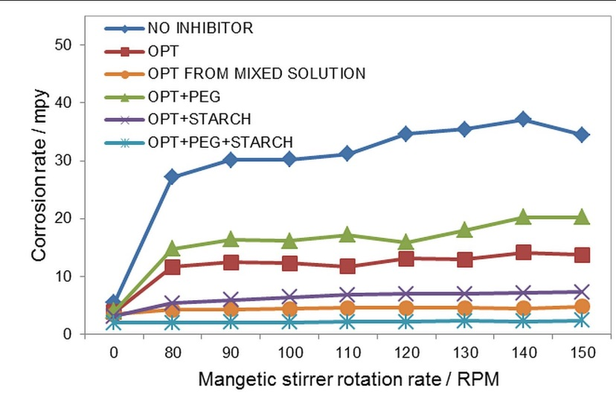
Figure 1. LPR corrosion rated on electrodes with the uninhibited rust layer or with the inhibited layer formed under the influence of various inhibitor mixtures, measured in quiescent 0.51 M NaCl solution and in the same solution mixed at various magnetic stirrer rotation rates.

Figure 1 shows LPR measurements on steel electrodes with formed rust and inhibitor layer. The increase in corrosion rate is observed with the increase in magnetic stirrer rotation rate. The increase is most remarkable between the quiescent system and the system with the lowest mixing rate of 80 RPM. For the most efficient inhibitor mixture, denoted by OPT+PEG+STARCH, corrosion rate levels of immediately while the same happens for the other inhibitor mixtures at higher rotation rates.
Efficiency of the mixture is evident from the decrease in the corrosion rate of the inhibited v.s. uninhibited surface layer. Figure 1 also shows that the addition of PEG to OPT solution decreases mixture efficiency (probably due to deprotonation of PEG and the resultant pH decrease),¹³ while the addition of starch increases efficiency. However, addition of both, PEG and starch significantly increases efficiency thereby demonstrating synergism.
As propolis is of limited solubility and forms an emulsion, the inhibitor layer has also been formed form the OPT solution mixed at 80 RPM. The efficiency is somewhat lower than in the most efficient mixture, but higher than in the all other systems, indicating that addition of PEG and starch could have influenced the stability of propolis emulsion.
The efficiency of inhibitors apparently increases with the increase in magnetic stirrer rotation rate and is the lowest in quiescent solution (75%) and the highest at 140 RPM (95%) for the most efficient inhibitor mixture. This result indicates that inhibitor acts as a barrier for oxygen diffusion to the surface of metal.
Figure 2 shows 10 day measurements performed on the unprotected LPR electrodes and the electrodes with a layer formed under the influence the most efficient inhibitor mixture, OPT+PEG+STARCH. Every day, the measurement was carried out in a quiescent solution and at different mixing rates.

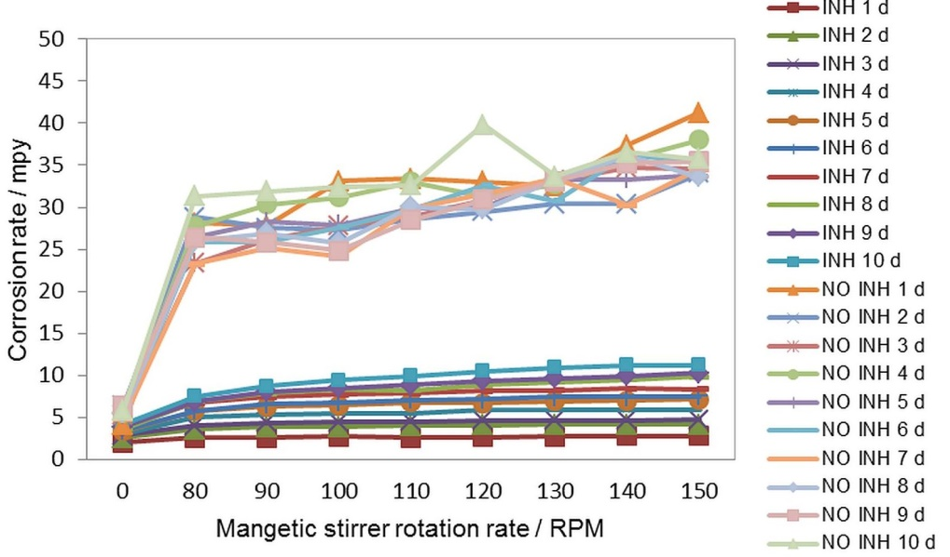
Figure 2. LPR corrosion rates on electrodes with the uninhibited rust layer and with the inhibited layer formed under the influence of OPT+PEG+STARCH inhibitor mixture, measured in quiescent 0.51 M NaCl solution and in the same solution mixed at various magnetic stirrer rotation rates.
The rusted electrodes show no significant change in corrosion rate with time, while the corrosion rates of the inhibitor protected electrodes increase with time indicating gradual loss of efficiency. However, it should be noted that the chosen stirrer rotation rates correspond to linear flow rates from 5 to 10 m s⁻¹ that may be considered very high for carbon and low alloyed steel, which are known to endure rates up to 1 m s⁻¹ without excessive flow induced corrosion.²⁰ After 10 days of immersion, the maximum corrosion rate with the inhibited layer is still below 8 mpy (0.2 mm per year) as opposed to inhibitor free system in which the maximum corrosion rate roughly equals 35 mpy (0.875 mm per year). The concept of improving corrosion resistance of steel by the formation of a surface layer that efficiently blocks corrosive components from surrounding medium, is self-explanatory, and has also previously been proposed in for steel corrosion in hot tapwater.^{21,22}

a) | b) | c)
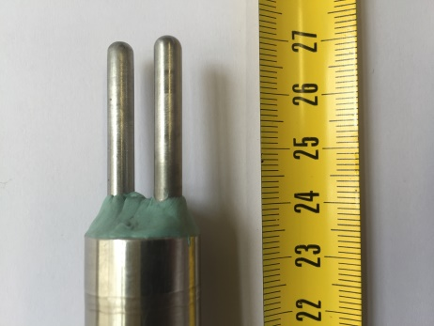 | 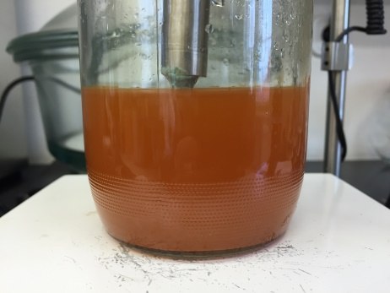 | 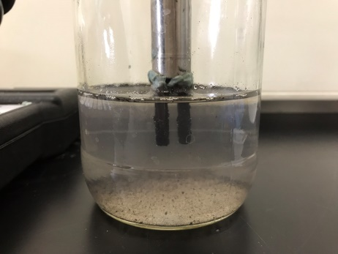
Figure 3. LPR probe: a) before the experiment, b) after the experiment with the uninhibited layer on electrodes and c) after the experiment with the inhibited layer on electrodes.

Figure 3 a) shows LPR probe electrodes before the experiment. The base of the electrodes is protected by a viscoelastic coating in order to avoid ingress of the solution into the electrode threads and creation of the short circuit between the electrodes and the probe body. Only the working area of the electrodes has been immersed into the solution. Figure 3 b) shows unprotected LPR electrodes after the end of 10 days experiment in 0.51 M NaCl (immediately after mixing). The colour of the solution corresponds to the colour of the rust layer on the electrodes that are not visible due to the rust dispersed within the solution. The colour of rust indicates that its main component is lepidocrocite (γ-FeOOH).²³ On the inhibitor protected electrode, a black layer is visible, proving formation of ferric tannate. Significantly smaller amount of corrosion products in the solution indicates better protection offered by the inhibitor layer compared to the protection provided by the pure rust layer.
3.2. Electrochemical Impedance Spectroscopy (EIS)
Figure 4 shows the EIS results for the electrodes with layers formed without and with OPT+PEG+STARCH inhibitor mixture. To compare protective effect of the presence of the inhibitors in solution, the measurement was also done in inhibited solution immediately before transfer of the electrode with the formed protective layer into fresh 0.51 M NaCl solution. Table 1 shows EIS fitting results.
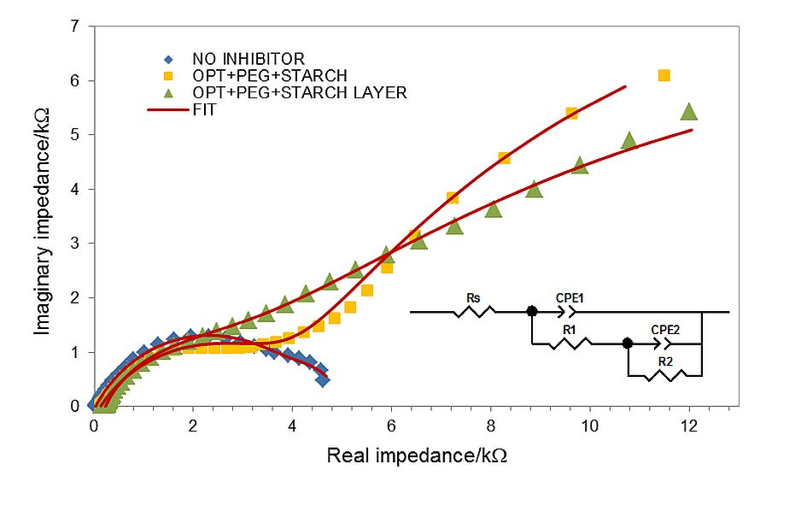
Figure 4. EIS results on steel electrode immersed in 0.51 M NaCl, with a rust layer formed in inhibitor free solution, immersed in OPT+PEG+STARCH solution and in 0.51 M NaCl with an inhibitor layer formed in OPT+PEG+STARCH solution.

Table 1. Results of EIS data fitting to the equivalent circuit shown in Figure 4.
 | Rs/Ω | CPE1  /μSs^{-n} | C  /μF | n1 | R1/Ω | CPE2  /mSs^{-n} | C  /mF | n2 | R2/Ω
NO INHIBITOR | 23.52 | 584.41 | 951.72 | 0.666 | 4526 | 145.51 | 145.51 | 1 | 514
OPT+PEG+STARCH | 126.6 | 104.15 | 60.94 | 0.607 | 4197 | 2.03 | 20.57 | 0.632 | 26333
OPT+PEG+STARCH LAYER | 224.9 | 124.25 | 79.57 | 0.711 | 2686 | 0.59 | 29.52 | 0.431 | 32845

Efficiency higher than 85% that may be calculated form R1+R2 value is obtained irrespective of the inhibitor presence or absence in the solution. More pronounced low frequency EIS semicircle of the protected electrode and the decrease of n2 parameter from 1 to the value close to 0.5, as well as the shape of Nyquist plots,²⁴ indicate that the inhibited layer presents a barrier for oxygen diffusion, as previously concluded from LPR measurements.

3.3. Fourier Infrared spectroscopy (FTIR)
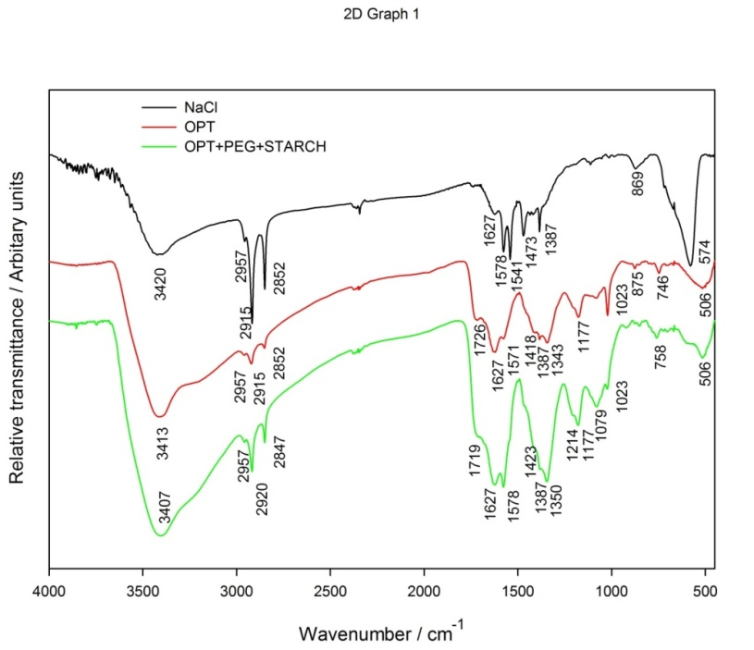
Figure 5. FTIR spectra of layers formed on X52 5L steel electrodes in pure 0,51 NaCl, OPT and OPT+PEG+STARCH solutions.
Figure 5 shows FTIR spectra of layers formed on steel electrodes in uninhibited, OPT and OPT+PEG+STARCH solutions.
Spectrum of the rust layer from the uninhibited solution indicates a mixture of FeCl₃ (spectrum ID=8ns2iWUHtq7,²⁵), Fe₃O₄ (spectrum ID=8ns2iWUHtq7,²⁶) and Fe₂O₃ (Spectrum ID=AVGw5xAY59X,²⁷). In particular, the band at 574 cm⁻¹ corresponds to the Fe-O vibrations of magnetite,²⁸ the bands around 750 and 870 cm⁻¹ show presence of goethite and the bands at 1023 and 1177 cm⁻¹ indicate presence of lepidocrocite. Fingerprint region of FTIR spectra between 400 and 1800 cm⁻¹ of tannin (not shown), propolis (not shown) and OPT layer, is similar between the three samples and is also similar to the reference tannin spectrum (Spectrum ID=KPLVhGlArJg,²⁹). Dark purple coloration of the electrode surface layer that fully develops over the period of 24 hours, confirms presence of tannin in the form of ferric tannate.¹³ Peaks around 1079, 1214, 1345 and 1420 could be linked to tannate formation.³⁰
The most remarkable difference in FTIR spectra of uninhibited and inhibited layers is the disappearance of magnetite peak at 574 cm⁻¹ in the inhibited layer, probably due to the conversion process to ferric tannate.²⁷ Relatively more intense ferric tannate peaks at 1079, 1214 cm⁻¹ ml are observed in OPT+PEG+STARCH inhibited layer than in OPT inhibited layer. FTIR spectra show dominant role of flavanoid species, present both in tannin and propolis, on the formation of the inhibited layer.
4. Scanning Electron Microscopy (SEM) and Energy Dispersive X-ray (EDX) Analysis
Before the electron microscope scanning, the loosely held part of the layer has been blown off in the nitrogen gas stream so that only the firmly held parts of the layer remained. Figures 6 a) and b) show the surface of metal with the uninhibited layer and Figures 6 c) and d) with the inhibited layer from OPT+PEG+STARCH solution.
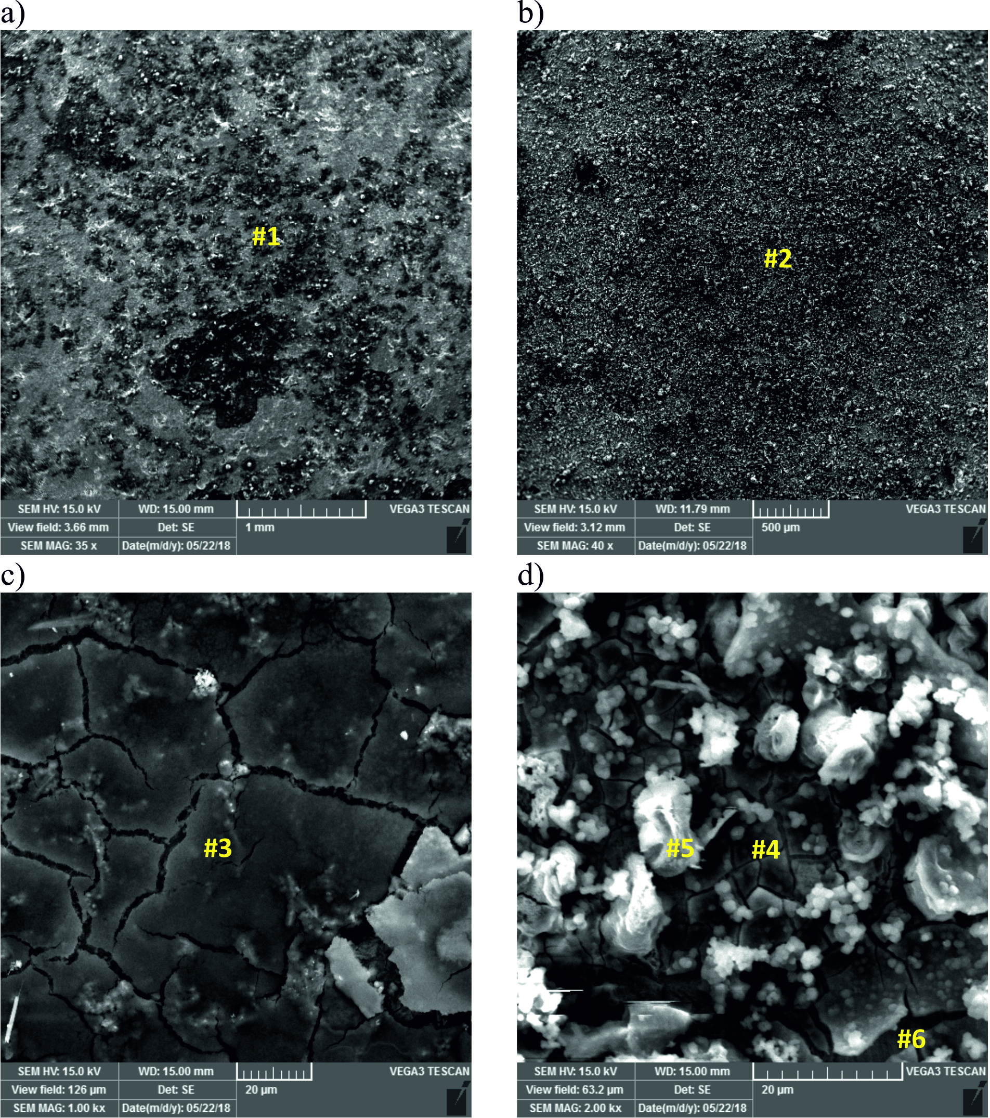
Figure 6. Surface of metal with the uninhibited layer a) and b), and with the inhibited layer c) and d), from OPT+PEG+STARCH solution.
EDX results for measurement positions #1 to #6 are shown in table 2.
Oxygen content of both layers and a fine grained structure observed in both cases is probably due to surface oxides, but it is significantly more dense and uniform in micrograph of the inhibited layer (Figure 6 c) than of the uninhibited in (Figure 6 a). Corrosion defects in the form of shallow pits are visible only in the case of uninhibited layer. Carbon content of the layer is much higher in the inhibited (16-25 wt%) than in the uninhibited (<6 wt%) case probably due to inhibitor presence. In both cases, the layer has cracks protruding to the metal surface.
Table 2. EDX elemental analysis results for measurement positions in Figure 6.
Eelement | #1 | #2 | #3 | #4 | #5 | #6
Fe | 68.7 | 46.9 | 57.4 | 40.6 | 40.4 | 66.5
O | 25.9 | 31.7 | 34.8 | 29.1 | 33.2 | 26.2
C | 4.2 | 16.5 | 4.6 | 25.9 | 21.4 | 5.6
Na | 1.2 | 3.6 | 3.2 | 3.9 | 3.1 | 1.7
Cl | - | 1.3 | - | 0.5 | 1.8 | -

Oxygen content of both layers and a fine grained structure observed in both cases is probably due to surface oxides, but it is significantly more dense and uniform in micrograph of the inhibited layer (Figure 6 c) than of the uninhibited in (Figure 6 a). Corrosion defects in the form of shallow pits are visible only in the case of uninhibited layer. Carbon content of the layer is much higher in the inhibited (20-25 wt%) than in the uninhibited (<6 wt%) case probably due to inhibitor presence.

4. CONCLUSION
Rust layer obtained by exposing steel surface to 0.51 M NaCl solution containing a mixture of non-toxic, environmentally friendly compounds (propolis, tannin, benzoate, PEG400 and starch) has shown better protective characteristics than the rust layer formed in the inhibitor free solution. From LPR probe measurements in quiescent and mixed solutions and from the values of EIS parameters, it may be concluded that the inhibited layer primarily presents a barrier for oxygen diffusion. The inhibited layer shows persistency at solution mixing rates corresponding to high flow rates that are usually detrimental to carbon and low-alloy steels. The efficiency of inhibited layer measured by LPR is the lowest in quiescent solution 75% and the highest, equalling 95%, at approximate flow rates of 5-10 m s⁻¹. Visual observation and FTIR data confirm formation of ferric tannate in the inhibited layer while the SEM/EDX data show increased carbon content of the inhibited layer having fine grain structure that is more uniform and dense than the one of the uninhibited layer. A synergy effect has been demonstrated for the last two components added, but applies to all of the mixture components.
The persistency of the inhibited layer is of great technological interest as it allows batch application, increases flow corrosion resistance and offers prolonged protection at acceptable corrosion rates. The suggested concept of attaining these beneficial effects through synergistic approach is not fully exploited in scientific reports, and is worth of further investigation.

5. LITERATURE
1. T. Huiwen, L. Weihua, A. Liua, X. Gaoa, P. Hana, R. Dinga, C. Yanga, D. Wang, Corros. Sci. 2017, 131, 1-16.
2. M. El-S. Sherif, Int. J. Mol. Sci. 2014, 19, 9962-9974.
3. H. Hassan, A. Ismaila, S. Ahmada, C. F. Soonb, IOP Conf. Mater. Sci. Eng. 2017, 215, 012-023.
4. M. Ramezanzadeha, Z. Sanaeia, G. Bahlakehb, B. Ramezanzadeha, J. Mol. Liq. 2017, 256, 67-83.
5. S. Martinez, L. Valek, I. Stipanović, J. Electrochem. Soc. 2007, 154, 11; 671-677.
6. S. Martinez, I. Štagljar, J. Mol. Struct. 2003, 640, 1-3; 167-174.
7. P. Kern, D. Landolt, Electrochim. Acta, 2001, 47, 589-598.
8. L. M. P. Dolabella, J. G. Oliveira, J. Coat. Technol. Res. 2016, 13, 543–555.
9. L. Vrsalović, S. Gudić, D. Gracić, I. Smoljko, I. Ivanić, M. Kliškić, E. E. Oguzie, Int. J. Electrchem. Sci. 2018, 13, 1; 2102-2117.
10. L. Kubiliene, V. Laugaliene, A. Pavilonis, A. Maruska, D. Majiene, K. Barcauskaite, R. Kubilius, G. Kasparaviciene, A. Savickas, BMC Compl. Altern. Med. 2015, 15, 156.
11. W. Yang, Z. Wu, ZY. Huang, X. Miao, J. Food Sci. Technol. 2017, 54, 3375-3383.
12. H. M. Boudellioua, Y. Hamlaoui, L. Tifouti, F. Pedraza, J. Mater. Eng. Perform. 2017, 26, 4402.
13. S. Martinez, I. Štern, Chem. Biochem. Eng. Q. 1999, 13, 191-199.
14. The 2015 UKM FST Postgraduate Colloquium, Faculty of Science and Technology, 2015, Postgraduate Colloquium, Conference Paper, Malaysia.
15. F. Wormwell, A. D. Mercer, J. Chem. Technol. Biotechnol. 1952, 2, 150-160.
16. A. Shaban, I. Felhosi, J. Telegdi, Int. J. Corros. Scale Inhib. 2017, 6, 262–275.
17. V. М. Ledovs’kykh, Y. P. Vyshnevs’ka, І. V. Brazhnyk, S. V. Levchenko, Mater. Sci. 2017, 52, 634-642.
18. C. W. Hahn, P. R. Petersen, Nace Corros. Paper, 2001, 01526.
19. P. Lorbeer, W. J. Lorenz, Electrochim. Acta, 1980, 25, 375-381.
20. H. R. Copson, Corros. 1960, 16, 86-92.
21. G. S. Vasyliev, Corros. Sci. 2015, 98, 33-39.
22. S. E. Kaskah , M. Pfeiffer , H. Klock , H. Bergen, G. Ehrenhaft , P. Ferreira , J. Gollnick, C. B. Fischer, Surf. and Interfac., 2017, 9, 70-78.
23. J. Argo, Stud. Conserv. 1981, 26, 140-142.
24. S. Y. Cai, L. Wen, Y. Jin, Int. J. Min. Met. Mater. 2017, 24, 1112 – 1124.
25. Bio-Rad Laboratories, Inc. SpectraBase; SpectraBase Compound ID=BvsSOr0JLoz SpectraBase Spectrum ID=ESQ8z2iupzm. (accessed Aug 18, 2018).
26. Bio-Rad Laboratories, Inc. SpectraBase Compound ID=6sXm4f3qGO3, SpectraBase Spectrum ID=8ns2iWUHtq7. (accessed Aug 18, 2018).
27. Bio-Rad Laboratories, Inc. SpectraBase Compound ID=Sahb89o6Tw, Spectrum ID=AVGw5xAY59X. (accessed Aug 18, 2018).
28. S. F. Merino, J. J. Caprari, L. V. Torres, L. F. Ramos, A. H. Girola, Anti-Corros. Method M. 2017, 64, 136-147.
29. Bio-Rad Laboratories, Inc. SpectraBase Compound ID=BT7y97K1oFp, SpectraBase Spectrum ID=KPLVhGlArJg. (accessed Aug 18, 2018).
30. Y. Li, Y. Ma, B. Zhang, B. Lei, Y. Li, Acta Metall. Sin. 2014, 27, 1105-1113.

