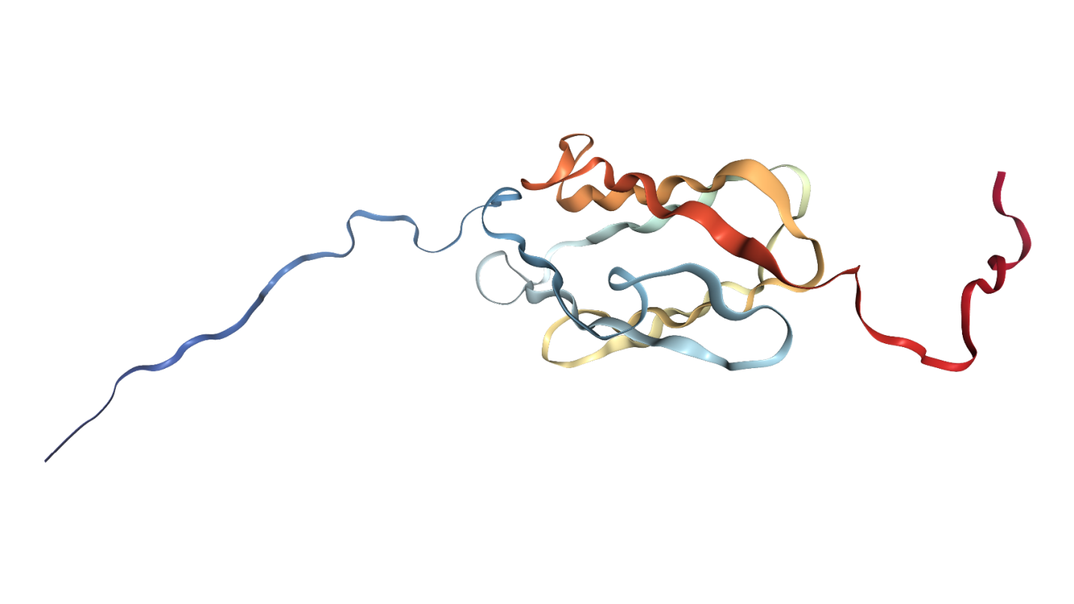
Supplementary Figure 1. Legumain cleavage of filamin B (Uniprot: O75369, PDB structure: 2EEC). Cleavage site is annotated at Asn2483.

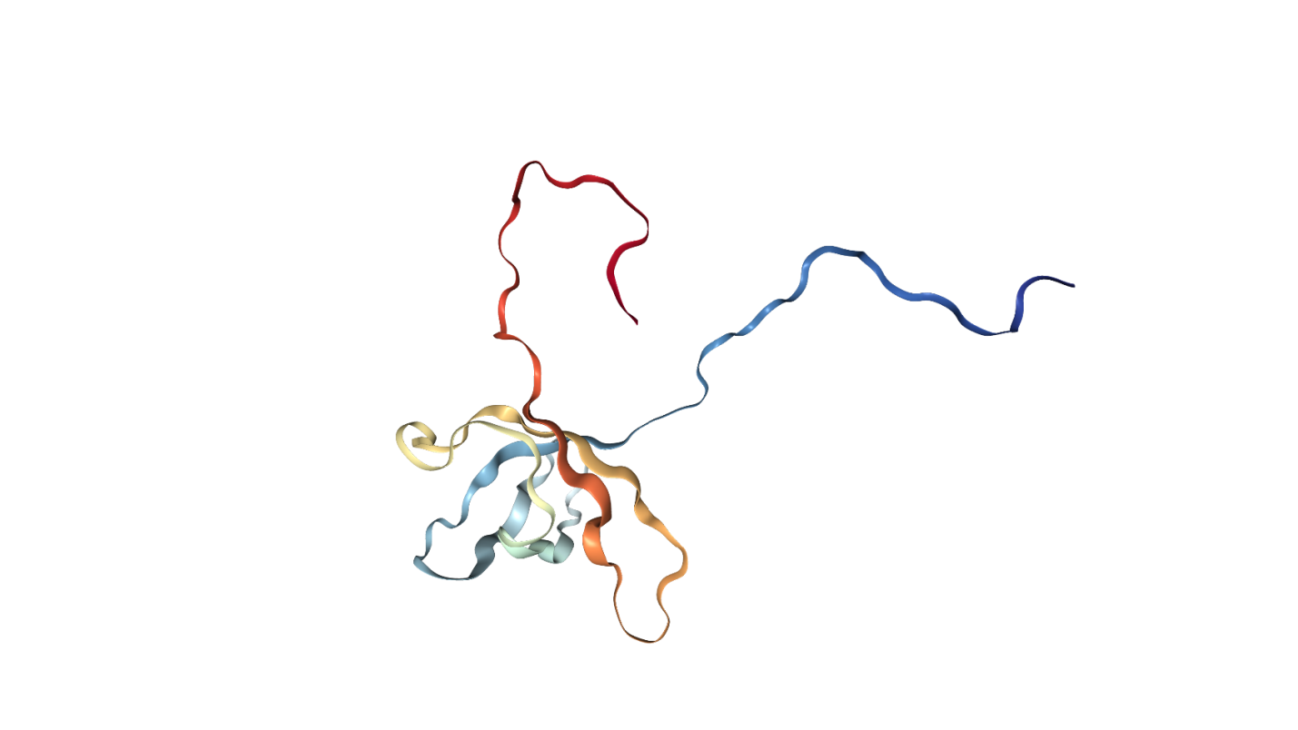
Supplementary Figure 2. Legumain cleavage of cold shock domain-containing protein E1 (Uniprot: O75534, PDB structure: 2YTX). Cleavage site is annotated at Asn175.

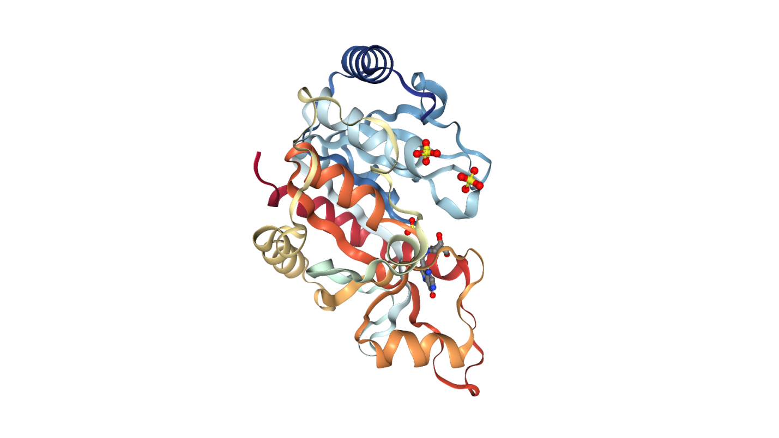
Supplementary Figure 3. Legumain cleavage of purine nucleoside phosphorylase (Uniprot: P00491, PDB structure: 1RSZ). Cleavage site is annotated at Arg58.

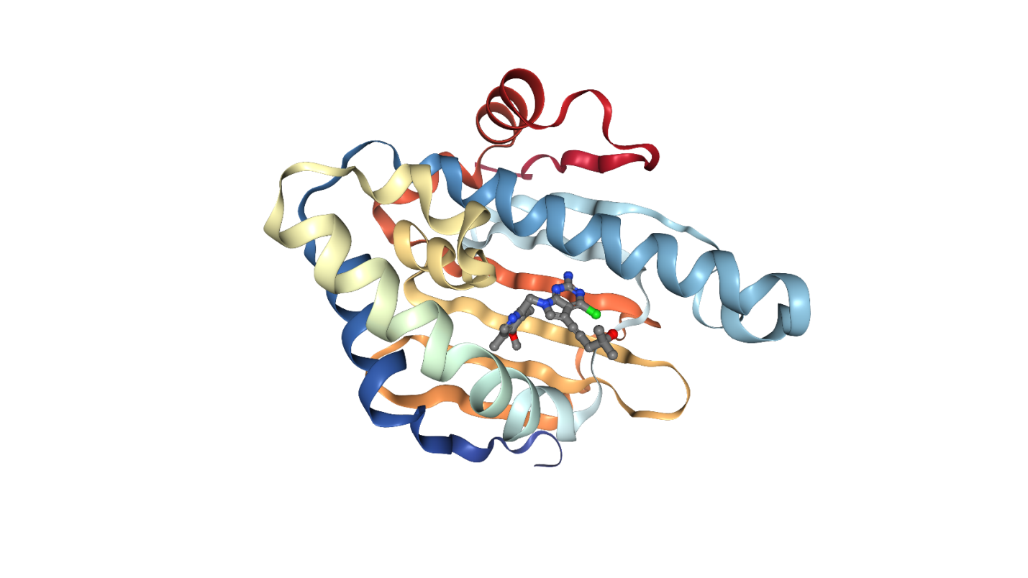
Supplementary Figure 4. Legumain cleavage of heat shock protein HSP 90-beta (Uniprot: P08238, PDB structure: 3NMQ). Cleavage site is annotated at Asn46.

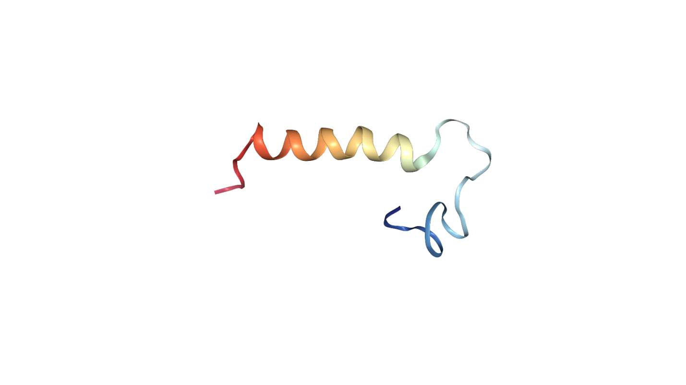
Supplementary Figure 5. Legumain cleavage of elongation factor 1-delta (Uniprot: P29692, PDB structure: 2MVM). Cleavage site is annotated at Asn164.

