Alumazene Reactivity with Quinolinols – Addition and Substitution Reactions on the Al₃N₃ Ring

Iva Kollhammerova,ª Michal Babiak,^{b} Marek Necas,^{a,b} Petr Taborsky,ª Josef Kucera,ª and Jiri Pinkas^{a,b,*}
ª Masaryk University, Faculty of Science, Department of Chemistry, Kotlarska 2, CZ-61137 Brno, Czech Republic.
^{b} Masaryk University, Central European Institute of Technology (CEITEC MU), Kamenice 5, CZ-62500 Brno, Czech Republic.

* Corresponding author: E-mail: jpinkas@chemi.muni.cz
Abstract Molecular structures of two compounds obtained in reactions of alumazene [2,6-i-Pr₂C₆H₃NAlMe]₃ (1) with substituted quinolinols have been elucidated by the single-crystal X-ray diffraction analysis. Quinolin-8-ol (Hq) provides a dinuclear complex [(2,6-i-Pr₂C₆H₃NH)AlMe(q)]₂ (2) with a central Al₂O₂ ring and five-coordinate Al atoms. The compound 2⋅THF crystallizes in the orthorhombic Pbca space group with a = 18.4340(2) Å, b = 19.5025(2) Å, c = 24.8159(3) Å, V = 8921.54(17) Å³ at 120 K with Z = 8. The molecular structure of a mononuclear complex [(2,6-i-Pr₂C₆H₃NH)Al(q)₂] (3) obtained in the reaction of 1 with 2-methyl-quinolin-8-ol (HMeq) possesses a five-coordinate Al center. The structure was solved in a triclinic cell P−1 with a = 9.2594(6) Å, b = 12.0558(8) Å, c = 13.0966(9) Å, α = 97.9614(17)°, β = 97.0073(17)°, γ = 109.2690(18)°, V = 1344.59(16) Å³ at 120 K with Z = 2. The dinuclear complex 2 can be considered as a model product of alcohol addition on the formal Al−N double bond, while the mononuclear complex 3 represents subsequent reaction of remaining Al−Me moiety with proton. Both complexes 2 and 3 are highly luminescent showing emission around 500 nm in solid state.

Keywords:
alumazene; crystal structure; quinolin-8-ol; 2-methylquinolin-8-ol; luminescence

1. Introduction
So far only two examples of synthetic procedures leading to cyclic trimeric iminoalane (alumazene-type) molecules were published. The first one is a two-step synthesis from trimethylaluminium and diisopropylaniline in toluene. Dimeric aminoalane formed in the initial step is transformed in the second step by heating to trimeric iminoalane [2,6-i-Pr₂C₆H₃NAlMe]₃ (1).^{1–3} The second route to an alumazene derivative is a one-pot reaction of (Me₃Si)₃Al∙OEt₂ with 2,6-diisopropylaniline. An adduct [(Me₃Si)₃Al∙N(H)₂(2,6-i-Pr₂C₆H₃)] is formed by coordination of the nitrogen lone pair to the Al center. Refluxing in toluene leads to the formation of [2,6-i-Pr₂C₆H₃NAlSiMe₃]₃ (4).⁴ Alumazene in comparison with its isoelectronic analogue benzene is not aromatic, its π electrons are not delocalized, and the Al−N bonds are highly polar.^{5,6} Chemical reactivity of alumazene reflects this bonding situation. The Al atoms are Lewis acidic and are capable of accepting lone pairs of Lewis O- and N-bases. Several types of mono-, bis-, and trisadducts were reported in the literature.^{7–11} Stepwise fluorination of alumazene 1 by Me₃SnF or by BF₃ represents metathesis reactivity leading to the substitution of the methyl groups on aluminium.¹² Dealkylsilylation reactions of 1 with trimethylsilyl esters of sulfonic, phosphoric, and phosphonic acids are another type of alumazene reactivity.^{13,14} These reactions are driven by the formation of strong Al−O−P/S bonds and elimination of small molecules, such as SiMe₄. Although all bonds in the planar Al₃N₃ core of 1 are of the same length, the ring can undergo reactions that can be classified as an addition on a formal double bond. This type of transformations can be exemplified by reactions of 1 with silanetriols and isoelectronic triaminosilanes. Adamantane-like structures are formed in these reactions by triple proton transfer to the alumazene nitrogen atoms and connecting the three Al atoms to oxygens or nitrogens of the particular reagent. In the resulting molecules, alumazene ring lost its planarity and both Al and N atoms are four-coordinate.¹⁵ Titanocene and zirconocene fluorides react with 1 under fluorine-nitrogen exchange creating adamantane-like cage molecules.^{16,17}
Quinolin-8-olate complexes of aluminium are widely investigated because they are suitable materials for use in organic light-emitting diodes (OLED). Metal complexes bearing quinolin-8-olato derivatives are applied as the emissive and electron transporting materials in electroluminiscent devices.¹⁸⁻²⁰ The most frequently used material is Al(quinolin-8-olate)₃ (Alq₃)¹⁸ which has been carefully studied and its physico-chemical properties, such as refractive index^{21,22} and absorption coefficient^{23,24} have been measured.
Besides the tris(quinolin-8-olato) complexes, other types of ligand arrangement are sought as they provide a way to control emission wavelength. Bis(2,4-dimethyl-quinolin-8-olato)(triphenylsilanolato)aluminum was synthesized from aluminium iso-propoxide and two ligands, 2,4-dimethyl-quinolin-8-ol and triphenylsilanol. This complex with five-coordinate Al showed no glass temperature and no phase transition before the melting point and the thermally stable thin films could be easily formed.²⁵ The photoluminescence (PL) spectrum of the complex shows the largest hypsochromic shift among the blue-emitting [q₂AlOR]-type complexes. Some complexes of Al with polymerizable quinolin-8-olato ligands were used in a copolymerization reactions leading to products with good PL properties.²⁶ Two new complexes were prepared by the reactions between AlCl₃∙6H₂O and 5,7-dichloro- or 5,7-dibromo-quinolin-8-ol providing homoleptic Al(ligand)₃ complexes.²⁷ Authors studied their electroluminescent properties. A series of 3-, 4-, and 5-methylquinolin-8-olate complexes of Al and Ga was prepared and the photo- and electroluminescence properties were examined.²⁸ Although methylation improved PL quantum efficiency, it also reduced intermolecular interactions and decreased charge transport through the film. Complexes of aluminium with 4-(2-arylvinyl)-quinolin-8-olates prepared by anhydrous Heck coupling with judicious choice of substituents display enhanced PL intensity and quantum yield.²⁹
Quinolin-8-olate complexes of Al are also used as catalysts in the ring-opening polymerization (ROP). Mononuclear and dinuclear complexes with bulky 2-(arylimino)quinolin-8-ols were prepared. The dimeric complexes were obtained by the stoichiometric reaction of AlMe₃ with the corresponding ligands in n-heptane. These compounds are insoluble in n-heptane and only slightly soluble in toluene, THF, CH₂Cl₂, and CHCl₃. The stoichiometric reactions of appropriate ligands with AlMe₃ in toluene produce molecular compounds Me₂AlL and by-products Me₂AlL∙AlMe₃. The mononuclear complexes exhibit high activity towards the ROP reaction of ε-caprolactone in the presence of benzyl alcohol, while the dinuclear complexes exhibit no activity in this polymerization reaction.^{30,31} The complexes of aluminium with quinoline-based N,N,O-tridentate and N,N,N-chelate ligands were used for ring-opening polymerization of ε-caprolactone. Complexes were prepared by simple mixing of ligand and AlMe₃ at room temperature in toluene.^{32,33}
The aim of this research was to investigate the reactivity of alumazene 1 towards quinolinols as chelating ligands bearing an active proton and a nitrogen donor atom. The two ligands used in this study differ in their steric hindrance and we expected different products from their reactions. We present here the synthesis and characterization by single-crystal X-ray diffraction analysis of two complexes 2 and 3 displaying a different nuclearity and metal-to-ligand ratio.

2. Experimental

2. 1. General Procedures and Characterization
All manipulations were performed under a dry nitrogen atmosphere by Schlenk techniques or in MBraun Unilab dry box maintained under 1 ppm of both O₂ and H₂O. Solvents were stored and handled under nitrogen atmosphere in a glovebox or in Schlenk flasks. Melting points were measured on a Buchi B540 apparatus in glass capillaries sealed in glovebox. The IR spectra (4000–400 cm^{–1}) were recorded on a Bruker Tensor T27 spectrometer. Samples were prepared as KBr pellets. EI-MS measurements were performed on a TSQ Quantum XLS mass spectrometer. Solid samples of 2 and 3 were introduced into the spectrometer via direct insertion probe (DIP) in open quartz capillaries and heated from r. t. to 450 °C. The source temperature was set to 200 °C and ionization energy to 22 eV. Aluminium contents were determined on an ICP optical emission spectrometer iCAP 6500 Duo (Thermo, UK) equipped with a solid-state generator with a frequency of 27.12 MHz and a maximum power input 1350 W. The measurements of Al were performed at 308.2, 394.4 and 396.1 nm with RF power of 1150 W; analysis pump rate 1 cm³ min^{–1}; nebulizer gas flow 0.65 dm³ min^{–1}; coolant gas flow 12 dm³ min^{–1}; auxiliary gas flow 0.6 dm³ min^{–1}; flush time 30 s; flush pump rate 2 cm³ min^{–1}; pump stabilization time 5 s; integration time (high WL range) 5 s; the number of repeats 3; plasma view radial.
2. 2. Reagents
8-hydroxyquinoline (Hq, Aldrich, 99 %) and 2-methylquinolin-8-ol (HMeq, Aldrich, 98 %) were dried under dynamic vacuum for 2 d prior to use. Solvents were dried over and distilled from Na/benzophenone under nitrogen. Solvents were degassed prior to use. Alumazene 1 was prepared by a modified procedure from AlMe₃ and 2,6-diisopropylaniline.³

2. 3. Synthesis of 2
8-hydroxyquinoline (0.023 g, 0.16 mmol) was added to the solution of 1 (0.1045 g, 0.1603 mmol) in dry deoxygenated heptane (1 mL). THF (5 mL) was added and the reaction mixture was stirred for 2 h. The reacting mixture was concentrated to ¼ of its starting volume and stored at −25 °C. After six months, colorless crystals were obtained. The crystals for the X-ray diffraction analysis were used directly from the mother liquor. Yield: Crystals 0.013 g, 5.5 %, polycrystalline powder 0.140 g, 73 %. Melting point: 247 °C.

EI DIP MS (22 eV): m/z (int. %) 651.84 (10) [M − i-Pr − 2CH₃]⁺; 460.74 (40) [M − Dipp − i-Pr − 4CH₃]⁺; 333.73 (30) [M − Dipp − i-Pr − 4CH₃ − C₉H₆N]⁺; 314.90 (90) [M − Dipp − i-Pr − 4CH₃ − C₉H₆NO]⁺; 282.49 (70); 184.03 (100); 144.95 (100) [C₉H₇NO]⁺.

Elemental analysis: Al% Calcd. for C₄₈H₆₂N₄O₃Al₂ 6.77. Exp. 6.44 ± 0.03.

IR (cm⁻¹): ν 3046 w, 2961 w, 2928 w, 2865 w, 1065 m, 1058 m, 1499 vs, 1470 s, 1385 vs, 1330 m, 1283 w, 1230 w, 1115 m, 1033 w, 825 m, 805 m, 789 m, 749 s, 649 m, 549 m, 457 w, 419 m.

2. 4. Synthesis of 3
2-methylquinolin-8-ol (0.024 g, 0.15 mmol) was added to the solution of 1 (0.119 g, 0.183 mmol) in dry deoxygenated THF (5 mL). The reaction mixture was concentrated to ¼ of its starting volume and stored at −25 °C. The colorless crystals for the X-ray diffraction analysis were used directly from the mother liquor. Yield: Crystals 0.028 g, 10 %, polycrystalline powder 0.194 g, 68 %. Melting point: 214 °C.

EI DIP MS (22 eV): m/z (int. %) 343.01 (77) [M − HNDipp]⁺; 176.92 (55) [HNDipp]⁺; 161.86 (100) [Dipp]⁺.

Elemental analysis: Al% Calcd. for C₃₂H₃₄N₃O₂Al 5.19. Exp. 5.15 ± 0.05.

IR (cm⁻¹): ν 3053 m, 2962 s, 2926 m, 2867 w, 1613 m, 1578 vs, 1508 vs, 1465 vs, 1432 vs, 1432 vs, 1394 m, 1341 m, 1332 w, 1274 vs, 1262 s, 1243 w, 1171 w, 1114 vs, 1018 s, 869 w, 829 s, 795 s, 772 vs, 741 s, 688 m, 675 s, 530 m, 435 w.

2. 5. X-Ray structure determination
Diffraction data were collected using a Rigaku X-ray diffraction system, equipped with a MicroMax-007HF double wavelength rotating anode X-ray source (λ = 0.71075 Å, Mo radiation), VariMax DW optics, a partial χ axis geometry goniometer, a Saturn 724+ HG CCD detector and a Cryostream cooling device. CrystalClear³⁴ software was used for data collection.
Processing of diffraction images was carried out using CrysAlisPro.³⁵ SHELXT and SHELXL programs³⁶ were used to solve and refine models (full matrix least-squares refinement on F²). All non-hydrogen atoms were refined anisotropically. ADPs of nitrogen bonded hydrogen atoms were set to 1.2 U_{eq} of carrier atoms, and respective N–H distances were restrained to 0.88 Å. All other hydrogen atoms were placed to the calculated positions and refined as riding (CH₃ hydrogens also rotating), with their U_{iso} values set to 1.2 U_{eq} (1.5 U_{eq} for methyl hydrogens) of respective carrier atoms. Positionally disordered fragments were treated by geometric restraints, ADP similarity restraints and rigid bond restraints. In these cases, the sum of site occupancy factors was fixed to be equal to 100 %. Relevant crystallographic data are shown in Table 1.
2. 6. Luminiscence measurements
Samples of 2 and 3 were prepared as powders in quartz capillaries (4 mm diam.) and as dilute solutions (0.719 mol l⁻¹ for 2 and 0.718 mol l⁻¹ for 3) in CH₂Cl₂. Emission and excitation spectra were measured by steady-state fluorescence spectroscopy on the Aminco Bowman Series 2 spectrofluoremeter equipped with 150 W Xe lamp. Excitation monochromator was set at 370 nm for both samples. Emission monochromator was set at 502 nm for sample 2 and 497 nm for sample 3. Quantum yields were estimated using secondary method with quinine bisulphate in H₂SO₄ as a luminescence standard. Luminescence lifetimes were measured by time correlated single photon counting instrument SPC-130EM (Becker and Hickl GmbH) equipped with 408 nm laser diode (picosecond resolution, repeating frequency 150 MHz).All luminescence measurement were recorded at 25 °C.

Table 1. Crystal data and structure refinement summary
Compound | 2⋅THF | 3
Empirical formula | C₄₈H₆₂Al₂N₄O₃ | C₃₂H₃₄AlN₃O₂
Formula weight | 796.97 | 519.60
Temperature (K) | 120(2) | 120(2)
Crystal system | orthorhombic | triclinic
Space group | Pbca | P-1
a (Å) | 18.4340(2) | 9.25960(10)
b (Å) | 19.5025(2) | 12.05340(10)
c (Å) | 24.8159(3) | 13.09420(10)
α (°) | 90 | 97.9350(10)
β (°) | 90 | 97.0130(10)
γ (°) | 90 | 109.2860(10)
Volume (Å³) | 8921.54(17) | 1344.06(2)
Z | 8 | 2
ρ_{calc} (g/cm³) | 1.187 | 1.284
μ (mm⁻¹) | 0.110 | 0.110
F(000) | 3424.0 | 552.0
Index ranges | -22 ≤ h ≤ 22  -23 ≤ k ≤ 23  -30 ≤ l ≤ 29 | -10 ≤ h ≤ 11  -14 ≤ k ≤ 14  -15 ≤ l ≤ 15
Reflections collected | 52737 | 16096
Independent reflections | 8470  (R_{int} = 0.0201,  R_{sigma} = 0.0102) | 5048  (R_{int} = 0.0136,  R_{sigma} = 0.0123)
Data / restraints / parameters | 8470 / 244 / 576 | 5048 / 1 / 352
Goodness-of-fit on F² | 1.017 | 1.037
Final R indices  [I ≥ 2σ(I)] | R₁ = 0.0442  wR₂ = 0.1171 | R₁ = 0.0358  wR₂ = 0.0940
Final R indices  [all data] | R₁ = 0.0477  wR₂ = 0.1205 | R₁ = 0.0385  wR₂ = 0.0962
Largest diff. peak / hole  (e Å⁻³) | 0.47 / -0.31 | 0.32 / -0.27

3. Results and Discussion

3. 1. Synthesis
The compound 2 was prepared as yellow air- and moisture-sensitive crystals, by the reaction of alumazene 1 with 8-hydroxyquinoline in the 1:1 molar ratio (Scheme 1). In the first step quinoline adds at a formal Al−N double bond in 1. Trimeric iminoalane ring structure is destabilized and intermediate substituted aminoalane is probably formed. This intermediate dimerizes and aluminium atoms are connected by oxygen bridges to form the central Al₂O₂ ring. Aluminium coordination number increases to five by bonding to quinoline nitrogen.

Scheme 1

The compound 3 was prepared as air- and moisture-sensitive colorless crystals, by the reaction of 1 with 2-methylquinolin-8-ol in the 1:1 molar ratio (Scheme 2). The first step of the reaction proceeds as in the previous case and 2-methylquinolin-8-ol adds at the formal Al−N double bond in alumazene 1. However, in the second step the intermediate aminoalane reacts with the second molecule of 2-methylquinolin-8-ol by the proton transfer to the methyl group and CH₄ is eliminated. The resulting molecule is monomeric and the coordination number of aluminium atom is increased to five by coordination of two quinolinol nitrogens.

Scheme 2

3. 2. Crystal Structures
Single crystals of 2 suitable for the X-ray diffraction analysis were grown from the mother liquor. The molecular structure is displayed in Figure 1, selected interatomic distances and angles are listed in Table 2. Molecules of 2 crystallize in the orthorhombic space group Pbca. Bonds between aluminium and oxygen atom are longer in comparison with oxoaminoalumosilicates [NH(2,6-i-Pr₂C₆H₃)MeAl]₃O₃SiR₁ with adamantane-like structure, where the Al–O bond distance is 1.74−1.75 Å. Also the bond between aluminum and nitrogen is in comparison with 1 (1.78 Å) elongated to 1.84 Å. The Al–N bond to quinolinol is 2.09 Å long and it is comparable with other donor-acceptor bonds in alumazene–nitrile adducts and in alumazene–pyridine adducts. The Al–C bond as well N–C bond are similar to starting alumazene 1.^{8,15,37} The aluminium atom is five-coordinate and its coordination environment lies between trigonal bipyramidal and tetragonal pyramidal shape (τ = 0.53). All nitrogen atoms have coordination number three, as is the case for bridging oxygen atoms. One molecule of solvent tetrahydrofurane (THF) cocrystallizes within the structure. Packing in the unit cell of 2 is shown in Figure 2.

Table 2. Selected interatomic distances and angles of 2⋅THF
Distances (Å)
Al1–N3 1.8368(13) O1–C10 1.3512(17) Al2–N2 2.1195(13)
Al1–O1 1.8921(11) N3–C21 1.4112(18) Al2–C2 1.9647(18)
Al1–O2 1.9516(11) Al2–N4 1.8283(13) O2–C19 1.3572(18)
Al1–C1 1.9653(17) Al2–O1 1.9769(10) N4–C33 1.4196(18)
Al1–N1 2.0864(13) Al2–O2 1.8778(12)
Angles (°)
O1–Al1–N3 113.80(6) O2–Al2–N4 116.87(6)
O1–Al1–O2 73.85(5) O2–Al2–O1 73.57(4)
O1–Al1–N1 80.01(5) O2–Al2–N2 79.41(5)
O1–Al1–C1 118.68(6) O2–Al2–C2 117.54(7)

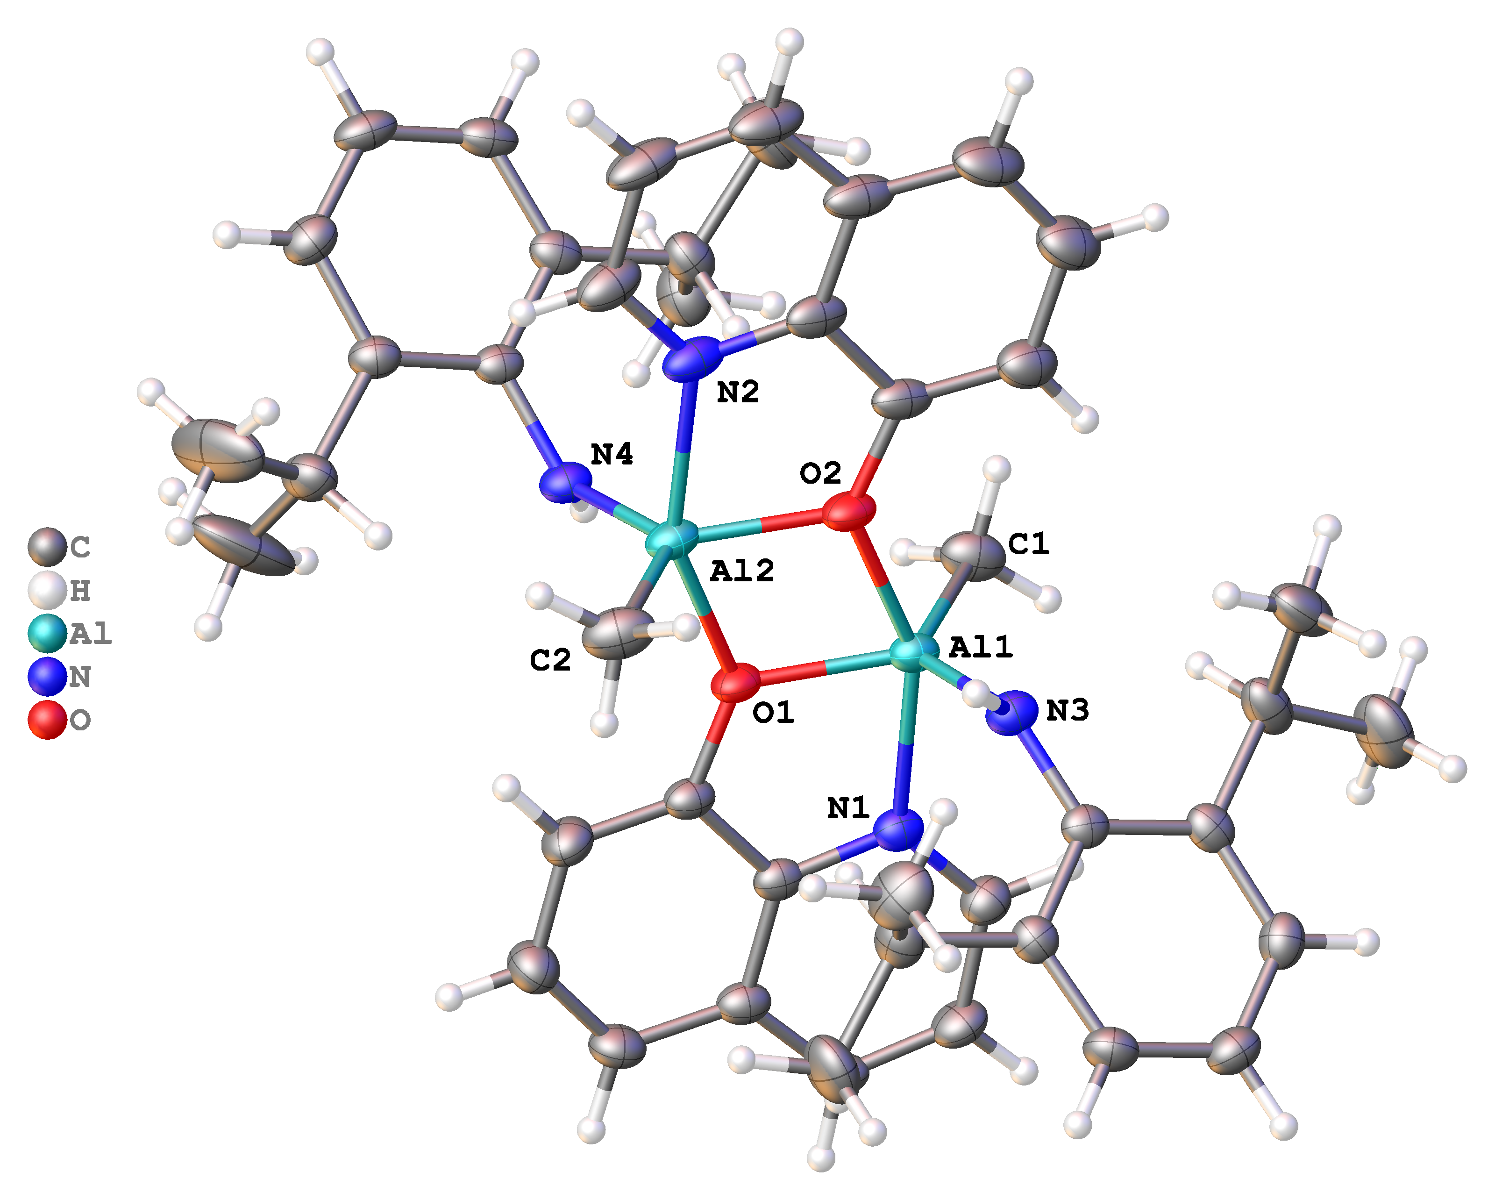

Figure 1. Thermal ellipsoid plot of 2 (disordered solvent molecule was omitted for clarity)
Suitable single crystals of 3 for the X-ray diffraction analysis were grown from the mother liquor. The molecular structure is displayed in Figure 3, selected interatomic distances and angles are listed in Table 3. Molecules crystallize in the triclinic space group P−1. The Al–O bonds are shorter than in 2, but longer than Al–O bonds in oxoaminoalumosilicates [NH(2,6-i-Pr₂C₆H₃)MeAl]₃O₃SiR₁ (1.74−1.75 Å). The Al1–N41 bond is comparable to 2 but it is longer in comparison with 1 (1.78 Å). The other Al–N bonds are 2.08 Å long and they are comparable with Al–N in other alumazene-nitrile and alumazene-pyridine adducts. The coordination number of aluminium is five and its environment is close to trigonal bipyramidal (τ = 0.76).^{8,15,37} Packing in the unit cell of 3 is shown in Figure 4.

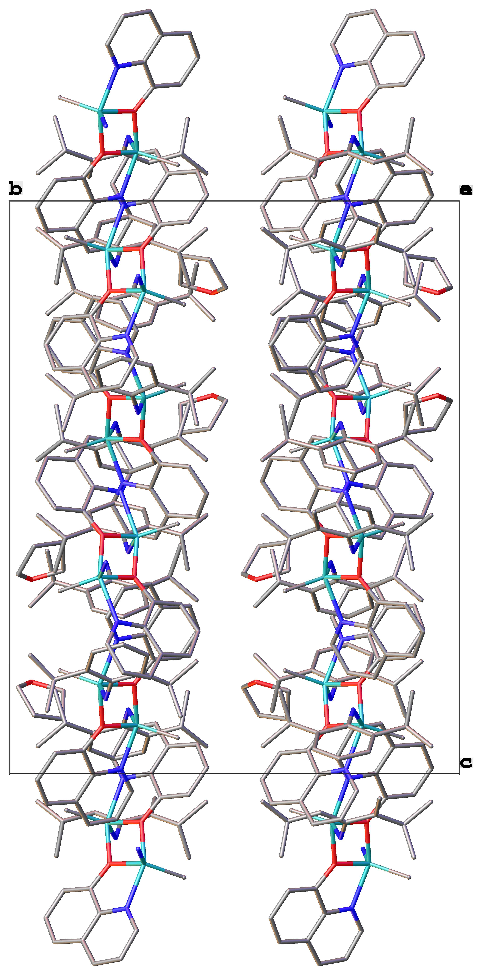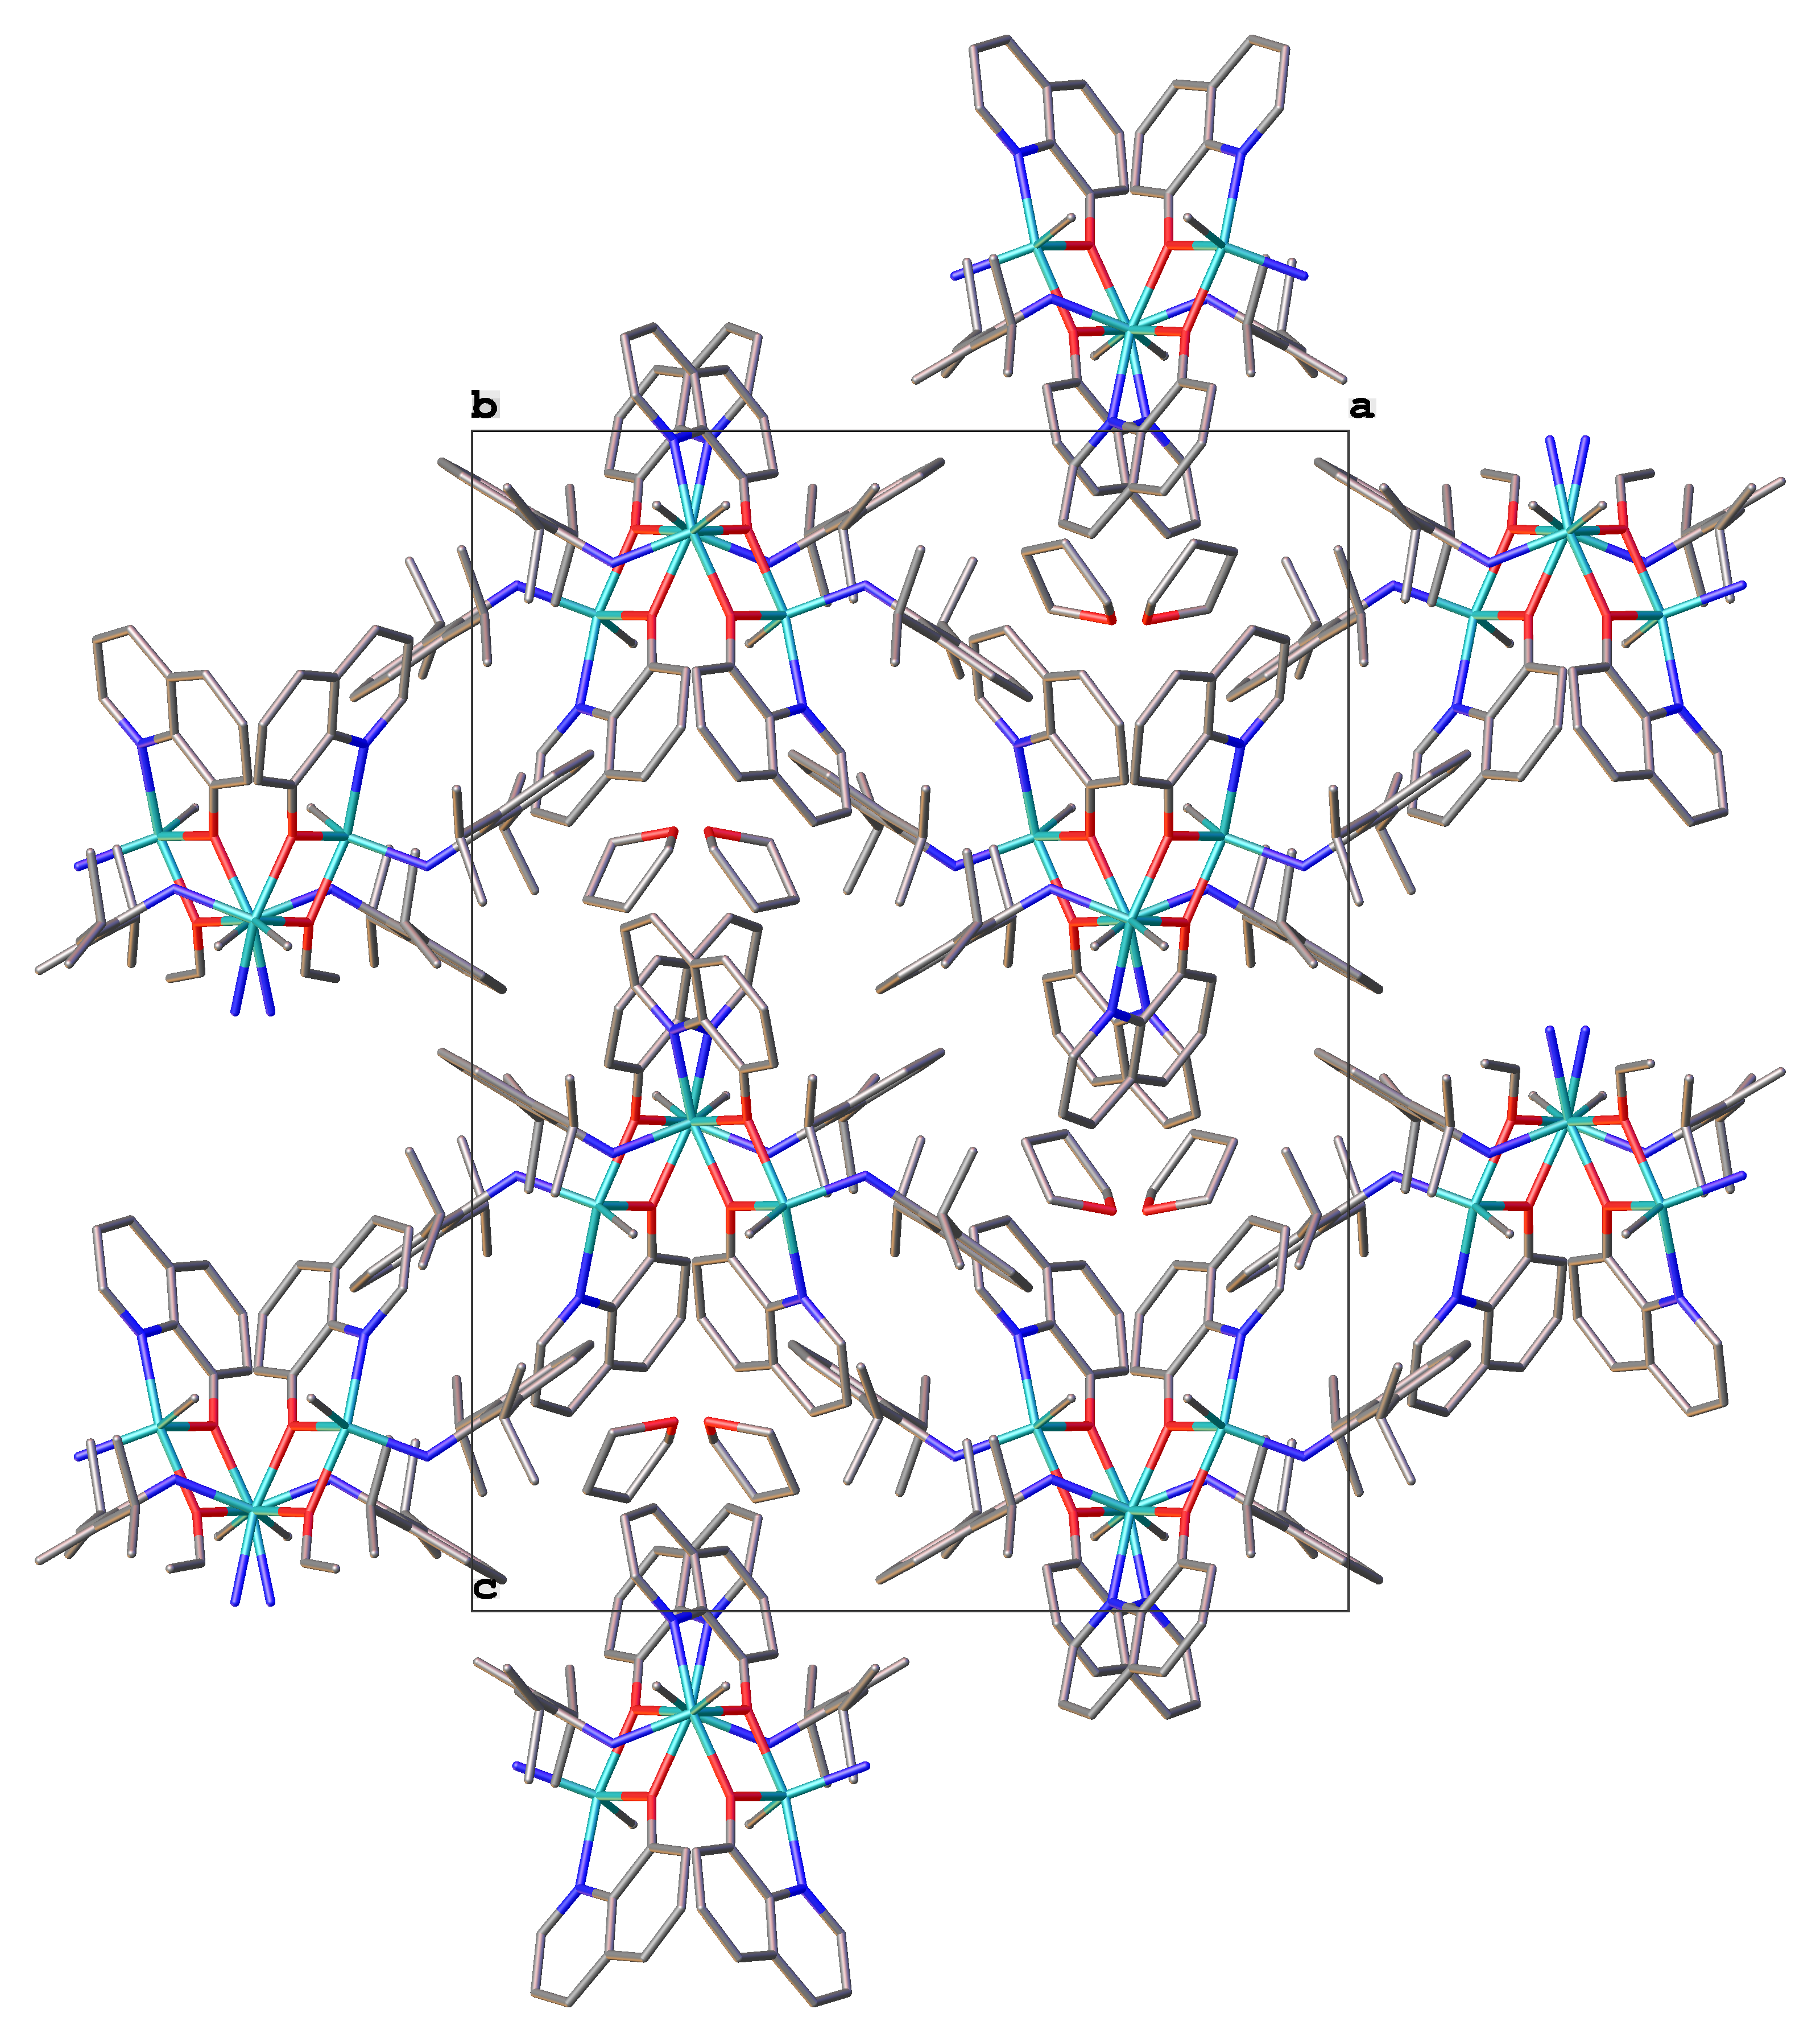

Figure 2. Packing in the unit cell of 2, viewed along b-crystallographic axis (left) and a-crystallographic axis (right), hydrogen atoms were omitted for clarity

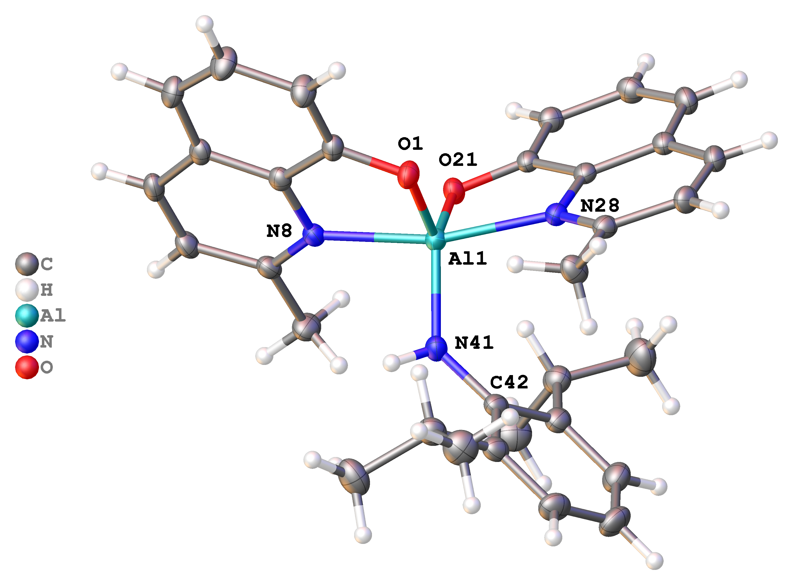
Figure 3. Thermal ellipsoid plot of 3

Table 3. Selected interatomic distances and angles of 3
Distances (Å)
Al1–N8 2.0784(11) Al1–O21 1.8039(9) Al1–O1 1.8034(9)
Al1–N28 2.0782(11) Al1–N41 1.8301(11) N41–C42 1.4057(16)

Angles (°)
O1–Al1–N8 83.78(4) O1–Al1–N28 89.93(4)
O1–Al1–O21 116.08(4) O1–Al1–N41 119.44(5)
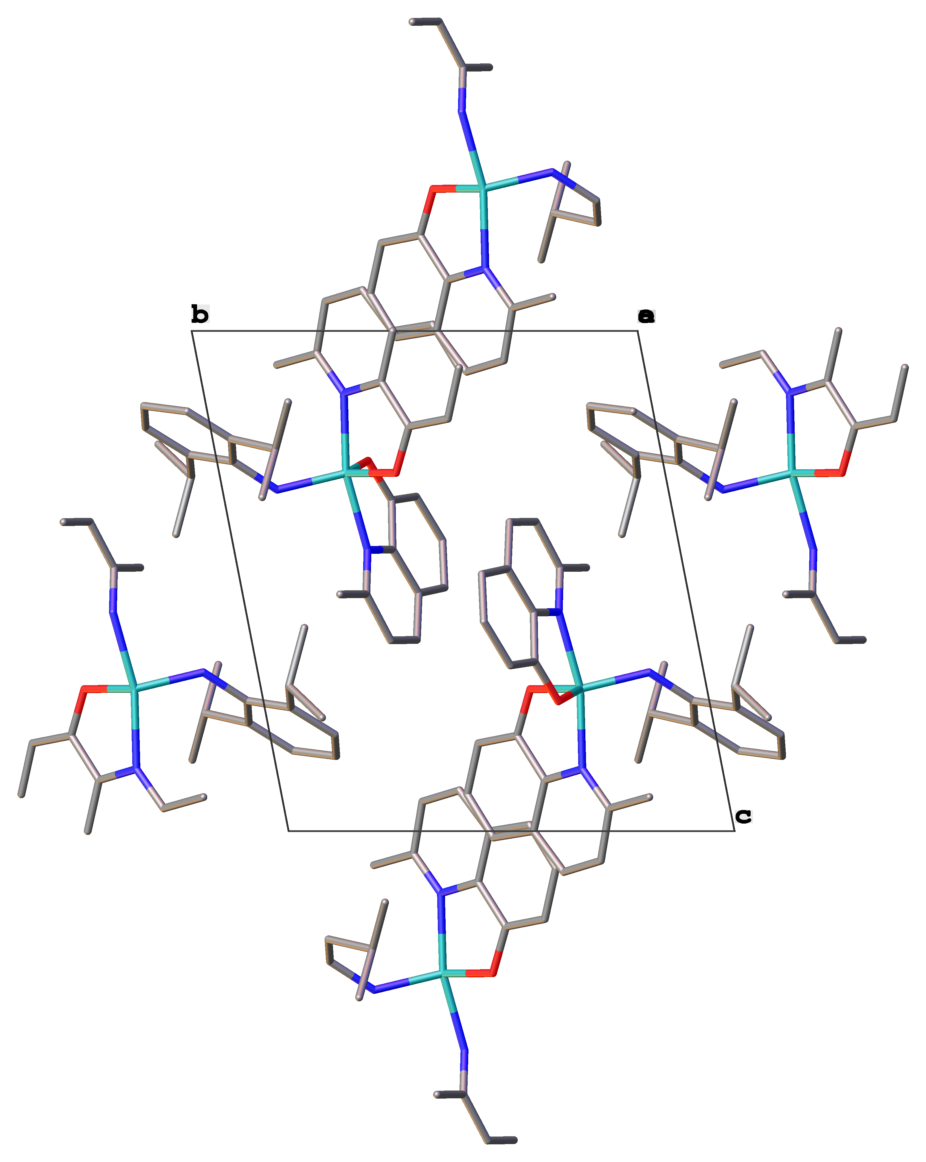
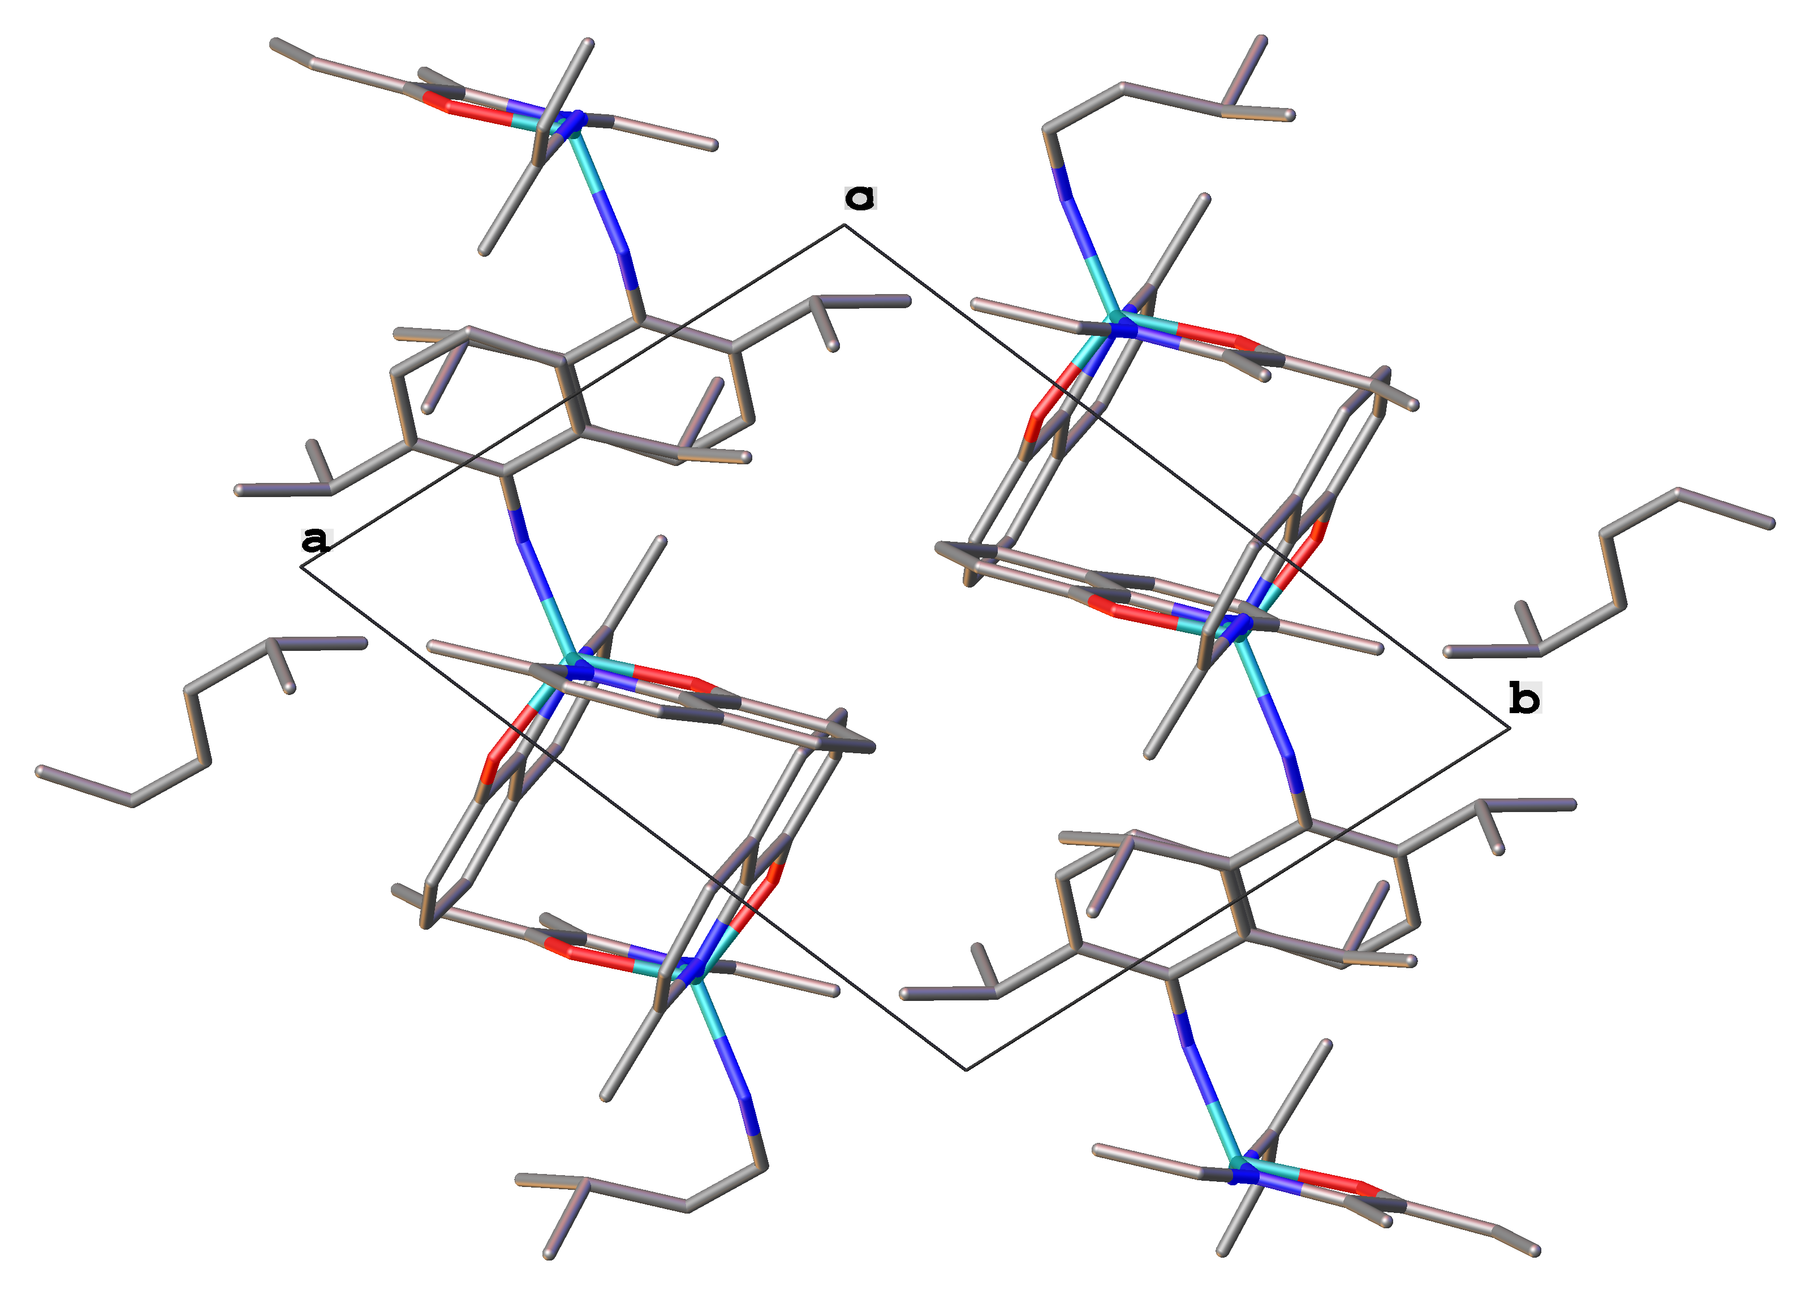

Figure 4. Packing in the unit cell of 3, viewed along c-crystallographic axis (left) and a-crystallographic axis (right), hydrogen atoms were omitted for clarity

3.3. Luminiscence properties
Emission spectra display maxima at 502 nm for 2 and at 497 nm for 3 in solid state (Figure 5). The excitation spectrum of 2 in solid state has shown a wide absorption region (300−450 nm) with maximum around 370 nm while the spectrum of diluted solution of 2 (in CH₂Cl₂) is shifted to higher wavelengths showing several maxima (375, 450, 465 nm). The excitation spectrum of 3 in solid state has maximum also around 370 nm whereas diluted solution of 3 shows at least two distinct peaks (372 and 446 nm). Emission maxima of complexes diluted in CH₂Cl₂ were slightly shifted to shorter wavelengths (500 nm for complex 2, respectively 481 nm for complex 3). Luminescence quantum yields were estimated using secondary method. We have used quinine bisulphate as a standard. Quantum yield of complex 2 was found to be 0.29 whereas 3 displays a yield of only 0.12. Luminescence lifetime of diluted complex 2 was found to be about 17 ns (Figure 6). Lifetime of complex 3 was measured to be significantly longer (27 ns).
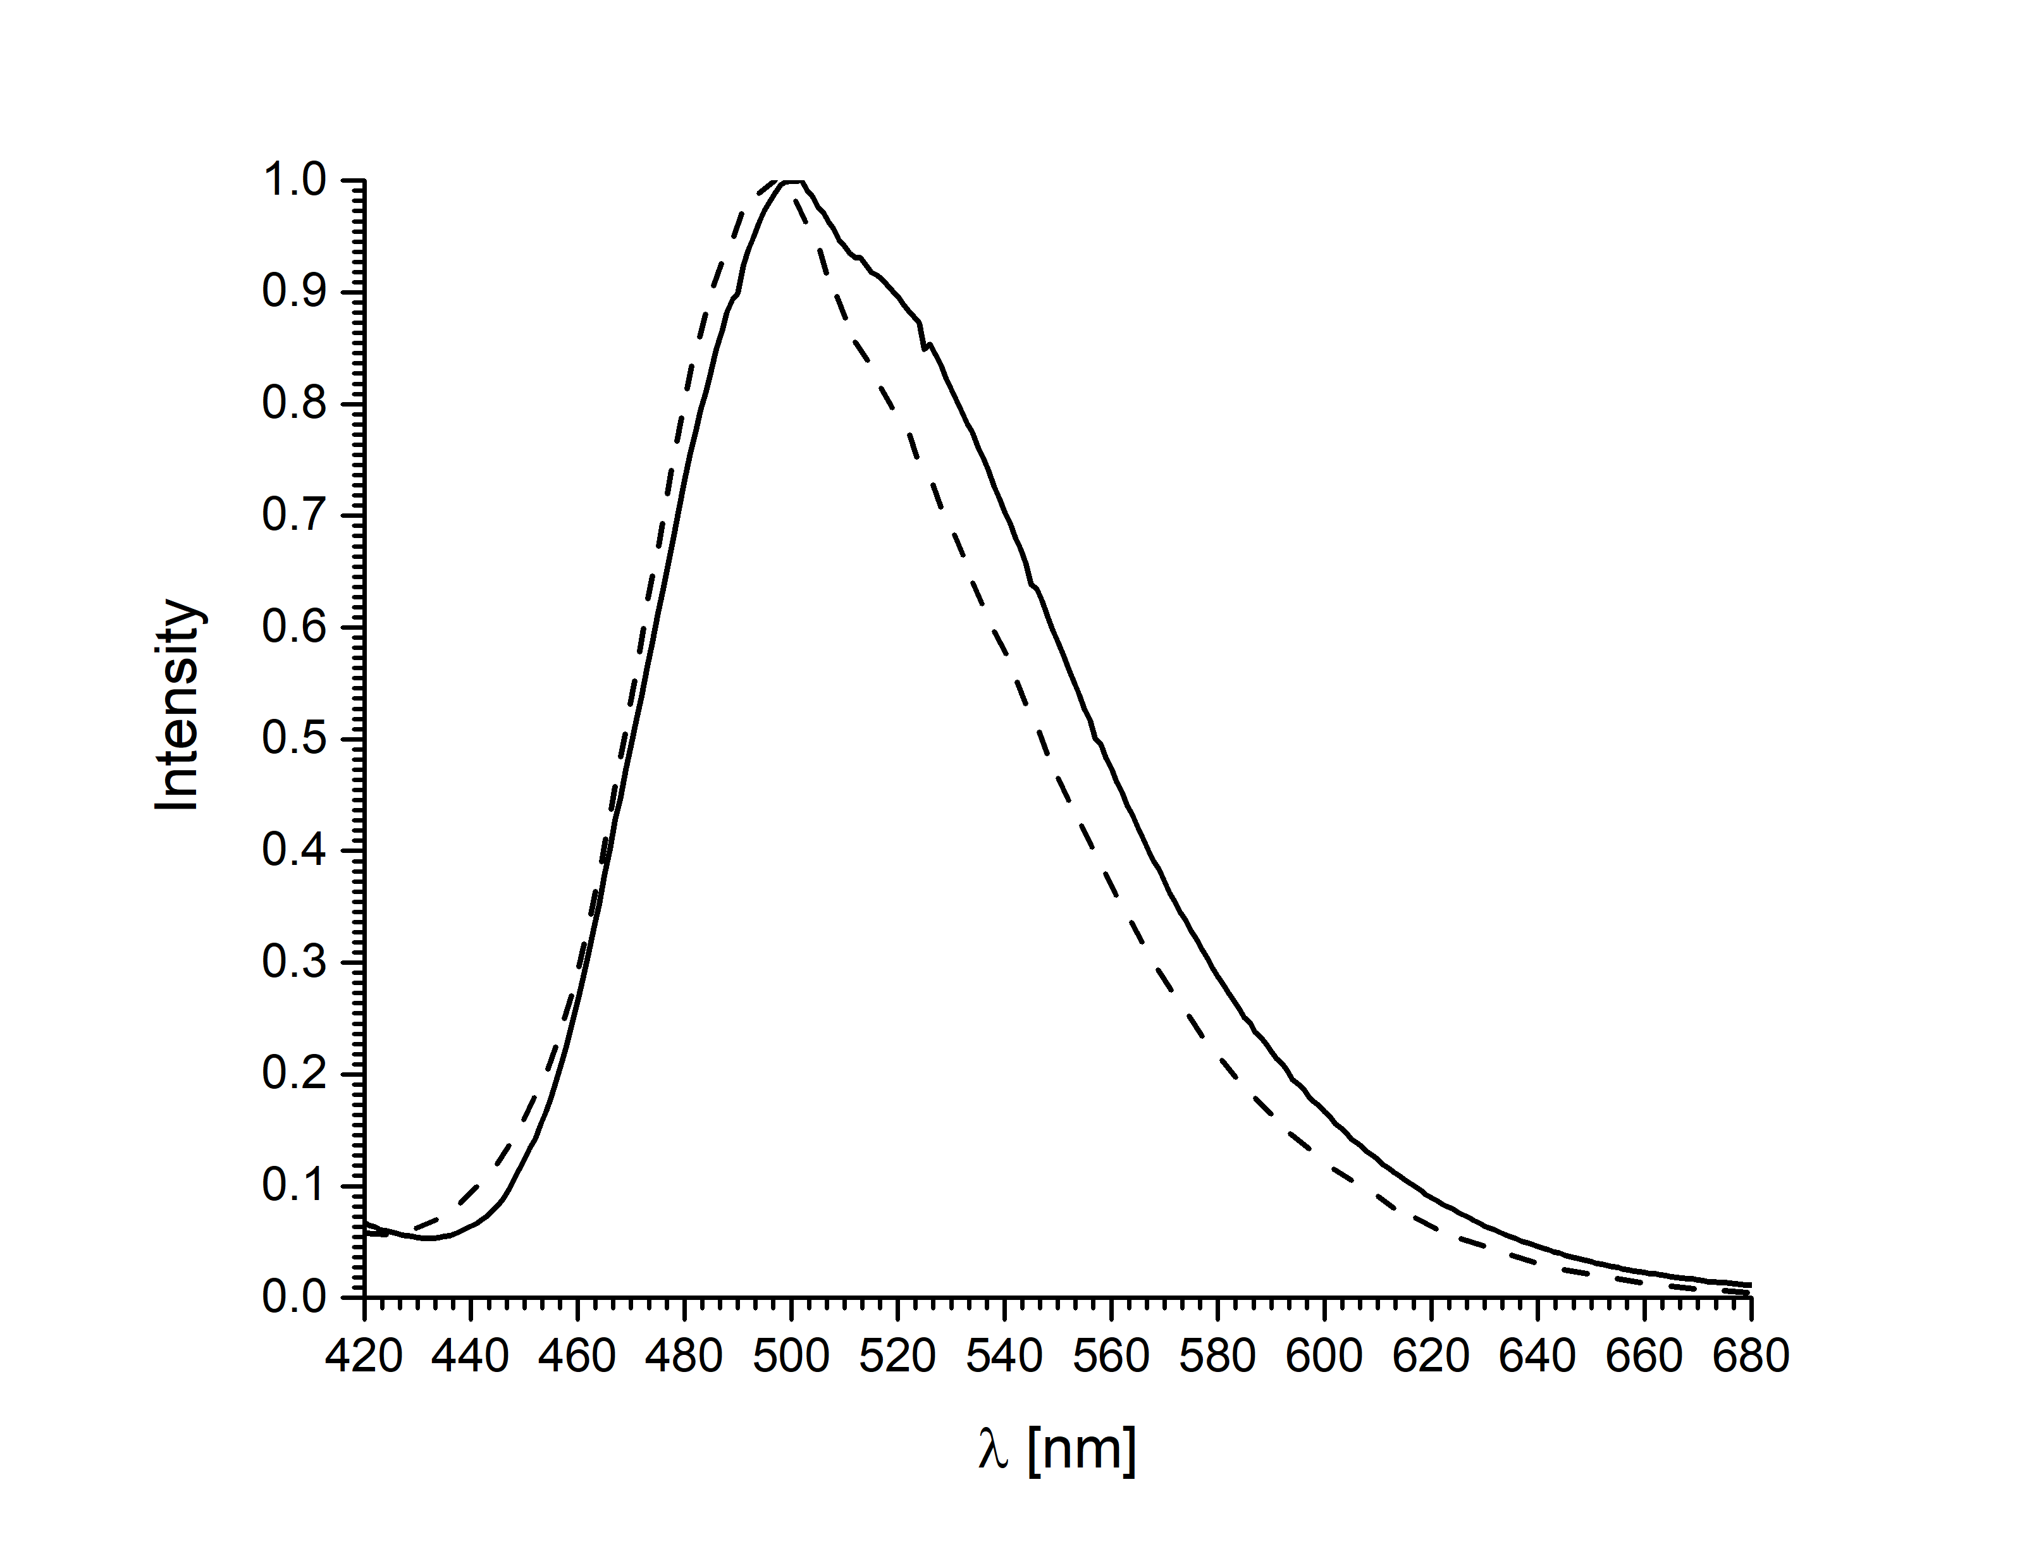
Figure 5. Normalized corrected emission spectra of 2 (solid) and 3 (dashed) complexes in solid state

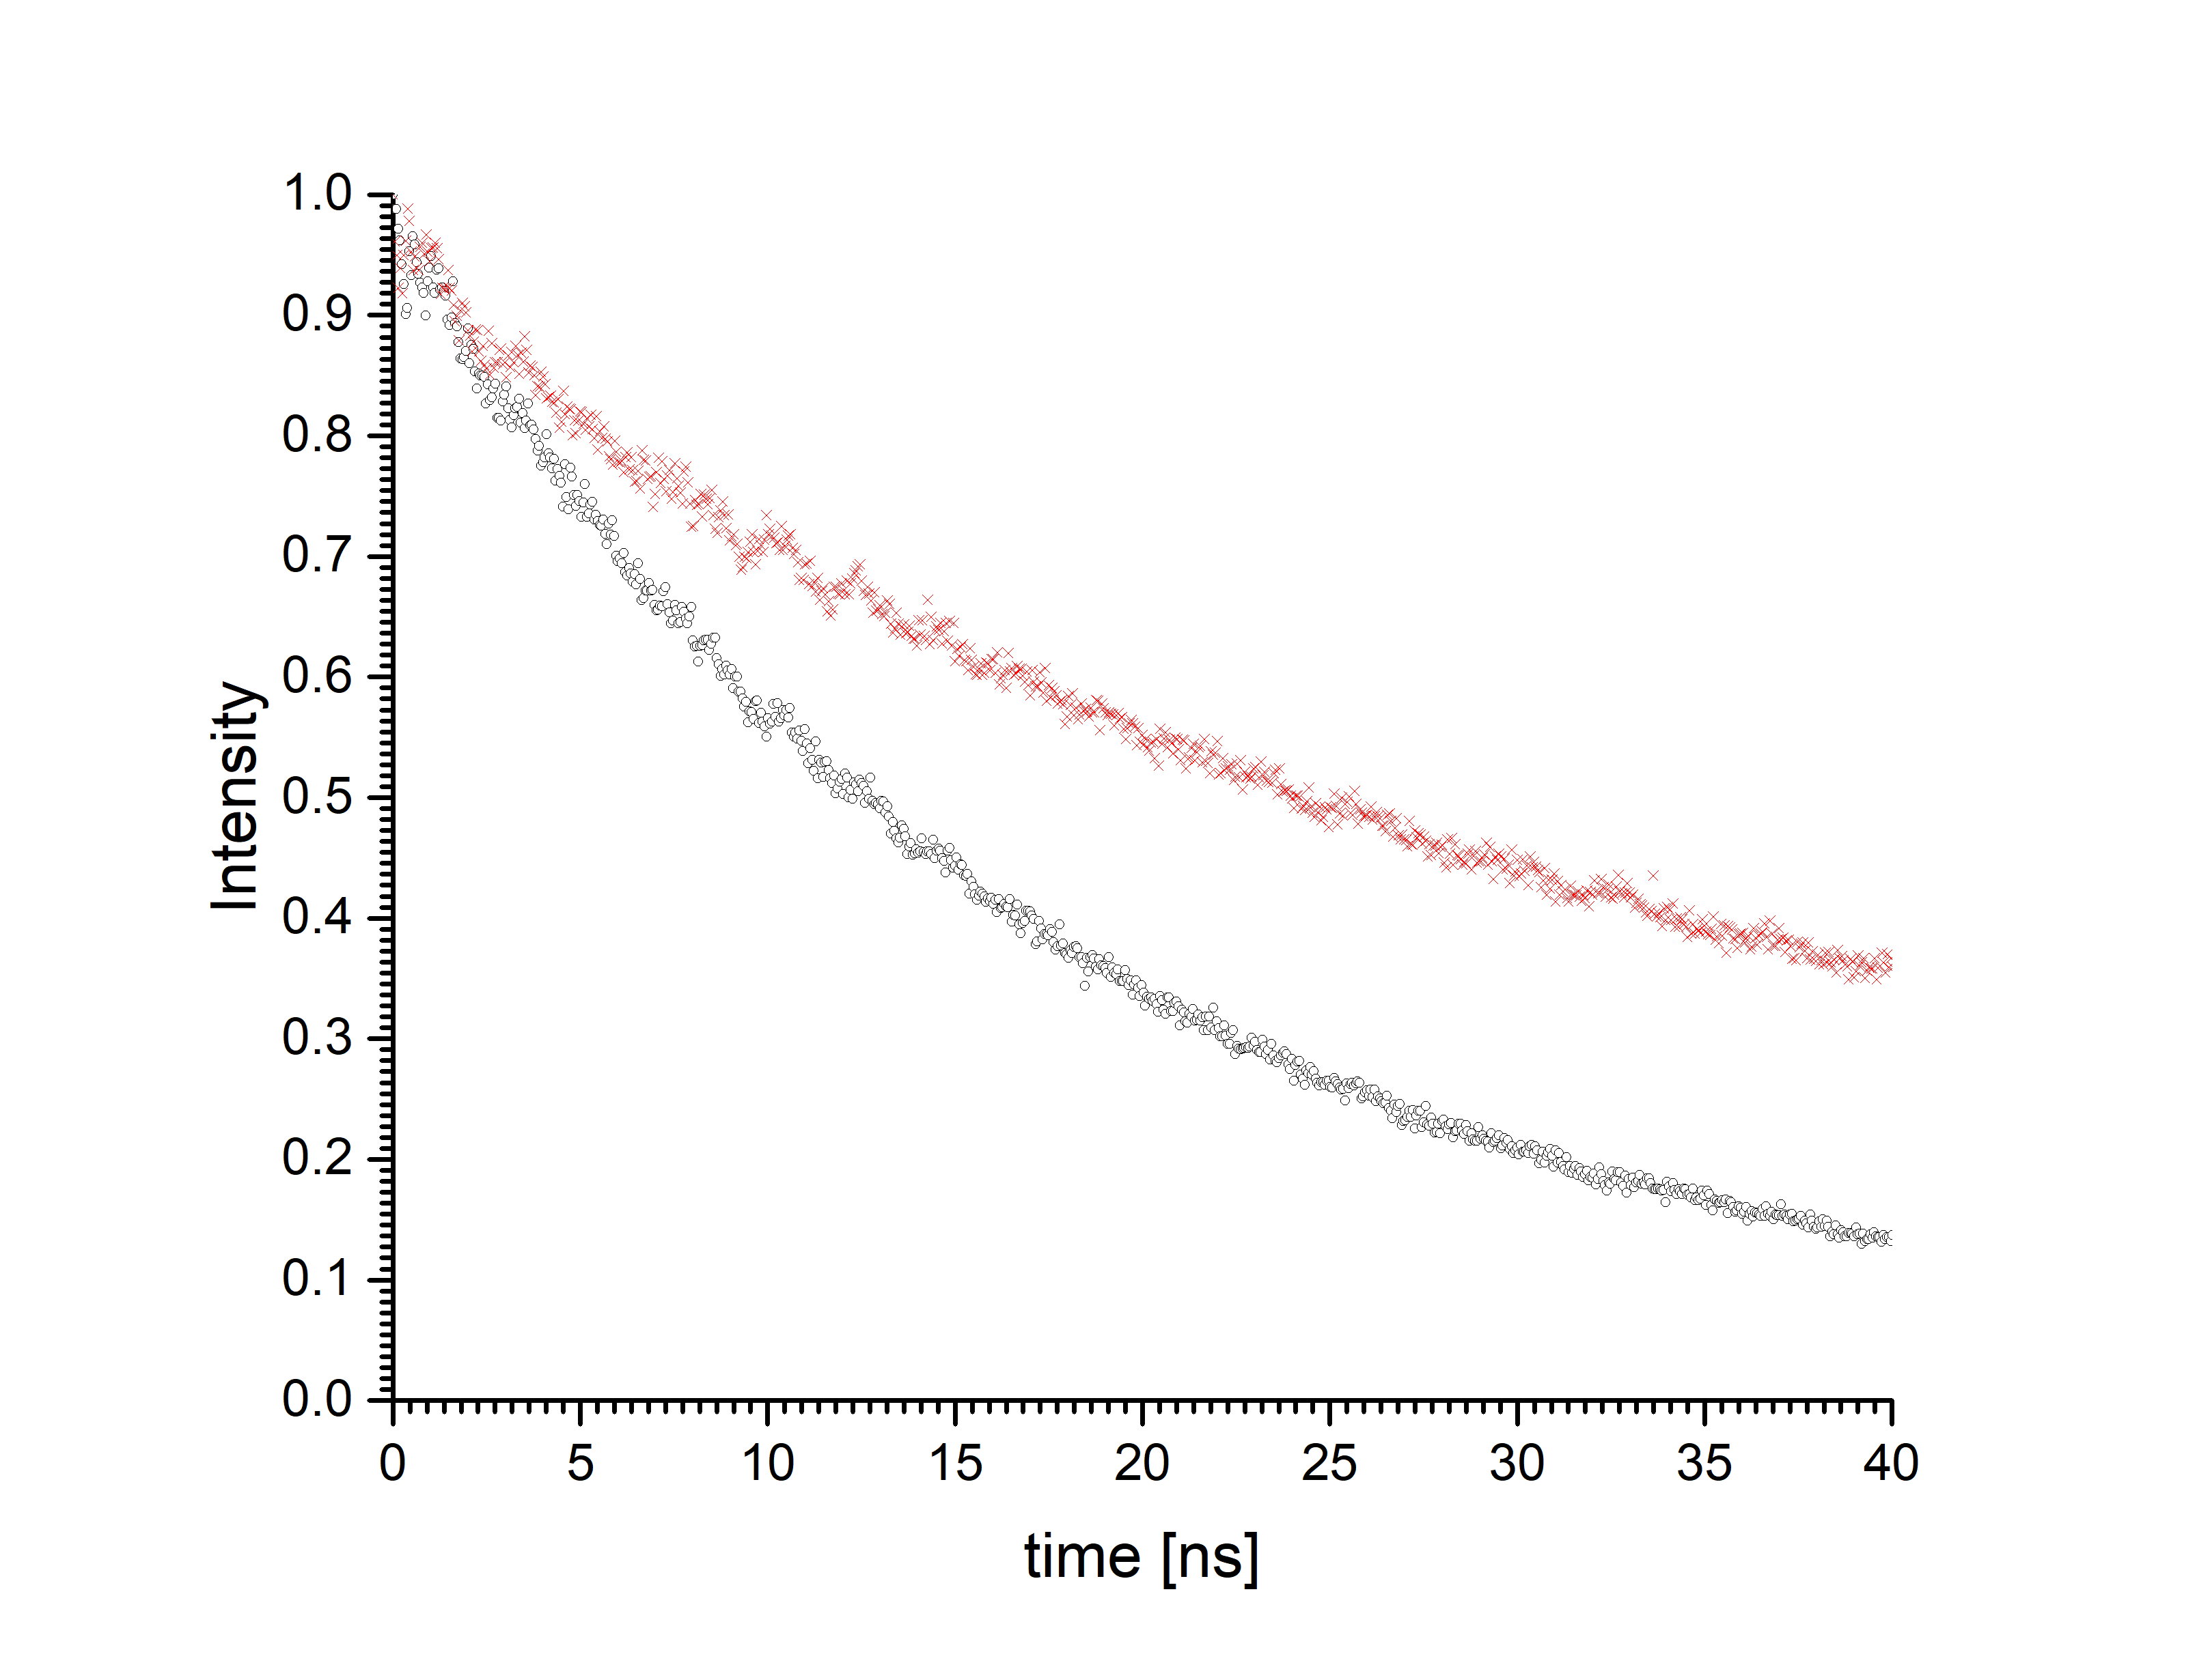
Figure 6. Lifetime measurement of 2 (bottom trace) and 3 (upper trace)

4. Conclusions
New crystalline complexes 2 and 3 were prepared and structurally characterized. The alumazen ring 1 behaves in these reactions as a structure with alternating double and single Al−N bonds, although the calculations predict that the free electron pair is localized at the nitrogen atom and delocalization energy is minimal in comparison to benzene.^{5,6,38} Previous reactions of alumazene (1) were designed as reactions with N- or O-bases.⁷⁻¹⁰ In the present case we use the ligands with the N-donor site and the acidic OH group. The proton is transferred to alumazene imidic nitrogen. In both 2 and 3, the oxygen and nitrogen ligand atoms are coordinated to the aluminium in chelating fashion. Although the used quinolinols differ only in one Me substituent, the final products are quite different. It is well know that the Me group in position 2- on the pyridine ring hinders the formation of tris complexes.¹⁹ The first step of both reactions is identical, addition to a formal Al−N double bond and deoligomerization of the trimeric Al₃N₃ ring. In the second step in the case of complex 2, dimerization of an intermediate occurs, while in the case of 3, an intermediate undergoes substitution reaction of the remaining Me group at aluminium atom and the monomeric product is formed. Both 2 and 3 are interesting precursors for the synthesis of a series of derivatives as they still possess reactive moieties, Al−CH₃ and Al−NH−Dipp, capable of further reactions with protic reagents, such as alcohols, silanols, and carboxylic acids. Both complexes (2 and 3) have relatively high luminescence quantum yields and show greenish-blue (cyan) emission in the solid state. The described complexes may open routes to the development of cyan-light-emitting OLEDs using subtractive colour systems (or subtractive CMYK systems).

5. Acknowledgements
The results of this research have been acquired within CEITEC 2020 (LQ1601) project with financial contribution made by the MEYS CR within special support paid from the National Program for Sustainability II funds. CIISB research infrastructure project LM2015043 funded by MEYS CR is gratefully acknowledged for the financial support of the measurements at the CF X-ray Diffraction and Bio-SAXS and the Josef Dadok National NMR Centre. The authors thank P. Machac for MS measurements and L. Simonikova for ICP-OES analyses.

6. Supplementary Material
The crystallographic data of the structures described in this paper were deposited with the Cambridge Crystallographic Data Centre as supplementary publication no. CCDC-1850453 (2) and 1850454 (3). Copies of these data are available free of charge from http://www.ccdc.ac.uk/conts/retrieving.html, or from the Cambridge Crystallographic Data Centre, 12 Union Road, Cambridge CB2 1EZ, UK; fax: (+44)1223-336-033; or email: deposit@ccdc.cam.ac.uk.

7. References
- K. M. Waggoner, H. Hope, P. P. Power, Angew. Chem. Int. Ed. Engl., 1988, 27, 1699–1700.
- K. M. Waggoner, P. P. Power, J. Am. Chem. Soc., 1991, 113, 3385–3393.
- J. Pinkas, Inorganic Experiments, Woollins J. D., Ed., VCH Weinheim, 3rd Edition, 2010, 402–404, ISBN-10: 3-527-32472-0, ISBN-13: 978-3-527-32472-9.
- M. Fan, E. N. Duesler, H. Hoth, R. T. Paine, Main Group Chem., 2011, 10, 37−50.
- W. H. Fink, J. C. Richards, J. Am. Chem. Soc., 1991, 113, 3393–3398.
- J. J. Engelberts, R. W. A. Havenith, J. H. van Lenthe, L. W. Jenneskens, P. W. Foyer, Inorg. Chem., 2005, 44, 5266–5272.
- J. Löbl, M. Necas, J. Pinkas, Main Group Chem., 2006, 5, 79–88.
- J. Löbl, A. Y. Timoshkin, T. Cong, M. Necas, H. W. Roesky, J. Pinkas, Inorg. Chem., 2007, 46, 5678–5685.
- D. A. Doinikov, I. Kollhammerova, J. Löbl, M. Necas, A. Y. Timoshkin, J. Pinkas, J. Organometal. Chem., 2016, 809, 38–44.
- K. Maheswari, N. M. Rajendran, J. Meyer, N. D. Reddy, Organometallics, 2010, 29, 3799–3807.
- J. Pinkas, H. Wessel, Y. Yang, M. L. Montéro, M. Noltemeyer, M. Fröba, H. W. Roesky, Inorg. Chem., 1998, 37, 2450–2457.
- H. Hohmeister, H. Wessel, P. Lobinger, H. W. Roesky, P. Muller, I. Uson, H. G. Schmidt, M. Noltemeyer, J. Magull, J. Fluorine Chem., 2003, 120, 59–64.
- J. Pinkas, J. Löbl, D. Dastych, M. Necas, H. W. Roesky, Inorg. Chem., 2002, 41, 6914–6918.
- J. Löbl, J. Pinkas, H. W. Roesky, W. Plass, H. Görls, Inorg. Chem., 2006, 45, 6571–6573.
- H. Wessel, C. Rennekamp, S.-D. Waezsada, H. W. Roesky, M. L. Montero, I. Usón, Organometallics, 1997, 16, 3243–3245.
- H. Wessel, M. L. Montéro, C. Rennekamp, H. W. Roesky, P. H. Yu, I. Uson, Angew. Chem.-Internat. Ed., 1998, 37, 843–845.
- H. Wessel, C. Rennekamp, H. W. Roesky, M. L. Montero, P. Muller, I. Uson, Organometallics, 1998, 17, 1919–1921.
- C. W. Tang, S. A. Vanslyke, Appl. Phys. Lett., 1987, 51, 913–915.
- C. H. Chen, J. Shi, Coord. Chem. Rev., 1998, 171, 161–174.
- L. S. Hung, C. H. Chen, Mater. Sci. Eng., R 2002, 39, 143–222.
- A. Niko, C. Hochfilzer, T. Jost, W. Graupner, G. Leising, Mater. Res. Soc. Symp. Proc., 1998, 488, 713–718.
- D. Z. Garbuzov, S. R. Forrest, A. G. Tsekoun, P. E. Burrows, V. Bulovic, M. E. Thomson, J. Appl. Phys., 1996, 80, 4644–4648.
- A. Aziz, K. L. Narasihman, Synth. Metals, 2000, 114, 133–137.
- D. Z. Garbuzov, V. Bulovic, P. E. Burrows, S. R. Forrest, Chem. Phys. Lett., 1996, 249, 433–437.
- J. T. Lim, C. H. Jeong, J. H. Lee, G. Y. Yeom, H. K. Jeong, S. Y. Chai, I. M. Lee, W. I. Lee, J. Organometal. Chem., 2006, 691, 2701–2707.
- J. Luo, Ch. Yang, J. Zheng, J. Ma, L. Liang, M. Lu, Eur. Polymer J., 2011, 47, 385– 393.
- H. Jang, L.-M. Do, Y. Kim, T. Zyung, Y. Do, Synth. Metals, 2001, 121, 1667–1668.
- L. S. Sapochak, A. Padmaperuma, N. Washton, F. Endrino, G. T. Schmett, J. Marshall, D. Fogarty, P. E. Burrows, S. R. Forrest, J. Am. Chem. Soc., 2001, 123, 6300–6307.
- W. A. E. Omar, O. E. O. Hormi, Tetrahedron, 2009, 65, 4422–4428.
- W.-H. Sun, M. Shen, W. Zhang, W. Huang, S. Liu, C. Redshaw, Dalton Trans., 2011, 40, 2645–2653.
- M. Shen, W. Zhang, K. Nomura, W.-H. Sun, Dalton Trans., 2009, 41, 9000–9009.
- M. Wen-An, W. Zhong-Xia, Dalton Trans., 2011, 40, 1778–1786.
- M. Wen-An, W. Zhong-Xia, Organometallics, 2011, 30, 4364–4373.
- Rigaku, 2014. CrystalClear-SM Expert 2.1 b32.
- Rigaku Oxford Diffraction, 2016, CrysAlisPro Software system, vision 1.171.38.43, Rigaku Corporation, Oxford, UK.
- G. M. Sheldrick, Acta Cryst. A 2008, 64, 112–122.
- J. Löbl, Ph. D. Thesis, MU Brno, 2007.
- A. S. Lisovenko, A. Y. Timoshkin, Russ. J. General Chem., 2011, 81, 831–839.

