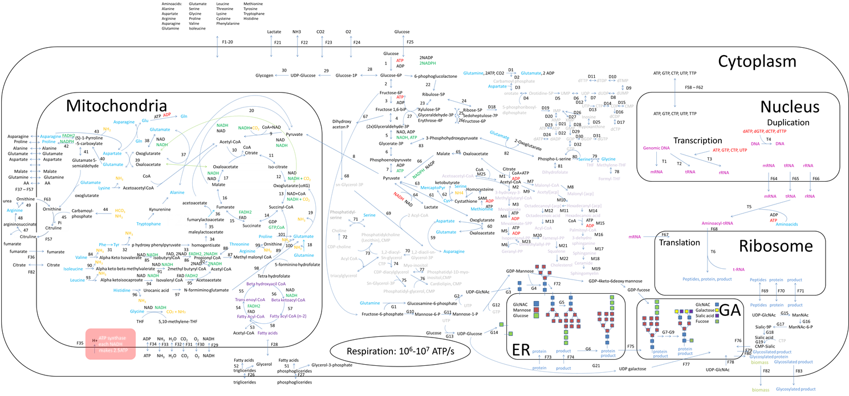
Supplementary figure 1: Complex scheme of CHO cell metabolism. In the scheme intermediates of glycolysis, pentose phosphate pathway, glutaminolysis, nucleotide synthesis pathway, lipid synthesis, beta oxidation, transcription, translation and glycosylation are shown. Each equilibrium reaction is numbered. Metabolic pathways included in the models are marked in supplemental table. For more information check Table 1.
Supplementary figure 1: Empirically determined metabolic flux values used in published models

 |  |  | Hagrot 2015 | Nyberg 1998 | Altamirano 2001 |  | Sengupta 2010 | Altamirano 2006 | Xing 2011 | Provost 2004 | Goudar 2009 | Jiang 2016
Index | Pathway | Reaction | flux (pmol/cellday) | mmol/gdry cell | nmol/10⁶cellsh | nmol/10⁶cellsh | mmol x 10⁻⁵/10⁺⁵ cells/day | nmol10⁻⁶cells/h | nmol10⁻⁶cells/h | mM/d/10⁺⁹cells | pmol/celld | nmol/ug protein/h
1 | Glycolisys | Glucose+ATP => Glucose6P+ADP |  | 4,96 | 59,89 | 25,04 | 19,2 | 129 |  | 5 | 1,499
2 | Glycolisys | Glucose-6P = > Fructose6P |  |  |  |  | 12,1
4 | Glycolisys | ATP + Fructose6P => Fructose1,6BP + ADP | 3,13 (from glucose) | 4,52 |  |  | 2x16,83 (from f6p in dhap) |  | 83,9 (from glucose) | 3,76 | 1,417 (from G6P)
5 | Glycolisys | Fructose-1,6BP + ADP + NADP => 2Glyceraldehyde-3P +ATP + NADPH |  |  |  |  | 36,03
6 | Glycolisys | 3PG => PhosphoenolPyruvate |  |  | 56,94 (from G6P) | 21,11
7 | Glycolisys | Phosphoenolpyruvate + ADP => Pyruvate + ATP | 3,13 (from glycine) | 7,98 | 113,89 | 42,21 | 36.04 | 125,19 (from glucose) | 165,1 (from g3p) | 7,53 |  | 1,2369(from glucose)
8 | Glycolisys | Pyruvate cyto => Pyruvate mito | 1,15 (from pyruvate) |  | 44,51 | 1,54 | 34,1 |  |  |  | 2,852 (from GAP) | 0,5952
9 | Glycolisys | Pyruvate => acetyl-CoA | 2,49 | 9,53 | 44,51 | 23,1 | 34,1 | 14,19 | 105,9 | 0,35 | 1,809 | 0,5167
10 | TCA cycle | oxaloacetate + Acetyl-CoA => Citrate + CoA | 2,49 |  | 44,51 | 33,34 | 34,1 | 14,19 |  | 0,3472 |  | 0,5594
12 | TCA cycle | isocitrate + NAD => Oxoglutarate + NADH |  | 6,03 (from oaa) | 35,73 (from citrate) | 33,34 | 34,16 (from citrate) | 14,19 (from citrate) | 110,1 (from acCoa) | 0,3472(from citrate) | 1,322 (from oxaloacete) | 0,1376 (from citrate)
13 | TCA cycle | oxoglutarate + NAD + CoA => succinyl-CoA + NADH | 3,33 | 10,02 | 49,9 | 36,06 | 33,56 |  | 113,7 |  | 1,726
14 | TCA cycle | succinyl-CoA + GDP => Succinate + GTP | 3,33 |  | 50,08 | 36,46 | 33,63 |  |  |  |  | 0,2578( from oxoglutarate)
15 | TCA cycle | succinate + FAD => Fumarate + FADH2 |  | 10.05 (from sucCoA) |  |  |  |  |  |  | 1,879 (from succoa) | 0,2578
16 | TCA cycle | fumarate => Malate | 3,33 (from succinate) |  | 50,48(from succinate) | 36,86 | 33,71 (from succinate) | 31,54 (from oxoglutarate) |  | 1,1051(from oxoglutarate) |  | 0,2578
17 | TCA cycle | malate + NAD => Oxalacetate + NADH | 2,54 | 10.05 (from fumarate) | 44,18 | 32,94 | 34,05 | 14,25 | 114,6(from succoa) | 0,6327 | 1,911(from fumarate) | 0,4809
18 | Glutaminolysis | glutamine => Glutamate | 0,58 | 4,67 | 3,54(?) | 4,74 |  |  |  | 0,7579 | 0,225 | 0,2362
19 | Glutaminolysis | glutamate + NAD => Oxoglutarate + NADH | -4,89 | 2,31 |  |  |  | 6,05 |  | 0,2038 | 0,254 | 0,2153
20 |  | malate => Pyruvate | 0,79 |  | 15,4 | 16,2 |  | 19,2 |  | 0,4724 | 1,809 (from oaa)
23 | Pentose phosphate pathway | ribulose-5P => xylulose-5P |  |  | 1,15 | 1,54 | 7,1 | 2,59 |  | 0,28
24 | Pentose phosphate pathway | ribulose-5P => ribose-5P |  |  |  |  | 7,1(iz g6p)
25 | Pentose phosphate pathway | Ribose-5P + xylulose-5P => glyceraldehyde-3P + sedohuptolose-7P |  |  |  |  | 2,369
26 | Pentose phosphate pathway | glyceraldehyde-3P + sedohuptolose-7P => Erythrose-4P + Fructose-6P |  |  |  |  | 2,369
27 | Pentose phosphate pathway | fructose-6P + xylulose-5P => Erythrose-4P + glyceraldehyde-3P |  |  |  |  | 2,369
31 | Amino acid metabolism | Phe => Tyr |  |  | 0.0001
37 | Amino acid metabolism | oxoglutarate + alanine => pyruvate + glutamate | -0,56 | 0,95 (opposite) |  |  |  |  |  | 0,27
39 | Amino acid metabolism | aspartate + oxoglutarate => oxaloacetate + glutamate | -0,06 |  | 0,01 | -0,02 |  | 0,06 |  | 0,2854
42 | Amino acid metabolism | s-1-pyroline-5-carboxylate => proline |  |  | 0,02
43 | Amino acid metabolism | asparagine => Aspartate + NH2 | 0,66 |  | 3,58
60 | Amino acid metabolism | oxaloglutarate + aspartate => Glutamate + oxaloacetate |  |  |  |  |  |  |  |  |  | 0,0786
63 | Amino acid metabolism | cys => Pyruvate | 0,05(from cys) |  | 0,54 (From pyruvate)
64 |  | pyruvate + NADH => Lactate + NAD | 6,27 | 1,89 | 80,6 |  | 0.65 | 245 | 52,7 | 7,39 | 1,719 | 2,0938
65 |  | oxaloacetate => malate |  |  |  |  |  |  |  |  |  | 0,4383
66 |  | malate + NADP => Pyruvate + NADPH |  |  |  |  |  |  |  |  |  | 0,2152
79 |  | glycine + Methylene-THF => serine + THF | 2,24 |  | 3,05 | 3,74 |  |  | 6,2
80 |  | Phospho-L-serine => serine | 7,32 (to pyruvate) |  | 1,26 (to pyruvate) | 0,32
82 |  | 2-Oxoglutarate + Phospho-L-serine => 3-Phosphohydroxypyruvate + glutamate | 5,12 (kontra)
M1 |  | citrate + CoA + ATP => Acetyl-CoA + ADP + oxaloacetate |  |  |  |  |  |  |  |  |  | 0,5169
M10 |  | Acetyl[acp] => Hexadecanyl-[acp] |  |  |  |  |  |  |  |  |  | 0,0646 (from AcCoA)
D1 |  | glutamine + ATP => glutamate + ADP |  |  |  |  |  |  | 12,4
D5 |  | Orotidine-5P => UMP |  |  |  |  |  |  |  | 0,1427 (nucleotide syn)
T1 |  | genomicDNA => mRNA |  |  | 0,85
T4 |  | DNA => DNA |  |  | 0.3
F1 | Transport | AlanineMedium => Alaninecyto |  |  |  |  |  | 2,1
F3 | Transport | ArginineMedium => Argininecyto | 0,11
F4 | Transport | AspartateMedium => AspartateCyto |  |  |  |  |  | -0,4
F6 | Transport | GlycineMedium => GlycineCyto | -0,12 |  |  |  |  | 2,9
F7 | Transport | GlutamineMedium => GlutamineCyto | 1,12 |  |  |  |  | -36,1 |  |  |  | 0,2362 (intra)
F8 | Transport | GlutamateMedium => GlutamateCyto |  |  |  |  |  | 5,2 |  |  |  | 0,0730 (secretion)
F10 | Transport | IsoleucineMedium => IsoleucineCyto |  |  |  |  |  | -6,4
F11 | Transport | LeucineMedium => LeucineCyto |  |  |  |  |  | -6,9
F13 | Transport | MethionineMedium => MethionineCyto |  |  |  |  |  | -1,7
F14 | Transport | PhenylalanineMedium => PhenylalanineCyto |  |  |  |  |  | -2,9
F15 | Transport | ProlineMedium => ProlineCyto |  |  |  |  |  | -0,3
F16 | Transport | SerineMedium => SerineCyto | -0,04 |  |  |  |  | -7,5
F17 | Transport | ThreonineMedium => ThreonineCyto |  |  |  |  |  | -4,3
F19 | Transport | TyrosineMedium => TyrosineCyto |  |  |  |  |  | -2,2
F20 | Transport | ValineMedium => ValineCyto |  |  |  |  |  | -5,3
F21 | Transport | lactateMedium => lactateCyto |  |  |  |  |  | 299,5 |  |  |  | 2,0938
F22 | Transport | NH3Medium => NH3Cyto |  |  |  |  |  | 27
F25 | Transport | GlucoseCyto => GlucoseMedium |  |  |  |  |  | -201,1 |  |  |  | 1,2369
F44 | Transport | GlutamateCyto => GlutamateMito |  |  | 7,64 |  |  |  |  |  |  | 0,073

