Feature Article: Metabolic Network Modelling of Chinese Hamster Ovary (CHO) Culture Bioreactors Operated as Microbial Cell Factories
Authors: Jernej Gašperšičª, Miha Kastelicª, Uroš Novakª, Blaž Likozarª
Affiliations: ªNational Institute of Chemistry, Department of Catalysis and Chemical Reaction Engineering, Hajdrihova 19, 1000 Ljubljana, Slovenia
Email Addresses: Jernej Gašperšič (jernej81@gmail.com), Miha Kastelic (miha.kastelic@ki.si), Uroš Novak (uros.novak@ki.si), Blaž Likozar (blaz.likozar@ki.si)
Corresponding author: Jernej Gašperšič

Abstract
Chinese hamster ovary (CHO) epithelial cells are one of the most used therapeutic medical lines for the production of different biopharmaceutical drugs. They have a high consumption rate with a fast duplication cycle that makes them an ideal biological clone. The higher accumulated amounts of toxic intracellular intermediates may lead to lower organism viability, protein productivity and manufactured biosimilar, so a careful optimal balance of medium, bioreactor operational parameters and bioprocess is needed. A precise phenomenological knowledge of metabolism’s chemical transformations can predict problems that may arise during batch, semi-continuous fed batch and continuous reactor operation. For a better detailed understanding (and correlation), future performance optimization and scaling, mechanistic model systems have been built. In this specific work, the main metabolic pathways in mammalian structured CHO cultures are reviewed. It starts with organic biochemical background, controlling associated phenomena and kinetics, which govern the sustaining conversion routes of biology. Then, individual turnover paths are described, overviewing standard mathematical formulations that are commonly applied in engineering. These are the core of black box modeling, which relates the substrates/products in a simplified relationship manner. Moreover, metabolic flux analysis (MFA)/flux balance analysis (FBA), that are traditionally characterizing mechanisms, are presented to a larger portion extent. Finally, similarities are discussed, illustrating the approaches for their structural design. Stated variables’ equations, employed for the description of the growth in the controllable environmental conditions of a vessel, the researched reaction series of proliferating dividing CHO population, joint with the values of maximal enzymatic activity, and solutions are outlined. Processes are listed in a way so that a reader can integrate the state-of-the-art. Our particular contribution is also denoted.

Keywords: Microbial cell factory; Chinese hamster ovary (CHO) cell metabolism; Bioreactor operation modeling; Biochemical reaction kinetics; Metabolic flux analysis; Biopharmaceutical and biosimilar

1. Introduction
Chinese hamster ovary (CHO) cells are one of the most important cell lines for production of therapeutic biopharmaceuticals.^{1,2} CHO cells are characterized by high consumption rates of nutrients and large amount of toxic intermediates, which may lead to lower cell viability and protein production.^{1,2,3} Production of recombinant proteins is promoted in growth mediums with high content of glucose and glutamine.^{4,5} Further optimization of the medium is needed to reduce lactate and ammonia accumulation and to increase antibody yields.^{3,6-9} In recent years technology has made a remarkable impact in bioreactor fermentation yields using kinetic models that are commonly used to describe fermentation processes in industrial fermentors. These models turn out to be useful at process monitoring, acquiring and storing the data, and troubleshooting. In the last three decades databases of CHO cell metabolism have been extended, likewise the tracing of fluxes into biomass and by-products, which led to major evolution of bioreactor models.^{2,5,10-17} This knowledge has guided the researchers to develop several mathematical models, which are able to describe the fluxes within metabolic pathways.^{4,18-23}
Analysis of fluxes usually focuses on measuring concentrations of extracellular metabolites.¹³ Biocatalysis of substrates into commercially attractive products as well as by-products is connected through pathways of cell metabolism.^{13,24-26} Intracellular fluxes are most often estimated by flux balance analysis (FBA) and metabolic flux analysis (MFA).²⁷ In recent years genotype was also included into in silico methodologies.²⁸ The following pathways of the cell metabolism are usually assumed: (i) glycolysis, (ii) pentose phosphate (PPP) pathway, (iii) tricarboxylic acid (TCA) cycle, (iv) amino acid metabolism, (v) protein synthesis, (vi) urea cycle, (vii) nucleic acid synthesis, (viii) membrane lipid synthesis, and (ix) biomass production.^{1-5,14-19,29-32,44,65,87-88} Glycogen ^{5,16} synthesis and glycosylation pythways are part of more precise models.^{29,33-37}
Numerous models were build for the purpose of data analysis and growth optimization in cell cultures. A hybrid simulation framework was proposed to predict the dynamics in bioreactors.³⁸ A simplified model of central carbon metabolism provides the framework for analyzing measurements of external metabolites.²⁹ Simulation assuming pseudo steady state assumption and extracellular metabolite concentrations accurately predicted the effects of process variables, temperature shift, seeding density, specific productivity and nutrient concentrations.³⁹ A mathematical model was developed for optimization of batch and fed batch bioreactor.²⁰ The kinetic model that jointed several phases of cell culture was capable to describe the time evolution of experimental data.¹⁶ Similar model was build and its correctness validated on experimental data from CHO cells grown in spinner flasks.¹⁹ The model was assembled from submodels, where each of them described a separate phase of CHO cell (growth, stationary, and decline phase).⁴⁴ The model was then used to explain the experimental data from batch cultivated CHO cells. In another example, the phenotype of mammalian cells was studied by the aims of metabolic flux analysis.⁵ Fluxes were measured using ¹³C MFA variant and stoichiometric modeling.^{2,40} MFA was also used to estimate total energy production of growing CHO-320 cells.²⁴
New metabolic information was mined from the models and associated simulations. Analysis of experiments showed the existence of multiple steady states.¹⁷ In silico modeling of CHO cells allowed the identification of major growth-limiting factors including oxidative stress and depletion of lipid metabolites.⁵⁰ These factors may lead to a better development of strategies to enhance CHO culture performance.⁵⁰ Continuous cell lines can downregulate their oxidative metabolism when nutrients get depleted or growth rate slows.¹⁵ Flux analysis shows significant rewiring of intracellular metabolic fluxes in the transition from growth to stationary phase. Changes were noticed in energy metabolism, redox metabolism, oxidative pentose phosphate pathway and anaplerosis.¹⁶ In stationary phase glycolysis is rerouted through PPP pathway - no lactate production is observed.² Unusual lipogenic pathway was discovered with modeling. Carbon from glucose supplies mitochondrial production of alpha-ketoglutarate (αKG), which is trafficked to the cytosol and used to supply reductive carboxylation by isocitrate dehydrogenase.⁴¹ It was suggested that endogenous lactate is not being used for ATP production through TCA cycle when the medium is supplemented with galactose. It was observed that lactate starts to get depleted at the same time as glucose is used up and cell switches to a galactose source.¹ With kinetic model of CHO cell growth Lopez-Meza estimated substrate threshold below which growth is not observed and obatined the α and β factor from Luedeking-Piret equation.¹⁸ Analysis showed that CTP deficient cells use different central carbon metabolism, suppress pyruvate dehydrogenase and induce glucose dependent anaplerosis through pyruvate carboxylase.⁴¹
Composition optimization of limiting amino acids in growth medium increased maximum cell density by 55 % and protein titer production by 27 %.³ The medium did not have any influence on sialic acid content. Mannose carbon source also improved recombinant protein productivity.⁴² Glucose consumption was 5 times higher than that of glutamine (¹³C labeled glucose, 2D-NMR spectroscopy). 41 % of glucose was channeled through PPP, while flux of pyruvate to lactate and to TCA cycle was evenly distributed 55% - 45%.¹⁴ Anaplerotic conversion to oxaloacetate accounted to 10 % of whole pyruvate conversion.¹⁴ The developed model can be routinely used in bioprocess development.¹⁴
We describe the research done in the area of bioreactor modeling and contribution of our lab to the field. Complete literature search and data collection of known metabolic fluxes was made to ease the design of future models. The improvement of models is ongoing with a goal to make a good theoretical framework and to foresee possible errors in the fermentation process.
- Contribution of the author
Complete literature search of published models and metabolism of CHO cells leads to a successful build of model of bioreactor. Review of preferred articles is included with the emphasis on bioreactor operation equations and metabolic pathways of CHO cell lines.
Contribution is divided into two parts:
- Black box models: Evolution of mathematical equations used in CHO mechanistic models
- Selection of important CHO cell metabolic pathways and its CHO cell line unique properties
2.1. Black box models: Formulation of mathematical equations
Protein production in a bioreactor requires perfect agitation and aeration to maintain a homogenous distribution of cells, substrate and oxygen throughout the bioreactor. Extracellular medium composition analysis, coupled with intracellular metabolic pathway analysis give rise to CHO cell bioreactor models.
2.1.1. Growth of biomass
Growth of biomass is described in different ways. Growth is influenced by specific growth factor μ and concentration of cells X (Eq.1).^{16,19,20}
Standard biomass growth equation:
$\frac{dX}{dt}=µ X$ (1)
Specific growth factor μ is described in different way. Commonly used formulations are standard Verhulst and Monod equations that can be suitably modified to satisfy the needs of bioreactor parameters (Eqs. 2 and 6).
Monod: One limit substrate:
µ = µ_{max} $\frac{⦋S⦌}{\left[S\right]+K_{S}}$ (2)
del Val (2016):³⁴
$μ=μ_{g}\left[\frac{\left[S\right]}{K_{m}+\left[S\right]}-\frac{\left[X_{v}\right]}{α_{x}}\right]$ (3)
Monod: Two limit substrate:
µ = µ_{max} $\frac{⦋S_{1}⦌}{[S_{1}]+K_{S_{1}}}$ $\frac{⦋S_{2}⦌}{{[S}_{2}]+K_{S_{2}}}$ (4)
Monod: n-limit substrates:
µ = µ_{max} $\frac{⦋S_{1}⦌}{{[S}_{1}]+K_{S_{1}}}$ $\frac{⦋S_{2}⦌}{{[S}_{2}]+K_{S_{2}}}×…×\frac{⦋S_{n}⦌}{[S_{n}]+K_{S_{n}}}$ (5)
By Monod, biomass growth is influenced by limiting substrate (Eq. 2). Here X represents cell concentration – number of cells per mL; S represent substrate, μ_{max} is the maximum value of growth rate, K_{S} is the substrate saturation constant. By del Val, an upgraded Monod equation for continuous production is utilized, where X_{v} is density of viable cells and α_{x} is the specific factor (cellular carrying capacity) (Eq.3). Note that specific growth rate μ may be influenced by one limiting substrate (Eq. 2),¹⁸ two (Eq. 4)³³ or more limiting substrates from the growth medium (Eq. 5).⁴³
Verhulst:
$µ=µ_{max}$ (1- $\frac{X}{X_{max}}$) (6)
By Verhulst, maximum cell density of the culture is a limiting factor to cell growth (Eq. 6). In this case substrate is available in large quantities or may be fed additionally to the bioreactor. X_{max} represents maximum cell concentration under given conditions. The equation is commonly used to describe the growth of bacterial cultures.
Evolved equations for growth of biomass used in bioreactor systems are described below (continuous, fed batch).
Altamirano (2001)¹⁷, Xing (2011)³:
$μ=D\frac{X_{T}}{X_{V}}$ (7)
By Altamirano, the specific growth rate in the continuous bioreactor is described as dilution rate (D) multiplied by the ratio of the total cell number (X_{T}) and the viable cell number (X_{V}) (Eq. 7).
Goudar (2009)⁴:
$μ=\frac{F_{d}}{V}+\frac{F_{h}}{V}\frac{X_{V}^{H}}{X_{V}^{B}}+\frac{1}{X_{V}^{B}}\frac{dX_{V}^{B}}{dt}$ (8)
By Goudar, the specific growth rate designed for perfusion system, where V is the reactor volume, F_{d} is the discard rate, F_{h} is the harvest flow rate,$X_{V}^{H}$ is the harvest viable cell density, and $X_{V}^{B}$ is the density of viable cells in bioreactor (Eq. 8).
Hagrot (2016)²¹:
$μ=\frac{ln\left(\frac{X_{v}}{X_{v,0}}\right)}{t-t_{0}}$ (9)
By Hagrot, the specific growth rate depends upon viable cell concentration before renewal (X_{v}) and after renewal (X_{v0}) (Eq. 9). Here t and t₀ are corresponding times of sampling.
It is essential for the model of bioreactor to select the mathematical formulation that suits type of the bioreactor and the cell culture.
2.1.2. Final product formation
Final product formation is described in connection with the cell concentration (X) or viable cell concentration (X_{v}) multiplied by product growth factors (r or α) (Eq. 10 and 11).^{20,44}
Standard equation to describe product formation:
$\frac{dP}{dt}=rX$ (10)
Naderi 2011²⁰, Provost 2004¹⁹:
$\frac{dP}{dt}=α_{g} X_{v}$ (11)
Ludeking-Piret model:
$\frac{dP}{dt}=α\frac{ dX}{dt}+βX$ (12)
By Ludeking-Piret, two coefficients α and β describe the product formation, both are product specific (Eq. 12). In the case of Lopez-Meza P was the concentration of glycosylated product at a time; dX/dt is biomass cell concentration increase.
Xing 2011³, Berrios 2011⁴²:
$\frac{dP}{dt}=\frac{D\left(C_{i}^{out}-C_{i}^{in}\right)}{X_{V}}X$ (13)
$\frac{dP}{dt}=\frac{C_{i}(t_{2})-C_{i}(t_{1})}{{IVCD}_{i}(t_{2})-{IVCD}_{i}(t_{1})}X$ (14)
By Xing, product growth is described by the ratio of concentration difference of product (C_{i}) between two time points. $X_{V}$ is viable cell density, D is dilution factor (Eq. 13). By Berrios concentration difference of product (c_{i}) was divided by corresponding difference of integral viable cell density (IVCD) (Eq. 14).
Zamorano 2013²⁴:
$\frac{dP}{dt}=N_{p}v\left(t\right)$X (15)
By Zamorano r factor (Eq. 10) was evolved as multiplication of metabolic flux v(t) and stoichiometric matrix for final product N_{p} (Eq. 15).

Goudar 2009⁴:
$\frac{dP}{dt}=\frac{1}{X_{V}^{B}}\left(\frac{F_{m}P}{V}+\frac{dP}{dt}\right)X$ (16)
Goudar 2009⁴ describes equation for product growth (Eq. 16). $X_{V}^{B}$ is viable cell density. F_{m} is the flow rate. The equation is used for perfusion systems.
del Val 2016³⁴:
$\frac{dP}{dt}=\left(Y_{P/S}\right)q_{S}X$ (17)
del Val 2016³⁴ describes product growth as yield of product per substrate multiplied by substrate consumption q_{S} (Eq. 17).
The formula for product growth must be developed for each individual product, based on the phenotye and the type of bioreactor.
2.1.3. Mathematical description of substrate consumption
Substrate intake-consumption is dependent upon cell density (X) and specific uptake rate (v_{S}) (Eq. 18) (Provost 2006-44, Zamorano 2013-24, Altamirano 2001-17).^{17,24,44}
$\frac{dS}{dt}=-v_{S}\left(t\right) X\left(t\right)$ (18)
Jedrzejewski 2014³³:
$\frac{dS}{dt}=$ ($\frac{µ}{Y_{glc}}$ +$m_{glc}$)$X$ (19)
By Jedrzejewski substrate consumption is influenced by number of cells, steady state consumption of substrate m_{glc} and biomass growth coefficient Y_{glc} (Eq. 19) (Jedrzejewski 2014³³).
Goudar 2009⁴, Xu 2016⁶:
$\frac{dS}{dt}=\frac{1}{X_{V}^{B}}\left(\frac{F_{m}\left(S_{m}-S\right)}{V}-\frac{dS}{dt}\right)X$ (20)
Goudar 2009⁴, Xu 2016⁶ uses an equation, where specific substrate consumption rate depends upon perfusion rate F_{m}, difference of substrate concentration (starting minus current), bioreactor volume V and viable cell density (Eq. 20).
del Val 2016³⁴:
$\frac{dS}{dt}$= $\left(\frac{1}{Y_{X/S}}\right)\left(\frac{S}{K_{m}+S}\right)X$ (21)
del Val (2016)³⁴ describes an equation for substrate uptake. Y_{X/S} is yield coefficient from substrate, S represents concentration of substrate, K_{m} is constant specific for each substrate (Eq. 21).
Ahn 2011¹⁶:
$\frac{dS}{dt}=-k S-q_{S} X$ (22)
Ahn 2011¹⁶ additionally includes decomposition of substrate k that is independent of biomass. S represents substrate concentration, X represents cell concentration, and q_{s} is a substrate consumption per cell concentration unit (Eq. 22).

2.1.4. Oxygen consumption
Oxygen consumption is traditionaly described as follows:^{5,17,45}
$\frac{dDO}{dt}=OTR-OCR$ (23)
OTR = K_{L}a (DO*-DO) (24)
Oxygen concentration is dependent upon oxygen transfer rate (OTR) (Eq. 24)^{29,46} between gas and liquid phase and oxygen consumption rate (OCR) of biomass. OTR is dependent upon K_{L}a (bioreactor specific) and dissolved oxygen concentration (DO). Saturated oxygen (DO*) is temperature dependent (Eq. 24).²⁹
Jorjani 1999:⁴⁷
$OCR=q_{O2} X_{v}$; q_{O2} = q_{O2}⁰ e^{-E/RT} (25)
OCR is dependent upon q_{O2}⁰ and temperature (Eq. 25),⁴⁷ while q_{O2}⁰ is cell culture and clone specific. It depends mostly on the number and condition of mitochondria per cell (place of origin of respiratory chain). It is also dependent upon availability of substrate with which cell and later mitochondria are fed.⁴⁸

Nyberg 1998:²⁹
OUR = K_{L}a (C*-C_{R}) + D (C_{F}-C_{R}) (26)
Nyberg describes a formula for continuous bioreactor, where oxygen uptake rate - OUR is dependent upon OTR (K_{L}a (C*-C_{R})), dilution rate D and difference of oxygen concentration (feed minus reactor) (C_{F}-C_{R}) (Eq. 26). C* represents saturated oxygen concentration at operating temperature.
Oxygen is consumed in the respiratory chain. H₂O is a byproduct of the respiratory chain reactions.⁴⁹ Oxygen that is incorporated in waste CO₂ comes from glucose or other substrates. Since metabolism is affected by pH value, O₂ consumption is pH dependent.
2.1.5. CO₂ and NH₃ waste production
CO₂ production is integrated into models to address reactions in TCA cycle.^{5,45,50} CO₂ is mostly produced in Krebs cycle, while NH₃ is produced during metabolism of glutamine or other amino acids.^{5,17,44,51}
$\frac{dD{CO}_{2}}{dt}={CO}_{2}PR-{CO}_{2}TR = K_{L}a \left(DCO2-DCO2*\right)+ R_{CO2}X$ (27)
CO₂ concentration is dependent upon CO₂ transfer rate (CO₂TR), CO₂ production from biomass (CO₂PR) (Eq. 27). CO₂ importantly influences cell growth and productivity.⁵² Free carbon dioxide together with amino group can be recycled during fixation into carbamoyl phosphate and later integrated into arginine (urea cycle). Dissolved CO₂ (DCO₂) partially transforms into HCO₃⁻ ions that serve as a regulator of pH in the cell. CO₂ is generated during pyruvate, isocitrate and oxoglutarate degradation (TCA cycle). It is also generated in lysine and glycine lysis and formation of ribose-6-phosphate from glucose-6-phosphate.
Nyberg 1998:²⁹
$CER=\frac{n_{g}}{V_{R}}\left(y_{CO2}^{R}-y_{CO2}^{F}\right)$+ D $\left(C_{A}^{R}-C_{A}^{F}\right)$ (28)
Nyberg 1998²⁹ describes the equation for carbon dioxide evolution rate (Eq. 28). Here n_{g} is molar gas flow rate to the reactor, V_{R} is liquid volume of the reactor,is mole fraction of CO₂ in reactor headspace,is mole fraction of CO₂ in the feed gas.is concentration of CO₂ and bicarbonate in the liquid phase,is concentration of CO₂ and bicarbonate in the liquid feed phase.
$\frac{dD{NH}_{3}}{dt}={NH}_{3}PR-{NH}_{3}TR$= K_{L}a(DNH₃-DNH₃*) + $R_{NH3}×X$ (29)
NH₃ concentration is similarly dependent as CO₂ (Eq. 29). K_{L}a is different for each gas and varies with the reactor and temperature. Ammonia production is highly dependent upon lysis of amino acids that is biomass dependent and independent (catalytic degradation in water medium dependent upon temperature). Ammonia is produced from the amino acids and transferred into gas phase. It is recycled during carbamoyl formation.

2.1.6. Temperature, pH optimum
Temperature and pH are important process parameters that influence optimal growth of CHO cell lines.⁵³⁻⁵⁹ Normal operating temperature for the growth of mammalian cells in bioreactors is 37 °C.⁶⁰ At 33 °C remarkable decrease in specific growth rate is observed. At 30 °C, growth of cells started to stagnate. Mammalian cells grow in the range from 35 to 38 °C.^{61,62} On the other hand, production rate of product (unspecified recombinant protein) is increased at 33 and 30°C. Lower temperatures (below 37 °C) inhibit cell growth, enhance cellular productivity of the recombinant protein, maintain high cell viability, suppress medium consumption, and suppress release of waste products from the cells.^{63,64}
CHO cells have been reported to grow best at pH 7.1.⁶¹ Maximum product concentration (recombinant protein) was achieved at pH 6.8; 1.8-fold higher than at pH 7.1.⁶¹ Regardless of the culture temperature, the highest specific growth rate was observed in the range of pH from 7.0 to 7.4.⁶⁵
2.1.7. Cell phases of CHO cell lines in bioreactor
When cells are transferred to a new bioreactor batch, they need accommodation time to reach stable operation. The cells need to multiply enzymes that are needed to catalyze biochemical reactions in the cell interior.
In the beginning concentrations of glucose and other amino acids are falling, while lactate and glutamate (by-products) concentrations are rising in the medium. After glucose is depleted, lactate starts to get consumed. When substrates are depleted, biomass stops to grow and uses internal reserves to maintain cell functions. Reserve glycogen and lipids are used to supply the cell with the energy. The nutrients from dead cells can be recycled and reused as the energy source. Most common substrate used is glucose. If substrate is switched for example to galactose, specific enzymes need to multiply to optimal concentration, before cells readapt. Mitochondria divide rapidly inside cells in the presence of large concentrations of substrates and supply the cells with large amounts of energy (ATP). Until mitochondria sufficiently multiply, the excess flux of glucose is diverted to lactate or other metabolites, such as alanine. If cells are fed a different substrate, they need some time to multiply the necessary enzymes to turn substrates into energy and basic building blocks for proteins, lipids and DNA.
In the growth phase cells are in the optimal condition and multiply with ease. The lactate does not accumulate anymore and is used up by cells as a substrate. Cells stop to grow when they reach maximum cell density or when they have used up all substrates. Cells start to use nutrients from energy storage: glycogen and lipid molecules. When cells run out of the substrates and nutrients from energy storage they enter an atypical cell death due to starvation.
The viable CHO cells are in G1, S, G2/M (part of the interphase) or apoptotic phase.^{66,67} The production of protein is usually phase specific.⁶⁶ In apoptosis cell enter programmed cell death. After certain number of duplications, cells die off. Certain percentage of biomass in the working bioreactor belongs to dead cells.
2.2. Precise description of metabolic pathways
In the past two decades much research has been done on CHO cell metabolism. At modeling, cell metabolism is described using kinetic laws, equilibrium equations and associated parameters. Table 1 shows metabolic pathways, which were included in the models published in the literature. The following pathways were reviewed: (i) substrate intake, (ii) glycolysis, (iii) glutaminolysis, (iv) pentose phosphate pathway (PPP), (v) UDP-monosaccharides production, (vi) nucleotide synthesis, (vii) amino acid metabolism, (viii) tricarboxylic acid cycle (TCA), (ix) lipid metabolism, (x) glycogen synthesis, (xi) lipid synthesis, (xii) DNA duplication, (xiii) RNA transcription and protein translation, (xiv) glycosylation, and (xv) feedback loops.

Table 1: CHO cell modeled metabolic pathways: Used metabolic pathways in reviewed models.
 | Altamirano 2001 | Jiang 2016 | Nolan 2011 | Quek 2010 | Selvarasu 2012 | Sanderson 1999 | del Val 2016 | Krambeck 2005 | Jedrzejewski 2014 | Zamorano 2013 | Dean 2013 | Young 2013 | Ghorbaniaghdam 2013 | Hagrot 2016 | Nyberg 1998 | Sengupta 2011 | Altamirano 2006 | Xing 2011 | Provost 2004 | Goudar 2010
Glycolysis | YES | YES | YES | YES | YES | YES | no | no | no | YES | YES | YES | YES | YES | YES | YES | YES | YES | YES | YES
Pentose phosphate pathway | YES | YES | no | YES | YES | YES | no | no | no | no | YES | YES | no | no | no | YES | no | no | YES | YES
Lactate production | YES | YES | YES | YES | YES | YES | no | no | no | YES | no | YES | no | YES | YES | YES | YES | YES | YES | YES
Glycogen synthesis | no | no | no | YES | no | no | no | no | no | no | no | no | no | no | no | no | no | no | no | no
Nucleotide synthesis | no | no | no | YES | no | no | no | no | no | no | no | no | no | no | no | no | no | no | YES | no
TCA cycle | YES | YES | YES | YES | YES | YES | no | no | no | YES | no | YES | YES | YES | YES | YES | YES | YES | YES | YES
Glutaminolysis | YES | YES | YES | YES | YES | YES | no | no | no | no | YES | YES | YES | YES | YES | no | no | YES | YES | YES
Amino acid metabolism | YES | no | YES | YES | YES | YES | no | no | no | YES | no | no | no | YES | no | YES | YES | YES | no | YES
Oxidative phosphorilation | YES | no | YES | YES | no | no | no | no | no | no | no | YES | no | no | no | no | no | no | no | no
Lipid synthesis | no | YES | no | YES | YES | no | no | no | no | no | YES | YES | no | no | no | no | no | no | no | no
Glycosylation | no | no | no | no | no | no | YES | YES | YES | no | no | no | no | no | no | no | no | no | no | no

2.2.1. Substrate intake (part of metabolic flux pathway analysis)
High influxes of substrates contribute to high osmotic pressure.⁶⁸ The cell regulates its pressure with fast conversion into more favorable intermediates and products. Other regulatory mechanisms are passive and active transport. One of the major metabolites is glycogen, which serves as energy storage.69 Glucogenic amino acids may transform into glucose and then into glycogen, while ketogenic amino acids transforms into ketone bodies that may be stored through acetyl CoA in fatty acids (Figure 1).⁷⁰ Mathematical descriptions (Eqs. 18-22) of substrates’ consumption are selected in accordance with phenotype, while associated constants are substrate specific. Majority of the models include glucose intake, lactate, ammonia, CO₂ and oxygen. More precise models include also transport of glutamine and glutamate.
Figure 1: Biochemical reactions associated with mitochondria: degradation pathway of keto- into glucogenic amino acids (Sanderson 1999).⁴⁵
2.2.2. Glycolysis and Glutaminolysis (AA lysis)
Glycolysis is one of the most important pathways in the metabolism of cells and is therefore included in majority of the models (Table 1).1-5,15,17,19,21,24,29-31,39,41,45,50
During a high multiplication rate of cells excessive use of glucose and glutamine is observed in normal cells and even higher in mutated, cancerous cells.⁷¹ Due to osmotic pressure, excess glucose and glutamine are diverted into glycogen,⁶⁸ lactate, glutamate, lipids.^{1,16,39,72}

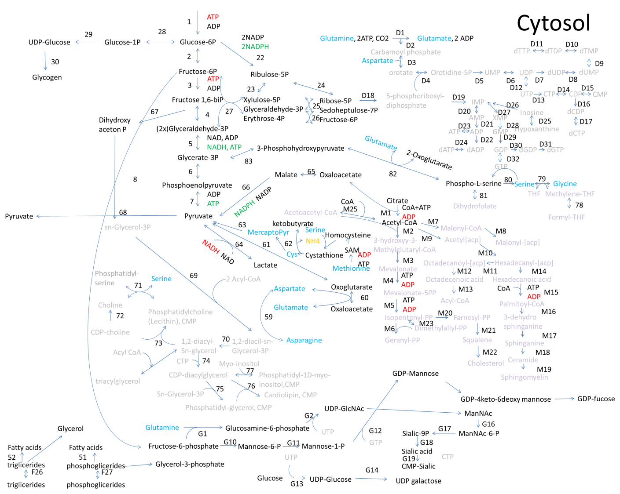
Figure 2: Biochemical reactions in the cytosol.
Glucose enters tricarboxylic acid (TCA) cycle through pyruvate (Figure 2). Lactate is a waste product of surplus pyruvate produced during glycolysis that cannot enter TCA cycle due to unavailable mitochondria machinery. Lack of oxygen produces similar effect (Figure 2). Lactate is removed from the cell into the cell medium and later reused.^{1,18} Two molecules of ATP and two molecules of NADH are generated in the process. When pyruvate enters mitochondria it is converted into 3 molecules of CO₂. In this process three molecules of NADH, one molecule of FADH₂ and one molecule of GTP are produced per molecule of pyruvate. Each molecule of NADH produces three molecules of ATP through electron transport chain; each molecule of FADH₂ produces two ATP molecules due to lower proton energy. If lactate is produced, one molecule of NADH is consumed, and recycled when lactate is being converted back. High concentration of lactate may lead to lower pH value. Note that pH is regulated with NH₃ release during glutamate metabolism. Amino acids lysis gives huge amount of ATP due to independent enzymatic pathways to TCA cycle (Figure 3). In isoleucine degradation pathways three NADH molecules, one acetylCoA and one succinyl CoA molecule are generated. ATP is further generated through electron transport chain.
Metabolic models comprise metabolic steps of glycolysis pathway into lumped reactions due to less important, short half-life intermediates.^{1-4,17,21,29,41} In simplified models, fluxes are diverted directly to stable intermediates. Complete amino acid lysis integration shows that amino acids regenerate TCA cycle intermediate much faster then glycolysis due to independent enzyme machinery of each amino acid. Enormous energy comes from branched chain amino acids (BCAA): valine, isoleucine, leucine (Figure 3).
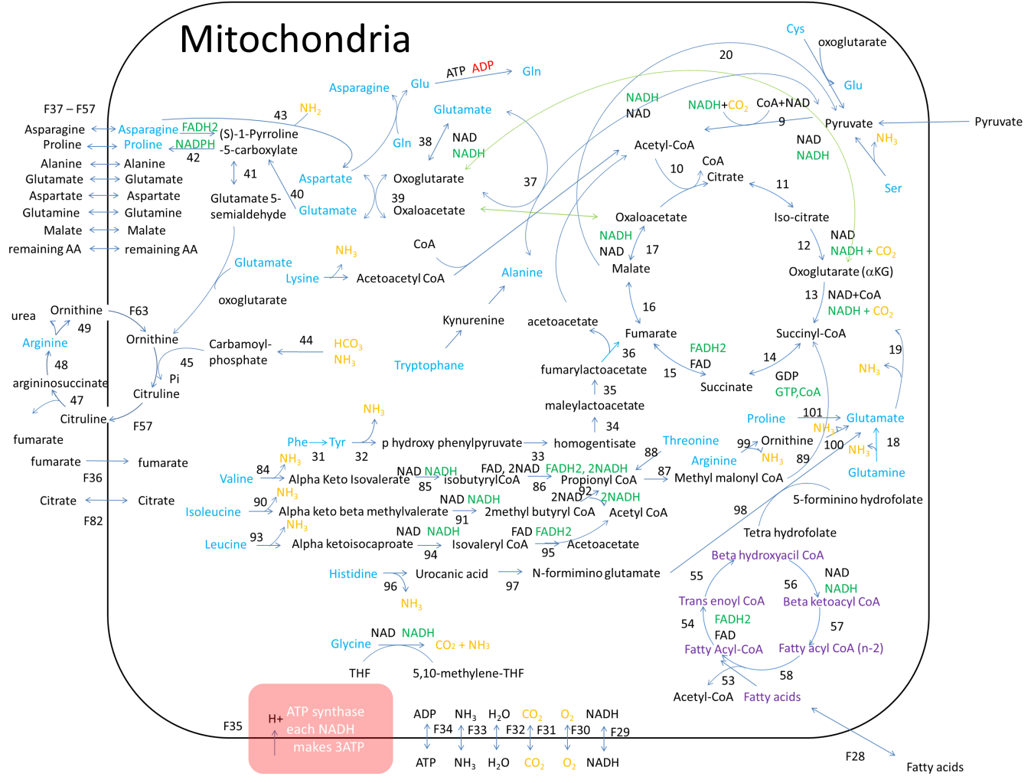
Figure 3: Metabolic pathways inside mitochondria: TCA cycle is the major metabolic pathway. Fatty acids are pre-metabolized in beta oxidation cycle, amino acids enter TCA cycle through oxoglutarate, fumarate, and succinyl CoA. Oligosaccharides enter TCA cycle through PPP and glycolysis pathway.
2.2.3. Pentose phosphate pathway and UDP-monosaccharides stock
Like glycolysis, pentose phosphate pathway (PPP) is also included in most models (Table 1).^{1,2,4,5,15,17,19,30,41,45,50} An alternative route for glucose is generation of different monosaccharides (Figure 2). From glucose-6-P cell produces ribulose-5-P, xylulose-5-P, erythrose-4-P, fructose-6-P, sedoheptulose-7-P and ribose-5-P.⁴⁴ Ribose-5-P enters synthesis of nucleotides.⁵ Monosaccharides from PPP can be transformed into glyceraldehyde-3-P and fructose-6-P, which again enters glycolysis pathway (Figure 2).
Few models also include generation of UDP-monosaccharides (Figure 2).^{33,34,36} In excess of UTP, different UDP monosaccharides are generated, including: GDP-mannose, UDP-galactose, UDP-glucose, UDP-N-acetyl glucosamine (GlcNAc), and CMP-sialic acid. These metabolites are included in the models that describe glycosylation pattern of proteins (Figure 2).^{29,33-35} UDP-monosaccharides are used for the synthesis of glycans that undergo N-, O-, C- and phospho- glycosylation.^{33,73} Nucleotide sugars are transported into the endoplasmic reticulum (ER) and Golgi apparatus (GA) where they get concentrated and ready to be added to the protein (Figure 2).
2.2.4. Glycogen synthesis
Glycogen synthesis is included only in a few models (Table 1),⁵ despite its important role in glucose homeostasis. In excess of ATP cell transfers extra glucose into glycogen that is used as energy source, when glucose is run out from the medium or cytosol. One molecule of glycogen can store up to 30000 molecules of glucose. This contributes to lower osmotic pressure and removes harmful effects of high glucose concentration. Glucose is readily available, if there is a energy or carbon source demand (Figure 2). The path described above is ATP controlled. Glucose is transformed into Glucose-1-P, in this process one molecule of ATP is consumed. UTP molecule binds to Glucose-1-P, leading to production of UDP-Glucose. UDP-Glucose attaches itself to glycogen, leading to release of UDP.
2.2.5. Lipid synthesis
Lipid synthesis is included in several models (Table 1). They used simplified pathways^{13,15,17,45,74} or very precisely defined pathways.⁵
During cell division, lipid synthesis is enhanced due to membrane assembly. Phosphoglycerides, triglycerides, phosphatidylserine, phosphatidyllecithine, cholesterol, sphingomyelin, and geranyl pyrophosphate are synthesized (Figure 2). Successive enzymatic pathway starts wih the acetyl-CoA and leads to complex lipid molecules (Figure 4). Different glycerides are synthesized with the addition of fatty acids and other groups to glycerol.
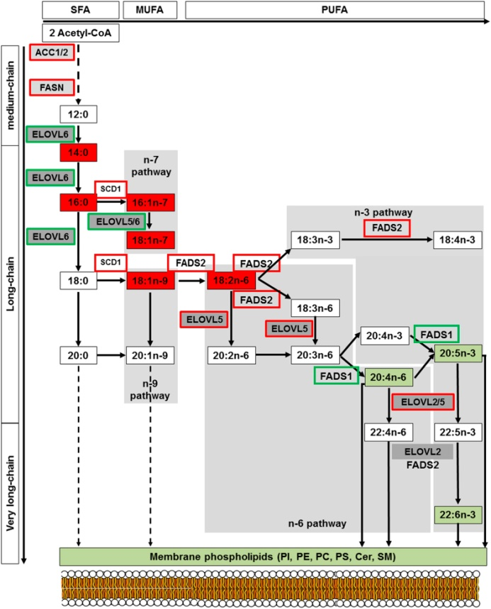
Figure 4: Synthesis of fatty acids from acetyl-CoA: Complex enzymatic pathway leads to different lipid molecules that assemble into membrane bilayer. The saturated fatty acids and unsaturated fatty acids of the n-3, n-6, n-7 and n-9 series can be synthesized from myristic acid (C14) and palmitic acid (C16) produced by ACC and FASN. Long-chain fatty acids of the n-6 and n-3 series can also be synthesized from precursors obtained from dietary precursors to elongation (ELOVL) and desaturation (FADS) steps as indicated in these pathways. Lipids in red and in green are those found “up” and “down” in our analysis, respectively. Increase in enzyme activities is framed in red whereas a decrease is framed in green. ACC: acetyl-CoA carboxylase; ELOVL: elongase of very long chain fatty acid; FASN: fatty acid synthase; FADS: fatty acid desaturase; SCD: stearoyl-CoA desaturase.⁷⁵
2.2.6. Amino acid synthesis
Amino acid degradation is described in most models, but usually only partial set of amino acids is integrated into a model (Table 1).1-5,15,17,19,21,24,29-31,39,41,45,50 Altamirano et al. includes synthesis of alanine, aspartate and glutamine in highly interconnected metabolic network. Quek et al. describes precise metabolic network with interconnected synthesis of amino acids: alanine, glutamate, asparagine, proline, serine, glycine, aspartate. Provost et al. includes synthesis of alanine into the model.
Essential amino acids cannot be synthesized de novo (from scratch) by the organism, therefore must be supplemented from the medium. There are nine amino acids that humans cannot synthesize: phenylalanine, valine, threonine, tryptophan, methionine, leucine, isoleucine, lysine, and histidine (single letter abbreviations in the order they appear: F, V, T, W, M, L, I, K, and H). Tyrosine is synthesized directly from phenylalanine; cysteine can be synthesized from methionine through short metabolic pathway. Glutamate can be synthesized from glutamine or oxoglutarate (Figure 5). Alanine can be synthesized from pyruvate, with the help of glutamate; aspartate can be synthesized from glutamate and oxaloacetate. Proline can be synthesized in short metabolic pathway from glutamate, while arginine can be synthesized from ornithine, that is synthesized from glutamate and carbamoyl phosphate that is produced from dissolved ammonia and carbon dioxide. Serine can be produced from glycerate-3-phosphate by the aid of glutamate. Glycine is directly synthesized from serine. Asparagine can be synthesized from aspartate by the aid of glutamine (Figure 5).
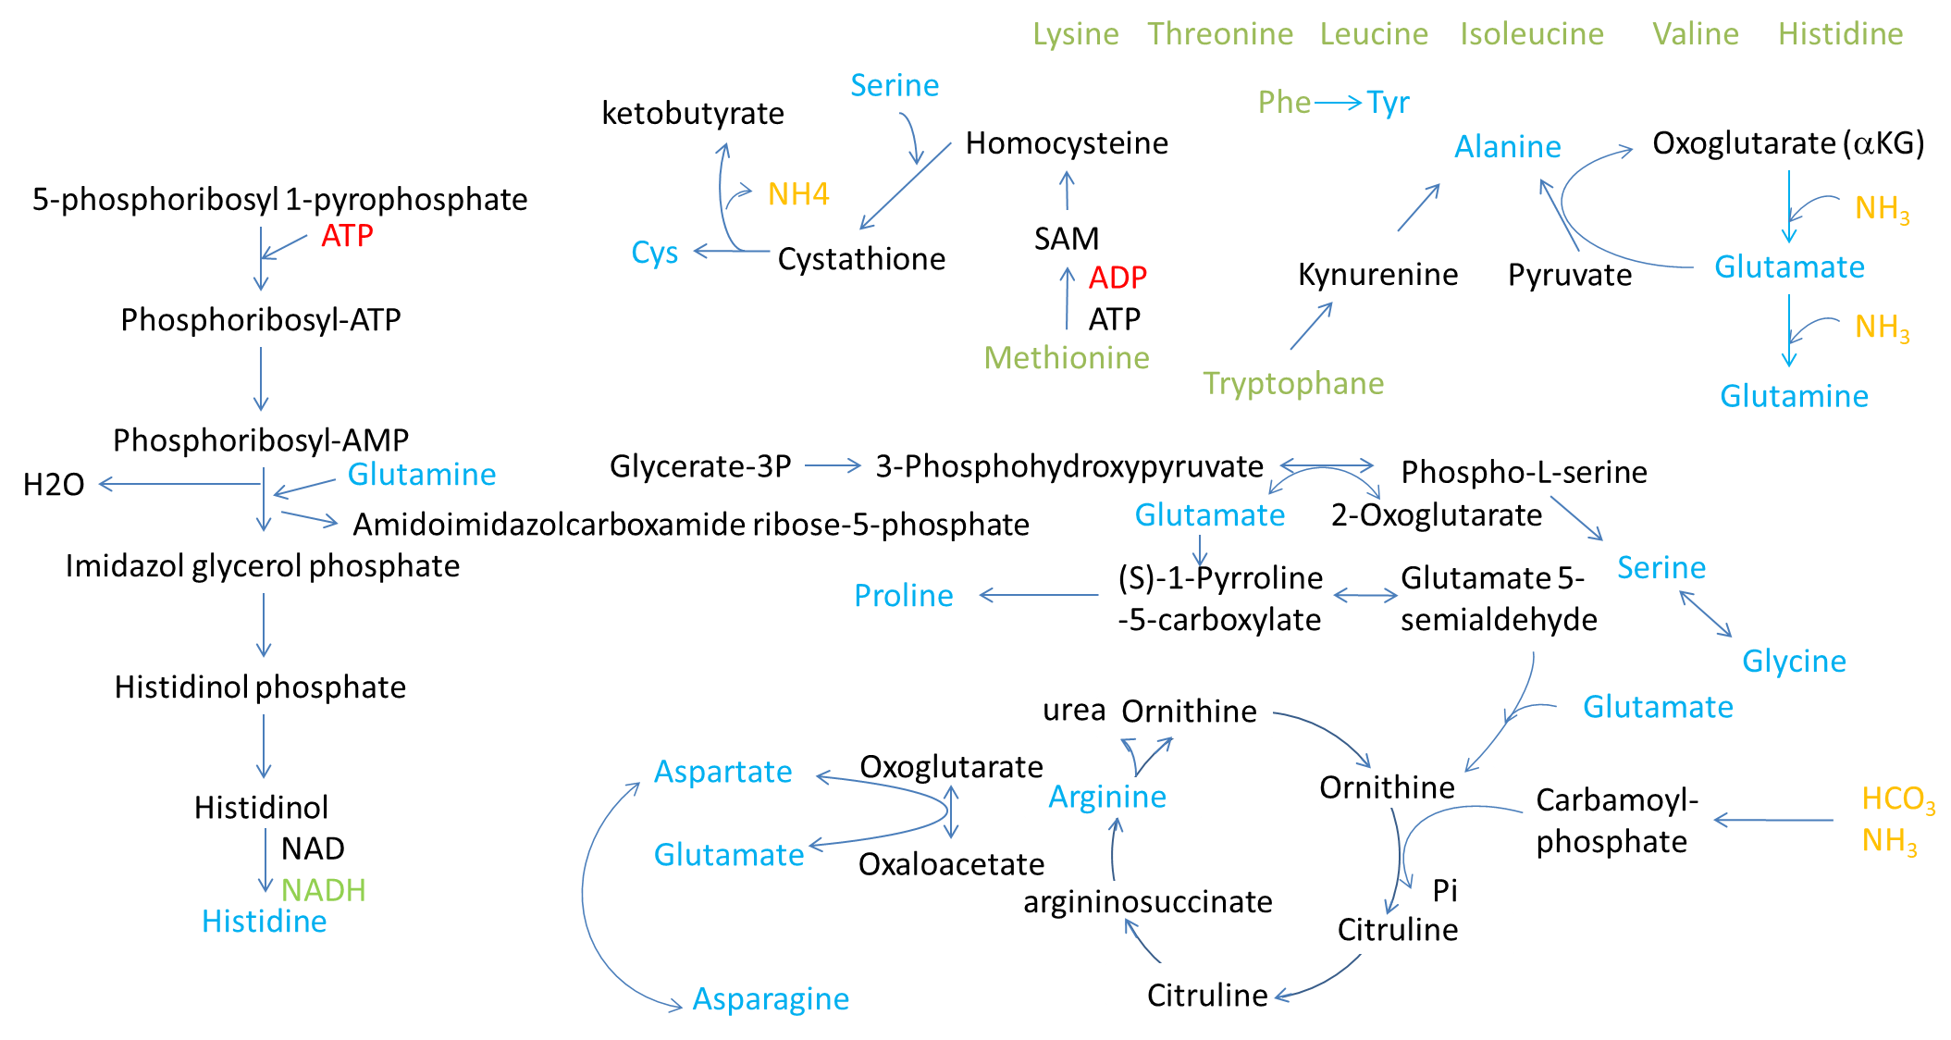
Figure 5: AA synthesis of non-essential amino acids.
2.2.7. DNA duplication, RNA transcription and protein translation
Nucleotides are synthesized through PPP pathway. In a few models nucleotide synthesis is incorporated.^{5,19} Provost et al. describes highly simplified model. Quek et al. describes precise metabolic pathway, where glucose is transformed into ribose, which is further converted to IMP (inosine monophosphate-purine precursor) and UMP (uridine monophosphate-pyrimidine precursor). These precursors are then transformed into ATP, CTP, UTP, GTP, and dATP, dCTP, dTTP, dGTP (Figure 2).
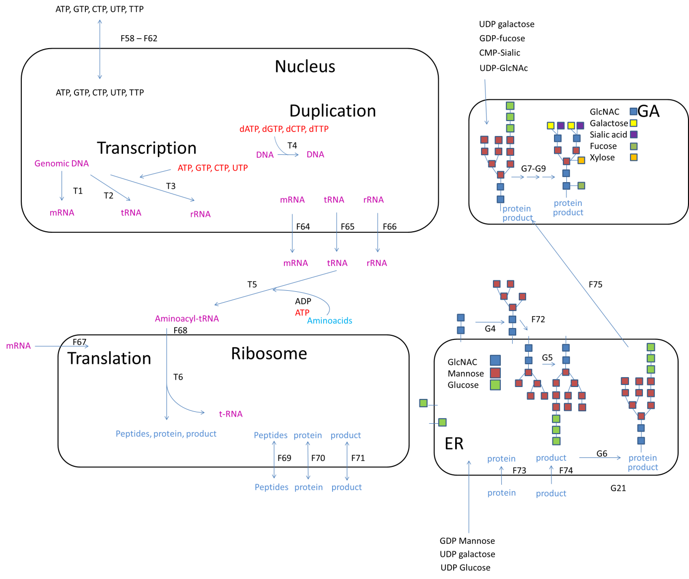
Duplication of DNA and translation of RNAs take place in the cell nucleus. mRNA is transported to the cytosol, rRNA takes position in ribosome, while mRNA is translated into protein by the aid of tRNA. Nucleotide triphosphates (NTPs) are used as an energy source during transcription. For each amino acid, codon is assembled from three NTPs. mRNA is assembled of: 5’ cap, 5’ and 3’ untranslated region (UTR), sequence for signal peptide, coding region, poly AAA end. mRNA exits the nucleus and enters a ribosome, where the protein is translated with the help of amino acid-bearing tRNA (AA-tRNA). One ATP molecule is used for AA-tRNA bond (Figure 6). Transcription and translation are usually not integrated into the models.

Figure 6: Transcription of DNA takes place in the nucleus and translation of mRNA takes place in the cytosol on ribosome. Glycan attachments are done in ER, while associated modifications take place in GA.
2.2.8. Glycosylation
Glycosylation is the addition of a glycan chain to a protein after translation. It was modeled separately from the rest of the cell metabolism.^{33,34,36} Peptide or protein can enter ER, if signal sequence is in front of protein. Inside ER, specific glycans assembled from monosaccharides are attached to the protein through amino group of the asparagine. Glycan part of the protein is additionally glycosilated in the ER and at the end of this process consists of two N-acetyl glucosamine and nine mannose residues. Afterwards, the glycosylated protein enters the GA where the glycan part of the protein is additionally modified with the help of specific enzymes. N-acetyl glucosamine, galactose, sialic acid, and fucose might be added to final glycan structures. The final products then leave the GA (Figure 6).^{73,76} The destination of the glycosylated protein isoforms is determined by a signal peptide in the protein sequence. Glycosylated proteins can be excreted from the cell, incorporated into membrane or transported into other destinations inside the cell (Figure 6).^{73,76}
Availability of glycosylation machinery relative to cellular secretory capacity may play a crucial role in protein glycosylation.³⁴ A modeling platform is able to predict the distribution of different glycoforms based on extracellular conditions³³ likewise the form of glycan, when expression of the protein is elevated.³⁶
2.2.9. Feedback loops
The catabolism is regulated by ATP. High concentration of ATP inhibits conversion of glucose-6-phosphate into ribulose-5-phosphate, fructose-6-phosphate into glycerate-3-phosphate, phosphoglycerate into phosphoenolpyruvate, pyruvate into acetylCoA (glycolysis), glutamine into glutamate, and glutamate into ketoglutarate (glutaminolysis).⁴⁵ ATP also inhibits Krebs cycle in two places: conversion of ketoglutarate into succinyl CoA, and oxaloacetate into citrate.⁴⁵
High concentration of ATP slows down catabolism and transfers excess glucose into glycogen. ATP is used for biomass and final product production. It stops glutaminolysis; glutamine is metabolized into other amino acids. Glucose is metabolized into nucleotide monosaccharides that are transported into ER and GA. The pathway of glycolysis is highly regulated to sustain sufficient concentration of ATP (Figure 7). In rapidly dividing cells glucose and glutamine consumption is major step for energy and compound production. Both pathways are ATP regulated by negative feedback loop.
High production of lipids from AcCoA and nucleotides from ribose-5-phosphate and glutamine leads to anabolism in CHO cells. DNA is duplicated by the aid of DNA polymerase. Proteins are synthesized in more complex way; first transcription of mRNA is needed, followed by translation of proteins by the aid of mRNA, tRNAs, and ribosomes.
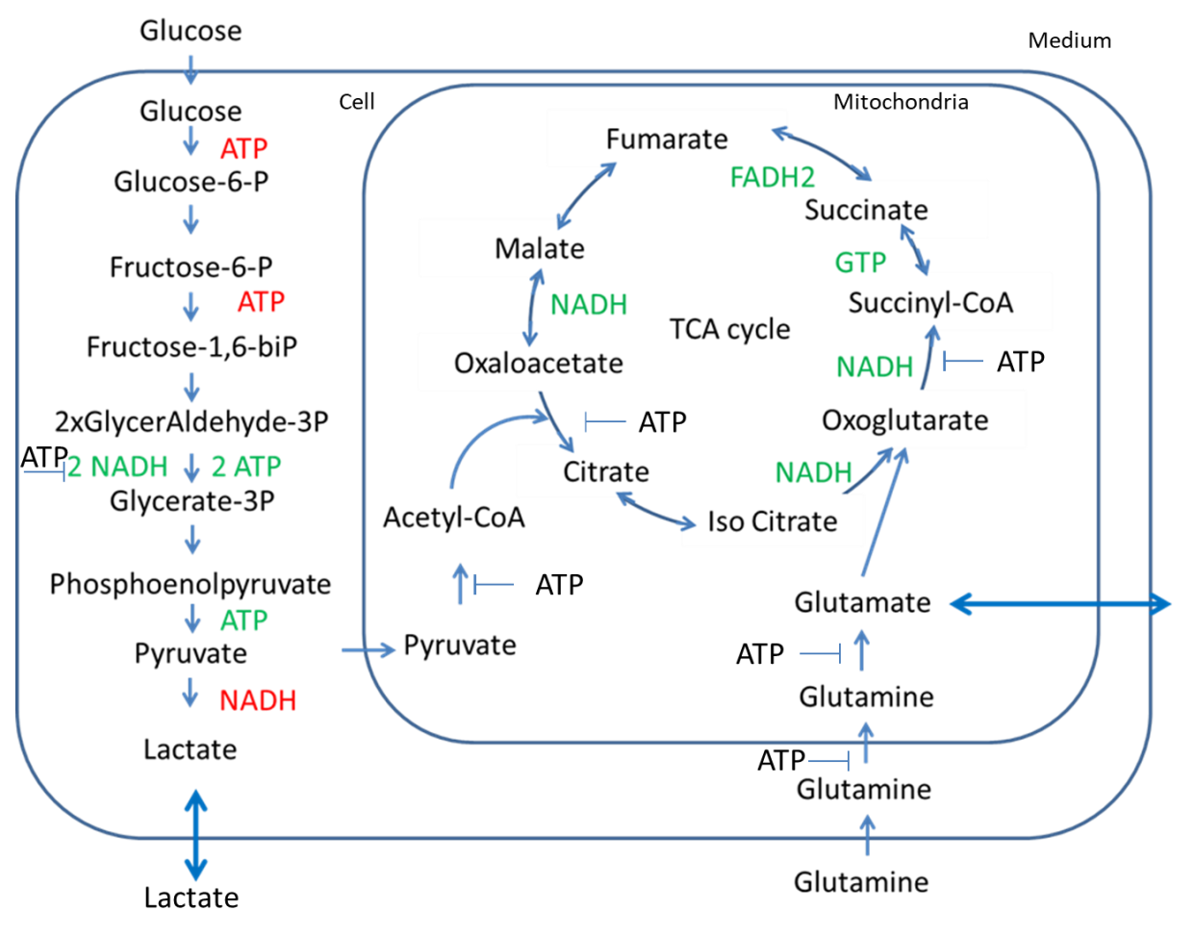
Figure 7: Glycolysis and Glutaminolysis

2.2.10. Mechanistic models

In addition to black box models, mechanistic models have gained increasing interest in a detailed description of mammalian cell metabolism. Mechanistic models start with a set of metabolites linked up with biochemical reactions, which organize metabolites in the metabolic network. Metabolic network comprises intracellular transformations of metabolites and the membrane transport, which couples the cell interior with the cell medium. Metabolic network modeling is commonly associated with the metabolic flux analysis (MFA), flux balance analysis (FBA), and other derived methodologies.⁷⁷ MFA considers experimental data to estimate flux rates for biochemical reactions within a metabolic network, while FBA assumes objectives and constraints to tailor the solution space of flux rates. These methods originally provide static insights into metabolic routes, what allows to study cell cultures at a state of particular interest. Even though several extensions were proposed to include extracellular dynamics in the framework of MFA and FBA,⁷⁸ precise mathematical representation of reaction kinetics and regulation mechanisms remains a challenge. See the review for a concise overview of metabolic models.⁷⁹
Several attempts have been made to address dynamic behavior of mammalian cell cultures. Nolan used the metabolic network with 34 reactions to describe CHO cell metabolism.³⁹ They used MFA to estimate reactions’ flux rates, which were further rationalized by optimization protocols. To imitate the distribution of co-factors they assumed two types: co-factors, which are located within the mitochondria and others within the liquid part of a cytoplasm. They defined the redox variable as the ratio between the rate of generated NADH and the transport rate of NADH from cytosol to mitochondria. The redox variable took place in the kinetic expressions and it was envisaged that governs dynamics of lactate.
Provost et at (2006) and later Zamorano et al (2013) used MFA and the associated concept of elementary flux modes (EFMs) to recognize probable metabolic routes (macro reactions). They obtain three sets of macro reactions (three submodels), each for the corresponding phase of the cell culture: growth, stationary, and decline phase. Macro reactions were modeled by the Monod kinetic law (Eq. 5). Finally, they assume the interplay between submodels to describe transitions through phases of the cell culture.
In another approach Hagrot et al ²¹ used the metabolic network with 30 reactions and enumerate the whole EFM spectrum. Then, they used several experimental sets to estimate maximal flux rates of EFMs. Dynamic behavior of EFMs was induced by additional terms that described substrate saturation, product inhibition, and metabolite inhibition. The so-called Poly-pathway model simulated multiple metabolic stages of CHO cell metabolism and thus addresses the diversity seen from experiments. However, the dissemination of the approach toward metabolic networks of larger extent remains a challenge due to time-consuming EFM enumeration. An example of such models are the genome-scale metabolic models (GEMs), which treat the metabolic network in a more detail together with enzymatic activity and the genome, which encodes enzymes of biochemical reactions in the metabolic network.^{50,81} GEMs are phenotype-specific and requires large amount of data and computer facilities. For further reading, see the excellent review of genome-scale approaches.⁸²
Mechanistic models have been applied also to study post-translational modifications (glycosylation) of antibodies within mammalian cell cultures.^{37,65,83,84} Glycosylation process takes place in endoplasmic reticulum and within Golgi apparatus, where sugar units get attached to antibody molecules. Multiple attachments of different sugar units determine diverse spectrum of glycosylated antibodies (glycoforms), which take part in reaction scheme. Along with the reaction scheme, eight enzymes govern attachments of sugar units. These processes are modeled by three types of kinetic laws, which describe interplay among enzymes and glycoforms: (i) Michaelis Menten with competitive and product inhibitions, (ii) Sequential-order Bi-Bi with competitive and product inhibitions and (iii) Random-order Bi-Bi with competitive and product inhibitions. In a greatly accepted approach, authors assume continuous plug flow reactor (PFR) model to represent maturation of glycoforms along the Golgi apparatus.⁸³ Coupled with the mass balances for nucleotide sugar donors, byproducts, and transport proteins, the PFR model provides a mechanistic explanation for glycosylation profiles of commercial antibodies. Recently, Hutter et al proposed glycosylation flux analysis (GFA) as an MFA analogue to apply constraint-based modeling of the glycosylation network by using a pseudo steady state assumption.³⁷ Using the GFA, the authors were able to elucidate dynamical changes of glycoforms, caused by media variations.
In our recent work, we proposed a simple metabolic network with 103 biochemical reactions, to investigate transitions between cell phases in mammalian CHO cell cultures.^{80,85} Figure 8 shows schematic representation of the metabolic pathways.
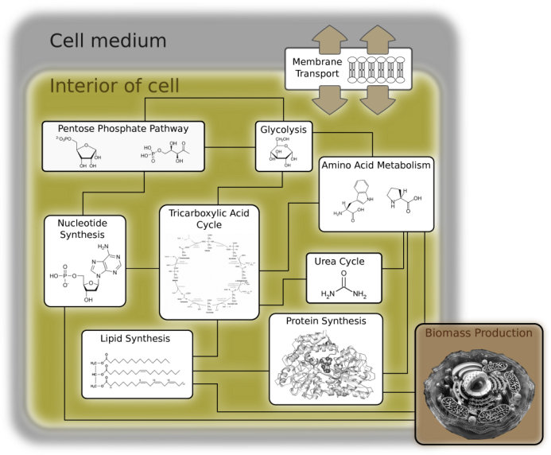
Figure 8: Metabolic network comprises Glycolysis, Pentose Phosphate Pathway, Nucleotide Synthesis, Tricarboxylic Acid cycle, Amino Acid Metabolism, Urea Cycle, Lipid Synthesis, Protein Synthesis Biomass Production, and Membrane Transport. Each pathway comprises detailed set of biochemical reactions, which describes transformations among metabolites on the molecular level.

In our approach, the Biomass (density of viable cells) evolves as dictated by the cell metabolism, and not via the logistic-typed description (Eq. 1) that is traditionally used in mechanistic models for Biomass production. Then, we used the interplay between FBA and MFA to impose constraints within the cell interior, and to estimate the reactions’ flux rates. We used the random sampling approach to calculate the set of EFMs (macro reactions), without the precalculated EFM spectrum. Assigning Monod kinetic law to macro reactions is a common approach to describe individual phases of the cell culture. Unfortunately, the approach is not suitable to describe transitions between growth, stationary, and decline phase. To overcome this issue, we included negative terms (reversible kinetics) in Monod kinetic law to address inhibition phenomena and the possible rewiring of metabolic routes, caused by products in macro reactions. After performing the parameter estimation, sensitivity analysis, and the reduction of model parameters, we obtained 17 kinetic parameters, which described dynamics of metabolites in the cell medium. Figure 9 shows time evolution of the representative metabolites.

Figure 9: Metabolites’ concentration profiles as a function of time. Green points label metabolite uptake or secretion in the cell medium during the cultivation of CHO-320 cells (Zamorano 2013-24). Purple lines apply to macro reactions, which are characterized by kinetic parameters; see also Tables 2 and 4 of the original paper.⁸⁵

Figure 9 shows characteristics of mammalian CHO cell cultures. At the growth phase, cells exhibit very high consumption rates of Glc and Gln, resulting in high secretion of Lac. Amino acids are mostly depleted. The end of growth phase (t ≈ 90 h) is characterized by Glc deprivation: to compensate it, the produced Lac is consumed as the carbon source instead of Glc.
As seen in Figure 9, the model is capable to describe transitions between cell phases. The important feature of the model turned out to be reversible nature of kinetic expressions, which allow to describe non-monotonic behavior of metabolites’ concentrations by means of flux reversal instead of user-defined switching functions that are in general difficult to obtain.

3. Summary
The present review describes how the research needs to be done from the start to successfully finish the bioreactor model. In the review we revise important knowledge of bioreactor operation and CHO metabolic pathways.
Black box models describe reactor with simple equations that fits curves of growth, substrate consumption and product formation. These are simple formulations that describe working bioreactor with culture at given conditions. Mechanistic models usually describe growth through complex metabolic pathways joint with complex operation equations. Black box equations can be also integrated into mechanistic models, a good example is description of biomass growth, where biomass depends on factors independent of network metabolic flows. Thorough study of metabolic pathways brings new ideas how to address existing problems that may arise during batch, fed batch and continuous bioreactor operation.
Acknowledgements
Special thanks go to partners on the Biopharm.si project. We are thankful to Miša Mojca Cajnko for all the help with comments and corrections on the paper.
Funding
This work was supported from program BioPharm.Si co-funded by Republic of Slovenia and European Union from European regional development fund.
Literature

- C. Altamirano, A. Illanes, S. Becerra, J. J. Cairo, F. Godia, J. Biotechnol. 2006, 125, 547–556.
- N. Sengupta, S. T. Rose, J. A. Morgan, Biotechnol. Bioeng. 2011, 108, 82–92.
- Z. Xing, B. Kenty, I. Koyrakh, M. Borys, S. H. Pan, Z. J. Li, Process Biochem. 2011, 46, 1423–1429.
- C. Goudar, R. Biener, K. B. Konstantinov, J. M. Piret, American Institute of Chemical Engineers Biotechnol. 2009, 25, 986–998.
- L. E. Quek, S. Dietmair, J. O. Kromer, L. K. Nielsen, Metab. Eng. 2010, 12, 161–171.
- S. Xu, L. Hoshan, H. Chen, Bioproc. Biosyst, Eng. 2016, 39, 1689–1702.
- L. Xie, D. I. Wang, Biotechnol. Bioeng. 1994, 43, 1175–1189.
- C. A. Sellick, A. S. Croxford, A. R. Maqsood, G. Stephens, H. V. Westerhoff, R. Goodacre, A. J. Dickson, Biotechnol. Bioeng. 2011, 108, 3025–3031.
- M. D. Rocha-Pizana, G. Ascencio-Favela, B. M. Soto-Garcia, M. M. Alvarez, M. D. L. Martinez-Fierro, Protein Expres. Purif. 2017, 132, 108–115.
- H. Hansen, C. Emborg, Appl. Microbiol. Biotechnol. 1990, 41, 560–564.
- L. Xie, D. I. Wang, Biotechnol. Bioeng. 1996, 52, 579–590.
- H. P. Bonarius, V. Hatzimanikatis, K. P. Meesters, C. D. de Gooijer, G. Schmid, J. Tramper, Biotechnol. Bioeng. 1996, 50, 299–318.
- F. Zamorano, A. V. Wouwer, G. Bastin, J. Biotechnol. 2010, 150, 497–508.
- C. Goudar, R. Biener, C. Boisart, R. Heidemann, J. Piret, A. de Graff, K. Konstantinov, Metab. Eng. 2010, 12, 138–149.
- J. D. Young, Curr. Opin. Biotech. 2013, 24, 1108–1115.
- W. S. Ahn, M. R. Antoniewicz, Metab. Eng. 2011, 13, 598–609.
- C. Altamirano, A. Illanes, A. Casablancas, X. Gamez, J. J. Cairo, C. Godia, Biotechnol. Progr.. 2001, 17, 1032–1041.
- J. Lopez-Meza, D. Araiz-Hernandez, L. M. Carrillo-Cocom, F. Lopez-Pacheco, M. del Refugio Rocha-Pizan,; M. M. Alvarez, Cytotechnology. 2016, 68, 1287–1300.
- A. Provost, G. Bastin, J. Process Control. 2004, 14, 717–728.
- S. Naderi, M. Meshram, C. Wei, B. McConkey, B. Ingalls, H. Budman, J. Scharer, Biotechnol. Prog. 2011, 27, 1197–1205.
- E. Hagrot, H. A. Oddsdottir, J. G. Hosta, E. W. Jacobsen, V. Chotteau, J. Biotechnol. 2016, 228, 37–49.
- J. Robitaille, J. K. Chen, M. Jolicoeur, PLoS ONE. 2015, 10, e0136815.
- J. A. Papin, N. D. Stelling,; S. Price Klamt; S. Schuster; B. O. Palsson, Trends Biotechnol. 2004, 22, 400–405.
- F. Zamorano, A. V. Wouwer, R. M. Jungers, G. Bastin, J. Biotechnol. 2013, 164, 409–422.
- P. Farzan, B. Mistry, M. G. Ierapetritou, AIChE J. 2017, 63, 398–408.
- B. Berry, J. Moretto, T. Matthews, J. Smelko, K. Wiltberger, Biotechnol. Progr. 2015, 31, 566–577.
- X. Chen, A.P. Alonso, D.K. Allen, J. L. Reed, Metab. Eng. 2011, 13, 38–48.
- N. E. Lewis, H. Nagarajan, B. O. Palsson, Nat. Rev. Microbiol. 2012, 10, 291–305.
- G. B. Nyberg, R. R. Balcarel, B. D. Follstad, G. Stephanopoulos, D. I. C. Wang, Biotechnol. Bioeng. 1998, 62, 324–335.
- J. Dean, P. Reddy, Biotechnol. Bioeng. 2013, 110, 1735–1747.
- A. Ghorbaniaghdam, O. Henry, M. Jolicoeur, Bioproc. Biosyst. Eng. 2013, 36, 469–487.
- B. Ben Yahia, B. Gourevitch, L. Malphettes, E. Heinzle, Biotechnol. Bioeng. 2017, 114, 785–797.
- P. M. Jedrzejewski, I. J. del Val, A. Constantinou, A. Dell, S. M. Haslam, K. M. Polizzi, C. Kontoravdi, Int. J. Mol. Sci. 2014, 15, 4492–4522.
- I. J. del Val, K. M. Polizzi, C. Kontoravdi, Sci. Rep. 2016, 6, 1–16.
- P. N. Spahn, N. E. Lewis, Curr. Opin, Biotech. 2014, 30, 218–224.
- J. Krambeck, M. J. Betenbaugh, Biotechnol. Bioeng. 2005, 92, 711–728.
- S. Hutter, T. K. Villiger, D. Bruhlmann, M. Stettler, H. Broly, M. Soos, R. Gunawan, Metab. Eng. 2017, 43, 9–20.
- E. S. Bayrak, T. Wang, A. Cinar, C. Undey, IFAC-PapersONLine. 2015, 48, 1252–1257.
- R. P. Nolan, K. Lee, Metab. Eng. 2011, 13, 108–124.
- N. Templeton, K.D. Smith, A. G. Mcatee-Prereira, H. Dorai, M. J. Betenbaugh, S. E. Lang, J. D. Young, Metab. Eng. 2016, 43, 218–225.
- L. Jiang, A. Boufersaoui, C. Yang, B. Ko, D. Rakheja, G. Guevara, Z. Hu, R. J. Debarardinis, Metab. Eng. 2017, 43, 198-207.
- J. Berrios, C. Alatmirano, N. Osses, R. Gonzales, Chem. Eng. Sci. 2011, 66, 2431–2439.
- E. E. Gonzo, S. Wuertz, V.B. Rajal, Biotechnol. Bioeng. 2014, 111, 2252–2264.
- A. Provost, G. Bastin, S. N. Agathos, Y. J. Schneider, Bioprocess Biosyst. Eng. 2006, 29, 349–366.
- C. S. Sanderson, J. P. Barford, G. W. Barton, Biochem. Eng. J. 1999, 3, 203–211.
- T. Goudar, R. Biener, B. K. Konstantinov, J. M. Piret, Biotechnol. Progr. 2012, 25, 986–998.
- P. Jorjani, S. S. Ozturk, Biotechnol. Bioeng. 1999, 64, 349-356.
- S. R. Chowdhury, J. Djordjevic, B. C. Albensi, P. Fernyhough, Bioscience Rep. 2016, 36, e00286.
- L. P. Zielinski, A. C. Smith, A. G. Smith, A. J. Robinson, Mitochondrion. 2016, 31, 45–55.
- S. Selvarasu, Y. S. Ho, W. P. K. Chong, N. S. C. Wong, F. N. K. Yusufi, Y. Y. Lee, M. G. S. Yap, D. Y. Lee, Biotechnol. Bioeng. 2012, 109, 1415–1429.
- W. S. Ahn, M. R. Antoniewicz, Biotechnol. J. 2012, 7, 61–74.
- Z. Z. Xing, A. M. Lewis, M. C. Borys, Z. J. Li, Biotechnol. Bioeng. 2017, 114, 1184–1194.
- N. Jenkins and A. Hovey, Biotechnol. Bioeng. 1993, 42, 1029–1036.
- B. Rossler, H. Lubben, G. Kretzmer, Enzyme Microb. Tech. 1996, 18, 423–427.
- S. Becerra, J. Berrios, N. Osses, C. Altamirano, Biochem. Eng. J. 2012, 60, 1–8.
- Watanabe and Okada S., J. Cell Biol. 1967, 32, 309–323.
- P. Ducommun, P. A. Ruffieux, A. Kadouri, U. von Stockar, I. W. Marison, Biotechnol. Bioeng. 2002, 77, 838–42.
- S. K. Yoon, S. L. Choi, J. Y. Song, G. M. Lee, Biotechnol. Bioeng. 2005, 89, 345–56.
- V. Avello, B. Tapia, M. Vergara, C. Acevedo, J. Berrios, J. G. Reyes, C. Altamirano, Electron. J.Biotechn. 2017, 27, 55–62.
- N. Kurano, C. Leist, F. Messi, C. Gandor, S. Kurano, A. Fiechter, J.Biotechnol. 1990, 6, 245–258.
- E. Trummer, K. Fauland, S. Seidinger, K. Schriebl, C. Lattenmayer, R. Kunert, K Vorauer-Uhl, R. Weik, N. Borth, H. Katinger, D. Muller, Biotechnol. Bioeng. 2006, 94, 1033–1044.
- J. S. Seo, Y. J. Kim, J. M. Cho, E. Baek, G. M. Lee, Appl. Microbiol. Biot. 2013, 97, 5283–5291.
- K. Furukawa, K. Ohsuye, Cytotechnology, 1998, 26, 153–64.
- H. Kaufmann, X. Mazur, M. Fussenegger, J. E. Bailey, Biotechnol. Bioeng., 1999, 63, 573–582,
- S. N. Galleguillos, D. Ruckerbauer, M. P. Gerstl, N. Borth, M. Hanscho, J. Zanghellini, Comput. Struct. Biotechnol. J. 2017, 15, 212–221.
- R. L. Dutton, J. Scharer, M. Moo-Young, Cytotechnology, 2006, 52, 55–69.
- V. Hendrick, P. Winnepenninckx, C. Abdelkafi, O. Vandeputte, M. Cherlet, T. Marique, G. Renemann, A. Loa, G. Kretzmer, J. Werenne, Cytotechnology 2001, 36, 71–83.
- M. Rasouli, Clin. Biochem. 2016, 49, 936–941.
- A. Philip, M. Hargreaves, K. Baar, Am. J. Phisiol. 2012, 302, 1343–1351.
- L. Hildebrandt, T. Spennetta, R. Ackerman, C. Elson, E. Shrago, R. T. Ackermann, Biochem. Bioph. Res. Co. 1996, 225, 207–212.
- Moncada, S.; Higgs, E.A.; Colombo, S.L.; Biochem. J. 2012, 446, 1–7.
- O. Feron, Radiother. Oncol. 2009, 92, 329–333.
- E. Maverakis, K. Kim, M. Shimoda, M. E. Gershwin, F. Patel, R. Wilken, S. Raychaudhuri, L.R. Ruhaak, C. B Lebrilla, J. Autoimmun. 2015, 57, 1–13.
- E.J.M. Blondeel, R. Ho, S. Schulze, S. Sokolenko, S. R. Guillemette, I. Sliva, Y. Durocher, J. G. Guillemette, B. J. McConkey, D. Chang, M. G. Aucoin. J. Biotechnol 2016, 234, 127–138.
- F. Chiappini, A. Coilly, H. Kadar, P. Gual, A. Tran, C. Desterke, D. Samuel, J. C. Duclos-Vallée, D. Touboul, J. Bertrand-Michel, A. Brunelle, C. Guettier, F. Le Naour, Sci Rep. 2017, 7, 1–17.
- B. Imperiali and S.E. O’Connor, Curr. Opin. Chem. Biol. 1999, 3, 643–649.
- P. J. D’Huys, I. Lule, D. Vercammen, J. Anné, J. F. Van Impe, K. Bernaerts, J. Biotechnol. 2012, 161, 1–13.
- F. Llaneras, A. Sala, J. Picó, J. Process Contr. 2012, 22, 1946–1955.
- E. O. Voit, WIREs Syst. Biol. Med. 2017, 9, e1391.
- Kaučič, V. (Ed.). Zbornik referatov in povzetkov, Slovenski kemijski dnevi 2017, Portorož, Slovenia, 2017, J. Gašperšič, U. Novak, A. Pohar, B. Likozar, 2017, pp. 1-6.
- H. Hefzi, K. S. Ang, M. Hanscho, A. Bordbar, D. Ruckerbauer, M. Lakshmanan, C. A. Orellana, D. Baycin-Hizal, Y. Huang, D. Ley, V. S. Martinez, S. Kyriakopoulos, N. E. Jiménez, D.C. Zielinski, L.E. Quek, T. Wulff, J. Arnsdorf, S. Li, J. S. Lee, G. Paglia, N. Loira, P.N. Spahn, L. E. Pedersen, J. M. Gutierrez, Z. A. King, A. M. Lund, H. Nagarajan, A. Thomas, A. M. Abdel-Haleem, J. Zanghellini, H. F. Kildegaard, B. G. Voldborg, Z. P. Gerdtzen, M. J. Betenbaugh, B. O. Palsson, M. R. Andersen, L. K. Nielsen, N. Borth, D. Y. Lee, N. E. Lewis, Cell Syst. 2016, 3, 434–443.
- Ž. Rejc, L. Magdevska, T. Tršelič, T. Osolin, R. Vodopivec, J. Mraz, E. Pavliha, N. Zimic, T. Cvitanović, D. Rozman, M. Moškon, M. Mraz, Comput. Bio.l Med. 2017, 88, 150–160.
- I. J. del VAL, J. M. Nagy, C. A. Kontoravdi, Biotechnol. Prog. 2011, 27, 1730–1743.
- T. K. Villiger, E. Scibona, M. Stettler, H. Broly, M. Morbidelli, M. Soos. Biotechnol Prog. 2016, 32, 1135–1148.
- M. Kastelic, D. Kopač, U. Novak, B. Likozar, ACS Synth. Biol. 2018, In Press

