Green synthesis of bromo organic molecules and investigations on their antibacterial properties: an experimental and computational approach
Naruti Longkumer,ª Kikoleho Richa,ª Rituparna Karmaker,ª Visekhonuo Kuotsu,^{b} Aola Supong,ª Latonglila Jamir,^{b} Pranjal Bharali^{b} and Upasana Bora Sinha^{a*}
ª Department of Chemistry, Nagaland University, Lumami-798627, Nagaland, India
^{b} Department of Environmental Science, Nagaland University, Lumami-798627, Nagaland, India
* Corresponding author. Email: upasanabsinha@gmail.com; Tel: +91-9436006754

Abstract
A simple, environmentally benign methodology has been developed to synthesize some bromoorganic compounds which have potential as antimicrobial agents. This is obtained through microwave irradiation, on-water and using Cetyltrimethylammonium tribromide (CTMATB) as the bromine source. That high yield of the product could be achieved within short reaction times is the main attribute of the present synthetic approach. The compounds were evaluated for in vitro antibacterial activity against Escherichia coli, Klebsiella pneumoniae, Staphylococcus aureus and Bacillus subtilis. Further, in silico studies were carried out to define the interaction of the compounds with the bacterial proteins.

Keywords: Bromo compounds, aqueous, green, antibacterial, in vitro, molecular docking.
1. Introduction
Bromo derivatives, both naturally occurring as well as synthesised compounds have been reported to have biological activities such as feeding deterrent, antimicrobial, anti-diabetic, antioxidant, anti-inflammatory and enzyme inhibition.¹⁻⁷ Considering the importance of bromo organic compounds, new methods of their synthesis are always sought and literature enumerates a few reports of the use of quaternary ammonium tribromides (QATBs) under MW irradiation for their synthesis.^{8,9} Among the tribromides reported so far, the efficacy and versatility of cetyltrimethylammonium tribromide (CTMATB) has been reported in many important organic transformations.¹⁰⁻¹⁷ Its proven mildness as a brominating reagent and versatility towards various organic substrates added to its compatibility to aqueous media is what prompted us to choose this reagent for the present study.
In recent years, there has been an increasing emphasis on avoidance of use of solvents in organic reactions. It often happens that while many reaction strategies are efficient as well as benign, use of organic solvents in these reactions prevent them from being considered as perfectly green.¹⁸ There is an extensive current debate over the relative “greenness” of the use of various solvent media, but water can undeniably be considered the cleanest solvent available, and the use and release of clean water clearly will have the least impact to the environment. Numerous publications report the combination of water as an environmentally benign solvent for chemical transformations with the use of MW irradiation as an efficient heating method.^{19,20} In fact, microwave (MW) heating has become a broadly accepted non-conventional energy source for performing organic synthesis²¹⁻²⁷ as well as in various aspects of inorganic chemistry and polymer chemistry.^{28,29} Microwave heating is preferred in the context of environmentally benign synthesis because it is a more homogenous method and accelerates reaction processes as compared to the traditional heating methods (e.g in oil bath or heating mantle),^{23,26,30,31} hence our choice of MW irradiation and water as the solvent medium.
While the presently synthesized compounds are examples of small molecules which are very common, small molecules have found significance as new-age pharmaceutical compounds due to their less challenging manufacturing procedure as compared to larger biologicals. Further, even though bromoorganic compounds have been commonly used as antimicrobial agents,³⁻⁷ there seems to be no reports of the anti-microbial essay of the presently synthesized compounds, in the literature. This led us to consider the prospects of such an investigation through experimental and computational approaches
To explain the promising activity of these compounds, this work includes the molecular docking study of the synthesised compounds within the binding pockets of DNA gyrase subunit B (PDB ID: 1KZN) and Dihydrofolate reductase (PDB ID: 3SRW). DNA gyrase is a bacterial protein of the topoisomerase family involved in DNA replication and transcription by catalysing the negative supercoiling of the closed-circular DNA. As this function is essential for DNA replication and transcription, gyrase is really a suitable target for antibacterial agents.³¹ Dihydrofolate reductase (DHFR) is an important target in a number of therapeutic areas including cancer and antiinfectives where it is used to generate antibacterial, antifungal and antiparasitic agents.³²
2. Experimental
2.1. General chemistry. All the solvents and substrates were purchased from Merck, Spectrochem, Sigma-Aldrich, and S.D Fine Chem. Hexane and ethyl acetate were distilled for use in column chromatography while the substrates were used without further purification. All reactions were monitored by TLC on silica gel HF₂₅₄. The microwave reactions were carried out in a scientific microwave system CATA 2R from Catalyst System (Pune, India). Melting points were determined by digital melting point apparatus. IR spectra were recorded with KBr pellets on a Perkin Elmer FT-IR (spectrum two). ¹H NMR and ¹³C NMR spectra were recorded on a JEOL ECS-400 using CDCl₃ as the internal standard.
2.1.1 Procedure for synthesis of CTMATB.
CTMATB was synthesised using a modified method. In this procedure, a mixture of 4.89 g (41.07 mmol) of potassium bromide (KBr) and 5g (13.74 mmol) of cetyltrimethylammonium bromide (CTMAB), and 0.057g (0.53 mmol) of sodium carbonate (Na₂CO₃) were taken in a mortar and 10 mL (88.24 mmol) of 50% H₂O₂ added to the whole. The resultant mixture was grinded thoroughly and then was dissolved in 50 mL of water taken in a 100 mL beaker. The reaction solution was stirred at room temperature for 5 minutes and then 30 mL of 1 M H₂SO₄ was added drop-wise. An exothermic reaction followed and the CTMATB precipitated out. CTMATB formed was filtered using suction pump, washed with water many times till the filtrate contained no trace of acid (tested using litmus paper), and then initially air-dried and finally dried in a vacuum dessiccator.

The compound was then dried in a vacuum desiccator using anhydrous calcium chloride (CaCl₂) as desiccant. The product was obtained as bright yellow micro-crystals which was further recrystallized in methanol. Yield of the product was 5.52 g (96 %). M.P: 87 – 88 C.
2.1.2 General procedure for the synthesis of compounds 1a-9a. A homogenous mixture of the reagent (2 mmol) and substrate (2 mmol) were taken in 1:1 ratio in a 50 ml round bottomed flask. 10 ml H₂O was added to the mixture and was stirred thoroughly. The reaction mixture was placed inside a microwave reactor. The reactor was switched on and kept at a controlled power of P-7 which corresponds to 595 watt. The progress of the reaction was monitored by TLC on silica gel HF₂₅₄ using ethylacetate-hexane solvent system (volume ratio varied for different substrate). After completion of reaction, the product was extracted with 10ml (x2) ethylacetate and washed with 5 ml (x2) sodium bicarbonate solution. The crude product thus obtained was subjected to column chromatography over a pad of silica gel using ethylacetate-hexane solvent system (volume ratio varied for different substrate) to obtain the desired product.
2.2 Antibacterial studies
All the synthesized compounds were evaluated for their in vitro antibacterial activities against Escherichia coli and Klebsiella pneumonia as Gram negative bacteria, Staphylococcus aureus and Bacillus subtilis as Gram positive bacteria. The antimicrobial properties of the synthesised compounds were performed by determining the zone of inhibition, using agar well diffusion method.³³ Subsequently minimum inhibitory concentration (MIC) of the compounds were determined by the twofold broth dilution method in Nutrient broth. DMSO was run as a control and the tests were performed at 10 mg/ml concentration using DMSO as solvent. Streptomycin was used as the standard reagent. Each experiment was performed in triplicate and the average reading was taken.
2.3 Docking studies
Molecular docking studies were conducted so as to validate the obtained data and to provide comprehensible evidence for the observed antibacterial activity of all synthesized compounds. In this study, molecular docking simulations were performed using Molegro Virtual Docker (MVD). The pdb file format of enzymes DNA Gyrase B (Pdb id: 1KZN) and Dihydrofolate Reductase (Pdb id: 3SRW) as receptors were obtained from the RCSB Protein Data Bank and were prepared for molecular Docking. All the 3D structure of the ligands was drawn using ChemBioDraw as mol2 file. For molecular docking simulation, water molecules were removed and charges were assigned. By using MVD cavities were predicted and the ligands were docked against the target proteins and 30 independent runs were performed for each ligand.³⁴⁻³⁷
3. Results and Discussion
Cetyltrimethylammonium tribromide (CTMATB), having the molecular formula C₁₉H₄₂NBr₃ is a bright orange crystalline solid with sharp melting point at 87-88°C. However, from thermo gravimetric analysis it was revealed that the compound is stable even up to ca. 200 C. One of the major implications of this property is that the tribromides may be very useful for the appropriate organic transformations at relatively higher temperatures as well. It is obviously feared that tribromides, upon heating, release bromine, which is an environmentally hazardous chemical. However, while investigating their thermal stability by thermo gravimetric (TG) experiments, it was observed that CTMATB loses Br₂ as the tail fragment at the temperature of 265–267°C, which is much higher than the temperature at which brominations take place.¹⁷
In order to determine the versatility of CTMATB in aqueous condition, different types of organic compounds were taken and the reactions were performed under microwave conditions. The results of the bromination reactions are presented in Table 1. The products were identified by comparing their melting points and IR absorption spectra with that of authentic samples.^{8,9,17,18,38}

Table 1. Aqueous microwave bromination of organic substrates with CTMATBª

Substrate | Product^{b} | Reaction time | Yield^{c}
1 | 1a | 4 min | 70%
2 | 2a | 5 min | 75%
3 | 3a | 4 min | 80%
4 | 4a | 4 min | 80%
5 | 5a | 5 min | 62%
6 | 6a | 2 min | 69%
7 | 7a | 3 min | 60%
8 | 8a | 5 min | 69%
9 | 9a | 4 min | 86%
ªReactions were monitored by TLC; ^{b}Confirmed by IR, ¹H NMR and ¹³CNMR; ^{c}Isolated yields.
The antibacterial activity of the synthesised compounds was tested against Escherichia coli and Klebsiella pneumonia as Gram negative bacteria, Staphylococcus aureus and Bacillus subtilis as Gram positive bacteria. The results of the primary screening have been shown in Table 2. The investigation of the screening revealed that the test compounds showed varying degree of activity against all the tested microorganisms. Almost all the compounds showed moderate to potent activity against the strains. Subsequently minimum inhibitory concentration (MIC) of the compounds was determined to quantify the antibacterial potency of the compounds. The results of the MIC values of antibacterial activity have been given in Table 3. Compound 2a showed a better activity against E. coli with a MIC of 0.058 mg/ml and compounds 4a and 5a has less effectiveness against the bacterial strains. In comparison, compound 2a showed the best activity indicating its promising broad spectrum of antibacterial property.
Table 2. Zone of inhibition values (mm) of the synthesised compounds
Compounds (10 mg/ml) | Zone of inhibition (mm)
Compounds (10 mg/ml) | E. coli | K. pneumoniae | S. aureus | B. subtilis
1a | 19 | 12 | 18 | 14
2a | 24 | 15 | 21 | 18
3a | 18 | 17 | 19 | 16
4a | 12 | 10 | 15 | >10
5a | 10 | >10 | 12 | 10
6a | 19 | 15 | 16 | 12
7a | 12 | 17 | <10 | 14
8a | 16 | 18 | 16 | >10
9a | 19 | 12 | 17 | 14
Streptomycin | 32 | 30 | 34 | 30

Table 3. MIC (minimum inhibitory concentration in mg/ml) of the synthesised compounds
Compounds (10 mg/ml) | MIC (mg/ml)
Compounds (10 mg/ml) | E. coli | K. pneumoniae | S. aureus | B. subtilis
1a | 0.117 | 0.468 | 0.117 | 0.234
2a | 0.058 | 0.144 | 0.234 | 0.117
3a | 0.117 | 0.144 | 0.117 | 0.144
4a | 0.937 | 0.937 | 0.144 | 0.937
5a | 0.937 | 0.937 | 0.468 | 0.937
6a | 0.117 | 0.144 | 0.144 | 0.468
7a | 0.468 | 0.117 | 0.937 | 0.234
8a | 0.144 | 0.937 | 0.144 | 0.937
9a | 0.117 | 0.937 | 0.144 | 0.234
Streptomycin | 0.014 | 0.029 | 0.014 | 0.014

Docking studies were performed on known target proteins to understand the antibacterial mechanisms of bromo compounds using Molegro virtual docker(MVD). The proteins used as target were DNA Gyrase B (Pdb id: 1KZN) from Escherichia coli and Dihydrofolate Reductase (Pdb id: 3SRW) from Staphylococcus aureus. The best pose of each compound were selected for ligand-protein interaction energy analysis as shown in Table 4 and 5. The interaction energy of 2a and 7a were -76.74 kJ/mol and -75.60 kJ/mol as compared to streptomycin with -150.03kJ/mol. This indicates that 2a and 7a also had favourable ligand-protein interaction energy at the binding cavity of 1KZN. Similarly, the interaction energy of 2a and 7a were -73.36 kJ/mol and -78.04kJ/mol as compared to streptomycin with -178.12kJ/mol. This indicates that 2a and 7a also had favourable ligand-protein interaction energy at the binding cavity of 3SRW. The snapshots of ligand-protein interaction depicting the binding mode of the best poses are shown in Fig1. A, B, C and D. In this study, the molecular interaction analysis as shown in Table 6 established a common molecular interaction with Val71 and Thr165. Similarly in Table 7, a common interaction with Thr122 and Asp121 in the compounds and streptomycin was established.

Table 4. Docking score of the compounds with 1KZN

Ligand | Moldock score | Rerank scoreª | Interaction^{b} | Internal^{c} | HBond^{d} | LE1e | LE3^{f}
1a | -64.19 | -49.54 | -61.17 | -3.01 | -2.50 | -8.02 | -6.19
2a | -66.34 | -57.59 | -76.74 | 10.40 | -2.29 | -6.63 | -5.76
3a | -56.97 | -48.30 | -66.03 | 9.06 | -2.58 | -7.12 | -6.04
4a | -63.30 | -52.11 | -72.49 | 9.19 | -2.02 | -7.03 | -5.79
5a | -62.87 | -52.41 | -72.86 | 9.99 | -1.94 | -6.99 | -5.82
6a | -62.12 | -52.74 | -72.86 | 11.71 | -2.08 | -6.90 | -5.86
7a | -62.72 | -55.09 | -75.60 | 12.87 | 0.00 | -5.70 | -5.01
8a | -62.50 | -50.56 | -73.12 | 10.61 | -2.12 | -6.25 | -5.06
9a | -63.07 | -54.09 | -72.88 | 9.81 | -3.31 | -7.01 | -6.01
Strepto-mycin | -101.15 | -29.04 | -150.03 | 48.87 | -8.81 | -2.53 | -0.73
ªThe rerank score is a linear combination of E-inter (steric, Van der Waals, hydrogen bonding, electrostatic) between the ligand and the protein, and E-intra. (torsion, sp2-sp2, hydrogen bonding, Van der Waals, electrostatic) of the ligand weighted by pre-defined coefficients. ^{b}The total interaction energy between the pose and the protein (kJ/mol). ^{c}The internal energy of the pose. ^{d}Hydrogen bonding energy (kJ/mol). ^{e}Ligand efficiency 1: MolDock score divided by heavy atoms count. ^{f}Ligand efficiency 3: Rerank score divided by heavy atoms count.

Table 5. Docking score of the compounds with 3SRW

Ligand | Moldock score | Rerank scoreª | Interaction^{b} | Internal^{c} | HBond^{d} | LE1e | LE3^{f}
1a | -64.94 | -49.76 | -61.92 | -3.02 | -4.18 | -8.12 | -6.22
2a | -62.98 | -54.19 | -73.36 | 10.38 | -3.19 | -6.30 | -5.42
3a | -50.44 | -41.89 | -59.50 | 9.06 | -1.49 | -6.30 | -5.24
4a | -55.92 | -46.30 | -65.12 | 9.19 | -1.43 | -6.21 | -5.14
5a | -55.86 | -46.43 | -65.85 | 9.99 | -1.78 | -6.21 | -5.16
6a | -54.38 | -46.44 | -66.10 | 11.71 | -1.91 | -6.04 | -5.16
7a | -64.85 | -56.88 | -78.04 | 13.19 | -8.59 | -5.90 | -5.17
8a | -61.56 | -51.24 | -72.18 | 10.62 | -2.38 | -6.16 | -5.12
9a | -60.34 | -49.08 | -70.15 | 9.81 | -4.37 | -6.70 | -5.45
Strepto-mycin | -134.60 | -39.20 | -178.12 | 43.52 | -9.39 | -3.36 | -0.98
ªThe rerank score is a linear combination of E-inter (steric, Van der Waals, hydrogen bonding, electrostatic) between the ligand and the protein, and E-intra. (torsion, sp2-sp2, hydrogen bonding, Van der Waals, electrostatic) of the ligand weighted by pre-defined coefficients. ^{b}The total interaction energy between the pose and the protein (kJ/mol). ^{c}The internal energy of the pose. ^{d}Hydrogen bonding energy (kJ/mol). ^{e}Ligand efficiency 1: MolDock score divided by heavy atoms count. ^{f}Ligand efficiency 3: Rerank score divided by heavy atoms count.

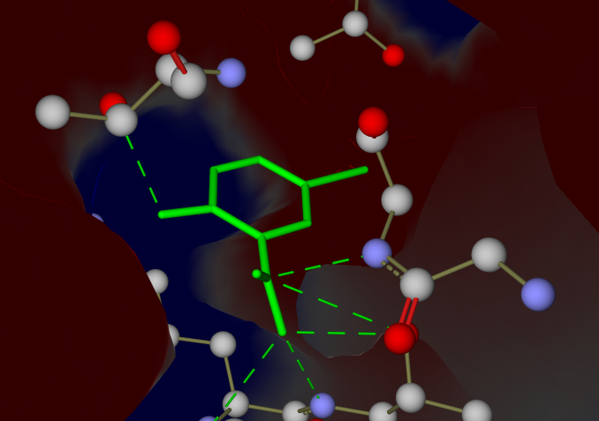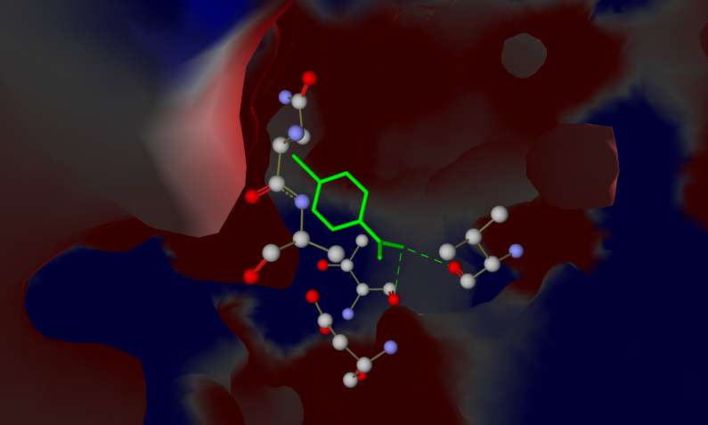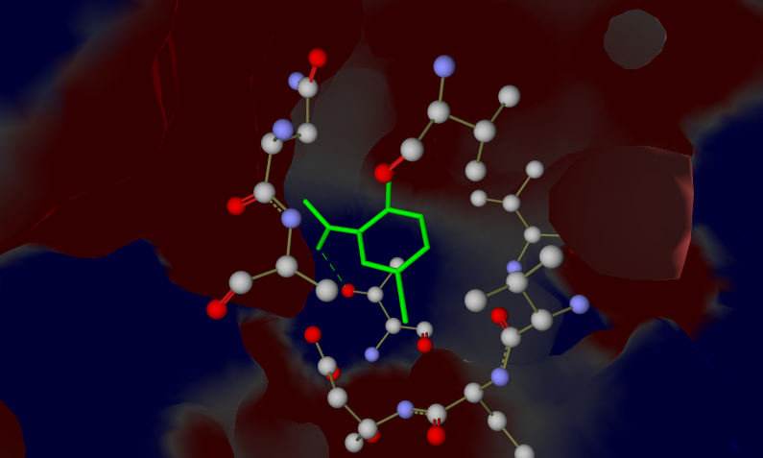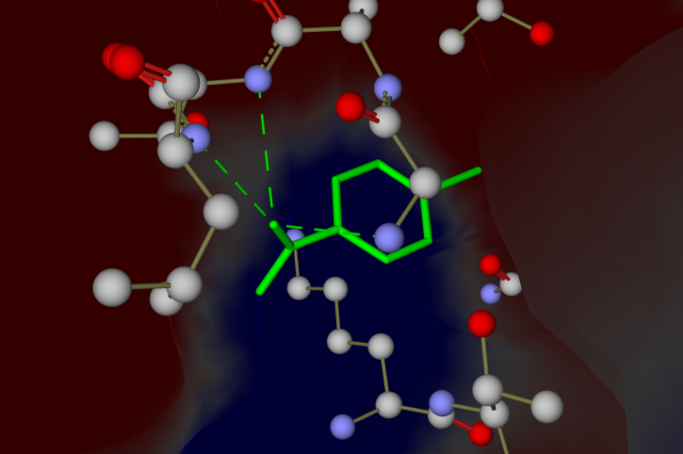
D
7a
A

2a
B
7a
2a
C

Figure 1. Molecular interaction of the compounds 2a and 7a at the active pockets of the protein 1KZN (A and B) and 3SRW(C and D); (green dotted lines indicates the mode of interaction with the protein).

Table 6. Molecular interaction analysis of the compounds with the active site of 1KZN

Compound | Interaction (Protein...Ligand) | Interaction Energy (kJ/mol) |  | Interaction distance (Å) |  | Hybridisation (Protein) |  |  | Hybridisa-tion (Ligand)
1a | Asp73(OD1)...N(4) |  | -2.5 |  | 2.785 |  | sp³(A) | sp²(D)
2a | Val71(O)....N(8)  Thr165(O)....N(8) |  | -2.409  -2.209 |  | 2.589  2.901 |  | sp²(A)  sp²(A) | sp²(D)  sp²(D)
3a | Thr165(O)....N(6)  Val71(O)....N(6) |  | -2.5  -2.5 |  | 2.928  2.815 |  | sp²(A)  sp²(A) | sp³(D)  sp³(D)
4a | Val71(O)....N(0) |  | -2.5 |  | 2.676 |  | sp²(A) | sp³(D)
5a | Val71(O)....N(0) |  | -2.5 |  | 2.663 |  | sp²(A) | sp³(D)
6a | Val71(O)....N(0) |  | -2.5 |  | 2.683 |  | sp²(A) | sp³(D)
7a | Thr165(OG1)....O(14) |  | -2.423 |  | 3.115 |  | sp³(B) | sp²(A)
8a | Val71(O)....N(0) |  | -2.5 |  | 3.020 |  | sp²(A) | sp³(D)
9a | Val167(N)....O(0)  Val71(O)....O(0) |  | -0.922  -2.5 |  | 3.217  2.672 |  | sp²(D)  sp²(A) | sp³(B)  sp³(B)
Streptomycin | Asn46(ND2)....N(36)  Asn46(ND2)....O(11)  Asp49(OD1)....N(38)  Asp49(OD1)....N(39)  Asn46(O)....N(39)  Asn46(O)....O(20)  Asp73(OD1)....O(20)  Thr165(OG1)....O(14)  Thr165(O)....O(35)  Val71(O)....O(35)  Val167(N)....O(35) |  | -2.5  -1.937  -0.377  -1.968  -1.153  -2.44  -2.5  -0.464  -0.335  -2.5  -0.890 |  | 2.866  2.532  3.524  2.880  3.396  3.111  2.676  3.507  3.009  2.621  3.112 |  | sp²(D)  sp²(D)  sp³(A)  sp³(A)  sp²(A)  sp³(A)  sp³(A)  sp³(B)  sp²(A)  sp²(A)  sp²(D) | sp²(A)  sp³(B)  sp²(D)  sp²(D)  sp²(D)  sp³(B)  sp³(B)  sp³(A)  sp³(B)  sp³(B)  sp³(B)
(A): Acceptor (D): Donor (B): Both donor and acceptor

Table 7. Molecular interaction analysis of the compounds with the active site of 3SRW

Compound | Interaction (Protein...Ligand) | Interaction Energy (kJ/mol) | Interaction distance (Å) | Hybridisat-ion  (Protein) | Hybridist-ion (Ligand)
1a | Gln96(N)....N(1)  Thr97(N)....N(1)  Thr97(OG1)....N(1) | -0.042  -2.210  -2.225 | 3.480  3.157  3.148 | sp²(D)  sp²(D)  sp³(B) | sp²(A)  sp²(A)  sp²(A)
2a | Gly95(N)....O(7)  Thr95(N)....O(7)  Leu98(N)....O(7) | -0.175  -0.510  -2.5 | 2.944  3.223  3.027 | sp²(D)  sp²(D)  sp²(D) | sp²  sp²  sp²
3a | Thr122(OG1)....N(6)  Asp121(OD1)....N(6) | -2.5  -2.5 | 2.867  3.052 | sp³(B)  sp³(A) | sp³(D)  sp³(D)
4a | Thr122(OG1)....N(0) | -2.5 | 2.883 | sp³(B) | sp³(D)
5a | Thr122(OG1)....N(0) | -2.5 | 2.971 | sp³(B) | sp³(D)
6a | Thr122(OG1)....N(0) | -2.5 | 2.956 | sp³(B) | sp³(D)
7a | Thr97(OG1)....N(0)  Gly95(N)....N(13)  Thr47(OG1)....N(13)  Thr47(OG1)....O(14)  Thr47(N)....O(14)  Lys46(N)....O(14) | -1.813  -2.208  -0.699  -2.5  -2.5  -0.280 | 2.882  2.932  3.460  2.813  2.713  3.402 | sp³(B)  sp²(D)  sp³(B)  sp³(B)  sp²(D)  sp²(D) | sp³(D)  sp³(A)  sp³(A)  sp²(A)  sp²(A)  sp²(A)
8a | Thr122(OG1)....N(0) | -2.5 | 2.815 | sp³(B) | sp³(D)
9a | Thr97(N)....O(0)  Gly95(N)....O(0)  Leu98(N)....O(0) | -0.673  -1.197  -2.5 | 3.110  2.639  2.746 | sp²(D)  sp²(D)  sp²(D) | sp³(B)  sp³(B)  sp³(B)
Streptomycin | Ala8(N)….O(35) | -0.660 | 3.225 | sp²(D) | sp³(B)
Streptomycin | Ala8(O)....O(34) | -1.812 | 2.517 | sp²(A) | sp³(B)
Streptomycin | Gln20(O)....O(10) | -0.676 | 2.601 | sp²(A) | sp³(B)
Streptomycin | Ser50(OG)….O(12) | -2.5 | 2.702 | sp³(B) | sp³(B)
Streptomycin | Ser50 (OG)….O(22) | -2.5 | 2.607 | sp³(B) | sp²(A)
Streptomycin | Thr47(OG1)….N(39) | -2.5 | 2.775 | sp³(B) | sp²(D)
Streptomycin | Thr122(OG1)….N(3) | -2.5 | 3.085 | sp³(B) | sp²(A)
Streptomycin | Thr122(OG1)….O(11) | -2.5 | 2.772 | sp³(B) | sp²(B)
Streptomycin | Asp121(OD1)….N(2) | -2.5 | 3.053 | sp³(A) | sp²(D)
Streptomycin | Asp121(OD1)….N (0) | -2.5 | 2.817 | sp³(A) | sp²(D)
Streptomycin | Asn19(OD1)….N(2) | -2.093 | 3.181 | sp²(A) | sp²(D)
(A): Acceptor (D): Donor (B): Both donor and acceptor
4. Conclusion
To conclude, microwave assisted aqueous reactions for the bromination of organic compounds is an attractive protocol as it is eco-friendly, efficient and economic. The use of a CTMATB in the bromination reactions which is less toxic compared to using molecular bromine makes the process more environmentally benign. The antimicrobial study of these novel bromoorganic derivatives against gram positive and gram negative species showed that synthetic mimics of naturally occurring bromoorganic compounds can be a promise to drug- resistant bacteria. Docking studies revealed that both streptomycin and the synthesized compounds have a common interaction at the active sites of the protein and further studies on these compounds might increase their potency thereby enhancing their anti bacterial activity. Thus, this study adopts significance in view of simple molecules that are potent and easy to synthesize. Further studies on derivatives involving synthetic mimics of naturally occurring moieties would provide a lead in the development of novel bromoorganic-based antimicrobial compounds.

Acknowledgement
The authors N. Longkumer and K. Richa are thankful to the UGC Non-NET fellowship and UGC Project (UGC MRP No.43-192/2014) respectively for financial support. We also acknowledge the BIF center, Nagaland University, Lumami for extending the facilities.

References
- I. Saikia, A. J. Borah, P. Phukan, Chem. Rev. 2016, 116, 6837-7042. DOI: 10.1021/acs.chemrev.5b00400
- L. Xiukun, L. Ming, J. Ocean Univ. China 2012, 11, 533-538. DOI:10.1007/s11802-012-2109-1
- P. Rajasulochana, P. Krishnamoorthy, R. Dhamotharan, IJPBS 2012, 3, 173-186.
- M. M. Rathore, V. V. Parhate, P. R. Rajput, IJRPBS 2013, 4, 59-62.
- K. B. Oh, J. H. Lee, S. C. Chung, J. Shin, H. J. Shin, H. J. Kim, H. S. Leeb, Bioorg. Med. Chem. Lett. 2008, 18, 104-108. DOI:10.1016/j.bmcl.2007.11.003
- T. S. Bante, V. V. Parhate, P. R. Rajput, IJCPS 2015, 4, 218-220.
- S. G. Patil, P. S. Utale, S. D. Thakur, S. V. Pande, Der Pharma Chem. 2011, 3, 189-196.
- A. Kumar, A. Jamir, L. Jamir, D. Sinha, U. B. Sinha, Org. Commun. 2011, 4, 1-8.
- A. Kumar, A. B, L. Jamir, D. Sinha, U. B. Sinha, Org. Commun. 2012, 5, 64-69.
- G. Bose, P. M. B. Barua, M. K. Chaudhuri, D. Kalita, A. T. Khan, Chem. Lett. 2001, 4, 290-291. DOI:10.1246/cl.2001.290
- G. Kar, A. K. Saikia, U. Bora, S. K. Dehury, M. K Chaudhuri, Tetrahedron Lett. 2003, 44, 4503-4505. DOI:10.1016/S0040 4039(03)01015-3
- J. Rabai, I. Kapovits, B. Tanacs, J. Tamas, Synthesis 1990, 847-849. DOI:10.1055/s-1990-27033
- S. Kajigaeshi, K. Murakawa, S. Fujisaki, T. Kakinami, Bull. Chem. Soc. Jpn. 1989, 62, 3376. DOI:10.1246/bcsj.62.3376
- M. H. Ali, S. Stricklin, Synth. Commun. 2006, 36, 1779-1786. DOI:10.1080/00397910600619044
- E. Mondal, P. R. Sahu, G. Bose, A. T. Khan, Tetrahedron Lett. 2002, 43, 2843-2846. DOI:10.1016/S0040-4039(02)00345-3
- E. Mondal, G. Bose, A. T. Khan, Synlett 2001, 6, 785-786. DOI: 10.1055/s-2001-14579
- U. B. Sinha, J. Applicable Chem. 2012, 1, 137-142.
- A. Bernard, A. Kumar, L. Jamir, D. Sinha, U.B. Sinha, Acta Chim. Slov. 2009, 56, 457-461.
- D. Dallinger, C. O. Kappe, Chem. Rev. 2007, 107, 2563-2591. DOI:10710.1021/cr0509410
- P. R. Likhar, G. N. Reddy, M. R. Reddy, Res Chem. Intermed. 2016, 42, 5991–5991. DOI:10.1007/s11164-015-2419-1
- R. Gedye, F. Smith, K. Westaway, H. Ali, L. Baldisera, L. Laberge, J. Rousell, Tetrahedron Lett. 1986, 27, 279-282; DOI:10.1016/S0040-4039(00)83996-9
- A. de la Hoz, A. D. Ortiz, A. Moreno, Chem. Soc. Rev. 2005, 34, 164–178. DOI:10.1039/b411438h
- M. Francavilla, S. Intini, L. Luchetti, R. Luque, Green Chem. 2016, 18, 5971–5977. DOI:10.1039/c6gc02072k
- J. Peng, F. Shi, Y. Gu, Y. Deng, Green Chem. 2003, 5, 224–226. DOI:10.1039/B211239F
- J. McNulty, P. Das, P. McLeod, Chem. Eur. J. 2010, 16, 6756 – 6760. DOI:10.1002/chem.201000438
- R. S. Varma, Green Chem. 1999, 1, 43-55. DOI:10.1039/A808223E
- J. D. Moseley, C. O. Kappe, Green Chem. 2011, 13, 794-806. DOI:10.1039/C0GC00823K
- S. A. Galema, Chem. Soc. Rev. 1997, 26, 233-238. DOI:10.1039/CS9972600233
- H. E. Blackwell, Org. Biomol. Chem. 2003, 1, 1251-1255. DOI:10.1039/ b301432
- P. Lidstrom, J. Tiemey, B. Wathey, J. Westman, Tetrahedron 2001, 57, 9225-9283. DOI:10.1016/S0040-4020(01)00906-1
- D. Lafitte, V. Lamour, P. O. Tsvetkov, A. A. Makarov, M. Klich, P. Deprez, D. Moras, C. Briand, R. Gilli, Biochemistry 2002, 41, 7217-7223. DOI:10.1021/bi0159837
- X. Li, M. Hilgers, M. Cunningham, Z. Chen, M. Trzoss, J. Zhang, L. Kohnen, T. Lam, C. Creighton, G. C. Kedar, K. Nelson, B. Kwan, M. Stidham, V. Brown-Driver, K. J. Shaw, J. Finn, Bioorganic Med. Chem. Lett. 2011, 21, 5171-5176. DOI:10.1016/j.bmcl.2011.07.059
- P. Bharali, J.P. Saikia, A. Ray, B.K. Konwar, Colloids Surf. B. 2013, 103, 502-509. DOI:10.1016/j.colsurfb.2012.10.064
- C. S. Mizuno, A. G. Chittiboyina, F. H. Shah, A. Patny, T. W. Kurtz, H. A. Pershadsingh, R. C. Speth, V. T. Karamyan, P. B. Carvalho, M. A. Avery, J. Med. Chem. 2010, 53, 1076-1085. DOI: 10.1021/jm901272d
- D. Pathak, N. Chadha, O. Silakari, J. Mol. Grap. Modl. 2016, 70, 85-93. DOI:10.1016/j.jmgm.2016.09.013
- B. M. Vinoda, Y. D. Bodke, M. Vinuth, M. A. Sindhe, T. Venkatesh, S. Telkar, Org. Chem. Curr. Res. 2016, 5. DOI:10.4172/2161-0401.1000163
- M. Madhuri, C. Prasad, V. R. Avupati, Int. J. Comp. Appl. 2014, 95, 0975 – 8887. DOI:10.5120/16597-6403
- V. Kavala, S. Naik, B. K. Patel, J. Org. Chem. 2005, 70, 4267-4271. DOI:10.1021/jo050059u

