Synthesis of Fe₃O₄ Nanoparticles Modified by Oak Shell for Treatment of Wastewater Containing Ni(II)
Seyyed Mojtaba Mousavi¹, Seyyed Alireza Hashemi², Hossein Esmaeili^{3*}, Ali Mohammad Amani⁴ and Fatemeh Mojoudi⁵
¹Department of Chemical Engineering, School of Chemical and Petroleum Engineering,
Shiraz University, Shiraz 71345, Iran
²Department of Mechanical Engineering, Najafabad Branch, Islamic Azad University, Najafabad, Iran
³ Department of Chemical Engineering, Bushehr Branch, Islamic Azad Uinversity, Bushehr, Iran
⁴Department of Medical Nanotechnology, School of Advanced Medical Sciences and Technologies, Shiraz University of Medical Sciences, Shiraz, Iran
⁵Department of Environment, Faculty of Natural Resources, College of Agriculture & Natural Resources, University of Tehran, Karaj, Iran
*esmaeili.hossein@gmail.com & esmaeili.hossein@iaubushehr.ac.ir

Abstract
In present study, removal of nickel ions (Ni (II)) from synthetic wastewater using Fe₃O₄ nanoparticles modified by oak shell have been investigated. The FTIR and SEM images of the adsorbent suggested the occurrence of interaction between the carboxyl group on oak shell-modification magnetic nanoparticles (OSMMN) surface and Ni (II). Also, the morphology and size of synthesized oak shell-coated magnetic nanoparticle were observed by TEM. Additionally, effect of different parameters such as contact time, adsorbent dose, solution pH and initial concentration of the nickel (II) ions were checked on the adsorption of nickel. The adsorption experiments indicated that the maximum adsorption capacity of Ni (II) is found to be 93.88 % at the pH of 4.5, adsorbent dosage of 2.6 g/L, temperature of 25ºC and contact time of 15 min. Moreover, in order to study equilibrium behavior of adsorption, Langmuir and Freundlich isotherm models were applied. The results showed that the equilibrium data were fitted well with the Langmuir isotherm model, and the maximum adsorption capacity of the OSMMN using Langmuir model was determined to be 454.54 mg/g which was a considerable amount.
Keywords: Oak shell, Magnetic nanoparticles, Adsorption, Synthetic wastewater, Nickel

- Introduction
Heavy metal contamination of water is a common phenomenon. The effluent of a number of industrial and metallurgical processes like plating, photography, aerospace, atomic energy and petrochemical facilities can result heavy metals pollution in the water resources, if the metal content is not treated.^{1,2} So, the discharge of heavy metals into an aquatic ecosystem has become a matter of concern over the last decades because of their extreme toxicity and tendency for bioaccumulation in the food chain even in relatively low concentrations.³ Pollutants of serious concern include lead, chromium, mercury, uranium, selenium, zinc, arsenic, cadmium, gold, copper and nickel.⁴ Nickel is a toxic heavy metal that is widely used in silver refineries, electroplating, zinc base casting and storage battery industries.⁵ The chronic toxicity of nickel to humans and the environment has been well documented. For example, high concentration of nickel (II) causes cancer of the lungs, nose and bone. It is essential to remove Ni (II) from industrial wastewater before being discharged.
There are a number of methods for removal of heavy metals from aqueous solutions and industrial wastewater. Common removal techniques of heavy metals from industrial wastewaters are chemical precipitation, ion change, solvent extraction, reverse osmosis, ultrafiltration, electro-dialysis and adsorption. Adsorption technique is an attractive method for water treatment, especially if the adsorbent is costly efficient, convenient to separate and easy to regenerate.^{6,7} Nowadays, bio-adsorption is used for heavy metals ions removal and is highly favorable. In such biologic adsorption processes, many biomaterials are employed. Using agricultural residues or industrial by-products having biological activities has received a considerable attention.⁸ In recent years, a number of agricultural materials such as moss peat,^{5,9} banana peels,^{10,11} orange peel,¹² peanut hulls,¹³ activated charcoal,¹⁴ almond husk,¹⁵ eggshell¹⁶ and other unimportant agricultural wastes have been used to remove heavy metals contaminants. Recently, magnetic particles have also gained special attention in water treatment.¹⁷ In terms of simplicity, high potential, high surface area and high efficiency to removal heavy metal ions from waste water. Of these particles, Fe₃O₄ is the traditional particle that is extensively used in wastewater treatment; because of their high activities, hydrophilic, chemically stable, non-toxic and magnetic. Also, it’s an environment-friendly adsorbent, cheap and available.^{18,19,20}
The purpose of this study was to determine the potential and adsorption capacity of Fe₃O₄ nanoparticles modified by oak shell (OSMMN) for the removal of Ni (II) from aqueous solution. The effect of various parameters such as namely contact time, adsorbent dose, pH, and the initial concentration of Ni(II) ions was studied. Also, equilibrium behavior of adsorbent was investigated. To the best of author’s knowledge, this is the first report of the application of OSMMN for attenuating of Ni ions from aqueous solution.

- Materials and methods
  - Chemicals
All chemicals and reagents were analytical grade. FeCl_{2.}4H₂O (99.9%), FeCl_{3.}6H₂O (96%), diphenylamine sulfonic acid, KCl salt, citrate, hydrochloric acid (37%) and ammonia (NH₃OH) solution (25%), were purchased from Merck company (Darmstadt, Germany) and used without further purification. Nickel was also purchased from Sigma-Aldrich (Germany) and oak shell was were collected from local trees. The spectrophotometric measurements were carried out with a Cintra 101 spectrophotometer (GBC Scientific Equipment, Australia) at a wavelength of 546 nm. In addition, a transmission electron microscope (906E, LEO, Germany), pH-meter (632Metrohm, Herisau, Switzerland) and a super magnet (1.2 T, 10cm×5cm×2 cm) were used in the experiments.

2.2 Preparation of citrate buffer of pH 4.5
The citrate buffer solution with pH 4.5 was prepared using citric acid (0.1 M), NaOH and HCL (0.1 M).

2.3 Preparation of Fe₃O₄ nanoparticles modified by oak shell
Magnetic oak shells nanoparticles was prepared by co-precipitation method. To do so, Fe₃O₄ nanoparticles were synthesized by the co-precipitation of 4 mmol ferric (FeCl₃.6H₂O) and 2 mmol ferrous salts (FeCl₂.4H₂O) in distilled water. After stirring for 1 h, chemical precipitation was achieved at 80°C under vigorous stirring by adding 40 ml of NH₄OH solution. During the reaction process, the pH was maintained approximately at 10. After adding ammonia solution, it is stirred for 1 h. Afterwards, the precipitate was washed with distilled water for the removal of all existing in the effluents. Next, using a magnet, the magnetic adsorbent provided at the bottom part of the balloon was collected and the solution was discarded. After preparing Fe₃O₄, one gram of oak shell added to the solution and stirred for 20 min. Then, in order to oxidize the mixture, NH₄OH solution added as dropwise and stirring continued for 50 min, and stirring was then stopped. After, the product was separated from the solution using a magnetic field and washed with distilled water. The solution was then heated in an oven at 105°C for 24 h until dry. After cooling, the adsorbent was pulverized by a mill.

2.4 Adsorption experiments
The adsorption experiments were done by means of batch method. 0.03 g of magnetic oak shell nanoparticles were equilibrated with 50 ml of solution containing various amounts of nickel in the presence of 0.03 g of diphenylamine sulfonic acid. The pH value of the samples was adjusted by using diluted solutions of NaOH and HCl (0.1 M). After addition of magnetic oak shell nanoparticles, the resulting solution was stirred for a defined time 5 min. Then, the suspension was allowed to settle by a magnet and the supernatant was analyzed for measuring the remaining nickel by atomic absorption apparatus.
In all experiments, bio-adsorption percentage of the Ni ions (R%) was calculated with equation 1:^{20,21,22}
(1)
Where C₀ and C_{f} represent the initial and final ion concentrations, respectively. All experiments were done duplicate.

3.Results and discussion
3.1 Characterization of biosorbent
To characterize the functional groups in bio-adsorbent, FTIR was applied. The FT-IR spectra of Fe₃O₄ nanoparticles in the range of 400-4000 cm⁻¹ are represented in Fig. 1-a. An adsorption band at 593 cm⁻¹ is belonged to the vibrations of the Fe-O functional group. The bands appearing at 3447 cm⁻¹ can be attributed to O-H group that cover iron oxide surfaces in an aqueous environment. Modification of oak shell onto the Fe₃O₄ MNPs was also ascertained by FTIR. As shown in Fig. 1-b, the sharp peak at 612 cm⁻¹ corresponds to Fe-O vibration in magnetite. The peak at 3412 cm⁻¹ belongs to the C-H bond of oak shell that indicates the presence of oak shell onto magnetic iron oxide nanoparticles. Also, several peaks have been viewed in this Figure which can be related to the groups of C=C, N-H and etc.

Fig. 1 - (a) FT-IR spectra of Fe₃O₄ nanoparticles and (b) FT-IR spectra of OSMMN

Furthermore, SEM and TEM images provide information about size and morphology of oak shell magnetic nanoparticles. Figs. 2 and 3 are shown SEM and TEM images, respectively. It can be observed that the magnetic nano-particles with the mean size of 40 nm have a high surface area and abundant pore for adsorption of ions.
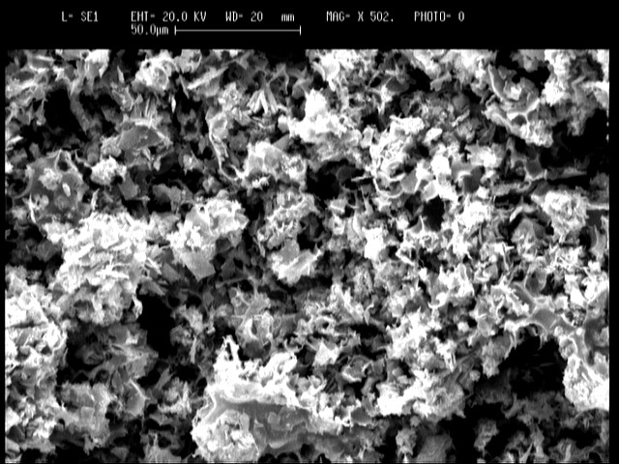
Fig. 2- SEM image of OSMMN
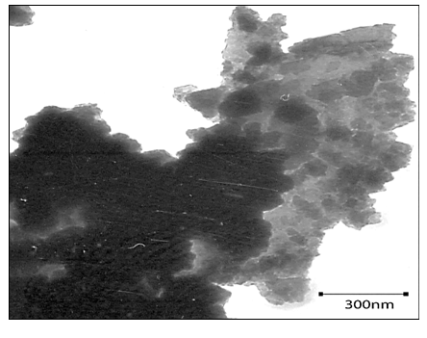
Fig. 3-TEM image of OSMMN

Also, particle size distribution of adsorbent is displayed in Fig. 4. As shown in this Fig., the average size of particles is about 10 nm.
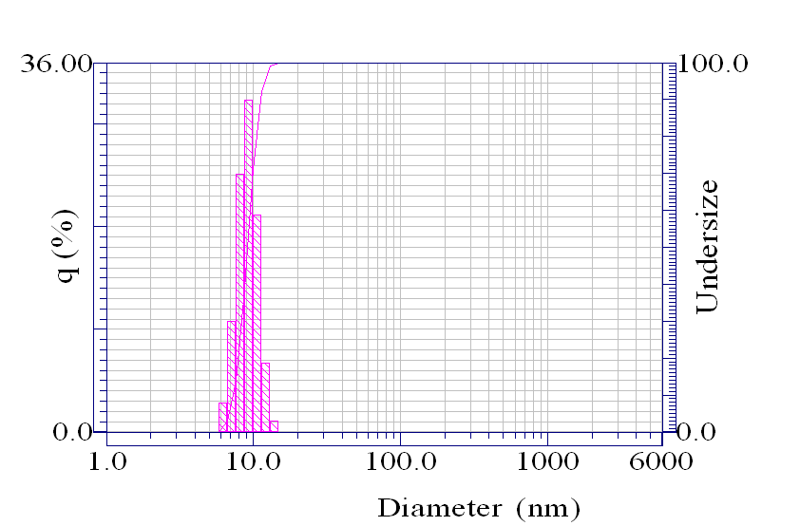
Fig. 4-Particle size distribution of adsorbent

3.2 Effect of solution pH and buffer volume
Initial solution pH is one of the effective parameters in adsorption of metal ions, because hydrogen ion competes with metal ions to relocate active sites of the bio-adsorbent.²³ The effect of pH was conducted by mixing 0.03 g (0.6 g/L) of adsorbent in 50 ml Ni (II) solution with the concentration of 20 mg/L. HCl and NaOH was utilized for the purpose of keeping pH in the range of 4-7 throughout the experiments. The effect of pH on the removal of Ni²⁺ from aqueous solution is presented in Fig. 5. It can be observed that the removal of nickel ions increased with increase in pH and reached a maximum at pH 4.5. At lower pH values, Ni (II) ion removal was inhibited, because at low pHs the medium contains a high concentration of hydrogen ions, therefore competition between H⁺ and Ni²⁺ ions for the available adsorption sites could be possible. The percentage removal of Ni was observed to be sharp between pH value of 4.5 to 7 (from the percentage removal of 92.2 % to 66.38%). At pH values greater than 4.5, the adsorption of Ni (II) ions decreases because of the precipitation of nickel hydroxide resulting from Ni (II) ions reacting with hydroxide ions. In further works, the pH of the solutions was adjusted by using citrate buffer volume. The effect of buffer volume on the removal efficiency is displayed in Fig. 6. As shown in this Fig., the removal yield was increased with increasing buffer volume and the maximum efficiency was obtained at 3 ml of buffer solution with the adsorption of 92.8%.

Fig. 5- Effect of solution pH on Ni (II) removal (Conditions: temperature of 25ºC, initial ion concentration of 20mg/L, contact time 5 min, adsorbent dose of 0.6 g/L)

Fig. 6- Effect of buffer volume (ml) of solution on Ni (II) removal

3.3 Effect of electrolyte
The effect of electrolyte concentration (adjusted by KCl) on the adsorption of Ni (II) is illustrated in Fig. 7. As shown in this Figure, the adsorption efficiency of Ni (II) decreased within the concentration range of 0–1 mol/L of KCl in the test solution. At higher concentration, the Ni ion removal efficiency was decreased. So, it is concluded that the presence of KCl electrolyte has negative effect on bio-adsorption of Ni (II) ions using oak shell magnetic nanoparticles and a concentration of 0.0 mol/L (93.52 % removal) was used for further works.

Fig. 7- Effect of electrolyte concentration (adjusted by KCl) on the removal of Ni (II)

3.4 Effect of temperature
The effect of temperature on the adsorption of Ni (II) from synthetic wastewater was examined within the temperature range of 5-25^{ο}C. The effect of temperature on nickel (II) removal using OSMMN is illustrated in Fig. 8. The results showed that the adsorption of Ni (II) using 0.6 g/L of OSMMN at the pH of 4.5 is increased versus variation of temperature. At 25^{ο}C, the adsorption efficiency was 93.6% that the highest adsorption rate was obtained.

Fig. 8- Effect of temperature on Ni (II) removal from aqueous solution using OSMMN (Conditions: initial ion concentration 20mg/L, contact time 5 min, adsorbent dosage 0.6 g/L and pH of 4.5)

3.5 Bio-adsorbent dosage effect
Adsorbent dosage is considered as an important parameter, because this parameter defines the capacity of adsorbent.²⁴ The effect of bioadsorbent dose on the removal of Ni (II) from aqueous solution was investigated in a batch system by adding various amounts of adsorbent (0.6–3 g/L) into a flask containing 50 mL of Ni (II) solution. The initial ion concentration and pH value of the solutions were fixed at 20 mg/L and 4.5 for all batch experiments, respectively. Also, the suspension was stirred for 5 min. After that time, the solution was coagulated and settled and the supernatant was analyzed for the remaining Ni (II). The results are shown in Fig. 9. The results revealed that as adsorbent dosage went up, the bio-adsorption also increased owing to rise in the number of active sites of bio-adsorbent. The optimum dosage of oak shell magnetic nanoparticles for removing Ni (II) was obtained 2.6 g/L with the maximum removal of 93.66%.

Fig. 9 - Effect of OSMMN dosage on the removal of Ni (Conditions: temperature of 25ºC, initial ion concentration of 20mg/L, contact time 5 min and pH of 4.5)

3.6 Effect of contact time
Contact time is one of the important parameters in bio-adsorption process.^{25,26} The effect of stirring time on the performance of OSMMN in adsorbing Ni (II) was investigated. The solution pH and oak shell magnetic nanoparticles dosage were fixed at their obtained optimum values. Fig. 10 shows removal efficiencies for Ni (II) as a function of stirring times (1-20 min). These data elucidate that adsorption started immediately upon adding the magnetic oak shell particles to nickel solution. The removal efficiency of Ni (II) was rapidly increased from 56.81 % to 93.88 % as the stirring time was increased from 1 to 15 min. After 15 min, no change in biosorption was observed. So, according to these results, the optimum stirring time for removing nickel obtained 15 min.

Fig. 10- Effect of contact time on Ni (II) removal (Conditions: temperature of 25ºC, initial ion concentration of 20mg/L, pH of 4.5 and adsorbent dose of 2.6 g/L)

3.7 Modeling of isothermal adsorption
Adsorption isotherms are useful for the description of adsorption process and its mechanisms and also adsorption isotherms provide the basic requirements for designing adsorption process. Two important isotherm models were selected in this study, Langmuir and Freundlich isotherm models.^{20,21,25}
Freundlich model is an empirical model and can describe adsorption capability of adsorbents. This model is applied for non-ideal adsorption on heterogeneous surfaces. The linear form of this model is expressed by Equation 2.²⁵
(2)
In Eq. (2) K_{F} (Lg⁻¹) and n (dimensionless) are Freundlich isotherm constants and the degree of nonlinearity between solution concentration and adsorption, respectively. The plot of Ln q_{e} versus Ln C_{e} for the adsorption was employed to generate K_{F} and n from the intercept and the slope values, respectively (Fig. 11-a).
Also, the Langmuir model describes the monolayer bio-sorption process onto the adsorbent surface with specific binding sites. The linear form of Longmuir model is written as follows:²⁵
(3)
In Eq. (3), q_{m} is the monolayer adsorption capacity (mg/g); and K_{L} is the Langmuir constant (L/mg), and is related to the free energy of adsorption. A plot of C_{e}/q_{e} versus C_{e} for the adsorption of Ni onto bio-adsorbent shows a straight line of slope, 1/q_{m}, and intercept, 1/K_{L}q_{m} (Fig. 11 (b). In order to determine the variability of adsorption, a dimensionless constant called as separation parameter ‘R_{L}’ was used and defined as in the Equation (4).
(4)
Where C_{o} is the highest initial Ni concentration (mg/L). The value of separation parameter indicates the shape of isotherm to be either favorable (0 < R_{L} < 1), unfavorable (R_{L} > 1), linear (R_{L} = 1) or irreversible (R_{L} = 0).^{25,26}

Fig. 11- The adsorption isotherm curves related to a) Freundlich and b) Langmuir models for adsorption of Ni (II) on oak shell modified by magnetic nanoparticle.

The capacities of magnetic oak shell nanoparticles to adsorb Ni (II) were examined by measuring the initial and the final concentration of Ni (II) at the pH of 4.5 and the temperature of 25 °C in a batch system. Both Langmuir and Freundlich adsorption isotherms were used to normalize the adsorption data. The correlation of ion adsorption data with the Langmuir isotherm model was higher (with R² values of 0.9993) than the Freundlich model (R²=0.9299). Summarizes the models, constants, and coefficients are listed in Table 1. According to this table, the maximum predictable adsorption capacity of Ni (II) is 454.54 mg ion/g adsorbent. K_{L} represents the equilibrium biosorption constant and therefore higher values of K_{L} were representative of a desirable adsorption process.

Table 1: Parameters and constants of Langmuir and Freundlich isotherm models for the removal of Ni(II) by means of OSMMN.
Langmuir
Parameters | Values
q_{max} (mg/g) | 454.54
K_{L} (L/mg) | 0.46
R² | 0.9993
Freundlich
K_{F} (mg/g) | 8.24
n | 5.75
R² | 0.9299

3.8 Recycling of the adsorbent
The ability of recovering and reusing of the adsorbent was tested in several steps of adsorption and desorption. It was concluded that the desired removal of 90% can be achieved after 6 cycles.

4. Conclusions
Fe₃O₄ nanoparticles modified by oak shell was used as an applicatory bio-adsorbent for Ni (II) removal from aqueous solution. The effect of pH, adsorbent dosage, temperature, buffer volume, electrolyte and time were studied. The maximum removal of Ni (II) is found to be 93.88% at pH 4.5, temperature of 25ºC, adsorbent dose of 2.6 g/L and contact time of 15 min. The equilibrium data fitted well with the Langmuir model. Based on Langmuir model, the maximum adsorption capacity of Ni (II) was determined 454.54 mg/g. The capability of adsorbent to remove Ni (II) from aqueous solution efficiently after long cycles (e.g. 6 cycles) was acceptable. In General, resulting tests on the nickel ion removal from effluent using OSMMN showed the potential applicability of this adsorbent in industrial wastewater treatment.

Conflict of Interests Statement
The authors declare that there is no conflict of interests.

References
1. M. Kobya, E. Demirbas, E. Senturk, M. Ince. Bioresour. Technol. 2005, 96, 1518-1521. DOI: 10.1016/j.biortech.2004.12.005.
2. S. Congeevaram, S. Dhanarani, J. Park, M. Dexilin, K. Thamaraiselvi.. J. Hazard. Mater. 2007, 146, 270-277. DOI: 10.1016/j.jhazmat.2006.12.017.
3. M. Bansal, D. Singh, V. K. Garg, P. Rose, Int. J. Civ. Environ. Eng. 2009, 1, 108-114.
4. P. E. Aikpokpodion, R. R. Ipinmoroti, S. M. Omotoso, Am.-Eurasian J. Toxicol. Sci. 2010, 2, 72-82.
5. K. Kadirvelu, K. Thamaraiselvi, C. Namasivayam, Sep. Purif. Technol. 2001, 24, 497–505. DOI: 10.1016/S1383-5866(01)00149-6.
6. F. M. Mohammed, E. P. L. Roberts, A. Hill, A. K. Campen, N. W. Brown, Water Res. 2011, 45, 3065-3074. DOI: 10.1016/j.watres.2011.03.023.
7. F. Ahmadi, H. Esmaeili, Desalin. Water Treat. 2018, 110, 154-167. DOI:10.5004/dwt.2018.22228.
8. T. W. Tee, A. R. M. Khan, Environ. Technol. Lett. 1988, 9, 1223-1232. DOI: 10.1080/09593338809384685.

9. D. C. Sharma, C.F. Forster, Water Res. 1993, 27, 1201-1208. DOI: 10.1016/0043-1354(93)90012-7.
10. M. R. Mehrasbi, Z. Farahmandkia, B. Taghibeigloo, A. Taromi, Water Air Soil Pollut. 2009, 199, 343–351. DOI: 10.1007/s11270-008-9883-9.
11. R. S. D. Castro, L. E. G. Caetano, P. M. Ferreira, M. Padilha, J. Margarida, L. F. Saeki, M. Zara, U. Antonio, G. Martines, R. Castro. Ind. Eng. Chem. Res. 2011, 50, 3446–3451. DOI: 10.1021/ie101499e.
12. L. Xiaomin, Y. Tang, X. Cao, D. Lu, F. Lu, W. Shao, Colloids Surf. A Physicochem. Eng. Asp. 2008, 317, 512–521. DOI: 10.1016/j.colsurfa.2007.11.031
13. F. D. Oliveira, A. C. Soares, O. Freitas, S. A. Figueiredo, Global NEST Journal 2010, 12, 206-214.
14. M. C. S. Minello, A. L. Paco, R. S. D. Castro, L. Caetano, P. M. Padilha, G. Ferreira. M. A. U. Martines, G. R. Castro. Fresen. Environ. Bull. 2010, 19, 2210-2214.
15. H. Hasar, J. Hazard. Mater. 2003, 97, 49–57. DOI: 10.1016/S0304-3894(02)00237-6.
16. B. S. Zadeh, H. Esmaeili, R. Foroutan, Indones. J. Chem. 2018. https://doi.org/10.22146/ijc.28789.
17. S. Lunge, S. Singh, A. Sinha, J. Magn. Magn. Mater. 2014, 356, 21–31. DOI: 10.1016/j.jmmm.2013.12.008
18. R. Taman, M. E. Ossman, M. S. Mansour, H. A. Farag, J. Ad. Chem. Eng. 2015, 5, 125-132. DOI: 10.4172/2090-4568.1000125.
19. M. Kumari, C. U. Pittman, D. Mohan, J. colloid interface sci. 2015, 442, 120-132. DOI:10.1016/j.jcis.2014.09.012.

20. F. S. Khoo, H. Esmaeili, J. Serb. Chem. Soc. 2018, 83, 237-249. DOI: 10.2298/JSC170704098S.
21. R. Mahini, H. Esmaeili, R. Foroutan, Turk. J. Biochem. 2018. DOI: https://doi.org/10.1515/tjb-2017-0333.
22. A. Teimouri, H. Esmaeili, R. Foroutan, B. Ramavandi, Korean J. Chem. Eng. 2018, 35, 479–488. DOI: 10.1007/s11814-017-0311-y.
23. M. Rafatullah, O. Sulaiman, R. Hashim, A. Ahmad, J. Hazard. Mater. 2009, 170, 969-977. DOI:10.1016/j.jhazmat.2009.05.066.
24. R. Foroutan, H. Esmaeili, M. Abbasi, M. Rezakazemi, M. Mesbah.. Environ. Technol. 2017. DOI: 10.1080/09593330.2017.1365946
25. F. S. Sarvestani, H. Esmaeili, B. Ramavandi, 3 Biotech. 2016, 6, 251. DOI: 10.1007/s13205-016-0570-z.
26. R. Foroutan, H. Esmaeili, S. M. Derakhshandeh Rishehri, F. Sadeghzadeh, S. R. Mirahmadi, M. Kosarifard, B. Ramavandi, Data Brief. 2017, 12, 485–492. DOI: 10.1016/j.dib.2017.04.031.

