Tacrine-Coumarin Derivatives and Their Anti-Cancer Effect

Zuzana Solárová¹, Martin Kello¹, Slávka Hamuľaková², Ladislav Mirossay¹, Peter Solár^{3*}

¹ Institute of Pharmacology, Faculty of Medicine, P. J. Šafárik University in Košice, SK-04154 Košice, Slovak Republic
² Department of Organic Chemistry, Institute of Chemistry, Faculty of Science, P. J. Šafárik University in Košice, SK-04154 Košice, Slovak Republic
³ Institute of Medical Biology, Faculty of Medicine, P. J. Šafárik University in Košice, SK-04154 Košice, Slovak Republic
*Corresponding author: assoc. prof. Peter Solár, PhD., Department of Medical Biology, Faculty of Medicine, Pavol Jozef Šafárik University in Košice, SNP 1, SK-04154 Košice, Slovak Republic
E-mail: peter.solar@upjs.sk

Abstract

Acridine derivatives were first used as antibacterial and antiparasitic agents, later as antimalarials and anti-HIV drugs and now due to their high cytotoxic activity as potentially anticancer ones. Since their serious adverse effects, new synthetic derivatives were introduced and tested based on the modification of naturally occurring substances such as acridone derivatives which also exhibit potential antitumor activity. Most of them are DNA-damaging substances, causing relatively strong and selective destruction of tumor cells. We have tested in vitro antiproliferative effects of newly-synthesized tetrahydroacrid derivatives, namely tacrine-coumarin hybrid molecules. Our results have shown that tacrine-coumarin hybrids with seven, eight and nine methylene groups in spacer reduce proliferation of cancer cells. The most significant anti-cancer effect revealed hybrid with nine methylene groups.

Key words: tacrine-coumarin hybrid molecules, cancer cells, antiproliferative effects

- Introduction
Coumarin and coumarin derivatives are well known as anticancer agents. The anticancer activity of coumarin derivatives 3-, 4-, 7-, 8- substituted, biscoumarins and fused coumarins has been described according to the type and position of the side chain on the coumarin core structure. ¹ The number, location and length of the side chain had important effects on their anti-tumor activities. ² The chemical structure of some 4-substituted coumarins affording interesting anti-cancer activity are shown in Fig. 1.
Figure 1. Structures of 4-substituted coumarin derivatives 1-4 and bis-coumarines 5, 6 with anticancer activities
Basanagouda et al ³ synthesized a new series of iodinated-4-aryloxymethyl coumarin derivatives 1 (Fig. 1). These compounds were screened for their in vitro anticancer activity against two cancer cell lines, MDA-MB human adenocarcinoma mammary gland and A-549 human lung carcinoma. The compounds having the chlorine at C-6 and C-7 position on coumarin ring and iodine at C-4 position on phenoxy moiety exhibited significant anticancer activity (MIC = 1.56 μg/mL). ³ Bana et al ⁴ designed and synthesized a novel coumarin-quinone inhibitor 2 (SV37, Fig. 1), whose structure is based on both coumarin and quinone moieties as a potent CDC25 inhibitor. An analytical in vitro approach shows that this compound efficiently inhibits all three purified human CDC25 isoforms, CDC25A, B, C with IC₅₀ between 1 and 9 µM. Moreover, 2 had superior antiproliferative activity against MCF7 and MDA-MB-231 cells (IC₅₀ = 1-11 μM) versus hTERT-HME1 (IC₅₀ = 18 μM). ⁴ Puttaraju et al ⁵ have designed and synthesized a new series of coumarin substituted dihydrobenzo[4,5]imidazo[1,2-a]pyrimidin-4-ones 3. The coumarin derivative having i-Pr at C-3 position on dihydrobenzo[4,5]imidazo[1,2-a]pyrimidin-4-one and chlorine at C-6 position on coumarin ring was found to be the most potent cytotoxic compound (88%) against Dalton's Ascitic Lymphoma cell line. ⁵
A series of 4-(1,2,3-triazol-1-yl)coumarin derivatives 4 were synthesized and subsequently their anticancer activities studied in vitro against human cancer cell lines, including human breast carcinoma MCF-7 cell, colon carcinoma SW480 cell and lung carcinoma A549 cell. Among them 4-(4-(4-fluorophenoxy) methyl)-1,2,3-triazol-1-yl)-7-+methoxycoumarin 4, exhibited excellent broad spectrum anticancer activity in vitro against MCF-7, SW480 and A549 (IC₅₀ = 5.89, 1.99 and 0.52 μM), respectively. ⁶
In general, the dimeric coumarin often showed more efficacy against cancer cells than the monomeric one. ² Some bis-coumarine dimers with the anti-cancer activity are shown in Fig. 1. A series of novel bis-coumarin polysulfides as di-, tri- and tetrasulfides 5 were synthesized and tested in the HCT116 colorectal cancer cell line to assess the capability of inducing cell growth inhibition and apoptosis. The coumarin polysulfides effectively reduced cell viability (around 50%) in a concentration and time depend manner and reduced cell viability more efficiently than the corresponding diallyldisulfide. ⁷ Tan et al ² designed and synthesized a novel dimers of triphenylethylene-coumarin hybrid 6 containing one amino side chain. These dimeric substances were subjected to anti-proliferative tests against four tumor cell lines, MCF-7, A549, K562 and Hela, and exhibited significant anti-proliferative activity at IC₅₀ near to 10 μM.
Based on the knowledge that coumarin functional groups as well as tetrahydroacridine derivatives have anti-tumor effects and since the anti-cancer activity of such hybrids in which the coumarin ring is connected with tacrine has not yet been reported, we have decided to test such effects using newly synthesized tacrine-coumarin hybrids 7a-g (Fig. 2). Both the synthesis, as well as the biological activity of relevant tacrine-coumarin hybrids have been already published. ⁸
Figure 2. Structures of tacrine-coumarin hybrids 7a-g

There has been little work done on the anti-tumor effects of tacrine. However, published results clearly demonstrated that only high concentration of tacrine can induces apoptosis by lysosome- and mitochondrial-dependent pathway in HepG2 cells. ^{9,} ¹⁰ On the other hand, despite of high concentration, tacrine did not show any cytotoxic effect on the promyelocytic leukemia HL-60 cell line. ¹¹

- Experimental

  - Cell lines and cell culture
Human colorectal carcinoma HCT116 (HCT), human breast adenocarcinoma MCF-7, human A549 lung carcinoma, and mouse mammary carcinoma 4T1, as well as non-cancer mouse mammary gland cells NMuMG and human endothelial cells isolated from umbilical vein HUVEC were used in our experiments. The HCT, MCF7 and 4T1 cell lines were cultured in RPMI medium (Sigma-Aldrich, St. Louis, MO, USA), A549 and NMUMG in DMEM medium with high glucose (4.5 g/l) and L-glutamine (GE Healthcare, Little Chalfont, UK) and HUVEC cells in HMEC medium (Sigma-Aldrich) with added vascular endothelial growth factor and bovine fibroblast growth factor. The media contained 10% fetal bovine serum (Thermo Fisher Scientific, Inc., Waltham, MA, USA) and except of 4T1 and NMuMG cells also an addition of antibiotics (Sigma-Aldrich). The cells were incubated at 37°C in a humidified 5% CO2 (v/v) atmosphere. Tacrine-coumarin derivatives were synthesized by Dr. Hamuľaková from the Institute of Chemistry, Faculty of Science, Pavol Jozef Šafárik University in Košice.

  - MTT assay
HCT, MCF-7, A549, 4T1, NMuMG and HUVEC cells were seeded into 96-well cell culture plates at a density of 5 × 10³ per well. MTT (3-(4.5-dimethylthiazol-2-yl)-2.5-diphenyl tetrazolium bromide; Sigma-Aldrich Co.) was added at the final concentration of 0.2 mg/ml after 72 h incubation with the concentration scale 0.001 - 10 µM of tacrine-coumarin hybrid molecules (Fig. 1; synthesized and characterized by Hamuľaková et al. ⁸, followed by 4 h incubation at 37°C and solubilisation of MTT-formazan product using 3.3% sodium dodecyl sulphate (Sigma-Aldrich Co.). The absorbance measurements were carried out using a universal microplate reader (FLUOstar Optima, BMG Labtechnologies GmbH, Offenburg, Germany) and expressed as a percentage of the dye extracted from untreated control cells ([OD value of treated cells/mean OD value of control cells] x 100%).

  - Cell cycle analysis
The distribution of monitored cancer and normal cells at different stages of the cell cycle was estimated by flow cytometric DNA analysis. All the cell lines were harvested after 72 h incubation with 10 µM concentration of 1b/sh_7, 1c/sh_8 or 1d/sh_9, washed with phosphate-buffered saline (PBS), fixed in 70% ice cold ethanol and stored at 4°C for 24 h. Fixed cells were centrifuged, washed with PBS, stained with staining solution (20 µg/mL propidium iodide, 137 µg/mL RNAse A and 0.1% Triton X-100 (Sigma-Aldrich Co.) in PBS) in the dark for 30 min and measured with a flow cytometer (FACSCalibur, Becton Dickinson, San Diego, CA, USA). For each sample, a minimum of 15 × 10³ cells was evaluated and analysed using FlowJo software (FLOWJO, LLC; Ashland, OR, USA). Cells characterized by DNA content lower than diploid (subG0/G1 population) were considered as apoptotic cells.

  - IncuCyte ZOOM system
Experiments were performed using an IncuCyte ZOOM system (Essen BioScience, Ann Arbor, MI, USA), which consists of a microscope gantry in a humidified incubator at 37˚C and 5% CO₂, and a networked external controller hard drive that gathers and processes image data. The cells were seeded in 96-well plates in sextuplicates at 5000 cells/well (as 100 µl cell suspension/well) and placed in the IncuCyte ZOOM system. After attachment (24 h) the cells were treated with test substances 1b/sh_7, 1c/sh_8 a 1d/sh_9 (dissolved in media). The cells growing in media without tested substances were used as controls. The IncuCyte zooM system automatically monitored the cell confluence in each well through a 4X objective (Nikon) every 2 h, up to 130 h of the substance treatment. The experiment was performed two times.

- Results and Discussion
In the view of biological significance of tacrine and coumarin derivatives a series of tacrine-coumarin heterodimers 7a-g were tested for their potential cytotoxic and/or anti-cancer activities using tumor as well as normal cell lines. In this regard, the response of 4T1 (mouse mammary carcinoma), MCF-7 (human breast adenocarcinoma), HCT116 (human colorectal carcinoma), A549 (human lung carcinoma), NMuMG (normal mouse mammary gland cells) and HUVEC (human endothelial cells isolated from umbilical vein) was compared. Application of compounds 7a and 7e-g resulted in no toxic effects in both cancer as well as normal cells till now (not shown), There were only compounds 7b-d involved in further analysis. The concentrations of 7b-d hybrids used in both cell cycle as well as cell proliferation assays were derived based on the extensive screening of the cell metabolism and/or cell growth response (MTT). The concentrations of 7b-d derivatives inhibiting 50% (IC₅₀) of the metabolic activity and/or the cell growth are shown in supplementary data (Table S01). Based on IC₅₀ values the synthesized compounds showed moderate to significant activity in the μM range from 5.7 to > 100 μM. The effect of chain lengths linking tacrine and coumarin skeleton was examined. In particular, the compounds 7d and 7c showed significant anti-metabolic activity against 4T1 cell lines with IC₅₀ values of 5.7 μM and 7.0 μM, respectively (Fig. 3). The compound 7d has also shown promising activity against MCF-7 cell line with IC₅₀ value of 6.0 μM (Fig. 3). On the other hand, derivatives 7b and 7c showed stronger effect compared to 7d in the reduction of HUVEC cells metabolism (Fig. 3). Interestingly, based on MTT results HCT, A549 and NMuMG cells did not response to the effect of 7b-d compounds (Fig. 3). These results demonstrate that the length of the alkyl spacer have some influence on the metabolic activity and/or the cell growth of breast cancer cell lines 4T1 and MCF-7.

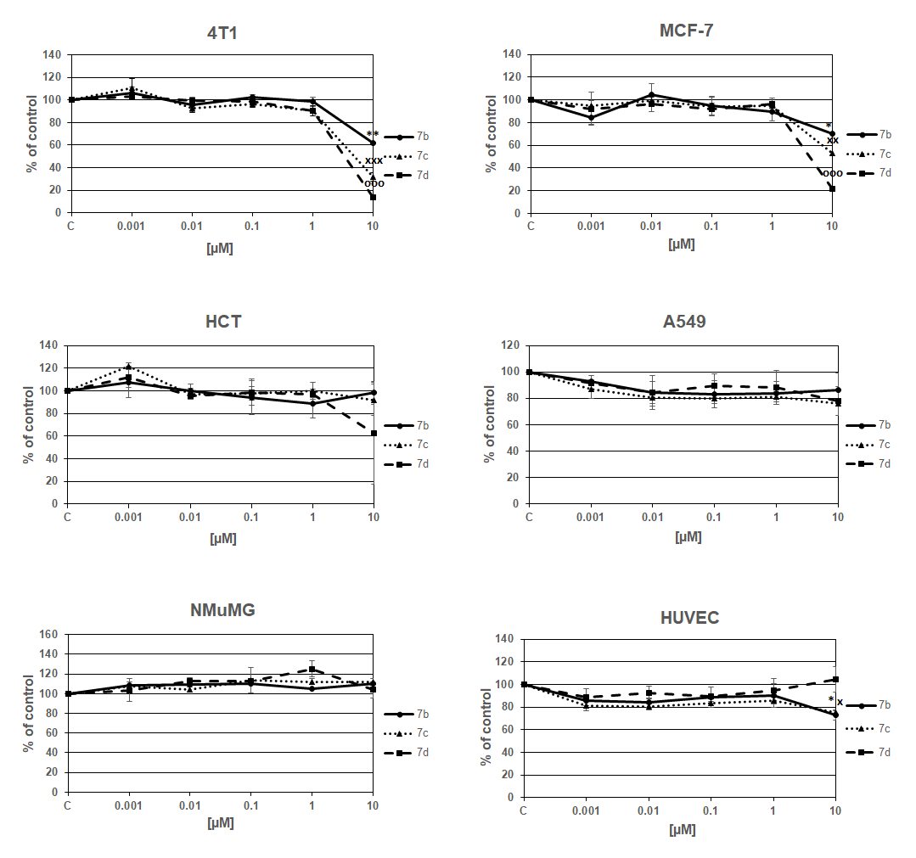
Figure 3. The effect of 7b-d tacrine-coumarine derivatives on the metabolic activity of 4T1, MCF-7, HCT, A549, NMuMG and HUVEC cells. The metabolic activity of 4T1, MCF-7, HCT, A549, NMuMG and HUVEC cells was analyzed by MTT assay after their 72 h treatment with 7b-d derivatives. Data are expressed as mean ± SEM (% of control) of three independent experiments. The statistical significance is designated as follows: * P < 0.05 and ** P < 0.01 for 7b derivative vs. control (C); ^{x} P < 0.05 and ^{xx} P < 0.01 for 7c derivative vs. C and °°° P < 0.001 for 7d derivative vs. C.

Flow cytometric analysis was performed to evaluate the cell cycle progression in all monitored cell lines after their incubation with 7b-d derivatives at the concentration of 10 µM. Data showed that the most significant effect on the cell cycle progression had 7d hybrid (Fig. 4). This compound increased apoptotic sub G0/G1 population in 4T1, MCF-7, HCT and HUVEC cells and reduced G1 population in 4T1 and MCF-7. On the other hand, all derivatives 7b-d increased G1 and decreased S population of HUVEC cells (Fig. 4). Without the change in the cell cycle progression stayed cancer A549 and normal NMuMG cells (Fig. 4).
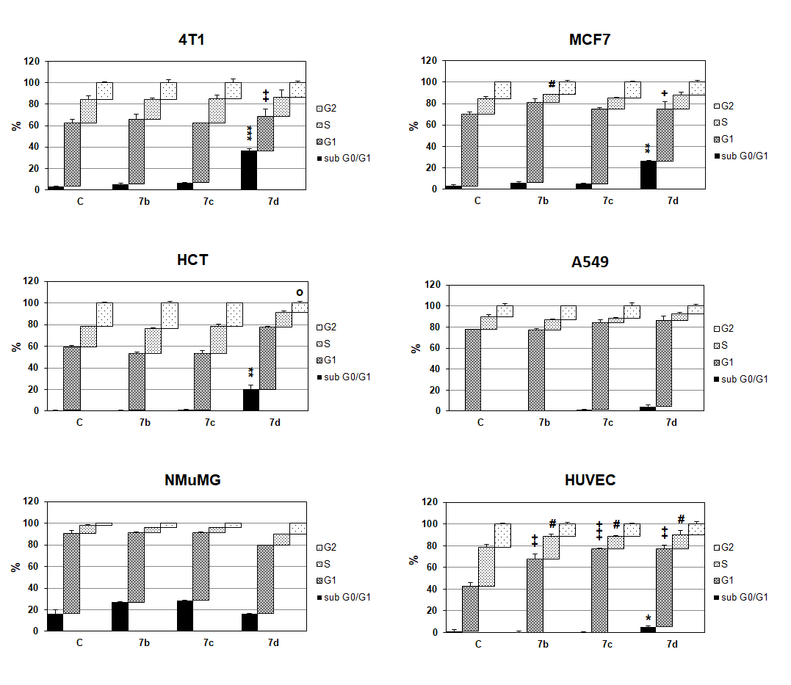
Figure 4. The cell cycle distribution of 4T1, MCF-7, HCT, A549, NMuMG and HUVEC cells after tacrine-coumarine derivatives 7b-d treatment. 4T1, MCF-7, HCT, A549, NMuMG and HUVEC cells were treated with 7b-d derivatives at the concentration of 10 µM for 72 h. Data are expressed as mean ± SEM of three independent experiments. The statistical significance is designated as follows: * P < 0.05, ** P < 0.01, *** P < 0.001 for sub G0/G1 fraction of 7b-d vs. control cells (C); + P < 0.05, ++ P < 0.01, +++ P < 0.001 for G1 fraction of 7b-d vs. C; # P < 0.05 for S fraction of 7b-d vs. C and ° P < 0.05 for G2 fraction of 7b-d vs. C.

The synthesized compounds 7b-d were also evaluated for their in vitro anti-proliferative activity monitored by IncuCyte system. The most sensitive tumor cell line was the MCF-7 (Supplementary data, Fig. S01), whose proliferative activity decrease depends on the increase of carbon number in the tested compounds 7b-d. HCT (Supplementary data, Fig. S02) and 4T1 (Supplementary data, Fig. S03) tumor cell lines showed lower sensitivity to the tested hybrids 7b-d, the responses of both were very similar. On the other hand, A549 tumor cells (Supplementary data, Fig. S04) proved to be the most resistant, with proliferation not significantly different after the administration of the above-mentioned three tacrine-coumarin derivatives, when compared to other cell lines. In addition, HUVEC cells (Supplementary data, Fig. S05) responded only to the 7d derivative while the normal mouse mammary gland cells of NMuMG (Supplementary data, Fig. S06) remained after the application of the tested substances without the decrease in proliferation.
Among the synthesized compounds, the tacrine-coumarin heterodimer 7d with nine methylene groups between the two amino groups in the side chain, exhibited the greatest efficiency of the whole series. According to the results, in the case of tacrine-coumarin heterodimers 7e-g with a longer side chain, the replacement of some methylene group to amine moiety dramatically decreased the anti-cancer activity.
Emami et al ¹ has also confirmed, that the anti-proliferative activity depends on the presence of the quinone skeleton. The structure-activity relationship of compound 4-(4-((4-fluorophenoxy)methyl)-1,2,3-triazol-1-yl)-7-methoxycoumarin 4, (Fig. 1) suggested that - CH₂-O- bridge at C-4 position of 1,2,3-triazole core is the best optimal for its bioactivity; a hydrogen bond acceptor at C-4 position of phenyl is indispensable for the improvement of the potency; the hydrogen bond acceptor at C-7 position of coumarin can make a positive contribution to the activity. ⁶
In the case of bis-coumarin derivatives possessing one amino side chain 6 (Fig. 1), the length of the linker (dicarboxylic acid) had profound effects on their anti-proliferative activities. Compounds linked by the malonic amide (three carbons) showed the best anti-proliferative activities against MCF-7, A549, K562, Hela cell lines, however as the linker was prolonged to five, six or ten carbons, their anti-proliferative activities decreased obviously. In this regard, the incorporation of the aromatic or heterocyclic ring into the chain causes also a decrease in anti-proliferative activity. ²

- Conclusions
In conclusion, structural modification of natural substances allows to obtain new analogues whose biological efficacy can be higher than that of the parent compounds. In our experimental study we found that tacrine-coumarin hybrids with seven, eight and nine methylene groups in spacer have significant anti-cancer activity in all cancer cell lines tested, with exception of A549 cells. Indeed, the most significant anti-cancer effect revealed hybrid with nine methylene groups. Interestingly, the sensitivity of tumor cells was greater than the sensitivity of normal cells, which points to the importance of further research of the antitumor effects of tacrine-coumarin hybrid molecules.

- Conflict of Interest
There is no conflict of interest

- Acknowledgment
This study was supported (50%) by the project Medicínsky univerzitný
park v Košiciach (MediPark, Košice) ITMS: 26220220185 (95%) supported by
Operational Programme Research and Development (OP VaV-2012/2.2/08-RO) (Contract No. OPVaV/12/2013).

7. References
S. Emami and S. Dadashpour, Eur J Med Chem 2015, 102, 611-30.
G. Tan, Y. Yao, Y. Gu, S. Li, M. Lv, K. Wang, H. Chen and X. Li, Bioorg Med Chem Lett 2014, 24, 2825-30.
M. Basanagouda, V. B. Jambagi, N. N. Barigidad, S. S. Laxmeshwar, V. Devaru and Narayanachar, Eur J Med Chem 2014, 74, 225-33.
E. Bana, E. Sibille, S. Valente, C. Cerella, P. Chaimbault, G. Kirsch, M. Dicato, M. Diederich and D. Bagrel, Mol Carcinog 2015, 54, 229-41.
K. B. Puttaraju, K. Shivashankar, Chandra, M. Mahendra, V. P. Rasal, P. N. Venkata Vivek, K. Rai and M. B. Chanu, Eur J Med Chem 2013, 69, 316-22.
W. Zhang, Z. Li, M. Zhou, F. Wu, X. Hou, H. Luo, H. Liu, X. Han, G. Yan, Z. Ding and R. Li, Bioorg Med Chem Lett 2014, 24, 799-807.
N. E. Saidu, S. Valente, E. Bana, G. Kirsch, D. Bagrel and M. Montenarh, Bioorg Med Chem 2012, 20, 1584-93.
S. Hamulakova, P. Poprac, K. Jomova, V. Brezova, P. Lauro, L. Drostinova, D. Jun, V. Sepsova, M. Hrabinova, O. Soukup, P. Kristian, Z. Gazova, Z. Bednarikova, K. Kuca and M. Valko, J Inorg Biochem 2016, 161, 52-62.
C. Gao, Y. Ding, L. Zhong, L. Jiang, C. Geng, X. Yao and J. Cao, Toxicol In Vitro 2014, 28, 667-74.
M. J. Ezoulin, C. Z. Dong, Z. Liu, J. Li, H. Z. Chen, F. Heymans, L. Lelievre, J. E. Ombetta and F. Massicot, Toxicol In Vitro 2006, 20, 824-31.
J. Janockova, J. Plsikova, J. Koval, R. Jendzelovsky, J. Mikes, J. Kasparkova, V. Brabec, S. Hamulakova, P. Fedorocko and M. Kozurkova, Bioorg Chem 2015, 59, 168-76.

