Supplementary data

Table S01 IC₅₀ values of the tacrine-coumarin derivatives 7b, 7c and 7d against human cancer and normal cell lines.

compounds |  |  | IC₅₀ (μM)
 | 4T1 | MCF-7 | HCT | A549 | NMuMG | HUVEC
7b | 39.0 | > 100.0 | - | - | - | > 100.0
7c | 7.0 | 16.0 | - | - | - | > 100.0
7d | 5.7 | 6.0 | > 50.0 | - | - | -

The in vitro anti-proliferative activity of the target compounds 7b-d with human cancer and normal cell lines are sumarized in Table 1. Based on Table 1 the synthesized compounds showed moderate to significant activity in the μM range with IC₅₀ values ranging from 5.7 to > 100 μM.
The effect of chain lengths linking tacrine and coumarin skeleton was examined. In particular, the compounds 7d and 7c showed significant anti-proliferative activity with IC₅₀ values of 5.7 μM and 7.0 μM against 4T1 cell lines. The compound 7d have shown promising activity with IC₅₀ value of 6.0 μM against MCF-7 cell line. From these results it can be seen that the length of the alkyl spacer have some influence on the levels of anti-proliferative activities. This trend was observed in cancer cell lines 4T1 and MCF-7.

Cell proliferation monitored by IncuCyte ZOOM system after the administration of tacrine-coumarin derivatives 7b, 7c and 7d.
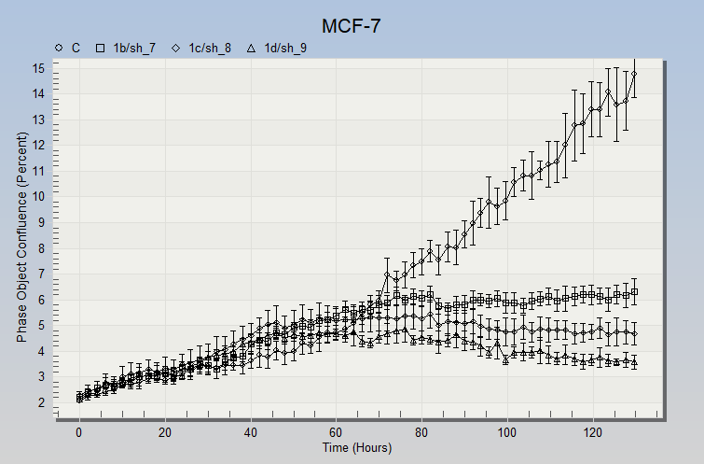
Fig. S01 The proliferation (cell confluency) of MCF-7 cells monitored by the IncuCyte ZOOM system after the administration of tacrine-coumarin derivatives 7b, 7c and 7d compared to the (C).

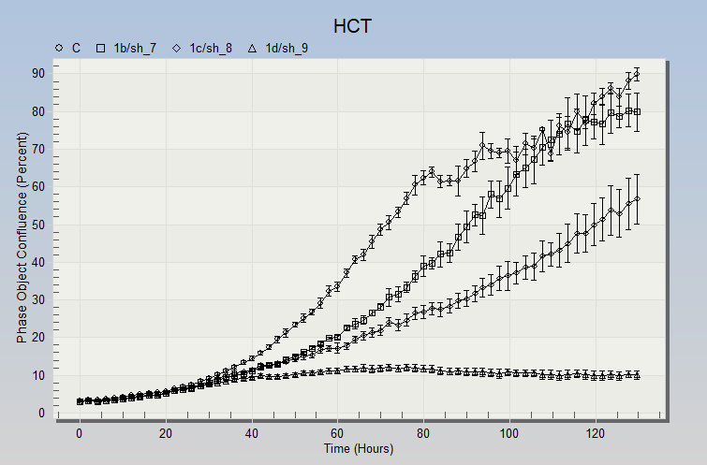
Fig. S02 The proliferation (cell confluency) of HCT116 (HCT) cells monitored by the IncuCyte ZOOM system after the administration of tacrine-coumarin derivatives 7b, 7c and 7d compared to the control (C).

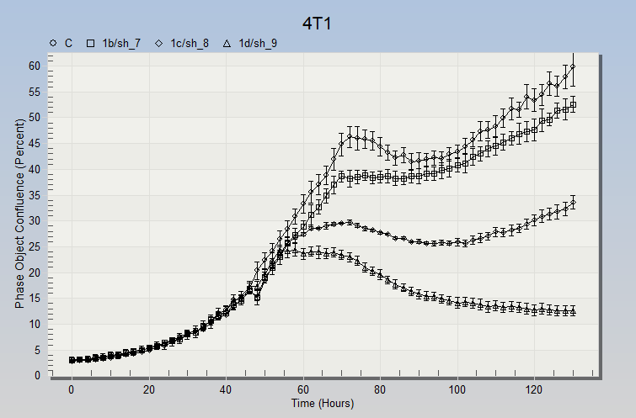
Fig. S03 The proliferation (cell confluency) of 4T1 cells monitored by the IncuCyte ZOOM system after the administration of tacrine-coumarin derivatives 7b, 7c and 7d compared to the control (C).

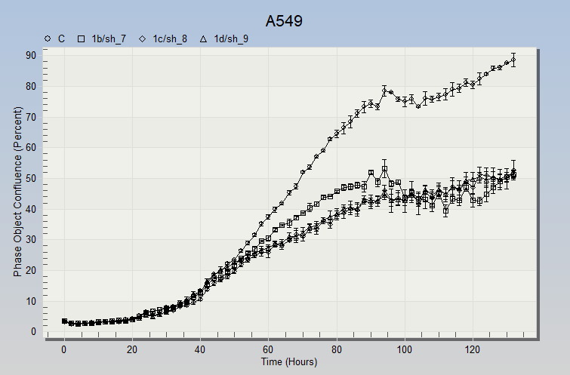
Fig. S04 The proliferation (cell confluency) of A549 cells monitored by the IncuCyte ZOOM system after the administration of tacrine-coumarin derivatives 7b, 7c and 7d compared to the control (C).

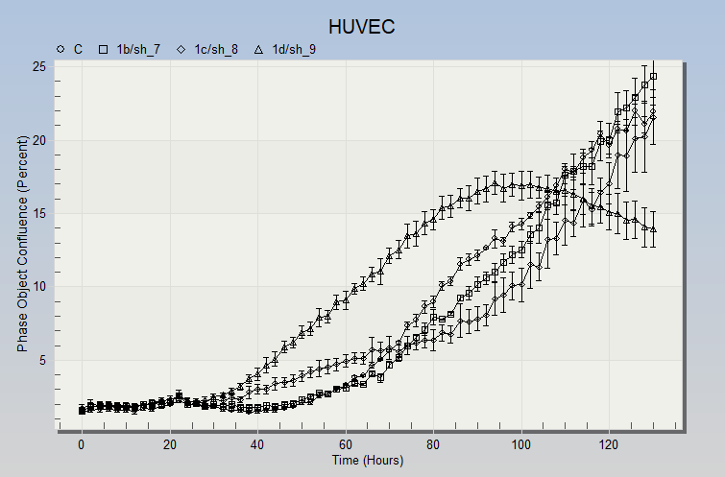
Fig. S05 The proliferation (cell confluency) of HUVEC cells monitored by the IncuCyte ZOOM system after the administration of tacrine-coumarin derivatives 7b, 7c and 7d compared to the control (C).

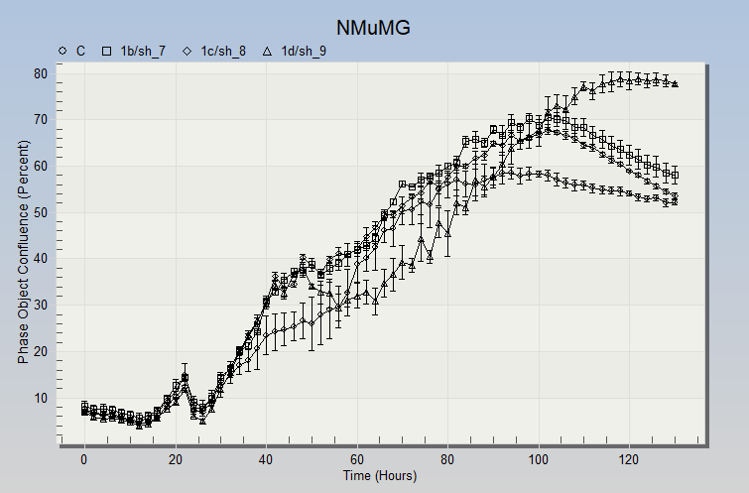
Fig. S06 The proliferation (cell confluency) of NMuMG cells monitored by the IncuCyte ZOOM system after the administration of tacrine-coumarin derivatives 7b, 7c and 7d compared to the control (C).

