Dawson-wells Polyoxometalate Incorporated into Nanoporous MIL-101(Cr): Preparation, Characterization and Application for Ultrafast Removal of Organic Dyes
Afsoon Jarrah and Saeed Farhadi*
Department of chemistry, Lorestan University, Khorramabad, 68151-44316, Iran
*Corresponding author: Tel: +986633120611, fax: +986633120618.
E-mail address: sfarhadi1348@yahoo.com (S. Farhadi)
______________________________________________________________________________
Abstract
In this work, Dawson-type K₆P₂W₁₈O₆₂ polyoxometalate salt was successfully encapsulated into mesoporous MIL-101(Cr) metal organic framework and was applied as a new adsorbent to remove methylene blue (MB), Rhodamine B (RhB) and methyl orange (MO) organic dyes from aqueous solutions. The as-prepared nanohybrid (P₂W₁₈@MIL-101(Cr)) was characterized by FT-IR Spectroscopy, XRD, Raman spectra, EDS, SEM, AFM, and BET surface area. The specific surface area of the nanohybrid is 1167 m²g⁻¹ that was more than pure P₂W₁₈. The effect of effective parameters such as adsorbent dosage, dye concentration, pH, and the temperature was studied on dye removal. The results indicated that the dye adsorption followed Langmuir isotherm. The thermodynamic data showed that the adsorption was an endothermic process. Furthermore, the selective adsorption of the nanohybrid was investigated towards MB+MO, MB/RhB, MO/RhB and MB/MO/RhB mixed solutions. It can be concluded that nanohybrid exhibit excellent sorption properties and it can function as the versatile adsorbent for the rapid removal of various textile dyes from aqueous solutions.
Keywords: Dawson-type polyoxometalate, MIL-101(Cr), Metal organic framework (MOF), Nanohybrid, Dye adsorption.
______________________________________________________________________________

1. Introduction
Metal-organic frameworks (MOFs) have attracted the consideration of scientists over the past few decades.¹⁻³ They are a novel category of porous nanomaterials that include metal ions and organic ligands. They have high porosity and specific capabilities such as catalysis,⁴ luminescence,⁵ magnetism,⁶ drug delivery,⁷⁻¹⁰ nonlinear optics, ion exchange,^{11,12} separation, pollutant removal, and gas adsorption.^{13,14} Additionally, they have ultrahigh surface areas and are available in tunable pore shapes and sizes. MOFs can be utilized as hosts for encapsulating large molecules to construct novel multifunctional materials.¹⁵
The use of polyoxometalates (POMs) within porous MOFs to acquire POM-encapsulating MOF (POM@MOF) nanohybrid is a major topic of research in this field.¹⁶ POMs, as nanoscale metal–oxo clusters, are indicated to have specific functions in washable acid/base, redox, and electro-induced catalysis. However, the major defect of POMs from the point of view of heterogeneous catalysis is their relatively small specific surface area.¹⁷⁻²⁰ Hence, introducing such catalysts to porous MOFs creates the following advantages: i) homogeneous distribution of POMs within a MOF porous framework at the surface of the molecule; ii) providing both POM and MOF units with abilities and functionalities, such as size-selective catalysis; iii) POM@MOF materials are easy to recycle after catalytic reactions. To fabricate POM@MOF materials, the direct saturation of MOFs into POM solution is a routine method. But owing to the unconformity between POMs and MOFs in size, charge, structural symmetry, solubility, and pH stability, this method does not always work well. So far, only a few MOFs have been successfully loaded with guest POM catalysts, including MIL-101, HKUST-1, and NENU-11.²¹⁻²³ In this hybrid material, following the combination of MOFs with POMs, it is possible the voids of MOF may be fully occupied by POM units. This is a possible disadvantage of these hybrid materials.^{24,25} Therefore, fabrication of the new POM@MOF hybrid materials while ensuring that the holes are not completely occupied remains a challenge. To be suitable loading medium for POMs, MOFs must demonstrate several features: i) MOFs must stably load POMs without losing or collapsing the framework during the reaction; ii) the POM@MOF hybrid must maintain porous structural properties for the arrival and reaction of various substrates; iii) MOFs must be capable of improving the loading content of POM. The fabrication of cationic MOFs is a promising method for meeting the above requirements, for these materials can strongly interact with anionic POM units by virtue of electrostatic forces.
In this work, MIL-101 (Cr) MOF was used for the fabrication of a new nanohybrid with the Dawson-type P₂W₁₈ POM (P₂W₁₈@MIL-101 (Cr)) for the first time by a hydrothermal route. It can be easily recycled by centrifugation and filtration. Therefore, it has been shown that the new nanohybrid is an adsorbent with a better adsorption property and high performance in the separation of the dyes methyl orange (MO), rhodamine B (RhB), and methylene blue (MB) from aqueous solution. Different factors such as dye concentration, pH, adsorbent dosage, and temperature were studied for dye elimination. Moreover, in order to investigate the adsorption capacity of the nanohybrid P₂W₁₈@MIL-101 (Cr), its kinetics, thermodynamic, and isothermal properties were studied.
2. Experimental
2.1. Materials
Chromium (III) nitrate [Cr(NO₃)₃.9H₂O, 99.0%], terephethalic acid (H₂BDC, 98%), sodium tungstate (Na₂WO₄.2H₂O, 99%), phosphoric acid (H₃PO₄, 85%) were provided from Sigma-Aldrich. All organic solvents were purchased from Merck or Aldrich and were utilized without further purification. Potassium chloride (KCl, 98%), hydrochloric acid (HCl, 35%), methyl orange (MO, C₁₄H₁₄N₃NaO₃S, 98%), methylene blue (MB, C₁₆H₁₈ClN₃S, 98%) and Rhodamine B (RhB, C₂₈H₃₁ClN₂O₃, 98%) were purchased from Merck Chemical Co.
2.2. Synthesis of MIL-101(Cr) Metal Organic Framework
MIL-101(Cr) was synthesized with a hydrothermal method.²⁶⁻²⁸ The detailed procedure for the fabrication of the MIL-101(Cr) is as follows: Cr(NO₃)₃.9H₂O (2.4 g), terephthalic acid (0.98 g) were blended in 29 ml distilled water and mixed at room temperature for time 10-20 min was stirred. The suspension to a 50 ml Teflon-lined autoclave was transferred and in oven was heated for 24 h at 200 ◦C. After slowly cooling at room temperature, the green solid was filtered to remove the crystals of H₂BDC and the green raw product was washed with DMF at 60 ◦C for 3h and then at 70 ◦C for 2.5 h was washed with ethanol. Finally, the green solid was separated by centrifugation and was dried at room temperature.
2.3. Synthesis of Dawson-Type K₆P₂W₁₈O₆₂ Polyoxometalate²⁹
The powder Na₂WO₄. 2H₂O (300 g; 0.91 mmol) in 350 mL distilled water dissolved and by addition of HCl 4M (250 mL; 1.00 mmol) was acidified under stirring. Then, H₃PO₄ 4M (250 mL; 1.00 mmol) was added slowly when the cloudy solution grows clear again. For time 24h was refluxed the pale yellow and limpid solution. After this reaction time, the yellow color of the solution had become more vigorous. Then, the solution was cooled and 150 g KCl was added to it. After filtering, the precipitate obtained was dried at room temperature. This raw material was dissolved in 650 mL distilled water, and the solution was filtered to eliminate insoluble impurities. Then for time 72 h, the solution with 80 ºC was refluxed. After this period of time, the solution was cooled at room temperature before being placed in a refrigerator at 4ºC. After a few days were collected well-behaved yellow crystals of α-K₆P₂W₁₈O₆₂.14H₂O (232.5 g; 70%).
2.4. Synthesis of P₂W₁₈@MIL-101 (Cr) Nanohybrid
The P₂W₁₈@MIL-101 (Cr) nanohybrid was fabricated as follows: Cr(NO₃)₃.9H₂O (2.0 g, 5mmol), terephthalic acid (0.83g, 5mmol), K₆P₂W₁₈O₆₂ (2.0 g, 0.7mmol) in 20 mL of distilled water were dispersed for 15 minutes by sonicated. The suspension color with a pH of 2.58 became dark blue. The suspension to a 50 ml Teflon-lined autoclave was transferred and heated at 200 °C for 18 h without stirring under autogenous pressure. Then, green powder was separated by centrifugation, washed five times with distilled water, one-time ethanol, and acetone, and then was dried at room temperature. The ICP results indicated that the loading amount of P₂W₁₈ in the as-prepared P₂W₁₈/MIL-101 nanocomposite was estimated to be 36 %.

2.5. Methods of Characterization
FT-IR was registered using a Shimadzu-8400S (Japan) spectrometer with temperature controlled high sensitivity detector (DLATGS detector) in the wavenumber range of 500-4000 cm⁻¹. Powder X-ray Diffraction (PXRD) patterns were recorded at room temperature using Philips X-Pert diffractometer (Philips 8440) at 40 kV between 2.0 and 60.0 (2ϴ) with Cr Ka radiation (k = 2.289 °A) by a step size of 0.020. UV-Vis spectra were recorded on a Carry 100 Conc Varian spectrophotometer. The morphological properties nanohybrid acquired by Scanning Electron Microscopy (SEM, MIRA3 TESCAN) along with the energy-dispersive X-ray analysis (EDX). BET–BJH measurement method was carried out by N₂ as adsorption-desorption gas and surface area analyzer (Micrometrics PHS-1020) that for time 4 h in the nitrogen atmosphere slowly heated at 200 ºC. The Atomic force microscopy (AFM) measurement was carried out by (AFM, full plus model). Nanohybrid for UV–Vis investigation was dispersed in distilled water by sonication (37 KHz) for 30 min to form a homogeneous suspension for measurement with the spectrophotometer. Raman spectrum acquired by using (SENTERRA 2009) with the 785 nm line. The adsorption of dyes was evaluated by a Cary 100 Varian UV-vis spectrophotometer.
2.6. Dye Adsorption Tests
Experiments were carried out to investigate the adsorption attributes and parameters affecting the adsorption of the dyes. First, stock solutions (200 mgL⁻¹) of RhB, MB, and MO dyes were prepared by dissolving them in distilled water. Then, the stock solution was constructed in the form of dye solutions of MB, MO, and RhB, with consecutive dilutions using distilled water. The adsorbent (30 mg) was shed into 30 mL of the aqueous solution of different dyes with an initial concentration of 25 mg L⁻¹ such as MB, RhB, and MO. In order to prevent degradation of the dyes, the containers holding the dye solution were wrapped in dark paper during the adsorption tests to protect the dye from light. The mixture was stirred gently at a speed of 300 rpm at 25 ºC for 30 seconds to 10 min, and then using the centrifuge were separated into suspended particles. The prepared solutions were studied by using a UV-vis spectrophotometer. Also, using the UV-vis spectrophotometer, the residual dye concentrations were indicated at the maximum wavelength of 463 nm for MO solution, 553 nm for RhB solution and 664 nm for MB solution. Other experiments were performed to study the adsorption of MB with different dosages of the compound; (10, 20, 30, and 40 mg). In addition, different initial concentrations of MB dye solution (25, 50, 75, 100, 125, 150, 175, and 200 mg L⁻¹) were used for studying the capability of the synthesized nanohybrid. Also, the nanohybrid was poured into mixtures of MO&RhB, MO&MB, RhB&MB, and MB&RhB&MO (v: v 1/1, 30 mL, 25 mg L⁻¹) to study the selective adsorption activity of adsorbent. The effect studies of initial solution pH (2-10) on nanohybrid adsorption capacity were studied. The equilibrium adsorption capacity qe (mg/g) and the dye removal efficiency (R%) were calculated according to Equations (1) and (2), respectively:

Where C₀ and C_{t} (mg L⁻¹) are the dye concentrations at initial and t time, respectively. V (in L) is the volume of the dye solution and m (in g) indicates the mass of the adsorbent in the adsorption process.³⁰ Thermodynamic studies were conducted at different temperatures (25-75°C) to investigate the dye adsorption.
2.7. Desorption Studies
Nanohybrid after each adsorption test of the MB dye solution using centrifugation was separated and several times with mixed distilled water, NaCl (0.1 M), and Ethanol was washed and at room temperature was dried and reused for the next adsorption experiment.
3. Results and Discussion
3.1. Characterization of Nanohybrid
One well- known MOF is MIL-101 (Cr), which has two types of cages, with maximum internal diameters of 29 and 34 Å and porous holes with maximum diameters of 0.12 and 0.16 nm. MIL-101 (Cr) is formed of terephthalate ligands and chromium (III) clusters that have super-tetrahedral building units. The acquired solids have two types of porous cages with 12 pentagonal faces and four hexagonal faces (large) or that are formed of 12 pentagonal faces (medium). This offers extraordinary facilities for immobilizing active heteropolyanions.^{12,31} To fabricate the porous framework, the hydrothermal method was used. In this work, the Dawson-type K₆P₂W₁₈O₆₂ POM was immobilized upon entering the porous MOF and a new adsorbent was utilized for the elimination of organic dyes from aqueous solutions. Scheme 1 shows the general preparation procedure of the nanohybrid P₂W₁₈@MIL-101 (Cr). In the first step, Cr (NO₃)₃.9H₂O, and terephthalic acid were dissolved in distilled water and stirred at room temperature. Then, the suspension was transferred to a 50 ml Teflon-lined autoclave and heated in an oven for 24 h at 200 ◦C. Dawson-type K₆P₂W₁₈O₆₂ POM salt on the surface of MIL-101 (Cr) supported the reaction to form a new surface with the formula P₂W₁₈@MIL-101Cr.³² Nanohybrids can be easily recycled and reused, and no POM leached in the dye adsorption process. The preparation process of the P₂W₁₈@MIL-101(Cr) nanocomposite as summerized in Scheme 1. The structure and composition of the hybrid nanomaterial was further characterized by FT-IR, Raman, XRD, EDX, SEM, and BET surface area analyses
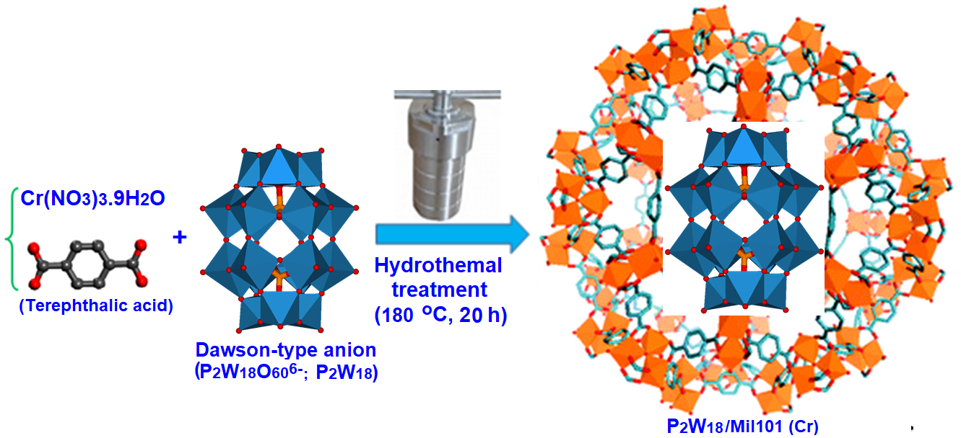
Scheme 1. Schematic illustration for the preparation of P₂W₁₈@MIL101 (Cr).

FT-IR spectra, P₂W₁₈, MIL-101 (Cr), and P₂W₁₈@MIL-101 (Cr) were registered in the range of 400–4000 cm⁻¹as shown in Figure (1). The vibrational bands of pure MIL-101 (Cr) were observed at 1658, 1639, 1539, 1433, 1394 cm⁻¹, ³³⁻³⁶ and the vibrational bands of pure P₂W₁₈ were appeared at 775, 912, 960 and 1091 cm⁻¹. After forming P₂W₁₈@MIL-101(Cr) nanocomposite, the characteristic peaks related to MIL-101 (Cr) are almost the same. Additionally, four P₂W₁₈ related peaks are well retained in the P₂W₁₈@MIL-101 (Cr) sample. However, there are slightly shifted peaks compared with the pure Dawson-type P₂W₁₈. These shifts imply that interaction exists between the Dawson-type anion and MIL-101(Cr) MOF.
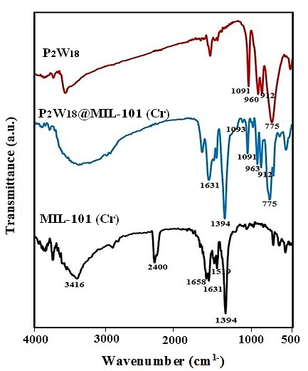
Figure 1. The FT-IR spectra of (a) MIL-101 (Cr), (b) P₂W₁₈@MIL101 (Cr), (c) P₂W₁₈.

The phase purity confirmation and crystallinity examination of the samples was carried out by using an X-ray powder diffraction pattern. In Figure 2a, the XRD pattern of the as-synthesized MIL-101(Cr) is shown. The successful synthesis and the purity of MIL-101 (Cr) are confirmed by the diffraction peak severities and widths, which show some variations.^{23,26,27,37} The Similarities in the XRD patterns of MIL-101(Cr) and P₂W₁₈@MIL-101 (Cr) indicate that after incorporating P₂W_{18,} the crystalline structure of the MIL-101(Cr) MOF is retained. This demonstrates the homogeneous distribution of the molecular P₂W₁₈ within the porous structure of MIL-101(Cr). The XRD pattern together with the IR spectra demonstrates that the structure of the MOF with the incorporation of P₂W₁₈ does not lead to the destruction of the framework.
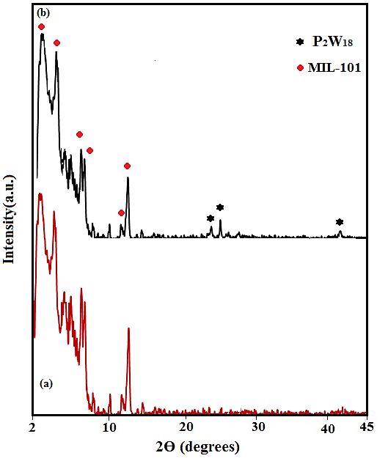
Figure 2. The XRD patterns of (a) MIL-101 (Cr), (b) P₂W₁₈@MIL101 (Cr).
The existence of the Dawson-type polyoxotungstate P₂W₁₈ in the MIL-101(Cr) framework was further recognized by FT-Raman spectrum of the nanohybrid material in comparison with those of the isolated compounds. As can be seen in Figure 3, the FT-Raman spectrum of the nanohybrid material reveals the typical bands of the porous support material MIL-101 and some vibrational modes of the P₂W₁₈.³⁴ In particular, the strong band located at about 965 cm⁻¹ assigned to W=O symmetrical stretching mode is clearly evident in the spectrum of the composite material P₂W₁₈@MIL-101(Cr).³⁸ The characteristic spectral bands verify the existence of the both P₂W₁₈ and MIL-101 in the P₂W₁₈@MIL-101(Cr) nanocomposite.

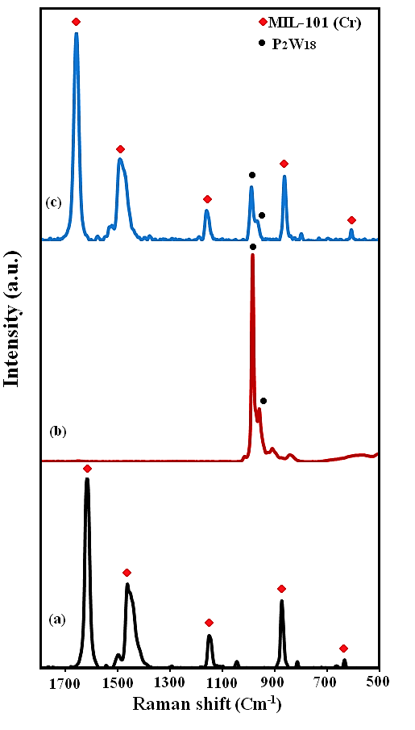
Figure 3. The FT-Raman spectra of (a) MIL-101 (Cr), (b) P₂W_{18,} (c) P₂W₁₈@MIL101 (Cr).
The morphology and microstructure of samples were clarified by FE-SEM observations. The SEM images of the fabricated compounds are indicated in Figure 4. Figure 4a-c exhibits FE-SEM images of the pristine MIL-101 (Cr) particles. It shows that the MIL-101 (Cr) particles are irregular polyhedral in shape with high porosity. The sizes of these polyhedral crystals are in the range of 0.5-2 μm. The SEM images of the P₂W₁₈@MIL-101(Cr) composite in Figure 4d-e clearly show that its shape and morphology are similar with those of the MIL-101(Cr). Confirming that the crystalline structure of MIL-101 (Cr) remains unchanged after incorporating P₂W₁₈ anions. However, as can be seen, the porosity of MIL-101 (Cr) decreased with the incorporation of P₂W₁₈ anions.
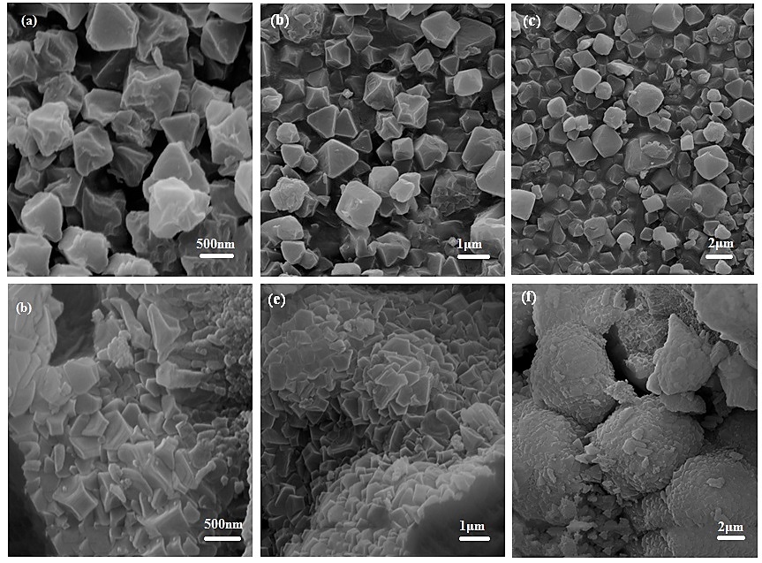
Figure 4. The SEM images of (a-c) MIL-101 (Cr) and (d-f) P₂W₁₈@MIL-101 (Cr).

As shown in Figure 5, the EDX spectrum of the nanohybrid corroborates the presence of W, K, and P from the POM and C and Cr from MIL-101(Cr). The elemental mapping analysis of the nanohybrid indicates the homogeneous distribution of all these elements, thus confirming the uniform incorporation of P₂W₁₈ into the porous MIL-101 (Cr) framework

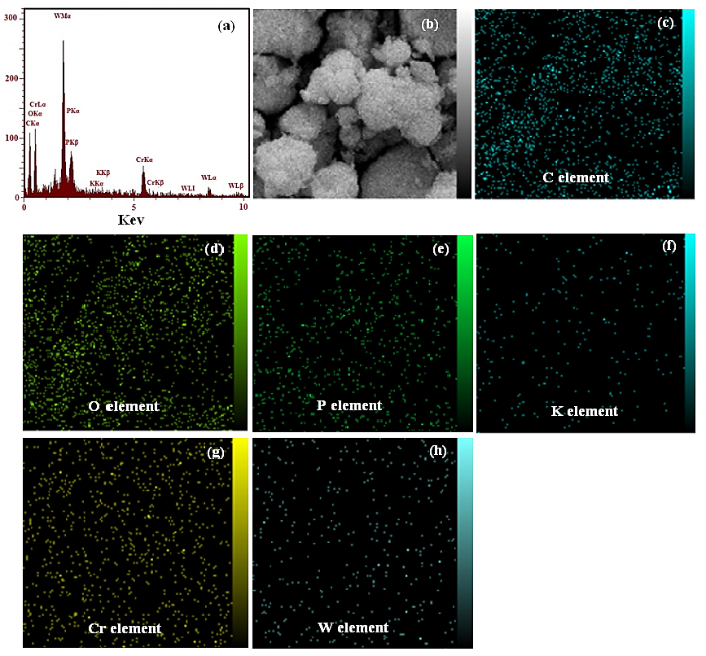Figure 5. The EDX spectra and Element mapping by SEM for P₂W₁₈@MIL101 (Cr).

The N₂ adsorption-desorption isotherms for determining the pore volumes and the BET surface areas are indicated in Figure 6. On the basis of the IUPAC classification, the N₂ adsorption–desorption isotherms of the sample in Fig. 6(a) reveal mixed type I isotherms with H4-type hysteresis loop, which is characteristic of solids with mesoporous cages.^{8,32} Nanohybrids have a BET surface area of 1167.4 m² g⁻¹ and a pore volume of 0.324 cm³ g⁻¹. Compared with texture properties of the pristine MIL-101(Cr) in literature,^{28,39} the encapsulated sample demonstrated a significant decrease in both pore volume (from 1.80 to 0.32 cm³/g) and surface area (3460 to 1167 m²/g) owing to the insertion of large Dowson-type POM into the cages of MOF. In addition, the pore size of the P₂W₁₈/MIL-101(Cr) is 2.6 nm that was calculated using BJH method (Figure 6b). Obviously, the P₂W₁₈/MIL-101(Cr) showed smaller average pore size than that of pristine MIL-101(Cr). The great difference between MIL-101(Cr) and P₂W₁₈/MIL-101(Cr) was ascribed to the insertion of large P₂W₁₈ anions into the pores of MIL-101(Cr) that can occupy part of the pore space
Table 1. The textural properties of P₂W₁₈@MIL-101 (Cr).
Entry | Sample | BET surface area (m²/g) | Langmuir surface area (m²/g) | Total pore volume  (p/pº= 0.960) (cm³ /g) | Average pore diameter (nm) | Ref
1 | MIL-101 (Cr) | 3460 | 4710 | 1.80 | 3.6 | ^{28, 39}
2 | P₂W₁₈@MIL-101(Cr) | 1167.4 | 1671.4 | 0.32 | 2.6 | This work

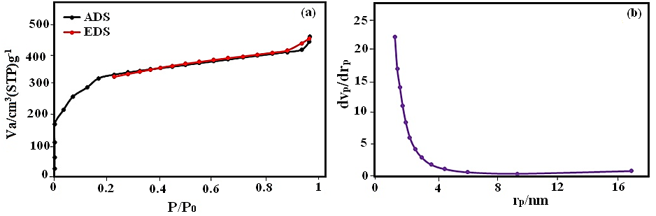
Figure 6. (a) Nitrogen adsorption-desorption isotherms curve at 77 K and (b) pore size distributions obtained by the BJH method for nanohybrid.
In order to further investigate and evaluate the thickness of the P₂W₁₈@MIL-101 (Cr) nanohybrid, the AFM analysis was used. The AFM image of the nano-hybrid and its surface morphology, is illustrated Figure 7. The AFM image depicts that the attendance of the cubic nanoparticles, their related particle size, and their morphology were close to those illustrated by the SEM images. The surface of the nanohybrid indicated an almost uniform structure; in the surface of MIL-101 (Cr), the size (altitude) of the particles is 154.4 nm as shown in Figure 7b.
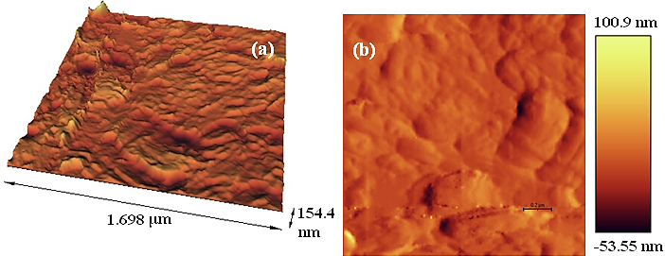
Figure 7. AFM results of the nanohybrid P₂W₁₈@MIL101 (Cr).

3.2. Adsorption Capability of Nanohybrid Toward Organic Dyes
In this work, the removal of dyes from infected waters by nanohybrids (P₂W₁₈@MIL-101) was investigated. Three organic dyes were used herein: MB and RhB as cationic dyes and MO as the anionic dye. Their adsorption was determined using the characteristic UV-vis adsorption band. The process of adsorption was specified with the fading of the blue, red, and orange colors of MB, RhB, and MO, respectively. The adsorption of MB from aqueous solution by the nanohybrid appeared after 30 seconds with a removal efficiency of 100%, as shown in Figure (8a). For the removal of the RhB and MO dyes, the adsorption ability of the nanohybrid studied is shown in Figures (8b, and 8c). The results indicate that the nanohybrid is weakly adsorbent with respect to the anionic MO dye and strongly adsorbent with respect to the two cationic MB and RhB dyes. This is because that P₂W₁₈ polyanions can quickly and effectively adsorb cationic MB and RhB dyes, whereas strongly reject anionic MO dye.
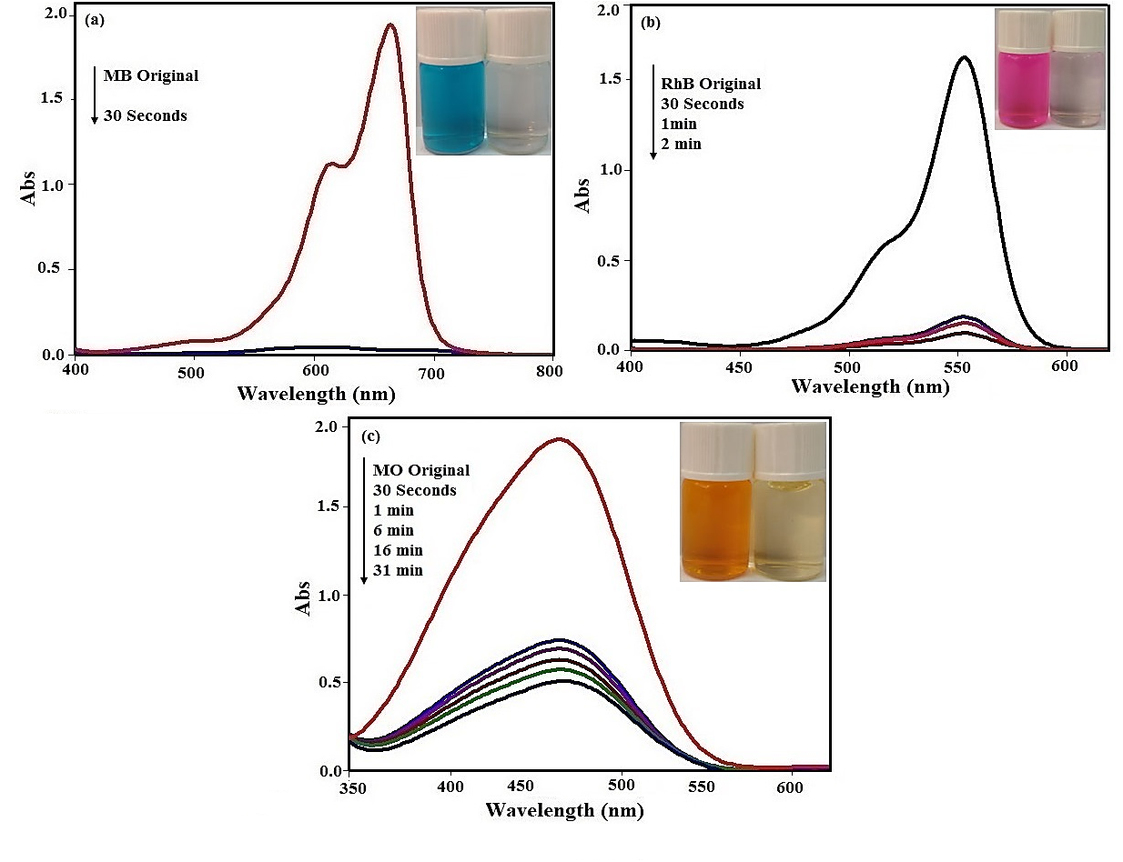
Figure 8. Time dependent UV-Vis spectra during adsorption of dyes over P₂W₁₈@MIL-101 (a) MB, (b) RhB, (c) MO. [dye]₀ = 25 mgL⁻¹, adsorbent amount= 30 mg, temp.= 25 °C.

3.2.1. Effect of pH
One of the important parameters affecting the adsorption of dyes is the pH of solution. The effect of pH on dye elimination by P₂W₁₈@MIL-101 (Cr) is shown in Figure 9a. The results showed that the pH dependency specifications represent adsorption independent of the entire pH range because nanohybrids have a negative charge, which allows them to interact with the positive charges of the dyes in all ranges of pHs.
3.2.2. Effect of Initial Dye Concentration
As shown in Figure 9b, with an increment in the initial dye concentration, the dye removal decreases. With the increment of the initial MB concentration in the solution more dye was adsorbed onto P₂W₁₈@MIL-101 (Cr), in the event that the dosage of adsorbent remained unchanged. The reason for this is that with the increased initial dye concentration, an increment occurs in the driving force of the concentration gradient. The adsorption of dye by P₂W₁₈@MIL-101 (Cr) in a low initial concentration is very intense and a balance is reached quickly. In fact, for the initial concentration of MB in 25 mg L⁻¹, the nanohybrid has a removal efficiency of 100%, in 30 seconds. This demonstrates that P₂W₁₈ was probably distributed homogeneously and uniformly within the porosities of the MIL-101 (Cr). At a constant adsorbent dosage, with an increasing concentration of the solution, the amount of adsorbed dye increased while the adsorption efficiency of the nanohybrid decreased. ^{40, 41}
3.2.3. Effect of Adsorbent Dosage
For the purpose of wastewater purification, determining a suitable adsorbent dosage is very important.⁴² The influence of POM@MOF dosage on dye elimination was investigated with fixed conditions such as dye solution volume of 30 mL, dye concentration of 100 mgL⁻¹ , pH= 6, and temperature of 25 ºC for MB. The adsorbent dosage was applied in different amounts within a range of 10 to 40 mg. Following this, the dye solution was centrifuged and samples were investigated by a spectrophotometer, as Figure 9d shows. With increasing adsorbent dosage, the removal of MB dye increases which could be related to the more adsorption sites. In the result, the suitable adsorbent dosage was found to be 30 mg.
3.2.4. Effect of Temperature
The effect of temperature is another significant physicochemical process parameter because the temperature can change the adsorption capacity of the adsorbent.^{43,44} The adsorption investigations were carried out at different temperatures (25, 35, 45, 55, 65, and 75 °C) (Figure 9c). Decreasing the adsorption time with temperature shows that the adsorption is a spontaneous and endothermic process. With an increase in the temperature, the mobility of the dye is likely to increase. ⁴⁵ In addition, large dye molecules will then be able to penetrate the inner structure of the nanohybrid further. ⁴⁶

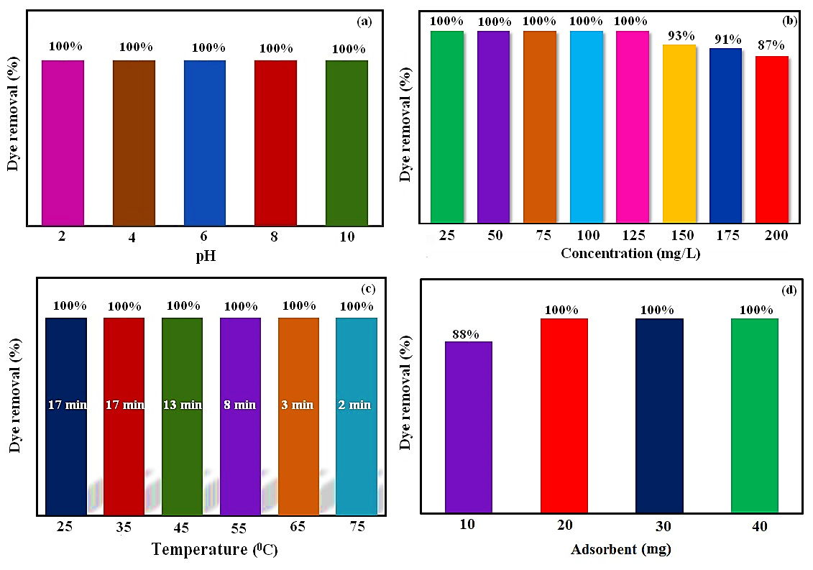
Figure 9. Effects of pH, dye concentration, different temperatures and adsorbent dosage on dyes elimination by P₂W₁₈@MIL-101(Cr). (C_{o}: 100 mg/L, pH 6).

To show the advantages of the present adsorbent, we have compared the obtained results in the removal of MB from aqueous solution by the P₂W₁₈/MIL-101(Cr) nanohybrid with some reported similar adsorbents in the literature.^{12,47-51} From Table 2, it is clear that with respect to the adsorption conditions (adsorption time, initial dye concentration and adsorption efficiency), the present method is more suitable and/or superior. We can see that the adsorption process in the presence of most reported adsorbents required longer reaction time compared to the P₂W₁₈/MIL-101(Cr) nanohybrid. The P₂W₁₈ polyanions with a large number of negative charges incorporated in the hybrid have a stronger attraction force with the positive charges of cationic dyes (e.g. MB). In fact, higher adsorption efficiency of the P₂W₁₈/MIL-101 (Cr) is due to synergistic effect between MIL-101 (Cr) and P₂W₁₈ polyanions.
Table 2. Comparison of the results of the newly synthesized nanohybrid with reported adsorbents based on MIL-101 (Cr) for the removal of dye pollutants.

Adsorbent | Dye pollutant | Concentration of dye (mg/L) | Removal efficiency (%) | Time (min) | Ref
H₆P₂W₁₈O₆₂@Cu₃(BTC)₂ | MB | 20 | 80 | 60 | 12
PV₂Mo₁₀-M (membrane) | MB | 20 | 100 | 48h | 47
amino-MIL-101(Al) | MB | 50 | 100 | 360 | 48
LaMnO₃@SiO₂/PW₁₂ | MB | 25 | 98 | 30 | 47
MIL-101@ PW₁₁V | MB | 10 | 98 | 60 | 12
MIL-101@ PW₁₁V | RhB | 10 | 60 | 60 | 12
MIL-101@MoS₂ | RhB | 20 | 90 | 10 | 49
MRGO-4 | RhB | 5 | 91 | 120 | 50
MIL-101@ PW₁₁V | MO | 10 | 19 | 60 | 12
Fe₃O₄/MIL-101 | MO | 25 | 25 | 150 | 51
P₂W₁₈@MIL-101 (Cr) | MB | 25 | 100 | 0.5 | This work
P₂W₁₈@MIL-101 (Cr) | RhB | 25 | 100 | 2 | This work
P₂W₁₈@MIL-101 (Cr) | MO | 25 | 31 | 73 | This work

3.2.5. Selective Adsorption Ability of the Nanohybrid for the Mixed Organic Dyes
The separation process based on charge and size selectivity is further demonstrated in the solutions containing three different dyes. The mixture of three dye solutions (MB&RhB&MO) was selected to indicate their ability to separate the nanohybrid. In a mixture of binary and triple dye solutions, the adsorption bands of RhB and MB decrease quickly (Figure 10), which shows that the nanohybrid can select cationic dyes.
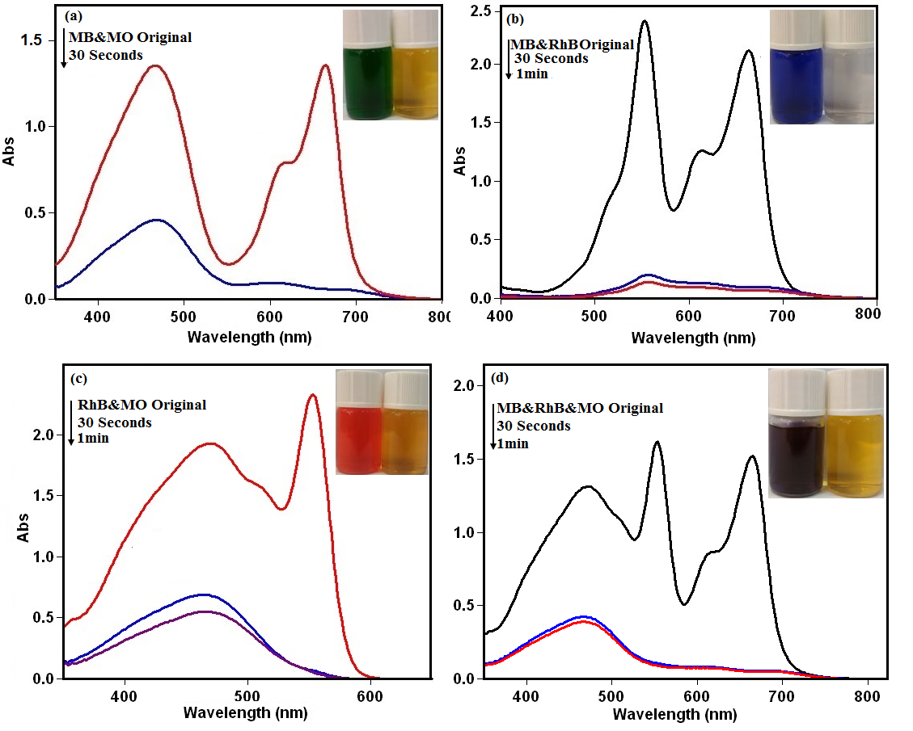
Figure 10. The adsorption capability of P₂W₁₈@MIL-101 (Cr) (a-d) toward mixed dyes. [Cº= 25 mg L⁻¹, T= 25 ºC].

3.2.6. Adsorption Kinetics
According to the adsorption kinetics, several models for a mechanism of solution adsorption onto an adsorbent can be expressed. To investigate the controlling mechanisms and the rate controlling steps in the overall adsorption process, such as diffusion control, chemical reaction, and mass transfer, different kinetic models (intraparticle diffusion, pseudo-first-order, and pseudo-second-order) are utilized.^{46,52} To study the empirical data and investigate the probability of intraparticle diffusion that can influence the adsorption process, the equation below is used: ^{42, 53}

The values I and kp demonstrate the intraparticle dissemination rate constant and intercept, respectively. The parameters I, kp and R² were computed for several dye concentrations and listed in Table 4. The parameter I indicates the thickness of the frontier layer. The results show that the surface adsorption can be performed by the dissemination of the particles. Generally, a pseudo-first-order equation is illustrated as follows: ⁵⁴

The parameters qe and k₁ indicate the value of dye adsorbed at equilibrium (mg/g) and the equilibrium rate constant of the pseudo-first-order kinetic (1/min), respectively.
The pseudo-second-order kinetic equation is expressed as follows: ^{55, 56}

To adsorb dyes onto P₂W₁₈@MIL-101 (Cr) at the different dye concentration amounts (150, 175, and 200 mg/L) linear plots of t/qt versus t are indicated in Figure 11b. The parameters of K₁, K₂, R₁² (correlation coefficient for pseudo-first-order adsorption kinetics), R₂² (correlation coefficient for pseudo-second-order adsorption kinetics) K_{P}, I, and R₃² (correlation coefficient for intra-particle diffusion model) were calculated and have been presented in Table 3. As it can be seen in Table 3, the values of the q_{e(exp}) (mg/g) are lower than the calculated q_{e(cal)} (mg/g) according to pseudo-second-order equation, which further supports that the pseudo-second-order equation can be utilized to describe the adsorption of dye onto the P₂W₁₈@MIL-101 (Cr).

Table 3. Kinetic models parameters for MB dye adsorption at 150, 175 and 200 mg/L dye concentrations.
C₀ (mg/L) | qe_{exp} (mg/g) | Pseudo-first-order kinetic |  | Pseudo-second-order kinetic |  |  |  | Intraparticle diffusion model
 |  | k₁ (min⁻¹) | qe_{cal} (mg/g) | R₁² | k₂ (g/mg min) | qe_{cal} (mg/g) | R₂² | kp | I | R₃²
150 | 146.1 | 0.07 | 7.4 | 0.9892 | 0.003 | 151. 5 | 0.9992 | 12.1 | 66.7 | 0.6937
175 | 169.47 | 0.07 | 12.2 | 0.9891 | 0.003 | 175.4 | 0.9993 | 13.8 | 59.8 | 0.6819
200 | 192 | 0.04 | 18.1 | 0.9849 | 0.002 | 200 | 0.9989 | 15.8 | 50.9 | 0.6937
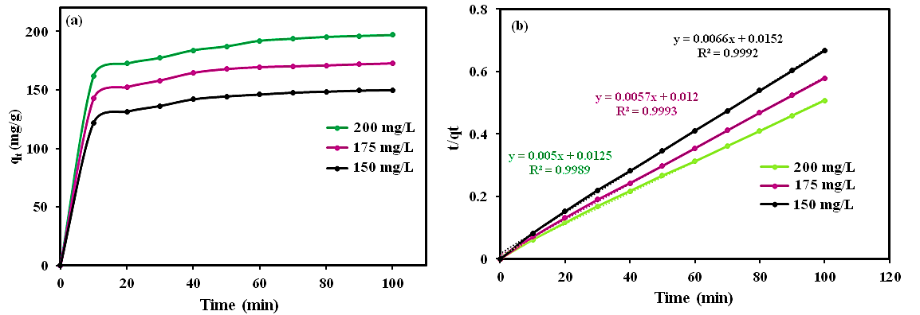

Figure 11. Kinetic adsorption data plots for MB: (a) plot of removal rate qt vs. t and (b) Pseudo-second- order adsorption kinetics on nanomaterial.

3.2.7 Adsorption Isotherm
The design of an adsorption system for the sorption of adsorbent provides the most suitable correlation for the equilibrium curves. Different adsorption isotherms were investigated such as the Freundlich, Langmuir, and Temkin isotherms. The basic supposition in the Langmuir theory is that the adsorption within the adsorbent occurs at particular homogeneous sites. This equation can be expressed linearly as bellow:^{42,46,57}

The parameters C_{e}, K_{L,} and q_{m} are the equilibrium concentration of the dye solution (mg/L), the Langmuir constant (L/mg), and the maximum adsorption capacity (mg/g), respectively.
By assuming a non-homogenous surface with a non-uniform diffusion of heat of adsorption over the surface the Freundlich equation is derivative. The Freundlich equation can be represented linearly as follows:^{46,58}

Where KF and 1/n indicate the adsorption capacity at unit concentration and the adsorption severity as Freundlich constants, respectively. The isotherm type is determined according to the values of 1/n, that is, unfavorable (1/n > 1), favorable (0 < 1/n < 1), and irreversible (1/n = 0). ⁵⁹ Some indirect adsorbate/adsorbate interactions studied by Temkin in relation to adsorption isotherms were examined, and it was suggested that for all the molecules, the heat of adsorption ncreases linearly with coverage. The Temkin equation can be expressed linearly as follows: ^{56, 60}

The Temkin isotherm expresses that pending some maximum binding energy, the adsorption is characterized by a uniform distribution of binding energies. The isotherm constants B₁ and K_{T} were determined using the values qe and Ln Ce, which represent the slope and the intercept, respectively. The constant B₁ represents the heat of adsorption and the constant K_{T} indicates the maximum binding energy. The correlation coefficients for the Langmuir, Freundlich and Temkin isotherms are listed in Table 4. Based on the results obtained, the Langmuir isotherm is most suitable for studying the MB dye.
Table 4. Isotherm constants for MB dye adsorption at 150, 175 and 200 mg/L dye concentrations
Dye |  | Langmuir isotherm model |  | Freundlich isotherm model |  |  | Temkin isotherm model
 | R² | K_{L} (L mg⁻¹) | Qm (mg g⁻¹) | R² | K_{F} (mg g⁻¹) | n (mgL⁻¹) | R² | K_{T} | B₁
MB | 1 | 0.3 | 270 | 0.9944 | 7 | 2.6 | 0.9987 | 2.6 | 63.83

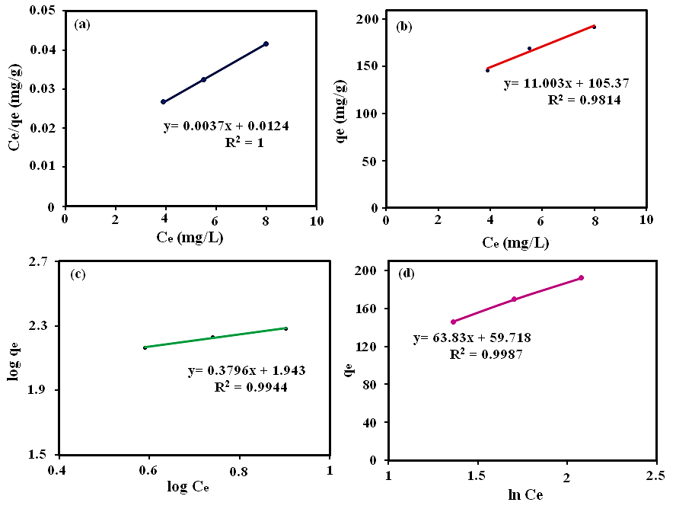
Figure 12. (a) Isotherm plot of dye elimination, (b) Langmuir isotherm, (c) Freundlich isotherm, (d) Temkin isotherm of dye removal by P₂W₁₈@MIL-101 (Cr).

3.2.8. Adsorption Thermodynamics
In the adsorption process, energy and entropy are very significant. The value of MB adsorbed at equilibrium for determining the thermodynamic parameters at the different temperatures was examined. The enthalpy (ΔHº: kJ/mol), entropy (ΔSº: kJ/mol K), and change in Gibbs energy (ΔGº: kJ/mol) were obtained using the following equations : ^{42, 61}

The parameters Kc (L/g), T, and R (8.314 J/mol K) are the standard thermodynamic equilibrium constant, the equilibrium concentration of the dye in the solution (Ce), the value of dye adsorbed on the adsorbent of the solution at equilibrium (qe), the absolute temperature, and the gas constant, respectively. The values ΔHº and ΔSº can be determined by drawing curves of ln Kc versus 1/T from the slopes and intercepts, respectively (Figure 13). Table 5 indicates the negative values of ΔGº and positive ΔHº. The data demonstrate that the MB adsorption process is an endothermic and spontaneous process. The increase randomly at the solid/solution interface based on the positive amount of ΔSº occurs in the internal structure of the adsorption of MB dye onto P₂W₁₈@MIL-101 (Cr). Also, the positive amount of ΔHº indicates the presence of an energy impediment in the adsorption process and the endothermic process.^{62,63}
According to the negative amounts of ΔGº, the adsorption process is a spontaneous process. Moreover, the increase in temperature which leads to a decrease in the amounts of ΔGº indicates that the adsorption is higher at a temperature than is the spontaneous process. Given the values obtained from ΔGº, of between 20 and 0 kJ/mol, the dominating mechanism in this study is the physisorption mechanism (Table 5).^{46, 64}

Table 5. Thermodynamic parameters of dye adsorption on P₂W₁₈@MIL-101 (Cr).
Temperature °C | Thermodynamic parameters
MB | ΔGº (kJ/mol) | ΔHº (kJ/mol) | ΔSº (J/mol K)
25 | -9.63 | 30.52 | 133.02
35 | -10.44
45 | -11.78
55 | -13.1
65 | -14.43
75 | -15.76

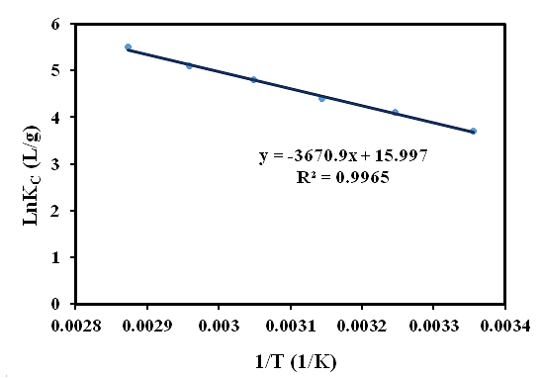
Figure 13. Plots ln K_{C} versus 1/T for adsorption of dyes.
3.2.9. Stability and Recyclability of Hybrid Nanomaterial
The stability and reusability of P₂W₁₈@MIL-101 (Cr) are important aspects of the practical removal of dye pollutants. By using cycle tests, the removing of MB was studied. The adsorbent was separated by centrifugation was completely separated by simple centrifugation due to its insoluble property in water. Following, the fast release process of the adsorbed MB was achieved by thoroughly washing the adsorbent with ethanol, water, and NaCl mixture several times and dried overnight at 60 °C and reused for adsorption again under the same condition. As can be seen in Figure 14a, only a negligible drop was happened in removal efficiency after four cycles. This property is significant as it can reduce the cost of the adsorption without the collapse or loss of the structure of the material. As shown in Figure 14(b)-(d), FT-IR, SEM and XRD pattern of the recycled P₅W₃₀/MIL-101 (Cr) adsorbent did not show significant changes after the third run compared to the fresh adsorbent. Therefore, these observations confirm that the as-prepared P₂W₁₈@MIL-101 (Cr)) adsorbent can work as an effective adsorbent for cationic dyes removal with good stability and recyclability.
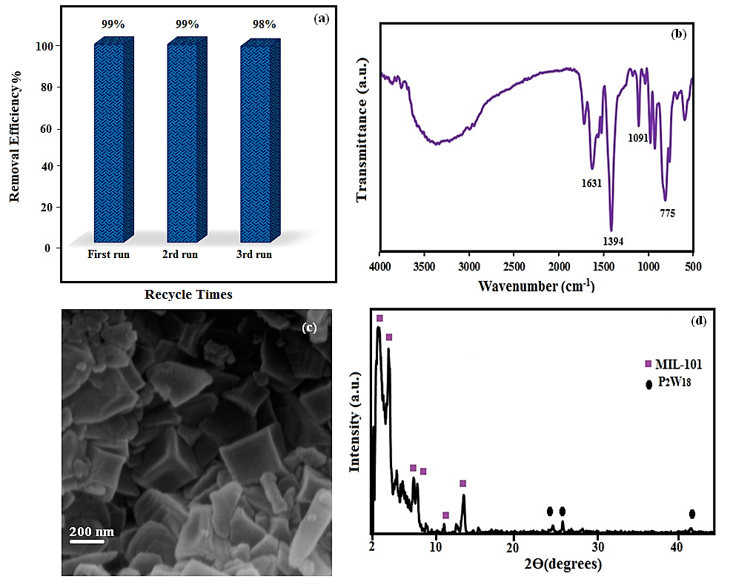
Figure 14. (a) Recycling tests of magnetic nanohybrid toward MB adsorption. (b) FT-IR spectrum (c) SEM image and (d) XRD pattern of the recovered nanohybrid after 3rd cycle.
4. Conclusions
In summary, the Dowson-type polyoxometalate/MIL-101(Cr) metal-organic framework (P₂W₁₈/MIL-101(Cr)) nanohybrid with a high BET specific surface area of 1167.4 m² g⁻¹ were successfully prepared by a simple one-pot hydrothermal route. The FT-IR, XRD, and EDX analyses confirmed the successful incorporartion of the P₂W₁₈ in MIL-101 (Cr) fromework. This nanohybrid could selectively adsorb cationic dyes because of the presence of P₂W₁₈ polyanions in its structure and strong interaction with cationic dyes. The results revealed that the adsorption process was followed pseudo-second-order kinetic Furthermore, the P₂W₁₈/MIL-101 (Cr) nanohybride could be recycled and reused several times without losing the adsorption capacity. Thus, this material is a promising adsorbent for the treatment of toxic organic pollutants in the colored wastewater.
5. Acknowledgements
The authors gratefully acknowledge the Lorestan University for financial support.
6. References
1. J. Juan-Alcañiz, E. V. Ramos-Fernandez, U. Lafont, J. Gascon and F. Kapteijn, J. Catal, 2010, 269, 229-241.
2. K. Ariga, Y. Yamauchi, G. Rydzek, Q. Ji, Y. Yonamine, K. C.-W. Wu and J. P. Hill, Chem. Lett., 2013, 43, 36-68.
3. K. Ariga, H. Ito, J. P. Hill and H. Tsukube, Chem. Soc. Rev., 2012, 41, 5800-5835.
4. R. Q. Zou, H. Sakurai and Q. Xu, Angew. Chem., 2006, 118, 2604-2608.
5. M. Allendorf, C. Bauer, R. Bhakta and R. Houk, Chem. Soc. Rev., 2009, 38, 1330-1352.
6. M. Kurmoo, Chem. Soc. Rev., 2009, 38, 1353-1379.
7. M. Li, D. Li, M. O’Keeffe and O. M. Yaghi, Chem. Rev., 2013, 114, 1343-1370.
8. A. Aijaz, T. Akita, N. Tsumori and Q. Xu, J. Am. Chem. Soc., 2013, 135, 16356-16359.
9. Y. Yuan, F. Sun, L. Li, P. Cui and G. Zhu, Nat. Commun., 2014, 5, 4260.
10. D. Tian, Q. Chen, Y. Li, Y. H. Zhang, Z. Chang and X. H. Bu, Angew. Chem. Int. Ed., 2014, 53, 837-841.
11. I. D. Mall, V. C. Srivastava, N. K. Agarwal and I. M. Mishra, Chemosphere, 2005, 61, 492-501.
12. X. Liu, J. Luo, Y. Zhu, Y. Yang and S. Yang, J. Alloys Compd., 2015, 648, 986-993.
13. S. Qiu, M. Xue and G. Zhu, Chem. Soc. Rev., 2014, 43, 6116-6140.
14. S. Wang and Z. Zhu, J. Hazard. Mater., 2006, 136, 946-952.
15. F.-J. Ma, S.-X. Liu, C.-Y. Sun, D.-D. Liang, G.-J. Ren, F. Wei, Y.-G. Chen and Z.-M. Su, J. Am. Chem. Soc., 2011, 133, 4178-4181.
16. D.-Y. Du, J.-S. Qin, S.-L. Li, Z.-M. Su and Y.-Q. Lan, Chem. Soc. Rev., 2014, 43, 4615-4632.
17. H. N. Miras, J. Yan, D.-L. Long and L. Cronin, Chem. Soc. Rev., 2012, 41, 7403-7430.
18. X. L. Hao, Y. Y. Ma, H. Y. Zang, Y. H. Wang, Y. G. Li and E. B. Wang, Chem. Eur. J., 2015, 21, 3778-3784.
19. X.-B. Han, Z.-M. Zhang, T. Zhang, Y.-G. Li, W. Lin, W. You, Z.-M. Su and E.-B. Wang, J. Am. Chem. Soc., 2014, 136, 5359-5366.
20. I. V. Kozhevnikov, Chem. Rev., 1998, 98, 171-198.
21. L. Bromberg, X. Su and T. A. Hatton, ACS Appl. Mater. Interfaces, 2013, 5, 5468-5477.
22. A.-X. Yan, S.Yao, Y.-G. Li, Z.-M. Zhang, Y. Lu, W.-L. Chen and E.-B. Wang, Chem.- A Eur. J., 2014, 20, 6927-6933
23. E. Haquea, J. E. Lee, I. T. Jang, Y. K. Hwang, J.-S. Chang, J. Jegal, S. H. Jhung, J. Hazard. Mater., 2010, 181, 535–542
24. X. L. Hao, Y. Y. Ma, H.-Y. Zang, Y.-H. Wang, Y.-G. Li, E.-B. Wang., Chem.- A Eur. J., 2015, 21, 3778-3784
25. X.-X. Huang, L.-G. Qiu, W. Zhang, Y.-P. Yuan, X. Jiang, A.-J. Xie, Y.-H. Shen and J.-F. Zhu, CrystEngComm, 2012, 14, 1613-1617.
26. B. F. Hoskins and R. Robson, J. Am. Chem. Soc., 1989, 111, 5962-5964.
27. S. S.-Y. Chui, S. M.-F. Lo, J. P. Charmant, A. G. Orpen and I. D. Williams, Science., 1999, 283, 1148-1150.
28. Y. Yu, B. N. Murthy, J. G. Shapter, K. T. Constantopoulos, N. H. Voelcker and A. V. Ellis, J. Hazard. Mater., 2013, 260, 330-338.
29. J. A. Real, E. Andrés, M. C. Munoz, M. Julve, T. Granier, A. Bousseksou and F. Varret, Science, 1995, 268, 265-267.
30. S. Farhadi, M. M. Amini, M. Dusek, M. Kucerakova and F. Mahmoudi, J. Mol. Struct, 2017, 1130, 592-602.
31. L. Bromberg, Y. Diao, H. Wu, S. A. Speakman and T. A. Hatton, Chem. Mater., 2012, 24, 1664-1675.
32. C. Roch‐Marchal, T. Hidalgo, H. Banh, R. A. Fischer and P. Horcajada, Eur. J. Inorg. Chem., 2016, 2016, 4387-4394.
33. J. J. Walsh, DCU, 2011.
34. E. Locci, S. Lai, A. Piras, B. Marongiu and A. Lai, Chem. Biodivers., 2004, 1, 1354-1366.
35. B. Elena and L. Emsley, J. Am. Chem. Soc., 2005, 127, 9140-9146.
36. G. J. Halder, K. W. Chapman, S. M. Neville, B. Moubaraki, K. S. Murray, J.-F. Létard and C. J. Kepert, J. Am. Chem. Soc., 2008, 130, 17552-17562.
37. N. M. Mahmoodi and F. Najafi, Microporous Mesoporous Mater., 2012, 156, 153-160.
38. L. E. Briand, H. J. Thomas and G. T. Baronetti, Appl. Catal. A., Gen, 2000, 201, 191-202.
39. D. M. Fernandes, A. D. Barbosa, J. O. Pires, S. S. Balula, L. Cunha-Silva and C. Freire, ACS Appl. Mater. Interfaces, 2013, 5, 13382-13390.
40. N. M. Mahmoodi, J. Taiwan. Inst. Chem. Eng., 2013, 44, 322-330.
41. N. M. Mahmoodi, U. Sadeghi, A. Maleki, B. Hayati and F. Najafi, J. Ind. Eng. Chem., 2014, 20, 2745-2753.
42. S. I. Noro, R. Kitaura, M. Kondo, S. Kitagawa, T. Ishii, H. Matsuzaka and M. Yamashita, J. Am. Chem. Soc., 2002, 124, 2568-2583.
43. J. Lee, O. K. Farha, J. Roberts, K. A. Scheidt, S. T. Nguyen and J. T. Hupp, Chem. Soc. Rev., 2009, 38, 1450-1459.
44. J.-R. Li, R. J. Kuppler and H.-C. Zhou, Chem. Soc. Rev., 2009, 38, 1477-1504.
45. S. Ma, D. Sun, X. S. Wang and H. C. Zhou, Angew. Chem. Int. Ed., 2007, 46, 2458-2462.
46. T. K. Trung, P. Trens, N. Tanchoux, S. Bourrelly, P. L. Llewellyn, S. Loera-Serna, C. Serre, T. Loiseau, F. Fajula and G. Férey, J. Am. Chem. Soc., 2008, 130, 16926-16932.
47. L. J. Murray, M. Dincă and J. R. Long, Chem. Soc. Rev., 2009, 38, 1294-1314.
48. C. Mellot-Draznieks, C. Serre, S. Surblé, N. Audebrand and G. Férey, J. Am. Chem. Soc., 2005, 127, 16273-16278.
49. C. Yang, J. Cheng, Y. Chen and Y. Hu, J. Colloid Interface Sci., 2017, 504, 39-47.
50. J. L. Rowsell and O. M. Yaghi, Microporous Mesoporous Mater., 2004, 73, 3-14.
51. R. Bansal, J. Donnet and N. Stoeckli, New York, 1988.
52. S. M. Humphrey and P. T. Wood, J. Am. Chem. Soc., 2004, 126, 13236-13237.
53. T. Uemura, N. Yanai and S. Kitagawa, Chem. Soc. Rev., 2009, 38, 1228-1236.
54. N. M. Mahmoodi, B. Hayati and M. Arami, Ind Crops Prod., 2012, 35, 295-301.
55. A. Maleki, U. Sadeghi, H. Daraei, B. Hayati, F.Najafi, G. McKay, R. Rezaee, Chem. Eng. J., 2017, 313, 826–835
56. J. An, S. J. Geib and N. L. Rosi, J. Am. Chem. Soc., 2009, 131, 8376-8377.
57. G. Férey, Chem. Soc. Rev., 2008, 37, 191-214.
58. J. D. Joshi, N. B. Patel and S. D. Patel, Iran. Polym. J, 2006, 15, 219.
59. K. A. Cychosz, A. G. Wong-Foy and A. J. Matzger, J. Am. Chem. Soc., 2008, 130, 6938-6939.
60. Y. Kim, C. Kim, I. Choi, S. Rengaraj and J. Yi, Environ. Sci. Technol., 2004, 38, 924-931.
61. Z. A. Lethbridge, J. J. Williams, R. I. Walton, K. E. Evans and C. W. Smith, Microporous Mesoporous Mater., 2005, 79, 339-352.
62. F. Di Renzo, Catal. Today, 1998, 41, 37-40.
63. T. O. Drews and M. Tsapatsis, Curr. Opin. Colloid Interface Sci., 2005, 10, 233-238.
64. W. J. Rieter, K. M. Taylor and W. Lin, J. Am. Chem. Soc., 2007, 129, 9852-9853.

