Microwave assisted conversion of an amino acid into a fluorescent solution
Lena Charlyn Greiler¹, Hajo Haase², Boris Mahltig¹*
1 Niederrhein University of Applied Sciences, Faculty of Textile and Clothing Technology, Webschulstr. 31, 41065 Mönchengladbach, Germany
2 Technische Universität Berlin, Institut für Lebensmitteltechnologie und Lebensmittelchemie, Gustav-Meyer Allee 25, 13355 Berlin, Germany

* to whom correspondence should be addressed
e-mail: boris.mahltig@hs-niederrhein.de

Submission to: Acta Chimica Slovenica

Abstract
Microwave assisted synthesis is a well established method in organic and inorganic chemistry. It is also used in material science to realize novel carbon nanoparticles exhibiting fluorescence properties. The results presented here are related to a microwave driven solvothermal process used for the conversion of aqueous amino acid and ethylenediamine systems into fluorescent solutions. The process temperatures are set in the range of 80° to 140°C and the maximum process pressure is 4.5 bar. The process duration is set from 5 to 30 minutes. The fluorescence effect is increased with increasing temperature. The prepared aqueous fluorescent solutions can be used as media to induce fluorescence in textile substrates. The current study can be understood as a first proof-of-concept of a very simple microwave-assisted solvothermal synthesis of fluorescent compounds useful for the modification of different substrates.

Keywords: microwave synthesis, solvothermal process, fluorescence, carbon nanoparticles

1 Introduction
Nanoparticles made from metals or semi-metals are well known and intensively investigated during the last decades.¹⁻⁷ In comparison, the investigations of nanoparticles made from carbon started only recently. The fluorescence properties of carbon nanoparticles were discovered in 2004 during the investigation of carbon nanotubes.⁸ Carbon nanoparticles with diameters below 10 nm are named carbon quantum dots or more simply C-dots.⁹ These C-dots are counted together with the other carbon modification of the fullerene type to the zero-dimensional carbon nanomaterials.¹⁰
It is suggested that the fluorescence properties of carbon nanoparticles are caused by defects of the particle surface.^{11,12} An important influence on the fluorescence is caused by primary amino groups onto the carbon particle surface.¹³ It is reported that the nitrogen content influences the intensity and duration of luminescence of carbon nanoparticles. Especially the preparation of carbon nanoparticles starting from nitrogen containing educts is expected to lead to high fluorescence components.¹²
Conventional fluorescence dyes often have the disadvantage of low light stability. With this background, the development of new fluorescent carbon particles is of high interest, especially to realize long-term stable fluorescent components.¹⁴
The preparation of carbon nanoparticles can be achieved by several methods and especially the use of biomaterial precursors is prominently reported in literature. Carbon dots can be prepared e.g. by treatment of chicken egg substrate with a plasma beam or by hydrothermal treatment of tomato extract.^{11,15}
Microwave assisted preparations are well known in organic chemistry and are also applied for the preparation of carbon dots.^{12,16} The use of microwave assisted devices is very well known in organic chemistry to prepare new compound with higher yield and high purity.¹⁷⁻²¹ For the synthesis of inorganic materials, microwave assisted procedures have also been developed. Platinum nanoparticles are prepared by using a microwave-assisted solvothermal technique.²² Metal particles of copper, silver and gold are also available from microwave-assisted solvothermal processes.^{23,24} Compounds such as titanium dioxide or calcium hydroxyapatite can be obtained with microwave processes.^{24,25}
A very simple experiment shows the formation of carbon dots by the treatment of yogurt in a household microwave oven at 800 W for 30 min. The carbon dots obtained by this method are reported to have a size of 2 nm and a significant content of nitrogen and oxygen.²⁶
Biomaterials like the mentioned chicken egg, tomatoes or yogurt are attractive examples to show how simple the preparation of carbon dots could be. However, the reproducibility of such preparations is limited, because of the possible variation in material composition of substances from natural resources.
Nevertheless, carbon quantum dots can be prepared by microwave treatment of very simple organic molecules such as the amino acid arginine and ethylendiamine in water.¹² This preparation has been reported to be done in a domestic microwave oven with 700 W and duration of 3 min. As result of this procedure a brown solid is obtained, which has to be cleaned by centrifugation, dialysis and freeze drying.¹²
With this background, the aim of the present investigation is to support a synthesis of fluorescent carbon nanoparticles under defined and controlled microwave assisted conditions. To reach this aim, an aqueous solution of an amino acid is treated in a synthesis microwave originally developed for organic synthesis. This microwave device is a closed system, so the preparation can be carried out under solvothermal conditions, which is one main difference to a conventional domestic microwave. Also the process temperature and pressure can be controlled during the preparation. By this microwave-assisted process it is possible to prepare stable and transparent solutions with fluorescence properties. The correlation between process parameters and the gained fluorescence properties is clearly determined.
To give an example for a first application of these fluorescent solutions in a first proof-of-concept study, they are applied in a simple padding process onto cotton substrates from cotton.

2 Experimental Section
2.1 Preparation
For the preparation, two types of chemicals are used: 1.2-Diaminoethane (ethylenediamine) C₂H₈N₂ and D-arginine monohydrochloride (arginine HCl) C₆H₁₄N₄O₂ HCl both from Carl Roth GmbH (Karlsruhe, Germany). First, 21.4 mL ethylenediamine is mixed into 160 mL distilled water. Second, 67.4 g L-arginine monohydrochloride is dissolved in this solution. After stirring for 5 minutes, a colorless clear solution results. This solution is treated in a microwave synthesis device (Discover LabMate, CEM GmbH, Kamp-Lintfort, Germany). Detailed information concerning this device are available in the literature.^{27,28}
For all preparations the heating power is set to 250 W. The process temperatures are set in the range from 80° to 140°C. The process vessel is a closed system, so the preparation is done under solvothermal conditions. Process pressures are determined by the chosen process temperatures. The relation of process pressure to process temperature is depicted in Figure 1.

Figure 1: Process pressure as function of the set process temperature in the used solvothermal arrangement. The error bars indicate the range of process pressures observed during the whole process time of 5 minutes.

A typical temperature / pressure diagram as a function of time for a process temperature of 140°C is presented in Figure 2. After the set process temperature is reached, the process duration starts. Process temperatures of higher than 140°C were not tested, because of the pressure limits of the used device. For all process temperatures, the process duration is set to 5 min. For the highest process temperature of 140°C, also longer process durations of 15 and 30 min were evaluated.

Figure 2: Process temperature and process pressure as a function of the process time. In this example the set temperature is 140°C and the process duration is 15 min. This set temperature is reached after a run time of around 6 min.

After microwave treatment the gained solutions were clear and transparent. With treatment for 5 min duration, the solutions exhibited a light yellow color. Both samples prepared with heating to 140°C and longer process duration, exhibited deeper yellow color and also a significant smell. The received solutions were subjected to dialysis against distilled water. For dialysis a tube with an average pore size of 2.5 to 3 nm was used (Nadir-Dialyseschlauch, Carl Roth GmbH, Karlsruhe, Germany). After dialysis solutions were colorless and their smell disappeared. The solutions obtained after cleaning with dialysis were used for textile treatment. For this, cotton substrates with a size of 6 cm X 3 cm and a weight per area of 388 g/m² was used. The textile treatment was done by dipping the textile sample into the solutions and subsequent drying at room temperature or at 120°C in an oven.

2.2 Analytics
The first evaluation of the prepared solutions was done visually by illumination with a UV-lamp with a maximum intensity around 365 to 370 nm (Philips Lighting Holding B.V.). Further, the optical properties of the solutions were investigated using UV/Vis spectroscopy in transmission arrangement. For this, a UV-2600 spectrometer of Shimadzu was used.
Fluorescence properties were examined with a SPARK fluorescence well plate reader equipped with monochromators (Tecan Deutschland GmbH, Crailsheim, Germany). All measurements were performed by placing the samples in 96-multiwell cell culture plates from TPP (Techno Plastic Products AG, Trasadingen, Switzerland), using 30 flashes per wavelength, an integration time of 40 µs and a lag time of 0 µs. For the investigation of liquids, 100 µL per well were applied, measuring excitation spectra from 280 to 400 nm (in steps of 2 nm) at an emission wavelength of 440 nm, whereas emission spectra were recorded from 380 to 600 nm (4 nm steps) at an excitation wavelength of 360 nm. In each case, measurements were performed as top reading with a Z-position of 15,500 µm, excitation and emission band widths of 5 nm, and a manual gain of 100. For the investigation of textile samples, 5 mm diameter disks were prepared by a conventional hole puncher, and analyzed in bottom reading mode with the Z–position manually set to 31,000 µm and a manual gain of 50. Excitation spectra were obtained from 280 to 400 nm (steps of 10 nm, excitation and emission band widths of 5 nm) measuring the emission at 440 nm, whereas emission spectra were recorded from 410 to 600 nm (10 nm steps, excitation and emission band widths of 10 nm) at an excitation wavelength of 360 nm.

3 Results and Discussion
3.1 Properties of prepared solutions
The prepared solutions were at first investigated simply by illumination with a UV-lamp emitting UV-A light. For all prepared samples, the fluorescence was obvious upon illumination with UV-A light (Figure 3). Even the solution prepared with the lowest process temperature of 80°C and a short process duration of 5 min, a fluorescence effect was observed. However, only the low fluorescence effect of the sample prepared at 80°C is clearly indicated (Figure 3).

Figure 3: Solutions after preparation under illumination with a UV lamp. The process temperature and process duration is indicated for each solution.

The optical transmission of the prepared liquid samples is different for the UV-range from 230 to 400 nm (Figure 4), especially for the samples prepared with higher process temperature exhibiting a light yellow color, which is related to a lower optical transmission of these solutions for visible light in the range of 400 to 450 nm. The sample prepared at 100°C exhibited two minima in the transmission spectrum at 290 and at 358 nm. For the samples prepared at 120° or 140°C, around 370 nm only a shoulder was detected in the transmission. However, the second minimum around 290 nm was more significant for these two samples. For UV-light below 240 nm, all samples exhibit no transmission. The samples were cleaned by dialysis with a tube containing a pore size of 2.5 to 3 nm. After the dialysis, the samples were non-smelling and the yellow color had disappeared, which is also confirmed by the optical transmission spectra shown in Figure 4.

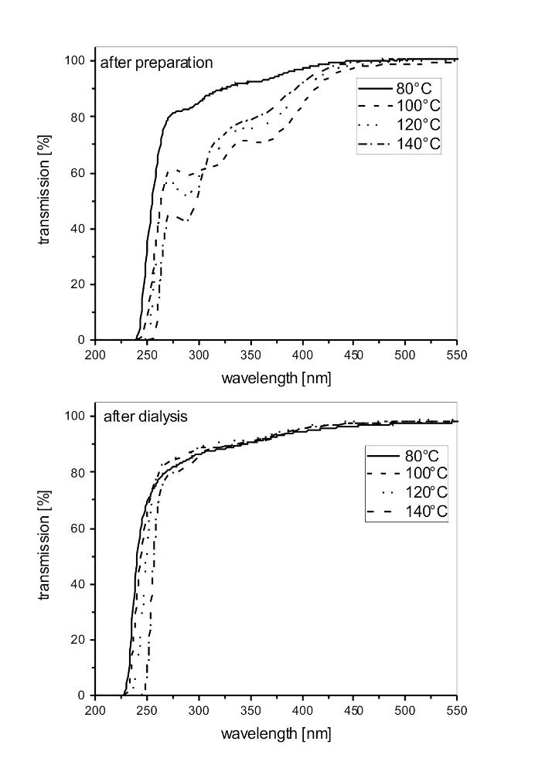

Figure 4: UV/Vis-transmission spectra of the prepared solution recorded directly after preparation (image above) and after treatment by dialysis (image below). Presented are spectra from solutions prepared at different process temperatures with a process duration of 5 min.

The optical transmission spectra of the solutions prepared at 140°C at different process durations are compared in Figure 5. Compared to the sample obtained after 5 min, a longer process duration leads to lower transmission values in the range of 250 to 400 nm. The lowest values are determined for the sample with 15 min process duration. Even after dialysis, the transmission values are still low (compare Figures 4 and 5). This observation indicates that during microwave synthesis UV-absorbing particles with diameters larger than 3 nm are formed.

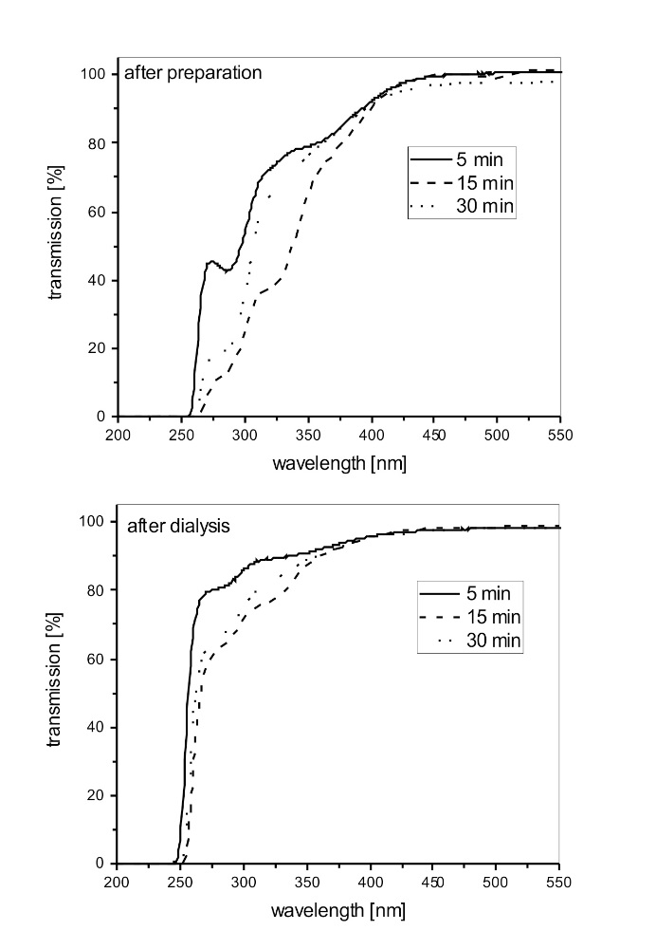
Figure 5: UV/Vis-transmission spectra of the prepared solution recorded directly after preparation (image above) and after treatment by dialysis (image below). Presented are spectra from solutions prepared with different process duration under a process temperature of 140°C.

The fluorescence spectra of the prepared solutions are presented in Figure 6. The activation of fluorescence is done with UV-light of 360 nm. The fluorescence is correlated to the used process temperature for sample preparation. The lowest fluorescence is found for samples prepared at 80°C (Figure 6). The strongest fluorescence is reached after preparation at 140°C. Using a process temperature of 100° or 120°C leads to solutions with similar mean fluorescence values. After cleaning by dialysis, the fluorescence is strongly decreased but for samples prepared at 140°C it is still significant (Figure 6). It can be assumed that fluorescent compounds are formed by the used microwave synthesis. These components have different particle sizes higher and lower than 3 nm. The larger fluorescence particles are still present in the solution after the dialysis.

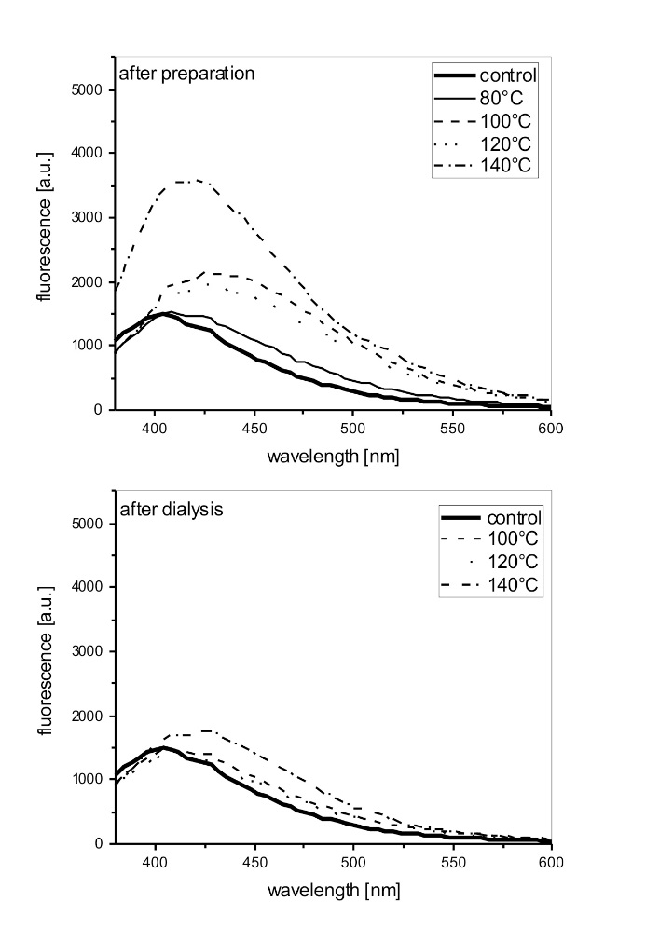
Figure 6: Fluorescence emission spectra of the prepared solutions. For activation, light with 360 nm is used. Presented are spectra from solutions prepared at different process temperatures with a process duration of 5 minutes.

The fluorescence emission spectra of samples prepared at 140°C and with increasing process duration are compared in Figure 7. It is clearly seen that the process duration has a significant influence on the gained fluorescence. Highest fluorescence values are received for the sample prepared at 140°C with 15 minutes process duration in the microwave. For fluorescence activation with light of 360 nm, the maximum fluorescence emission is found to be at 428 nm. After performing the dialysis, the intensity of the fluorescence decreases but is still significant. The strongest fluorescence is gained for the sample prepared at 140°C with a process duration of 30 min. For these preparation conditions the fluorescence emission maximum is observed at 436 nm for an activation with light of 360 nm.

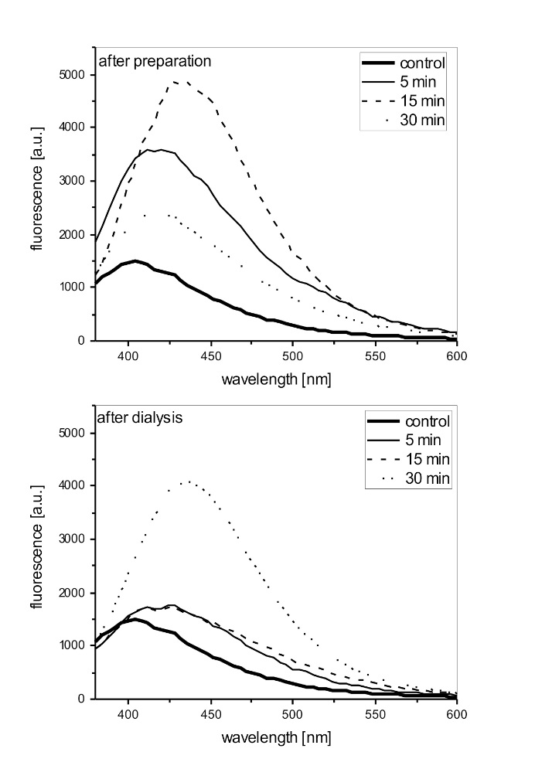
Figure 7: Fluorescence emission spectra of the prepared solutions. For activation light with 360 nm is used. Presented are spectra from solutions prepared with different process duration under a process temperature of 140°C.

The activation spectra for an emission at 440 nm are recorded in Figures 8 and 9. For samples prepared at 80°, 100° or 120°C, the activation of fluorescence is mainly supported by UV-light in the range of 360 to 380 nm (Figure 8). In contrast, the activation spectrum for the sample prepared at 140°C is totally different. In addition to the activation in the area of 360° to 380°C, for this sample the activation spectrum exhibits a strong maximum at 324 nm (Figure 8). After dialysis, no fluorescence activation around 320 nm or below is recorded. The fluorescence for that spectral area is obviously related to lower molecular mass compounds or small particles with diameters smaller than 3 nm. However, the fluorescence in the range of 340 to 380 nm is still present after dialysis, so this fluorescence is probably related to particles with diameters larger than 3 nm.

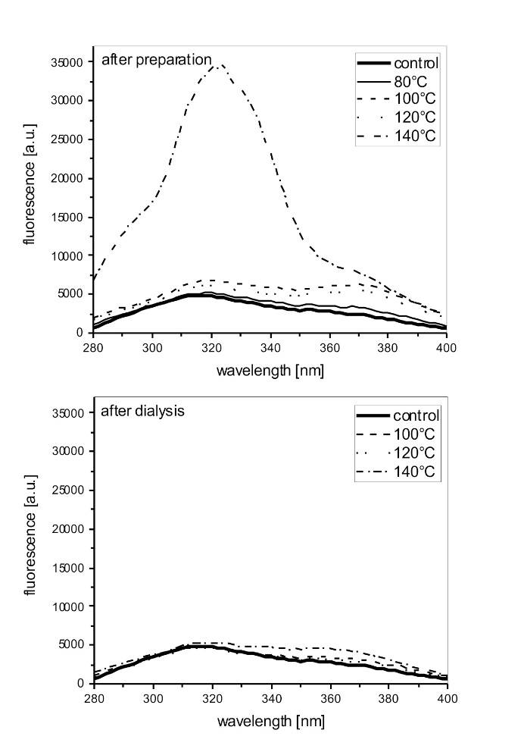
Figure 8: Fluorescence activation spectra of the prepared solutions. The activation is recorded for fluorescence light emitted at 440 nm. Presented are spectra from solutions prepared at different process temperatures with a process duration of 5 min.

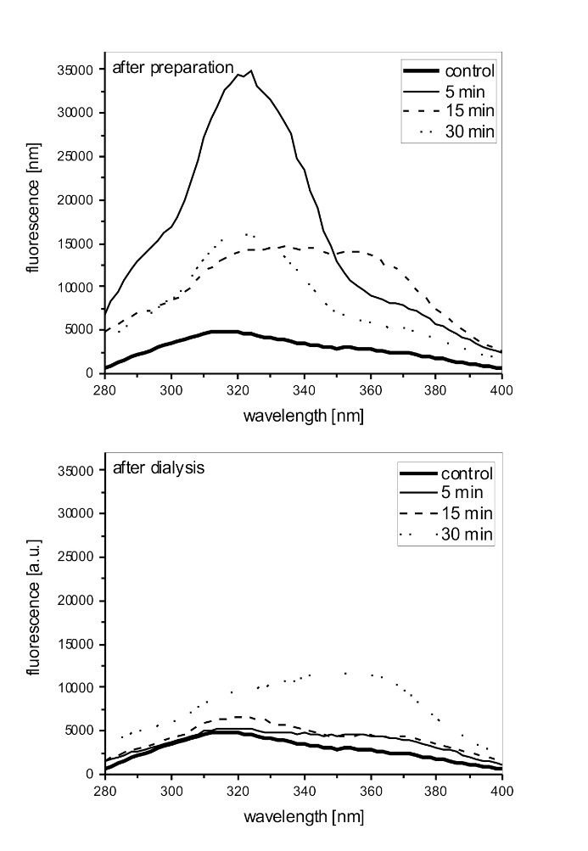
Figure 9: Fluorescence activation spectra of the prepared solutions. The activation is recorded for fluorescence light emitted at 440 nm. Presented are spectra from solutions prepared with different process duration under a process temperature of 140°C.

For many practical applications, as e.g. on textile substrates, a fluorescence activation in the range of 360 to 380 nm is required, while an activation at lower wavelengths of around 320 nm is of lower relevance. An optical brightener transfers UV-light into visible blue light and gives the treated textile a whitened appearance.^{29,30} For this application a fluorescence activation in the range of 360 to 380 nm is important, because the UV-content in sunlight filtered by glass is mainly present in this range and not at lower wavelength of 320 nm.^{31,32}
The fluorescence activation spectra for an emission of 440 nm of samples prepared at 140°C and different process durations are presented in Figure 9. The fluorescence activation is strong over the whole range from 280 to 400 nm. For a process duration of 5 or 30 min a prominent activation maximum around 320 nm is recorded. For the intermediate duration of 15 min a broad activation plateau from 320 to 360 nm is observed. After dialysis, the activation is decreased, especially for wavelengths smaller than 340 nm. The sample prepared after 30 min exhibits after dialysis a significant fluorescence activation with UV-light around 360 nm.

3.2 Properties of prepared textile samples
Cotton samples treated with the solutions prepared at 140°C and cleaned by dialysis are presented in Figure 10. Under illumination with UV-A light, these samples exhibit the emission of a blue fluorescence.

Figure 10: Textile samples treated with the different solutions under illumination with a UV-lamp. The process temperature of 140°C and process duration for solution preparation is indicated for each sample. After application of the solution, the textile samples are dried at 120°C.

The fluorescence activation spectra of the textiles are given in Figure 11. These activation spectra are recorded for fluorescence light emitted at 440 nm. In Figure 11, samples with different process duration for solution preparation and different drying procedures of the treated textiles are compared. All samples exhibit a significant activation maximum for UV-light with 380 nm. A slightly stronger activation is determined for the sample with process duration of 15 min. The drying of textile samples at 120°C does not lead to an increase of the fluorescence, so the fluorescent components are obviously stable under these thermal conditions. As mentioned above, from the point of view of practical applications, both the activation maximum around 380 nm and the thermal stability are important.

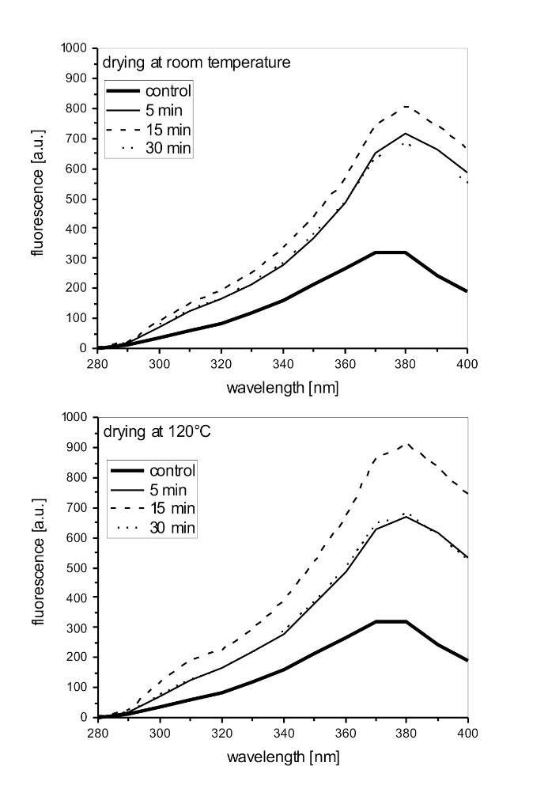
Figure 11: Fluorescence activation spectra of the prepared textiles. The activation is recorded for fluorescence light emitted at 440 nm. Presented are textiles prepared with solutions realized with different process duration under a process temperature of 140°C. After solution application the textile samples are dried at room temperature or at 120°C.

The fluorescence emission spectra of the treated textiles (380 nm activation) are summarized in Figure 12. The maximum of the fluorescence emission is around 450 nm. Samples prepared from solutions with process durations of 5 or 30 min exhibit nearly the same intensity of fluorescence. In comparison with the intermediate process duration of 15 min a higher fluorescence emission is observed. For both drying procedures of the treated textiles (at room temperature or at 120°C) the same high fluorescence values are determined.

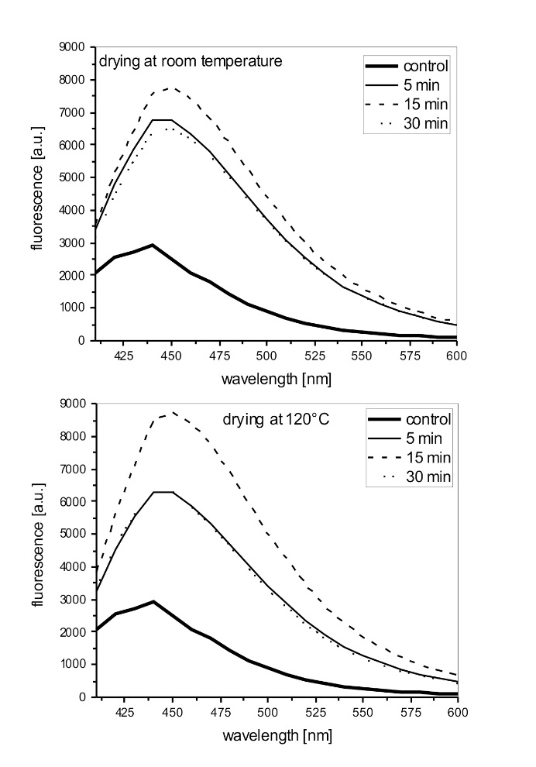
Figure 12: Fluorescence emission spectra of the prepared textiles. For activation light with 380 nm is used. Presented are textiles prepared with solutions realized with different process duration under a process temperature of 140°C. After solution application the textile samples are dried at room temperature or at 120°C.

4 Conclusions
A microwave process driven under solvothermal conditions can be used for the preparation of fluorescent solutions based on the thermal conversion of simple amino acids. The effectivity of conversion is determined by the process temperature used in the solvothermal process. Best results are gained for a process temperature of 140°C. The fluorescent components can be distinguished into components with different particle sizes smaller and larger than 3 nm in diameter. The solutions are suitable for application onto textiles, e.g. as optical brighteners or as fluorescence marker. The fluorescence activation is driven mainly with UV-light in the range of 360 to 380 nm which fits to the UV-light present in sunlight. Also the thermal stability necessary for drying and fixation processes is given. A first proof-of-concept is provided that by microwave synthesis the conversion of amino acids into fluorescent particles is possible. These particles present in homogeneous, transparent and aqueous solutions can be used as finishing agent for textiles.

Acknowledgements
All product and company names mentioned in this chapter may be trademarks of their respective owners, also without labeling. For many helpful discussions and technical help in the lab many thanks have to be acknowledged to Dr. Thomas Grethe from Niederrhein University of Applied Sciences.

References
1. P.K. Jain, X. Huang, I.H. El-Sayed, M.A. El-Sayed, Plasmonics 2007, 2, 107-118.
2. F.E. Kruis, H. Fissan, A. Peled, J. Aerosol Sci. 1998, 29, 511-535.
3. S. Farhadi, B. Ajerloo, A. Mohammadi, Acta Chim. Slov. 2017, 64, 129-143.
4. E. Soleimani, N. Zamani, Acta Chim. Slov. 2017, 64, 644-653.
5. S. Abdolmohammadi, M. Afsharpour, Z. Naturforsch. 2015, 70b, 171-176.
6. B. Mahltig, H. Haufe, K. Muschter, A. Fischer, Y.H. Kim, E. Gutmann, M. Reibold, D.C. Meyer, T. Textor, C.W. Kim, Y.S. Kang, Acta Chim. Slov. 2010, 57, 451-457.
7. B. Mahltig, M. Reibold, E. Gutmann, T. Textor, J. Gutmann, H. Haufe, H. Haase, Z. Naturforsch. 2011, 66b, 905-916.
8. X. Xu, R. Ray, Y. Gu, H. J. Ploehn, L. Gearheart, K. Raker, W. A. Scrivens, J. Am. Chem. Soc. 2004, 126, 12736-12737.
9. Y. Wang, A. Hu, J. Mater. Chem. C 2014, 2, 6921-6939.
10. X. T. Zheng, A. Ananthanarayanan, K. Q. Luo, P. Chen, Small 2015, 11, 1620-1635.
11. J. Wang, C.-F. Wang, S. Chen, Angew. Chem. 2012, 124, 9431-9435.
12. K. Suzuki, L. Malfatti, D. Carboni, D. Loche, M. Casula, A. Moretto, M. Maggini, M. Takahashi, P. Innocenzi, J. Phys. Chem. C 2015, 119, 2837-2843.
13. X. Zhai, P. Zhang, C. Liu, T. Bai, W. Li, L. Dai, W. Liu., Chem. Commun. 2012, 48, 7955-7957.
14. J. Baker, 50 Schlüsselideen Quantenphysik, Springer Spektrum Verlag, Berlin, 2015.
15. P. Wang, R.-B. Zhong, M. Yuan, P. Gong, X. Zhao, F. Zhang, Nucl. Sci. Techn. 2016, 27, 35.
16. M. Gupta, S. Paul, R. Gupta, Acta Chim. Slov. 2009, 56, 749-764.
17. C.O. Kappe, Ange. Chem. Int. Ed. 2004, 43, 6250-6284.
18. N. Kuhnert, Ange. Chem. Int. Ed. 2002, 41, 1863-1866.
19. M. Larhed, A. Hallberg, Drug Discovery Today 2001, 6, 406-416,
20. P. Lidström, J. Tierney, B. Wathey, J. Westman, Tetrahedron 2001, 57, 9225-9283.
21. R.M. Shaker, M.A. Elrady, Z. Naturforsch. 2008, 63b, 1431-1437.
22. D. Li, S. Komarneni, Z. Naturforsch. 2006, 61b, 1566-1572.
23. S. Komarneni, Y.D. Noh, J.Y. Kim, S.H. Kim, H. Katsuki, Z. Naturforsch. 2010, 65b, 1033-1037.
24. B. Mahltig, E. Gutmann, M. Reibold, D.C. Meyer, H. Böttcher, J. Sol-Gel Sci. Technol. 2009, 51, 204-214.
25. B. Mahltig, H. Miao, J. Coat. Technol. Res. 2017, 14, 721-733.
26. S. Dinc, M. Kara, M. D. Kars, F. Aykül, H. Cicekci, M. Akkus, Appl. Phys. A 2017, 123, 572-579.
27. U. Sengutta, H.-P. Meier, GIT laboratory trade magazine 2002, 46, 1038-1043.
28. J. Theis, H. Ritter, GIT laboratory trade magazine 2011, 55, 170-173.
29. R.A. Mustalish, Studies in Conservation 2000, 45, 133-136.
30. I.H. Leaver, B. Milligan, Dyes and Pigments 1984, 5, 109-144.
31. P. Brennan, C. Fedor, G. Pausch, Paint and Resin 1988, 58, 17.
32. C. Tuchinda, S. Srivannaboon, H.W. Lim, J. Am. Acad. Dermatol. 2006, 54, 845-854.

