SUPPORTING INFORMATION

Atmospheric Solids Analysis Probe with Mass Spectrometry for Chlorpyrifos and Chlorpyrifos-Oxon Determination in Apples

Mirjana R. Cvijović,¹* Valerio Di Marco,² Srboljub J. Stanković,³ Zoran P. Nedić,⁴ Ljubinka G. Joksović,⁵ Nevena R. Mihailović⁵

¹Faculty of Medicine, Institute for Microbiology and Immunology, University of Belgrade,
Dr Subotića 1, 11000 Belgrade, Serbia
²Dipartimento di Scienze Chimiche, University of Padova, Via Marzolo 1, 35131 Padova, Italy
³Department of Radiation and Environmental Protection, Vinča Institute of Nuclear Sciences,
University of Belgrade, Mike Petrovića 12-14, 11000 Belgrade, Serbia
⁴Faculty of Physical Chemistry, University of Belgrade, Studentski trg 12-16, 11000 Belgrade,
Serbia
⁵Faculty of Science, Department of Chemistry, University of Kragujevac, Radoja Domanovića
12, 34000 Kragujevac, Serbia

Corresponding author:
email: *mirjanacvijovic6@gmail.com
University of Belgrade, Faculty of Medicine, Belgrade,
Institute for Microbiology and Immunology, University of Belgrade
Dr Subotića 1, 11000 Belgrade, Serbia
Phone/fax: +381 11 3643366

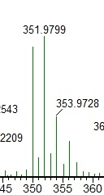
Figure 1S. Experimental isotopic pattern of CPS.

Figure 2S. Fragmentation pattern for CPS obtained in the GC-MS analysis.

Figure 3S. Fragmentation pattern for CPO obtained in the GC-MS analysis.

Table 1S. Results obtained in the UPLC-DAD analysis of CPS in apples (blank or treated). Mesoderm and skin samples were considered. The first column reports the concentrations of EC or EW formulations, if used, for apples spraying.
Samples | C_{(CPS)} in mesoderm [mg/kg] | C_{(CPS)} in apple skin [mg/kg]
Blank apple | ≤0.03 | ≤0.03
treated with 0.1 - EW | ≤0.03 | ≤0.03
treated with 0.5 - EW | ≤0.03 | 0.43±0.03
treated with 5.0 - EW | ≤0.03 | 4.59±0.34
treated with 0.1 - EC | ≤0.03 | ≤0.03
treated with 0.5 - EC | ≤0.03 | 0.40±0.03
treated with 5.0 - EC | ≤0.03 | 4.52±0.32
domestic apple 1 | ≤0.03 | ≤0.03
domestic apple 2 | ≤0.03 | ≤0.03
domestic apple 3 | ≤0.03 | ≤0.03

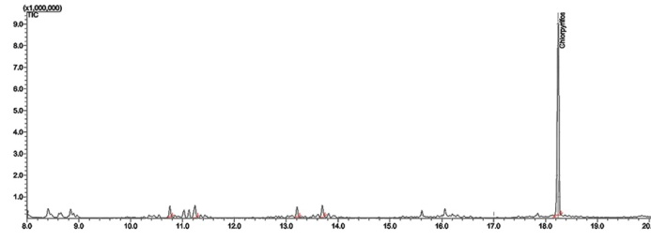  a | 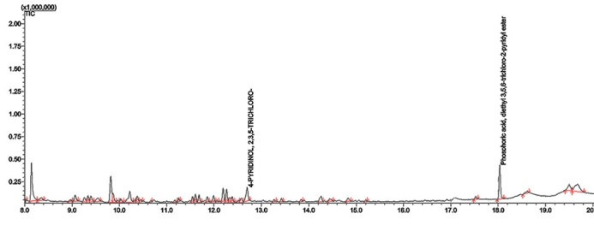  b
Figure 4S. a) TIC of 5 mg/L EC formulation (GC-MS analysis). b) TIC of 5 mg/L EC formulation, gamma irradiated (GC-MS analysis).

