Clodoaldo Valverde

Universidade Estadual de Goiás
Campus de Ciências Exatas e Tecnológicas - Endereço: Br 153 nº 3.105 - Fazenda Barreiro do Meio - Anápolis - Goiás - Brasil. Caixa Postal: 459. CEP: 75.132-903.
05/04/2018
Dear Editor,

We wish to submit a new manuscript entitled " Theoretical Study on the Electronic Structure and Third-Order Nonlinear Optical Properties of a Carboxylic Acid Derivative" for consideration by Acta Chimica Slovenica.

We confirm that this work is original and has not been published elsewhere nor is it currently under consideration for publication elsewhere.
In this paper, we report on nonlinear electrical properties of the Carboxylic Acid derivative. The properties concern mainly the linear polarizability, the second hyperpolarizability, and third-order electric susceptibility. The objective in the investigation is whether this crystal exhibits such properties with significant values, allowing applications as NLO devices. As results we found some electrical properties (e.g., linear polarizability and third-order electric susceptibility) showing significant values.
The results are significant because these organic crystals may offer the possibility of NLO applications, e.g., as good candidates for photonic devices, such as optical switches, modulators, pyrazoline derivatives and also optical energy applications. The paper should be of interest to readers in the areas of chemistry and physics, for researchers involved with nonlinear properties of organic crystals and their applications.

Please address all correspondence concerning this manuscript to me at valverde@ueg.br.

Thank you for your consideration of this manuscript.
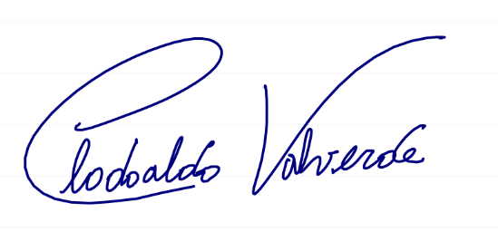
Sincerely,

Clodoaldo Valverde

