Short communication

Carboxypeptidase activity of cathepsin X is not controlled by endogenous inhibitors

Urša Pečar Fonović^{1*}, Milica Perišić Nanut², Nace Zidar¹, Brigita Lenarčič³, Janko Kos^{1,2}

¹ Faculty of Pharmacy, University of Ljubljana, Aškerčeva 7, 1000 Ljubljana, Slovenia
² Department of Biotechnology, Jožef Stefan Institute, Jamova 39, 1000 Ljubljana, Slovenia
³ Faculty of Chemistry and Chemical Technology, University of Ljubljana, Večna pot 113, 1000 Ljubljana, Slovenia

*Corresponding author: Tel.: +386 1 4769 500; Fax: +386 1 4258 031;
E-mail: ursa.pecarfonovic@ffa.uni-lj.si

Abstract
Cysteine cathepsins are a group of peptidases with housekeeping function on one side and different specific roles in various tissues on the other. Endogenous peptidase inhibitors, such as cystatins and thyropins represent ultimate way of controlling their activity. It appears that cathepsin X, a monocarboxypeptidase, whose overexpression is associated with several pathological processes, is not under the control of endogenous inhibitors. The inhibitors belonging to different groups revealed the relevant inhibition of other cathepsins tested, but none of them decreased carboxypeptidase activity of cathepsin X. The escape from the inhibitor control is another feature that makes cathepsin X distinct from other members of cysteine peptidases.

Keywords: cathepsin X, inhibitor, cystatin, stefin, thyropin

1. Introduction
Lysosomal cysteine cathepsins are expressed as inactive precursors. When they are activated, their activity is controlled by endogenous inhibitors.¹ These inhibitors are divided into superfamilies of cystatins (which includes stefins, cystatins, kininogens and non-inhibitory fetuins) and thyropins.² Physiologically, endogenous inhibitors can act as emergency inhibitors that usually act on peptidases released from cells or lysosomes or from infecting microorganisms or as regulatory inhibitors modulating peptidase activity. Regulatory inhibitors are further divided into 1) the threshold inhibitors that act when there is accidental activation of peptidase, 2) buffer type inhibitors that keep peptidases inactive when there is no substrate present or 3) delay type inhibitors that bind to the active enzyme slowly allowing its action for certain amount of time.²
Cathepsin X is a carboxypeptidase expressed predominantly in immune and neuronal cells.³ It regulates cell migration, adhesion, proliferation, and maturation, together with phagocytosis and signal transduction.⁴ Its overexpression, increased activation or mislocalization may trigger pathological processes, such as cancer,⁵⁻⁹ neurodegenerative disorders¹⁰ or inflammatory diseases.¹¹
Studies describing the inhibitory action of endogenous peptidase inhibitors towards cathepsin X are rare and contradictive. Whereas some of them did not demonstrate inhibition of cathepsin X by cystatins C and F¹²⁻¹⁵ other reported its potent inhibition by cystatin C¹⁶ as well as by stefins A and B and by chicken cystatin, but not by L-kininogen.
The aim of this study was to evaluate the inhibitory effect of a broader assortment of endogenous protease inhibitors from cystatin and thyropin families on cathepsin X, in comparison to related cathepsins B and L. In the assay a recombinant cathepsin X, void of the contamination with other cathepsins, and its specific substrate Abz-FEK(Dnp)OH were used.

2. Experimental
Activity assays were performed with recombinant cathepsins X (prepared in P.pastoris),¹⁷ B and L ( both prepared in E.coli).^{18,19} Assay buffers were 100 mM sodium acetate buffer, pH 5.5 (for cathepsins X and L), 60 mM acetate buffer pH 5.0 (for cathepsin B exopeptidase activity) and 100 mM phosphate buffer pH 6.0 (for cathepsin B endopeptidase activity). All assay buffers contained 5 mM cysteine, 1.5 mM EDTA and 0.1% PEG 8000. Enzymes were activated at 37 °C for 5 min before the assay. Cystatin F was incubated for 15 min at 37 °C in the appropriate assay buffer containing 100 mM cysteine. Substrates Abz-FEK(Dnp)-OH,²⁰ Z-FR-AMC, Abz-GIVRAK(Dnp)-OH²¹ and Z-RR-AMC were used for the determination of cathepsins X, L and B exo- and endo- peptidase activities, respectively. Cystatin F (wild type and truncated form Δ15N) was expressed in FreeStyle 293F cells,²² chicken cystatin was isolated from chicken egg white,²³ recombinant cystatin C and stefins A and B were expressed in E. coli,^{24,25} thyropins were from B. Lenarčič lab.
90 μL of the activated enzyme (20 nM cathepsin X or 0.5 nM cathepsin L or 0.6 nM/5.5 nM cathepsin B for its exo/endopeptidase activity) was incubated for 30 min with 5 μL of the inhibitor (100-fold molar excess over the enzyme) at 37 °C and then added to a black 96-well plate with 5 μL of substrate. The reaction was monitored continuously at 420 nm ± 10 nm with excitation at 320 nm ± 20 nm for Abz substrates and at 460 nm ± 10 nm with excitation at 380 nm ± 20 nm for AMC substrates, at 37 °C.

3. Results and discussion
A set of various peptidase inhibitors was tested in a standard kinetic assay to determine inhibition of cathepsin X. Previous data on their inhibitory activities towards cathepsin X are ambiguous, probably due to the use of a native cathepsin X, isolated from human liver, that was later shown to be contaminated with cathepsin B¹² or recombinant cathepsin X contaminated with cathepsin L which is needed for the activation of procathepsin X.²⁶ Also, the substrates used were not specific, such as FR-AMC, which is degraded also by other cathepsins. As most of cystatins used in these studies (cystatin C, chicken cystatin, stefins A and B)¹⁶ potently inhibit cathepsins L and B, their inhibitory effect on cathepsin X could be only apparent and the major part of the decrease in substrate degradation could result from lower cathepsins B and L activity.
In our study we used recombinant cathepsin X, with the content of cathepsin L below the detection limit of western blot and ELISA assays¹⁷ and cathepsin X specific substrate Abz-FEK(Dnp)-OH.²⁶ Figure 1 shows that tested inhibitors (in 100-fold molar excess) did not significantly inhibit cathepsin X. Irreversible inhibitor of cysteine peptidases E-64 was used as a control.
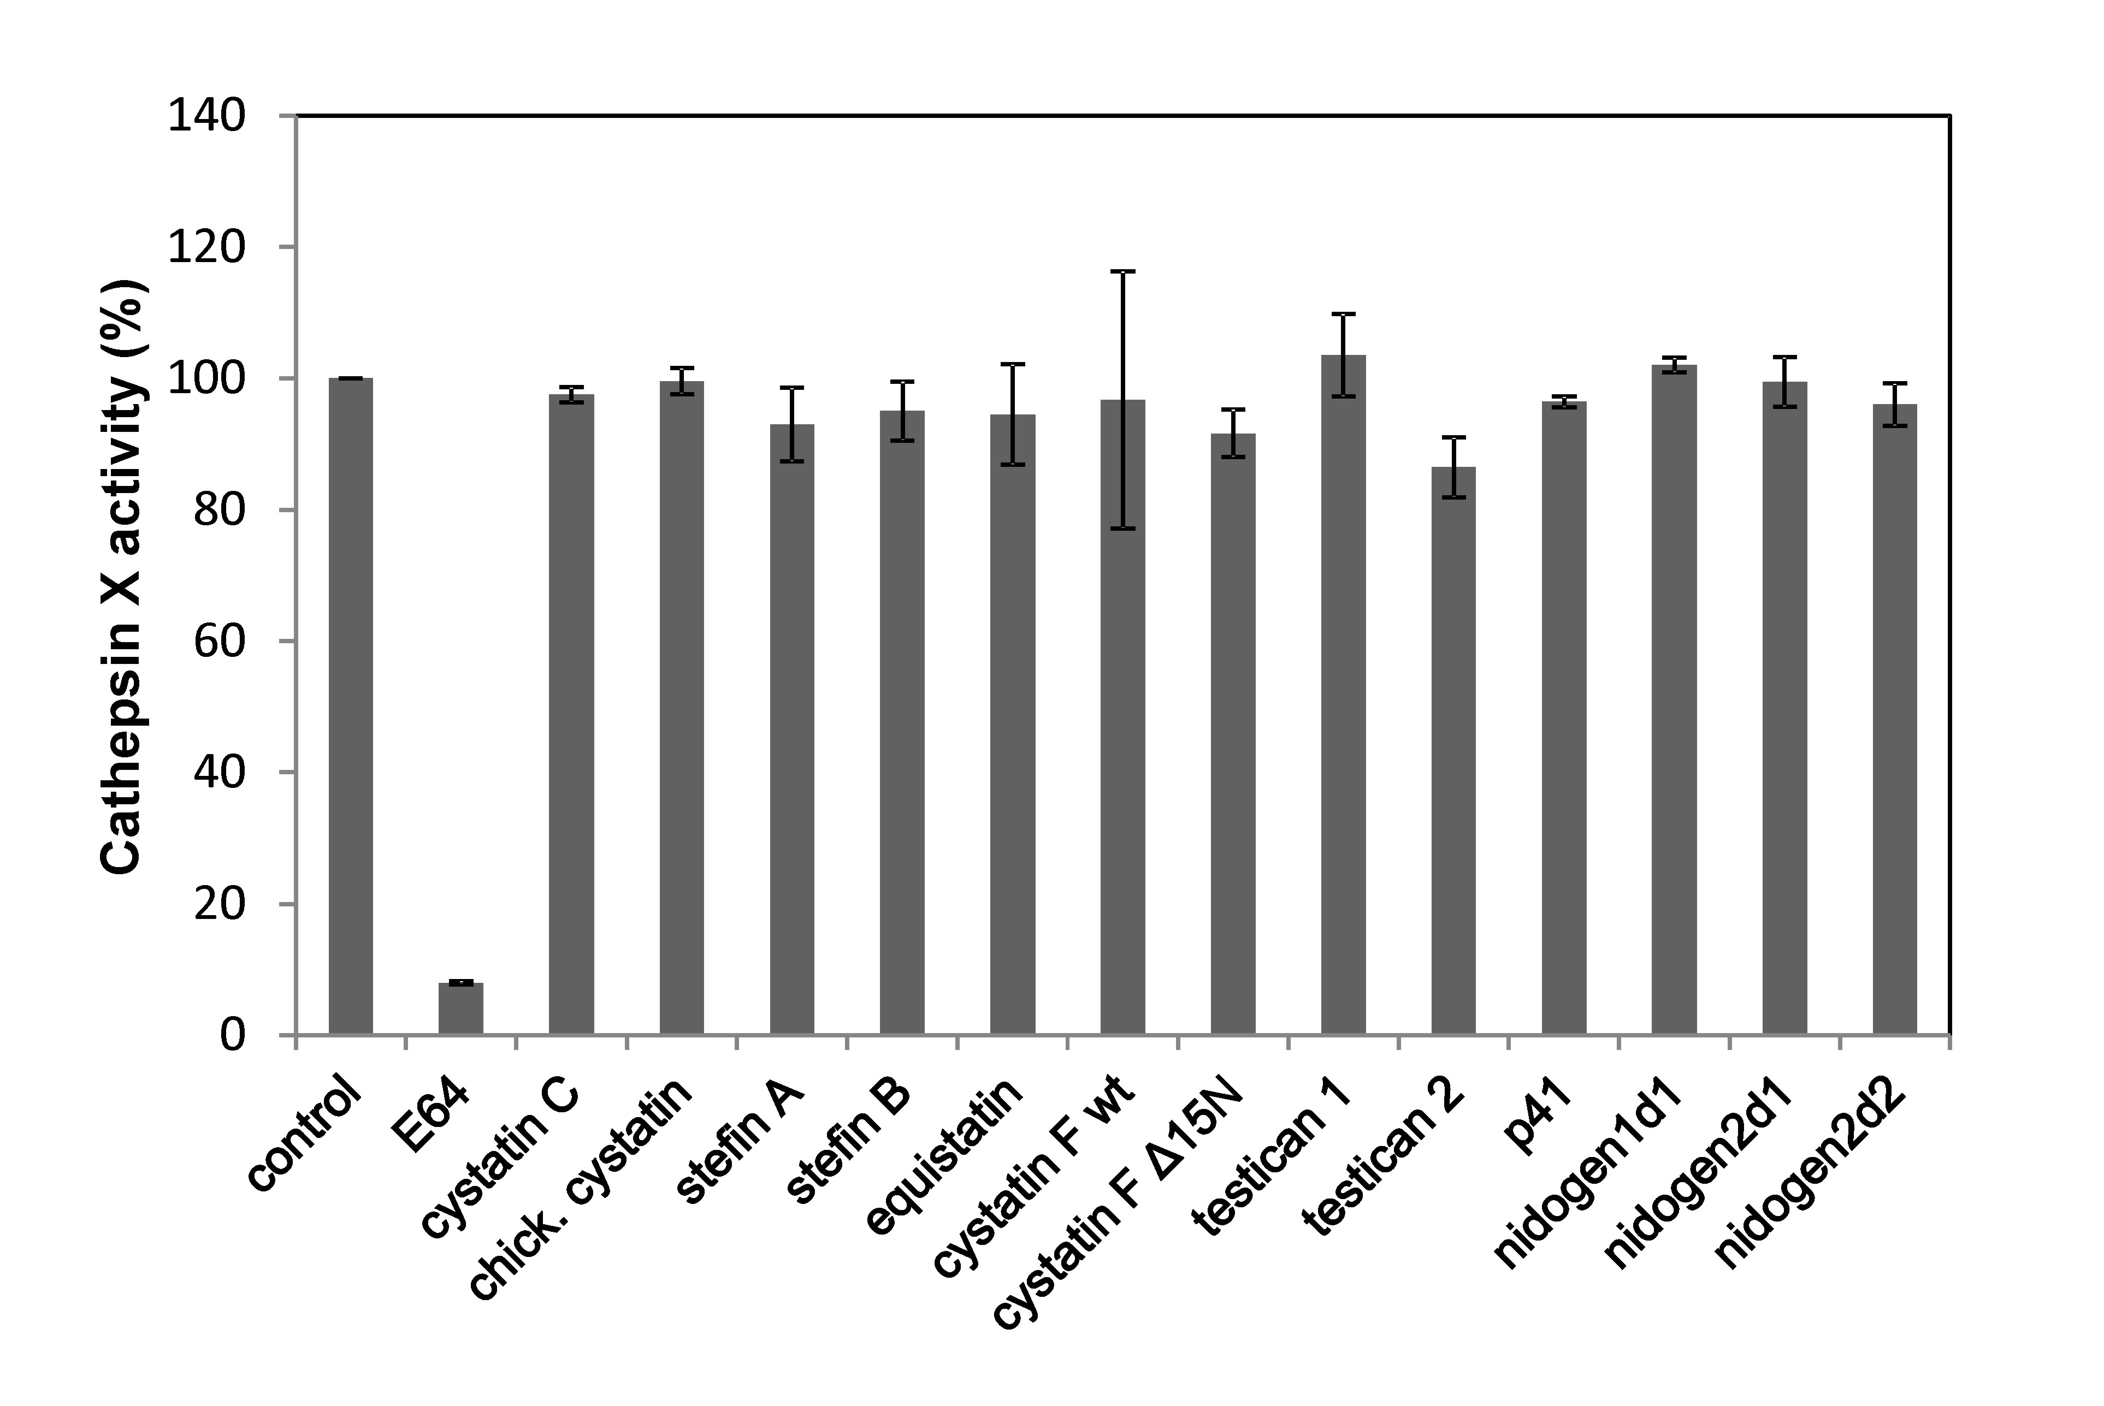
Figure 1: Cathepsin X is not inhibited with endogenous peptidase inhibitors.
Relative inhibition of cathepsin X with various inhibitors was tested in a kinetic assay. Concentrations of endogenous inhibitors were 2 µM (100-fold higher than the enzyme's), while E-64 was tested at 10 µM concentration. Assay buffer was used in a control experiment. Values are the means of two or three independent experiments performed in duplicate ± SEM.

Inhibitors from the cystatin and thyropin families were included in the study, namely cystatins C, F (wild type and N-terminally truncated form¹⁵), chicken cystatin, stefins A and B, p41, equistatin, testicans 1 and 2 and thyroglobulin domains of nidogens 1 and 2 (domain 1 from nidogen 1 and domains 1 and 2 from nidogen 2). Our results revealed the lack of inhibition even at high inhibitor to enzyme ratio and are in line with studies on cystatins C and F.¹²⁻¹⁵ Inhibitory activity of thyropins has not been probed for cathepsin X yet. Like cistatins, they also showed no inhibition of cathepsin X.
The same set of inhibitors was tested on endo- and exopeptidase (carboxypeptidase) activity of cathepsin B (Figure 2). Cystatin C, stefin A and equistatin potently inhibit both, endopeptidase and exopeptidase activities of cathepsin B, whereas stefin B, cystatin F and testican 1 are better inhibitors of endopeptidase activity. We also tested inhibitory activities toward cathepsin L (Figure 2). As already reported cathepsin L was inhibited with majority of inhibitors except testican 2 and nidogen 2.^{27,28} Nidogen 1 also was not very effective in inhibiting cathepsin L.
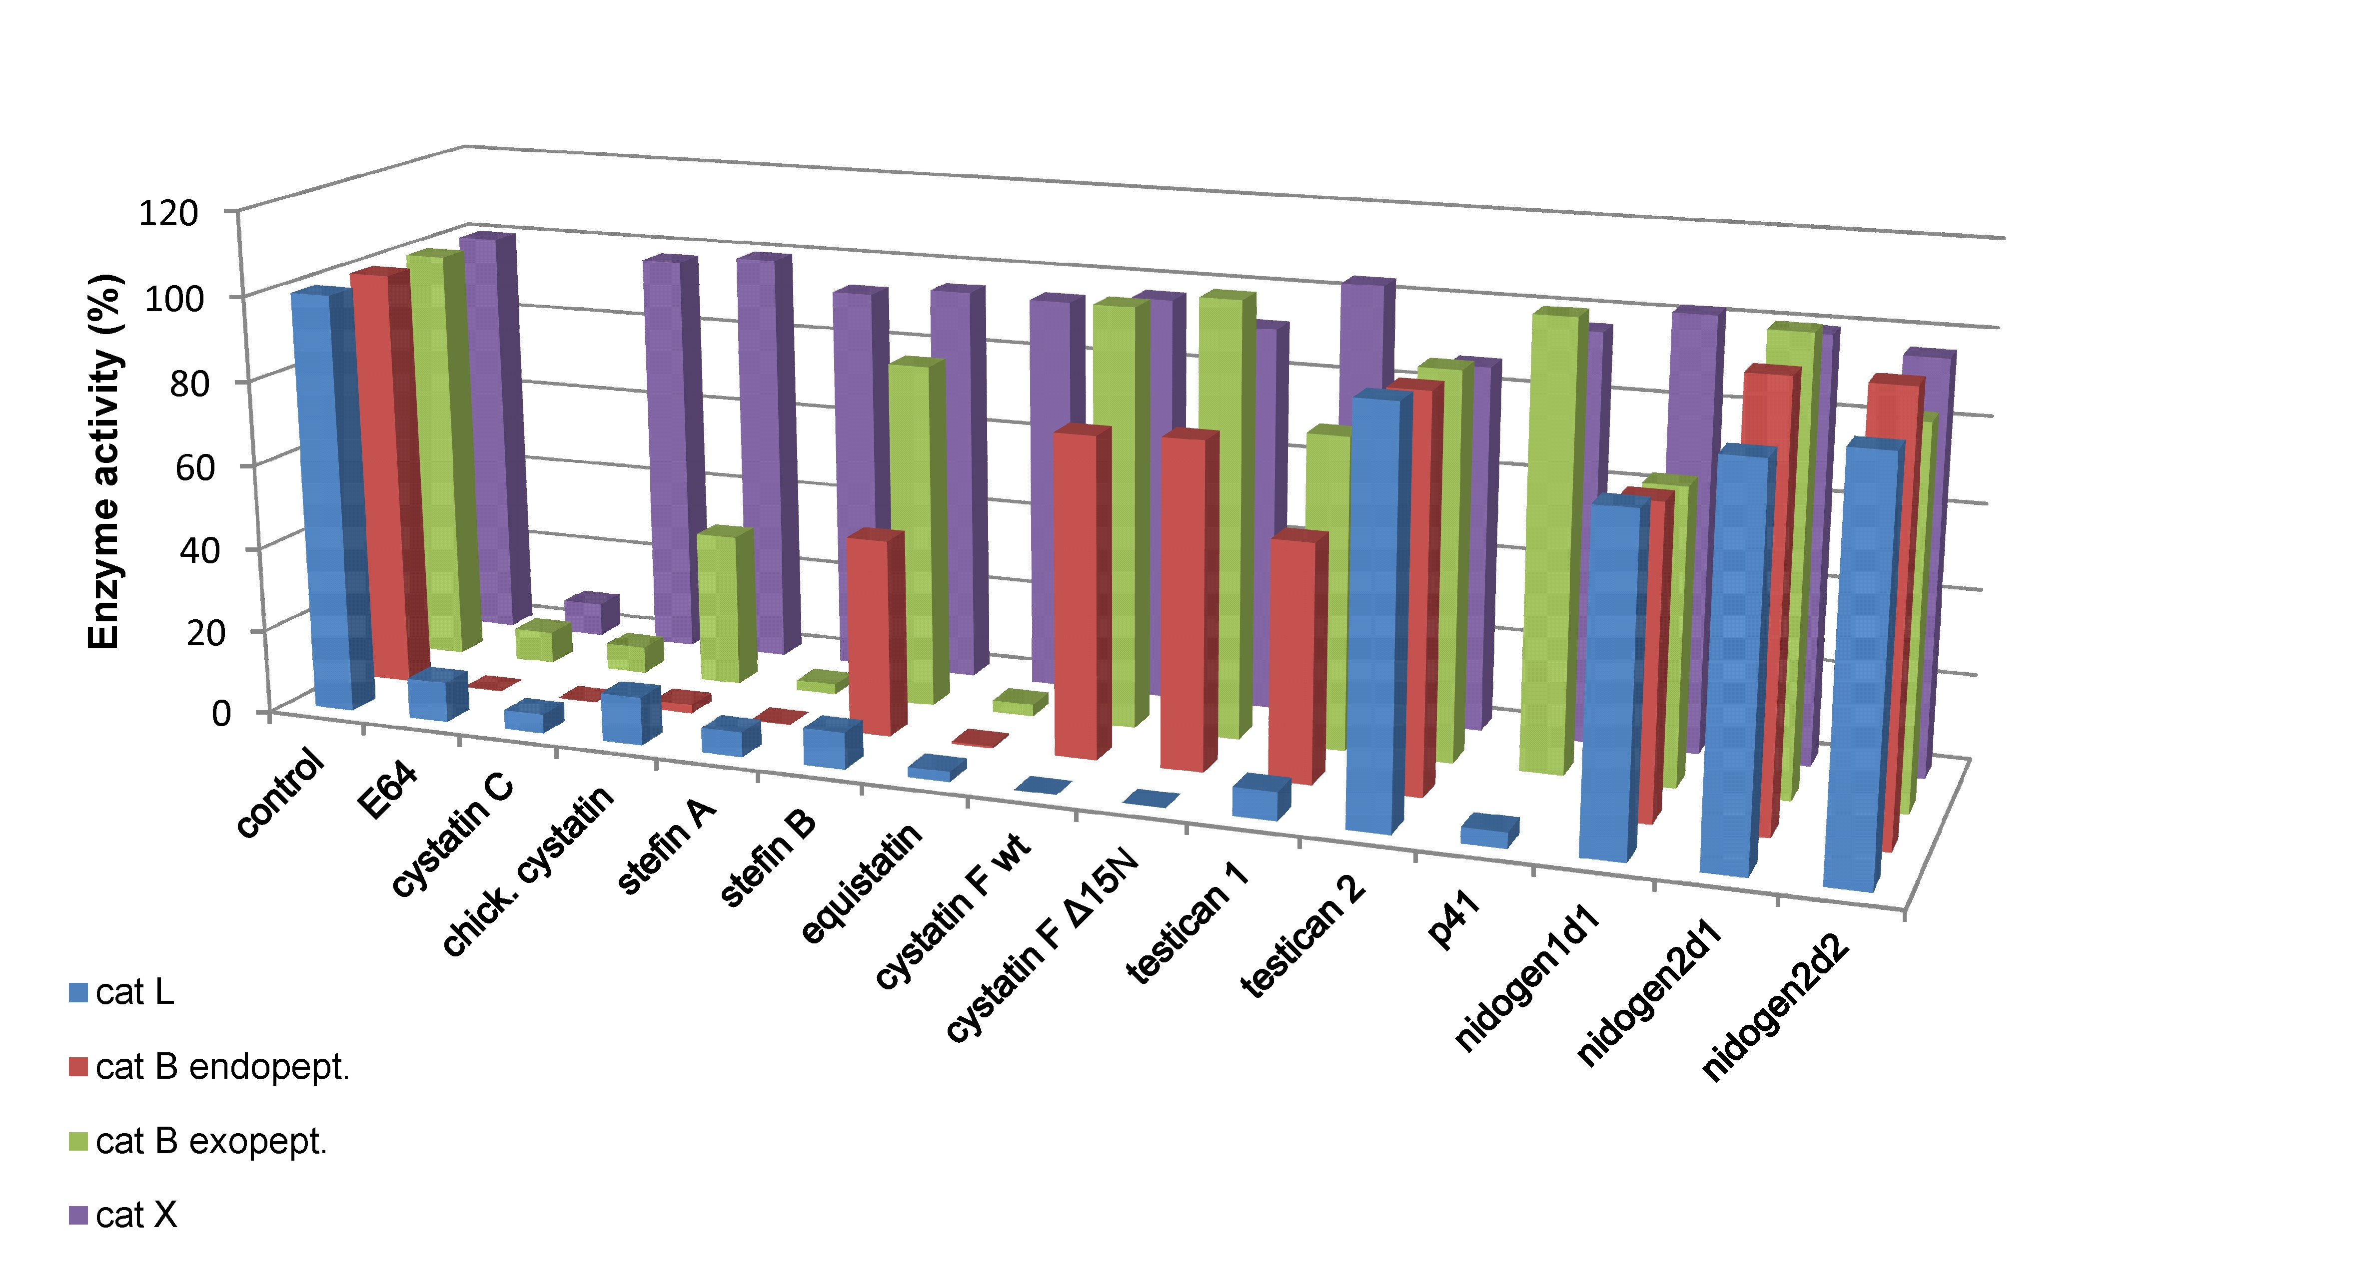
Figure 2: Comparison of endogenous inhibitors activities toward cathepsins X, B (exo- and endopeptidase activity) and L.
Relative inhibition of cysteine cathepsins with various inhibitors was tested in a kinetic assay (p41 was not tested on cathepsin B endopeptidase activity). Concentrations of inhibitors were 100-fold higher than the enzyme's, E-64 used as a positive control was tested at 10 µM concentration. Assay buffers were used in control experiments. Values are the means of two or three independent experiments performed in duplicate.

4. Conclusions
Our results show that endogenous inhibitors of cysteine peptidases do not inhibit cathepsin X. This indicates that cathepsin X carboxypeptidase activity escapes this ultimate control, however, the possible physiological and pathological consequences of this observation have not yet been addressed. The inhibition of other cathepsins, tested with the same set of inhibitors in parallel to cathepsin X, demonstrate a great difference in their potency, which is opposite to general opinion that cystatins and thyropins act in a broad, nonspecific fashion.

5. Acknowledgement
This work was supported by the Slovenian Research Agency grant P4-0127 (JK).

6. References
1 B. Turk, D. Turk, V. Turk. EMBO J 2012, 31, 1630-1643.
2 B. Turk, D. Turk, G. S. Salvesen, Curr Pharm Des 2002, 8, 1623-1637.
3 J. Kos, A. Sekirnik, A. Premzl, V. Zavašnik Bergant, T. Langerholc, B. Turk, B. Werle, R. Golouh, U. Repnik, M. Jeras, V. Turk, Exp Cell Res 2005, 306, 103-113.
4 J. Kos, Z. Jevnikar, N. Obermajer, Cell Adh Migr 2009, 3, 164-166.
5 G. Rumpler, B. Becker, C. Hafner, M. McClelland, W. Stolz, M. Landthaler, R. Schmitt, A. Bosserhoff, T. Vogt, Exp Dermatol 2003, 12, 761-771.
6 D. K. Nägler, S Kruger, A. Kellner, E. Ziomek, R. Menard, P. Buhtz, M. Krams, A. Roessner, U. Kellner, Prostate 2004, 60, 109-119.
7 S. Krueger, T. Kalinski, T. Hundertmark, T. Wex, D. Kuster, U. Peitz, M. Ebert, D.K. Nagler, U. Kellner, P. Melfertheiner, M. Naumann, C. Rocken, A. Roesnner, J Pathol 2005, 207, 32-42.
8 J. Wang, L. Chen, Y. Li, X. Y. Guan, PLoS One 2011, 6, e24967.
9 T. Vižin, I. J. Christensen, M. Wilhelmsen, H. J. Nielsen, J. Kos, BMC Cancer 2014, 14, 259.
10 A. Pišlar, J. Kos, Mol Neurobiol 2014, 49, 1017-1030.
11 D. K. Nägler, A. M. Lechner, A. Oettl, K. Kozaczynska, H. P. Scheuber, C. Gippner-Steppert, V. Bogner, P. Biberthaler, M. Jochum, J Immunol Methods 2006, 308, 241-250.
12 C. Therrien, P. Lachance, T. Sulea, E. O. Purisima, H. Qi, E.Ziomek, A. Alvarez-Hernandez, W. R: Roush, R. Menard, Biochemistry , 2001, 40, 2702-2711.
13 D. K. Nägler, R. Zhang, W. Tam, T. Sulea, E. O. Purisima, R. Ménard, Biochemistry 1999, 38, 12648-12654 (1999).
14 T. Langerholc, V. Zavasnik-Bergant, B. Turk, V. Turk, M. Abrahamson, J. Kos, FEBS J 2005, 272, 1535-1545.
15 S. Magister, N. Obermajer, B. Mirković, U. Svajger, M. Renko, A. Softić, R. Romih, J. D. Colbert, C. Watts, J. Kos, Eur J Cell Biol 2012, 91, 391-401.
16 I. Klemencic, A. K. Carmona, M. H. Cezari, M. A. Juliano, L. Juliano, G. Guncar, D. Turk, I. Krizaj, V. Turk, B. Turk, Eur J Biochem 2000, 267, 5404-5412.
17 U. Pečar Fonović, J. Kos, Acta Chim. Slov. 2009, 56, 985-988.
18 R. Kuhelj, M. Dolinar, J. Pungercar, V. Turk, Eur J Biochem 1995, 229, 533-539.
19 M. Dolinar, D. B. Maganja, V. Turk, Biol Chem Hoppe Seyler 1995, 376, 385-388.
20 A. M. Sadaghiani, S. H. Verhelst, V. Gocheva, K. Hill, E. Majerova, S. Stinson, J. A. Joyce, M. Bogyo, Chem Biol 2007, 14, 499-511.
21 S. S. Cotrin, L. Puzer, W. A. de Souza Judice, L. Juliano, A.K. Carmona, M. A. Juliano. Anal Biochem 2004, 335, 244-252.
22 M. Perišić Nanut, J. Sabotič, U. Švajger, A. Jewett, J. Kos, Front Immunol 2017, 8, 1459.
23 W. Bode, R. Engh, D. Musil, U. Thiele, R. Huber, A. Karshikov, J. Brzin, J. Kos, V. Turk, EMBO J 1988, 7, 2593-2599.
24 N. Cimerman, Preparation of some recombinant human cystatin C
mutants and their characterisation, Ph.D. thesis, University of Ljubljana, Slovenia, 1993.
25 R. Jerala, E. Zerovnik, K. Lohner, V. Turk, Protein Eng 1988, 7, 977-984.
26 L. Puzer, S. S. Cotrin, M. H. Cezari, I. Y. Hirata, M. A. Juliano, I. Stefe, D. Turk, B. Turk, L. Juliano, A. K. Carmona, Biol Chem 2005, 386, 1191-1195.
27 A. Leonardi, B. Turk, V. Turk, Biol Chem Hoppe Seyler. 1996, 377, 319-21.
28 P. Meh, M. Pavsic, V. Turk, A. Baici, B. Lenarcic, Biol Chem 2005 386, 75-83.

