Room-temperature synthesis and optical properties of NdVO₄ nanoneedles
Mirela Dragomir^{1,§*} and Matjaž Valant^{1,2}
¹Materials Research Laboratory, University of Nova Gorica, Slovenia
²University of Electronic Sciences and Technology of China, Institute of Fundamental and Frontier Science, North Jianshe Road No. 4 Section 2, Chengdu, China
*Corresponding Author: Mirela Dragomir
E-mail address: mirela85.dragomir@gmail.com

§Present address: Electronic Ceramics Department, Jozef Stefan Institute, Jamova cesta 39, 1000 Ljubljana, Slovenia
Abstract
Tetragonal NdVO₄ nanoneedles were prepared via a simple room-temperature coprecipitation method in the absence of any surfactant or template, starting from simple inorganic salts, NdCl₃ and Na₃VO₄, as raw materials. The nanoneedles were characterized by XRPD, SEM, Raman, PL, and lifetime spectroscopy. The particles have a length of about 100 nm and a diameter of 20 nm and grow along <112> direction. The advantages of this method lie in the high yield, non-toxic solvents, mild reaction conditions, and it can potentially be employed for the preparation of other 1D lanthanide vanadates.
Keywords: nanostructures, chemical synthesis, optical properties, Raman spectroscopy, X-ray diffraction.
- Introduction
The interesting optical properties of lanthanides such as luminescence, up-conversion, wide optical transparency, or large birefringence originate primarily from the multitude of transitions within the 4f^{n} electronic states of the lanthanide ion. Thus, lanthanide-containing materials find applications as laser host matrices, optical polarizers, thermophosphors, sensors, solar cells, scintillators for γ-rays detection, in nuclear waste storage, ionic conductors, catalysis or photocatalysis.,,, The efficiency of the 4f^{n} excitations in a lanthanide ion can be enhanced through a charge transfer from a host material with a higher absorption coefficient. The vanadate group, ${VO}_{4}^{3-}$, is a good host for the trivalent ion because it can excite most of the lanthanide ions via the charge transfer transition within the ${VO}_{4}^{3-}$ group, followed by an energy transfer to the emissive lanthanide ion. Choosing a crystal site with a very low symmetry for the lanthanide ion further increases the rate of absorption and emission, which can result in higher quantum yields.
In a tetragonal ABO₄ structure type, the A-site ion has a D_{4h} symmetry. Thus, a lanthanide ion sitting on this crystal site has a low symmetry which favours the electric dipole transitions resulting in higher radiative rate constants and less quenching processes. Neodymium vanadate, NdVO₄, is one of the most studied orthovanadate from the lanthanide orthovanadate family with the ABO₄-type structure. Numerous investigations have been made on optical materials based on NdVO₄ due to their good optical properties.^{3,,} For example, Y-doped NdVO₄ is a well-known laser material with five times higher absorption coefficient at 808 nm (the standard wavelength of the currently available laser diodes) than the Nd:YAG laser diode.⁵ The catalytic properties of NdVO₄ have also been investigated, i.e. for oxidative dehydrogenation of propane.² Additionally, it has been found that NdVO₄ exhibits a photocatalytic activity for degradation of dyes and organic pollutants comparable or even higher than that of the commercial TiO₂., Another study indicated that Mo-doping increased the photocatalytic activity of NdVO₄ for the degradation of different dyes (e.g., methylene blue, rhodamine B, remazol brilliant blue).⁴
At ambient conditions, NdVO₄ adopts a zircon-type structure (ZrSiO₄) with the I4₁/amd (Z = 4) space group, with the lanthanide ion located in a polyhedron and coordinated with eight oxygen ions. Under an applied pressure of about 6 GPa, the zircon-type NdVO₄ undergoes a phase transformation to a metastable monazite-type structure with the space group P2₁/n (Z = 4) where the Nd atoms are located in a nine-coordinate site (with nine unique Nd–O bond distances)., At around 11.4 GPa, NdVO₄ further transforms to a scheelite-type phase and so to a denser packing. All these phase transformations are accompanied by a decrease of 0.5 eV in the band gap (measured on a single crystal).⁹
Nanocrystalline materials exhibit properties that are usually not observed in the corresponding bulk materials due to large specific surface areas and quantum size effects. Accordingly, the lanthanide orthovanadates in the form of nanocrystals show properties that make them potential multiphoton fluorescent materials, biochemical labels solar cells, light emitting diodes (LEDs), oxidant sensors and contrast agents in magnetic resonance imaging.,,,, Therefore, the design and synthesis of the nanosized NdVO₄ opens up many opportunities for applications. Several methods have been developed for the synthesis of 0D, 1D or 2D NdVO₄ nanostructures such as: microwave synthesis, co-precipitation followed by thermal treatment, hydrothermal, metathesis reactions, or sonochemical synthesis.^{7,,,,,} Each of these methods has certain drawbacks − the requirement of either thermal treatment at high temperatures, long reaction time (up to several days), expensive equipment or use of toxic solvents.
A new and simple method to obtain crystalline NdVO₄ nanoparticles at room temperature through a coprecipitation method, using cheap and non-toxic solvents, is reported in this study. In addition of being a very convenient and fast method, this route also saves energy because it does not involve any thermal treatment.
- Experimental Part
2.1. Synthesis
The coprecipitation procedure for the synthesis of NdVO₄ nanoparticles employed in this study is summarized in the scheme below.
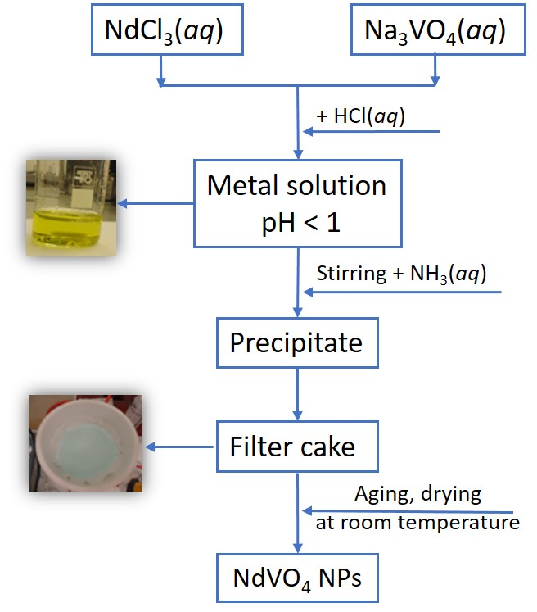
Fig. 1. A schematic representation of the synthetic procedure to obtain NdVO₄ nanoneedles.
In this method, NdCl₃·6 H₂O (99.9%, Alfa Aesar) and Na₃VO₄ (99.9%, Alfa Aesar), were used as precursors and NH₃(aq) (25 %) was the precipitating agent. Firstly, a NdCl₃ aqueous solution was prepared by adding 0.05 mol NdCl₃·6 H₂O in 2 mL distilled H₂O, while a Na₃VO₄ solution was prepared by adding 0.05 mol Na₃VO₄ in 3 mL distilled H₂O. The pH of the final solution was adjusted to < 1 with few mL of HCl(aq) (32%). Secondly, the two solutions were mixed slowly until a yellow solution resulted. NH₃(aq) (25%) was then added fast and under vigorous stirring to the above sol until the pH reached the value of ∼11. A blueish-green precipitate formed. Then the obtained mixture was stirred for five more minutes before the precipitate was filtered, washed thoroughly with NH₃(aq) and then dried at room temperature overnight. The reactions that lead to the formation of NdVO₄ can be summarized as follows:
NdCl₃(aq) + Na₃VO₄(aq) $\underset{→}{+NH_{3}\left(aq\right)}$NdVO₄(s) + 3NaCl(aq) (1)
  - Characterisation
The phase composition was analysed by X-ray powder diffraction (XRPD) using a PANalytical X'Pert PRO diffractometer with Cu Kα₁ radiation (λ = 1.54056 Å). The X-ray powder diffraction pattern was collected over the 2θ range 5–80° with a step size of 0.017°. A structure refinement was conducted using Topas (version 6, Bruker, AXS, Karlsruhe, Germany). A Fundamental Parameters Approach was used for the profile fitting. A profile refinement was conducted in which the background (6th order Chebychev polynomial), the unit cell parameters, the scale factor, the crystallite size, the sample displacement, and preferred orientation were stepwise refined to obtain a calculated diffraction profile that best fit the experimental pattern. All the occupancies were fixed at nominal composition and kept constant during refinement. Finally, the quality of the fit was assessed from the fit parameters such as R_{wp}, R_{p}, R_{exp}, R_{B}, and G.O.F.
The morphology of the NdVO₄ nanopowders was examined with a Scanning Electron Microscope (SEM) model JEOL JSM 7100F, operating at an accelerating voltage of 10 kV (in secondary electron mode). The samples were first dispersed in ethanol, then few drops of this dispersion were added onto a Si wafer and air dried. The Si wafer was fixed on the SEM sample holder using carbon tape.
Raman spectroscopy was used for identification and structural characterisation of the NdVO₄ nanoparticles. Room temperature Raman spectra were collected in a 180° backscattering geometry, with a microprobe Raman system type Horiba Jobin-Yvon Lab RAM HR spectrometer equipped with a holographic notch filter and a CCD detector, using a 632.81 nm excitation line of a 25 mW He-Ne laser. The samples were placed and oriented on an Olympus BX 40 microscope equipped with 50× objective and the spectra were recorded in the 50–1000 cm⁻¹ range with a special resolution of 1 μm. To test the phase purity, the spectra were recorded on different parts of the sample.
Diffuse reflectance spectroscopy (DRS) measurements were performed to obtain the band gap energies. The DRS spectra were recorded in the 250−800 nm range, with a UV-Vis spectrophotometer (Perkin Elmer, model λ 650S) equipped with a 150 mm integrated sphere and using Spectralon as a reference material. The DRS data were converted to absorbance coefficients according to Kubelka-Munk method where NdVO₄ was considered a direct band gap semiconductor. The details of the determination of band gap energies by using the Kubelka-Munk theory are described elsewhere. The photoluminescence (PL) emission spectra were collected with an Edinburgh Instruments Spectrometer (model FLS920) using a steady state 450 W Xenon arc lamp. The experimental setup was equipped with a blue-sensitive high speed photomultiplier (Hamamatsu H5773-03 detector) tube. The emission spectra were collected at room temperature, in a 400–700 nm range, using an excitation wavelength of 371 nm (λ_{em} = 524 nm).
Information on the electron relaxation and recombination mechanisms were be obtained by monitoring the PL intensity at a specific wavelength as a function of time delay after an exciting laser pulse. The time-resolved PL spectra were recorded at room temperature on a pico-second diode laser EPL 375 with an excitation wavelength of 371 nm, in the time range 0 to 50 ns. The analysis of the fluorescence decays was performed using the F900 analysis software. The measured (convoluted) data was fitted using the “Reconvolution Fit method”.. This method fits the sample response to the data over the rising edge, to match the theoretical sample response, R(t). The Reconvolution Fit procedure extracts the raw data (fluorescence decay) and eliminates both the noise and the effects of the exciting light pulse.
- Results and Discussion
3.1. X-ray and FESEM studies
Fig. 2 shows the XRPD patterns of the as-obtained NdVO₄ sample, which was indexed as a tetragonal NdVO₄ phase with the space group I4₁/amd (ICSD code 78077). No impurities were detected. Additionally, the Rietveld refinement indicated that the (112) reflection appears with higher intensity due to the preferred directional growth of the nanoneedles along <112>. The unit cell parameters obtained after the Rietveld refinement are presented in Table 1. The agreement factors were: R_{p} = 6.59, R_{wp} = 7.78, and G.O.F = 1.26. As it can be seen, the refined cell parameters are in good agreement with the literature reported values.
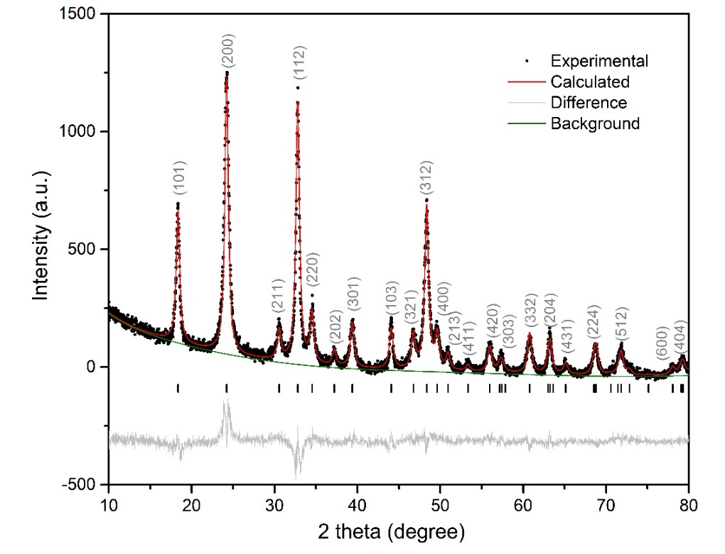
Fig. 2. X-ray powder diffraction pattern of the NdVO₄ nanopowder. The black full circles represent raw data and, red solid line is the Rietveld fit, the black vertical bars are the Bragg reflections, while the grey line shown below is the difference between observed and calculated intensity.
Table 1 The unit cell parameters obtained after Rietveld refinement of the NdVO₄ nanoneedles and a comparison with the literature reported values.
Unit cell parameters  Space group: I4₁/amd | This study  (nanoneedles) | Yuvaraj et al.  (27 nm particles) | Fuess et al.  (polycrystalline) | Panchal^{10,} Erradonea  (polycrystalline)
a (Å) | 7.3397(6) | 7.3571 | 7.3290 | 7.334(1)
b (Å) | 7.3397(6) | 7.3571 | 7.3290 | 7.334(1)
c (Å) | 6.4128(6) | 6.4227 | 6.4356 | 6.436(1)
c/a | 0.8737(6) | 0.8729 | 0.7878 | 0.8776(1)
V (Å) | 346.332(65) | 347.641 | 345.683 | 346.177
Fig. 3. SEM images of the NdVO₄ nanopowders. (a) Low magnification, (b) High magnification.
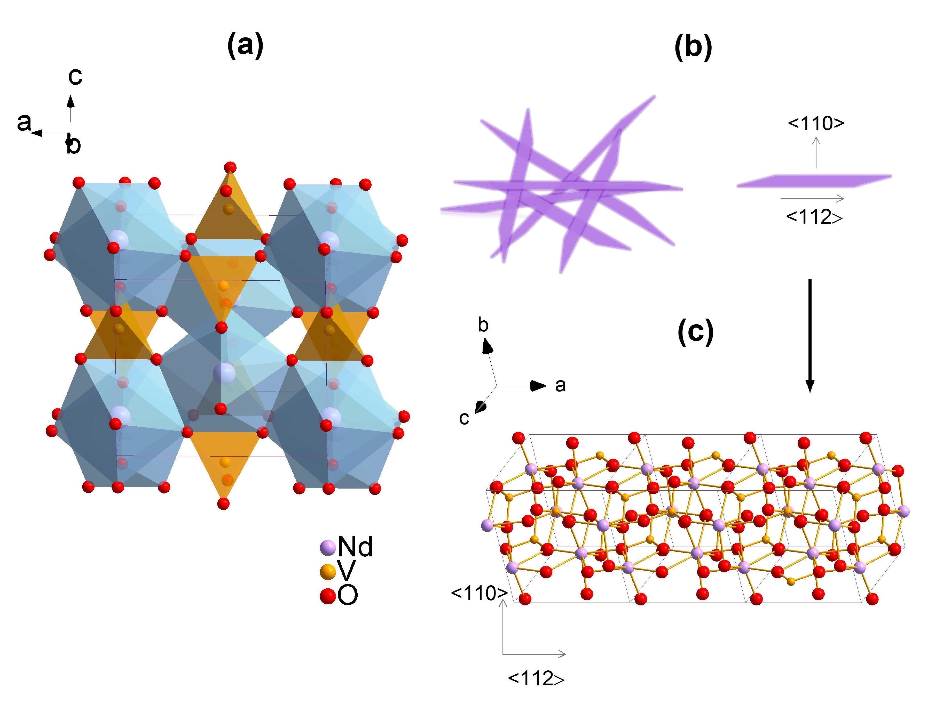
Fig. 4. (a) Crystal structure of NdVO4; (b) Schematic representation of the as-grown NdVO₄ nanoneedles; (c) Ball-and-stick model showing a tetragonal NdVO₄ nanowire grown along <112>.
The particle size and morphology were examined by SEM. From Fig. 3 it can be seen that the NdVO₄ particles prepared in this study have a needle-like shape with a length of about 100 nm and a diameter of about 20 nm. The nanoparticles tend to agglomerate leading to formation of larger clusters.
  - Raman analysis
Di
Raman analysis was performed on the as-obtained NdVO₄ nanopowders to study finer structural details (Fig. 5). As the XRD analysis already suggested, the NdVO₄ synthesised in this study is adopting the zircon-type structure. From a group theory consideration NdVO₄ adopting this structure has 12 Raman active modes: 2A_{1g}, 4B_{1g}, B_{2g}, and 5E_{g}. From these 12 modes, 7 are internal modes associated with vibrations in the VO₄ structural unit (2A_{1g}, 2B_{1g}, 1B_{2g}, 2E_{g}), and 5 are external vibrations (3E_{g}, 2B_{1g}).
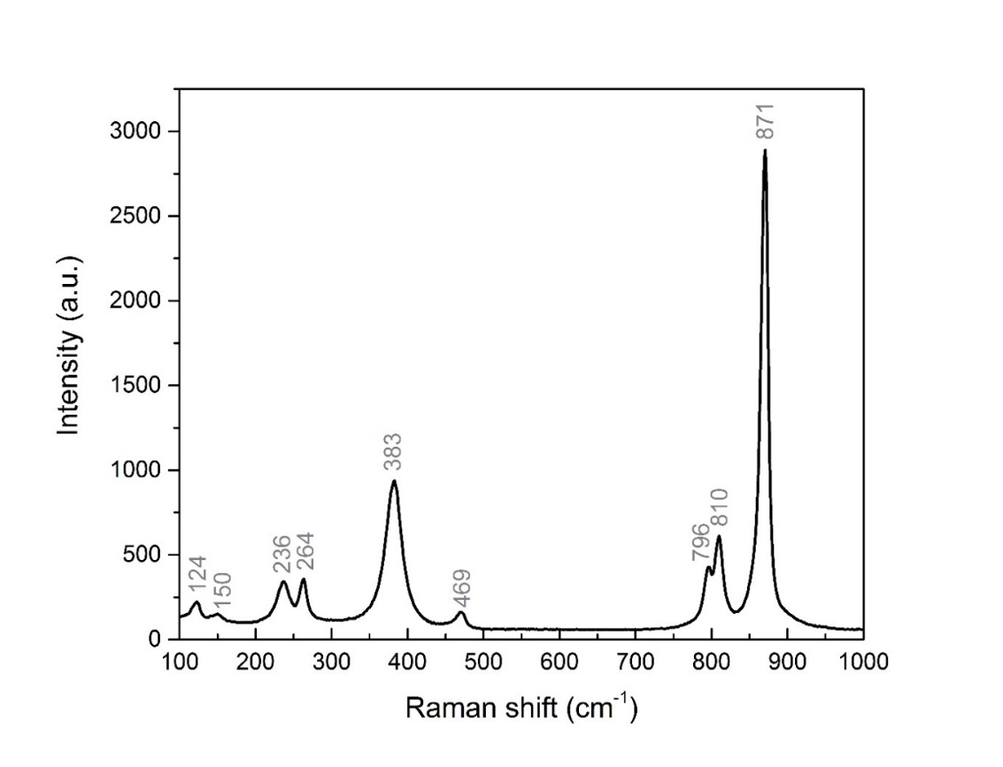
Fig. 5. Raman spectrum of the NdVO₄ nanoparticles prepared in this study.
So far, the Raman spectra of NdVO₄ have been measured on single crystals and polycrystalline samples by several research groups. a comparison of our results with the literature reports is shown in Table 2. It can be seen that the observed Raman modes in this study are in good agreement with the literature data. The only modes that were not observed (these modes are rarely observed) are the modes located at 113, 225, and 373 cm⁻¹. In the 100–1000 cm⁻¹ region, the Raman spectrum of NdVO₄ shows 9 modes that separated in two regions. The high frequency region includes the internal modes in the VO₄ units, while the external modes occur at lower frequency and correspond to motions of the Nd−O bond in the NdO₈ dodecahedron. The symmetry annotations were made in accordance with the previous results reported in the literature.^{9,10,26}
Table 2 The Raman modes of NdVO₄ reported in the literature and the Raman modes observed in this study.
Study | Sample type |  | Peak position (cm⁻¹) |  |  |  |  |  |  |  |  |  |  | Temp.
This study | Nanoneedles | 871 | 810 | 796 | 469 | 383 | - | 264 | 236 | 150 | 124 | - | 297 K
Panchal et al.¹⁰ | Polycrystalline | 871 | 808 | 794 | 472 | 381 | 373 | 260 | 243 | 151 | 124 | 113 | 297 K
Yuvaraj et al.²⁵ | Nano rods | 876 | - | 770 | - | -- | - | - | - | - |  |  | 297 K
Jandl et al. | Single crystal | 873 | 810 | 797 | 472 | 381 | - | 259 | 242 | 151 | 122 |  | 10 K
Nguyen et al.²⁸ | Single crystal | 871 | 808 | 795 | 472 | 381 | 375 | 260 | 237 | 148 | 123 | 113 | 297 K
Fidancev et al. | Polycrystalline | 873  868 | 810  805 | 797  790 | 473  471 | 380  380 | 378  375 | 259  262 | 242  235 | 151  151 | 121  122 | 111  112 | 4.2 K  4.2 K
Santos et al. | Single crystal | 871 | 808 | 795 | 472 | 381 | 375 | 260 | 237 | 148 | 123 | 113 | 297 K
  - Optical studies
Fig. 6 shows the UV-Vis diffuse reflectance spectrum of the NdVO₄ nanoneedles prepared in this study. The light absorption was observed at a wavelength of about 770 nm, followed by another absorption at about 615 nm. A third absorption peak started at about 353 nm, increased sharply and reached a maximum at about 280 nm (associated with the O²⁻−V⁵⁺ charge transfer within the VO₄³⁻ group)., The sharp increase at about 353 nm corresponds to the band gap transition in NdVO₄. The additional absorption peaks observed in the UV-Vis spectrum of NdVO₄ at about 615 and 770 nm have been described in the literature and they are summarized in Table 3.
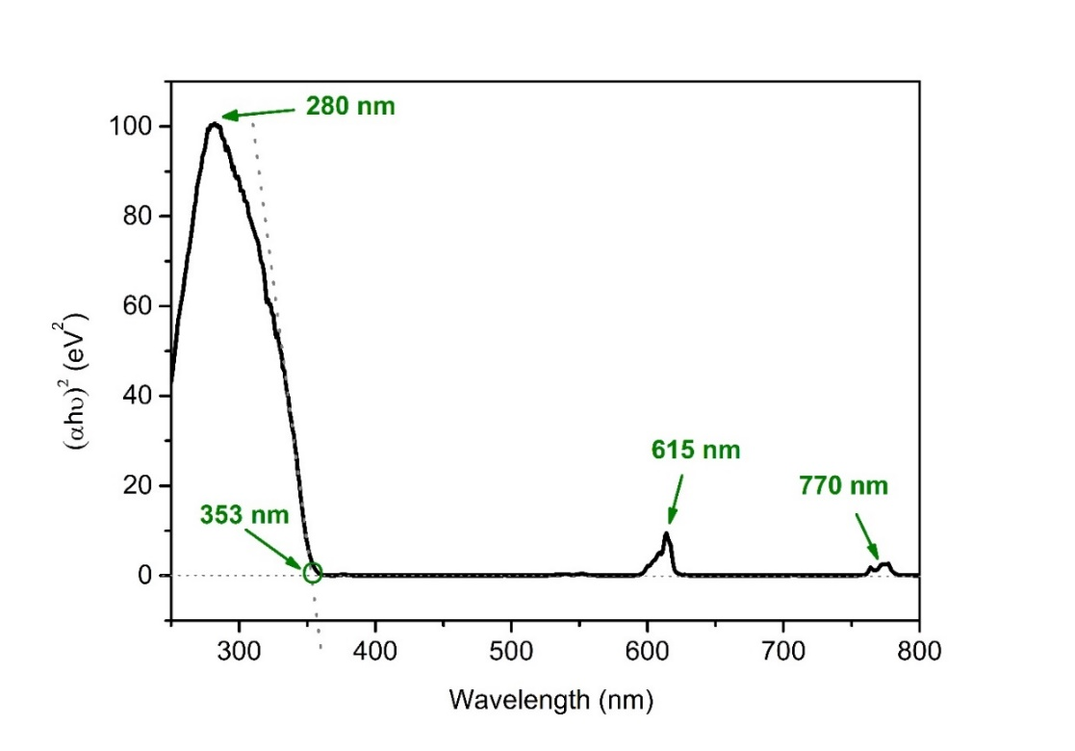
Fig. 6. The UV-Vis diffuse reflectance spectrum of the NdVO₄ nanopowder prepared in this study.
Table 3 Characteristic peaks observed in the 500–800 nm range in the UV-Vis absorption spectra of NdVO₄.
Peak position  (nm) |  |  | Synthesis method and particle size | Study | Comments/  Assignment
(1) | (2) | (3) | Synthesis method and particle size | Study | Comments/  Assignment
- | 615 | 770 | Co-precipitation, needles of ~100 nm length and 20 nm diameter | This study | From ⁴I_{9/2} to:  (1) / , (2) ⁴G_{5/2} and (3) ⁴F_{7/2}
- | 590 | 750 | Solid-state reactions, ~1μm. | Dragomir et al., Singh et al^{23,} | (1) / , (2) ⁴I_{9/2} to ⁴G_{5/2},  (3) ⁴I_{9/2} to ⁴F_{7/2}
532 | 582 | 744 | Templated sol-gel  Nanotubes with the diameter of about 40 nm | Peng et al. | (1) ⁴G_{7/2} and ⁴G_{9/2}  (2) ⁴G_{7/2}, (3) ⁴F_{7/2} and ⁴S_{3/2}
538 | 590 | 752 | Nanowires, 100 nm diameter and 3μm length | Xu et al. | From ⁴I_{9/2} to:  (1) ²G_{7/2}, (2) ⁴G_{5/2}, (3) ⁴F_{7/2}
~525 | 593 | 753 | Hydrothermal, nanorods, length: 400–700 nm. | Wu et al. | (1) /, (2) ⁴I_{9/2} to ⁴G_{5/2}, (3) ⁴F_{7/2}
From the plot of the absorbance versus the energy (Fig. 7) the band gap of the NdVO₄ nanopowders was calculated to be 3.50 eV, which is in the UV region of the electromagnetic spectrum. This value falls well in the range of values reported by other researcher groups.^{7,9}
The electronic structure of zircon-type NdVO₄ has also been investigated by Panchal et al.⁹ They observed that NdVO₄ shows similar band shape with LuVO₄ and YVO₄; the upper part of the valence band and the lower part of the conduction band is mainly comprised of the V 3d and O 2p states, while the Nd 6s states contribute to a decrease in the band gap due to their hybridization with the antibonding conduction band states.
Under UV excitation (Fig. 8) the NdVO₄ nanoneedles show green, yellow, and orange emissions. The NdVO₄ spectrum consists of a broad peak centred at about 500 nm with three small shoulders at about 523, 545, and 600 nm. Several researchers have reported the photoluminescence spectra of nanosized NdVO₄ (excited with UV light). Wu et al. reported the PL emission spectrum of single crystalline nanorods (of ~200 nm in diameter and 400–700 nm in length).³⁷ The spectrum shows a strong emission around 490 nm followed by two less intense peaks at ~525 and 550 nm and a triplet at about 600–615 nm.
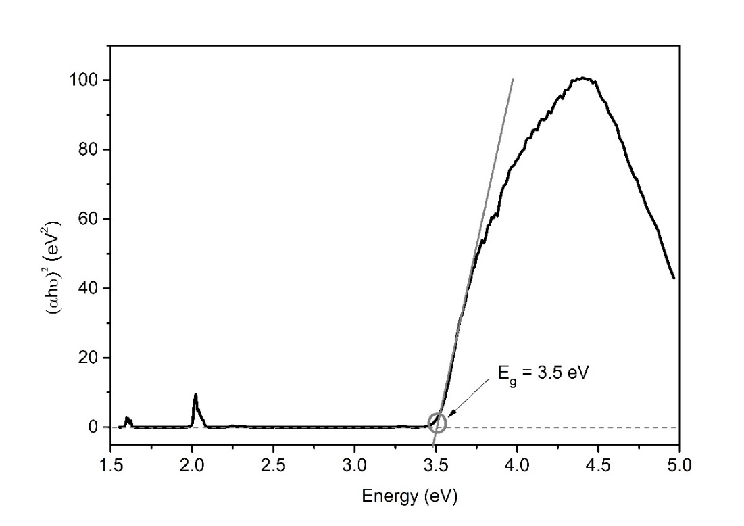
Fig. 7. Optical band gap of NdVO₄ nanoparticles.
The NdVO₄ nanoneedles prepared in this study show similar peaks. Similar results were also obtained for 1 μm NdVO₄ particles prepared by a solid-state method and described by Dragomir et al.^{34,23} Briefly, the emission at about 500 nm can be assigned to the ⁴G_{11/2} → ⁴I_{11/2} transition, while the shoulders at ~525, 545, and 600 nm can be attributed to the ⁴G_{7/2} → ⁴I_{9/2}, ⁴G_{7/2} → ⁴I_{9/2}, and ⁴G_{5/2} → ⁴I_{9/2} transitions, respectively.
Fig. 9 shows the time-resolved photoluminescence spectrum of the NdVO₄ nanoneedles excited by a 371 nm laser wavelength and monitored at 524 nm. This decay curve could only be simulated by a third-order exponential function with the three lifetimes: τ₁ = 0.16 ns, τ₂ = 1.70 ns and τ₃ = 4.74 ns. The fitting parameters of the photoluminescence decay curves are presented in Table 4. These results suggest that the PL decay processes were dominated by third order kinetics. To the authors’ knowledge, this is the first report on the dynamics of photo-excited carriers in NdVO₄.
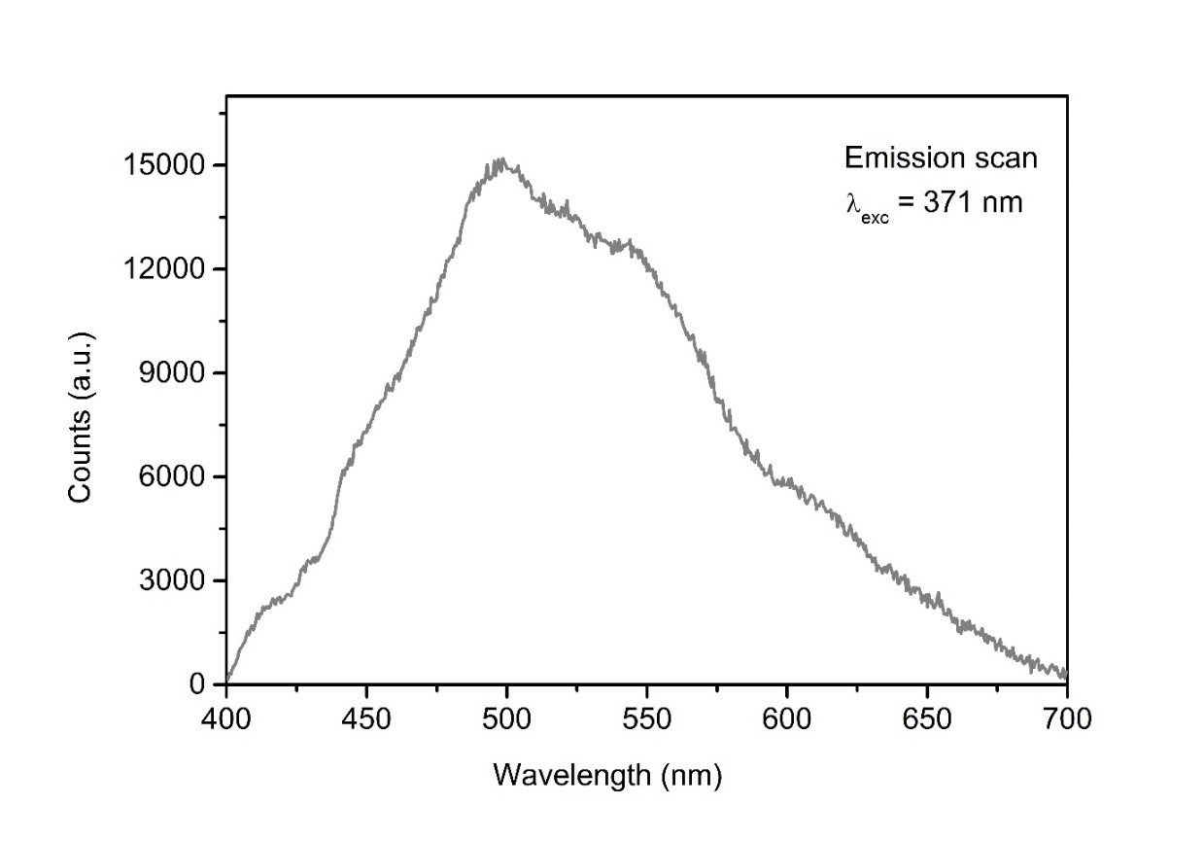
Fig. 8. The emission spectrum of NdVO₄ nanoneedles, measured at room temperature.
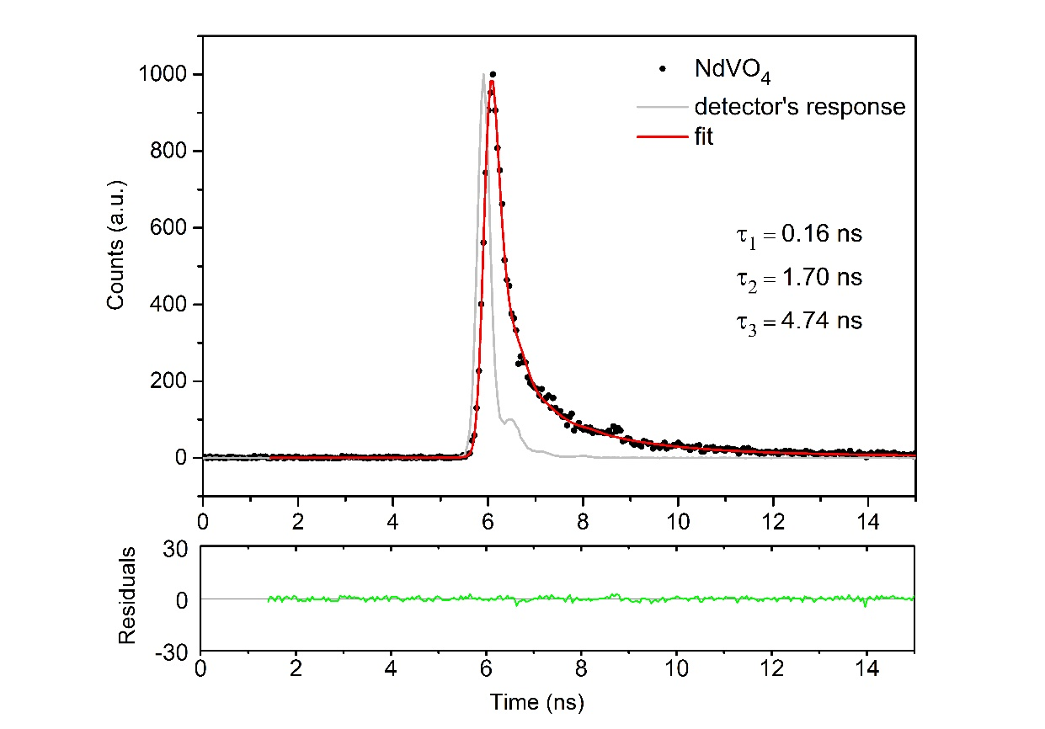
Fig. 9. Photoluminescence lifetime measured on the NdVO₄ nanoneedles, λ_{em} = 524 nm. The black dots represent the time-domain intensity decay. The red line is the fitting curve, while the blue line is the response of the detector. The green line below represents the difference between the fitted curve and the measured data. The goodness of fit, χ², is 1.418.
Table 4 Fitting parameters of the photoluminescence decay curves of the NdVO₄ nanoneedles (λ_{ex} = 371 nm, λ_{em} = 524 nm).
Sample | Lifetime (ns) | Standard deviation (ns) | χ² | B1 | B2 | B3
NdVO₄ nanoparticles | τ₁ = 0.16 (50.61%)  τ₂ = 1.70 (30.64%)  τ₃ = 4.74 (18.75%) | 0.01  0.15  0.59 | 1.418 | 0.35 | 0.03 | 0.00
- Conclusions
We have successfully developed a facile room-temperature coprecipitation method for the synthesis of NdvO4 nanoneedles. This approach is based on aqueous solutions of NdCl₃ and Na₃VO₄ and using NH₃(aq) as a precipitating agent. The synthesis yielded impurity-free, crystalline NdVO₄ nanoneedles with a tetragonal structure, space group I₄/amd. The Rietveld refinement study indicated a preferential growth of the nanoparticles along the <112> direction. The Raman analysis further supported the fact that the nanoparticles are single phase NdVO₄ with a zircon-type structure, while SEM analysis showed that the as-synthesised particles have a needle-like morphology with a length of about 100 nm and a width of about 20 nm. The UV-vis absorption spectrum showed an absorption band located at 353 nm (3.5 eV) which corresponds to the band gap transition. The room-temperature PL spectrum of the NdVO₄ nanoneedles shows green, yellow, and orange emissions. The lifetimes of the nanoneedles were monitored for the 524 nm emission and were found to be 4.74 nanoseconds.
In addition to its simplicity, the synthetic method proposed in this study also saves energy as it does not require any thermal treatment. In conclusion, we believe that this method could be extended to prepare other 1D lanthanide vanadate structures.
Acknowledgements
This work was supported by the Slovenian Research Agency under the Research Program P2-0337.
References

. J.A. Baglio, O.J. Sovers. J. Solid State Chem. 1971, 3, 458–465.
. C.-T. Au, W.-D. Zhang. Faraday Trans. 1997, 93, 1195–1204.
. X. Wu, Y. Tao, L. Dong, J. Zhu, Z. Hu. J. Phys. Chem. B 2005, 109, 11544–11547.
. S. Mahapatra, G. Madras, T.N.G. Row. J. Phys. Chem. C 2007, 111, 6505–6511.
. R.A. Fields, M. Birnbaum, C.L. Fincher. Appl. Phys. Lett. 1987, 51 1885–1887.
. H. Zhang, H. Kong, S. Zhao, J. Jiu et al. J. Cryst. Growth 2003, 256, 292–297.
. S. Mahapatra, G. Madras, T.N.G. Row. Ind. Eng. Chem. Res. 2007, 46, 1013–1017.
. A. Di Paola, E. Garcia-Lopez, G. Marci, L. Palmisano. J. Hazard. Mater. 2012, 211– 212, 3–29.
. V. Panchal, D. Errandonea, A. Segura, P. Rodriguez-Hernandez, A. Munoz, S. Lopez- Moreno, M. Bettinelli. J. Appl. Phys. 2011, 110, 043723–043733.
. V. Panchal , D. Erradonea, F.J. Manjon, A. Munoz, P. Rodriguez-Hernandez, S.N. Achary, A.K. Tyagi. J. Phys. Chem. Solids 2017, 100, 123–133.
. X. Huang, S. Han, W. Huang, X. Liu. Chem. Soc. Rev. 2013, 42, 173–201.
. C. Che Lin, R.-S. Liu. J. Phys. Chem. Lett. 2011, 2, 1268–1277.
. Y. Liu, D. Tu, H. Zhu, X. Chen. Chem. Soc. Rev. 2013, 42, 6924–6958.
. C. Yao, Y. Ton. TrAC, Trends Anal. Chem. 2012, 39, 60–71.
. M. Abdesselem, M. Schoeffel, I. Maurin, R. Ramodiharilafy, G. Autret, O. Clément, P-L Tharaux, J-P Boilot, T. Gacoin, C. Bouzigues, A. Alexandrou. ACS Nano, 2014, 8, 1126–11137.
. S. Mahapatra, S.K. Nayak, G. Madras, T.N.G. Row. Ind. Eng. Chem. Res. 2008, 47, 6509–6516.
. J. Liu, Y. Li. J. Mater. Chem. 2007, 17, 1797–1803.
. Z. Xu, C. Li, Z. Hou, C. Peng, J. Lin. CrystEngComm 2011, 13, 474–482.
. M. Jang, K.M. Doxsee. CrystEngComm 2011, 13, 1210–1214.
. R. Kalai Selvan, A. Gedanken, P. Anilkumar, G. Manikandan, C.J. Karunakaran. J. Cluster. Sci. 2009, 20, 291–305.
. R.W. Cheary, A. Coelho. J. Appl. Crystallogr. 1992, 25, 109–121.
. P. Kubelka, F. Munk. Z. Tech. Phys. 1931, 12a., 593–601.
. M. Dragomir. Ph.D. thesis, 2013, University of Nova Gorica.
. Manual of the fluorescence lifetime. Edinburgh Instruments, 2000, UK.
. S. Yuvaraj, R.K. Selvan, V. Kumar, I. Perelshtein, A. Gedanken, S. Isakkimuthu, S. Arumugam. Ultrason. Sonochem. 2014, 21, 599–605.
. H. Fuess, A. Kallel. J. Solid State Chem. 1972, 5, 11–14.
. D. Errandonea, C. Popescu, S.N. Achary, A.K. Tyagi, M. Bettinelli. Mater. Res. Bull. 2014, 50, 279–284.
. A.-D. Nguyen, K.M. Murdoch, N.M. Edelstein, L.A. Boatner, M.M. Abraham. Phys. Rev. B 1997, 56, 7974–7987.
. S. Jandl, Y. Lévesque, V. Nekvasil, M. Bettinelli. Opt. Mater. 2010, 32, 1549–1552.
. E. Antic-Fidancev, J. Holsa, M. Lemaitre-Blaise, P. Porcher. J. Phys.: Condens. Matter. 1991, 3, 6829–6843.
. C. C. Santos, E. N. Silva, A. P. Ayala, I. Guedes, P. S. Pizani, C.-K. Loong, L. A. Boatner. J. Appl. Phys. 2007, 101, 053511.
. Y.-S. Chang, F.-M. Huang, Y.-Y. Tsai, L.-G. Teoh. J. Lumin. 2009, 129, 1181–1185.
. N. S. Singh, R. S. Ningthoujam, G. Phaomei, S. D. Singh, A. Vinu, R. K. Vatsa. Dalton Trans. 2012, 41, 4404–4412.
. M. Dragomir, I. Arčon, S. Gardonio, M. Valant. Acta Mater. 2013, 61, 1126–1135.
. X. N. Peng, X. Zhang, L. Yu, L. Zhou. Mod. Phys. Lett. B 2009, 23, 2647–2653.
. J. Xu, C. Hu, G. Liu, H. Liu, G. Du, Y. Zhang. J. Alloys Compd. 2011, 509, 7968–7972.
. X. Wu, Y. Tao, L. Dong, J. Zhu, Z. Hu. J. Phys. Chem. B 2005, 109, 11544–11547.

