Plate-Like Bi₄Ti₃O₁₂ Particles and their Topochemical Conversion to SrTiO₃ Under Hydrothermal Conditions

Alja Čontala^{1,2}, Marjeta Maček Kržmanc¹, Danilo Suvorov¹
¹ Advanced Materials Department, Jožef Stefan Institute Jamova cesta 39, 1000 Ljubljana, Slovenia
² Jožef Stefan International Postgraduate School, Jamova cesta 39, 1000 Ljubljana, Slovenia
* Corresponding Author: marjeta.macek@ijs.si

Abstract
Plate-like Bi₄Ti₃O₁₂ particles were synthesized using a one-step, molten-salt method from Bi₂O₃ and TiO₂ nanopowders at 800 °C. The reaction parameters that affect the crystal structure and morphology were identified and systematically investigated. The differences between various Bi₄Ti₃O₁₂ plate-like particles were examined in terms of the ferroelectric-to-paraelectric phase transition and the photocatalytic activity for the degradation of Rhodamine B under UV-A light irradiation. The results encouraged us to conduct further testing of the as-prepared Bi₄Ti₃O₁₂ plate-like particles as templates for the preparation of plate-like SrTiO₃ perovskite particles using a topochemical conversion under hydrothermal conditions. The characteristics of the Bi₄Ti₃O₁₂ plates and the reaction parameters for which the SrTiO₃ preserved the shape of the initial Bi₄Ti₃O₁₂ template particles were determined.

Keywords: Bi₄Ti₃O₁₂, Aurivillius layered perovskites, molten-salt synthesis, plate-like Bi₄Ti₃O₁₂, template plates, topochemical conversion

- Introduction
Bi₄Ti₃O₁₂ (BIT) is a member of the Aurivillius-type perovskites that have a layered structure in which pseudo-perovskite (Bi₂Ti₃O₁₀)²⁻ units are alternating with (Bi₂O₂)²⁺ layers. As a piezoelectric material with a high Curie temperature of 675 °C, Bi₄Ti₃O₁₂ has the potential for use in high-temperature piezoelectric applications.^{1,2}
The most common synthesis approaches for the preparation of Bi₄Ti₃O₁₂ ceramics and particles are solid-state, molten-salt, hydrothermal and some other methods with lower reaction temperatures, e.g., coprecipitation and sol-gel. ^{3,4,5} During the preparation of Bi₄Ti₃O₁₂ from Bi₂O₃ and TiO₂ in molten salt or by solid-state reaction, secondary phases such as Bi₁₂TiO₂₀ or Bi₂Ti₂O₇ are commonly formed and must be removed from the product prior to further use due to their detrimental effect on the piezoelectric properties of Bi₄Ti₃O₁₂ ceramics.^{6–8} Plate-like Bi₄Ti₃O₁₂ particles with a side length of around 1 µm and a thickness of 50 nm were formed in molten NaCl/KCl at 800 °C.⁹ In contrast to the thickness, the side length of the plates was not uniform, varying from 0.25 μm to 3 μm. He et al.systematically studied the influence of the salt/precursor ratio on the morphology of plate-like Bi₄Ti₃O₁₂ particles prepared in molten salt. They observed that the average side length and thickness of the Bi₄Ti₃O₁₂ plates decreased with an increase in the amount of salt; however, at high dilutions (molar ratios: NaCl:KCl:Bi₄Ti₃O₁₂ ≥32:32:1) the influence of the salt content was no longer significant. These Bi₄Ti₃O₁₂ (00l)-oriented plates were also proved to be more effective for the photocatalytic degradation of Rhodamine B (RhB) than irregularly shaped Bi₄Ti₃O₁₂ particles obtained using the solid-state method. Thickness, surface defects and faceting of the surface are all parameters that influence the photocatalytic activity (PA). Bi₄Ti₃O₁₂ particles prepared with the hydrothermal method usually exhibited smaller dimensions and higher aggregation than those prepared in molten salt.^{11,12} Therefore, a decision has to be taken regarding the preparation method for the specific application of the material.
Bi₄Ti₃O₁₂ has a monoclinic crystal structure. In contrast to MTiO₃ perovskites (M = Ba, Sr, Pb) with a cubic or tetragonal crystal structure, Bi₄Ti₃O₁₂ has a tendency to grow in an anisotropic shape due to its large crystal anisotropy. Therefore, plate-like Bi₄Ti₃O₁₂ particles can be used as a template for the preparation of plate-like MTiO₃ perovskites with a topochemical conversion.⁹ Different templates including MBi₄Ti₄O₁₅ (M = Ba, Sr, Pb) were also reported. However, most of them are prepared using a time-consuming, two-step reaction process in which the MBi₄Ti₄O₁₅ is firstly formed from the Bi₄Ti₃O₁₂ and then the MBi₄Ti₄O₁₅ is transformed into the MTiO₃ perovskite.^{13–15} Single-step conversion from Bi₄Ti₃O₁₂ to the MTiO₃ perovskite is expected to enable better control of the reaction mechanism and morphology. Bi₄Ti₃O₁₂ particles were already used for a topochemical conversion to BaTiO₃ or SrTiO₃ in molten salt.^{9,16,17} To the best of our knowledge, the topochemical conversion from Bi₄Ti₃O₁₂ to BaTiO₃, SrTiO₃ or CaTiO₃ particles under hydrothermal conditions has not yet been reported. It is well known that the quality and morphology of the initial precursor particles, in addition to the reaction conditions, greatly influence the particle morphology. In this study we report on the preparation of Bi₄Ti₃O₁₂ particles with two morphologies and their topochemical transformation to SrTiO₃ under hydrothermal conditions.

- Methods

  - Experimental
Bi₄Ti₃O₁₂ plates were synthesized using the molten-salt method. The process is illustrated in Figure 1. KCl (Sigma-Aldrich, ≥ 99.0 %) and NaCl (Merck, ≥ 99.7 %) were weighed in a 1:1 molar ratio, ground and mixed well in a mortar to achieve a homogeneous mixture. Next, an appropriate amount of Bi₂O₃ nanopowder (99.9 % Alfa Aesar) and TiO₂ nanopowder (P25, Degussa) were weighed, added to the salt mixture and mixed well again. A homogeneous mixture of powder was then transferred to the Al₂O₃ crucible, covered and placed in the furnace. The heating rate was 10 °C/min until the temperature reached 800 °C. The morphology and crystal structure for the Bi₄Ti₃O₁₂ obtained under different reaction conditions were investigated in order to determine the best reaction conditions for the preparation of well-developed, plate-like Bi₄Ti₃O₁₂ particles with a narrow size distribution. The influence of various reaction conditions such as time (20 minutes and 2 hours), Bi:Ti molar ratio (1.33, 2.0 and 2.67), NaCl:KCl:Bi₄Ti₃O₁₂ molar ratio (50:50:1 or 25:25:1) and cooling rate (5 °C/min, 10 °C/min and natural cooling) were examined. In the case of natural cooling, the heating system was turned off after the reaction was performed, and the product was left in the furnace until the furnace reached room temperature. Natural cooling means uncontrolled cooling in a furnace by natural convection, conduction and radiation to room temperature. It was demonstrated that the cooling time from 800 °C to the eutectic temperature of 650 °C in the case of natural cooling was 8 minutes, while for cooling rates of 10 °C/min and 5 °C/min, the cooling times were 15 and 30 minutes, respectively. In this temperature range, where the particle growth still took place, the natural cooling was the fastest. Below 650 °C, the diffusion is expected to be too slow and thus the growth of the particles is negligible. For comparison, Bi₄Ti₃O₁₂ was also synthesized under selected conditions (Bi:Ti=1.33, 800 °C 2 h, natural cooling) using anatase TiO₂ (Sachtleben Pigments Oy, HOMBITAN AFDC 001517011, 99 %) μm-sized powder instead of the P25 nanopowder.
After the reaction, the product powders were washed with deionized water by suction filtration in order to remove the salt. Afterwards, they were also washed with 2-M HNO₃ (soaking time 10 minutes) in order to remove the secondary phases and finally with deionized water again (until pH = 7). The product powders were freeze-dried.
In the second part of the study, Bi₄Ti₃O₁₂ template plates were tested for the topochemical conversion to SrTiO₃ under hydrothermal conditions. For this reaction SrCl₂×6H₂O (Sigma Aldrich, ≥ 99 %) was added to the Bi₄Ti₃O₁₂ in the molar ratio Sr:Ti = 3. The reaction was performed under hydrothermal conditions in 4-M NaOH (Merck, 99 %) with stirring at 200 °C for 12 hours. The product was cooled naturally and washed with deionized H₂O, 1-M HNO₃ and once again with deionized H₂O. The product was freeze-dried.

  - Characterization
The crystal structure was characterized with X-ray powder diffraction (Bruker AXS D4 Endeavor) using Cu–K_{α} radiation (1.5406 Å). For an estimation of the preferential orientation, a few drops of suspension of the particles in iso-propanol were deposited on a Si single crystal and left for the alcohol to evaporate. The morphology and size of the prepared particles were studied by field-emission scanning electron microscopy (FE-SEM, JSM 7600 F, JEOL). The specific surface area was measured using the BET method with nitrogen adsorption (Gemini 2370 V5.00).
For the PA of the Bi₄Ti₃O₁₂ particles, the decomposition of RhB was measured in UV-A light. The concentration of the sample, mixed with RhB and exposed to UV-A light, was 0.2 mg/ml, and the concentration of the RhB was 10 mg/l. Prior to irradiation, the solution was sonicated for 1 minute (pulse:pause was 2:1 seconds) at 80 % and afterwards it was stirred in the dark at 500 rpm for 30 minutes. Samples were taken before irradiation and after 1 h, 2 h, 3 h, 4 h and 24 hours of irradiation with UV-A light. The powder was removed after centrifugation. The absorbance was measured at λ = 554 nm using a Synergy Micro Plate Reader (BIOTEK). Control reactions in the dark for RhB with the sample and a parallel reaction for pure RhB were also performed. Differential scanning calorimetry (DSC) measurements were made on a Jupiter 449 simultaneous thermal analysis (STA) instrument (Netzsch, Selb, Germany). The measurements were made with a heating rate of 20 °C/min in an Ar/O₂ (40/20) atmosphere using a TG/DSC-cp sample holder and platinum crucibles. The temperature and enthalpy calibrations of the STA instrument were made with BaCO₃, CsCl, K₂CrO₄, KClO₄ and RbNO₃ standards.
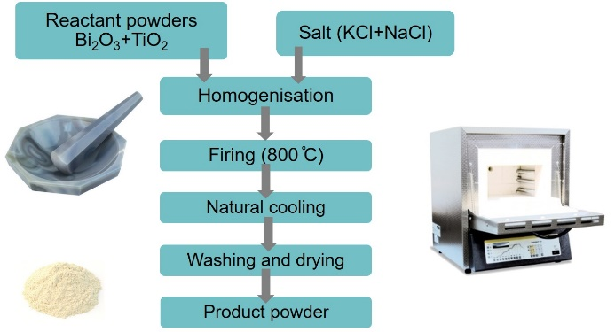
Figure 1: Schematic illustration of Bi₄Ti₃O₁₂ synthesis in molten salt

- Results and Discussion
  - Influence of the reaction conditions on the morphology and crystal structure
Bi₄Ti₃O₁₂ was formed in the molten salt by dissolution-precipitation. This means that Bi₂O₃ and TiO₂ firstly dissolved in the molten salt and then Bi₄Ti₃O₁₂ plates precipitated at a high degree of supersaturation. Further growth of the plates occurred by Ostwald ripening. Therefore, the particle size could be tailored with the duration of the reaction. Longer and shorter times were selected for the preparation of larger (μm-sized) and smaller (sub-μm-sized) Bi₄Ti₃O₁₂ plates, respectively.⁹ In particular, sub-μm- and nano-sized anisotropic particles of ferroelectrics (Bi₄Ti₃O₁₂ and BaTiO₃) have recently become of great scientific and technological interest due to their unique shape- and size-dependent functional properties with reduced sub-μm-size dimensions. At first, the phase composition and morphology of the Bi₄Ti₃O₁₂ particles obtained at 800 °C after 2 hours in the first experiment (BIT1) and 20 minutes in the second experiment (BIT2) were examined and compared (Fig. 2, Table 1). In both of these cases the reaction was performed with surplus Bi₂O₃ (Bi:Ti=2.67, stoichiometric Bi:Ti=1.33). The Bi₂O₃ was added in excess in order to provide a high concentration of Bi³⁺ for the formation of Bi₄Ti₃O₁₂ plates. In the case of a shorter synthesis time (20 minutes), the Bi₄Ti₃O₁₂ plates exhibited a smaller average side length as well as a reduced thickness compared to the plates obtained after a longer synthesis time (2 hours), when the particles had more time available for Ostwald-ripening growth. In both cases the XRD analyses showed that a significant amount of Bi₁₂TiO₂₀ secondary phase (PDF #034-0097) was present (Fig. 3, XRD pattern A) in addition to the Bi₄Ti₃O₁₂ (PDF #035-0795). The formation of Bi₁₂TiO₂₀ was a consequence of excess Bi₂O₃ in the reaction mixture. During washing with 2-M HNO₃ the Bi₁₂TiO₂₀ was dissolved and monoclinic Bi₄Ti₃O₁₂ became the only phase in both cases. Reaction conditions for the described Bi₄Ti₃O₁₂ (BIT1 and BIT2) and for the Bi₄Ti₃O₁₂ prepared under other conditions are presented in Table 1. Bi:Ti and NaCl:KCl:Bi₄Ti₃O₁₂ are molar ratios.
Table 1: Reaction conditions of BIT1-BIT9 for the investigation of the influence of the reaction parameters on the morphology and crystal structure of Bi₄Ti₃O₁₂
Sample | TiO₂ | Bi:Ti | NaCl:KCl:Bi₄Ti₃O₁₂ | T (°C) | Time | Heating | Cooling
BIT1 | P25 | 2.67 | 50:50:1 | 800 | 2 h | 10 °/min | 10 °/min
BIT2 | P25 | 2.67 | 50:50:1 | 800 | 20 min | 10 °/min | 10 °/min
BIT3 | P25 | 2.67 | 25:25:1 | 800 | 2 h | 10 °/min | 10 °/min
BIT4 | P25 | 2.0 | 25:25:1 | 800 | 2 h | 10 °/min | 10 °/min
BIT5 | P25 | 1.33 | 25:25:1 | 800 | 2 h | 10 °/min | 10 °/min
BIT6 | P25 | 1.33 | 50:50:1 | 800 | 2 h | 10 °/min | 10 °/min
BIT7 | P25 | 1.33 | 25:25:1 | 800 | 2 h | 10 °/min | 5 °/min
BIT8 | P25 | 1.33 | 25:25:1 | 800 | 2 h | 10 °/min | natural
BIT9 | anatase | 1.33 | 25:25:1 | 800 | 2 h | 10 °/min | natural

In the next step the molar ratio of bismuth to titanium (denoted as Bi:Ti in Table 1) was studied. We selected three values of Bi:Ti: 2.67, 2.0 and 1.33 (stoichiometric) for BIT3, BIT4 and BIT5, respectively. In the experiment using a ratio of 1.33 the plates had a more defined shape and a narrower size distribution (Fig. 2C) than in the other two cases and Bi₄Ti₃O₁₂ was the main phase, observed by XRD after the synthesis. In the other two cases, washing with HNO₃ was necessary to remove the secondary Bi₁₂TiO₂₀ phase.
The influence of the amount of salt on the morphology and crystal structure was also investigated. In accordance with the literature¹⁰ we used a 50:50:1 molar ratio (BIT6) of KCl:NaCl:Bi₄Ti₃O₁₂. However, when the ratio was reduced to 25:25:1 (BIT5) the size distribution of the product particles became more uniform. With a smaller amount of salt, the diffusion distance of the reactant particles is smaller; therefore, the reaction occurs faster and more uniformly. Powder XRD patterns confirmed the dominance of the monoclinic Bi₄Ti₃O₁₂ phase (PDF #035-0795) for both products.
Cooling rates of 10 °C/min (BIT6), 5 °C/min (BIT7) and natural cooling (BIT8-Fig. 2D) were also compared. Based on SEM observations we concluded that there is no significant difference in the morphology when the cooling rates were 10 °C/min, 5 °C/min or natural cooling.
The most differing BIT products (BIT2 and BIT8) were selected for further analysis. SEM micrographs and XRD patterns for those plate-like Bi₄Ti₃O₁₂ samples are shown in Figures 2 and 3, respectively. The higher degree of aggregation of BIT2 compared to BIT8 is evident from the SEM micrographs as well as from the XRD patterns of the Bi₄Ti₃O₁₂ particles deposited on the Si single crystal (Figure 3, XRD patterns C and D). Due to the random orientation of the plate-like Bi₄Ti₃O₁₂ particles in the aggregates of BIT2 sample, the relative intensities of the (00l)/(117) planes (l=even number) were considerably lower in comparison to those of the larger Bi₄Ti₃O₁₂ (BIT8) plates, which oriented during deposition on a Si single crystal in a way that the (00l) planes were parallel to the substrate. Based on this we can infer that 1–2-μm-sized Bi₄Ti₃O₁₂ plates exhibited a high (00l) preferential orientation (Figure 3, XRD pattern D).
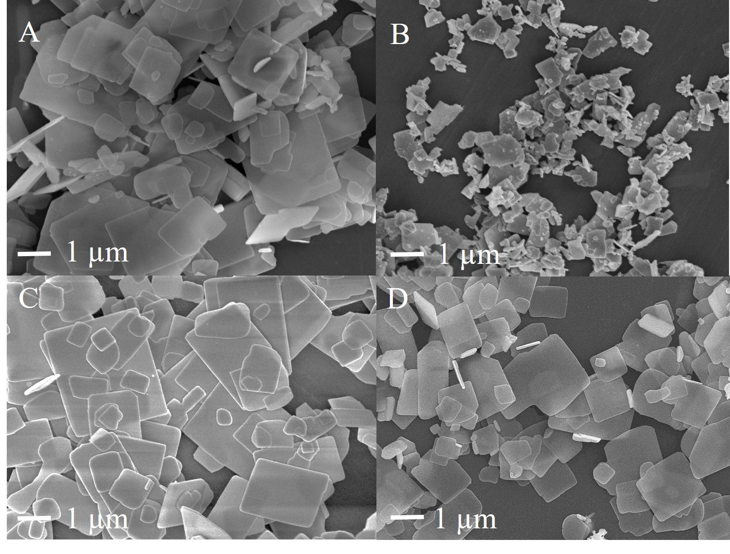
Figure 2: SEM micrographs of the Bi₄Ti₃O₁₂ plates that were synthesized at 800°C for 20 min (B-BIT2) and for 2h (A-BIT1, C-BIT5, D-BIT8). Other synthesis details are shown in Table 1.
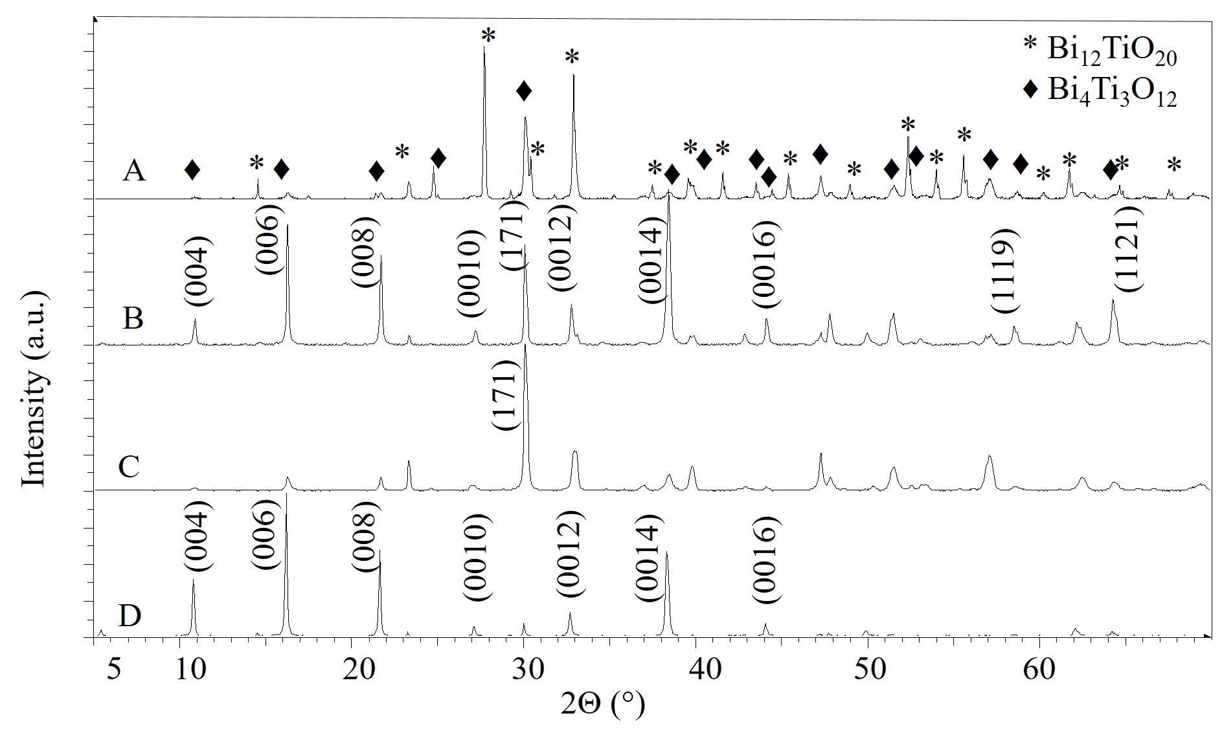
Figure 3: XRD patterns of Bi₄Ti₃O₁₂ plates prepared at 800 °C for 20 min (patterns A and C for BIT2) and for 2 h (patterns B and D for BIT8). The A and B patterns represent the XRD patterns of Bi₄Ti₃O₁₂ powders washed only by water in order to determine possible secondary phases. The XRD patterns C (for BIT2) and D (for BIT8) were obtained from Bi₄Ti₃O₁₂ plates that were cast on the Si single crystal. The Bi₄Ti₃O₁₂ plates prepared for examination of their average preferential orientation in these two patterns were washed with 2-M HNO₃ to ensure a single-phase product. In the XRD pattern A, ♦ and * denote the Bi₄Ti₃O₁₂ and Bi₁₂TiO₂₀ phases, respectively. The hkl indexation is given for Bi₄Ti₃O₁₂.
Finally, Bi₄Ti₃O₁₂ was also prepared from μm-sized anatase TiO₂ particles (BIT9) instead of P25 TiO₂ nanopowder, but under the same reaction conditions as for the BIT8. As expected, the plates were less uniform in size. The majority of the plates were much smaller (approx. 100 nm) and the rest were between 1 and 2 microns. This non-uniform particle size distribution was most probably a consequence of the larger anatase particles, which dissolved more slowly and unevenly than the P25 nanoparticles. Also in this case, the XRD pattern confirmed that monoclinic Bi₄Ti₃O₁₂ was the main phase.

For smaller and larger Bi₄Ti₃O₁₂ plates (BIT2 and BIT8) the specific surface area (BET), the photocatalytic activity (PA) and the DSC measurements were performed in order to confirm the significant difference in size and the specific surface area. The BET results were in agreement with the SEM observations. The specific surface area was larger for BIT2 than for BIT8 (Table 2), which is in accordance with the SEM observation and confirmed that the BIT2 particles were smaller and consequently the specific surface area was larger than for BIT8.
Since it is well known that PA is also influenced by surface defects, which are also very important when the plates are considered for topochemical conversion, we decided to test both types of plates in terms of their capability to degrade organic dye (RhB) under UV-A radiation. A high concentration of defects is not beneficial, neither for the photocatalysis nor for the epitaxial growth of a new phase on the template. Nevertheless, the acceptable level of defects is different for both processes. For photocatalysis, some defects are advantageous when they introduce intermediate surface states that narrow the band gap. In general, a high density of defects, which act as recombination centers for photo-induced electrons and holes, lowered the PA. The photodegradation of RhB in BIT2 was 88 % and in BIT8 it was 65 % after 4 hours of irradiation with UV-A light. This confirmed our expectations that the PA of BIT2 is larger than that of BIT8. The larger PA of BIT2 can also be ascribed to smaller particles with a higher specific surface area, which provide more active sites for the photocatalytic reaction.
For the DSC measurements both samples (BIT2 and BIT8) were first washed with 2-M HNO₃ to ensure single-phase Bi₄Ti₃O₁₂. The DSC measurements revealed a very similar DSC peak temperature (T_{c}) for the ferroelectric-to-paraelectric phase transition for both types of Bi₄Ti₃O₁₂ plates (643.6 °C for BIT2 and 642.9 °C for BIT8). However, the absolute values of the phase-transition enthalpies (⏐ΔH_{FET}⏐) of the two samples differ significantly. The measured⏐ΔH_{FET}⏐ for BIT2 and BIT8 were 1.457 J/g and 4.555 J/g, respectively. The decrease of the phase-transition enthalpy with a decrease in the particle size was already observed for other ferroelectric particles (BaTiO₃). ¹⁸ Taking into account that the enthalpy of the phase transition is proportional to the polarization (P) (ΔH_{FET} = 2 πP² T_{c} /C (Eq. 1), where C is the Curie Weis constant) the decrease of ⏐ΔH_{FET}⏐ could be explained by the decrease of P. It is also known that the phase-transition enthalpy is related to the domain structure. ^{18,19} The larger ⏐ΔH_{FET}⏐ of BIT8 could correlate with larger particles and be expected to exhibit a multi-domain structure. Due to the domain clamping the enthalpy of the phase transition was higher for larger particles compared to the single-domain smaller particles. In addition, with a decrease of the particle size, the ratio between the disordered surface and the ordered bulk is increasing, which additionally causes a destruction of the polar state.¹⁸
Table 2: Results for BET, DSC and PA measurements of BIT2 and BIT8
Sample | BET (m²/g) | T_{c} (°C) | ${∆H}_{FET}$(J/g) | PA_{4 hours}
BIT2 | 2.9075 | 643.6 | 1.457 | 88.6 %
BIT8 | 0.4855 | 642.9 | 4.555 | 65.0 %

  - Bi₄Ti₃O₁₂ plates as a template for topochemical conversion to SrTiO₃
Due to the pseudo-perovskite units the Bi₄Ti₃O₁₂ plates are regarded as a suitable template for the preparation of MTiO₃ perovskite plates via topochemical conversion. It was already shown that the transformation from Bi₄Ti₃O₁₂ to BaTiO₃ is possible in the molten salt.⁹ There is great interest in whether this kind of conversion is also possible under hydrothermal conditions. Kalyani et al. studied the hydrothermal crystallization of SrTiO₃ on anatase nanowires and proved that the formation of SrTiO₃ was driven by the topochemical reaction,²⁰ since the formed SrTiO₃ mesocrystals retain the wire-like shape of the initial anatase particles. To the best of our knowledge there are no literature reports about the topochemical conversion of Bi₄Ti₃O₁₂ to MTiO₃ perovskites under hydrothermal conditions. In the present study we firstly aimed to examine whether under these conditions Bi₄Ti₃O₁₂ plates are an appropriate template for the preparation of SrTiO₃ plates and secondly we wanted to verify how differently sized Bi₄Ti₃O₁₂ template plates (sub-μm- and above-μm-sized) influenced the final morphology of the SrTiO₃ particles. From the standpoint of advanced development and the improvement of applications and electronic devices, controlling the shape and size of particles can lead to new or combined and improved properties of existing materials. The miniaturization of electronic devices is also of great interest in nanotechnology; however, it is already well known that materials lose some of their functional properties (i.e., ferroelectricity) below certain small dimensions. Additionally, it is easier to observe the growth of SrTiO₃ on larger plates. For this reason we decided to study the formation of SrTiO₃ from two types of Bi₄Ti₃O₁₂: smaller, sub-μm-sized, Bi₄Ti₃O₁₂, plate-like particles with a broad particle size distribution (BIT2) and larger, 1–2-μm-large and well-defined Bi₄Ti₃O₁₂ plates (BIT8). The XRD examination of the reaction products in both cases confirmed the formation of SrTiO₃ (PDF #035-0734) from the Bi₄Ti₃O₁₂ plates under alkaline (4-M NaOH) hydrothermal conditions at 200 °C for 12 hours (Fig. 4, XRD pattern A). The smaller Bi₄Ti₃O₁₂ template particles (BIT2) that were very non-uniform in size, consequently resulted in a non-ideal morphology of the SrTiO₃ particles. This means that the as-prepared SrTiO₃ particles differed in their shape and size. The cube-like particles prevailed, but some of them also exhibited a preferable plate-like shape (Fig. 5A). In contrast, the SrTiO₃ particles prepared from larger Bi₄Ti₃O₁₂ template plates (BIT8) preserved the shape of the template. The XRD revealed that (00l)-oriented Bi₄Ti₃O₁₂ plates transformed into (h00)-oriented SrTiO₃ plates (Fig. 4, XRD pattern B). However, the morphology of the SrTiO₃ plates was still not perfect. The particles varied in their size, which was most probably the consequence of the non-uniform size distribution of the initial Bi₄Ti₃O₁₂ plates. Figure 5B demonstrates that there were small holes present in some of those SrTiO₃ plates. These holes were either the consequence of the defective surface of the Bi₄Ti₃O₁₂ plates or originated from the lattice mismatch between the pseudo-perovskite layer of the template and the SrTiO₃ plates. In addition, the removal of the (Bi₂O₂)²⁺ layer during the conversion could also cause exfoliation, the result of which could be those holes. An examination of the morphology of the SrTiO₃ particles prepared from the different Bi₄Ti₃O₁₂ template plates revealed that the completeness of the SrTiO₃ plates strongly depended on both the quality of the Bi₄Ti₃O₁₂ template plates and the reaction conditions. For example, the worst preservation of the initial Bi₄Ti₃O₁₂ template shape during the conversion to SrTiO₃ was observed for the Bi₄Ti₃O₁₂ plates that were prepared from the large, μm-sized, TiO₂ anatase particles. With this study we confirmed that the μm-sized Bi₄Ti₃O₁₂ plate-like particles with a rather uniform particle size distribution (i.e. BIT8) can be used as a template for the topochemical transformation to plate-like SrTiO₃ particles with a (h00) preferential orientation.
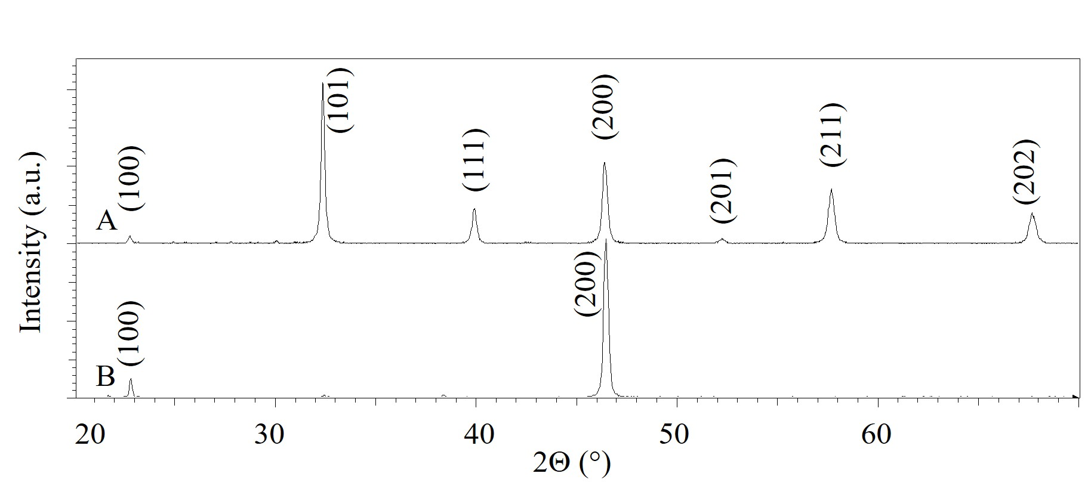
Figure 4: XRD patterns of SrTiO₃ powder prepared from BIT8 (pattern A) and SrTiO₃ plates cast on the Si single crystal (pattern B). XRD pattern of the SrTiO₃ plates deposited on the Si single crystal revealed that their preferential orientation was (100).
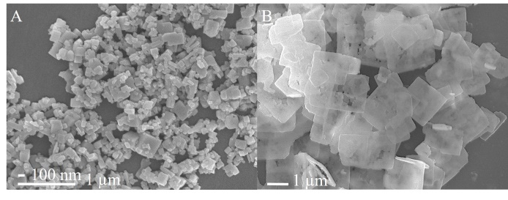
Figure 5: SEM micrographs of SrTiO₃ particles obtained from the topochemical conversion of different Bi₄Ti₃O₁₂ plate-like particles under the same hydrothermal reaction conditions (Sr:Ti molar ratio 3:1, 4-M NaOH, 200 °C for 12 hours). The SrTiO₃ particles A were prepared from the BIT2 template and the SrTiO₃ particles B were prepared from the BIT8 template.

- Conclusions
In the first part of this research the influence of molten-salt synthesis conditions on the morphology of Bi₄Ti₃O₁₂ plate-like particles was studied. The most appropriate conditions for the growth of μm-sized Bi₄Ti₃O₁₂ plates with a uniform size distribution are as follows: Bi:Ti molar ratio = 1.33 (stoichiometric), molar ratio of NaCl:KCl:Bi₄Ti₃O₁₂ = 25:25:1 and 2-hour reaction time at 800 °C.
In the second part of the study we proved that the as-prepared Bi₄Ti₃O₁₂ plates are an appropriate template for the preparation of plate-like (h00)-oriented SrTiO₃ plates using a topochemical conversion under hydrothermal conditions. We also confirmed that the type of TiO₂ precursor (P25 or anatase used for Bi₄Ti₃O₁₂ synthesis) has a great influence on the morphology of the formed Bi₄Ti₃O₁₂ plate-like particles, which, when transformed to SrTiO₃ under hydrothermal conditions, result in even more diverse morphologies. The photodegradation of RhB, BET and DSC measurements confirmed the difference between the used templates. These results also support the choice of template for the topochemical conversion of Bi₄Ti₃O₁₂ to SrTiO₃ under hydrothermal conditions.

Acknowledgement
The authors acknowledge the project J2-6753 and the M-era.Net project 3184 HarvEnPiez, which were financially supported by the Slovenian Research Agency and the Ministry of Higher Education Science and Technology, respectively. Alja Čontala is grateful to the Slovenian Research Agency for the financial support of her PhD study. The authors would like to thank Martyna Durko for performing the photocatalytic measurements.

- References
1. Z. Lazarevic, B. D. Stojanovic, J. A. Varela, Sci Sinter. 2005, 37, 199-216.
2. Z. Lazarevic, N. Rom, M. Todorovic, B. D. Stojanovic, Sci Sinter. 2007, 39, 177-184.
3. F. Zhang, T. Karaki, M. Adachi, Jpn J Appl Phys. 2006, 45, 7385-7388.
4. M. Villegas, C. Moure, J. F. Fernandez, P. Duran, J Mater Sci. 1996, 31, 949-955.
5. Y. G. Zhang, H. W. Zheng, J. X. Zhang, et al, Mater Lett. 2014, 125, 25-27.
6. M. G. Navarro-Rojero, J. J. Romero, F. Rubio-Marcos, J. F. Fernandez, Ceram Int. 2010, 36, 1319-1325.
7. M. Villegas, A. C. Caballero, C. Moure, P. Duran, J. F. Fernandez JF, J Am Ceram Soc. 1999, 82, 2411-2416.
8. T. Zaremba, J Therm Anal Calorim. 2008, 93, 829-832.
9. M. M. Kržmanc, B. Jančar, H. Uršič, M. Tramšek, D. Suvorov, Cryst Growth Des. 2017, 17, 3210-3220.
10. H. He, J. Yin, Y. Li, et al, Appl Catal B Environ. 2014, 156-157, 35-43.
11. Z. Chen, Y. Yu, J. Hu, A. Shui, X. He, J Ceram Soc Japan. 2009, 117, 264-267.
12. Q. Yang, Y. Li, Q. Yin, P. Wang, Y. B. Cheng, J Eur Ceram Soc. 2003, 23, 161-166.
13. Y. Chang, H. Ning, J. Wu, et al, Inorg Chem. 2014, 53, 1060-11067.
14. S. F. Poterala, Y. Chang, T, Clark, R. J. Meyer, G. L. Messinge, Chem Mater. 2010, 22, 2061-2068.
15. D. Liu, Y. Yan, H. Zhou, J Am Ceram Soc. 2007, 90, 1323-1326.
16. J. F. Cao, Y. X. Ji, Chinese Phys B. 2014, 23, 128104.
17. J. Cao, X. Huang, Y. Liu, J. Wu, Y. Ji, Mater Res Express. 2016, 3, 115903.
18. R. Asiaie, W. D. Zhu, S. A. Akbar, P. K. Dutta, Chem Mater. 1996, 8, 226-234.
19. H. I. Hsiang, F. S. Yen, Jpn J Appl Phys. 1993, 32, 5029-5035.
20. V. Kalyani, B. S. Vasile, A. Ianculescu, M. T. Buscaglia, V. Buscaglia, P. Nanni, Cryst Growth Des. 2012, 12, 4450-4456.

