Graphical Abstract

Synthesis, Characterization, Crystal structure and Molecular docking studies of a S-methyl-dithiocarbazate derivative: Bis[2-hydroxy benzylidene hydrazono)-(methylthio)-methyl]disulphide
Winaki P. Sohtun, Arunachalam Kannan, K. Hari Krishna, Dhandayutham Saravanan, M. Suresh Kumar, Marappan Velusamy

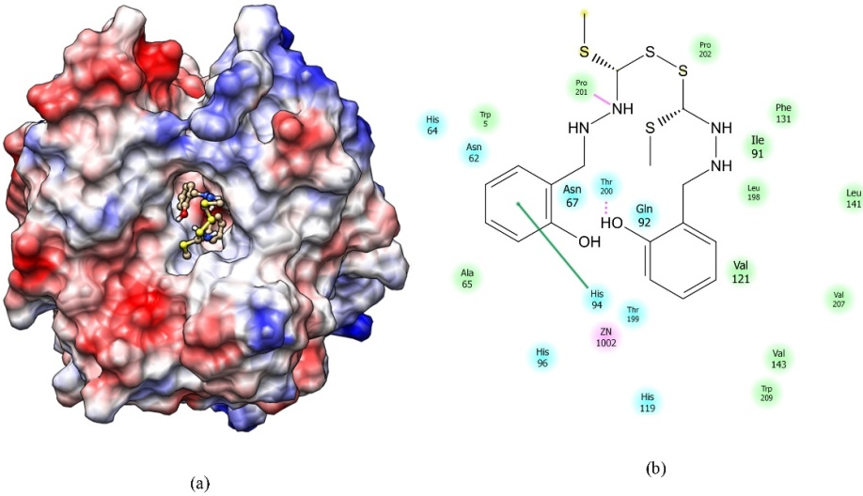

Synthesis and characterization of bis[2-hydroxy benzylidene hydrazono)(methylthio) -methyl]disulphide. The structure is confirmed by spectral data and single crystal X-ray analysis. Molecular docking results confirm the compound can act as a potent inhibitor for the carbonic anhydrase II.

