Hydrothermal Synthesis of Novel Magnetic Plate-Like Bi₂O₂CO₃-CoFe₂O₄ Hybrid Nanostructures and Their Catalytic Performance for the Reduction of Some Aromatic Nitrocompounds

Parisa Zarringhadam and Saeed Farhadi*
Department of Chemistry, Lorestan University, Khoramabad 68151-44316, Iran
*Corresponding author: Tel: +986633120611, fax: +986633120618
E-mail address: sfarhadi1348@yahoo.com (S. Farhadi)
_____________________________________________________________
Abstract
Novel magnetically separable Bi₂O₂CO₃-CoFe₂O₄ nanocomposites were prepared by a simple and feasible hydrothermal route. Fourier transform infrared (FT-IR) spectroscopy, X-ray diffraction (XRD), scanning electron microscopy (SEM), energy dispersive X-ray spectroscopy (EDX), transmission electron microscopy (TEM), X-ray photoelectron spectroscopy (XPS), UV-vis diffuse reflectance spectroscopy (DRS), vibrating sample magnetometer (VSM), and N₂ adsorption–desorption analysis were utilized to analyze the structure, morphology, particle size, phase composition, optical and magnetic properties of the as-synthesized nanocomposites. The results demonstrated the successful coupling of spherical CoFe₂O₄ nanoparticles and plate–like Bi₂O₂CO₃ nanostructures. The catalytic performance of magnetic Bi₂O₂CO₃-CoFe₂O₄ nanocamposites was evaluated in the reduction of some aromatic nitrocompounds such as nitrophenols and nitroanilines by using sodium borohydride (NaBH₄) aqueous solution at room temperature. The Bi₂O₂CO₃-CoFe₂O₄ nanocamposite with 30 %wt. CoFe₂O₄ exhibited the best performance in the reduction of aromatic nitrocompounds with 100% conversion into the corresponding amino compounds within 15-30 min with rate constant of 0.10-0.24 min⁻¹. The effect of catalyst dosage was also investigated on the efficiency of reduction process. Furthermore, magnetic Bi₂O₂CO₃-CoFe₂O₄ nanocomposite could be easily removed by an external magnet from the reaction system.
Keywords: Plate-like Bi₂O₂CO₃; Bismuth-based nanomaterials; Cobalt ferrite, Magnetic nanocomposite; Catalytic reduction; Nitrophenols.
_____________________________________________________________________________________
- Introduction
Nitrophenols are one of the most organic pollutants in industrial and agricultural waste waters.^{1,2} Nitrophenols and their derivatives are significant by-products produced from pesticides, herbicides and synthetic dyes.³⁻⁵ Among them, 4-nitrophenol (4-Np) is well known to cause damage to the central nervous system, liver, kidney and both animal and human blood. Hence its removal from the environment is a crucial task. ⁶⁻¹⁰ On the other hand, the reduction of 4-Np to 4-aminophenol (4-AP) is essential in pharmaceutical industries for the manufacture of analgesic, antipyretic and other drugs, in photographic developer, corrosion inhibitor, anticorrosion lubricant, etc.^{11,12} So, the conversion of 4-NP to 4-AP is an ideal way of wastewater treatment.
Over the past few decades, the catalytic reduction of nitrophonols using NaBH₄ as reducing agent in aqueous medium has received considerable attention as a relatively simple and clean method.¹³ Many reports are available on the application of metal and metal oxides nanocatalysts for the reduction of nitrophenols in the presence of NaBH₄. For example, Mandalimath and Gopal¹⁴ carried out nitrophenols reduction using NaBH₄ in the presence of first row transition metal oxides. Among them, CuO, Co₃O₄, Fe₂O₃, NiO oxides enhanced the reduction rate whereas TiO₂, V₂O₅, Cr₂O₃, MnO₂ and ZnO oxides were inactive. Au, Ag, Pd and Pt nanoparticles are most commonly used as efficient catalysts.^{15–22} However, the nanoscale metal or metal oxide particles are not very stable and easy to aggregate, and thus decrease their activity. In addition, the separation of them from the reaction mixture is an important issue. In order to solve these problems, many researchers are worked on the preparation of nanocomposites which combine the noble metal with magnetic materials. The magnetic nanocomposites can be separated from the reaction mixture using an external magnet thus it eliminates the necessity of catalyst filtration, prevents the loss of catalyst and renders the catalyst cost effective. Doong and Lin²³ used Au–Fe₃O₄ heterostructures for magnetically recyclable catalysis of nitrophenol reduction. Cai and Jiang²⁴ synthesized the Ag@Pd satellites-Fe₃O₄ core nanocomposites, which exhibited great catalytic reactivity towards 4-NP reduction. He and Gao²⁵ used Pt/Fe₃O₄ nanoparticles decorated carbon nanotubes as catalysts for the reduction of nitrophenols. Du et al.²⁶ exploited the nanocomposite Fe₃O₄/SiO₂/Ag of microspheres shape for the reduction of nitrophenol in aqueous medium at room temperature as a magnetic separable catalyst. In such approaches, although nanocomposites showed improved recyclability, they suffered from one or more drawbacks such as the usage of expensive noble metals, and the multi-step preparation procedures. Hence, the development of an alternative inexpensive, facile and easy-removal magnetic catalyst for the reduction of nitrophenols is highly desirable in the context of environmental and industrial concerns.
In recent years, bismuth-based nanostructured materials, such as Bi₂O₃,²⁷ BiVO₄,²⁸ Bi₂WO₆,²⁹ Bi₂MoO₆,^{30,31} BiOX (X = Cl, Br, I), and so on,^{32–34} have received a great deal of attention due to their unique catalytic and photocatalytic activities. Among these compounds, some studies have focused on the fabrication of bismuth subcarbonate (Bi₂O₂CO₃) and its composites.³⁵ Up to now, many kinds of Bi₂O₂CO₃-based hybrid composites such as Bi₂O₂CO₃–β-Bi₂O₃,³⁶ Bi₂O₂CO₃–MoS₂,³⁷ (BiO)₂CO₃–BiOX (X= Cl, Br and I),³⁸⁻⁴⁰ Bi₂O₂CO₃/Bi₂WO₆,⁴¹ Bi₂O₂CO₃–Bi₂S₃⁴², Bi₂O₂CO₃–CdS,⁴³ Bi₂O₂CO₃–BiPO₄,⁴⁴ g-C₃N₄–Bi₂O₂CO₃,⁴⁵ Ag₂O–Bi₂O₂CO₃,⁴⁶ Ag-AgBr–Bi₂O₂CO₃,⁴⁷ Ag₃PO₄–Bi₂O₂CO₃,⁴⁸ Ag2CO3–Bi2O2CO3,⁴⁹ and MWCNTs–Bi₂O₂CO₃⁵⁰ have been successfully synthesized, which showed enhanced catalytic or photocatalytic stability and activity than Bi₂O₂CO₃ alone. But these composites are difficult to separate and recycle, seriously limiting their extensive application. Therefore, fabrication of well-defined and easy separated Bi₂O₂CO₃-based catalysts from the suspended reaction system via a simple process remains to be a great challenge. To overcome this shortfall, coupling Bi₂O₂CO₃ with magnetic materials is highly desirable. Magnetic based materials can be easily recovered by a magnet and can be reused for catalysis reaction several times without any appreciable reduction in catalytic efficiency.⁵¹ Although pure magnetic materials are easily recovered, their catalytic activities are very weak. They usually take long time to degrade the organic pollutant. Therefore, it is desirable to couple the magnetic catalyst with catalyst having high catalytic efficiency. Such composite catalysts can exhibit good magnet-controlled recyclability as well as superior catalytic activity with improved stability. In this regard, cubic CoFe₂O₄ is known to have high magnetic performance as well as excellent chemical stability. CoFe₂O₄ nanoparticles themselves have a strong magnetic property, and therefore, CoFe₂O₄ based composites can be magnetically separable in a suspension by virtue of their own magnetic properties without introduction of additional magnetic particles. Based on the previous studies, it can be expected that the modification of Bi₂O₂CO₃ with CoFe₂O₄ to form Bi₂O₂CO₃-CoFe₂O₄ nanocomposites may improve the catalytic activity and recyclability. Furthermore, their magnetic nature makes composites magnetically separable from the reaction mixture in a convenient manner. As far as we know, there is still no report about CoFe₂O₄-modified Bi₂O₂CO₃ until now.
On the basis of the aforementioned considerations, in this work, novel magnetically separable Bi₂O₂CO₃-CoFe₂O₄ nanocomposits with high catalytic performance were synthesized through loading different amounts of CoFe₂O₄ nanoparticles on the surface of plate-like Bi₂O₂CO₃ nanostrucures by a hydrothermal method at 180 °C for 24 h. The structure, morphology, and optical properties of the obtained nanomaterials were characterized in detail. Then, the excellent catalytic activity of the as-prepared Bi₂O₂CO₃-CoFe₂O₄ composite nanomaterials was evaluated by the reduction of 4-nitrophenol in the presence of aqueous NaBH₄ solution under ambient conditions. In addition, the possible reaction mechanism was also proposed based on the experimental results. This study provides a promising candidate for efficient removal of nitrophenols from water by an environment-friendly and economical approach.
2. Experimental
2. 1. Materials
Bismuth nitrate pentahydrate (Bi(NO₃)₃.5H₂O, 98%), citric acid (98.5%), cobalt(II) nitrate hexahydrate (Co(NO₃)₂.6H₂O, 98%), iron(III) nitrat nanohydrate (Fe(NO₃)₃.9H₂O, 98%), sodium borohydride (NaBH₄, 98.5% ), 2-nitrophenol (2-NP, 99%), 4-nitrophenol (4-NP, 98%), 2-nitroaniline (2-NA, 99%) and 4-nitroaniline (4-NA, 99%) were obtained from Merck chemical company and used as received without further purification. All other chemicals were of analytical grade, commercially available and used without further purification.
2.2. Preparation of CoFe₂O₄ Nanoparticles
CoFe₂O₄ nanoparticles were prepared by hydrothermal process. Fe(NO₃)₃.9H₂O (1.72 g) and Co(NO₃)₂.6H₂O (0.62g) were dissolved in 25 mL distilled water (Co/Fe mole ratio of 1:2), and then the solution was adjusted to a pH of 12 with NaOH 6 M. After stirring for 60 min, the mixture was transferred to a 50 mL Teflon-lined stainless steel autoclave and maintained at 180 °C for 12 h before being cooled down in air. The resulting precipitate was filtered, washed with deionized water and ethanol, and dried at 60 °C for 6 h.
2.3. Preparation of Bi₂O₂CO₃-CoFe₂O₄ Nanocomposites
To synthesize Bi₂O₂CO₃-CoFe₂O₄ nanocomposites, 2.0 mmol of Bi(NO₃)₃.5H₂O was dissolved in 20 mL of 1 M HNO₃, and then 1.5 mmol of citric acid (C₆H₈O₇) was added under magnetic stirring. The pH of the solution was adjusted to 6 by adding 2 M NaOH aqueous solution under magnetic stirring. Then, the required amount of CoFe₂O₄ nanoparticles (30 and 45 wt%) was added to the Bi₂O₂CO₃ precursor suspension. After sonication for 30 min, the homogenized suspension was transferred into a 50 ml Teflon-lined stainless steel autoclave, sealed and maintained at 180 °C for 24 h. Then, the autoclave was naturally cooled down to room temperature and the resulting precipitate was separated by a magnet, washed with deionized water several times, dried at 60 °C and used for further characterization. The obtained samples with 30 and 45 wt% CoFe₂O₄ nanoparticles were denoted as Bi₂O₂CO₃-CoFe₂O₄30% and Bi₂O₂CO₃-CoFe₂O₄45%, respectively. For comparison, pure plate-like Bi₂O₂CO₃ nanostructure was synthesized according to the typical synthesis described above when CoFe₂O₄ was absent.
2.4. Materials Characterization
FT-IR spectra were recorded on a Schimadzu system FT-IR 8400S spectrophotometer in transmission mode from 4000 to 400 cm⁻¹ using KBr pellets. the XRD patterns of the samples were obtained on an X-ray diffractometer (Rigaku D-max C III) using Ni-ﬁltered Cu Kα radiation (λ=1.5406 Å) UV–vis diffuse reflection spectroscopy (DRS) was performed on a Snico S4100 spectrophotometer over the spectral range 200–1000 nm by using BaSO₄ as the reference. The shapes and morphologies of samples were observed by a MIRA3 TESCAN field emission scanning electron microscope (FESEM) equipped with a link energy-dispersive X-ray (EDX) analyzer. The particle size was determined by a CM120 transmission electron microscope (TEM) at an accelerating voltage of 80 kV. TEM samples were prepared by dropping the ethanol dispersion on a carbon coated copper grid. A PHS-1020 PHSCHINA instrument was used to measure the Brunauer-Emmett-Teller (BET) surface areas of the samples at liquid nitrogen temperature (77 K). Specific surface area calculations were made using Brunauer-Emmett-Teller (BET) method at the relative pressure (p/p₀) between 0.05 and 0.35. Magnetic measurements were carried out at room temperature using a vibrating sample magnetometer (VSM, Magnetic Daneshpajoh Kashan Co., Iran) with a maximum magnetic field of 10 kOe. X-ray photoelectron spectroscopy (XPS) was conducted using a thermo Scientifi, ESCALAB 250Xi, Mg X-ray resource instrument. UV-vis spectra of aqueous solutions of nitro compounds during the reduction reaction were analyzed using a Cary 100 double beam spectrophotometer operated at a resolution of 2 nm with quartz cells with path length of 1 cm in the wavelength range of 200 to 600 nm.
2.5. Catalytic Tests
The catalytic performance of the synthesized Bi₂O₂CO₃-CoFe₂O₄ nanocomposites in the reduction of 4-nitrophenol (4-NP) to 4-amiophenol (4-AP) was evaluated by excess aqueous NaBH₄ solution at room temperature. In a typical catalytic reaction, 2 mL of aqueous solution of 4-NP (0.2 mM) and 0.5 mL of aqueous NaBH₄ (0.02M) solution were mixed together in a standard quartz cell, having 1 cm path length and then a selected amount of Bi₂O₂CO₃-CoFe₂O₄ nanocomposite (e.g. 5 mg) was added to the reaction mixture under magnetic stirring. Then, the mixture was transferred to a standard quartz cell, and the concentration of 4-NP in the reaction mixture was monitored by the UV−visible absorption spectra recorded with a time interval of 2 min in a scanning range of 200–600 nm at ambient temperature. The effect of the catalyst dosage (2.5, 5, 10, 15, and 20 mg/in 2.5 mL solutions) was studied on the reduction of 4-NP. In order to confirm the effectiveness of the catalytic activity of the Bi₂O₂CO₃-CoFe₂O₄ nanocomposites, the reductions of 2-nitrophenol (2-NP) and 2-nitroaniline (2-NA) and 4-nitroaniline (4-NA) were also carried out under the same conditions. In addition, the photocatalytic activity of pure Bi₂O₂CO₃ and CoFe₂O₄ were also investigated under the same conditions. For recycling experiments, the Bi₂O₂CO₃-CoFe₂O₄ catalyst was recovered from the solution by an external magnet after completion of the reaction. The magnetically recovered catalyst was washed repeatedly with deionized water, dried at 60 °C and then employed for a new run.
3. Results and Discussion
3.2. Characterization of Bi₂O₂CO₃-CoFe₂O₄ Nanocomposites
FT-IR spectra of the as-prepared Bi₂O₂CO₃, CoFe₂O₄ and Bi₂O₂CO₃-CoFe₂O₄ samples are indicated in Fig.1. For pure Bi₂O₂CO₃ sample in Fig. 1(a), the sharp peaks at ca. 1400 and 845 cm⁻¹ are the characteristic stretching and bending vibrations of CO₃²⁻ groups, respectively.⁵² Meanwhile, the intensive peak at about 550 cm⁻¹ was attributed to the stretching vibration of the Bi-O, suggesting the formation of Bi₂O₂CO₃.⁵³ In the case of CoFe₂O₄ (Fig. 1(b)), the two peaks appeared at 603 and 458 cm⁻¹ are related to the stretching vibrations of M−O bonds in the tetrahedral and octahedral sites of spinel-type oxide, respectively.^{54,55} The FT-IR spectra of the Bi₂O₂CO₃-CoFe₂O₄ samples in Fig. 1(c)-(d), show the representative CO₃²⁻ group stretching and bending vibrations at about 1400 and 844 cm⁻¹, besides two characteristic absorption bands of CoFe₂O₄ in the 400-600 cm⁻¹ range. In addition, it can also be observed that the intensities of two characteristic bands of CoFe₂O₄ increased with increasing the amount of CoFe₂O₄ in the composites.
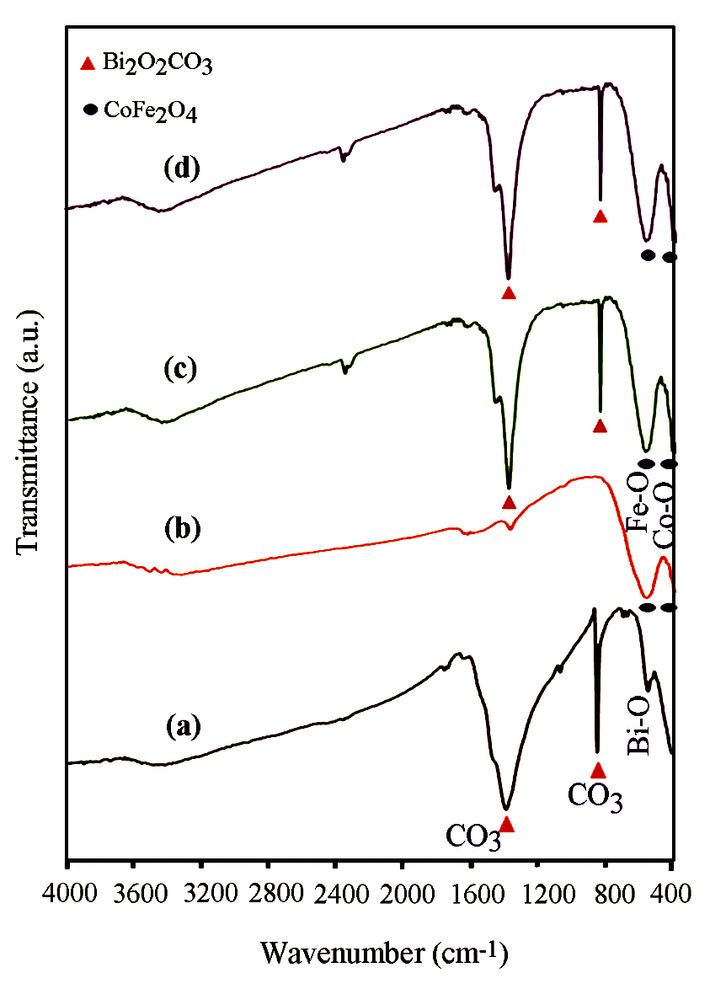
Fig. 1. FT-IR spectra of (a) Bi₂O₂CO₃, (b) CoFe₂O₄ (c) Bi₂O₂CO₃-CoFe₂O₄30%, and (d Bi₂O₂CO₃-CoFe₂O₄45%
The crystal structure of samples was further characterized using XRD. Fig. 2 shows the XRD patterns of the Bi₂O₂CO₃, CoFe₂O₄ and Bi₂O₂CO₃-CoFe₂O₄ nanocomposites with different contents of CoFe₂O₄. The patterns of Fig. 2(a) and (b) are well consistent with the tetragonal Bi₂O₂CO₃ phase (JCPDS no. 41-1488) and the spinel-type CoFe₂O₄ phase (JCPDS no. 01-1121). As shown in Fig. 2(c) and (d), all the Bi₂O₂CO₃-CoFe₂O₄ samples exhibit a coexistence of both Bi₂O₂CO₃ and CoFe₂O₄ phases without any impurity phase, indicating successful synthesis of composites. Besides, the intensity of characteristic CoFe₂O₄ peaks at 2θ = 35.76 and 63.13 in nanocomposite increased with increasing CoFe₂O₄ amount. Besides, the diffraction peaks of Bi₂O₂CO₃-CoFe₂O₄ nanocomposites exhibited sharp and intense state, indicating a promising crystalline nature which was beneficial for the following catalytic activity.
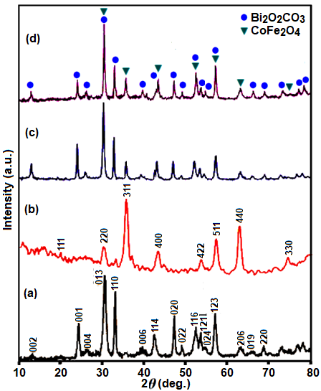
Fig. 2. XRD patterns of (a) Bi₂O₂CO₃, (b) CoFe₂O₄, (c) Bi₂O₂CO₃-CoFe₂O₄30%, and (d) Bi₂O₂CO₃-CoFe₂O₄45%

The shape and morphology of the as-synthesized CoFe₂O₄, Bi₂O₂CO₃ and Bi₂O₂CO₃-CoFe₂O₄ samples were investigated by FE-SEM, and the results are shown in Fig. 3. The SEM images of CoFe₂O₄ sample in Fig. 3(a) and (b) show a large quantity of nearly uniform monodispersed spheres with an average diameter of about 15 nm. The SEM images in Fig. 3(c) and (d) show that the bare Bi₂O₂CO₃ sample was formed from plate-like particles which were loosely aggregated. As can be observed, the porous structure was formed by self-assembly of these nanoplates. SEM images of the Bi₂O₂CO₃-CoFe₂O₄30% nanocomposite are shown in Fig. 3(e) and (f). From the SEM images in Fig. 4(a)-(d), it is evident that the shape and morphology of Bi₂O₂CO₃-CoFe₂O₄30% are similar to those of the pure Bi₂O₂CO₃, but many spherical CoFe₂O₄ nanoparticles are observed on the surface of plate-like Bi₂O₂CO₃ nanostructures. From images, it can be clearly seen that a lot of spherical CoFe₂O₄ nanoparticles with a size of about 15–20 nm were well deposited on Bi₂O₂CO₃ nanoplates.
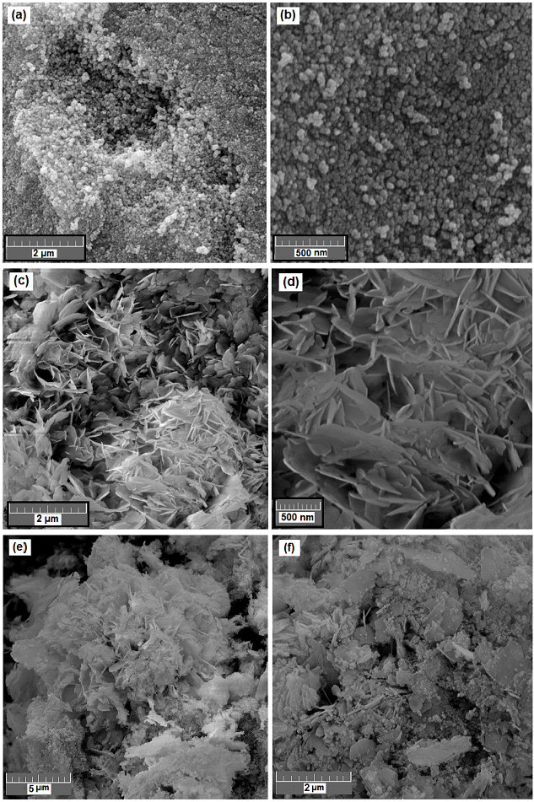

Fig. 3. SEM images of CoFe₂O₄ (a and b), Bi₂O₂CO₃ (c and d) and Bi₂O₂CO₃-CoFe₂O₄30% (e and f) samples
The size and microstructure of the as-prepared Bi₂O₂CO₃-CoFe₂O₄30% sample were further investigated by TEM. The sample powder was sonicated in ethanol for 30 min and a drop of the suspension was dried on a carbon-coated microgrid for TEM measurements. The TEM images in Fig. 4 show that the obtained nanocomposite was formed mainly from plate-like particles with a weak agglomeration. From the TEM images in Fig. 4(a)-(d), it is clear that the Bi₂O₂CO₃-CoFe₂O₄ contains a plate-like structure with the lengths of 15–40 nm and thicknesses of several nanometers while CoFe₂O₄ nanoparticles show sphere-like shapes. It is evident from the TEM images that the nanoplates exhibit mostly square-like shapes, though some are rectangular. As can be observed, many spherical CoFe₂O₄ dark-color particles are observed to be deposited on the surface of bright plates of the Bi₂O₂CO₃. The average size of CoFe₂O₄ particles was calculated to be 15 nm from the measurements on the TEM micrographs which is in close agreement with the size obtained from XRD analysis. As evident from the images, the morphology of the Bi₂O₂CO₃-CoFe₂O₄3% sample from TEM images agreed with the SEM results.

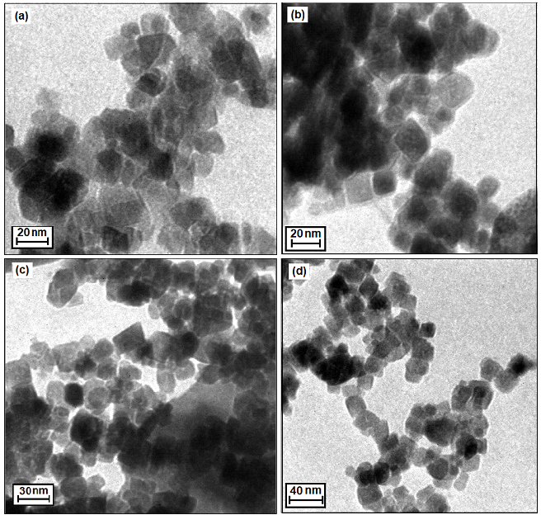
Fig. 4. TEM images of as-prepared Bi₂O₂CO₃-CoFe₂O₄30% sample.

The energy dispersive X-ray spectroscopy (EDX) was used to characterize the elemental composition of the as-prepared samples. The EDX spectra of CoFe₂O₄, Bi₂O₂CO₃ and Bi₂O₂CO₃-CoFe₂O₄-30% are shown in Fig. 5. The EDX spectrum of CoFe₂O₄ in Fig. 5a shows the presence of Ni, Fe and O elements and the EDX spectrum Bi₂O₂CO₃ (Fig. 5b) shows the existence of Bi, C and O elements. As observed in Fig. 5(c), the EDX elemental spectrum of the nanocomposite sample exhibits elemental peaks corresponding to both CoFe₂O₄ and Bi₂O₂CO₃ and no other impure peaks can be observed, indicating that the composite sample is composed of CoFe₂O₄ and Bi₂O₂CO₃ and the Bi₂O₂CO₃-CoFe₂O₄30% nanocomposites have been successfully prepared. In all samples, the presence of Au peak at 2.2 KeV is due to SEM-EDX sample holder.
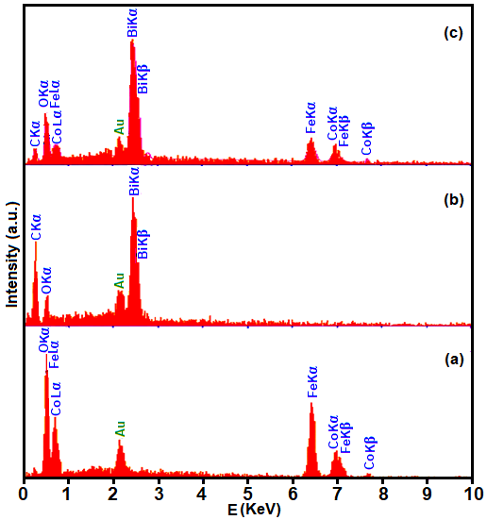
Fig. 5. EDX spectra of (a) CoFe₂O₄, (b) Bi₂O₂CO₃ and (c) Bi₂O₂CO₃-CoFe₂O₄30% nanocomposite.
To further determine the composition and element distributions of Bi₂O₂CO₃-CoFe₂O₄30% composite, EDX mapping measurements were also carried out. Fig. 6 shows a representative SEM image of the nanocomposite with corresponding EDX elemental mappings. From the maps in Fig 6(b)-(f), it can be seen that the Bi, C, O, Co and Fe elements are uniformly distributed over the sample, confirming the homogeneity of the nanocomposite. The EDX elemental mappings of the Bi₂O₂CO₃-CoFe₂O₄30% composite (Fig. 6(e) and (f)) display that the elements of Co and Fe from CoFe₂O₄ phase are distributed on the surface of the Bi₂O₂CO₃. The EDX mappings results further indicate that the Bi₂O₂CO₃-CoFe₂O₄ nanocomposites have been successfully synthesized.
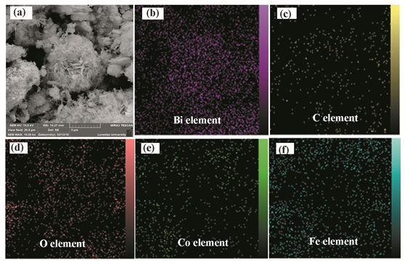
Fig. 6. SEM image of the Bi₂O₂CO₃-CoFe₂O₄30% nanocomposite with corresponding EDX elemental mappings.
The optical properties of the as-prepared Bi₂O₂CO₃, CoFe₂O₄ and Bi₂O₂CO₃-CoFe₂O₄ composites were investigated by the diffuse reflectance UV-vis spectra (DRS) absorption spectroscopy. Fig. 7(a) displays the UV-vis diffuse reflectance spectra of the Bi₂O₂CO₃-CoFe₂O₄ composite with 30% w/w of CoFe₂O₄, together with those of Bi₂O₂CO₃ and CoFe₂O₄. Bare Bi₂O₂CO₃ shows absorption edge at ~400 nm (Fig. 7(a), curve i) whereas pure CoFe₂O₄ shows good absorbance in the visible light region up to 490 nm (Fig. 7(a), curve ii). As can be seen in curve iii of Fig. 7(a), the UV-vis band of Bi₂O₂CO₃-CoFe₂O₄ nanocomposite indicates an enhancement in absorption intensity in the visible region together with a red shift, compared to that of the pure Bi₂O₂CO₃ due to the coupling with CoFe₂O₄ phase. The band gaps (Egs) of these three samples were calculated by the following formula based on the DRS results: ⁵⁷
(αhv)^{1/2} =B(hv-Eg)
Where α, h, v and B are absorption coefficient, plank constant, light frequency, and a constant, respectively. Therefore, Eg value of the samples can be estimated from a plot (αhv)^{1/2} versus photon energy (hv). The intercept of the tangent to the x axis would give an approximation of the band-gap energy of the samples (Fig. 7(b)). The Eg values of pure Bi₂O₂CO₃ and CoFe₂O₄ were found to be 3.49 and 2.79 eV, respectively. As evident from curve iii in Fig.7(b), the Bi₂O₂CO₃-CoFe₂O₄30% composite shows a band gaps at 2.89 eV with a red shift compared to that of the pure BOC (3.49 eV), indicating formation of hybrid heterostructures.
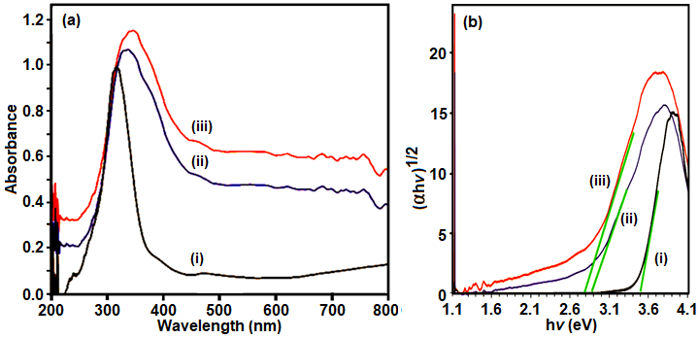
Fig. 7. (a) UV-vis diffuse reflectance spectra and (b) (ɑhv)² versus hv curves of (i) pure Bi₂O₂CO₃ (ii) Bi₂O₂CO₃-CoFe₂O₄30% and (iii) CoFe₂O₄.
The elemental composition and oxidation states of Bi₂O₂CO₃-CoFe₂O₄30% sample were carefully analyzed by XPS. The full XPS spectrum in Fig. 8(a) shows that the sample consists of Bi, O, C, Co and Fe elements, in consistent with the EDX results. In order to further investigate the chemical state of each element, the high-resolution XPS spectra of Bi 4f, C 1s, O 1s, Co 2p and Fe 2p for the as-prepared Bi₂O₂CO₃-CoFe₂O₄30% are separately shown in Fig. 8(b)-(e). As shown in Fig. 8(b), the peaks located at binding energies of 159.08 and 164.39 eV are attributed to Bi 4f_{7/2} and Bi 4f_{5/2}, respectively, indicating the existence of Bi³⁺ ions in the sample.⁵⁸ In Fig. 8(c), the peak at 284.78 eV is attributed to carbon reference, while the peak at 288.73 eV corresponds to the carbon of carbonate ion (CO₃²⁻) in Bi₂O₂CO₃.⁵⁸ For the oxygen element (Fig. 8(d)), the O 1s peaks are well fitted into three different peaks at 529.73 eV, 530.68eV and 532 eV. According to the experiment results, the peak located at 529.73 eV is arisen from Bi-O in Bi₂O₂CO₃ while that at 530.63 eV is from CO₃²⁻ species and CoFe₂O₄.⁵⁹ Other small peak at higher binding energy of 532 eV can be attributed to the presence of surface-chemisorbed adsorbed H₂O.⁶⁰ As shown in Fig. 8(e), the peaks at 979.91 eV and 795.67 eV could be assigned to Co 2p_{3/2} and Co 2p_{1/2}, respectively, shouldering with satellite peaks at 785.29 eV and 802.27 eV. Fig. 3(f) shows Fe 2p peaks at binding energies of 710.35 eV (Fe 2p_{3/2}) and 724.24 eV (Fe 2p_{1/2}) with weak satellite peaks at 718.50 eV and 733.04 eV. The observed Co 2p and Fe 2p photoelectron peaks are consistent with those reported for Co²⁺ and Fe³⁺ in CoFe₂O₄.⁶¹ The above results can powerfully support the presence of CoFe₂O₄ in the as-prepared Bi₂O₂CO₃-CoFe₂O₄ sample, implying the formation of heterojunction between CoFe₂O₄ and Bi₂O₂CO₃ in the resulted composite.
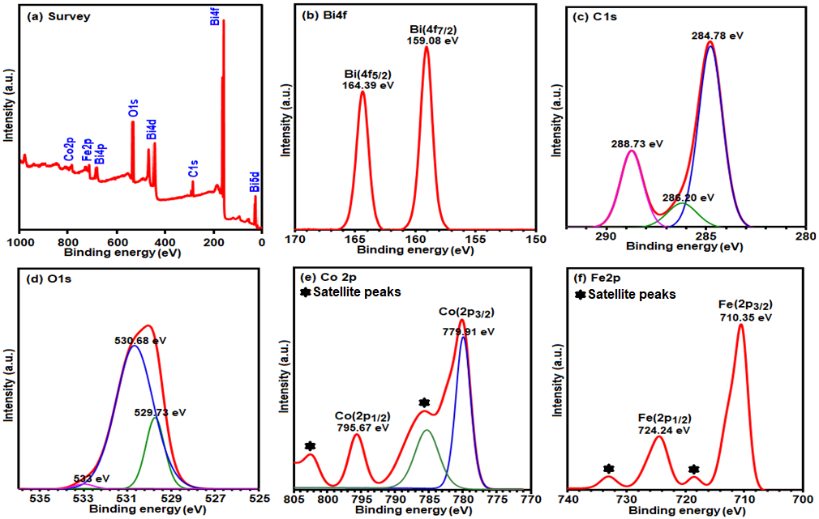

Fig. 8. (a) XPS survey spectrum of the Bi₂O₂CO₃-CoFe₂O₄30% nanocomposite. High-resolution XPS spectra of (b) Bi 4f, (c) C 1s, (d) O 1s, (e) Co 2p and (f) Fe 2p.
The BET surface areas and porous structures of the Bi₂O₂CO₃-CoFe₂O₄ composite were investigated based on nitrogen adsorption–desorption. Fig. 9 gives the adsorption–desorption isotherms of N₂, and the corresponding pore size distribution curve (the inset) of the Bi₂O₂CO₃-CoFe₂O₄30% sample. As observed in Fig. 9, the sample shows a type-III isotherm according to the IUPAC classification.⁶² The isotherm shows a distinct H3 hysteresis loop in the relatively high pressure range (p/p₀ = 0.8–1). Generally, it is believed that the H3 hysteresis loop is related to the mesopores through the aggregates of plate-like particles which were further observed from the corresponding pore size distribution curve in the inset of Fig 9.⁶³ The obtained BET specific surface area of the Bi₂O₂CO₃-CoFe₂O₄30% sample is 88.09 m² g⁻¹, whereas that of the Bi₂O₂CO₃ sample is 8.7 m² g⁻¹.⁶³ Accordingly, it is clear that the BET surface area of the Bi₂O₂CO₃-CoFe₂O₄30% catalyst is much larger (about10 times) than that of pure Bi₂O₂CO₃. The increased surface area may be also beneficial for the increase of active sites and catalytic activities. The total pore volume is and 0.297 cm³/g and the average pore size of this sample is 1.27 nm, which is estimated using the Barrett–Joyner–Halenda (BJH) method from the adsorption branch of the N₂ isotherm as shown in the inset of Fig. 9.
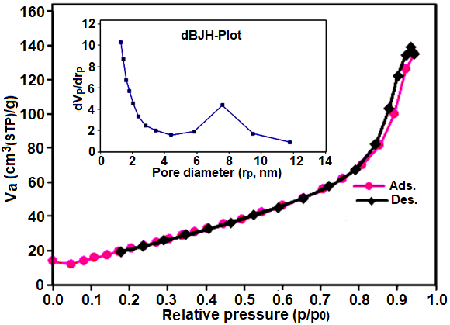
Fig. 9. N₂ adsorption–desorption isotherm of the Bi₂O₂CO₃-CoFe₂O₄30% sample. The inset is the pore size distribution curve.
Fig. 10 shows the magnetization measurement for the as-prepared Bi₂O₂CO₃-CoFe₂O₄ nanocomposites and pure CoFe₂O₄, using a vibrating sample magnetometer (VSM) at room temperature. The magnetization curves of the nanocomposites undoubtedly indicate ferromagnetism orders due to the presence of ferromagnetic CoFe₂O₄ nanoparticles. The saturation magnetization values of Bi₂O₂CO₃-CoFe₂O₄30%, Bi₂O₂CO₃-CoFe₂O₄40% and pure CoFe₂O₄ were found to be 17.15, 28.68 and 63.36 emu/g, respectively. The saturation magnetizations of the magnetic nanocomposites decrease compared with that of pure CoFe₂O₄, which can be attributed to the nano-magnetic Bi₂O₂CO₃ component. As demonstrated in the inset of Fig. 10, complete separation of the catalyst colloids from the solution can be achieved under an external magnetic field. The rapid and easy magnetically separation of hybrid from water will assure the effective collection of the used catalysts and avoid the loss of nanoparticles for environmental risks.
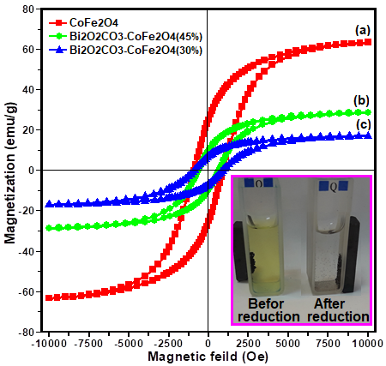
Fig. 10. Magnetization curves of (a) Bi₂O₂CO₃-CoFe₂O₄30%, (b) Bi₂O₂CO₃-CoFe₂O₄45% and (c) pure CoFe₂O₄, The photo inset shows magnetic separation of the nanocomposite catalyst before and after the reduction of 4-NP by NaBH₄.
3.2. Catalytic Reduction of 4-Nitrophenol
To investigate the catalytic activities of Bi₂O₂CO₃-CoFe₂O₄ nanostructures with different contents of CoFe₂O₄, the reduction of 4-nitrophenol (4-NP) to 4-amiophenol (4-AP) by excess NaBH₄ in aqueous solution was used as the model reaction (Fig. 11). Usually, 4-NP solution exhibits a strong absorption peak at 317 nm and a weak shoulder peak at 400 nm in the region of 250–550 nm.⁶⁴ After alkali NaBH₄ is added into 4-NP solution, the absorption peak at 317 nm disappears; only the one at 400 nm exists and markedly increases, which should be attributed to the production of the intermediate state, 4-nitrophenolate ion.⁶⁵ The intermediate can stably exist for a couple of day still a catalyst is introduced into the above system. Here, the peak at 400 nm gradually decreases, and concomitantly, a new peak at 305 nm appears due to the production of 4-AP.^{66,67} Fig. 11(a) exhibits the UV–vis absorption spectra of the 4-NP-NaBH₄-H₂O system after reacting for various durations in the presence of 5 mg pure Bi₂O₂CO₃ nanostructures. One can easily find that the peak intensity at 400 nm markedly decreases with the prolonging of the reaction time and disappeared after 32 min. However, Bi₂O₂CO₃ nanostructures with different contents of CoFe₂O₄ exhibit different catalytic activities for the reduction of 4-NP. As shown in Fig. 11(b), it merely took 20 min to completely convert 4-NP to 4-AP in the presence of Bi₂O₂CO₃-CoFe₂O₄30% nanocomposite. After the same amount of Bi₂O₂CO₃-CoFe₂O₄45% was used as the catalyst, it took 60 min to complete the reaction (Fig. 11(c)). Namely, among various samples, Bi₂O₂CO₃-CoFe₂O₄30% bears the strongest catalytic activity. Introduction of CoFe₂O₄ in the composite significantly improves the catalytic activities of Bi₂O₂CO₃. However, an excess addition of CoFe₂O₄ showed decrease in catalytic efficiencies. In the present work, the reduction reaction of 4-NP to 4-AP could be reasonably assumed as a pseudo-first-order kinetics with regard to 4-NP owing to the presence of excess NaBH₄. This pseudo-first-order kinetics equation can be described as lnC₀/C_{t} = kt. Here, C₀ and C_{t} represent the initial and instantaneous concentrations of 4-NP, respectively; and k and t stand for the apparent rate constant and the reaction time in turn. The apparent rate constant values were calculated from the slope of plot of ln (C₀/C_{t}) versus reaction time (Fig. 11(d)). The apparent rate constant (k) value for the Bi₂O₂CO₃-CoFe₂O₄30% sample (0.20 min ⁻¹) was estimated which is higher than Bi₂O₂CO₃-CoFe₂O₄45% (0.04 min⁻¹) and pure Bi₂O₂CO₃ (0.13 min⁻¹) samples. From the observed results, it was evident that the catalytic activity deteriorates with increasing CoFe₂O₄ content, showing that the loading percentage and intimate contact between two materials play an important role in determining catalytic efficiency. This means that with higher content of CoFe₂O₄ the number of the active catalytic reaction sites decreases and cause a negative influence on the catalytic processes. Excessive amount of CoFe₂O₄ may cover the active sites at the surface of Bi₂O₂CO₃ and also could hinder the contact with 4-NP. It could be further confirmed from the catalytic activity results that the low optimal molar ratio of Bi₂O₂CO₃-CoFe₂O₄30% is good for increasing surface active sites and increasing catalytic performance. The highest catalytic performance of Bi₂O₂CO₃-CoFe₂O₄30% composite can be attributed to intimate contact between Bi₂O₂CO₃ and CoFe₂O₄ which facilitates the electron transfer. Moreover, the existence of CoFe₂O₄ in composites makes them magnetically separable during catalytic reactions.
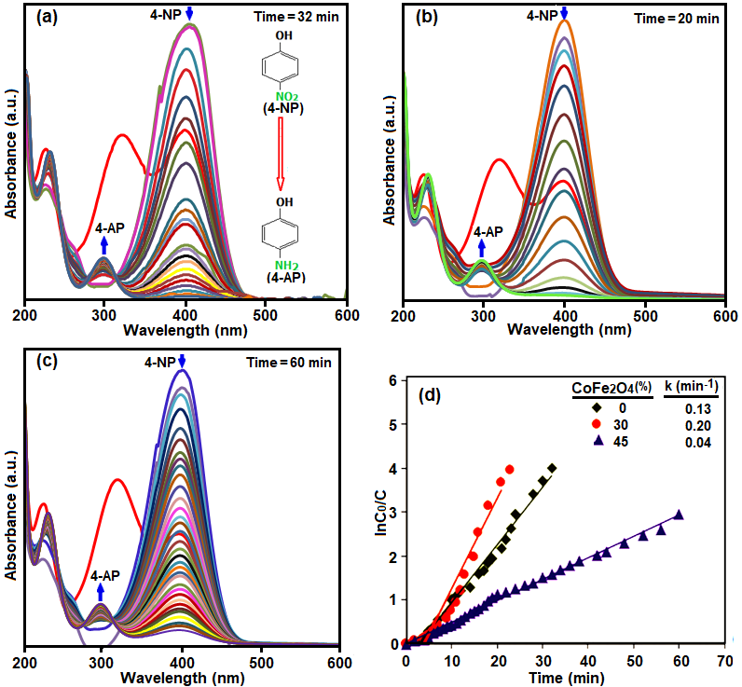
Fig. 11. UV-vis spectral changes during the reduction of 4-NP with NaBH₄ over different catalysts: (a) pure Bi₂O₂CO₃, (b) Bi₂O₂CO₃-CoFe₂O₄30%, (c) Bi₂O₂CO₃-CoFe₂O₄45%. (d) plot of ln(C₀/C_{t}) against the reaction time (the inset is the apparent rate constant values). Conditions: 4-NP (2 mL, 0.2 mM), catalyst (5.0 mg), NaBH₄ (0.5 mL, 20 mM), at 25˚C
The effect of the catalyst amount on the catalytic efficiency was investigated as well. Fig. 12(a) shows linear relationships between ln(C₀/C_{t}) and the reaction time in the presence of different amounts of Bi₂O₂CO₃-CoFe₂O₄30% nanostructure. As can be observed from Fig. 12(b), the k_{app} increased as the concentration of Bi₂O₂CO₃-CoFe₂O₄30% catalyst increasing from 2.5 to 20 mg. The rate constants (k_{app)} of 4-NP reduction reaction were calculated to be 0.04, 0.20, 0.51, 0.63 and 0.66 min⁻¹ from the slope of the straight with various amount of Bi₂O₂CO₃-CoFe₂O₄30% catalyst (Fig. 12(b)). A higher dosage of Bi₂O₂CO₃-CoFe₂O₄30% nanocomposite in the solution provides more active sites for the generation of H₂ and e⁻ (from NaBH₄), led to an increased reaction rate.
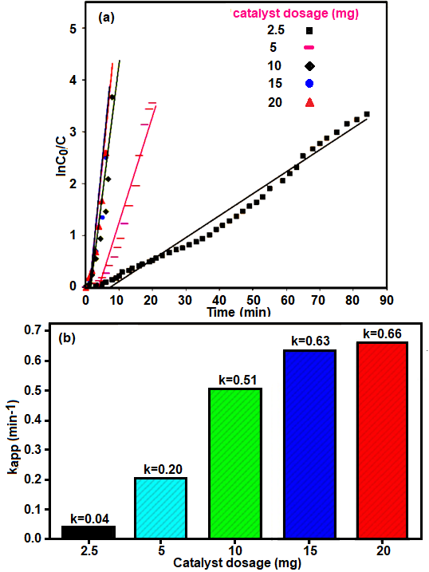
Fig. 12 (a) plot of ln (C₀/C) against the reaction time in the presence of different amounts of Bi₂O₂CO₃-CoFe₂O₄30% catalyst, and (b) the apparent rate constant values). Conditions: nitro compounds (2 mL, 0.2 mM) and NaBH4 (0.5 mL, 0.02 M), at 25˚C were used in all reactions.
Furthermore, it was found that the present catalyst could also catalyze the reduction of other aromatic nitrocompounds including 4-nitroaniline (4-NA), 2-nitroaniline (2-NA) and 2-nitrophenol (2-NP), to corresponding amines. Fig. 13(a)-(c) shows the reduction of three nitroarene by NaBH₄ in the presence of Bi₂O₂CO₃-CoFe₂O₄30% nanocomposite. The reductive reactions were completed within 15 min (for 4-NA), 29 min (for 2-NA) and 16 min (for 2-NP), respectively. The calculated reaction rate constants (k_{app}) for these substrates are displayed in Fig. 13(d). The k_{app} values of these three substrates are as the following order: 4-NA (0.24 min⁻¹) > 2-NP (0.23 min⁻¹) >2-NA (0.1 min⁻¹). Since the reactions were carried out under the same experimental conditions, the difference rates can be related to the structures of nitrocompounds.
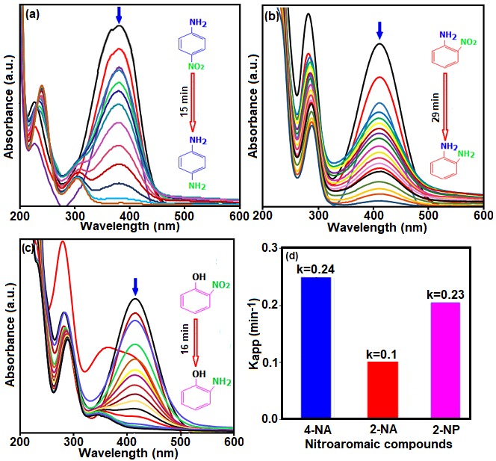
Fig. 13. The UV–vis absorption spectra change for the reduction process of (a) 2-nitrophenol (2-NP), (b) 4-nitroaniline (4-NA), and (c) 2-nitroaniline (2-NA) with NaBH₄ in the presence of Bi₂O₂CO₃-CoFe₂O₄30% catalyst. (d) the calculated apparent rate constant values. Conditions: catalyst (5.0 mg), NaBH₄ (0.5 mL, 0.02M), and nitro compound (2 mL, 0.2 mM) at 25˚C.

In addition to catalytic activity, the stability and reusability of catalysts are important issues for their practical applications. The stability of as synthesized Bi₂O₂CO₃-CoFe₂O₄30% catalyst was checked by performing four consecutive cycles. The catalyst used in any experiment was collected by external magnetic field, washed with distilled water, dried at 60 °C and then employed for a new run. As shown in Fig. 14, no significant loss of the catalytic activity can be observed after four successive runs of 4-NP reduction, indicating that the present composite catalysts are stable enough during the repeated experiments.
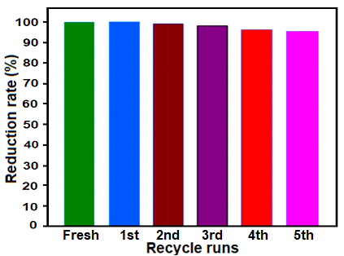
Fig. 14. Recyclability of the of Bi₂O₂CO₃-CoFe₂O₄30% nanocomposite in the reduction of 4-NP. Conditions: catalyst (5.0 mg), [4-NP] = 0.2 mM and [NaBH₄] = 0.02 M, at 25˚C.
The nature of the recovered catalyst was also tested. As shown in Fig. 15|(a) and (b), XRD pattern and FT-IR spectrum of the recycled Bi₂O₂CO₃-CoFe₂O₄30% nanocomposite catalyst did not show significant changes after the fourth run in comparison with the fresh catalyst (see Figs. 1(c) and 2(c)). Fig. 15(c) and (d) shows SEM and TEM images of the catalyst after five cycles, respectively. It could be observed that the recovered catalyst kept its initial size and morphology (see Figs. 3(e-f) and 4) and the surface of Bi₂O₂CO₃ nanoplates was still decorated with CoFe₂O₄ nanoparticles, revealing the strong binding between the CoFe₂O₄ nanoparticles and Bi₂O₂CO₃ nanoplates. Therefore, the as-prepared Bi₂O₂CO₃-CoFe₂O₄ composites can work as an effective catalyst for the of reduction nitroaromatic compounds with good stability and recyclability.
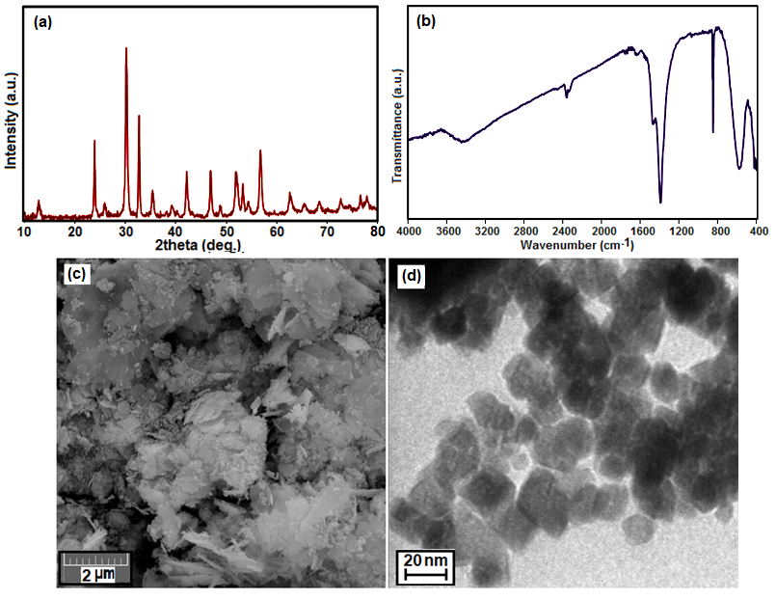
Fig.15. (a) XRD pattern, (b) FT-IR spectrum, (c) SEM image, and (d) TEM image of the recovered Bi₂O₂CO₃-CoFe₂O₄30% nanocomposite after the 5th run.
4. Conclusions
To conclude, a series of novel plate–like Bi₂O₂CO₃-CoFe₂O₄ magnetic nanocomposites were successfully synthesized via a simple hydrothermal method for the first time and applied to catalyze the reduction of nitroarenes. Compared with the individual Bi₂O₂CO₃ and CoFe₂O₄, the composite catalysts exhibit higher catalytic performance and stability for 4-nitrophenol reduction under ambient conditions. Compared with those noble metals such as Au, Ag, Pt and Pd, Bi₂O₂CO₃-CoFe₂O₄ composites were easy to available and inexpensive. The preparation procedure of Bi₂O₂CO₃-CoFe₂O₄ magnetic nanocomposites via hydrothermal method was simple. And the as-prepared Bi₂O₂CO₃-CoFe₂O₄ magnetic nanocomposites were stable and well-dispersed. Moreover, the prepared Bi₂O₂CO₃-CoFe₂O₄ nanocomposites were magnetically separable from water with higher long-time use stability. This study provides a new approach for reducing and removing nitroarenes pollutants (e.g. 4-NP) in wastewater without introducing secondary pollutant into the system. Studies on the synthesis of nanocomposites of Bi₂O₂CO₃ with other ferrites (MFe₂O₄; M = Ni, Zn, Cu, Mn, …) and their thermal catalytic and photocatalytic applications are currently in progress and underway in our laboratory.
5. Acknowledgements
This work was supported by the Lorestan University Research Council and Iran Nanotechnology Initiative Council (INIC).
6. References
1 J. R. Chiou, B. H. Lai, K. C. Hsu and D. H. Chen, J. Hazard. Mater., 2013, 248, 394–400.
2 Y. Shaoqing, H. Jun and W. Jianlong, Radiat. Phys.Chem., 2010, 79, 1039–1046.
3 A.C. Apolinario, A.M. Silva, B. F. Machado, H.T. Gomes, P.P. Araujo, and J. L. Figueredo, Appl. Catal. B: Environ., 2008, 84, 75–86.
4 V. Maurino, C. Minero, E. Pelizzetti, P. Piccinini, N. Serpone and H. Hidaka, J. Photochem. Photobiol. A: Chem., 1997, 109, 171–176.
5 P. Xiong, Y. Fu, L. Wang and X. Wang, J. Chem. Eng., 2012, 195, 149–157.
6 F. R. Zaggout and N. A. Ghalwa. J. Environ. Manag., 2008, 86, 291–296.
7 X. Zhu and J. Ni, Electrochim. Acta., 2011, 56, 10371–10377.
8 Y. Y. Chu, Y. Qian, W. J. Wang and X. Deng, J. Hazard. Mater., 2012, 199, 179–185.
9 C. Rizhi, D. Yan, X. Weihong and X. Nanping, Chin. J. Chem. Eng., 2007, 15, 884–888.
10 Z. Wu, J. Chen, Q. Di and M. Zhang, Catal. Commun., 2012, 18, 55–59.
11 Y. Du, H. Chen, R. Chen and N. Xu, Appl. Catal. A: Gen., 2004, 277, 259–264.
12 K.-I. Min, J.-S. Choi, Y.-M. Chung, W.-S. Ahn, R. Ryoo and P. K. Lim, Appl. Catal. A: Gen., 2008, 337, 97–104.
13 T. Aditya, A. Pal and T. Pal, Chem. Commun., 2015, 51, 9410-9431 and reference cited therein.
14 T. R. Mandlimath and B. Gopal, J. Mol. Catal A: Chem., 2011, 350, 9–15.
15 Y.-C. Chang and D.-H. Chen, J. Hazard. Mater., 2009, 165, 664–669.
16 Y. Deng, Y. Cai, Z. Sun, J. Liu, C. Liu, J. Wei, W. Li,C. Liu, Y. Wang and D.Y. Zhao, J. Am. Chem. Soc., 2010, 132, 8466–8473.
17 S. Harish, J. Mathiyarasu, K. Phani and V. Yegnaraman, Catal. Lett., 2009, 128, 197–202.
18 J. Huang, S. Vongehr, S. Tang, H. Lu, J. Shen and X. Meng, Langmuir, 2009, 25, 11890–11896.
19 H. Koga and T. Kitaoka, J. Chem. Eng., 2011, 168, 420–425.
20 P. Liu and M. Zhao, Appl. Surf. Sci., 2009, 255, 3989–3993.
21 J. Wang, X.-B. Zhang, Z.-L. Wang, L.-M. Wang, W. Xing and X. Liu, Nanoscale, 2012, 4, 1549–1552.
22 Y. Zhu, J. Shen, K. F. Zhou, C. Chen, X. Yang and C. Li, J. Phys. Chem. C, 2010, 115, 1614–1619.
23 F.-H. Lin and R.-A. Doong, J. Phys. Chem. C, 2011, 115, 6591–6598.
24 K. Jiang, H.-X. Zhang, Y.-Y. Yang, R. Mothes, H. Lang and W.-B. Cai, Chem. Commun., 2011, 47, 11924–11926.
25 H. He and C. Gao, J. Nanomater., 2011, 2011, 1–10.
26 X. Du, J. He, J. Zhu, L. Sun and S. An, Appl. Surf. Sci., 2012, 258, 2717–2723.
27 D. Y. Li, Y. G. Zhang, Y. L. Zhang, X. F. Zhou and S. J. Guo, J. Hazard. Mater., 2013, 258–259, 42–49.
28 R. G. Li, F. X. Zhang, D. G. Wang, J. X. Yang, M. R. Li, J. Zhu, X. Zhou, H. X. Han and C. Li, Nat. Commun., 2013, 4, 1432.
29 S. M. Sun, W. Z. Wang and L. Zhang, J. Phys. Chem. C, 2013,117, 9113–9120.
30 G. H. Tian, Y. J. Chen, W. Zhou, K. Pan, Y. Z. Dong, C. G. Tian and H. G. Fu, J. Mater. Chem., 2011, 21, 887–892.
31 X. Zhao, J. H. Qu, H. J. Liu and C. Hu, Environ. Sci. Technol., 2007, 41, 6802–6807.
32 J. Jiang, K. Zhao, X. Y. Xiao and L. Z. Zhang, J. Am. Chem. Soc., 2012, 134, 4473–4476.
33 Y. N. Wang, K. J. Deng and L. Z. Zhang, J. Phys. Chem. C, 2011, 115, 14300–14308.
34 L. Ye, J. Liu, C. Gong, L. Tian, T. Peng and L. Zan, ACS Catal., 2012, 2, 1677–1683.
35 Z. Ni, Y. Sun, Y. Zhang and F. Dong, Appl. Surf. Sci., 2016, 365, 314-335.
36 R. Hu, X. Xiao, S. Tu, X. Zuo and J. Nan, Appl. Catal. B: Environ., 2015, 163, 510–519.
37 Q. Wang, G. Yun, Y. Bai, N. An, J. Lian, H. Huang and B. Su, Appl. Surf. Sci., 2014, 313, 537-544.
38 H. Lu, L. Xu, B. Wei, M. Zhang, H. Gao and W. Sun, Appl. Surf. Sci., 2014, 303, 360–366.
39 N. Guo, Y. Cao, Y. Rong and D. Jia, RSC Adv., 2016, 6, 106046–106053
40 J. Cao, X. Li, H. Lin, S. Chen and X. Fu, J. Hazard. Mater., 2012, 239, 316–324.
41 X. Huang and H. Chen, Appl. Surf. Sci., 2013, 284, 843–848.
42 N. Liang, J. Zai, M. Xu, Q. Zhu, X. Wei and X. Qian, J. Mater. Chem. A., 2014, 2, 4208–4216.
43 Y. Ao, L. Xu, P. Wang, C. Wang, J. Hou and J. Qian, Dalton Trans., 2015, 44, 11321–11330.
44 Y. Liu, P. Zhang, H. Lv, J. Guang, S. Li and J. Jiang, RSC Adv., 2015, 5, 83764–83772.
45 Q. Zhang, H. Y. Wang, S. Z. Hu, G. Lu, J. Bai, X. X. Kang, D. Liu and J.Z. Gui, RSC Adv., 2015, 5, 42736–42743.
46 N. Liang, M. Wang, L. Jin, S. S. Huang, W.L. Chen, M. Xu, Q.Q. He, J.T. Zai, N. H. Fang and X. F. Qian, ACS Appl. Mater. Interfaces, 2014, 6, 11698–11705.
47 L. Jin, G. Q. Zhu, M. Hojamberdiev, X. C. Luo, C. W. Tan, J. H. Peng, X. M. Wei, J. P. Li and P. Liu, Ind. Eng. Chem. Res., 2014, 53, 13718–13727.

48 Y. Hu, C. Dong, K.-L. Wu, S.-H. Xia, X. Li and X.-W. Wei, Mater. Lett., 2015, 147, 69–71.
49 T. Li, X. Hu, C. Liu, C. Tang, X. Wang and S. Luo, J. Mol. Catal. A: Chem., 2016, 425, 124–135.
50 X. Zhang, S. Li, S. Hua, J. Chen, W. Jiang, J. Zhang, L. Ji, L. Cai, Y. Wang, W. Song and J. Liu, Mater. Lett., 2016, 185, 50–53.
51 S. Shylesh, V. Schunemann, W. R. Thiel, Angew. Chem., Int. Ed., 2010, 49, 3428–3459.
52 X. F. Shang, W. C. Lu, B. H. Yue, L. M. Zhang, J. P. Ni, Y. lv, Y. L. Feng, Cryst. Growth Des., 2009, 9, 1415 –1420.
53 G. E. Tobon-Zapata, S. B. Etcheverry and E. J. Baran, J. Mater. Sci. Lett., 1997, 16, 656–657.
54 Y. S. Fu and X. Wang, X. Ind. Eng. Chem. Res., 2011, 50, 7210–7218.
55 G. D. Hong, Y. Yamada, T. Nagatomi, Y. Takai and S. Fukuzumi, J. Am. Chem. Soc., 2012, 134, 19572–19575.
56 K. Modi, S. Shah, N. Pujara, T. Pathak, N. Vasoya and I. Jhala, J. Mol. Struct., 2013, 1049, 250–262.
57 J. Gunjakar, A. More, K. Gurav and C. Lokhande, Appl. Surf. Sci., 2008, 254, 5844–5848
58 Y.C. Huang, W.J. Fan, B. Long, H.B. Li, F.Y. Zhao, Z.L. Liu, Y.X. Tong and H.B. Ji,
Appl. Catal. B Environ., 2015, 185, 68–76.
59 D. D. Hu, K.Y. Zhang, Q. Yang, M. J. Wang, Y. Xi and C. G. Hu, Appl. Surf. Sci., 2014, 316, 93–101.
60 H.J. Lu, L.L. Xu, B. Wei, M.Y. Zhang, H. Gao and W.J. Sun, Appl. Surf. Sci., 2014, 303, 360–366.
61 S. Singh and N. Khare, RSC Adv., 2015, 5, 96562–96572.
62 P. Madhusudan, J. Yu, W. Wang, B. Cheng and G. Liu, Dalton Trans., 2012, 41, 14345–14353.
63 L. Xu, X. Yang, Z. Zhai and W. Hou, CrystEngCommun., 2011, 13, 7267–7275.
64 Z. Jin, M. Xiao, Z. Bao, P. Wang and J. Wang, Angew. Chem., Int. Ed., 2012, 51, 6406–6410.
65 A. K. Patra, A. Dutta and A. Bhaumik, Catal. Commun., 2010, 11, 651–655.
66 H. Li, J. K. Jo, L. Zhang, C. S. Ha, H. Suh and I. Kim, Adv. Funct. Mater., 2010, 20, 3864–3873.
67 M. Nemanashi and R. Meijboom, J. Colloid Interface Sci., 2013, 389, 260–267.

