Synthesis and Characterization of Zinc Oxide Nanoparticles with Small Particle Size Distribution

Nuraqeelah Mohammad Shamhari¹, Boon Siong Wee^{1,*}, Suk Fun Chin¹, Kuan Ying Kok²
¹ Faculty of Resource Science and Technology, University of Malaysia Sarawak, Kota Samarahan, 94300 Sarawak, Malaysia.
² Malaysian Nuclear Agency, Bangi, Kajang, 43000 Selangor, Malaysia.
*Corresponding author: Email: swboon@unimas.my
Tel: +60 82582965

Abstract
Solvothermal synthesis has shown a great potential to synthesize Zinc Oxide nanoparticles (ZnO NPs) with less than 10 nm size. In this study, we present a rapid synthesis of ZnO NPs in which ZnO NPs were synthesized using zinc acetate dihydrate (Zn(CH₃COO)₂∙2H₂O) and potassium hydroxide (KOH) as a precursor with the usage of absolute ethanol as solvent via solvothermal method. Absolute ethanol was used as a solvent and ZnO NPs was produced with more uniform shape and highly dispersed. Few techniques were exploited to characterize synthesized ZnO NPs including X-ray diffraction (XRD), transmission electron microscope (TEM), fourier transform infrared (FT-IR) spectroscopy, and ultraviolet visible (UV-Vis) spectroscopy. Synthesized ZnO NPs that was prepared via solvothermal synthesis method at 60ºC for 3 hours exhibited a wurtzite structure with a crystalline size of 10.08 nm and particle size of 7.4 ± 1.2 nm. The UV-vis absorption spectrum has shown peak at 357 nm indicate the presence of ZnO NPs. Hence, better quality of narrow size ZnO NPs can be easily synthesized with reduced amount of time via solvothermal synthesis method rather than using other complicated and lengthy synthesis methods.
Keywords: Zinc Oxide nanoparticles, Solvothermal method, small particle size, spectroscopy

1. Introduction
High demands of nanomaterials have produced enormous applications in global industries. Due to high demand as NPs based products, various types of engineered nanoparticles (ENPs) are synthesized for myriad of applications.¹ These days, ZnO NPs has become a promising candidate and gained more attention especially in nanomedicine and nano-semiconductors.²⁻⁴ ZnO NPs exhibit wurtzite crystal structure that has been widely used in industries due to its unique optoelectric properties.⁵ ZnO NPs are among of various semiconductivity materials with a distinctive electronic and photonic wurtzite semiconductor with a wide direct band gap (3.37eV) and high exciton binding energy (60 meV) at room temperature.⁶ This makes ZnO NPs particularly popular for use in commercially available especially in sunscreens and cosmetics which able to block UV radiation when they are less than 50 nm.⁷⁻⁹ Heitilag et al.¹⁰ stated that smaller size of NPs provide a better protections of skin against UV damage.
Besides, high optical absorption UVA and UVB in ZnO NPs are also beneficial in antimicrobial products in nanomedicine as nowadays various nano development have been applied to improve drugs and other medicine.¹¹ Among other MO NPs, Salem et al.¹² stated that ZnO NPs are the most recommended for antibacterial agent. Hence, the increase productions of consumer products eventually increase the productions of ZnO NPs. Heitilag et al.¹⁰ has also stated that the potential applications of ZnO NPs makes them one of a primary focus in NPs research. Naveed Ul Haq et al.¹³ also described that ZnO NPs is one of the cheap materials that this causes the extensive productions in industries. Morphologically, ZnO NPs is an attractive compound that possess thermal and chemical stability.¹⁴ ZnO NPs are made into various shapes and sizes depending on the use of NPs in industries including textile, energy, food, cosmetics, and medicines and other characteristics that make them attractive for broad range of application.¹⁵
Various methods of ZnO NPs synthesis were developed into different size and forms in order to be used in commercial products. This includes sol-gel method, precipitation, microwave assisted, and thermal oxidation.⁴ However, these methods are considered complicated as they involve multiple steps procedures, lengthy reaction period, and toxic solvent and reactants might be used for synthesis. ^{16,17} Prominent methods usually have undergone approximately 24 hours of reaction to yield NPs products. Due to high cost and maintenance as well as lengthy preparation time to set up expensive equipment for synthesis, solvothermal synthesis was developed to synthesize NPs.
According to Li et al.¹⁸, solvothermal process is defined as performing chemical reactions in solvents under specific temperature. Matei et al.¹⁹ also stated that solvothermal synthesis can be easily performed under controlled condition as ZnO NPs can be synthesized into different morphologies depending on the reaction conditions. Bai et al.²⁰ has stated that solvothermal method has the ability in enhancing the dispersity of ZnO NPs. Besides, this process has been widely used especially to synthesize metal oxides NPs since it is more reliable, affordable, and undergo simpler process of synthesis.²¹ Wu et al.¹⁷ also described that solvothermal synthesis method is free from using surfactant in which this offers a better potential for environmental friendly synthesis that can be produce in large quantities. Besides, solvothermal synthesis is considered one of the most promising approach to synthesize NPs.¹⁸ In solvothermal synthesis, organic solvent mainly alcohol such as ethanol as being used by previous researchers to synthesize ZnO NPs.^{4, 21, 22}
Furthermore, NPs characterization using XRD, TEM, FT-IR spectroscopy, and UV-Vis spectroscopy are fundamental steps especially for examining NPs surface properties and functionality. It is important to characterize NPs in order to determine the behaviour of NPs for further study such as toxicological studies.¹⁷ Due to extensive usage of ZnO NPs, ZnO NPs was prepared via solvothermal synthesis by using zinc acetate dihydrate (Zn(CH₃COO)₂∙2H₂O) as a zinc source and potassium hydroxide (KOH) as a precursor which dissolved in organic solvent mainly ethanol as only short reaction period is required for the synthesis. Ethanol was used for ZnO NPs synthesis as it has hydroxyl group that interact better with NPs as well as increase solubility to allow more interaction between particles and capping molecules.²³ This method has utilized the organic solvent mainly ethanol which generally has low boiling point and generate high pressure that are conducive to obtain a better product crystallizarion.²⁴ The utilization of absolute ethanol as a solvent has proven to be monodisperse size and shape of ZnO NPs via solvothermal methods. Wang et al.²⁴ has also explained that the presence of smaller surface tension of ethanol as compared to other alcohol has effectively contribute to inhibit the oxidation of powders thus uniform spherical ZnO NPs was formed. The aim of this research are to synthesize spherical ZnO NPs with less than 10 nm size by using zinc acetate dihydrate and potassium hydroxide with absolute ethanol as solvent via solvothermal method and to characterize synthesized ZnO NPs using few techniques including XRD, TEM, FT-IR, and UV-Vis spectroscopy.

2. Experimental

2.1 Synthesis of Zinc Oxide Nanoparticles
Zinc oxide nanoparticles was synthesized using solvothermal synthesis process from modified published procedures.²² Briefly, 1.48 g of Zn(CH₃COO)₂∙2H₂O (Sigma-Aldrich, India) was dissolved in 63 ml of absolute ethanol (HmBG Chemicals) under 60ºC with stirring. 0.74 g of KOH (VWR Amresco, USA) was also dissolved separately in 33 ml of absolute ethanol under same condition of Zn(CH₃COO)₂∙2H₂O. After both solution dissolved completely, dropwise, KOH was added into Zn(CH₃COO)₂∙2H₂O slowly under 60ºC with vigorous stirring. The mixture solution was left for 3 hours until the reaction was completed. A white precipitate (ZnO) was formed and collected by centrifugation at 4000 rpm for 10 minutes, washed with acetone twice and ultrapure water once to remove all the impurities. The product was the dried at room temperature and ground until powdered form of product was obtained.

2.2 Characterization of ZnO Nanoparticles
Different techniques were used to characterize the synthesized ZnO NPs. Crystal structure and primary crystal size was characterized using XRD. The XRD pattern was obtained using X-ray diffractometer with Cu-Kα radiation of 40 kV and 30 mA with step size of 0.017º.
Other than that, the morphological features especially the size and the shape of ZnO NPs was determined using TEM. Basically, copper grid was prepared by applying fomvar coating on the copper grid. ZnO NPs was diluted with ethanol and left for sonication 30 minutes. Then, 4 µl of ZnO NPs sample was loaded onto the coated copper grid before being observed under TEM.
Fourier transform infrared spectroscopy (FT-IR) was also used in order to obtain the surface functional group that is present in ZnO NPs. ZnO NPs powder was mixed with potassium bromide (KBr) with ratio of 1: 19. ²⁵ The sample was then placed in the metal hole, pressed until the sample compressed inside the hole, and analysed using FT-IR. Ultraviolet visible spectroscopy was also used in order to determine the optical absorption spectra of ZnO NPs that was dispersed in water.

3. Result and Discussion

3.1 X-Ray Diffraction (XRD)
XRD pattern of synthesized ZnO NPs is shown in Figure 1. Based on the XRD pattern obtained, synthesized ZnO NPs has high purity of wurtzite crystalline structure as the diffraction peak is seen to be intense and narrower. The peak shown is broad which indicates that the particles is smaller which wwere also described in previous literature.^{22,26} Apart from that, as mentioned by Tagreed et al. ²⁷ the average crystalline structure (D) was calculated according to Debye-Scherrer’s formula :-
Scherrer’s Equation:
Particle size (D_{p}) = $\frac{\text{0.89}\text{ λ}}{d\cos{θ}}$
Where 0.89 refers to Scherrer’s constant, $\text{λ}$ is a wavelength of X-rays, $θ$ refers to Bragg diffraction peak, and d is full width at half maximum (FWHM) of diffraction peak. The most intense diffraction was chosen which is <010> and the crystalline size of synthesized ZnO NPs was determined to be 10.08 nm. Besides, the percentage of zinc content from the synthesized ZnO NPs via XRD analysis, which revealed that there is 99% of zinc without any other elements being detected. From this obtained data, it shows that synthesized ZnO NPs were determined to be in high purity.

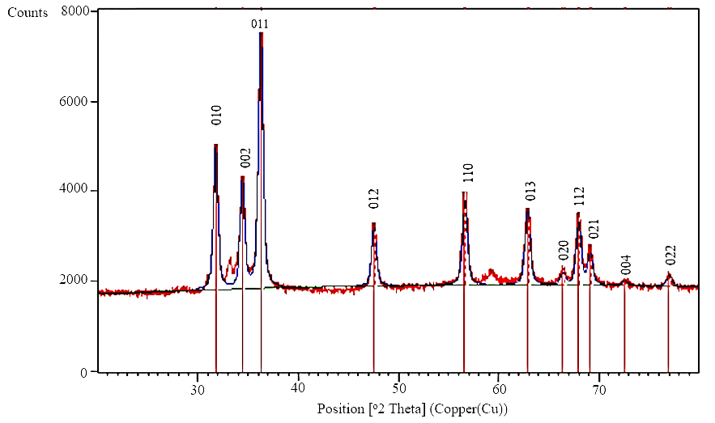
Figure 1. XRD pattern of synthesized ZnO nanoparticles.

3.2 Transmission electron microscope (TEM)
Physical characterization of NPs is commonly characterized using transmission electron microscope (TEM). Phoohinkong et al. ²⁸ stated that TEM was ccaried out in order to obtain high accuracy of the actual particle size and shape pattern. This shows that TEM is one of the reliable tools for NPs characterization. The morphological feature of synthesized ZnO NPs was determined using TEM as shown in Figure 2. Size of less than 10 nm was obtained by using solvothermal synthesis method. About 200 particles were chosen randomly and measured. The calculated mean size of synthesized ZnO NPs was determined to be 7.4 ± 1.2 nm. TEM particle distribution result in Figure 2 shown also confirmed that a narrow size distribution of ZnO NPs can be obtained via solvothermal synthesis method. Based on the particle size distribution in the figure, most of the NPs measured were determined to be 6, 7, and 8 nm which attribute to 23%, 29.5 % and 25% respectively. The biggest size of ZnO NPs measured is about 9 nm which only attribute to 10.5%. Besides, synthesized ZnO NPs that was observed under TEM showed a homogenous shape that seem to be near hexagonal or nanosphere that was also described from previous study in which solvothermal synthesis was being conducted by Zak et al. ²¹ which obtained 50 nm ZnO NPs. The synthesized ZnO NPs observed under TEM also correlates with the XRD patterns that reveal high purity of wurtzite crystalline structure of ZnO NPs. Therefore, this shows that solvothermal synthesis can be used to obtain a better image that proves the presence of less than 10 nm of synthesized ZnO NPs.

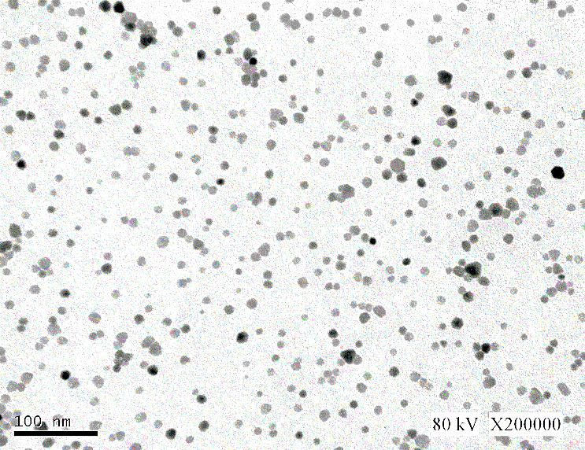
Figure 2. ZnO NPs image under transmission electron microscope (TEM) and particle size distribution of ZnO NPs.

3.3 Fourier transform infrared spectroscopy (FT-IR)
FT-IR was performed in order to study and determine the functional groups of prepared synthesized ZnO NPs. Figure 3 showed the FT-IR spectrum of synthesized ZnO NPs that were obtained from solvothermal synthesis procedure. FT-IR spectrum analysis was done by referring to Yang et al.²⁵ where by a broad absorption band was observed at 414 cm⁻¹ that attribute to Zn-O stretching vibration. Previous studies regarding ZnO NPs was also able to observe FT-IR spectrum within 400 cm⁻¹. ^{21, 25, 29}
All the observed peaks were referred from previous literatures in order to confirm the findings. Similar findings were also found from previous studies related to ZnO NPs synthesis and characterization. The peaks at 1339 and 1556 cm⁻¹ were symmetric and asymmetric O-C-O stretching vibration of adsorbed carbonate anion respectively. Meanwhile, the peaks at 1047 cm⁻¹ that indicate the lattice vibration of carbonate generated absorption peaks. Besides, hydroxyl group stretching can be seen at the absorption peak of 3417 cm⁻¹.
Apart from that, peaks of 1402 cm⁻¹ and 1339 cm⁻¹ indicate the presence of Zn(CH₃COO)₂∙2H₂O that associate with CH₃ bending modes similar with result obtained by previous literature.¹⁷ Many ZnO NPs has been made using different types of synthesis method however the obtained FT-IR spectrum regarding ZnO NPs synthesis have shown similarities.^{25,30} Therefore, FT-IR result has shown to be high purity of synthesized ZnO NPs. Wu et al.¹⁷ has stated that this technique provides information about surface functional group that are present on surface that give a useful description of surface speciation.
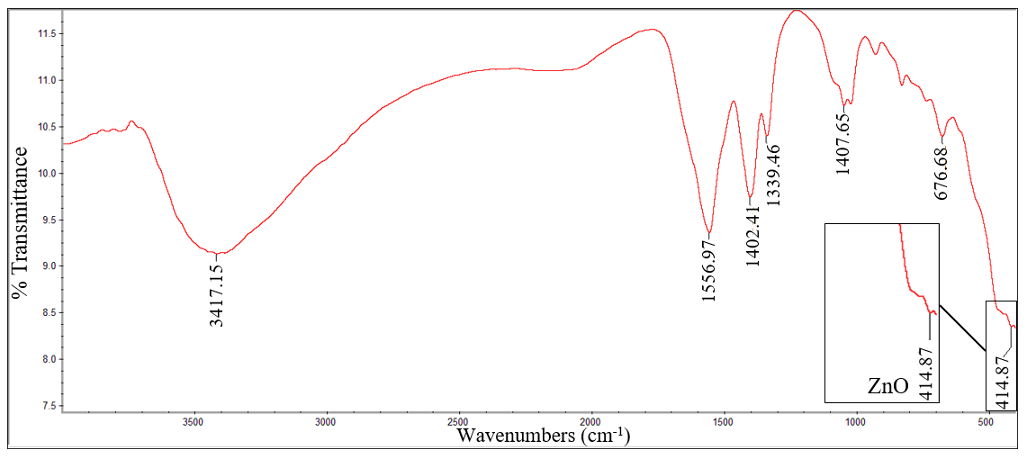
Figure 3. FT-IR spectrum of synthesized ZnO NPs.

3.4 UV-Vis Absorption Spectrum
UV-Vis spectroscopy was also performed for ZnO NPs characterization. The absorption spectra of synthesized ZnO NPs was shown in Figure 4. The UV-vis measurement was performed after the ZnO NPs was dispersed in ultrapure water. The absorption peak was observed at 357 nm which attribute to the intrinsic band-gap of ZnO absorption. Similar result of absorption band that represent ZnO NPs was also obtained from previous research in which the range of absorption band were from 355 to 380 nm. ^{4, 21, 22, 29, 31} These supporting data confirm the presence of ZnO NPs as the absorption band obtained are similar. Wang et al. ²⁴ also obtained similar findings which deduced that the obtained peak showed a better UV absorption for ZnO NPs.
Furthermore, the absorption peak of ZnO NPs also confirmed the properties of ZnO NPs, which is known for UV protections in sunscreens products.³² Hence, good absorption of ZnO NPs in UV region give an important information especially for manufacturers to produce a better quality of products using ZnO NPs in industries such as beauty care products or household products.
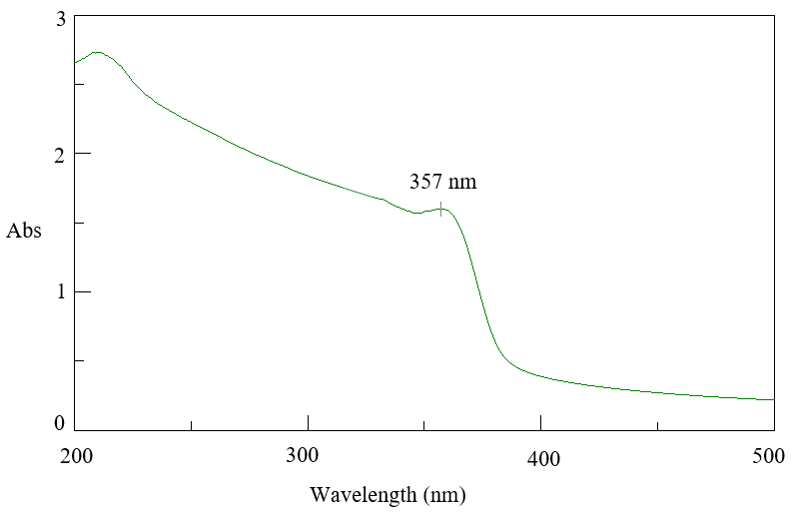
Figure 4. UV-Vis absorption spectra of synthesized ZnO NPs.

3.5 Absolute Ethanol Used as Solvent
From the obtained TEM result as shown in Figure 2, it shows that solvent also plays an important role for ZnO NPs synthesis. This includes the physico-chemical properties of ZnO NPs in terms of size and shape. The utilization of absolute ethanol as a solvent has formed a highly dispersed small ZnO NPs with uniform shape and size that was determined to be less than 10 nm as expected. Similar finding also described the formation of spherical shape of ZnO when ethanol was being used as solvent.¹⁴ Previous studies have also used other alcohol for ZnO NPs synthesis however, different forms of ZnO NPs were produced such as rod, flower-shaped, tubes, and etc. ²⁰ Wang et al. ²⁴ has found that different alcohol give significant effect on ZnO NPs morphology. Therefore, eminent production of ZnO NPs with spherical shape with high dispersity can be easily obtained by utilizing ethanol as solvent for solvothermal synthesis method.

4. Conclusion
ZnO NPs with less than 10 nm (7.4 nm) was successfully prepared by using zinc acetate dihydrate and potassium hydroxide via solvothermal synthesis process. The utilization of absolute ethanol was able to produce uniform shape and better dispersity of ZnO NPs. Synthesized ZnO NPs was also able to be confirmed by characterization using techniques including XRD, TEM, FT-IR, and UV-vis spectroscopy. XRD has revealed a wurtzite crystalline structure of ZnO NPs where by physical characterization of ZnO NPs was determined by using TEM and less than 10 nm of ZnO NPs was obtained. FT-IR and UV-vis spectroscopy also showed the absorbance spectrum that indicates the presence of ZnO NPs. Therefore, solvothermal synthesis method is one of the most suitable methods to obtain a better quality of ZnO NPs. This study also presents a potential effective method to prepare ZnO NPs within shorter time with smaller particle size distribution.

5. Acknowledgement
Authors sincerely thank MOHE grant FRGS/ST01(01)/1208/2014(09) for the funding, Faculty of Resource Science and Technology (FRST) for providing the necessary facilities to carry out this research. Authors also want to thank Mdm Ting Woei for the TEM image results.

6. References
- M. A. Maurer-Jones, I. L.Gunsolus, C. J. Murphy, C. L. Haynes, Anal. Chem., 2013, 85, 3036-3049. DOI: 10.1021/ac303636s
- B. Liu & H. C. Zeng, J. Am. Chem. Soc., 2003 125, 4430-4431. DOI: 10.1021/ja0299452
- V. Sharma, R. K. Shukla, N. Saxena, Toxicol. Lett., 2009, 185, 211-218. DOI 10.1016/j.toxlet.2009.01.008
- S. Talam, S. R. Karumuri, & N. Gunnam, ISRN Nano, 2012, 1-6. DOI: 10.5402/2012/372505
- H. Ma, P. L. Williams, S. A. Diamond. Environ. Pollut., 2013, 172, 76-85. DOI: 10.1016/j.envpol.2012.08.011.
- A. Kołodziejczak-Radzimska, T. Jesionowski, Mater, 2014, 7, 2833-2881. DOI:10.3390/ma7042833
- L. K. Adams, D. Y. Lyon, P. J. Alvarez, Water Res., 2006, 40, 3527-3532. DOI: 10.1016/j.watres.2006.08.004
- I. Blinova, A. Ivask, M. Heinlaan, M. Mortimer, A. Kahru, Environ. Pollut., 2010, 158, 41- 47. DOI: 10.1016/j.envpol.2009.08.017
- L. C. Wehmas, C. Anders, J. Chess, A. Punnoose, C. B. Pereira, J. A. Greenwood, R. L.
Tanguay, Toxicol Rep, 2015, 2, 702-715. DOI:10.1016/j.toxrep.2015.03.015

- F. J. Heiligtag & M. Niederberger, Mater. Today, 2013, 16, 262-271. DOI: 10.1016/j.mattod.2013.07.004
- S. Gunalan, R. Sivaraj, V. Rajendran, Mater Int., 2012, 22, 693-700. DOI: 10.1016/j.pnsc.2012.11.015
- W. Salem, D. R. Leitner, F. G. Zingl, G. Schratter, R. Prassl, W. Goessler, S. Schild, Int J Med Microbiol, 2015, 305, 85-95. DOI: 10.1016/j.ijmm.2014.11.005
- A. Naveed Ul Haq, A. Nadhman, I. Ullah, G. Mustafa, M. Yasinzai, & I. Khan. J. Nanomater., 2017. DOI: 10.1155/2017/8510342
- A. Šarić, G. Štefanić, G. Dražić, & M. Gotić, J. Alloys Compd, 2015, 652, 91-99. DOI: 10.1016/j.jallcom.2015.08.200
- E. Hughes, Big problems with little particles? Chemistry World, http://www.rsc.org/chemistryworld/2015/04/nanoparticle-toxicology (assessed: September 16, 2017)

- K. D. Bhatte, D. N. Sawant, R. A. Watile, B. M. Bhanage, Mater. Lett., 2012, 69, 66-68. DOI: 10.1016/j.matlet.2011.10.112
- C. M. Wu, J. Baltrusaitis, E. G. Gillan, V. H. Grassian, J. Phys. Chem. C, 2011, 115,10164-10172. DOI: 10.1021/jp201986j
- J. Li, Q. Wu, J. Wu, Handb. Nano., 2016, 295-328. DOI: 10.1007/978-3-319-15338-4_17
- A. Matei, V. Tucureanu, L. Dumitrescu, Bull. Transilv. Univ. Brasov Ser. I, 2014, 7, 45.
- X. Bai, L. Li, H. Liu, L. Tan, T. Liu, &X. Meng, ACS Appl. Mater. Interface, 2015, 7, 1308-1317. DOI: 10.1021/am507532p
- A. K. Zak, R. Razali, W. H. Majid, M. Darroudi, Int. J. Nanomedicine., 2011, 6, 1399-1403. DOI: 10.2147/IJN.S19693.
- S. W. Bian, I. A. Mudunkotuwa, T. Rupasinghe, V. H. Grassian, Langmuir, 2011, 27, 6059-6068. DOI: 10.1021/la200570n
- P. B. Khoza, M. J. Moloto, L. M. Sikhwivhilu. J. Nanotechnol., 2012, 1-7. DOI: 10.1155/2012/195106
- Y. X.Wang, J. Sun, & X. Yu, In Mater. Sci. Forum, 2011, 663, 1103-1106. DOI:10.4028/www.scientific.net/MSF.663-665.1103
- M. A. Mustafa, D. A. M. Osman. J. Nanosci. Nanoeng., 2016, 1, 248-251.
- M. A. Tagreed, A. B. Nabeel, A. H. Noor, Int. J. Eng. Tech. Res., 2014, 2, 191-195.
- W. Phoohinkong, T. Foophow, & W. Pecharapa, Adv. Nat. Sci., 2017, 8, 035003.
- K. Yang, D. Lin, B. Xing, Langmuir, 2009, 25, 3571-3576. DOI: 10.1021/la803701b.
- A. B. Lavand, Y. S. Malghe. Int. J. Photochem., 2015, 305-310. DOI: 10.1016/j.jksus.2016.08.009
- C. Jayaseelan, A. A. Rahuman, A. V. Kirthi, S. Marimuthu, T. Santhoshkumar, A. Bagavan, K. B. Rao. Spectrochim Acta A, 2012, 90, 78-84. DOI: 10.1016/j.saa.2012.01.006.
- K. Akhil, S. S. Khan, J. Photochem. Photobio. B, 2017, 167, 136-149. DOI: 10.1016/j.jphotobiol.2016.12.010.
- M. M. N.Yung, C. Mouneyrac, K. M. Y. Leung, Encyclop. Nano., 2014, 1-17. DOI: 10.1007/978-94-007-6178-0_100970-1

