Investigation of high-activity activated carbon-supported Co-Cr-B catalyst in the generation of hydrogen from hydrolysis of sodium borohydride
Orhan Baytarª
ª Siirt University, Faculty of Engineering and Architecture, Department of Chemical Engineering, Siirt, 56100, TURKEY
Abstract
In this study, activated carbon-supported Co-Cr-B catalyst was synthesized by chemical impregnation and precipitation method for use in the catalytic hydrolysis of NaBH₄. The activity of Co-Cr-B / activated carbon (5-20%) obtained by using different ratios was investigated while synthesizing activated carbon-supported Co-Cr-B catalyst. The effects of some parameters such as NaOH Concentration (0-5%), NaBH₄ concentration (2.5-10%), amount of catalyst (25-100 mg) and solution ambient temperature were investigated in the catalytic hydrolysis of NaBH₄. The hydrogen production rate of Co-Cr-B catalyst without support in hydrolysis of NaBH₄ was found as 6.5 Lg⁻¹ min⁻¹ while the hydrogen production rate of activated carbon supported Co-Cr-B catalyst was found as 30.2 Lg⁻¹ min⁻¹. In presence of activated carbon-supported Co-Cr-B catalyst, the hdyrolysis kinetic order and activation energy of NaBH₄ were found as 0.126 and 16.27 kJ/mol, respectively. The results suggest that activated carbon-supported Co-Cr-B catalysts can be used for mobile applications of Proton exchange membrane fuel cell (PEMFCs) systems.
Keywords: Activated carbon, catalyst, Co-Cr-B, NaBH₄

Introduction
Depletion of existing fossil fuels, global warming and environmental pollution are increasing demands for a clean and sustainable energy system.¹ Hydrogen can be considered as energy for the future due to clean and zero emission.² Therefore, a safe and practical hydrogen production system is required. Production, storage and consumption of hydrogen are very difficult due to its flammability and storage problem. Therefore, an aqueous solution of metal hydride stabilized can be considered as a suitable material for hydrogen storage³. Metal hydrides are compounds such as NaBH₄, NaH, CaH₂, MgH₂, LiAlH₂. Among these metal hydrides, NaBH₄ has some advantages such as high hydrogen storage capacity (10.8%), high stability and non-flammability at high pH, optimum control over the rate of hydrogen production with supported catalysts, acceptable hydrogen production rate even at low temperatures, ease of use and availability.⁴⁻⁵ The hydrolysis of NaBH₄ with water is indicated the following reaction.⁶
NaBH₄ (aq) + 2 H₂O(l) → NaBO₂ + 4 H₂(g)
Self-hydrolysis of sodium borohydride does not occur at high pH values. Many catalysts such as Co-B-P,⁶ Co-W-B,⁷ Co-Cu-B,⁸ Ce_{0.05}-Ni-W,⁹ carbon nanotube supported Co-B¹⁰ and carbon supported Ru ³ are used for hydrolysis of sodium borohydride. Therefore, hydrolysis of sodium borohydride takes place in the presence of suitable catalyst.
The activity of the catalyst is directly related to the particle size and surface area, since the catalyst having small particle size and high surface area is in more contact with the reactant. Therefore, higher amounts of catalyst are required to significantly increase the reaction rate. Hence, some materials with high surface area are used as support material.¹¹ Activated carbon,¹¹ carbon,³ Al₂O₃¹² and Pd-TiO₂⁴ can be used as support materials. Active carbon is more advantageous than other support materials due to its porous, high surface area and functional groups in its structure.¹³ The activated carbon is synthesized by physical or chemical activation method. Physical activation is the process of activation of the raw material at high temperature with a gas such as water vapor or CO₂. Chemical activation is the synthesis process using activators such as KOH, ZnCl₂, H₃PO₄. ¹⁴ The activated carbon is synthesized from raw materials such as pistachio shell,¹⁴ acorn shell,¹⁵ eleagnus angistofolia,¹⁶ carob bean seed husk.¹⁷
In this study, we have previously used carbon as a support material for the Co-Cr-B catalyst to be used in the hydrolysis of activated carbon sodium borohydride from the spindle core by the physical activation method using a mixture of CO₂ and water vapor.¹⁸ The experimental conditions for the sodium borohydride hydrolysis of the synthesized activated carbon supported Co-Cr-B catalyst were optimized. It was found that the activated carbon-supported Co-Cr-B catalyst has high activity in the hydrolysis of NaBH₄.

Experimental Part

Materials
All the chemical substances used in the experiments are in analytical grade purity and have not been subjected to any purification process. In our previous work,¹⁸ the production and properties of activated carbon were given and the BET surface area was determined as 1084 m²/g. Sodium borohydride (NaBH₄,> 98%) from Merk, CoCl₂.6H₂O and CrCl₃.6H₂O from Alpha Aesar and ethanol (C₂H₅OH,> 99.9%) from Sigma-Aldrich, were purchased. Pure water was used in our experiments.

Preparation of catalyst
Activated carbon supported Co-Cr-B catalyst was prepared by chemical impregnation and reduction method. The production scheme of the catalyst is given in Figure 1. Catalyst preparation procedure; A certain amount of CoCI₂.6H₂O and CrCI₃.6H₂O were dissolved in 50 ml of ethanol, then the required amount of activated carbon was added and the metals were adsorbed to active carbon at room temperature for 24 hours. The ethanol in the medium was then removed at 50 °C and 50 ml of distilled water was added to the metal-impregnated activated carbon, then left in the ice bath. The 50 ml of The NaBH₄ solution, prepared to be 5 times the total metal moles, was added drop wise to the metal impregnated activated carbon in the presence of N₂ gas. The resulting catalyst was filtered and washed several times with distilled water and anhydrous ethanol. The synthesized catalyst was dried in a nitrogen atmosphere at 80 °C for 6 hours. The obtained catalyst was maintained in a closed vessel in a nitrogen atmosphere to use in the hydrolysis of NaBH₄.
Figure 1 Application steps for production of activated carbon supported Co-Cr-B catalyst and for hydrolysis of NaBH₄.

Characterization of catalyst
Characterization of synthesized activated carbon-supported Co-Cr-B catalyst, Co-Cr-B catalyst and activated carbon was performed with BET surface area, XRD, FTIR and SEM-EDX measurements. Nitrogen adsorption-desorption of BET surface area at 77 K was determined by Quantachrome Nova 1200 series instrument. The structural properties was studied by x-ray diffraction (XRD) on a Rigaku x-ray diffractometer with Cu Kα (λ= 154.059 pm) radiation. The functional groups of the synthesized materials were determined with a Bruker Vertex 70 FT-IR instrument in the range of 4000-400 cm⁻¹ wave number. The surface morphology of the synthesized materials was determined by scanning electron microscopy (SEM) and the percentages were determined by EDX.

Determination of catalyst activity
The activity of synthesized activated carbon-supported Co-Cr-B catalysts for the hydrolysis of NaBH₄ was determined using the system given in Figure 1. Experimental studies in which catalyst activity was determined, were carried out in 10 ml of solution containing 2.5-10% NaBH₄, 0-5% NaOH and 25-100 mg of activated carbon supported Co-Cr-B (5-20% Co-Cr-B catalyst loaded). The temperature was changed between 20 and 60 ° C. The released hydrogen was noted cumulatively by time.

Results and discussions

SEM and EDX Analysis
The SEM and EDX results of activated carbon, activated carbon supported Co-Cr-B catalyst (15% Co-Cr-B loaded) and Co-Cr-B catalyst used as support materials are shown in Figure 2.
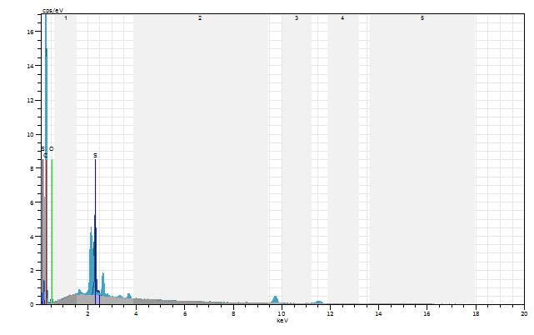 | 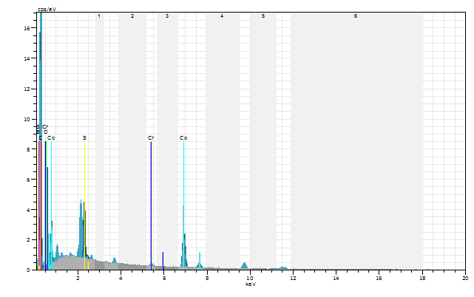 | 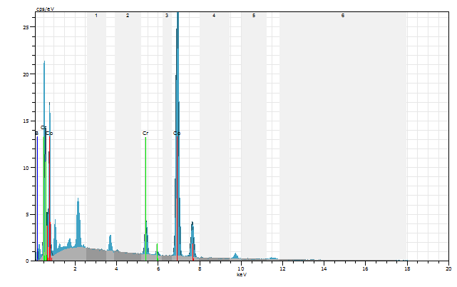
a | b | c
Figure 2 SEM and EDX results; a) activated carbon b) activated carbon-supported Co-Cr-B catalyst c) Co-Cr-B catalyst.

Figure 2 (a) shows that the surface of activated carbon is porous and the pore distribution is heterogeneous. It is apparent that there are more micro pores on the surface of activated carbon and this increases BET surface area of the activated carbon. Figure 2 (c) reveals that the surface of the Co-Cr-B catalyst is not porous and uneven. This causes the activity of the Co-Cr-B catalyst to be lowered in the hydrolysis of NaBH₄. Figure 2 (b) demonstrates that the Co-Cr-B catalyst in the activated carbon supported Co-Cr-B catalyst is retained on the surface of the activated carbon and inside the pores. This leads to a greater amount of hydrogen produced in the hydrolysis of NaBH₄ with a small amount of Co-Cr-B catalyst, thereby increasing the activity of the catalyst. Looking at the EDX results, it appears that the Co-Cr-B catalyst is present on the surface of the active carbon.

XRD Analysis
The structure properties of activated carbon, active carbon supported Co-Cr-B catalyst (15% Co-Cr-B loaded) and Co-Cr-B catalyst used as support materials were determined by XRD and the results are displayed in Figure 3.
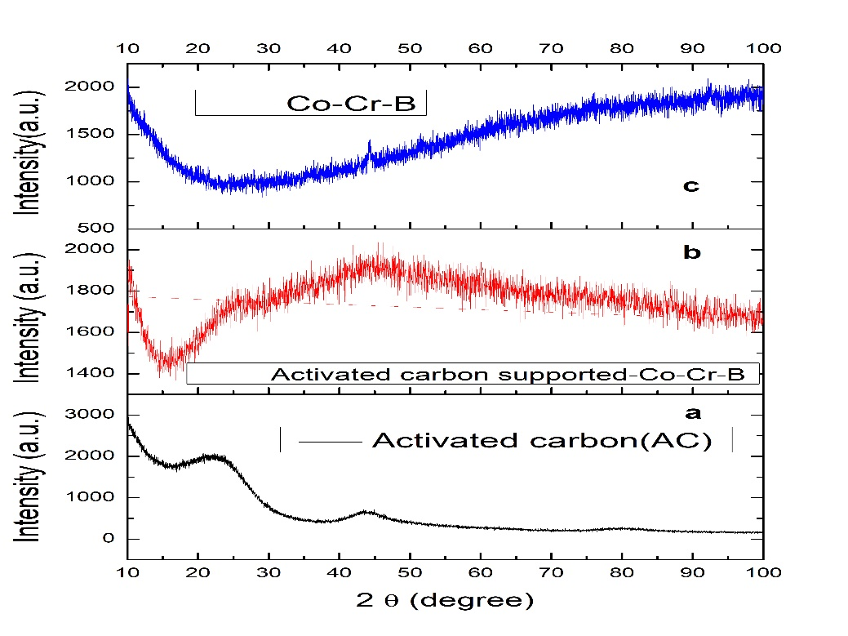
Figure 3 XRD results of a) activated carbon, b) active carbon supported Co-Cr-B catalyst (15% Co-Cr-B loaded) and Co-Cr-B catalyst.

As can be seen from Figure 3 (a), the characteristic peak of the carbon between 2θ = 20-25⁰. Zhu et al.¹ found the same results in their study of the synthesis of carbon-supported CoB catalysts. Fernandes et al.²³ reported that the Co-Cr-B catalyst gives a peak at 2θ = 45⁰. A peak at 2θ = 45⁰, is shown in Figure 3 (b-c), also was observed. From Figure 3, it is seen that the XRD results are in agreement with the EDX results.

FTIR Analysis
The FT-IR spectra of the activated carbon, active carbon supported Co-Cr-B catalyst (15% Co-Cr-B loaded) and Co-Cr-B catalyst are shown in Figure 4.
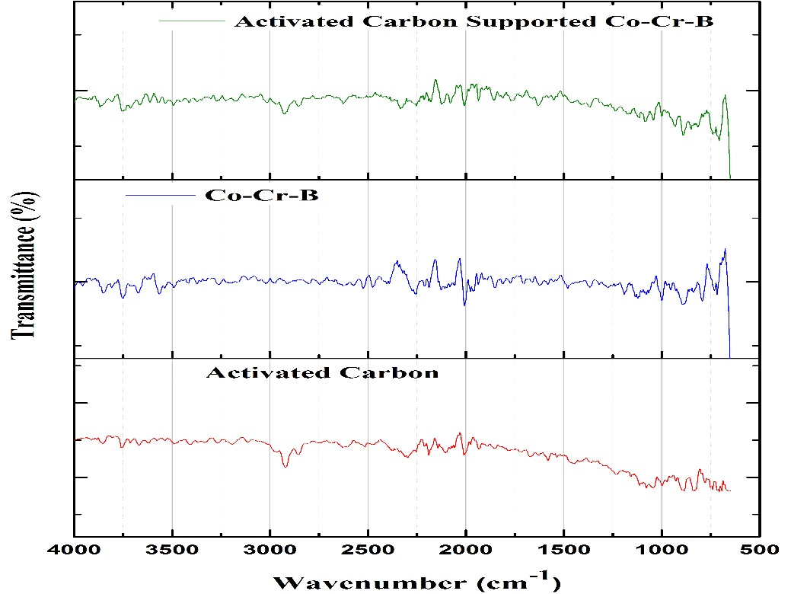
Figure 4 FTIR Results; a) activated carbon b) activated carbon-supported Co-Cr-B catalyst c) Co-Cr-B catalyst.

As can be seen from Figure 4 (a), the active carbon structure used as support material has; a peak at 3700 cm⁻¹ due to hydroxyl (OH-) functional groups bound by hydrogen bonds, a peak at 2900 cm⁻¹is related to the functional groups of CH originating from methyl or methylene groups, a peak at 2380 cm⁻¹ is associated with the -C = C functional groups, a peak at 2100 cm⁻¹ is related to the -COOH functional groups and a peak at 1400 cm⁻¹gives the _C-CH₃ functional groups. Figure 4 (b) reveals that after the Co-Cr-B catalyst is adsorbed on the activated carbon surface, some functional groups are weakened and others are becoming more visible. It is seen that the peak of OH- at 3700 cm⁻¹ and the peak of -C-H at 2900 cm⁻¹ in active carbon structure shown in Figure (3b) are weakened. A large peak at 700 cm⁻¹ was observed. The probable cause of this peak formation is due to the newly formed bond between the Co-Cr-B catalyst and activated carbon.
BET surface areas of activated carbon, activated carbon supported Co-Cr-B catalyst (loaded with 15% Co-Cr-B) and Co-Cr-B catalyst used as support materials are given in Table 1.
Table 1 BET surface area results
Samples | BET surface area (m²/g)
Activated carbon | 1084
Activated carbon supported Co-Cr-B catalyst | 666
Co-Cr-B catalyst | 219

As can be seen from Table 1, the surface area of the active carbon is observed to decrease very seriously by the adsorption of the Co-Cr-B catalyst. The probable cause of this situation is the placement of the Co-Cr-B catalyst in the activated carbon pores, as seen in the SEM images. The BET surface area for Co-Cr-B catalyst was obtained as 219 m²/g and this value is the same with result reported by Fernandes et al.²³

Effect of the ratio between metal and active carbon
Effect of Co-Cr-B catalyst / activated carbon ratio (5-20% Co-Cr-B loaded) was investigated in the presence of 2.5% NaBH₄ + 2% NaOH at 30 °C and 100 mg of catalyst in 10 ml of the solution. The change in the rate of hydrogen with % Co-Cr-B is given in Figure 5a.
Figure 5a displays that the hydrogen production rate of Co-Cr-B catalyst produced without support in NaBH₄ hydrolysis is 6.5 L.g⁻¹.min⁻¹ while the hydrogen production rate of 15% Co-Cr-B loaded on the activated carbon catalyst is 30.226 L. g⁻ ¹min⁻¹. This is probably due to the increase in the surface area of the Co-Cr-B catalyst with activated carbon and the increase in active sites on the surface of the activated carbon. Baydaroğlu et al.¹⁹ found that hydrogen production rate is 21.540 L.g⁻¹.min⁻¹ using carbon black supported CoB catalysts while it is 5.670 L.g⁻¹.min⁻¹using an unsupported CoB catalysts. It can be seen from Figure 5 that the rate of hydrogen production increases as the Co-Cr-B / activated carbon percentage increases from 5% to 15% and the rate of hydrogen production decreases after the maximum value reaches 15%. The probable cause of this situation is that as the amount of Co-Cr-B increases, there are multilayers of catalyst layers on the surface of activated carbon and in the pores.
a | 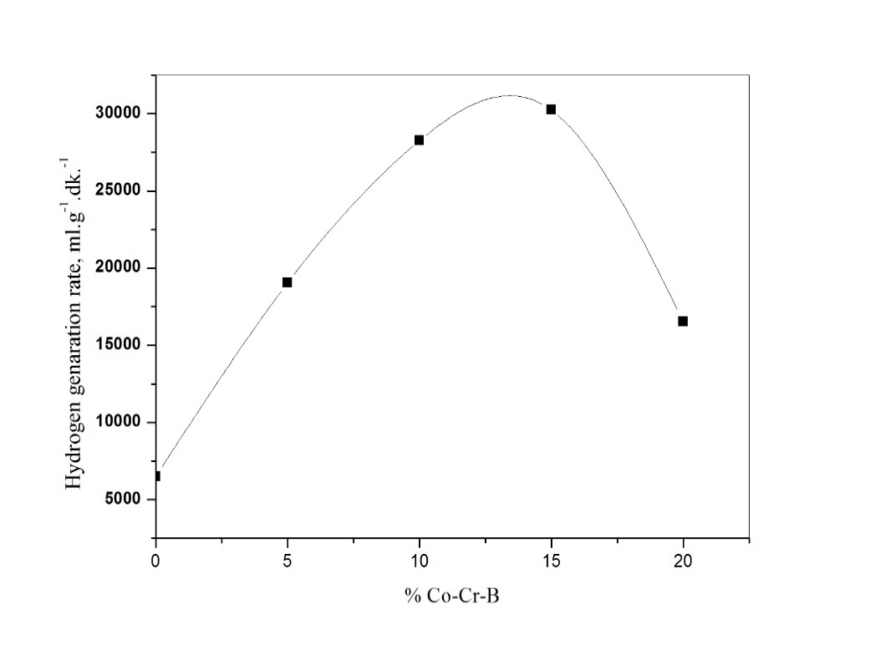
b | 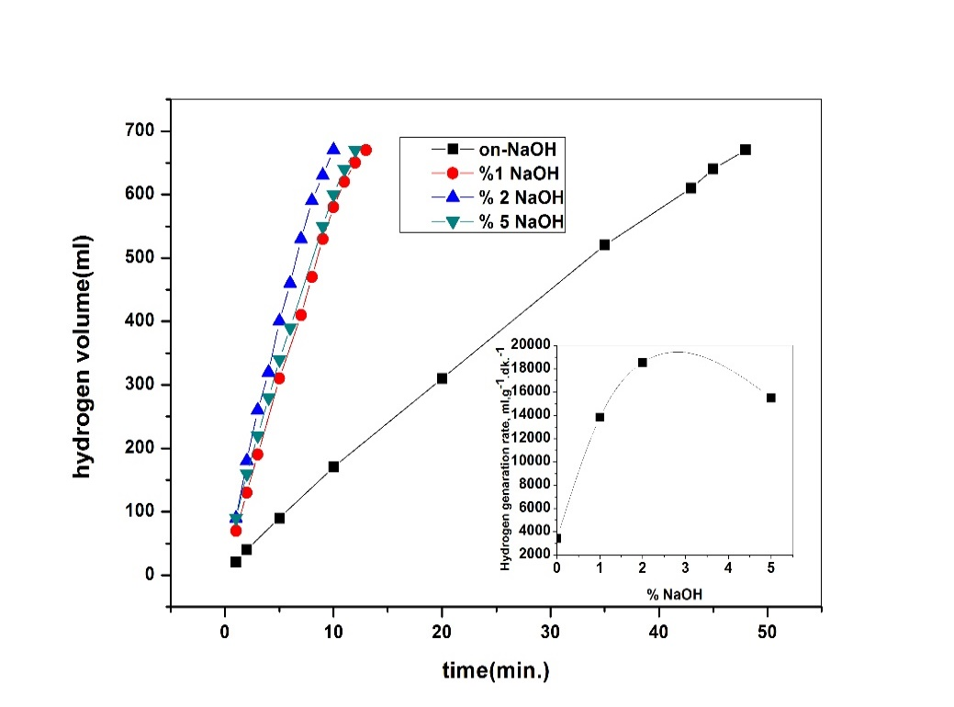
Figure 5 a-) Change of hydrogen production rate by the amount of Co-Cr-B loaded on the activated carbon. b-) Graph of the change in hydrogen content over time for different NaOH concentrations (V: 10 mL, 2.5% NaBH₄, 100 mg of catalyst, 30 ⁰C).

Effect of NaOH
Since aqueous solutions of NaBH₄ are not hydrolyzed at high pH values, NaOH is used to increase the pH value of the solution. In this part of the study, the effect of 10 ml of solution of 2.5% NaBH₄, 100 mg (loaded with 15% Co-Cr-B) activated carbon supported catalyst and different NaOH concentrations at 30 °C on the hydrolysis of NaBH₄ was investigated. The volume of hydrogen produced over time at different NaOH concentrations is given in Figure 5b.
As can be seen from Figure 5b, when the concentration of NaOH is increased from 1% to 2%, the rate of hydrogen production is increased whereas when the concentration of NaOH is more than 2%, the rate of hydrogen production is decreased. The probable cause of this behavior is that there are two different effects of OH ions in catalytic hydrolysis reactions. The first of these is the increase in the contact between NaBH₄ and the catalyst that results in increased electrostatic interaction between the activated carbon and the Co-Cr-B catalyst in the reaction solution medium at low NaOH concentrations. Hence, when the NaOH concentration is increased from 1% to 2%, the hydrogen production rate rises. The second is that OH - (more than 2%) ions present in the medium in excess have an inhibitory effect on NaBH₄ hydrolysis. Another possible cause of this situation is that NaOH, which is present in excess in the solution medium, reduces the aqueous solubility of NaBO₂, a by-product of hydrolysis of NaBH₄. Therefore, NaBO₂ in solution will collapse and block the active sites of the catalyst, thereby reducing the hydrogen production rate. Kaya et al.²⁰ found that the NaBO₂ metastatic area narrows with increasing solution pH in the study of NaBO₂ metastatic region. That is, if the concentration of NaOH is high, it accelerates NaBO₂ precipitation. Ye et al.¹² used Al₂O₃-supported CoB catalysts for hydrolysis of NaBH₄ in the presence of different NaOH concentrations and found the same results. The optimum concentration of NaOH for hydrolysis of NaBH₄ was determined as 2% and all subsequent runs were performed at a NaOH concentration of 2%.

3.6. Effect of concentration of NaBH₄
Hydrolysis of sodium borohydride is not only dependent on catalyst activity but also on factors such as NaBH₄ concentration, NaOH concentration and temperature. NaBH₄ hydrolysis was investigated at different concentrations in a 10 ml solution medium with 2% NaOH concentration, 100 mg activated carbon supported Co-Cr-B catalyst (loaded with 15% Co-Cr-B) and 30 ⁰C temperature environment. The time-eluted hydrogen volume at different NaBH₄ concentrations is given in Figure 6a. Initial production rates of hydrogen vs different concentration of NaBH₄ is also given on the same figure.
It can be seen from Figure 6a, as the NaBH₄ concentration increases, the initial production rate of hydrogen decreases. Especially, when the NaBH₄ concentration is 10%, there is a very serious decrease in the hydrogen production rate. The likely reason for this is that the solubility in water of the NaBO₂ which is by-product in the hydrolysis of NaBH₄ is limited. Another reason for this is; the high concentrations of NaBH₄ and NaBO₂ presented in the medium increase the viscosity of the final solution, which slows the mass transfer to the catalyst surface from the sodium borohydride present in the solution medium. Xu et al.²¹ found the same conclusion in their study.

a | 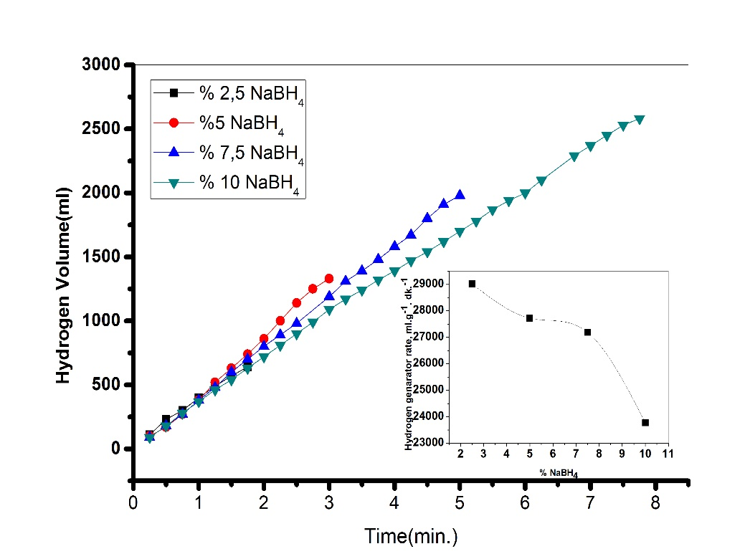
b | 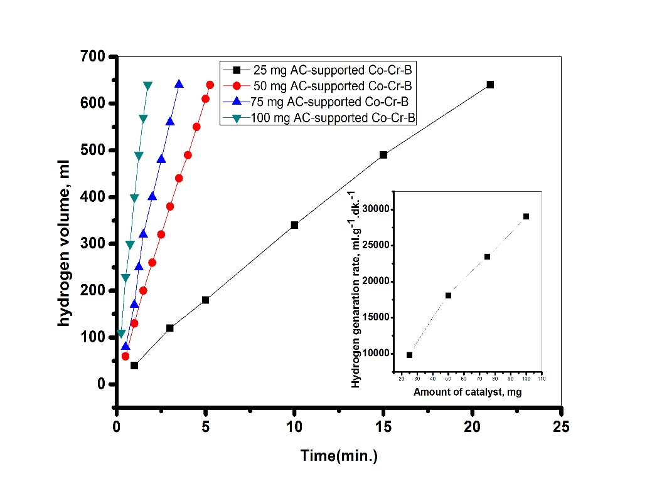
Figure 6 a-) The graph of change in hydrogen content over time for different NaBH₄ concentrations (V: 10 mL, 2% NaOH, 100 mg of catalyst, 30 ⁰C). b-) The graph of change in hydrogen content with time for different amounts of catalyst (V: 10 ml; 2.5% NaBH₄; 2% NaOH; 30 ⁰C).

Effect of amount of catalyst
The hydrolysis of sodium borohydride was studied in 10 ml of solution at a concentration of 2.5% NaBH₄ + 2% NaOH, at 30 °C and in different amounts of catalyst. The volume of hydrogen produced with time for different amounts of catalyst is given in Figure 6b.
As shown in the Figure 6b, as the amount of catalyst increases, the hydrogen rate also increases. This suggests that the hydrolysis of sodium borohydride is catalyst-controlled.

Effect of solution temperature
The effect of the temperature on the hydrolysis of sodium borohydride was investigated. The change in hydrogen volume of produced hydrogen at different temperatures is given in Figure 7a.
As can be seen from Figure 7a, there is a significant increase in the volume of hydrogen obtained in the hydrolysis of sodium borohydride as the temperature increases. 2.5% sodium borohydride hydrolysis takes place in 13 minutes at 20 °C, 1.75 minutes at 30 °C and 1 minute at 60 °C.
One of the most fundamental reasons for measuring the reaction time of any reaction at different temperatures is determining the reaction rate constant and determining the activation energy required for the reaction to take place accordingly. For this reason, first of all, a n-th reaction was used to determine the rate constants at different temperatures and the reaction rate constant for this reaction was determined by the equation given below.
$\frac{1}{n-1}\left(\frac{1}{C_{A}^{n-1}}-\frac{1}{C_{A_{0}}^{n-1}}\right)=kt$ (1)
Equation 2 was obtained if Equation 1 was set.
$\frac{1}{C_{A}^{n-1}}=\left(n-1\right)kt+\frac{1}{C_{A_{0}}^{n-1}}$ (2)
According to Equation 2, the slope of$\frac{1}{C_{A}^{n-1}}$versus t gives the reaction rate constant (k) for different temperatures.
However, when this equation was applied, the n values were selected in that form, until the regression coefficient was close to 1. After the most suitable n value was determined, k was obtained from the slope of the obtained curve. In this procedure, the graph of $\frac{1}{C_{NaBH4}^{n-1}}$ versus t is given in Figure 7b.
a | 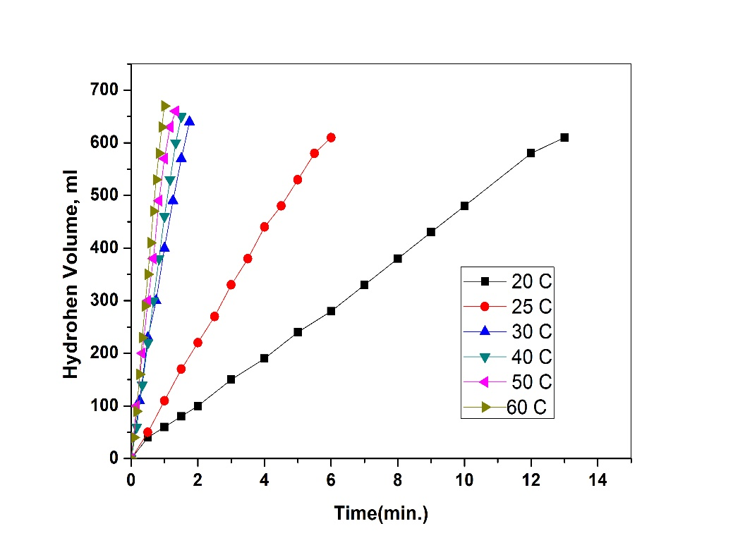
b | 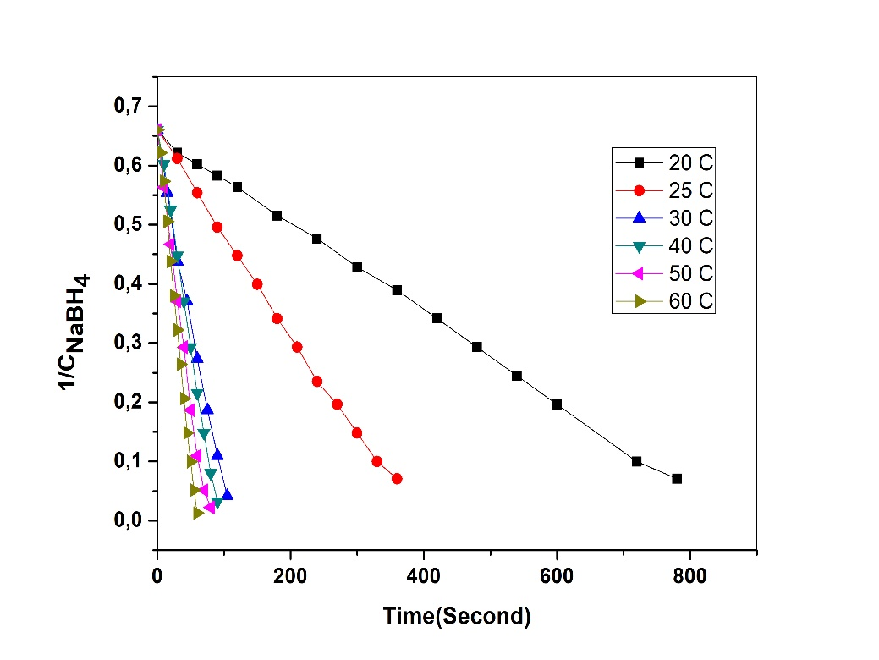
Figure 7 a-) The graph of change in hydrogen content with time for different temperatures (V: 10 ml; 2.5% NaBH₄; 2% NaOH; 100 mg of catalyst). b-) The graph of 1/C versus t for different temperatures.
As you can see in Figure 7b, the selected n values in all temperatures are consistent and linear. Within the above procedure, the optimum order of rate was found as 0.126. The rate constants at different temperatures are given in Table 2. Activation energy was determined by Arrhenius equation using these rate constants at different temperatures.

Table 2 The rate constants for different temperatures.
Temperatures (ºC) | Rate constants,k (ml.g⁻¹.min⁻¹) | Order
20 | 0.0518 | 0.126
25 | 0.1157 | 0.126
30 | 0.4217 | 0.126
40 | 0.4919 | 0.126
50 | 0.6038 | 0.126
60 | 0.7619 | 0.126

$k=Ae^{\frac{-E}{RT}}$ (3)
When Equation 3 was linearized, Equation 4 was obtained.
$\ln\left(k\right)=lnA-\frac{E}{RT}$ (4)
According to Equation 4, when the slope of the graph of ln k vs 1/T (is shown in Figure 8) was used, the activation energy required for the hydrolysis of NaBH₄ in the presence of activated carbon-supported Co-Cr-B catalyst was found as 16.27 kJ /mol. This value is very low and indicates that the activity of the catalyst is very high. The hydrogen production rate of activated carbon-supported Co-Cr-B catalyst in 2.5 ml of NaBH₄ hydrolysis in 10 ml of solution at 30 °C was determined as 30.266 L.g⁻¹.min⁻¹ and the comparison with literature is given in Table 3.
Table 3 Hydrogen production rates and activation energies of different catalysts for hydrolysis of NaBH₄ in the literature.
Catalyst | Hydrogen production rate (L.g⁻¹.min.⁻¹) | Activation energ, E(kj/mol) | Reference
Carbon supported CoB | 2.073 | 57,8 | 1
Carbon supported CoB |  | 44,1 | 21
Clay supported CoB | 3.350 | 56,32 | 22
Co-Cr-B | 3.400 | 37 | 23
Reduced Co-Cr-B in plasma medium | 1.416 | 16.17 | 24
Activated carbon supported Co-Cr-B | 30.226 | 16.27 | This study

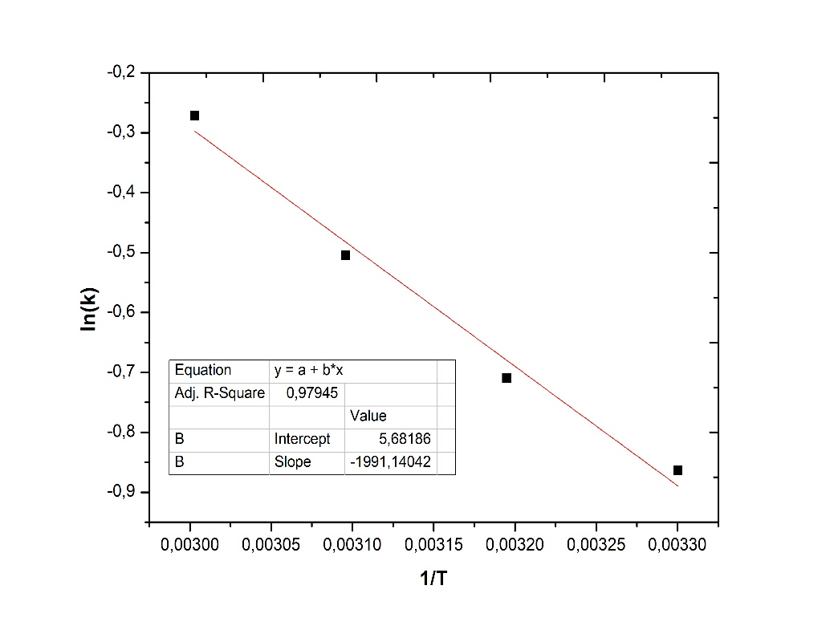
Figure 8 The graph of ln (k) versus 1/T.

Conclusions
In this study, activated carbon supported Co-Cr-B catalyst was prepared to use in the hydrolysis of NaBH₄. The hydrogen production rate of synthesized activated carbon-supported Co-Cr-B catalyst was found as 30.226 L.g⁻¹.min⁻¹ while the hydrogen production rate unsupported Co-Cr-B catalyst was found as 6.490 L.g⁻¹.min⁻¹. It was determined that the activity of the Co-Cr-B catalyst on the activated carbon surface increases approximately 5-fold. It was determined that the hydrogen production rate of the 15% Co-Cr-B loaded catalyst was the best when the NaOH concentration was 2%. The increase in the concentration of NaBH₄ reduced the production rate of hydrogen while the increase in the amount of catalyst increased the hydrogen production rate. It was determined that the production rate of hydrogen significantly increased with increasing temperature. The inhibition of hydrolysis kinetic of NaBH₄ and the activation energy in the presence of activated carbon-supported Co-Cr-B catalyst were found to as 0.126 and 16.27 kJ/mol, respectively. According to the results obtained, activated carbon-supported Co-Cr-B catalyst NaBH₄ can be used in PEMFC mobile systems.

References
- J. Zhu, R. Li, W. Niu, Y. Wu, Gou X, Journal of Power Sources, 2012, 211, 33.
- W. Luo, P.G. Campbell, L.N. Zakharov, S. Liu, J. Am. Chem. Soc. 2011, 133(48), 19326-19329.
- C. Crisafulli, S. Scire`, R. Zito, C. Bongiorno, Catalysis Letters, 2012, 142, 882-888.
- M. Rakap, E.E. Kalu, S. Özkar, Journal of Alloys and Compounds, 2011, 509, 7016-7021.
- J. Lee, K.Y. Kong, C.R. Jung, E. Cho, S.P. Yoon, Catalysis Today, 2007, 120, 305-310.
- Ö. Şahin, D. Karakas, M. Kaya, C. Saka, Journal of the Energy Institute, 2016, 90, 1-10.
- A. Ekinci, Ö. Şahin, C. Saka, T. Avci, International Journal Of Hydrogen Energy, 2013, 38, 15295 -15301
- M.S. Izgi, Ö. Şahin, C. Saka, International journal of Hydrogen Energy, 2016, 41, 1600-1608.
- C. Saka, A. Ekinci, Ö. Şahin, A. Balbay, Journal of the Energy Institute, 2016, 89, 190-198.
- Y. Huang, Y. Wang, R. Zhao., P.K. Shen, Z. Wei, International Journal of Hydrogen Energy, 2008, 33, 7110-7115.
- D. Xu, P. Dai, Q. Guo, X. Yue, International Journal of Hydrogen Energy, 2008, 33, 7371-7377.
- W. Ye, H. Zhang, D. Xu, L. Ma, B. Yi, Journal of Power Sources, 2007, 164, 544-548.
- C. Saka, Journal of Analytical and Applied Pyrolysis, 2012, 95: 21-24.
- H. Dolas, Ö. Sahin, C. Saka, H. Demir, Chemical Engineering Journal, 2011, 166, 191-197.
- Ö. Sahin, C. Saka, Bioresource Technology, 2013, 136, 163-168.
- Ö. Şahin, C. Saka, A.A. Ceyhan, O. Baytar, Separation Science and Technology, 2015, 50, 886-891.
- Ö. Şahin, C. Saka, A.A. Ceyhan, O. Baytar, Energy Sources, Part A: Recovery Utılızatıon And Envıronmental Effects, 2016, 38, 1756-1762.
- O. Baytar, Selçuk University Institute of Science, 2015 42.
- F. Baydaroglu, E. Özdemir, A. Hasimoglu, International Journal of Hydrogen Energy, 2014, 39, 1516-1522.
- M. Kaya, A.A. Ceyhan, Ö. Şahin, Russian Journal of Physical Chemistry, 2014, 88, 402-408.
- D. Xu, P. Dai, X. Liu, C. Cao, Q. Guo, Journal of Power Sources, 2008, 182, 616-620.
- H. Tian, Q. Guo, D. Xu, Journal of Power Sources, 2010, 195, 2136-2142.
- R. Fernandes, N.A. Patel, Applied Catalysis B: Environmental, 2009, 92, 68-74.
- F. Hansu, Journal of the Energy Institute, 2015, 88, 266-274.

