Scientific paper
Uses of anthranilic acid for the synthesis of dihydroquinazolin derivatives with antitumor, anti-proliferative and Pim-1kinase activities
Rafat M. Mohareb*ª, Peter A. Halim^{b}
ªDepartment of Chemistry, Faculty of Science, Cairo University, Giza, A. R. Egypt
^{b} Pharmaceutical Organic Chemistry Department, Faculty of Pharmacy, Cairo University, Cairo 11562, Egypt

Abstract
The reaction of anthranilic acid with ethoxycarbonylisothiocyanate gave the ethyl 4-oxo-2-thioxo-1,2-dihydroquinazoline-3(4H)-carboxylate (4). The reaction of compound 4 with hydrazine hydrate and α-halocarbnyl derivatives was studied to give either hydrazono or S-alkylated products. Heterocyclization reactions of some of the S-alkylated derivatives 8 and 12 were carried to afford thiophene, thiazole, pyran and pyridine derivatives. The cytotoxicity of the newly synthesized compounds towards the six cancer cell lines NUGC, DLD-1, HA22T, HEPG-2, HONE-1 and MCF-7 showed that compounds 8, 10, 16a, 19d-f, 21c, 21e, 21f, 24a and 24b showed the highest cytotoxicity. The c-Met kinase inhibition for some selected compounds showed that compounds 8, 13, 19d, 21e, 21f and 24a with the highest inhibitory effect. Activities towards tyrosine kinases revealed that compounds 13, 21e and 24a with the highest potency their molecular modeling was described. Compounds 13 and 24a showed the highest activities towards Pim-1 kinase.
Keywords: dihydroquinazolin; thiophene; thiazole; pyran; pyridine; cytotoxicity
- Introduction
2-Thioxoquinazolin-4(1H)-ones are important heterocyclic compounds that widely present in natural products as well as medicinal, and pharmacological compounds.¹ In addition, several thioxoquinazolin analogues have been developed as antitumor, antibiotic, antidefibrillator and antipyretic agent (Fig. 1). Further- more, they display a broad range of applications for diabetes,² cancer,³ and selective plant grow regulators.^{4,5} Given the importance of these nitrogen heterocyclic compounds, the devel- opment of mild, high yielding and clean synthesis of these important compounds is daunting challenge and has been extensively investigated in literatures.⁶⁻¹² The classical methods for the synthesis of quinazolinedione ring system are the reaction of anthranilic acid and their derivatives with isothiocyanates or their equivalents.¹³⁻²⁷ In this context, we aimed to develop an efficient and facile approach to synthesize a series of thioxoquinazolin-4(1H)-ones from anthranilic acid and ethoxycarbonylisothiocyanate.

- Results and discussion
In the present work we aimed to synthesis a series of heterocyclic compounds derived from dihydroquinazoline derivative. The reaction of anthranilic acid (1) with ethoxycarbonylisothiocyanate (2) in 1,4-dioxane gave the ethyl 2-thioxo-2,3-dihydroquinazolin-4(1H)-one-3-carboxylate (4). The formation of the latter product took place through intermediate formation of the thiourea derivative followed by cyclization. Compound 4 was used for the synthesis of different heterocyclic compounds through its reaction with different chemical reagents. Thus, the reaction of compound 4 with hydrazine hydrate (5) gave the hydrazone derivative 6. Compound 4 was capable to form thioether derivatives through its reaction with α-halocarbonyl compounds. Thus, the reaction of compound 4 with any of the ethyl chloroacetate (7), chloroacetone (9) or 2-bromo-1-(4-chlorophenyl)ethanone (11) gave the thioether derivatives 8, 10 and 12, respectively (Scheme 1). The structures of compounds 8, 10 and 12 were established on the basis of the analytical and spectral data. Thus, the ¹H NMR spectrum of compound 12 (as an example) showed the presence of a triplet at δ 1.13 and a quartet at δ 4.22 ppm equivalent for the ester CH₃ and CH₂, respectively, a singlet at δ 3.73 ppm equivalent for the OCH₃ group, a singlet at δ 5.49 for the CH₂ group and a multiplet at δ 7.23-7.42 ppm for the two C₆H₄ groups. In addition the ¹³C NMR spectrum showed δ 16.4 (ester CH₃), 37.5 (CH₂), 53.4 (ester CH₂), 55.2 (OCH₃), 119.2, 120.8, 122.3, 124.4, 124.9, 126.2, 126.8, 127.8, 128.4, 129.1 indicating the C₆H₅ and C₆H₄ groups and three signals at δ 163.2, 164.4, 165.8 confirming the three CO group.
On the other hand, the reaction of compound 4 with chloroacetylchloride (13) in a boiling dimethylformamide containing potassium carbonate gave the 1-(2-chloroacetyl)-3-phenyl-2-thioxo-2,3-dihydroquinazolin-4(1H)-one (14).
The reaction of compound 8 with hydrazine hydrate (5) gave the hydrazino derivative 13. On the other hand the reaction of compound 8 with either of malononitrile (14a) or ethyl cyanoacetate (14b) gave the dihydro[1,3,4]thiadiazino[3,2-a]quinazolin-6(1H)-one derivatives 16a and 16b, respectively (Scheme 2). Formation of compounds 16a and 16b took place through the intermediate formation of 15a,b followed by cyclization. The structures of compounds 16a and 16b were confirmed on the basis of analytical and spectral data. Thus, the ¹H NMR spectrum of 16a showed, beside the expected signals, two triplets at δ 1.12, 1.15 and two quartets at δ 4.16, 4.20 ppm indicating the presence of two esters CH₃ and CH₂ groups, respectively, a singlet at δ 6.01 ppm equivalent to the pyrimidine H-2 and a singlet at δ 8.28 ppm for the NH group. In addition its ¹³C NMR spectrum showed two signals at δ 16.3, 16.5 for the two ester CH₃ groups and two quartets at δ 52.1, 53.8 for the two ester CH₂ groups, three signats at δ 163.8, 164.4, 165.2 equivalent to the three CO groups.
In continuation of our recent interest to conduct multi-component reactions using aromatic aldehydes and cyanomethylene reagents²⁸⁻³⁰ we studied the multi-component reactions of compound 12. Thus, the multi-component reaction of compound 12 with any of the aromatic aldehydes namely, benzaldehyde (17a), 4-chlorobenzaldehyde (17b) or 4-methoxybenzaldehyde (17c) and either of malononitrile (14a) or ethyl cyanoacetate (14b) in 1,4-dioxane containing triethylamine gave the pyran derivatives 19a-f, respectively through the intermediate formation of 18a-f. The analytical and spectral data of the compounds 19a-f (Scheme 3) were based on their respective analytical and spectral data (see experimental section).
On the other hand, the multi-component reaction of compound 12 with any of benzaldehyde (17a), 4-chlorobenzaldehyde (17b) or 4-methoxybenzaldehyde (17c) and either of malononitrile (14a) or ethyl cyanoacetate (14b) in 1,4-dioxane containing ammonium acetate gave the pyridine derivatives 21a-f, respectively (Scheme 4). Formation of the latter products took place through the intermediate formation of 20a-f.
Recently, our research group was involved through a comprehensive program involving the reaction of active methylene reagents with phenylisothiocyanate in basic dimethylformamde solution followed by heterocyclization with α-halocarbonyl compounds.³¹⁻³³ Products of the reaction were either thiophene or thiazole derivatives or a mixture of both depending on the reaction conditions and the nature of the α-halocarbonyl compound. In continuation of this program we conducted the reaction of compound 8 with phenylisothiocyanate (23) in dimethylformamide containing potassium hydroxide gave the intermediate potassium salt 22. The reaction of the intermediate 22 with any of ethyl chloroacetate (7) chloroacetone (9) or 2-bromo-1-(4-chlorophenyl)ethanone (11) afforded the thiazole derivatives 24a-c, respectively (Scheme 5). All synthesized compounds were obtained in good yields and their cytotoxicity against cancer cell lines was measured.

  - Biological evaluation
    - In vitro cytotoxic assay
Chemicals
Fetal bovine serum (FBS) and L-glutamine, were purchased from Gibco Invitrogen Co. (Scotland, UK). RPMI-1640 medium was purchased from Cambrex (New Jersey, USA). Dimethyl sulfoxide (DMSO), doxorubicin, penicillin, streptomycin and sulforhodamine B (SRB) were purchased from Sigma Chemical Co. (Saint Louis, USA).

Cell cultures
Was obtained from the European Collection of cell Cultures (ECACC, Salisbury, UK) and human gastric cancer (NUGC and HR), human colon cancer (DLD1), human liver cancer (HA22T and HEPG2), human breast cancer (MCF), nasopharyngeal carcinoma (HONE1) and normal fibroblast cells (WI38) were kindly provided by the National Cancer Institute (NCI, Cairo, Egypt). They grow as monolayer and routinely maintained in RPMI-1640 medium supplemented with 5% heat inactivated FBS, 2 μM glutamine and antibiotics (penicillin 100 U/mL, streptomycin 100 lg/mL), at 37 ºC in a humidified atmosphere containing 5% CO₂. Exponentially growing cells were obtained by plating 1.5 x 10⁵ cells/mL for the seven human cancer cell lines including cells derived from 0.75 x 10⁴ cells/mL followed by 24 h of incubation. The effect of the vehicle solvent (DMSO) on the growth of these cell lines was evaluated in all the experiments by exposing untreated control cells to the maximum concentration (0.5%) of DMSO used in each assay.
The heterocyclic compounds, prepared in this study, were evaluated according to standard protocols for their in vitro cytotoxicity against six human cancer cell lines including cells derived from human gastric cancer (NUGC), human colon cancer (DLD1), human liver cancer (HA22T and HEPG2), human breast cancer (MCF), nasopharyngeal carcinoma (HONE1) and a normal fibroblast cells (WI38). All of IC₅₀ values were listed in Table 1. Some heterocyclic compounds was observed with significant cytotoxicity against most of the cancer cell lines tested (IC₅₀=10–1000 nM). Normal fibroblasts cells (WI38) were affected to a much lesser extent (IC50>10,000 nM). The reference compound used is the foretinib anti-tumor agent.

    - Structure activity relationship
It is clear from Table 1 that most of the tested compounds showed cytotoxicity against the selected cancer cell lines. Compound 4 showed high cytotoxicity against HEPG-2 and MCF-7 cell lines with IC₅₀’s 683 and 460 nM, respectively . The reaction of compound 4 with hydrazine hydrate gave the hydrazone derivative 6 which showed high potency against the six cancer cell lines, this was attributed to the high nitrogen content in this compound. It is worthy to note that compound 6 showed higher cytotoxicity than foretinib against DLD-1 and HEPG-2 cell lines with IC₅₀’s 69 and 125 nM, respectively. On the other hand, the reaction of compound 4 with ethyl α-chloroacetate gave the thioether derivative 8 with high cytotoxicity against the six cancer cell lines but its potency is a little bit less than that of compound 6. It is obvious that compound 8 showed higher cytotoxicity than foretinib against DLD-1 and HEPG-2 cell lines with IC₅₀’s 230 and 64 nM, respectively. On the other hand, the thioether 10 showed high potency against HONE-1 and MCF-7 cell lines but compound 12 showed low potency against the six cancer cell lines. The reaction of compound 8 with hydrazine hydrate gave the hydrazino derivative 13 with the high nitrogen content, showed relatively high potency against the six cancer cell lines. On the other hand, the dihydro-[1,3,4]thiadiazino[3,2-a]quinazoline derivatives 16a,b showed low potency. The multi-component reactions of compound 12 with any of the artomatic aldehydes 17a-c and either of malononitrile or ethyl cyanoacetate gave the pyran derivatives 19a-f. Compounds 19c (X = Cl, Y = NH₂), 19d (X = Cl, Y = OH) and 19e (X = OCH₃ Y = NH₂) showed the highest cytotoxicity among such series of compounds. On the other hand, for the pyridine derivatives 21a-f, the four compounds 21b (X = H, Y = OH), 21d (X = Cl, Y = OH), 21e (X = OCH₃, Y = NH₂) and 21f (X = OCH₃, Y = OH) showed the highest potency. Compound 21f showed cyctotoxicity higher than foretinib against the DLD-1 cell line with IC₅₀ 219 nM Considering the thiazole derivatives 24a-c, it is obvious that compounds 23a (Y = OH) and 24c (Y = 4-OCH₃-phenyl) showed higher potency than 24b (Y = CH₃). It is clear that throughout the synthesized compounds the presence of the electronegative groups like the Cl and OH groups or the electron reach NH₂ groups enhance the potency of the compound.

Table 1: Cytotoxicity of the newly synthesized products against a variety of cancer cell lines [IC₅₀ª (nM)]
Compound
No. Cytotoxocity (IC₅₀ in nM)

4  6  8  10  12  13  16a  16b  19a  19b  19c  19d  19e  19f  21a  21b  21c  21d  21e  21f  24a  24b  24c  Foretinib | NUGC^{b} | DLD-1^{b} | HA22T^{b} | HEPG-2^{b} | HONE-1^{b} | MCF-7^{b} | WI-38^{b}
 | 1250  75  137  1089  1224  430  1466  2557  2539  1368  65  159  30  1089  2166  88  1243  480  129  55  380  2848  93  23 | 1280  69  230  1694  1476  784  2369  2590  3167  1273  530  250  62  1146  2253  79  138  679  226  79  219  2218  68  258 | 1088  59  219  1741  2251  352  1763  2430  2577  1549  250  59  74  89  1259  194  229  1293  183  134  179  2214  169  48 | 683  125  64  2493  1122  280  2461  1461  2690  1366  149  114  39  122  2769  520  1821  580  480  109  229  2373  421  240 | 1159  312  312  253  1373  1879  2749  2893  1993  2165  259  189  1330  320  2429  287  128  744  136  85  312  1072  629  35 | 460  189  109  290  1229  128  1863  1279  3289  2540  426  550  88  422  2760  1221  220  124  229  93  59  1238  229  35 | NA  NA  NA  NA  NA  NA  NA  NA  NA  NA  NA  NA  NA  320  NA  NA  NA  NA  NA  NA  NA  NA  NA  NA

ªDrug concentration required to inhibit tumor cell proliferation by 50% after continuous exposure of 48 h.

^{b}NUGC, gastric cancer; DLD-1, colon cancer; HA22T, liver cancer; HEPG-2, liver cancer; HONE-1, nasopharyngeal carcinoma; MCF-7, breast cancer; WI-38, normal fibroblast cells. NA: Not Active.

    - Cell proliferation assay
The anti-proliferative activity of compounds 6, 8, 13, 19c, 19d, 19e, 21b, 21d, 21e, 21f, 24a and 24c were evaluated (Table 2) against the five c-Met-dependent cancer cell lines (A549, HT-29, MKN-45, U87MG, and SMMC-7721) and one c-Met-independent cancer cell line (H460) using the standard MTT assay in vitro, with foretinib as the positive control.^{34,35} The cancer cell lines were cultured in minimum essential medium (MEM) supplemented with 10% fetal bovine serum (FBS). Approximate 4 x 10³ cells, suspended in MEM medium, were plated onto each well of a 96-well plate and incubated in 5% CO₂ at 37 ºC for 24 h. The compounds tested at the indicated final concentrations were added to the culture medium and the cell cultures were continued for 72 h. Fresh MTT was added to each well at a terminal concentration of 5 μg/mL, and incubated with cells at 37 ºC for 4 h. The formazan crystals were dissolved in 100 μL of DMSO each well, and the absorbency at 492 nM (for absorbance of MTT formazan) and 630 nM (for the reference wavelength) was measured with an ELISA reader. All of the compounds were tested three times in each cell line. The results expressed as IC₅₀ (inhibitory concentration 50%) were the averages of three determinations and calculated by using the Bacus Laboratories Incorporated Slide Scanner (Bliss) software.

    - In vitro cell assays
The antitumor evaluations³⁶ of the synthesized compounds were measured against A549 (non-small cell lung cancer), H460 (human lung cancer), HT-29 (human colon cancer) and MKN-45 (human gastric cancer cancer), U87MG (human glioblastoma) and SMMC-7721 (human liver cancer) cell lines. cancer cell lines. Foretinib was used as the positive control by a MTT assay. The results expressed as IC₅₀ after three different experiments were summarized in (Table 2). The data listed in (Table 2) revealed that the compounds possessed moderate to strong cytotoxicity against the five tested cell lines in the single-digit lM range, and high selectivity for inhibition A549, H460 and MKN-45 cells. The promising compounds were 13, 19c, 19e, 21d, 21e and 24c were the most active IC₅₀ values of 0.09 and 0.83 μM, respectively. Moreover, compound 13 showed potency higher that foretinib towards H460 with IC₅₀ 0.06 μM. Compounds 6, 13, 19e, 21d, 21e showed activities toward U87MG cell line higher that foretinib with IC'₅₀ 0.39, 0.69, 0.26, 0.70 and 0.42 μM, respectively. It is of great value to note that compound 6 showed higher potency than foretinib with IC₅₀ 0.29 μM.
Table 2. In vitro growth inhibitory effects IC₅₀ ± SEM (μM) of the most potent compounds
Compound No | IC₅₀ ± SEM (μM)
Compound No | A549 | H460 | HT29 | MKN-45 | U87MG | SMMC-7721
6 | 1.28± 0.67 | 1.58 ± 0.65 | 0.65 ± 0.32 | 1.58± 0.49 | 0.39 ± 0.18 | 0.29± 0.19
8 | 1.02± 0.80 | 1.27 ± 0.69 | 1.28± 0.79 | 1.04 ± 0.48 | 1.49 ± 0.72 | 1.26± 0.73
13 | 0.09 ± 0.06 | 0.06 ± 0.01 | 0.04 ± 0.06 | 0.83 ± 0.26 | 0.69 ± 0.32 | 0.73± 0.25
19c | 0.77± 0.34 | 0.28 ± 0.06 | 0.93 ± 0.24 | 0.72± 0.14 | 0.48 ± 0.13 | 0.93± 0.18
19d | 1.02 ± 0.36 | 1.18 ± 0.42 | 0.93 ± 0.26 | 0.63± 0.14 | 1.63± 0.87 | 0.32± 0.16
19e | 0.63 ± 0.28 | 0.36 ± 0.25 | 0.03 ± 0.53 | 0.28 ± 0.11 | 0.26± 0.07 | 0.80± 0.24
21b | 3.26 ± 1.72 | 3.59 ± 1.30 | 1.42 ± 0.80 | 2.83 ± 0.46 | 1.74± 0.79 | 1.40± 0.73
21d | 0.87 ± 0.22 | 0.69 ±0.21 | 0.59 ± 0.11 | 0.69± 0.21 | 0.70± 0.12 | 0.83± 0.24
21e | 0.18 ± 0.02 | 0.25± 0.09 | 0.36 ± 0.09 | 0.16 ± 0.07 | 0.42± 0.16 | 0.55± 0.19
21f | 2.31± 0.69 | 2.49± 0.80 | 1.43 ± 0.79 | 1.08 ± 0.75 | 2.39± 0.93 | 1.38± 0.91
24a | 1.02 ± 0.53 | 1.08 ± 0.55 | 2.39 ± 0.88 | 1.48 ± 0.93 | 0.95± 0.29 | 1.63± 0.82
24c | 0.19 ± 0.01 | 0.28± 0.07 | 0.80 ± 0.09 | 0.57 ± 0.08 | 0.93 ± 0.27 | 0.75 ± 0.16
Foretinib | 0.08 ± 0.01 | 0.18 ± 0.03 | 0.15 ± 0.023 | 0.03 ± 0.0055 | 0.90 ± 0.13 | 0.44 ± 0.062

    - HTRF kinase assay
The c-Met kinase activity (Table 3) of the most potent compounds 6, 8, 13, 19c, 19d, 19e, 21b, 21d, 21e, 21f, 24a and 24c were measured using homogeneous time-resolved fluorescence (HTRF) assay as previously reported.^{37,38} In addition, the most potent compounds toward c-Met kinase were further evaluated against other five tyrosine kinase (c-Kit, Flt-3, VEGFR-2, EGFR, and PDGFR) using the same method [Table 4]. Briefly, 20 μg/mL poly (Glu, Tyr) 4:1 (Sigma) was used as a substrate in 384-well plates. Then 50 μL of 10 mMATP (Invitrogen) solution diluted in kinase reaction buffer (50 mM HEPES, Ph 7.0, 1 M DTT, 1 M MgCl₂, 1 M MnCl₂, and 0.1% NaN₃) was added to each well. Various concentrations of the tested compounds diluted in 10 μL of 1% DMSO (v/v) were used as the negative control. The kinase reaction was started by the addition of purified tyrosine kinase proteins diluted in 39 μL of kinase reaction buffer solution. The incubation time for the reactions was 30 min at 25 ºC and ceased by the addition of 5 μL of Streptavidin-XL665 and 5 μL Tk Antibody Cryptate working solution to all of wells. The plates were read using Envision (PerkinElmer) at 320 and 615 nM. The inhibition rate (%) was calculated using the mathematical equation: % inhibition = 100 - [(Activity of enzyme with tested compounds - Min)/(Max - Min)] x 100 (Max: the observed enzyme activity measured in the presence of enzyme, substrates, and cofactors; Min: the observed enzyme activity in the presence of substrates, cofactors and in the absence of enzyme). IC₅₀ values were calculated using the inhibition curves.

According to Table 3 it is clear that compounds 8, 13, 19d, 21e, 21f and 24a were the most active compounds towards c-Met kinase. Moreover, compounds 13, 19d and 24a showed activity towards c-Met enzymatic activity higher than that of foretinib.

Table 3. c-Met enzymatic activity and line of the most potent compounds
Compound No | X | Y | IC₅₀ (nM)  c-Met
6 | - | - | 10.22 ± 2.38
8 | - | - | 1.34 ± 0.81
13 | - | - | 0.06 ± 0.001
19c | Cl | NH₂ | 2.26 ± 0.80
19d | Cl | OH | 0.83 ± 0.19
21b | H | OH | 4.30±1.89
21d | Cl | OH | 12.28 ± 2.69
21e | OCH₃ | NH₂ | 1.27 ±0.98
21f | OCH₃ | OH | 1.40±0.51
24a | - | OH | 0.79 ± 0.09
24c | - | 4-OCH₃-C₆H₄ | 8.50 ±2.19
Foretinib | - | - | 1.16 ± 0.17

    - Inhibitory of the most active compounds towards Tyrosine kinases
The most potent compounds 8, 13, 19d, 21e, 21f and 24a towards c-Met enzametic activity five tyrosine kinase (c-Kit, Flt-3, VEGFR-2, EGFR, and PDGFR) using the same method described for c-Meth enzymatic activity and the data were shown in Table 4. Where foretinib was also used as the reference drug. It is clear from Table 4that compounds 13, 21e and 24a showed the highest inhibitory effect towards the five tyrosine kinases.

Table 4. inhibitory effect of compounds 8, 19d, 21e, 21f and 24a towards tyrosine kinases [Enzyme IC₅₀ (nM)]
Compound | c-Kit | Flt-3 | VEGFR-2 | EGFR | PDGFR
8 | 9.26 | 8.18 | 7.66 | 4.50 | 6.85
13 | 1.32 | 2.59 | 1.08 | 1.26 | 0.99
19d | 10.39 | 8.68 | 9.09 | 6.49 | 7.30
21e | 0.42 | 0.76 | 0.69 | 0.74 | 0.25
21f | 8.57 | 8.55 | 10.39 | 8.48 | 10.99
24a | 0.82 | 2.80 | 0.79 | 1.59 | 1.33
Foretinib | 0.19 | 0.17 | 0.20 | 0.13 | 0.26

    - Pim-1 kinase inhibition: 13, 21e and 24a
Compounds 13, 21e and 24a were selected to examine their Pim-1 kinase inhibition activity³⁹ at a range of 10 concentrations and the IC₅₀ values were calculated. Our slection for 13, 21e and 24a was based on their relative activity towards c-Met kinase, together with their inhibition towards tyrosine kinases, the more potent to inhibit Pim-1 activity 13 and 24a with IC₅₀ value of 0.36 and 0.28 μM, while 21e was less effective (IC₅₀ > 10 μM). SGI-1776 was used as positive control with IC₅₀ 0.048 μM in the assay. These profiles in combination with cell growth inhibition data of compounds 13, 21e and 24a was listed in Table 5 indicated that Pim-1 was a potential target of these compounds.

Table 5. The inhibitor activity of compounds 13, 21e and 24a on Pim-1 Kinase.
Compound | Inhibition ratio  At 10 μM | IC₅₀ (μM)
13 | 86 | 0.36
21e | 34 | > 10
24a | 95 | 0.28
SGI-1776 | - | 0.048

Experimental protocol of docking study
All the molecular modeling studies were carried out on an Intel Pentium 2.3 GHz processor, 8 GB memory with Windows 7 operating system using Molecular Operating Environment (MOE, 10.2008; Chemical Computing Group, Canada) software. The X-ray crystallographic structure of c-Met kinase enzyme with its co-crystallized ligand XL880 (Foretinib) in the file (PDB ID: 3LQ8) was obtained from RCSB Protein Data Bank with a 2.02A° resolution. Deleting all water of crystallization away from the active site except the one involved in interaction with the ligand. Hydrogens and partial charges were added to the system using protonate 3D application. Isolation of the active site, recognition of the amino acids and the backbone was hidden. The docking algorithm was validated via docking of the native ligand (Foretinib) into its c-Met kinase active site where the docking procedure was able to retrieve the co-crystallized pose with RMSD value of 0.55A°. The three-dimensional structures of the most active compounds 13, 21e & 24a were built using MOE molecular builder, then they were energy minimized by Merk Molecular Force Field (MMFF94x). Hydrogens and partial charges were added to the system using protonate 3D application.
Docking results
For each docked compound, only one pose was selected based on number of binding interactions, superposition with the original ligand, docking score and the formed H-bonds were measured. The docking results obtained from the docking study were summarized in table 6.

Table 6. Docking study data showing amino acid interactions and the hydrogren bond lengths of target compounds and foretinib on c-Met kinase enzyme.
Compound number | Number of H-bonds | Number of π−π interactions  with Phe¹²²³ | Atoms of compound forming H-bond | Amino acid residues forming H-bonds (H-bond length in A°) | Binding energy score  (Kcal/mol)
Ligand (Foretinib) | 2 | 1 | Quinoline N  (H-acceptor)  CO (H-acceptor) | Met¹¹⁶⁰ (3.05)  Lys¹¹¹⁰ (2.89) | -16.37
13 | 3 | - | Quinolone N1  (H-acceptor )  NHNH₂ (H-acceptor)  CONHNH₂  (H-acceptor) | Asp¹²²² (3.03)  Asp¹²²² (2.98)  Lys¹¹¹⁰ (2.75) | -11.45
21e | 3 | - | NH₂ (H-donor)  OCH₃ (H-acceptor)  OCH₃ (H-acceptor) | Asp¹¹⁶⁴ (1.46)  Asn¹¹⁷¹ (2.94)  His¹⁰⁹⁴ (2.86) | -7.83
24a | 2 | - | OH (H-donor)  OH (H-acceptor) | Asp¹¹⁶⁴ (1.23)  Asn¹¹⁷¹ (2.66) | -11.58

Discussion of molecular modeling
The X-ray crystallographic structure of XL880 (Foretinib) in complex with c-Met kinase showed that the inhibitor forms two hydrogen bonds between quinoline N and Met¹¹⁶⁰, CO of malonamide moiety and Lys¹¹¹⁰. Phe¹²²³ of the activation loop has relocated from the position in the active conformation to stack underneath the fluorophenyl ring (π−π interaction), placing the kinase in a pseudo-unactivated conformation⁴⁰ (Fig. 2). Compounds 13, 21e and 24a showed good fitting to the active binding site of c-Met kinase by interaction with Asp¹²²², Lys¹¹¹⁰, Asp¹¹⁶⁴, Asn¹¹⁷¹ & His¹⁰⁹⁴ amino acid residues (Fig. 2-5).

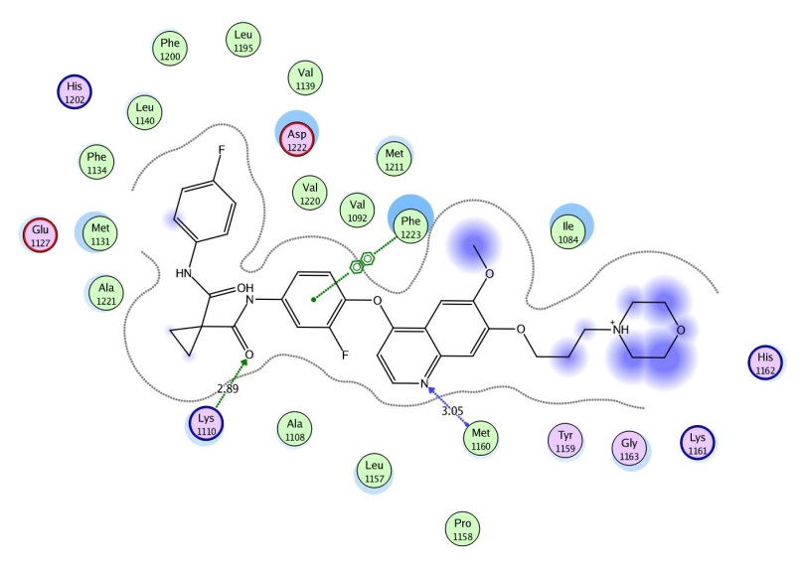
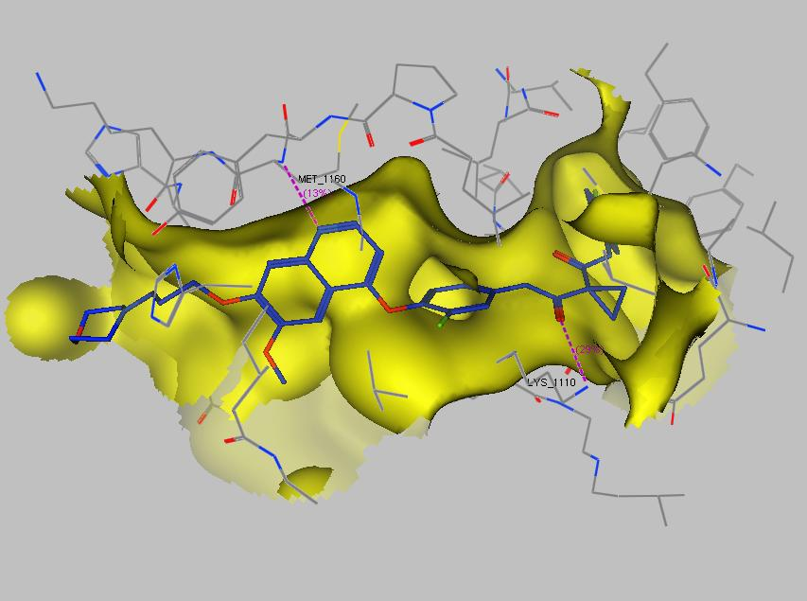

- (b)
Figure 2. Interactions of XL880 (Foretinib) with the amino acid residues of the active site of c-Met 3D(a) and 2D(b)
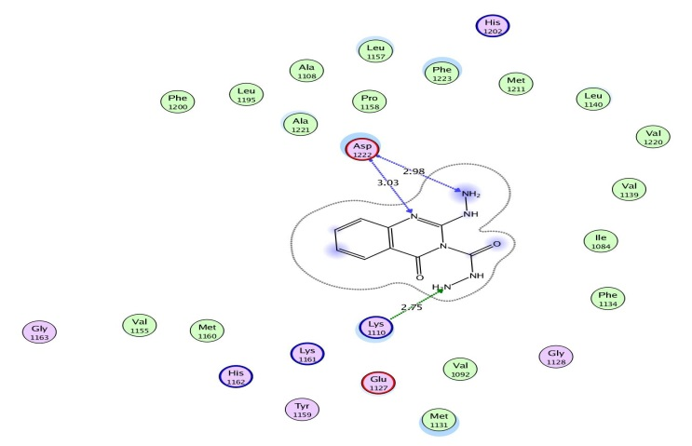
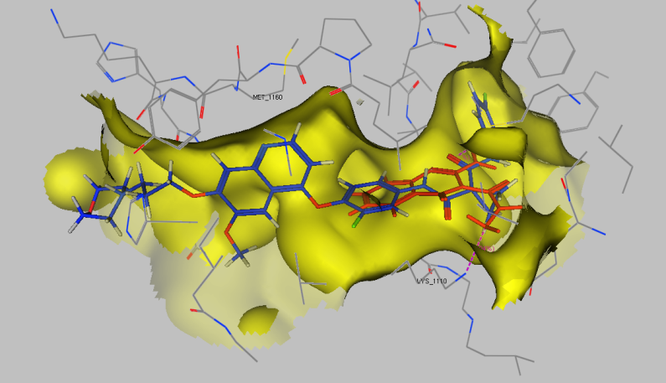

- (b)
Figure 3. (a) The superposition of Foretinib (Blue) and compound 13 (red) docked in the binding site of c-Met, the dotted lines represent H-bonding interactions (b) 2D ligand interaction of 13 in binding site of c-Met.

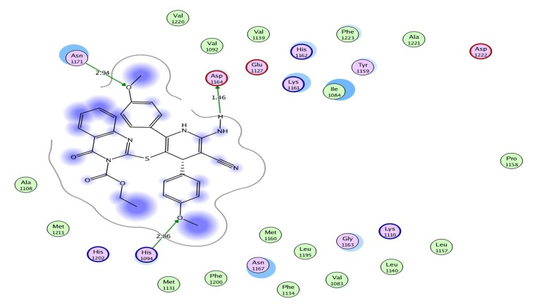
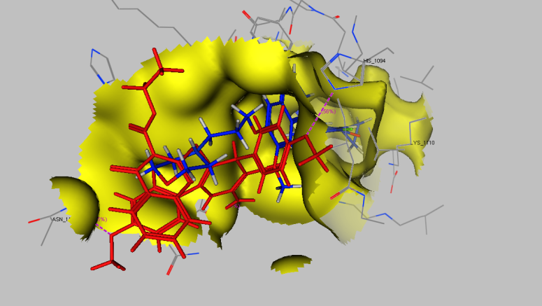

- (b)
Figure 4. (a) The superposition of Foretinib (Blue) and compound 21e (red) docked in the binding site of c-Met, the dotted lines represent H-bonding interactions (b) 2D ligand interaction of 21e in binding site of c-Met.
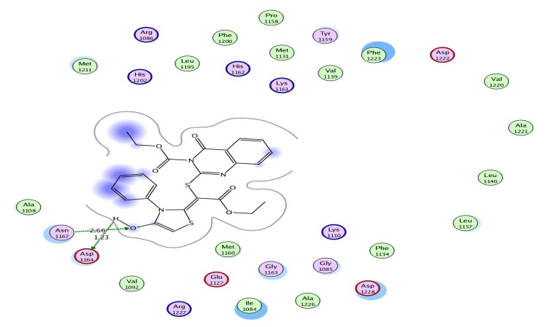
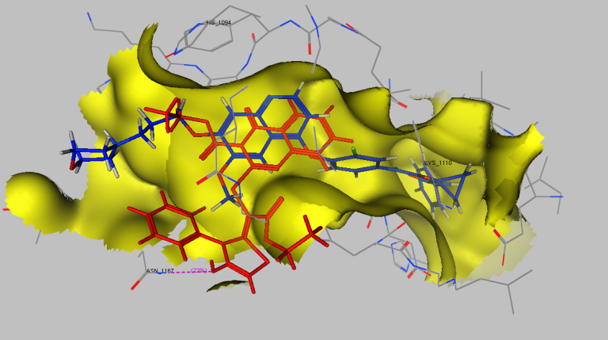

- (b)
Figure 5. (a) The superposition of Foretinib (Blue) and compound 24a (red) docked in the binding site of c-Met, the dotted lines represent H-bonding interactions (b) 2D ligand interaction of 24a in binding site of c-Met.

- Experimental
  - General
All melting points were determined on an electrothermal apparatus (Büchi 535, Switzerland) in an open capillary tube and are uncorrected. ¹³C-NMR and ¹H-NMR spectra were recorded on Bruker DPX200 instrument in DMSO with TMS as internal standard for protons and solvent signals as internal standard for carbon spectra. Chemical shift values are mentioned in δ (ppm). Mass spectra were recorded on EIMS (Shimadzu) and ESI-esquire 3000 Bruker Daltonics instrument. Elemental analyses were carried out by the Microanalytical Data Unit at Cairo University. The progress of all reactions was monitored by TLC on 2 x 5 cm pre-coated silica gel 60 F254 plates of thickness of 0.25 mm (Merck).

    - Ethyl 4-oxo-2-thioxo-1,2-dihydroquinazoline-3(4H)-carboxylate (4)
To a solution of anthranilic acid (1.37 g, 0.01 mol) in 1,4-dioxane (40 mL) a solution of ethyl carbonisothiocyanatidate (1.31 g, 0.01 mol) in 1,4-dioxane [prepared by the addition of ammonium thiocyanate (0.76 g, 0.01 mol) to ethyl chloroformate (1.08 g, 0.01 mol) in 1,4-dioxane (20 mL) and heating under reflux for 10 min] was added. The reaction mixture was heated under reflux for 1 h then poured onto ice/water and the formed solid product was collected by filtration.
Yellow crystals from ethanol; m.p. 210-212 ºC; IR (KBr) νmax 3480-3345 (NH), 3054 (CH aromatic), 2987, 2880 (CH₃, CH₂), 1688, 1682 (2CO), 1631 (C=C), 1205 (C=S) cm⁻¹; ¹H NMR (200 MHz, DMSO-d₆) δ 1.13 (t, 3H, J = 5.82 Hz, CH₃), 4.19 (q, 2H, CH₂), 7.29-7.38 (m, 4H, C₆H₄), 8.34 (s, 1H, D₂O exchangeable, NH); ¹³C NMR (75 MHz, DMSO-d₆) δ 16.2 (OCH₂CH₃), 53.8 (OCH₂CH₃), 119.4, 122.3, 125.4, 126.3, 128.4, 130.3 (C₆H₄), 164.2, 164.8 (2CO), 179.4 (C=S); Anal. Calcd. for C₁₁H₁₀N₂O₃S (250.27): C, 52.79; H, 4.03; N, 11.19; S, 12.81. Found: C, 52.83; H, 3.86; N, 11.37; S, 13.05; EIMS (m/z, %): 250 [M⁺, 42].
    - Ethyl 2-hydrazono-4-oxo-1,2-dihydroquinazoline-3(4H)-carboxylate (6)
To a solution of compound 4 (2.50 g, 0.01 mol) in ethanol (50 mL) hydrazine hydrate (0.50 g, 0.01 mol) was added. The reaction mixture was heated under reflux for 4 h then poured onto ice/water containing few drops of hydrochloric acid and the formed solid product was collected by filtration.
Yellow crystals from ethanol; m.p. 266-268 ºC; IR (KBr) νmax 3469-3339 (NH₂, NH), 3056 (CH aromatic), 2989, 2883 (CH₃, CH₂), 1689, 1684 (2CO), 1655 (C=N), 1630 (C=C) cm⁻¹; ¹H NMR (200 MHz, DMSO-d₆) δ 1.14 (t, 3H, J = 7.04 Hz, CH₃), 4.19 (q, 2H, J = 7.04 Hz, CH₂), 4.76 (s, 2H, D₂O exchangeable, NH₂), 7.26-7.37 (m, 4H, C₆H₄), 8.31 (s, 1H, D₂O exchangeable, NH); ¹³C NMR (75 MHz, DMSO-d₆) δ 16.1 (OCH₂CH₃), 53.6 (OCH₂CH₃), 120.5, 121.8, 124.8, 125.1, 127.8, 129.1 (C₆H₄), 164.3, 164.7 (2CO), 174.6 (C=N); Anal. Calcd. for C₁₁H₁₂N₄O₃ (248.24): C, 53.22; H, 4.87; N, 22.57. Found: C, 53.41; H, 4.69; N, 22.69; EIMS (m/z, %): 248 [M⁺, 26].
    - Synthesis of the thioether derivatives 8, 10 and 12
To a solution of compound 4 in ethanol (40 mL) any of compound 7 (1.22 g, 0.01 mol), 9 (0.92 g, 0.01 mol) or 11 (2.29 g, 0.01 mol) was added. The reaction mixture, in each case, was heated under reflux for 3 h then poured into ice/water mixture containing few drops of sodium hydroxide solution and the formed solid product was collected by filtration.
Ethyl 2-((2-ethoxy-2-oxoethyl)thio)-4-oxoquinazoline-3(4H)-carboxylate (8)
Yellow crystals from ethanol; m.p. 168-171 ºC; IR (KBr) νmax 3055 (CH aromatic), 2989, 2883 (CH₃, CH₂), 1691, 1686, 1884 (3CO), 1654 (C=N), 1630 (C=C) cm⁻¹; ¹H NMR (200 MHz, DMSO-d₆) δ 1.12, 1.14 (2t, 6H, J = 5.93, 6.73 Hz, 2CH₃), 4.16, 4.20 (2q, 4H, J = 5.93, 6.73 Hz, 2CH₂), 5.21 (s, 2H, CH₂), 7.28-7.38 (m, 4H, C₆H₄); ¹³C NMR (75 MHz, DMSO-d₆) δ 16.2, 16.4 (2 OCH₂CH₃), 37.5 (CH₂), 53.3, 53.5 (2 OCH₂CH₃), 120.8, 122.5, 125.3, 127.5, 127.8, 130.2 (C₆H₄), 164.3, 164.5, 165.0 (3CO), 174.6 (C=N); Anal. Calcd. for C₁₅H₁₆N₂O₅S (336.36): C, 53.56; H, 4.79; N, 8.33; S, 9.53. Found: C, 53.63; H, 4.49; N, 8.40; S, 9.70; EIMS (m/z, %): 336 [M⁺, 36].
Ethyl 4-oxo-2-((2-oxopropyl)thio)quinazoline-3(4H)-carboxylate (10)
Orange crystals from ethanol; m.p. 210-213 ºC; IR (KBr) νmax 3055 (CH aromatic), 2986, 2887 (CH₃, CH₂), 1694, 1686, 1882 (3CO), 1655 (C=N), 1631 (C=C) cm⁻¹; ¹H NMR (200 MHz, DMSO-d₆) δ 1.13 (t, 3H, J = 7.04 Hz, CH₃), 2.68 (s, 3H, CH₃), 4.23 (q, 2H, J = 7.04 Hz, CH₂), 5.38 (s, 2H, CH₂), 7.25-7.35 (m, 4H, C₆H₄); ¹³C NMR (75 MHz, DMSO-d₆) δ 16.3 (OCH₂CH₃), 22.8 (CH₃), 37.8 (CH₂), 53.2 (OCH₂CH₃), 120.4, 121.6, 123.4, 125.0, 127.8, 129.1 (C₆H₄), 163.8, 164.2, 165.2 (3CO), 174.8 (C=N); Anal. Calcd. for C₁₄H₁₄N₂O₄S (306.34): C, 54.89; H, 4.61; N, 9.14; S, 10.47. Found: C, 55.17; H, 4.53; N, 9.05; S, 10.66; EIMS (m/z, %): 306 [M⁺, 28].
Ethyl 2-((2-(4-methoxyphenyl)-2-oxoethyl)thio)-4-oxoquinazoline-3(4H)-carboxylate (12)
Orange crystals from ethanol; m.p. 148-151 ºC; IR (KBr) νmax 3056 (CH aromatic), 2983, 2889 (CH₃, CH₂), 1690, 1689, 1882 (3CO), 1653 (C=N), 1630 (C=C) cm⁻¹; ¹H NMR (200 MHz, DMSO-d₆) δ 1.13 (t, 3H, J = 6.99 Hz, CH₃), 3.73 (s, 3H, OCH₃), 4.22 (q, 2H, J = 6.99 Hz, CH₂), 5.49 (s, 2H, CH₂), 7.23-7.42 (m, 8H, 2C₆H₄); ¹³C NMR (75 MHz, DMSO-d₆) δ 16.4 (OCH₂CH₃), 37.5 (CH₂), 53.4 (OCH₂CH₃), 55.2 (OCH₃), 119.2, 120.8, 122.3, 124.4, 124.9, 126.2, 126.8, 127.8, 128.4, 129.1 (2C₆H₄), 163.2, 164.4, 165.8 (3CO), 174.6 (C=N); Anal. Calcd. for C₂₀H₁₈N₂O₅S (398.43): C, 60.29; H, 4.55; N, 7.03; S, 8.05. Found: C, 60.46; H, 4.69; N, 7.27; S, 7.86; EIMS (m/z, %): 306 [M⁺, 28].
    - 2-Hydrazinyl-4-oxoquinazoline-3(4H)-carbohydrazide (13)
To a solution of compound 8 (3.36 g, 0.01 mol) in dimethylformamide (30 mL) hydrazine hydrate (1.0 mL, 0.02 mol) was added. The reaction mixture was heated under reflux for 1 h then poured onto ice/water mixture containing few drops of hydrochloric acid and the formed solid product was collected by filtration.
White crystals from ethanol; m.p. 233-236 ºC; IR (KBr) νmax 3480-3320 (2NH₂, 2NH), 3053 (CH aromatic), 1687, 1883 (2CO), 1656 (C=N), 1632 (C=C) cm⁻¹; ¹H NMR (200 MHz, DMSO-d₆) δ 4.83, 4.91 (2s, 4H, D₂O exchangeable, 2NH₂), 7.26-7.36 (m, 4H, C₆H₄), 8.21, 8.27 (2s, 2H, D₂O exchangeable, 2NH); ¹³C NMR (75 MHz, DMSO-d₆) δ 120.3, 124.4, 127.5, 127.8, 128.0, 129.1 (C₆H₄), 163.0, 164.2 (2CO), 174.4 (C=N); Anal. Calcd. for C₉H₁₀N₆O₂ (234.21): C, 46.15; H, 4.30; N, 35.88. Found: C, 46.28; H, 4.46; N, 35.93; EIMS (m/z, %): 234 [M⁺, 36].
    - Synthesis of the 4a,5-dihydro-[1,3,4]thiadiazino[3,2-a]quinazolin-6(1H)-one derivatives 16a,b
To a solution of compound 8 (3.36 g, 0.01 mol) in dimethylformamide (30 mL) either of malononitrile (0.66 g, 0.01 mol) or ethyl cyanoacetate (1.13 g, 0.01 mol) was added. The reaction mixture was heated under reflux for 2 h then poured onto ice/water mixture containing few drops of hydrochloric acid and the formed solid product was collected by filtration.
Diethyl 2-(cyanomethyl)-6-oxo-4a,6-dihydro-[1,3,4]thiadiazino[3,2-a]quinazoline-3,5(1H)-dicarboxylate (16a)
Pale yellow crystals from 1,4-dioxane; m.p. 184-186 ºC; IR (KBr) νmax 3468-3341 (NH), 3056 (CH aromatic), 1689, 1885-1883 (3CO), 2220 (CN), 1653 (C=N), 1630 (C=C) cm⁻¹; ¹H NMR (200 MHz, DMSO-d₆) δ 1.12, 1.15 (2t, 6H, J = 6.16, 6.90 Hz, 2 OCH₂CH₃), 4.16, 4.20 (2q, 4H, J = 6.16, 6.90 Hz, 2 OCH₂CH3), 5.29 (s, 2H, CH₂), 6.01 (s, 1H, pyrimidine H-2), 7.27-7.38 (m, 4H, C₆H₄), 8.28 (s, 1H, D₂O exchangeable, NH); ¹³C NMR (75 MHz, DMSO-d₆) δ 16.3, 16.5 (2 OCH₂CH₃), 28.1 (CH₂), 52.1, 53.8 (2 OCH₂CH3), 92.6 (pyrimidine C-2), 117.8 (CN), 122.4, 124.8, 125.6, 126.3, 128.6, 143.8, (C₆H₄, thiadiazine C-5, C-6), 163.8, 164.4, 165.2 (3CO); Anal. Calcd. for C₁₈H₁₈N₄O₅S (402.42): C, 53.72; H, 4.51; N, 13.92; S, 7.97. Found: C, 53.92; H, 4.61; N, 14.05; S, 8.29; EIMS (m/z, %): 402 [M⁺, 18].
Diethyl 2-(2-ethoxy-2-oxoethyl)-6-oxo-4a,6-dihydro-[1,3,4]thiadiazino[3,2-a]quin-azoline-3,5(1H)-dicarboxylate (16b)
Pale yellow crystals from 1,4-dioxane; m.p. 132-135 ºC; IR (KBr) νmax 3468-3341 (NH), 3056 (CH aromatic), 1689, 1885, 1883 (3CO), 2220 (CN), 1653 (C=N), 1630 (C=C) cm⁻¹; ¹H NMR (200 MHz, DMSO-d₆) δ Pale yellow crystals from 1,4-dioxane; m.p. 184-186 ºC; IR (KBr) νmax 3468-3341 (NH), 3056 (CH aromatic), 1691- 1883 (4CO), 1656 (C=N), 1630 (C=C) cm⁻¹; ¹H NMR (200 MHz, DMSO-d₆) δ 1.12-1.15 (3t, 9H, 3 OCH₂CH₃), 4.16-4.20 (3q, 6H, J = 6.16, 6.90 Hz, 3 OCH₂CH₃), 5.29 (s, 2H, CH₂), 6.01 (s, 1H, pyrimidine H-2), 7.27-7.38 (m, 4H, C₆H₄), 8.28 (s, 1H, D₂O exchangeable, NH); ¹³C NMR (75 MHz, DMSO-d₆) δ 16.3, 16.4, 16.9 (3 OCH₂CH₃), 28.1 (CH₂), 52.6, 52.9, 53.8 (3 OCH₂CH₃), 92.6 (pyrimidine C-2), 120.8, 122.4, 123.9, 125.3, 125.8, 129.3, 141.3, 144.2 (C₆H₄, thiadiazine C-5, C-6), 163.3, 163.8, 164.4, 165.8 (4CO); Anal. Calcd. for C₂₀H₂₃N₃O₇S: C, 53.44; H, 5.16; N, 9.35; S, 7.13. Found: C, 53.28; H, 5.28; N, 4.93; S, 7.32; EIMS (m/z, %): 449 [M⁺, 48].
    - General procedure for the synthesis of the pyran derivatives 19a-f
To a solution of compound 12 (3.06 g, 0.01 mol) in 1,4-dioxane (40 mL) containing triethylamine (0.50 mL) any of benzaldehyde (1.06 g, 0.01 mol), 4-chlorobenzaldehyde (1.40 g, 0.01 mol) or 4-methoxybenzaldehyde (1.36 g , 0.01 mol) and either of malononitrile (0.66 g, 0.01 mol) or ethyl cyanoacetate (1.13 g, 0.01 mol) were added. The whole reaction mixture was heated under reflux for 3 h then left to cool and the formed solid product, in each case, was collected by filtration.
Ethyl 2-((6-amino-5-cyano-2-(4-methoxyphenyl)-4-phenyl-4H-pyran-3-yl)thio)-4-oxoquinazoline-3(4H)-carboxylate (19a)
Yellow crystals from ethanol; m.p.: 188-190 ºC; IR (KBr) νmax 3469-3316 (NH₂), 2223 (CN), 3056 (CH aromatic), 2984, 2870 (CH₃, CH₂), 1688, 1686 (2CO), 1652 (C=N), 1630 (C=C) cm⁻¹; ¹H NMR (200 MHz, DMSO-d₆) δ 1.14 (t, 3H, J = 7.18 Hz, OCH₂CH₃), 3.65 (s, 3H, OCH₃), 4.22 (q, 2H, J = 7.18 Hz, OCH₂CH₃), 4.58 (s, 2H, D₂O exchangeable, NH₂), 6.92 (s, 1H, pyran H-4), 7.27-7.36 (m, 13H, C₆H₅, 2C₆H₄); ¹³C NMR (75 MHz, DMSO-d₆) δ 16.2 (OCH₂CH₃), 52.8 (OCH₃), 55.3 (OCH₂CH₃), 59.6 (pyran C-4), 116.6 (CN), 119.6, 120.8, 122.5, 125.5, 127.4, 127.8, 130.9, 134.4, 136.8, 137.9, 138.8, 139.2, 140.6, 141.3, 142.6, 144.6 (C₆H₅, 2C₆H₄, pyran C), 164.3, 164.8 (2CO), 174.8 (C=N); Anal. Calcd. for C₃₀H₂₄N₄O5₃S (552.60): C, 65.20; H, 4.38; N, 10.14; S, 5.80. Found: C, 65.42; H, 4.63; N, 9.87; S, 5.83; EIMS (m/z, %): 552 [M⁺, 25].
Ethyl 2-((5-cyano-6-hydroxy-2-(4-methoxyphenyl)-4-phenyl-4H-pyran-3-yl)thio)-4-oxoquinazoline-3(4H)-carboxylate (19b)
Yellow crystals from 1,4-dioxane; m.p.: 203-205 ºC; IR (KBr) νmax 3583-3327 (OH), 2222 (CN), 3058 (CH aromatic), 2986 (CH₃), 1687. 1865 (2CO), 1650 (C=N), 1632 (C=C) cm⁻¹; ¹H NMR (200 MHz, DMSO-d₆) δ 1.14 (t, 3H, J = 6.80 Hz, OCH₂CH₃), 3.67 (s, 3H, OCH₃), 4.26 (q, 2H, J = 6.80 Hz, OCH₂CH₃), 6.94 (s, 1H, pyran H-4), 7.24-7.43 (m, 13H, C₆H₅, 2C₆H₄), 10.33 (s, 1H, D₂O exchangeable, OH); ¹³C NMR (75 MHz, DMSO-d₆) δ 16.1 (OCH₂CH₃), 52.6 (CH₃), 55.1 (OCH₂CH₃), 59.2 (pyran C-4), 116.7 (CN), 120.2,, 120.6, 121.9, 124.9, 126.2, 127.1, 129.1, 131.4, 132.3, 133.9, 134.2, 136.3, 138.5, 139.0, 141.2, 141.8, 142.9, 143.7 (C₆H₅, 2C₆H₄, pyran C), 164.5, 164.7 (2CO), 174.3 (C=N); Anal. Calcd. for C₃₀H₂₃N₃O₆S (553.59): C, 65.09; H, 4.19; N, 7.59; S, 5.79. Found: C, 65.28; H, 4.38; N, 7.62; S, 5.68; EIMS (m/z, %): 553 [M⁺, 32].
Ethyl 2-((6-amino-4-(4-chlorophenyl)-5-cyano-2-(4-methoxyphenyl)-4H-pyran-3-yl)thio)-4-oxoquinazoline-3(4H)-carboxylate (19c)
Yellow crystals from ethanol; m.p.: 166-169 ºC; IR (KBr) νmax 3472, 3329 (NH₂), 2220 (CN), 3052 (CH aromatic), 2986 (CH₃), 1688, 1686 (2CO), 1653 (C=N), 1633 (C=C) cm⁻¹; ¹H NMR (200 MHz, DMSO-d₆) δ 1.13 (t, 3H, J = 6.29 Hz, OCH₂CH₃), 3.69 (s, 3H, OCH₃), 4.19 (q, 2H, J = 6.29 Hz, OCH₂CH₃), 4.28 (s, 2H, D₂O exchangeable, NH₂), 6.91 (s, 1H, pyran H-4), 7.25-7.48 (m, 12H, 3C₆H₄); ¹³C NMR (75 MHz, DMSO-d₆) δ 16.1 (OCH₂CH₃), 52.6 (CH₃), 54.3 (OCH₂CH₃), 59.3 (pyran C-4), 116.4 (CN), 120.3,, 121.3, 122.4, 123.5, 126.8, 127.8, 129.1, 130.2, 132.3, 132.7, 134.0, 135.2, 138.9, 139.3, 140.0, 141.4, 142.5, 143.9 (3C₆H₄, pyrimidine C-2, pyran C), 164.3, 165.0 (2CO), 174.6 (C=N); Anal. Calcd. for C₃₀H₂₃ClN₄O₅S (587.05): C, 61.38; H, 3.95; N, 9.54; S, 5.46. Found: C, 61.27; H, 4.04; N, 9.59; S, 5.53; EIMS (m/z, %): 587 [M⁺, 28].
Ethyl 2-((4-(4-chlorophenyl)-5-cyano-6-hydroxy-2-(4-methoxyphenyl)-4H-pyran-3-yl)thio)-4-oxoquinazoline-3(4H)-carboxylate (19d)
Pale yellow crystals from 1,4-dioxane; m.p.: 193-195 ºC; IR (KBr) νmax 3563-3336 (OH), 2221 (CN), 3054 (CH aromatic), 2987 (CH₃), 1689, 1687 (2CO), 1650 (C=N), 1632 (C=C) cm⁻¹; ¹H NMR (200 MHz, DMSO-d₆) δ 1.15 (t, 3H, J = 7.37 Hz, OCH₂CH₃), 3.69 (s, 3H, CH₃), 4.19 (q, 2H, J = 7.37 Hz, OCH₂CH₃), 6.91 (s, 1H, pyran H-4), 7.25-7.46 (m, 12H, 3C₆H₄), 10.31 (s, 1H, D₂O exchangeable, OH); ¹³C NMR (75 MHz, DMSO-d₆) δ 16.4 (ester CH₃), 52.4 (CH₃), 54.8 (ester CH₂), 59.4 (pyran C-4), 116.4 (CN), 120.3, 121.4, 123.6, 126.0, 127.3, 129.6, 130.9, 131.6, 132.8, 133.4, 134.5, 135.1, 136.8, 138.3, 141.1, 142.3, 142.9, 143.4 (3C₆H₄, pyrimidine C-2, pyran C), 164.2, 164.5 (2CO), 174.6 (C=N); Anal. Calcd. for C₃₀H₂₂ClN₃O₆S (588.03): C, 61.28; H, 3.77; N, 7.15; S, 5.45. Found: C, 61.18; H, 3.80; N, 7.29; S, 5.64; EIMS (m/z, %): 588 [M⁺, 25].
Ethyl 2-((6-amino-5-cyano-2,4-bis(4-methoxyphenyl)-4H-pyran-3-yl)thio)-4-oxoquin-azoline-3(4H)-carboxylate (19e)
Yellow crystals from ethanol; m.p.: 148-150 ºC; IR (KBr) νmax 3468-3315 (NH₂), 2221 (CN), 3056 (CH aromatic), 2987 (CH₃), 2220 (CN), 1689, 1687 (2CO), 1633 (C=C) cm⁻¹; ¹H NMR (200 MHz, DMSO-d₆) δ 1.13 (t, 3H, J = 7.26 Hz, OCH₂CH₃), 3.67, 3.72 (2s, 6H, 2 OCH₃), 4.19 (q, 2H, J = 7.26 Hz, OCH₂CH₃), 4.28 (s, 2H, D₂O exchangeable, NH₂), 6.93 (s, 1H, pyran H-4), 7.24-7.49 (m, 12H, 3C₆H₄); ¹³C NMR (75 MHz, DMSO-d₆) δ 16.0 (OCH₂CH₃), 52.6, 53.2 (2 OCH₃), 54.3 (OCH₂CH₃), 59.1 (pyran C-4), 116.4 (CN), 120.6, 121.8, 123.9, 125.8, 127.9, 128.8, 131.6, 132.6, 133.8, 134.8, 135.3, 135.6, 136.3, 137.1, 140.9, 142.1, 143.0, 143.5 (3C₆H₄, pyrimidine C-2, pyran C), 164.3, 164.8 (2CO), 174.4 (C=N); Anal. Calcd. for C₃₁H₂₆N₄O₆S (582.63): C, 63.91; H, 4.50; N, 9.62; S, 5.50. Found: C, 61.73; H, 4.53; N, 9.63; S, 5.72; EIMS (m/z, %): 582 [M⁺, 18].
Ethyl 2-((5-cyano-6-hydroxy-2,4-bis(4-methoxyphenyl)-4H-pyran-3-yl)thio)-4-oxoquin-azoline-3(4H)-carboxylate (19f)
Yellow crystals from ethanol; m.p.: 242-146 ºC; IR (KBr) νmax 3530-3336 (OH), 2220 (CN), 3056 (CH aromatic), 2986 (CH₃), 2221 (CN), 1689, 1687 (2CO), 1634 (C=C) cm⁻¹; ¹H NMR (200 MHz, DMSO-d₆) δ 1.14 (t, 3H, J = 6.52 Hz, OCH₂CH₃), 3.66, 3.73 (2s, 6H, 2 OCH₃), 4.20 (q, 2H, J = 6.52 Hz, OCH₂CH₃), 6.90 (s, 1H, pyran H-4), 7.23-7.48 (m, 12H, 3C₆H₄), 10.37 (s, 1H, D₂O exchangeable, OH); ¹³C NMR (75 MHz, DMSO-d₆) δ 16.4 (OCH₂CH₃), 52.8, 53.4 (2 OCH₃), 54.6 (OCH₂CH₃), 59.0 (pyran C-4), 116.7 (CN), 120.2, 123.1, 124.2, 126.8, 127.9, 129.4, 131.8, 133.3, 133.8, 134.3, 135.3, 135.6, 136.3, 137.1, 141.3, 142.6, 142.50, 143.9 (3C₆H₄, pyrimidine C-2, pyran C), 164.3, 164.6 (2CO), 174.8 (C=N); Anal. Calcd. for C₃₄H₂₅N₃O₅S (583.61): C, 63.80; H, 4.32; N, 7.20; S, 5.49. Found: C, 63.69; H, 4.38; N, 7.29; S, 5.53; EIMS (m/z, %): 583 [M⁺, 18].
    - General procedure for the synthesis of the pyridine derivatives 21a-f
To a solution of compound 12 (3.06 g, 0.01 mol) in 1,4-dioxane (40 mL) containing ammonium acetate (0.50 g) any of benzaldehyde (1.06 g, 0.01 mol), 4-chlorobenzaldehyde (1.40 g, 0.01 mol) or 4-methoxybenzaldehyde (1.36 g , 0.01 mol) and either of malononitrile (0.66 g, 0.01 mol) or ethyl cyanoacetate (1.13 g, 0.01 mol) were added. The whole reaction mixture was heated under reflux for 3 h then left to cool and the formed solid product, in each case, was collected by filtration.
Ethyl 2-((6-amino-5-cyano-2-(4-methoxyphenyl)-4-phenyl-1,4-dihydropyridin-3-yl)thio)-4-oxoquinazoline-3(4H)-carboxylate (21a)
Yellow crystals from ethanol; m.p.: 231-235 ºC; IR (KBr) νmax 3483-3342 (NH, NH₂), 2220 (CN), 3054 (CH aromatic), 2989 (CH₃), 1689, 1687 (2CO), 1656 (C=N), 1630 (C=C) cm⁻¹; ¹H NMR (200 MHz, DMSO-d₆) δ 1.15 (t, 3H, J = 7.28 Hz, OCH₂CH₃), 3.66 (s, 3H, CH₃), 4.23 (q, 2H, J = 7.28 Hz, OCH₂CH₃), 4.59 (s, 2H, D₂O exchangeable, NH₂), 6.89 (s, 1H, pyridine H-4), 7.27-7.38 (m, 13H, C₆H₅, 2C₆H₄), 8.29 (s, 1H, D₂O exchangeable NH); ¹³C NMR (75 MHz, DMSO-d₆) δ 16.1 (OCH₂CH₃), 52.5 (CH₃), 54.1 (OCH₂CH₃), 59.5 (pyridine C-4), 116.5 (CN), 120.8, 121.6, , 123.1, 125.8, 126.9, 128.3, 128.9, 129.6, 132.3, 131.6, 135.2, 136.5, 138.3, 139.7, 140.3, 142.6, 143.3, 144.3 (C₆H₅, C₆H₄, pyridine C), 164.2, 164.7 (2CO), 174.3 (C=N); Anal. Calcd. for C₃₀H₂₅N₅O₄S (551.62): C, 65.32; H, 4.57; N, 12.70; S, 5.81. Found: C, 65.48; H, 4.61; N, 12.87; S, 5.92; EIMS (m/z, %): 551 [M⁺, 25].
Ethyl 2-((5-cyano-6-hydroxy-2-(4-methoxyphenyl)-4-phenyl-1,4-dihydropyridin-3-yl)thio)-4-oxoquinazoline-3(4H)-carboxylate (21b)
Yellow crystals from 1,4-dioxane; m.p.: 230-233 ºC; IR (KBr) νmax 3571-3320 (OH, NH), 2220 (CN), 3055 (CH aromatic), 2989 (CH₃), 2220 (CN), 1689, 1684 (2CO), 1653 (C=N), 1630 (C=C) cm⁻¹; ¹H NMR (200 MHz, DMSO-d₆) δ 1.14 (t, 3H, J = 6.89 Hz, OCH₂CH₃), 3.68 (s, 3H, CH₃), 4.22 (q, 2H, J = 6.89 Hz, OCH₂CH₃), 6.93 (s, 1H, pyridine H-4), 7.26-7.46 (m, 13H, C₆H₅, 2C₆H₄), 8.23 (s, 1H, D₂O exchangeable, NH); 10.33 (s, 1H, D₂O exchangeable, OH); ¹³C NMR (75 MHz, DMSO-d₆) δ 16.4 (OCH₂CH₃), 52.8 (CH₃), 54.6 (OCH₂CH₃), 59.9 (pyridine C-4), 116.7 (CN), 120.4, 121.2, 121.9, 122.6, 125.9, 126.2, 128.2, 129.2, 131.7, 132.3, 134.2, 136.3, 138.5, 139.0, 139.6, 141.8, 142.9, 143.8 (C₆H₅, 2C₆H₄, pyridine C), 164.2, 164.8 (2CO), 174.6 (C=N); Anal. Calcd. for C₃₀H₂₄N₄O₅S (552.60): C, 65.20; H, 4.38; N, 10.14; S, 5.80. Found: C, 65.14; H, 4.42; N, 10.08; S, 5.72; EIMS (m/z, %): 552 [M⁺, 32].
Ethyl 2-((6-amino-4-(4-chlorophenyl)-5-cyano-2-(4-methoxyphenyl)-1,4-dihydropyridin-3-yl)thio)-4-oxoquinazoline-3(4H)-carboxylate (21c)
Yellow crystals from ethanol; m.p.: 184-187 ºC; IR (KBr) νmax 3480, 3323 (NH₂, NH), 3054 (CH aromatic), 2988 (CH₃), 2220 (CN), 1656 (C=N), 1633 (C=C) cm⁻¹; ¹H NMR (200 MHz, DMSO-d₆) δ 1.13 (t, 3H, J = 7.01 Hz, OCH₂CH₃), 3.66 (s, 3H, OCH₃), 4.19 (q, 2H, J = 7.01 Hz, OCH₂CH₃), 4.68 (s, 2H, D₂O exchangeable, NH₂), 6.93 (s, 1H, pyridine H-4), 7.22-7.45 (m, 12H, 3C₆H₄), 8.28 (s, 1H, D₂O exchangeable, NH); ¹³C NMR (75 MHz, DMSO-d₆) δ 16.3 (OCH₂CH₃), 52.8 (OCH₃), 54.3 (OCH₂CH₃), 59.6 (pyridine C-4), 116.7 (CN), 120.3, 122.0, 123.5, 124.6, 126.8, 127.4, 129.0, 130.2, 132.3, 132.7, 134.0, 135.2, 138.9, 139.3, 140.0, 141.4, 142.5, 143.9 (3C₆H₄, pyridine C), 164.2, 164.6 (2CO), 174.8 (C=N); Anal. Calcd. for C₃₀H₂₄ClN₅O₄S (586.06): C, 61.48; H, 4.13; N, 11.95; S, 5.47. Found: C, 61.53; H, 4.24; N, 12.28; S, 5.60; EIMS (m/z, %): 586 [M⁺, 36].
Ethyl 2-((4-(4-chlorophenyl)-5-cyano-6-hydroxy-2-(4-methoxyphenyl)-1,4-dihydropyridin-3-yl)thio)-4-oxoquinazoline-3(4H)-carboxylate (21d)
Yellow crystals from 1,4-dioxane; m.p.: 166-168 ºC; IR (KBr) νmax 3572-3333 (OH, NH), 2221 (CN), 3054 (CH aromatic), 2987 (CH₃), 2220 (CN), 1689, 1684 (2CO), 1650 (C=N), 1632 (C=C) cm⁻¹; ¹H NMR (200 MHz, DMSO-d₆) δ 1.13 (t, 3H, J = 6.47 Hz, OCH₂CH₃), 3.69 (s, 3H, OCH₃), 4.18 (q, 2H, J = 6.47 Hz, OCH₂CH₃), 6.90 (s, 1H, pyran H-4), 7.22-7.46 (m, 12H, 3C₆H₄), 8.28 (s, 1H, D₂O exchangeable, NH), 10.31 (s, 1H, D₂O exchangeable, OH); ¹³C NMR (75 MHz, DMSO-d₆) δ 16.6 (OCH₂CH₃), 52.6 (OCH₃), 54.6 (OCH₂CH₃), 59.4 (pyridine C-4), 116.6 (CN), 120.6, 122.8, 123.4, 125.2, 126.8, 127.3, 130.9, 131.3, 132.5, 133.4, 134.5, 135.5, 136.8, 138.3, 141.0, 142.3, 142.9, 143.6 (C₆H₅, 3C₆H₄, pyran C), 164.2, 164.8 (2CO), 174.6 (C=N); Anal. Calcd. for C₃₀H₂₃ClN₄O₅S (587.05): C, 61.38; H, 3.95; N, 9.54; S, 5.46. Found: C, 61.42; H, 3.49; N, 9.70; S, 5.59; EIMS (m/z, %): 587 [M⁺, 48].
2-Amino-4,6-bis(4-methoxyphenyl)-5-((4-oxo-3-phenyl-3,4-dihydroquinazolin-2-yl)thio)-4H-pyran-3-carbonitrile (11e)
Yellow crystals from ethanol; m.p.: 148-152 ºC; IR (KBr) νmax 3468-3315 (NH₂, NH), 3056 (CH aromatic), 2987 (CH₃), 2220 (CN), 1689, 1682 (2CO), 1633 (C=C) cm⁻¹; ¹H NMR (200 MHz, DMSO-d₆) δ 1.14 (t, 3H, J = 7.19 Hz, OCH₂CH₃), 3.65, 3.74 (2s, 6H, 2 OCH₃), 4.20 (q, 2H, J = 7.19 Hz, OCH₂CH₃), 4.67 (s, 2H, D₂O exchangeable, NH₂), 6.91 (s, 1H, pyran H-4), 7.25-7.47 (m, 12H, 3C₆H₄), 8.30 (s, 1H, D₂O exchangeable, NH); ¹³C NMR (75 MHz, DMSO-d₆) δ 16.3 (OCH₂CH₃), 52.5, 53.8 (2CH₃), 54.6 (OCH₂CH₃), 59.5 (pyridine C-4), 116.8 (CN), 119.3, 123.4, 124.1, 124.5, 128.3, 129.6, 130.3, 132.8, 134.3, 134.8, 135.6, 135.6, 136.3, 137.1, 140.9, 142.7, 143.5, 143.5 (3C₆H₄, pyridine C), 163.9, 164.5 (2CO), 174.6 (C=N); Anal. Calcd. for C₃₁H₂₇N₅O₅S (581.64): C, 64.01; H, 4.68; N, 12.04; S, 5.51. Found: C, 63.93; H, 4.56; N, 11.84; S, 5.69; EIMS (m/z, %): 581 [M⁺, 22].
Ethyl 2-((5-cyano-6-hydroxy-2,4-bis(4-methoxyphenyl)-1,4-dihydropyridin-3-yl)thio)-4-oxoquinazoline-3(4H)-carboxylate (11f)
Yellow crystals from ethanol; m.p.: 263-265ºC; IR (KBr) νmax 3548-3322 (OH NH), 3054 (CH aromatic), 2987 (CH₃), 2221 (CN), 1688, 1684 (2CO), 1635 (C=C) cm⁻¹; ¹H NMR (200 MHz, DMSO-d₆) δ 1.13 (t, 3H, J = 7.08 Hz, OCH₂CH₃), 3.62, 3.73 (2s, 6H, 2 OCH₃), 4.21 (q, 2H, J = 7.08 Hz, OCH₂CH₃), 6.91 (s, 1H, pyran H-4), 7.25-7.48 (m, 12H, 3C₆H₄), 8.26 (s, 1H, D₂O exchangeable, NH), 10.31 (s, 1H, D₂O exchangeable, NH); ¹³C NMR (75 MHz, DMSO-d₆) δ 16.1 (OCH₂CH₃), 52.4, 53.8 (2CH₃), 54.4 (OCH₂CH₃), 59.6 (pyridine C-4), 116.6 (CN), 119.6, 121.8, 128.3, 130.3, 133.6, 133.8, 135.8, 136.1, 136.3, 137.1, 140.2, 142.3, 143.5, 143.8 (3C₆H₄, pyridine C), 164.1, 164.3 (2CO), 174.3 (C=N); Anal. Calcd. for C₃₁H₂₆N₄O₆S (582.63): C, 63.91; H, 4.50; N, 9.62; S, 5.50. Found: C, 63.88; H, 4.53; N, 9.71; S, 5.73; EIMS (m/z, %): 582 [M⁺, 31].
    - Synthesis of the thiazole derivatives 24a-c
To a solution of compound 8 (3.36 g, 0.01 mol) in dimethylformamide (40 mL) containing potassium hydroxide (0.40 g, 0.01 mol) phenylisothiocyanate (1.30 g, 0.01 mol) was added. The reaction mixture was stirred at room temperature for 24 h. On the second day any of ethyl chloroaceate (1.22 g, 0.01 mol), α-chloroacetone (0.92 g, 0.01 mol) or 2-bromo-1-(4-bromophenyl)ethanone (2.75 g, 0.01 mol) was added. The whole reaction mixture was stirred at room temperature for another 24 hours then poured onto ice/water containing few drops of hydrochloric acid and the formed solid product was collected by filtration.
Ethyl 2-((2-ethoxy-1-(4-hydroxy-3-phenylthiazol-2(3H)-ylidene)-2-oxoethyl)thio)-4-oxo-quinazoline-3(4H)-carboxylate (24a)
Orange crystals from ethanol; m.p.: 193-196 ºC; IR (KBr) νmax 3562-3345 (OH), 3055 (CH aromatic), 2985, 2889 (CH₃, CH₂), 1689, 1685, 1682 (3CO), 1632 (C=C) cm⁻¹; ¹H NMR (200 MHz, DMSO-d₆) δ 1.13, 1.15 (2t, 6H, J = 6.59, 6.18 Hz, 2 OCH₂CH₃), 4.18, 4.26 (2q, 4H, J = 6.59, 6.18 Hz, 2 OCH₂CH₃), 6.06 (s, 1H, thiazole H-5), 7.28-7.41 (m, 9H, C₆H₅, C₆H₄), 9.42 (s, 1H, D₂O exchangeable, OH); ¹³C NMR (75 MHz, DMSO-d₆) δ 16.1, 16.8 (2 OCH₂CH₃), 54.2, 54.6 (2 OCH₂CH₃), 69.2 (thiazole C-5), 84.5, 148.2 (C=C), 119.3, 124.1, 124.5, 128.3, 130.3, 132.8, 134.3, 135.6, 135.6, 137.1, 142.7, 143.5 (C₆H₅, C₆H₄, thiazole C-3, C-4), 163.4, 164.3, 164.6 (3CO), 174.4 (C=N); Anal. Calcd. for C₂₄H₂₁N₅O₆S₂ (511.57): C, 56.35; H, 4.14; N, 8.21; S, 12.54. Found: C, 56.48; H, 4.32; N, 8.40; S, 12.70; EIMS (m/z, %): 511 [M⁺, 38].
Ethyl 2-((2-ethoxy-1-(4-methyl-3-phenylthiazol-2(3H)-ylidene)-2-oxoethyl)thio)-4-oxoquin-azoline-3(4H)-carboxylate (24b)
Orange crystals from acetic acid; m.p.: 205-208 ºC; IR (KBr) νmax 3053 (CH aromatic), 2989, 2884 (CH₃, CH₂), 1688, 1686, 1680 (3CO), 1634 (C=C) cm⁻¹; ¹H NMR (200 MHz, DMSO-d₆) δ 1.14, 1.15 (2t, 6H, J = 7.26, 6.37 Hz, 2 OCH₂CH₃), 2.80 (s, 3H, CH₃), 4.18, 4.23 (2q, 4H, J = J = 7.26, 6.37 Hz, 2 OCH₂CH₃), 6.07 (s, 1H, thiazole H-5), 7.26-7.44 (m, 9H, C₆H₅, C₆H₄); ¹³C NMR (75 MHz, DMSO-d₆) δ 16.6, 16.9 (2 OCH₂CH₃), 54.6, 54.8 (2 OCH₂CH₃), 69.1 (thiazole C-5), 88.6, 148.0 (C=C), 119.8, 124.3, 124.8, 129.1, 130.6, 133.2, 134.6, 135.4, 136.3, 137.5, 140.8, 143.7 (C₆H₅, C₆H₄, thiazole C-3, C-4), 163.8, 164.8, 164.9 (3CO), 174.2 (C=N); Anal. Calcd. for C₂₅H₂₃N₃O₅S₂ (509.60): C, 58.92; H, 4.55; N, 8.25; S, 12.58. Found: C, 56.79; H, 4.70; N, 8.39; S, 12.39; EIMS (m/z, %): 509 [M⁺, 19].
Ethyl 2-((2-ethoxy-1-(4-(4-methoxyphenyl)-3-phenylthiazol-2(3H)-ylidene)-2-oxoethyl)thio)-4-oxoquinazoline-3(4H)-carboxylate (24c)
Orange crystals from acetic acid; m.p.: 177-179 ºC; IR (KBr) νmax 3055 (CH aromatic), 2987, 2888 (CH₃, CH₂), 1689, 1686, 1683 (3CO), 1632 (C=C) cm⁻¹; ¹H NMR (200 MHz, DMSO-d₆) δ 1.16, 1.18 (2t, 6H, J = 7.42, 7.07 Hz, 2 OCH₂CH₃), 3.69 (s, 3H, OCH₃), 4.18, 4.23 (2q, 4H, J = J = 7.42, 713 Hz, 2 OCH₂CH₃), 6.06 (s, 1H, thiazole H-5), 7.22-7.48 (m, 13H, C₆H₅, 2C₆H₄); ¹³C NMR (75 MHz, DMSO-d₆) δ 16.6, 16.8 (2 OCH₂CH₃), 52.6 (OCH₃), 54.3, 54.6 (2 OCH₂CH₃), 69.3 (thiazole C-5), 88.7, 148.0 (C=C), 120.3, 122.4, 123.8, 124.1, 124.8, 125.6, 126.9, 129.2, 130.8, 133.2, 134.6, 135.4, 136.3, 137.6, 142.4, 143.5 (C₆H₅, C₆H₄, thiazole C-3, C-4), 163.3, 164.6, 164.5 (3CO), 174.5 (C=N); Anal. Calcd. for C₃₁H₂₇N₃O₆S₂ (601.69): C, 61.88; H, 4.52; N, 6.98; S, 10.66. Found: C, 61.79; H, 4.66; N, 7.05; S, 10.81; EIMS (m/z, %): 601 [M⁺, 22].
- Conclusions
In the presented work The reaction of anthranilic acid with ethoxycarbonylisothiocyanate gave the ethyl 4-oxo-2-thioxo-1,2-dihydroquinazoline-3(4H)-carboxylate (4). The reaction of compound 4 with hydrazine hydrate and α-halocarbnyl derivatives was studied to give either hydrazono or S-alkylated products. Heterocyclization reactions of some of the S-alkylated derivatives 8 and 12 were carried to afford thiophene, thiazole, pyran and pyridine derivatives. The cytotoxicity of the newly synthesized compounds towards the six cancer cell lines NUGC, DLD-1, HA22T, HEPG-2, HONE-1 and MCF-7 showed that compounds 8, 10, 16a, 19d-f, 21c, 21e, 21f, 24a and 24b showed the highest cytotoxicity. The c-Met kinase inhibition for some selected compounds showed that compounds 8, 13, 19d, 21e, 21f and 24a with the highest inhibitory effect. Activities towards tyrosine kinases revealed that compounds 13, 21e and 24a with the highest potency. Compounds 13 and 24a showed the highest activities towards Pim-1 kinase.
5. Acknowledgments
R. M. Mohareb would like to thank the Alexander von Humboldt for affording him regular fellowships in Germany for doing research and completing this work.
6. References
- M. A. H. Ismail, S. Barker, D. A. A. El Ella, K. A. M. Abouzid, R. A. Toubar, M. H. Todd, J. Med. Chem. 2006, 49, 1526–1535.
http://dx.doi.org/10.1021/jm050232e
- S. B. Mhaske, N. P. Argade, Tetrahedron 62 (2006) 9787–9826.
https://doi.org/10.1016/j.tet.2006.07.098
- J. B. Koepfli, J. A. Brockman, J. Moffat, J. Am. Chem. Soc. 1950,72, 3323-3323.
https://doi.org/10.1021/ja01163a555
- H. Y. P. Choo, M. Kim, S .K. Lee, S.W. Kim, I. K. Chung, Bioorg. Med. Chem. 2002, 10,517–523.
https://doi.org/10.1016/S0968-0896(01)00299-1
- J. Panchompoo, L. Aldous, M. Kabeshov, Ben S. Pilgrim, T. J. Donohoe, R. G. Compton, New J. Chem. 2012, 36, 1265–1272.
https://doi.org/10.1039/C2NJ21007J
- L. He, H. Li, J. Chen, X.F. Wu, RSC Adv. 2014, 4, 12065–12079.
https://doi.org 10.1039/c4ra00351a
- W. Y. Li, Y.X. Zong, J. K. Wang, Y. Y. Niu, Chin. Chem. Lett. 2014, 25, 575–578.
https://doi.org/10.1016/j.cclet.2013.11.022
- F. R. Alexandre, A. Berecibar, T. Besson, Tetrahedron Lett. 2002, 43, 3911–3913.
https://doi.org/10.1016/S0040-4039(02)00619-6
- S. Oschatz, T. Brunzel, X.F. Wu, P. Langer, Org. Biomol. Chem. 2015, 13, 1150–1158.
https://doi.org/10.1039/C4OB02207F
- J. Chen, K. Natte, H. Neumann, X.F. Wu, A convenient palladium-catalyzed carbonylative synthesis of quinazolines from 2-aminobenzylamine and aryl bromides, RSC Adv. 2014, 4, 56502–56505.
https://doi.org/10.1039/C4RA11303A
- L. He, M. Sharif, H. Neumann, M. Beller, X. F. Wu, Green Chem. 2014, 16, 3763–3767.
https://doi.org/10.1039/c4gc00801d
- Z. Zhang, M. Wang, C. Zhang, Z. Zhang, J. Lua, F. Wang, Chem. Commun. 51 (2015) 9205–9207.
https://doi.org/10.1039/C5CC02785C
- D. Kumar, P. S. Jadhavar, M. Nautiyal, H. Sharma, P. K. Meena, L. Adane, S. Pancholia, A. K. Chakrabort, RSC Adv. 2015, 5, 30819–30825.
https://doi.org/10.1039/c5ra03888j
- B. Tanwar, P. Purohit, B.N. Raju, D. Kumar, D. N. Kommi, A. K. Chakraborti, RSC Adv. 2015, 5, 11873–11883.
https://doi.org/10.1039/C4RA16568C
- M. Rahman, I. Ling, N. Abdullah, R. Hashim, A. Hajra, RSC Adv. 2015, 5 (2015) 7755–7760
https://doi.org/10.1039/c4ra16374e
- X.S. Wang, K. Yang, J. Zhou, S.J. Tu, J. Comb. Chem. 2010, 12, 417–421.
https://doi.org/10.1021/cc900174p
- Y.H. Shang, L.Y. Fan, X.X. Li, M.X. Liu, Chin. Chem. Lett. 2015, 26, 1355–1358.
http://dx.doi.org/10.1016/j.cclet.2015.07.026
- V. Alagarsamy, V.R. Solomon, M. Murugan, Bioorg. Med. Chem. 2007, 15, 4009–4015.
http://dx.doi.org/10.1016/j.bmc.2007.04.001
- G. Gomathi, S.H. Dar, S. Thirumaran, S. Ciattini, S. Selvanayagam, Bis(N-benzyl-Nfurfuryldithiocarbamato-S,S0)mercury(II) as a precursor for the preparation of mercury sulfide nanoparticles, Compt. R. Chim. 2015, 18, 499–510
http://dx.doi.org/10.1016/j.crci.2014.10.003
- S.P. Bahekar, N.D. Dahake, P.B. Sarode, H.S. Chandak, Synlett (2015) 2575–2577.
http://dx.doi.org/10.1055/s-0035-1560483
- F. Hatamjafari, Organic Chem. Inter. 2014, 1-5
http://dx.doi.org/10.1155/2014/761209
- N. Azizi, M.R. Saidi, J. Mole. Catal. A: Chem. 2005, 238, 138–141.
https://doi.org/10.1016/j.molcata.2005.05.022
- M. R. Mahmoud, W. S. I. Abou-Elmagd, S. S. Abdelwahab, E. S. A. Soliman, Syn. Commun. 43 (2013) 1484–1490.
http://dx.doi.org/10.1080/00397911.2011.642924
- I. Ghiviriga, B. El-Dien, M. El-Gendy, P.J. Steel, A.R. Katritzky, Org. Biomol. Chem. 2009, 7, 4110–4119.
http://dx.doi.org/10.1039/b907577a
- A.V.D. Rao, B.P. Vykunteswararao, T. Bhaskarkumar, N. R. Jogdand, D. Kalita, J. K. D. Lilakar, V. Siddaiah, P. D. Sanasi, A. Raghunadh, Tetrahedron Lett. 2015, 56 4714–4717.
https://doi.org/10.1016/j.tetlet.2015.06.004
- A. M. Sh. El-Sharief1, Y. A. Ammar, Y. A. Mohamed, M. S. A. El-Gaby, Heteroat. Chem. 2002, 13, 291–298.
https://doi.org/10.1002/hc.10031
- Br. Pawlewski, Chem. Ber. 1906, 39, 1732–1736.
https://doi.org/10.1002/cber.190603902109
- N. N. Elsayed, M. A. Abdelaziz, W. W. Wardakhan, R. M. Mohareb, Steroids 2016, 107, 98–111.
https://doi.org/10.1016/j.steroids.2015.12.023
- . M. Mohareb, A. A, Mohamed , A. E.M. Abdallah, Acta Chim. Slov. 2016, 63, 227–240.
https://doi.org/10.17344/acsi.2015.1668
- R. M. Mohareb, N. Y. M. Abdo, A. A. Mohamed, Anti-Cancer Agents in Medicinal Chemistry, 2016, 16, 1043-1054.
https://doi.org/10.2174/1871520616666160310142204

- R. M. Mohareb, F. Al-Omran, Steroids, 2012, 77, 1551–1559
https://doi.org/10.1016/j.steroids.2012.09.007
- R. M. Mohareb, S. M. Sherif, A. M. Sami; Phosphorous, Sulfur & Silicon, 1995, 101, 57-65.
http://dx.doi.org/10.1080/10426509508042499
- R. M. Mohareb, N. A. Abbas, Rehab A. Ibrahim, Acta Chim Solv., 2013, 60, 583-594.
http://dx.doi.org/ chem-soc.si/60/60-3-583
- L. Liu, A.Siegmund, N. Xi,; P. Kaplan-Lefko, K. Rex, A. Chen, J. Lin, J. Moriguchi, L. Berry, L. Y. Huang, Y. Teffera,; Y. J. Yang, Y. H. Zhang, S. F. Bellon, M. Lee, R. Shimanovich, A. Bak, C. Dominguez, M. H. Norman, J. C. Harmange, I. Dussault, T. S. Kim, J. Med. Chem., 2008, 51, 3688-3691.
http://dx.doi.org/ 10.1021/jm800401t
- M. L. Peach, N. Tan, N. Tan, S. J. Choyke, A. Giubellino, G. Athauda, T. R. Burke, M. C. Nicklaus, D. P. Bottaro, J. Med. Chem., 2009, 52, 943-951.
http://dx.doi.org/ 10.1021/jm800791f
- S. Li, Q. Huang, Y. Liu, X. Zhang, S. Liu, C. He, P. Gong, Eur. J. Med. Chem., 2013, 64, 62-73.
http://dx.doi.org/ 10.1016/j.ejmech.2013.04.001
- L. Liu, A. Siegmund, N. Xi, P. Kaplan-Lefko, K. Rex, A. Chen, J. Lin, J. Moriguchi, L. Berry, L. Y. Huang, Y. Teffera, Y. J. Yang, Y. H. Zhang, S. F. Bellon, M. Lee, R. Shimanovich, A. Bak, C. Dominguez, M. H. Norman, J. C. Harmange, I. Dussault, T. S. Kim, J. Med. Chem., 2008, 51, 3688-3691.
http://dx.doi.org/ 10.1021/jm800401t
- M. L. Peach, N. Tan, N. Tan, S. J. Choyke, A. Giubellino, G. Athauda, T. R. Burke, M. C. Nicklaus, D. P. Bottaro, Directed Discovery of Agents Targeting the Met Tyrosine Kinase Domain by Virtual Screening. J. Med. Chem., 2009, 52, 943-951.
http://dx.doi.org/ 10.1021/jm800791f
- K. Li, Y. Li, D. Zhou, Y. Fan, H. Guo, T. Ma, J. Wen, D. Liu, L. Zhao, Bioorg. Med. Chem., 2016, 24, 889-1897.
https://doi.org/10.1016/j.bmc.2016.03.016
- F. Qian, S. Engst, K. Yamaguchi, P. Yu, K. A. Won, L. Mock, T. Lou, J.Tan, C. Li, D. Tam, J. Lougheed, F. M. Yakes, F. Bentzien, W. Xu, T. Zaks, R. Wooster, J. Greshock, A. H. Joly, Cancer Research, 2009, 69 8009-8016.
https://doi.org/10.1158/0008-5472.CAN-08-4889

