Capsicum annuum fruit extract: A novel reducing agent for the green synthesis of ZnO nanoparticles and their multifunctional applications

Dedicated to Dr. Sree Sree Sree Shivakumara Mahaswamiji, Siddaganga Matt, Tumakuru, Karnataka, India

Lalithamba Haraluru Shankraiah, ^{1,*} Raghavendra Mahadevaiah, ¹ Uma Kogali, ¹ Yatish Kalanakoppal Venkatesh, ¹ Mousumi Das, ² Nagendra Govindappa, ³

¹Department of Chemistry, Siddaganga Institute of Technology, B.H. Road, Tumakuru - 572 103, Karnataka, India
²Department of Biotechnology, Siddaganga Institute of Technology, B.H. Road, Tumakuru - 572 103, Karnataka, India
³Fakultat fur Chemie und Chemische Biologie, Technische Universität Dortmund, Germany

*Corresponding author: E mail: lalithambasit@yahoo.co.in; hslalithamba@gmail.com

Abstract A simple, efficient and convenient method for the preparation of zinc oxide (II) nanoparticle was described. Several parameters like size and morphology of the prepared nanoparticles were thoroughly characterized using a variety of analytical techniques such as XRD, FT-IR, UV-Vis and SEM. The nanoparticles formed have been successfully utilized for the formylation of amino acid esters and biodiesel production. Further, the synthesized formamide esters were characterized by HRMS, ¹H NMR and ¹³C NMR analysis and subjected for the in vitro aantibacterial and antifungal tests and the results indicated that some of them showed promising activity against targeted bacterial pathogens.

Keywords Zinc oxide NPs, Solution combustion, Formylation, Biodiesel production, Biological activities.

Introduction
Zinc oxide is a multifunctional material with its unique chemical and physical properties, such as high chemical stability, high electrochemical coupling co-efficient, high range of radiation absorption and high photostability.¹ ZnO as a catalyst with high specific surface area² finds the potential use in electronics, optoelectronics, laser technology and is made possible because of broad energy band (3.37a eV), high bond energy (60 meV), thermal and mechanical stability at room temperature.³ ZnO NPs have fascinated the research world through its significant applications in pigment electronics, spintronics and piezoelectricity fields.⁴ Nano structured ZnO has the ability to generate power, which finds extensive application in self-power generating devices for medical applications, wireless technologies and sensors.⁵ ZnO shows diverse group of growth morphologies such as nano rings, nano springs, nano combs, nanowires and nano cages.⁶ These have been synthesized using solid-vapour phase thermal sublimation technique⁷ under specific growth condition. ZnO nanoparticles have drawn attention due to their antimicrobial activity; this finds application in food packaging.⁸ Biocompatibility and biodegradability makes it a material of interest for biomedicine and in pro-ecological systems.⁹ Nano ZnO plays a vital role as a semiconductor photo catalyst, used for UV-induced degradation of methylene blue¹⁰ and doped ZnO also exhibits good optical and electrical properties.

Dhiman et al. reported the synthesis of Fe-doped ZnO nanoparticles by solution combustion method.¹¹ It has been widely studied that, ZnO is a highly efficient catalyst for a plethora of organic reactions, such as Friedel–Crafts acylation, Beckmann rearrangements, synthesis of cyclic ureas from diamines, N-alkylation of imidazoles and ring-opening of epoxides.¹² Nehal and others synthesized the ZnO nanoparticles via precipitation method and studied the effect of annealing temperature on its particle size.¹³ The prepared ZnO NPs were reported to be employed in various functional group transformations. Among the transformations, protection of reactive amino groups is commonly required in organic synthesis using formyl group.¹⁴ Formylation of amines is one of the significant protocols in organic synthesis and medicinal chemistry. Various formylating reagents such as, formic acid-DCC, formic acid-EDCI, formic acid esters, KF-alumina, ammonium formate were employed. The obtained formamides are the main class of organic intermediates, which act as Lewis bases.¹⁵ Synthesis of formamide was also achieved by the reaction of isocyanate and formic acid in the presence of DMAP,¹⁶ acetic formic anhydride¹⁷ and Zn metal.¹⁸ Literature survey reveals that, many catalysts were used for the N-formylation of amines with formic acid, such as amberlite IR-120,¹⁹ TiO₂-P25 or sulfated titania²⁰ and HEU zeolite.²¹ N-formylation of amines using hydroxylamine hydrochloride as a catalyst under neat condition was reported by Deepali agarwal and co-workers.²² Using amine and formic acid in the presence of a catalytic amount of thiamine hydrochloride, formamide derivatives have been synthesized in excellent yields.²³ Nano-MgO, ZnO and CeO₂ as catalysts for formamide synthesis was described.²⁴⁻²⁶ Chandra shekhar et al discussed the facile N-formylation of amines using Lewis acids such as, FeCl₃, AlCl₃, and NiCl₂ as novel catalysts.²⁷ There are various methods to produce nano structured particles. Some of the methods include chemical vapour deposition,²⁸ hydrothermal synthesis,²⁹ precipitation and sol-gel method.³⁰ The conventional physical and chemical methods available for NPs synthesis have adverse effects like critical temperature conditions and pressure, expensive chemicals, toxic byproducts etc.

Herein, green synthesis of zinc oxide nanoparticles using eco-friendly and non-toxic Capsicum annuum (chilli pepper) extract was reported. Capsaicin is an alkaloid found mainly in the fruit of the Capsicum genus, which provides spicy flavour andhas pharmacological effects to determine specific applications, such as for weight-loss and as an analgesic.³¹ Literature survey confirms that the capsaicin has anti-bacterial and anti-diabetic properties.³² Chilli pepper is a rich source of ascorbic acid generally known as vitamin C, a very essential antioxidant for human nutrition.³³ This method has several benefits such as simple procedure, inexpensive reagents and good stability of nanoparticles. The solid catalyst is of great importance because of its advantages such as non-hazardous nature, requirement in small proportions and easier reaction workup.

Biodiesel is recognized as an alternative fuel due to its similar bearing with diesel fuel. Existing days, research has been intensive to the alternative sources of energy.³⁴ Commonly, biodiesel is a mixture of fatty acid methyl ester (FAME), which is synthesized from vegetable oil, waste oils and animal fat through transesterification reaction. Homogeneous catalysts such as KOH, NaOH, CH₃OK and CH₃ONa show a favorable catalytic efficiency with various drawbacks such as generation of waste water, corrosion of equipment.³⁵ In display, solid heterogeneous catalysts are favorable for biodiesel synthesis because of environmentally friendly, easy separation and could be reused many times.³⁶ Many solid acid catalysts like zeolite,³⁷ WO₃/ZnO₂³⁸ and sulphated zirconia³⁹ are suitable for esterification reaction under 60-75 ºC. In fact, solid acid catalysts (phosphotungstic acid, 12-tungstophosphoric acid and ionic liquids) are used for the esterification and transesterification through one pot method. Meanwhile, solid base catalysts such as Ca(OCH₃)₂,⁴⁰ CaO⁴¹ and KOH/Al₂O₃are used in transesterification reaction at mild condition. Among the transition metal oxides, zinc oxide was reported the best catalyst for transesterification due to its minimum weight loss and high activity in the reaction.⁴² Currently, application of nano catalysts for biodiesel synthesis has drawn much attention, as a result of easy separation of products, less pollution, higher catalytic activity and reusability.⁴³ Recently, nano catalysts such as CaO,⁴⁴ Ti(SO₄)O,⁴⁵ KF/CaO-Fe₃O₄,⁴⁶ Ag/ZnO⁴⁷ and mixed oxide TiO₂-ZnO⁴⁸ were used for biodiesel production. Presently, non-edible oils are used for biodiesel production to reduce edible oil conflict among food and fuel purpose. In this study, Buteamonosperma oil (non-edible) is used for biodiesel production and this plant belongs to a fabaceae family which is native to Indian subcontinent and seeds contain 23% of oil.^{49,50}

In the present work, we report synthesis of ZnO NPs via solution combustion method using Capsicum annuum extractas a fuel and the obtained ZnO is employed as catalyst for the N-formylation of amino acid esters and biodiesel production. Further, the synthesized formamide derivatives were subjected for biological activities.

Experimental Section
General
All chemicals were purchased from Merck India and Sigma-aldrich and used without purification. The solvents were freshly distilled before use. TLC analysis was carried out using precoated silica gel F₂₅₄. The phase identity and crystalline size of ZnO NPs were characterized by shimadzu powder X-ray diffractometer (PXRD-7000). IR spectra were recorded on Bruker Alpha-T FT-IR spectrometer (KBr windows, 2 cm^{–1} resolution) and SEM analysis on Hitachi-7000 Scanning Electron Microscopy. UV–Vis diffused reflectance spectra were analyzed by perkinelmerLambda-35 spectrophotometer. Mass spectra were recorded on a Micromass Q-ToF Micro Mass Spectrometer. Melting points were taken on open capillaries, ¹H NMR and ¹³C NMR spectra of the formamide derivatives were done on a Bruker AMX 400 MHz spectrometer using Me₄Si as an internal standard and CDCl₃ as a solvent.

Synthesis of nano zinc oxide particles
The red chilli pepper (Capsicum annuum) was collected and washed with distilled water. The whole mass was grinded to get the powder and then mixed with distilled water and boiled at 80 ºC. After cooling to room temperature, the mixture was filtered using a Whatman filter paper no. 1 to obtain chilli extract. Zinc nitrate as precursor and red chilli pepper extract as fuel in the ratio of 4:1 were used for the synthesis of ZnO NPs. The solution was heated to 450 ºC for 30 min and then dried in hot air oven for 4-5 h to obtain ZnO NPs in good yield.

General procedure for the synthesis of formamide esters using ZnO NPs
The prepared amino acid ester (1.0 mmol) was dissolved in dry DCM and neutralized with NMM (1.5 mmol). To this solution, formic acid (2.0 mmol) was added at room temperature, followed by the addition of Nano ZnO (0.5 mmol). The reaction mixture was stirred till the completion of reaction. The product was extracted into DCM and the organic layer was washed with hydrochloric acid solution (10 mL), sodium carbonate solution (15mL x 2), water (15 mL) and brine (15 mL). It was dried over anhydrous sodium sulphate and concentrated under reduced pressure.

Synthesis of biodiesel production using ZnO NPs
Transesterification reaction was carried out in a three necked round bottom flask equipped with reflux condenser on the middle neck, thermometer on the side neck and placed on the plate of the magnetic stirrer. In the beginning, 100 ml of B. monosperma oil was pre heated at 70 ºC then a mixture of 2% wt. ZnO and 9:1 molar ratio of methanol to oil was added. The entire reaction was carried out at 65 ºC for duration of 2 h. After the completion of reaction, the mixture was allowable to phase separation, the biodiesel (top layer), glycerine (middle layer) and catalyst (bottom layer) phase were separated. Then catalyst and glycerine was drained out and unreacted methanol was recovered from biodiesel. The obtained biodiesel was filtered to remove any dissolved zinc oxide catalyst.

Results and Discussion
Characterization of ZnO NPs
XRD spectrum (Figure 1) has prominent peaks corresponding to diffraction planes (100), (002), (101), (102), (110), (103) and (112) approve with JCPDS card no. 36-1451, which confirms the hexagonal wurtzite structure of ZnO NPs. Average particle size (D) of synthesized NPs were found to be 33.26 nm using Scherer’s formula. From the below XRD analysis, it is concluded that ZnO NPs synthesised by biologically initiated green synthesis conferred uniform size distribution fluctuates between 30 to 40 nm.
The average crystallite size of prepared sample was calculated by Debye-Scherrer’s formula i.e.
(1)

Figure 1: XRD pattern of ZnO NPs.

where, D is crystalline size, λ is X-ray wavelength (0.154 nm), β is full-width at half-maximum and θ is Bragg’s angle. The average crystallite size of the ZnO NP was found to be 33.26 nm.
Figure 2(a) and 2(b) show DRS spectra and band gap plot of ZnO nanoparticles respectively. DRS spectrum reveals that the absorption is at ~ 400 nm. The Kubelka – Munk function^{51,52} was utilized to determine the band gap energy (E_{g}) of ZnO NPs. The intercepts of the tangents to the plots of [F(R∞) hν]^{1/2} versus photon energy (hν) were shown in Figure 2(a) and 2(b). The Kubelka- Munk function F (R∞) and photon energy (hν) can be calculated by following Equations (2), (3) and (4):
(2)
(3)
(4)
where R∞; reflection coefficient of the sample, A; the absorbance intensity of ZnO nanoparticles andλ; the absorption wavelength. The energy band gap value was found to 3.10 eV.

(a)
(b)

Figure 2: Diffuse reflectance spectrum (a) and direct band gap energy of ZnO (b).

Figure 3 shows the SEM images of as prepared zinc oxide NPs, which clearly specify that the particles are agglomerated cluster to form spongy cave like structures and well defined pores are identified from the images.
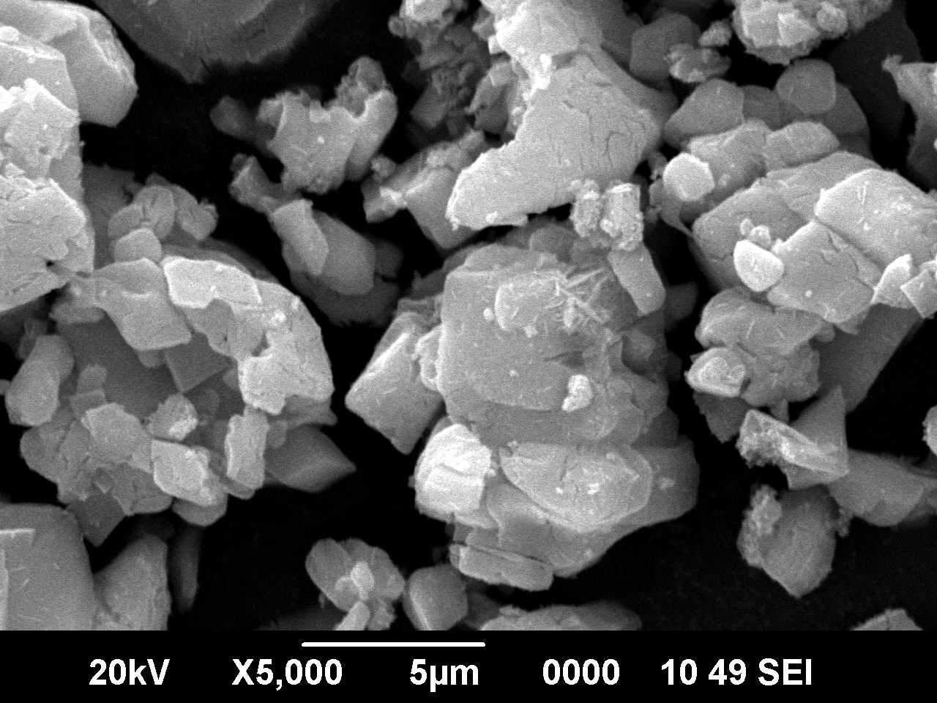
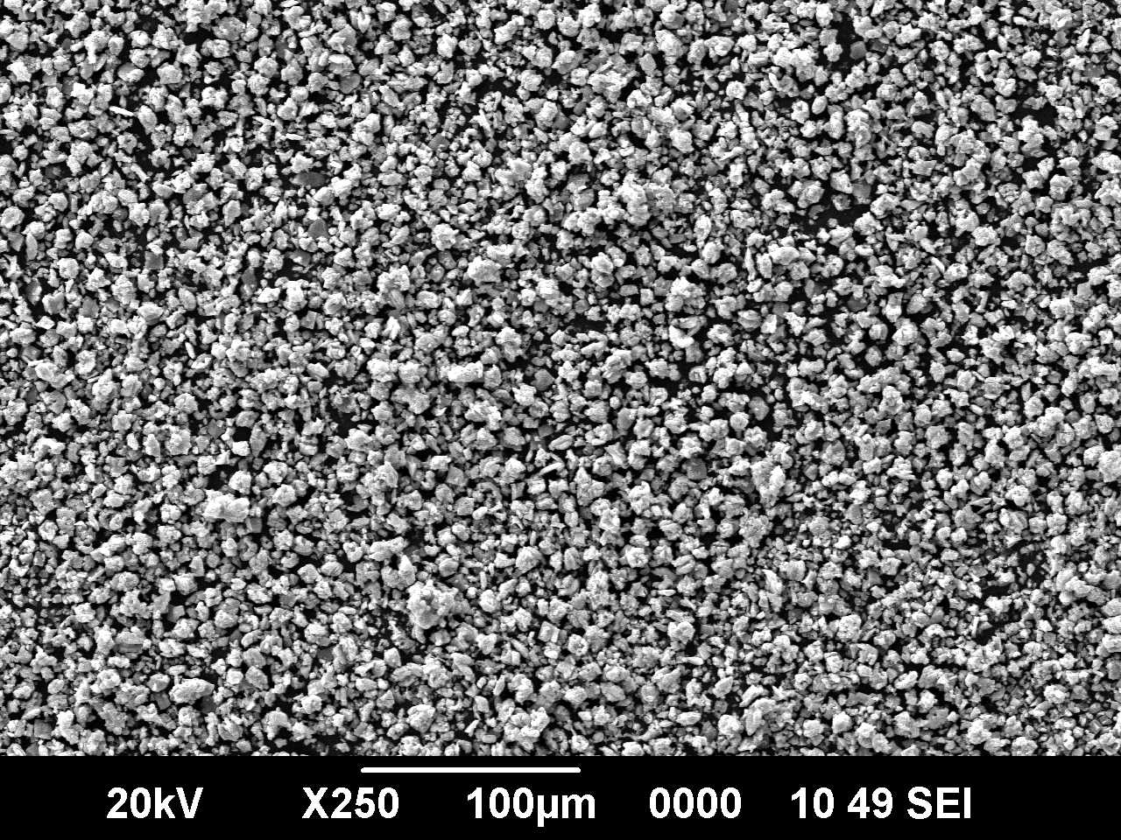
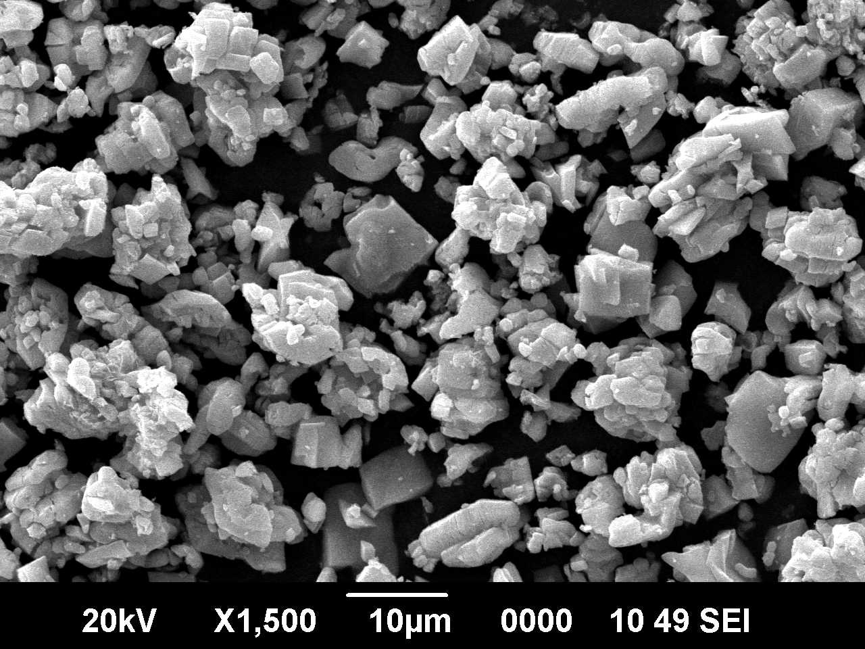

Figure 3: SEM image of ZnO nanoparticles.
Figure 4 is the FT-IR spectrum of ZnO NPs and the band in the region of 680–400 cm⁻¹ is characteristic of ZnO NPs. Thus, the formation of pure ZnO NPs at 535 cm⁻¹ is evidenced by FT-IR. The peaks observed at 1628 cm⁻¹ and 3500 cm⁻¹ were due to the presence of -OH stretching and bending vibrations respectively assigned to the H₂O adsorption on the surface of metal.

Figure 4: FTIR spectrum of ZnO nanoparticles.
Figure 5(a), (b) show the photoluminescence (PL) spectra of ZnO NPs recorded at room temperature. The recombination of photo generated free charge carriers leads to photoluminescence emission in semiconductor materials. The spectrum was recorded under UV excitation (375 nm) using Xenon lamp as source. The result obtained reveals that nano ZnO shows the strong emission peak at 600 nm (Figure 5(a)). The emission spectrum was monitored at 375 nm showed a broad emission at 600 nm was shown in Figure 5(b). The broad 600 nm peak was due to the transition between single charged oxygen vacancies. The correlated color temperature was one of the essential parameter to know the color appearance of the light emitted by a light source with respect to a reference light source when heated up to a specific temperature. The color clarity of any luminescent material was expressed in terms of chromaticity coordinates, called Commission International De I’Eclairage (CIE).

Figure 5: PL emission spectrum (a) and excitation spectrum (b) of nano ZnO.
Application of ZnO NPs as a catalyst for the formylation of amino acid esters
In the current years, the use of metaloxides as catalysts and reaction media has received considerable tremendous interest because of their high level of environmental compatibility, chemo selectivity and availability at low cost. Therefore we explored the application of nano ZnO powder as an inorganic catalyst to carry out N-formylation of amino acid ester (1 mmol) in DCM with aq. 98% formic acid (1.5 mmol) at room temperature. Formamide derivative of amino acid ester was obtained in trace amount in the absence of ZnO catalyst, while good results were obtained with use of 0.5 mmol ZnO catalyst after same reaction conditions as mentioned and improved the catalyst amount with inclusion of 0.25 mmol ZnO took longer time for the completion of reaction. Using more than 0.5 mmol of ZnO (0.7, 0.9, 1.0 and 1.1 mmol) has less effect on the final yield of the compound and reaction time. Thus, we found that 0.5 mmol of ZnO could efficiently catalyze the reaction for preparation of the desired product and observed that the excellent yield obtained using 1.5 mmol of formic acid. In literature survey Suresh babu et al achieved successful synthesis of formamide derivatives of protected amino acids by the reaction of isocyanate with aqueous formic acid using DMAP as an organo catalyst.⁵³ However, this procedure suffers from the difficulties such as expensive reagents, highly toxic, and may also require special care. Hence, it is necessary of convenient reagent for the synthesis of stable formamides in terms of economic viability and operational simplicity. Therefore, it is necessary to study this reaction using nano ZnO with a variety of amino acid esters as starting materials which were subjected to formylation reaction and the results were presented in Table 1. For the synthesis of titled compounds (2a-h), amino acid ester containing different aryl/alkyl groups prepared from thionyl chloride was dissolved in dry DCM and neutralized with NMM, to which formic acid was added followed by the addition of nano ZnO. The reaction mixture was stirred till the completion of the reaction as indicated by TLC. After the simple work-up, desired products were obtained in good yield (Scheme 1). Several formamide esters were synthesized from amino acid esters using the above procedure. The synthesized compounds were confirmed by ¹H NMR, ¹³C NMR and HRMS studies.
R = Aminoacid side chains
Scheme 1. Synthesis of N-formamide esters
Table 1. List of formamide esters prepared using ZnO NPs
Entry | Product | Yield (%) | M.p./ ºC
1 | 2a | 90 | 162
2 | 2b | 80 | Gum
3 | 2c | 89 | 188
4 | 2d | 85 | 132
5 | 2e | 79 | Gum
6 | 2f | 84 | Gum
7 | 2g | 85 | 158
8 | 2h | 88 | Gum

Spectral data of the synthesized compounds:
N-formylAla-OMe (2a): % Yield 90, Solid, Melting Point: 162 ºC. ¹H NMR (400 MHz, CDCl₃) δ 1.39 (d, J = 8 Hz, 3H), 2.02 (s, 1H), 3.46 (s, 3H), 4.55 (m, 1H), 8.20 (s, 1H). ¹³C NMR (100 MHz, CDCl₃) δ 17.5, 46.36, 52.0, 162.3, 170.1. MS: Cald. for C₅H₉NO₃m/z: 131.06, Found: 131.0576.
N-formylSer-OMe (2b): % Yield 80, Gum. ¹H NMR (400 MHz, CDCl₃) δ 1.81 (s, 2H), 3.60 (s, 3H), 4.06 (m, 2H), 4.42 (m, 1H), 8.22 (s, 1H). ¹³C NMR (100 MHz, CDCl₃) δ 51.4, 52.9, 60.5, 160.8, 171.0. MS: Cald. for C₅H₉NO₄m/z: 147.05, Found: 147.002.
N-formyl Tyr-OMe (2c): % Yield 89, Solid, Melting Point: 188 ºC. ¹H NMR (400 MHz, CDCl₃) δ 1.88 (s, 1H), 3.04 (m, 2H), 3.45 (s, 3H), 4.78 (m, 1H), 5.06 (s, 1H), 6.68 (d, J = 8 Hz, 2H), 6.80 (d, J = 8 Hz, 2H), 7.92 (s, 1H). ¹³C NMR (100 MHz, CDCl₃) δ 36.4, 50.8, 51.6, 114.8, 129.3, 131.4, 155.0, 162.6, 171.5. MS: Cald. for C₁₁H₁₃NO₄m/z: 223.08, Found: 223.0802.
N-formylLeu-OMe (2d): % Yield 85, Solid, Melting Point: 132 ºC.¹H NMR (400 MHz, CDCl₃) δ 1.06 (d, J = 8 Hz, 6H), 1.74- 1.80 (m, 3H), 2.0 (s, 1H), 3.47 (s, 3H), 4.46 (m, 1H), 8.10 (s, 1H). ¹³C NMR (100 MHz, CDCl₃) δ 22.4, 22.75, 40.34, 48.2, 51.62, 162.4, 170.8. MS: Cald. for C₈H₁₅NO₃m/z: 173.11, Found: 173.0998.
N-formyl Pro-OMe (2e): % Yield 79, Gum. ¹H NMR (400 MHz, CDCl₃) δ 1.60 (m, 2H), 1.68 (m, 2H), 2.65 (m, 2H), 3.53 (t, 1H), 3.62 (s, 3H), 8.0 (s, 1H).¹³C NMR (100 MHz, CDCl₃) δ 22.8, 28.4, 43.92, 50.73, 58.02, 162.1, 172.0. MS: Cald. for C₇H₁₁NO₃m/z: 157.07, Found: 157.0711.
N-formyl Val-OMe (2f): % Yield 84, Gum. ¹H NMR (400 MHz, CDCl₃) δ 1.08 (d, J = 8 Hz, 6H), 2.0 (s, 1H), 2.98 (m, 1H), 3.66 (s, 3H), 4.38 (d, J = 8 Hz, 1H), 8.0 (s, 1H). ¹³C NMR (100 MHz, CDCl₃) δ 17.8, 29.92, 51.0, 54.7, 163.4, 171.2. MS: Cald. for C₇H₁₃NO₃m/z: 159.09, Found: 159.0898.
N-formylPhe-OMe (2g): % Yield 85, Melting Point: 158 ºC. ¹H NMR (400 MHz, CDCl₃)δ 2.0 (s, 1H), 3.02 (m, 2H), 3.48 (s, 3H), 4.75 (t, 1H), 7.08-7.20 (m,5H), 8.17 (s, 1H). ¹³C NMR (100 MHz, CDCl₃) δ 37.6, 50.82, 51.7, 126.2, 127.5, 128.0, 138.65, 162.88, 171.1. MS: Cald. for C₁₁H₁₃NO₃m/z: 207.09, Found: 207.0930.
N-formyl Met-OMe (2h): % Yield 88, Gum. ¹H NMR (400 MHz, CDCl₃) δ 1.86 (s, 1H), 2.04 (s, 3H), 2.20 (m, 2H), 2.38 (t, 2H), 3.55 (s, 3H), 4.40 (t, 1H), 8.11 (s, 1H). ¹³C NMR (100 MHz, CDCl₃) δ 16.9, 29.64, 31.5, 50.12, 52.3, 163.82, 172.0. MS: Cald. for C₇H₁₃NO₃S m/z: 191.06, Found: 191.0602.

Antibacterial and antifungal activity of formamide derivatives
The broadest spectrum of antibacterial activity has been recorded against E. coli (MTCC 443) and S. Aureus (MTCC 5823). Lack of activity of the tested substances against gram +ve bacteria could be explained by the differences in the structure of the cellwalls of gram +ve and gram -ve microorganisms. In most gram +ve bacteria, the cell wall consists of many layers of peptidoglycan, forming a thick, rigid structure. Whereas, the cell walls of gram –ve bacteria consist of one or a very few layers of peptidoglycan and a lipid-rich outer membrane.⁵⁴ Similar type of results employing different type of compounds such as Schiff’s bases and amine derived from alkyl 2-(2-formyl-4-nitrophenoxy) alkanoates was recorded by Goszczyn´ska.⁵⁵ A contrasting difference in antibacterial activity employing gram +ve and gram –ve strains representing better susceptibility by E. coli than S. aureus employing novel benzothienopyrimidines compounds was shown.
In this study, the antibacterial screening indicated quite varied resultsamong the tested samples as depicted in Table 2, 3, and 4 exhibiting antibacterial and antifungal activities respectively. For E. coli (MTCC 443), formamide ester derivatives of Ala, Tyr, Phe have shown good susceptibility over a wide volume range taken for a fixed concentration of samples (Table 2). Serine derivative has shown best result in comparison to others at higher volume of fixed concentration of the sample tested. Rest of the samples were found to be resistant against the bacterial strain. A different result has been observed in terms of susceptibility pattern tested against S. aureus (MTCC 5823). Derivatives of Ala, Ser, Pro and Met were found to be resistant at fixed concentration with different range of volume from 50 to 300 µl. While, Tyr, Leu, Val and Phe derivatives have shown (Table 3) moderate susceptibility in comparison to gram –ve E. coli (MTCC 443). All comparisons were done keeping in record the values of standard tested.

Table 2. Antibacterial activity of standard and samples employing E. coli
Entry | Sample name | Standard  (Gentamicin) | Sample concentration (μl)
 | Escherichia coli |  | 50 | 100 | 150 | 200 | 250 | 300
 |  |  | Zone of Inhibition (mm)
3a | OHCHN-Ala-OMe | ++++ | - | - | + | + | + | +
3b | OHCHN-Ser-OMe | ++++ | - | - | - | + | + | ++
3c | OHCHN-Tyr-OMe | ++++ | - | - | - | + | + | +
3d | OHCHN-Leu-OMe | ++++ | - | - | - | - | - | -
3e | OHCHN-Pro-OMe | ++++ | - | - | - | - | - | +
3f | OHCHN-Val-OMe | ++++ | - | - | - | - | - | -
3g | OHCHN-Phe-OMe | ++++ | - | - | + | + | + | +
3h | OHCHN-Met-OMe | ++++ | - | - | - | - | - | -
Zone of Inhibition: (-) 0-4 mm; (+) 5-9 mm, (++) 10-12 mm, (+++) 13-14 mm, (++++) 14 mm

Table 3. Antibacterial activity of standard and samples employing S. Aureus
Entry | Sample name | Standard  (Gentamicin) | Sample concentration (μl)
 | S. Aureus |  | 50 | 100 | 150 | 200 | 250 | 300
 |  |  | Zone of Inhibition (mm)
3a | OHCHN-Ala-OMe | ++++ | - | - | - | - | - | -
3b | OHCHN-Ser-OMe | ++++ | - | - | - | - | - | -
3c | OHCHN-Tyr-OMe | ++++ | - | - | - | - | + | +
3d | OHCHN-Leu-OMe | ++++ | - | - | - | - | - | +
3e | OHCHN-Pro-OMe | ++++ | - | - | - | - | - | -
3f | OHCHN-Val-OMe | ++++ | - | - | - | - | - | +
3g | OHCHN-Phe-OMe | ++++ | - | - | - | - | - | +
3h | OHCHN-Met-OMe | ++++ | - | - | - | - | - | -
Zone of Inhibition: (-) 0-3mm; (+) 4-6 mm, (++) 7-9 mm, (+++) 10-12 mm, (++++) 12 mm
Table 4. Antifungal activity of standard and samples employing Humicolafuscoatra
Entry | Sample name | Standard  (Fluconazole) | Sample concentration (μl)
 | Humicolafuscoatra |  | 50 | 100 | 150 | 200 | 250 | 300
 |  |  | Zone of Inhibition (mm)
3a | OHCHN-Ala-OMe | +++ | + | - | - | + | + | -
3b | OHCHN-Ser-OMe | +++ | - | + | + | + | + | +
3c | OHCHN-Tyr-OMe | +++ | - | - | - | - | - | +
3d | OHCHN-Leu-OMe | +++ | - | + | + | + | - | +
3e | OHCHN-Pro-OMe | +++ | - | + | - | + | + | +
3f | OHCHN-Val-OMe | +++ | - | + | + | + | + | -
3g | OHCHN-Phe-OMe | +++ | - | + | + | + | + | +
3h | OHCHN-Met-OMe | +++ | - | + | + | + | + | +
Zone of Inhibition: (-) 0 - 1 mm; (+) 2-4 mm, (++) 5-7 mm, (+++) 8 mm
Summarization of antifungal activity has shown in Table 4. Derivatives of Ala, Tyr, Leu, Pro and Val have shown some activity in comparison to standard. While the derivatives of Phe, Ser, and Met have also shown good activity over a wide range of volume of samples (50-300 µl) tested for a fixed concentration.
The antimicrobial activity of formamide esters were evaluated against standard MTCC strains of gram +ve and gram -ve bacteria (standard strains: Staphylococcus aureus MTCC 5823, Eschsrichia coli MTCC 443) and a strain of fungi Humicolafuscoatra (MTCC 3938) by agar well diffusion method.⁵⁶ The optimum turbidity (<1.0) suitable for bacterial inoculum preparation was followed according to McFarland’s test⁵⁷ employing Luria Bertani Broth for E. coli and Nutrient Broth for S. aureus. For fungal inoculum preparation 72 h incubation period was optimized for choosing the culture suspension employing Potato dextrose broth pertaining to antifungal activity. The standards used were fluconazole at the conc. of 0.10 mg/ml and Gentamicin of 0.003 mg/ml concentration (Plating volume 50 μl) for antifungal and antibacterial activity respectively. The wells of 6 mm diameter were punched employing a sterile cork borer into the Mueller–Hinton Agar having the test microorganisms at concentration about 5 × 10⁶ CFU/ml for bacterial strains and 3 × 10⁵ CFU/ml for fungi. The wells were filled with different volumes in a range from 50 μl to 300 μl, at the concentration of 0.10 mg/ml employing DMSO. The plates were incubated for 18 h and 36 h at 35 ± 1 °C for E. coli and S. aureus respectively. For antifungal activity employing the same method with potato dextrose agar plates were incubated for 72 h at 28 ± 1 °C. Antimicrobial activity was evaluated by measuring the inhibition zone against the test microorganisms using an antibiogram scale and standard measurement protocol was followed according to CLSI guidelines.⁵⁸

Application of ZnO NPs as a catalyst for the biodiesel production
After transesterification of Buteamonosperma oil, the yield of biodiesel was found to be 82.7%. In order to evaluate the quality of biodiesel, the fuel properties of the biodiesel were determined according to ASTM D6751 standards as shown in the Table 5. The fuel properties such as kinematic viscosity (4.3 cSt), flash point (151 ºC), acid value (0.2 mg KOH/g), calorific value (37790 kJ/kg), density (880 kg/m³) and copper strip corrosion (1a) were within the range of ASTM standard.

Table 5. Fuel properties of Buteamonosperma biodiesel

Properties | Units | Testing procedure ASTM | BMME/ biodiesel | Biodiesel  standard  ASTM D6751
Viscosity at 40 ºC | cSt | D445 | 4.3 | 1.9-6.0
Flash point | ˚C | D4052 | 151 | >130
Acid value | mg KOH/g | D664 | 0.2 | 0.8 max
Calorific value | kJ/kg | D240 | 37790 | -----
Density | kg/m³ | D93 | 880 | 870-900
Copper strip corrosion, 50 ºC, 3h | ----- | D130 | 1a | no. 3 max
BMME= Buteamonosperma methyl ester

Conclusions
ZnO NPs synthesized via solution combustion method using Capsicum annuum extract as a new fuel. The prepared NPs were characterized by UV-Vis DRS, XRD and SEM analysis and also evaluated its photoluminescence property. The method is environmental friendly and overcome the demerits of conventional, physical and chemical methods of synthesis. In the presence of nano ZnO catalyst excellent yield of formamide esters and biodiesel have been obtained. The synthesized formamide esters were successfully characterized by ¹H NMR, ¹³C NMR and mass spectroscopy analysis. Finally, the prepared formamide esters exhibit considerable antibacterial activities against gentamicin standard and antifungal activities against fluconazole standard.

Acknowledgements
We thank the Principal and Director of Siddaganga Institute of Technology, Tumakuru, Karnataka, for the research facilities. One of the authors (HSL) is thankful to the Vision Group of Science and Technology (VGST), Department of Information Technology, Biotechnology and Science & Technology, Government of Karnataka for providing funds under CISEE programme (GRD No. 472) to carry out the present research work by means of a sponsored project.

References
1. H. G. Reza, P. Ferdos, P. Hossein, B. R. Mosavar, Orientational J. Chem. 2015, 31,
1219-1221.

2. S. M. Hosseini, S. Hashem, J. Org. Chem. 2006, 71, 6652-6654.
3. K. R. Agnieszka, J. Teofil, Materials. 2014, 7, 2833-2881.
4. D. Gnanasangeetha, T. D. Sarala, J. Chem. Biolog. Phy. Sci. 2013, 4, 238-246.
5. D. Indrani, A. Nitin, Nanomaterials and Nanotech. 2013, 3, 1-16.
6. Z. W. Lin, J. Phys. Condens. Matt. 2004, 16, 829-858.
7. L. Miao, S. Tanemura, Y. Ieda, M. Tanemura, Y. Hayashi, H. Y. Yang, S. P. Lau, B.
K. Tay, Y. K. Cao, Surface Sci. 2007, 601, 2660-2663.
8. J. J. Velázquez, V. D. Rodríguez, A. C. Yanes, J. del Castillo, J. Méndez-Ramos,
Appl. Phys. A. 2012, 108, 577-583.
9. G. M. Krishna, R. Jagannadha, J. Engg. Trends and Tech. 2015, 26, 272-275.
10. A. I. Muhammad, A. S. Iqbal, A. K. M. Rahman, A. M. Mahbubul, S. M. I. Saiful,
A. H. Mohammad, International J. Chemical Reactor Engg. 2011, 9, 1-20.
11. P. Dhiman, K. M. Batoo, R. K. Kotnala, M. Singh, Micro & Nano Lett. 2012, 7,
1333-1335.
12. Z. Ilona, S. Jakub, M. C. Anna, S. Kamil, L. Janusz, S. Jacinto, Chem. Science Rev.
and Lett. 2015, 4, 735-745.
13. A. S. Nehal, M. El-Kemary, M. I. Ebtisam, Nanoscience and Nanotech. 2015, 5, 82-
88.
14. S. Mojmir, A. H. E. Adam, H. E. H. Robert, Org. Lett. 2011, 13, 3952-3955.
15. H. S. Mona, Green Chem.-Envi. Benign Appro. 2012, 6, 103-120.
16. V. V. Sureshbabu, N. Narendra, Int. J. Pept. Res. Ther. 2008, 14, 201-207.
17. A. Jafar, H. Malak, S. Mehdi, H. Akbar, Arkivok. 2009, xi, 123-129.
18. K. Joong-Gon, J. Doo Ok, Bull. Korean Chem. Soc. 2010, 31, 2989-2991.
19. R. Madhusudana, T. M. V. Bhojegowda, N. Aatika, A. P. Mohamed, Chinese J.
Cat. 2010, 31, 518-520.
20. B. Krishnakumar, M. Swaminathan, J. Mol. Catalysis A: Chem. 2011, 334, 98-102.
21. B. Siavash, M. A. Babak, S. Mohammad, Z. Fereshteh, Bull. Korean Chem. Soc.
2012, 33, 2251-2254.
22. D. Agarwal, A. Agrwal, A. Bairagi, V. K. Kasana, Res. J. Chemical Sci. 2014, 4,
54-57.
23. L. Min, M. Lei, H. Lihong, Tetrahedron Lett. 2010, 51, 4186-4188.
24. M. M. B. Reddy, S. Ashoka, G. T. Chandrappa, M. A. Pasha, Catal. Lett. 2010,
138, 82-87.
25. S. S. Mohammad, M. Mehdi, R. Akbar, Lett. in Org. Chem. 2014, 11, 49-54.
26. M. Raghavendra, K. V. Yatish, H. S. Lalithamba, Eur. Phys. J. Plus. 2017, 132, 1-12.
27. S. A. Chandra, K. A. Ravi, G. Sathaiah, P. V. Luke, S. Madabhushi, R. P. Shanthan,
Tetrahedron Lett. 2009, 50, 7099-7101.
28. R. Namita, International J. Adv. in Engg. & Tech. 2015, 7, 1806-1881.

29. R. Donya, B. H. Mohd Zobir, T. Y. Yun Hin, Chm. Central J. 2013, 7, 1-10.
30. S. Jurablu, M. Farahmandjou, T. P. Firoozabadi, J. Sci. Islamic Republic of Iran.
2015, 26, 281-285.
31. R. E. Maria de Lourdes, G. G. M. Edith, V. T. Erika, Molecules. 2011, 16, 1253-
1270.
32. S. D. Joao, Food and Nutrition Sci. 2012, 3, 1354-1374.
33. A. O. Benin, H. Ahissou, Gbaguidi, F. Sanoussi, A. Houngbeme, A. Dansi, A. Sanni,
Int. J. Curr. Microbiol. App. Sci. 2015, 4, 394-403.
34. S. Veena, H. H. Bassim, C. S. Yogesh, Energy conversion and man. 2016, 122, 52-
62.
35. Z. Quan, Z. Heng, C. Fei, L. Hu, P. Hu, X. Wei, H. De-Yu, Y. Song, J. Industrial
and Engg. Chem. 2015, 31, 385-392.
36. E. M. Shahid, Y. Jamal, Renewable and Sustainable Energy Rev. 2011, 15, 4732-
4745.
37. Y. M. Park, J. Y. Lee, S. H. Chung, I. S. Park, S. Y. Lee, D. K. Kim, J. S. Lee, K.
Y. Lee, Bioresource Tech. 2010, 101, S59-S61.
38. K. H. Chung, B. G. Park, J. Ind. Eng. Chem. 2009, 15, 388-392.

39. X. R. Chen, Y. H. Ju, C. Y. Mou, J. Phys. Chem. C. 2007, 111, 18731-18737.

40. X. Liu, X. Piao, Y. Wang, S. Zhu, H. He, Fuel. 2008, 87, 1076-1082.

41. X. Liu, H. He, Y. Wang, S. Zhu, X. Piao, Fuel. 2008, 87, 216-221.
42. S. J. Yoo, H. S. Lee, V. Bambang, J. D. Kim, Y. W. Lee, Bior. Technol. 2010, 101,
8686-8989.
43. S. Hu, L. Wen, Y. Wang, X. Zhen, H. Han, Bior. Tech. 2012, 123, 413-418.

44. P. R. Pandit, M. H. Fulekar, J. Environ. Manage. 2017, 198, 319-329.

45. G. Jabbar, H. Ali, L. Xiaojun, H. A. Mukhtar, Appl.catalysis A: general. 2016, 527,

81-95.

46. H. Shengyang, G. Yanping, W. Yun, H. Heyou, Appl. Energy., 2011, 88, 2685-

2690.

47. G. Nagaraju, Udayabhanu, S. A. Shivaraj, M. S. Prashanth, K. V. Yathish, C.

Anupama, D. Rangappa, Mat. Res. Bull. 2017, 94, 54-63.
48. M. Rajesh, P. Shakkthivel, Bior. Tech. 2013, 150, 55-59.
49. A. U. Khan, Environ. Monit. Assess. 2010, 170, 171-184.
50. F. Rana, M. Avijit, Int. J. Rese. Pharm. Chemi. 2012, 2, 1035-1039.
51. L. Wan, J. F. Li, J. Y. Feng, W. Sun, Z. Q. Mao, Mater. Sci. Eng. B. 2007, 139,
216-220.
52. J. Zhang, J. Xi, Z. Ji, J. Mater Chem. 2012, 22, 17700-17708.
53. N. S. Sudarshan, N. Narendra, H. P. Hemantha, V. V. Sureshbabu, J. Org. Chem.
2007, 72, 9804-9807.

54. J. B. Terry, J. bacteriology. 1999, 181, 4725-4733.

55. G. Agata, K. Halina, F. Karol, Med. Chem. Res. 2015, 24, 3561-3577.
56. K. Uma, H. S. Lalithamba, M. Raghavendra, V. Chandramohan, C. Anupama,
Arkivoc. 2016, 4, 339-351.

57. W. Irith, H. Kai, E. W. H. Robert, Nature Proto. 2008, 3, 163-175.
58. L. B. Reller, M. Weinstein, J. H. Jorgensen, M. J. Ferraro, Clin Infect Dis. 2009,
49, 1749-1755.

