Supplementary Files

Chromium speciation using an aminated Amberlite XAD-4 resin column combined with microsample injection-flame atomic absorption spectrometry
Erkan Aksoy¹, Şükrü Gökhan Elçi¹, Ali Nawaz², Latif Elçi¹
¹Chemistry Department, Faculty of Science and Arts, University of Pamukkale, Denizli, Turkey
²Institute of Advance Research Studies in Chemical Science, University of Sindh, Jamshoro, Pakistan

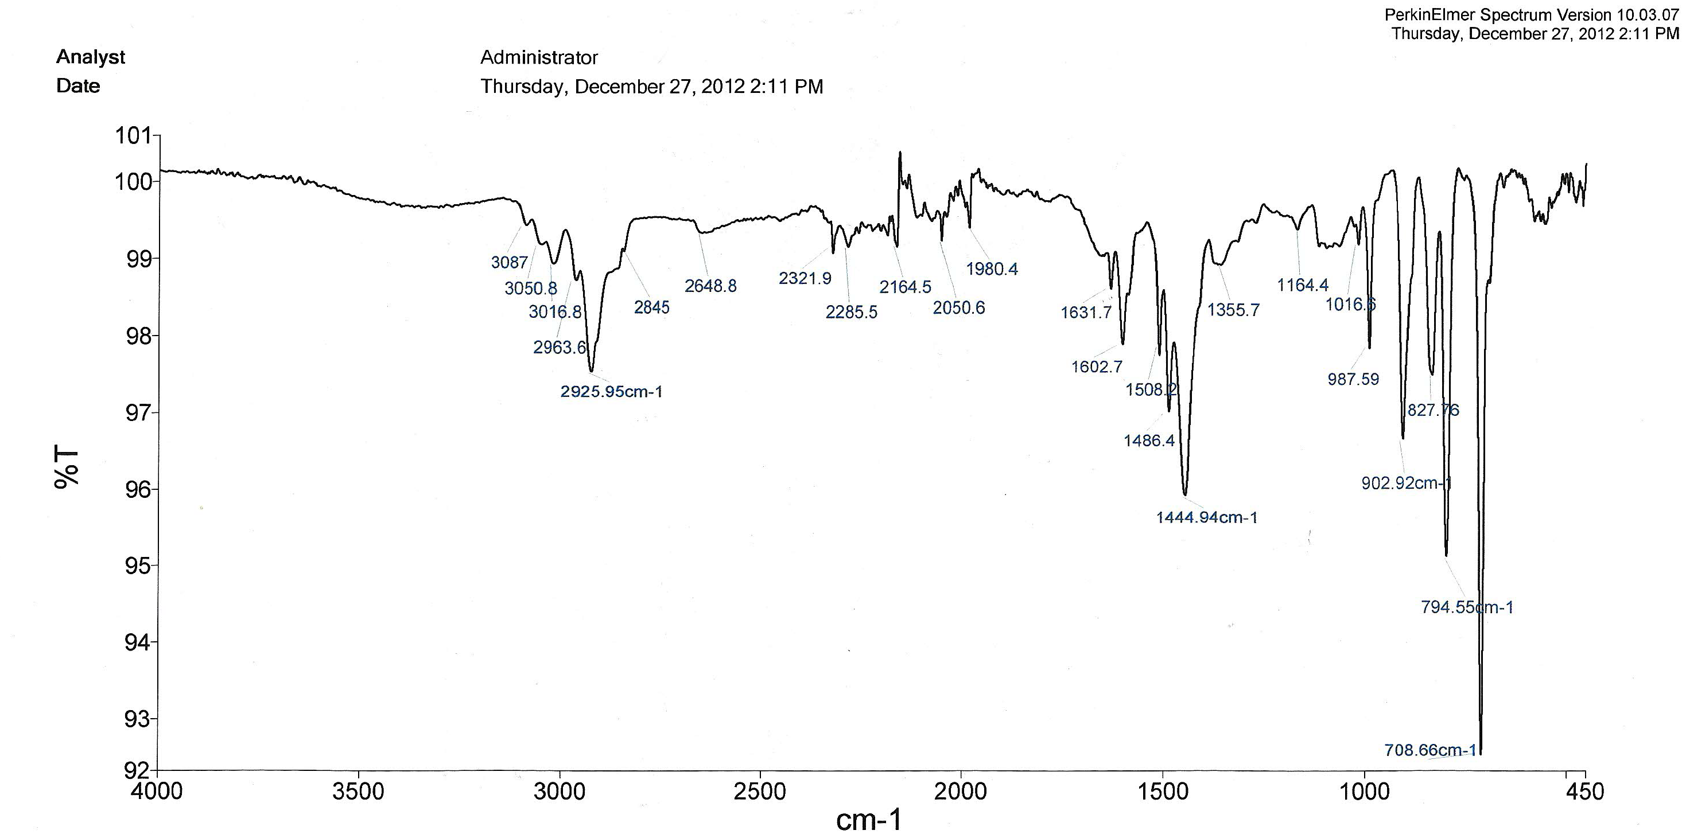

Figure S1. ATR-IR spectra of unmodified Amberlite XAD-4 resin

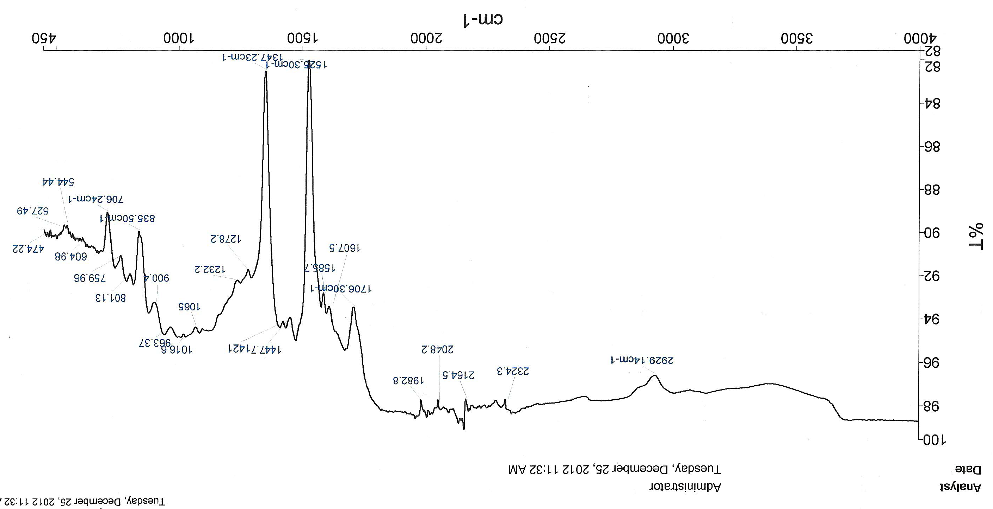

Figure S2 . ATR-IR spectra of nitro derivative of Amberlite XAD-4 resin
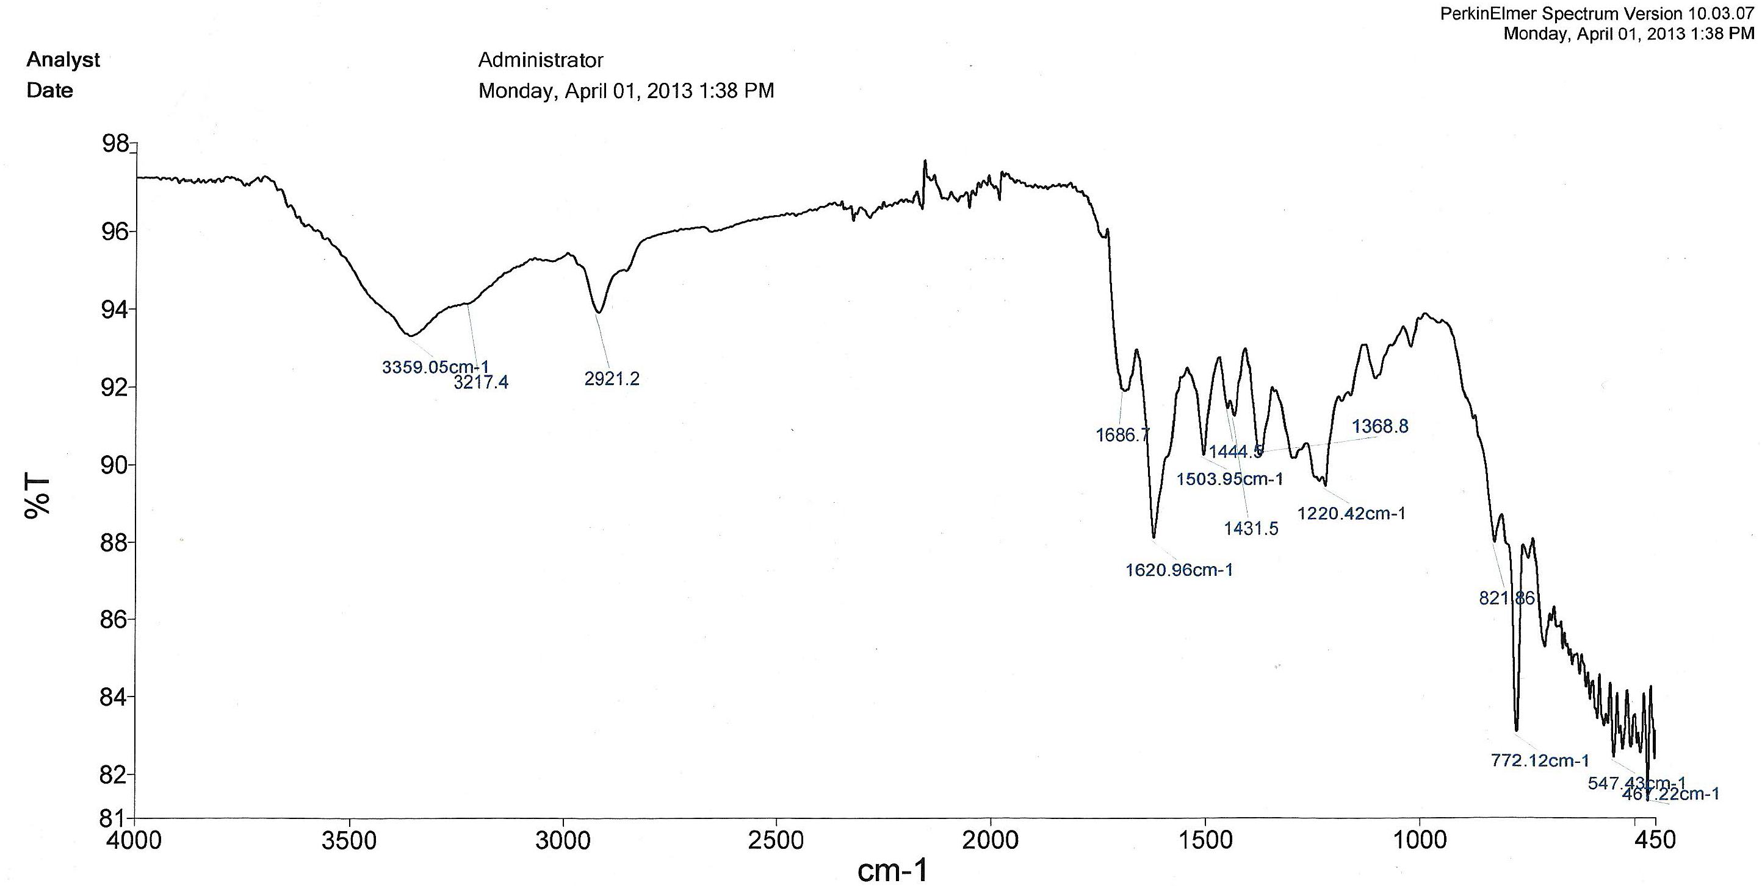

Figure S3. ATR-IR spectra of amino derivative of Amberlite XAD-4 resin

