BINDING SITE OF CHELATING AGENTS IN THE CHELATION OF BA/Y/ZR AND THEIR ELECTRONIC PROPERTIES: A DFT STUDY
Nor Ain Fathihah Abdullah and Lee Sin Ang*
Faculty of Applied Sciences (Physics), Universiti Teknologi MARA Cawangan Perlis,
02600 Arau, Malaysia
*Corresponding author: E-mail: anglee631@perlis.uitm.edu.my; Tel:+604 9882573

Density functional calculations were performed on the metal–complexes in the formation of barium zirconate (BZY). This compound has been synthesized previously, but the molecular interactions during the formation of the ligand-metal complexes are unknown. In this study, calculations were carried out in order to clarify the preferred coordination sites for the metal complexes. The metal cations of barium (Ba), yttrium (Y) and zirconium (Zr) were modeled to interact with two deprotonated chelating agents (citric acid (CA) and ethylenediaminetetraacetic acid (EDTA)) at strategic positions. Density Functional Theory (DFT), at the level of theory B3LYP with basis set 6-31G* and Universal Gaussian Basis Set (UGBS) were used. The relevant geometries, binding energies, and charge distributions of the complexes are reported. It is found that both CA and EDTA can bind the metal cations studied in this study. Metal cations prefer to bind at the electron–rich sites of the chelating agents. Of the three metal cations considered, the cation Zr⁴⁺ is found to possess strongest bonding to the ligands at deprotonated CA and EDTA, with a sequence of Zr > Y > Ba observed.
Keywords: Density functional theory; cations; chelating agents; binding energies; charges.

1. Introduction
Presently, perovskite is one of the most studied compounds in the research field of material sciences.¹⁻³ Ceramic perovskites-type oxide, with a general formula ABO₃ where A and B are two different metal cations with different sizes, were studied due to its high conductivity and low activation energy.^{4,5} Among perovskite-type oxide, cerate zirconate attract great attention because they are important for the future development of electrochemical devices such as fuel cells, magnetic refrigeration and solar cells.⁶⁻⁸ The formation of perovskite costs less as it can be made from common metals and industrial chemicals⁹ and is also convenient to prepare.⁷
Many researchers have investigated the role of the chelating agents in the formation of perovskite.¹⁰⁻¹² As the formation of perovskite involves the complexation process, the interaction between the metal and chelating agent is of utmost importance. Liu et al. pointed out that CA is more effective than EDTA in forming perovskite at low temperatures (<1000 ºC).¹² When the chelating agent is combined together, for example in the work of Osman et al.¹¹ where the CA and EDTA were mixed into a metal nitrate solution to form metal CA-EDTA complexes with ratio CA : EDTA : metal = 1 : 1 : 2, the combined CA and EDTA increases the chelating strength towards metal ion. The same effect was also observed by Tao et al. in synthesizing La_{0.6}Sr_{0.4}CoO_{3–δ}.¹³ Since CA has three carboxylate groups while EDTA has four carboxylate and two amine groups that can bind with metal cations, hence it shows that the strength of chelating agents affects the interactions during chelation process.^{12,14}
Even though the experiment results show that use of the chelating agents provided a good platform for the production of the perovskites, however, the molecular interactions involved are still ambiguous, as the microscopic behaviors and characteristics of the intermediate structures, as well as the ligand-metal complex, are not well known. Furthermore, the related reports on the microscopic properties of metal cation combinations with chelating agents are scarce.
Several theoretical studies on the favoured sites for complexation of metal have been carried out to find the most stable structure at intermediate state.¹⁵⁻¹⁷ For instance, Primikyri et al. performed DFT studies on the chelation of Zn with Quercetin and Luteolin in neutral and deprotonated forms.¹⁵ It was found that, the preferred cation were both in between carbonyl and deprotonated hydroxyl group of Quercetin and Luteolin. The result is in line with the work reported by Leopoldini et al..¹⁶ The preference of metal cations to this site is due to the abundance of electrons from the oxygen’s lone pair electron at the carbonyl and deprotonated hydroxyl groups.
In this study, we intended on confirming the important initial step involved in the one-pot synthesis of the BZCY. Metal cations yttrium (Y), barium (Ba) and zirconium (Zr) were modeled to combine with two chelating agents, CA and EDTA. DFT was employed to determine the interactions involved between the chelating agents and the metal cations at the microscopic level. This included possible attachment sites of the metal cations to the chelating agents and the electronic structure of the complexes formed. In this current study, as focus was only on the interaction between metal and chelating agent with a ratio of 1 : 1 = metal : chelating agent, the effects of the saturation of the coordination sphere for the metal ions are neglected.

2. Computational Details
In the previous experiment, part of the intermediate process involved dissolving Ba(NO₃)₂, Zr(NO₃)₂O.xH₂O and Y(NO₃)3.5H₂O.¹¹ This step produced the metal cations of Ba²⁺, Y³⁺ and Zr⁴⁺, where they formed the metal–chelating agent complexes. In order to portray correctly the charge state of the metal cations, the metal cations are modeled as having the indicated positive charges in the calculations. To further facilitate the calculations, the existence of the metal cations Zr⁴⁺ in the process of one-pot synthesis is approximated.
The structures of chelating agents CA and EDTA were obtained from the Chemspider database.¹⁸ The deprotonation of these complexes was done by removing all hydrogen (H) from carboxylic group (–COOH) in CA and EDTA, making them negatively charged as in the real system these hydrogen will be dissociated. The deprotonated chelating agents were labeled as CA_{3H} and EDTA_{4H}. The metal cations were then attached to the chelating agents at five positions considered, labeled as P1 to P5. These positions are as shown in Fig. 1.
All calculations were carried out using Gaussian 09 suite of programmes.¹⁹ The B3LYP functional with dual basis sets; 6-31G* for C, O, N, H atoms and Universal Gaussian Basis Set (UGBS) for metal cations were used. The D3 version of Grimme’s dispersion correction with Becke-Johnson (BJ) damping was adopted in the metal-complexes calculations.^{20,21} to improve the dispersion energy in the B3LYP method. All the results were visualized using GaussView²² and Chem3D molecular modeling software.
The binding energy (E_{b}) was used to compute the stability of the complexes. The E_{b} of metal complexes were calculated from the expression:²³
(1)
where E_{M-complex} is the energy of the metal and chelating agent, E_{chelate} represents the energy of the chelating agent and E_{M} is the energy of the metal cation.

(a) | P3  = carbon (C)  = oxygen (O)  P1  P2  P5  P4  = nitrogen (N)  = hydrogen (H)  = Ba/Y/Zr
(b) | P1  P2  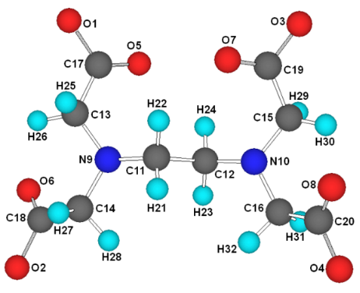  P5  P3  P4

Fig. 1. Molecular structure of (a) CA_{3H} and (b) EDTA_{H} attached with metal (Ba²⁺, Y³⁺, Zr⁴⁺) at different positions; P1 to P5. Metal cations = green; carbon (C), oxygen (O), nitrogen (N), and hydrogen (H) are colored grey, red and turquoise respectively.

3. Results and Discussions

3.1 Binding Energies
EDTA and CA are the chelating agents that can bind to metal cations to form metal complexes. EDTA is a type of polyamino carboxylic acid that can bind to a metal via four carboxylate and two amine groups, meaning it has six sites that have a lone pair of electron. CA, also known as polydentate ligand, can bind to metals via three carboxylate groups and has three sites of a lone pair of electron. In this study, the binding energy of metal–CA_{3H} and metal–EDTA_{4H} complexes were calculated in order to investigate the stability of these metal complexes.
At the level of theory B3LYP/6-31G* and UGBS geometry optimization, the following quantities were obtained: E (CA_{3H}) = –20626.57 eV, E (EDTA_{4H}) = –29911.50 eV, E (Ba²⁺) = –214598.65 eV, E (Y³⁺) = –90707.64 eV, and E (Zr⁴⁺) = –96342.96 eV.
The binding energies of CA_{3H} and EDTA_{4H} metal complexes calculated from Eq. (1) are as shown in Table 1 & 2. A higher negative value of E_{b} indicates higher stability of the complex. Table 1 shows the E_{b} of metal–CA_{3H} complexes at five different positions that the metal attaches to. Metal cation Ba²⁺ is attached strongly at P2 and has an E_{b} value of –19.39 eV. Interestingly, in Y–CA_{3H}, the E_{b} value is the highest at P4 and P5 sites and both sites have the same E_{b} value of –21.82 eV. In Zr–CA_{3H} complex, the E_{b} obtained at P4 and P5 sites are also of similar E_{b} value of –24.89 eV. The highest and the most stable of E_{b} value obtained was at P3 site (–25.69 eV).
The calculated E_{b} of metal–EDTA_{4H} complexes are tabulated in Table 2. In Ba–EDTA_{4H} complexes, Ba²⁺ prefers to attach at P2 site as the E_{b} value (–26.67 eV) obtained at P2 sites is the highest as compared to other sites. It can also be seen from Table 2 that the E_{b} for P1 site is differs by 0.01 eV from P2 site. Hence, these two sites (P1 and P2) in Ba–EDTA_{4H} complex are favorable for metal Ba to attach to. In the Y–EDTA_{4H} and Zr–EDTA_{4H} complexes, both cations bound strongly at P5 site and exhibited a high E_{b} value of –33.12 eV and –37.33 eV respectively.

Table 1. Binding energies of CA_{3H} complexes. Numbers in bold represent the energy values of the most stable metal-complexes.
Positions | Binding Energy, E_{b} (eV)
 | Ba–CA_{3H} | Y–CA_{3H} | Zr–CA_{3H}
P1 | –18.92 | –21.65 | –24.23
P2 | –19.39 | –21.65 | –24.23
P3 | –19.01 | –21.72 | –25.69
P4 | –18.92 | –21.82 | –24.89
P5 | –18.92 | –21.82 | –24.89

Table 2. Binding energies of EDTA_{4H} complexes. Numbers in bold represent the energy values of the most stable metal–complexes.
Positions | Binding Energy, E_{b} (eV)
Positions | Ba–EDTA_{4H} | Y–EDTA_{4H} | Zr–EDTA_{4H}
P1 | –26.66 | –29.62 | –32.31
P2 | –26.67 | –29.62 | –32.31
P3 | –25.71 | –27.34 | –28.99
P4 | –17.08 | –27.33 | –28.96
P5 | –26.56 | –33.12 | –37.33

The results discussed in the preceding paragraph can be explained with the electrostatic potential (ESP) maps surface for CA and EDTA molecules as illustrated in Fig. 2. ESP ables to visualize charge distribution in the molecules by representing it with colors. The red regions indicates more negative potential, while blue region for less negative potential (or positive potential). As displayed in Fig. 2 (a), it appears that the region of the most negative potential is distributed strongly over P4 and P5 in between the central carboxylic group and on the carboxylic groups at the two ends of the CA molecule. These groups are a susceptible site for electrophilic attack, hence the preference of metal cations of Ba²⁺, Y³⁺ and Zr⁴⁺ to bind with CA ligand as these two positions. For EDTA, it has four carboxylic and two amine groups with a lone pair of electron (where these groups are responsible for electrophilic attack), hence these sites have a high possibility of binding with the metal cations (in Fig. 2 (b), these sites are shown with orange shades). As can be seen in Table 2, the binding energies are low at P3 and P4 sites as compared to the other positions due to the low negative potential.

(a) | +0.06923 kcal/mol  –0.06923 kcal/mol  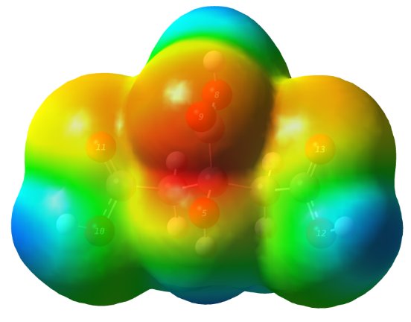
(b) | +0.05267 kcal/mol  –0.05267 kcal/mol  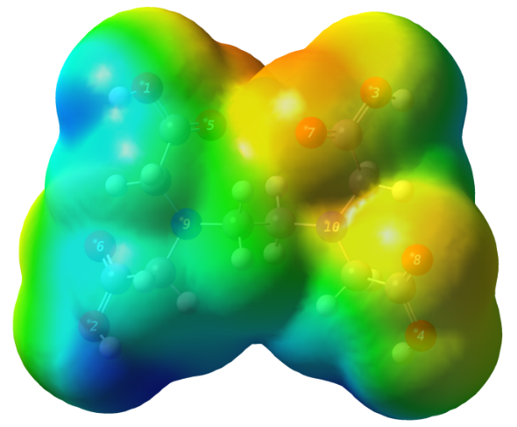
Fig. 2. The electrostatic potential map of (a) CA and (b) EDTA. Isovalue of electron density = 0.0002 au (e/aₒ³). The structure without isosurface can be referred to Fig. 1.

Among the favored sites, the Ba‒complexes have the smallest E_{b} value as compared to other metal-complexes. The bigger size of cation Ba makes it less stable and prevents the ligand from chelating the metal cations completely.²⁴⁻²⁶ Zr‒complexes exhibit a higher E_{b} value than Y‒complexes, although it has a bigger cation size. The ionic charge for Zr(4+) is larger than Y(3+) as the stability of complexes decrease with decreasing ionic charge.^{24,27} The results are supported by Bohm et al., as this study reported that the interaction energy increases as the size of metal decreases, K⁺ > Na⁺ > Li⁺ with values of ‒5.65 eV, ‒8.71 eV and ‒12.05 eV respectively.²⁸
Based on the Tables 1 and 2, a similar E_{b} value is observed at P1, P2 and P4, P5 in Y–CA_{3H} and Zr–CA_{3H} complexes. This is due to the symmetrical arrangement of the atoms in the CA molecules. However, this trend is not observed in Ba–CA_{3H}. This might be due to the large size of metal Ba. The same reason exists for Ba–EDTA_{4H} complex as its large size of cation makes it difficult to reside in the any other EDTA sites.

3.2. Geometry Optimization
Geometry optimizations were performed on metal complexes using 6-31G* and UGBS basis sets and no imaginary frequencies were observed. Therefore the stationary point of the structure where the energy is at minimum was ascertained.²⁹ The geometrically optimized structure of the most stable of metal–CA_{3H} and metal–EDTA_{4H} complexes formed are displayed graphically in Fig. 3 to 8. The selected bond length between metal and oxygen is discussed since oxygen and nitrogen act as donor electrons and play important roles in the interaction with metals.
In general, the attachment of metal cations only slightly changes the shape of CA_{3H}. For the optimized structure of Ba‒CA_{3H} complex as exhibit in Fig. 3, Ba²⁺ was found most stable at P2 sites with a bond length Ba–O5 = 2.704 Å, Ba–O9 = 2.602 Å and Ba–O11 = 2.602 Å. These results concur with similar findings from previous studies by Makrlik et al. where the bond length of cation Ba²⁺ to oxygen atoms of beauvericin ligand is within a range of 2.5~4.9 Å.³⁰

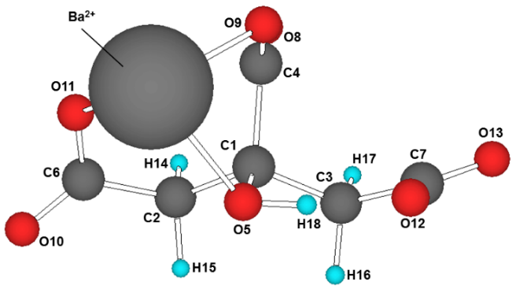
Ba‒O5 = 2.704 Å
Ba‒O9 = 2.602 Å
Ba‒O11 = 2.602 Å

Fig. 3. Optimized structure of the most stable Ba–CA_{3H} complex (P2)

From Fig. 4, metal cation Y³⁺ is found to be the most stable at equivalent sites of P4 and P5. Of the three nearest oxygens that form a bond with the metal cations, two are from the carboxylate and one from the hydroxyl group. The bond length obtained for Y–O9 at P4 and P5 is similar, at a value of 2.160 Å. Metal Y³⁺ that bonded to O13 and O11 at P4 and P5 respectively, also had the same bond length at 2.155 Å. While bond length observed for Y–O5 at P4 and P5 is differed by 0.001 Å. This small difference in bond lengths is negligible. These bond lengths were in accordance with the Y‒O bond length observed in the previous study.³¹

Y‒O5 = 2.339 Å
Y‒O9 = 2.160 Å
Y‒O13 = 2.155 Å

Y‒O5 = 2.340 Å
Y‒O9 = 2.160 Å
Y‒O11 = 2.155 Å

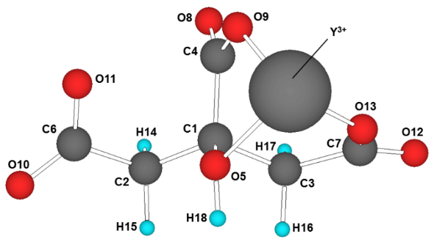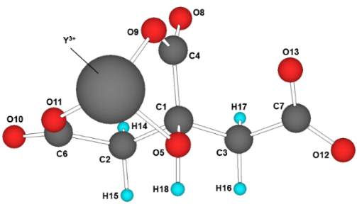
I II
Fig. 4. Optimized structure of the most stable Y–CA_{3H} complex at (I) P4 (II) P5

As depicted in Fig. 5, for the Zr‒CA_{3H} complex, metal cation Zr⁴⁺ preferred the P3 site to attach with. Metal Zr is caught by three oxygens (O8, O9 and O11) in between carboxylate group of CA_{3H} ligand. The bond length measured for Zr–O8, Zr–O9 and Zr–O11 are 2.035 Å, 2.021 Å and 2.009 Å respectively. Similar results for the bond lengths have been found in Vlaic et al. where it was discovered that bond lengths of Zr‒O in Rh/Ce_{0.5}Zr_{0.5}O₂ were within a range of 1.11~2.34 Å.³² Observation for the most stable sites for Ba‒CA_{3H}, Y‒CA_{3H} and Zr‒CA_{3H} complexes found that all the cations were attached in between carboxylate and hydroxyl groups and this results is similar to results reported by Primikyri et al.¹⁵ and Leopoldini et al..¹⁶

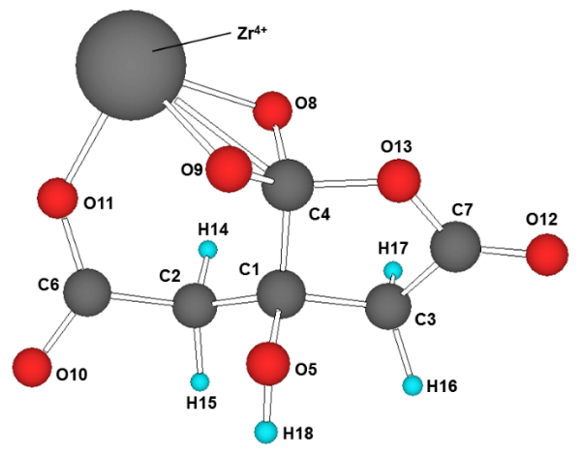
Zr‒O8 = 2.035 Å
Zr‒O9 = 2.021 Å
Zr‒O11 = 2.009 Å

Fig. 5. Optimized structure of the most stable Zr–CA_{3H} complex (P3)

Figs. 6 to 8 depict the optimized structure of the most stable metal–EDTA_{4H} complex. In the structure of this complexes, there were significant changes in the shape of EDTA_{4H} after binding with metal cations, as portrayed in Figs. 6 to 8. EDTA is known to be able to form bonds with any metal and its chelation depends on the size and ionic charge of metal cations.³³ For the most stable position of geometry structure of metal–EDTA_{4H}, carboxylate O atoms and N atoms moved closer to the metal cation creating a view that cation is being wrapped. Both O and N atoms are able to create bonds with the metal cations as they consist of a lone pair electron.
In the optimized structure of the Ba‒EDTA_{4H} complex as shown in Fig. 6, metal cation Ba²⁺ is found to be the most stable on the P2 site. Cation Ba²⁺ bonds with the two nearest oxygens from carboxylate groups with the bond lengths of Ba‒O4 and Ba‒O5 at 3.855 Å and 2.693 Å respectively. Owing to the large atomic radius of Ba²⁺, the bond length obtained for Ba‒O4 is comparatively longer and Ba cations seem far away from donor atoms. Furthermore, the geometry structure obtained for Ba–EDTA_{4H} did not change much from the original structure after the addition of metal cation Ba²⁺. Several experimental studies on forming single layer of perovskites encountered problems with BaCO₃ impurities at the end of the product, as they are using EDTA ligand as their chelating agent.^{11,34} However, in other previous experimental reports, TETA was discovered to be able to solve the BaCO₃ impurities at a lower temperature.^{10,35} This is might be due to the ability of chelating agents to bind with metal Ba²⁺. It can be concluded that Ba²⁺ is effectively complexed by –NH2 group.

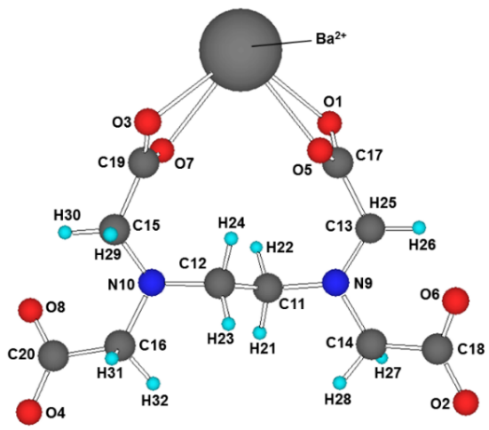
Ba‒O1 = 2.764 Å
Ba‒O3 = 2.750 Å
Ba‒O5 = 2.710 Å
Ba‒O7 = 2.725 Å

Fig. 6. Optimized structure of the most stable Ba–EDTA_{4H} complex (P2)

From Fig. 7, it can be observed that the metal cation Y³⁺ was embraced by EDTA_{4H}. A similar geometry was found by Thomas et al. in an investigation of the molecular structure of aqueous Hg(II)‒EDTA.³⁶ Contrary to Ba‒EDTA_{4H} complex, the four carboxylate O atoms and two N atoms in EDTA_{4H} bind strongly to cation Y³⁺ as its size is smaller than Ba²⁺, making it easy to be caught by the EDTA ligand. The bond lengths obtained for Y–EDTA_{4H} are as follows: Y–O5 = 2.273 Å, Y–O6 = 2.297 Å, Y–O7 = 2.273 Å, Y–O8 = 2.297 Å, Y–N9 = 2.528 Å and Y–N10 =2.527 Å. These bond lengths are congruent with the Y‒O and Y‒N bond lengths observed previously in the formation of guanidinate yttrium complexes.³¹

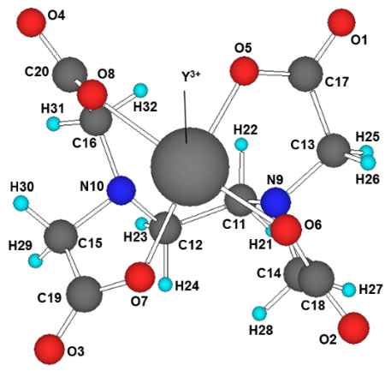
Y‒O5 = 2.273 Å
Y‒O6 = 2.297 Å
Y‒O7 = 2.273 Å
Y‒O8 = 2.297 Å
Y‒N9 = 2.528 Å
Y‒N10 = 2.527 Å

Fig. 7. Optimized structure of the most stable Y–EDTA_{4H} complex (P5)

A similar case took place for the Zr‒EDTA_{4H} complex (as portrayed in Fig. 8), the cation Zr⁴⁺ was wholly wrapped by EDTA_{4H} ligand at P5 site. The metal cation Zr⁴⁺ was enclosed by four –COOH groups and two –NH2 groups from EDTA_{4H} ligand. EDTA_{4H} is able to strongly wrap around metal cations due to their combination of a lone pair of electrons from two types of ligand (–COOH and –NH2). The interaction between metal cation Zr⁴⁺ and EDTA_{4H} is the strongest with bond lengths of Zr–O5 = 2.119 Å, Zr–O6 = 2.143 Å, Zr–O7 = 2.118 Å, Zr–O8 = 2.143 Å, Zr–N9 = 2.415 Å, Zr–N10 = 2.415 Å. The bond length measured was in agreement to the findings of Suzuki et al.,³⁷ where the bond length of Zr–O in [Zr(CO₃)edta]²⁺ was determined. Similarly, the findings of Pozhidaev et al. are also in accordance with the current bond length obtained, where it was measure that the bond length of Zr–O in the crystal structure of Zr-ethylenediaminetetracetate tetrahydrate was within a range of 2.1~2.3 Å while bond length of Zr–N was 2.43 Å.³⁸

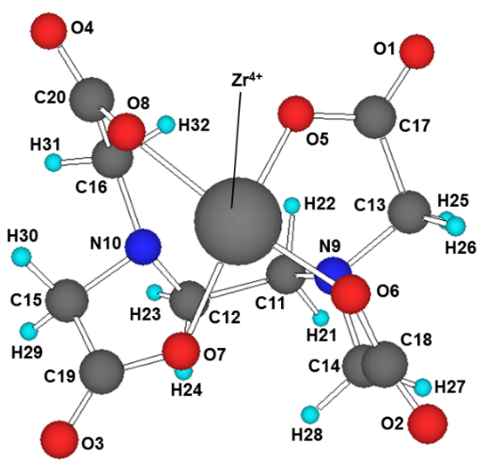
Zr‒O5 = 2.119 Å
Zr‒O6 = 2.143 Å
Zr‒O7 = 2.118 Å
Zr‒O8 = 2.143 Å
Zr‒N9 = 2.415 Å
Zr‒N10 = 2.415 Å

Fig. 8. Optimized structure of the most stable Zr–EDTA_{4H} complex (P5)

3.3 Mulliken Charges
The Mulliken charges of the most stable metal–CA_{3H} and metal–EDTA_{4H} complexes are tabulated in Tables 3 and 4. As shown in Table 3, the initial charges of +2 for Ba, +3 for Y and +4 for Zr are decreasing after complexation with CA_{3H} and EDTA_{4H} complex. The decreasing of charge in metals can be attributed to the charge transfer from CA to metal.^{39,40} The charge transfer in metal–complexes is utmost important as it influences the interaction between metal and chelating agent. It is noticed that the higher charge reduction from metals could be a factor to the stronger interaction in the metal–complex.⁴¹

Table 3. Charge of metals after complexation with the chelating agent
Metals | Mulliken atomic charge of metals in metal–complexes
Metals | Initial | After optimized (CA_{3H}) | After optimized (EDTA_{4H})
Ba | +2 | +1.544 | +1.508
Y | +3 | +2.104 | +1.449
Zr | +4 | +2.672 | +1.911

The carbon atoms, C2 and C3 in CA_{3H} (refer Table 4) and C11 to C16 in EDTA_{4H} (refer Table 4) carry a negative charge as they are bonded to carbon and nitrogen atoms respectively. Both atoms attract the bonding pair electron to exactly the same extent. That means, on average, the electron pair can be found half way in between two atoms and possessed similar negative charges. These results are in congruence with results by Arivazhagan et al. where it was discovered that with higher electronegativity pull more electrons and vice versa.⁴²
C1, C4, C6, and C7 in CA_{3H} and C17 to C20 in EDTA_{4H} (as shown in Tables 4 and 5) carry positive charges as they are bonded to oxygen. Oxygen atoms have stronger electronegativity than carbon atoms, meaning an oxygen bond attracts the bonding pair much stronger than a carbon atom. Consequently, the electron pair is pulled towards oxygen, making the carbon atom that is attached to it positively charged and the same trend is observed in hydrogen atoms. All hydrogen atoms have a positive charge. H18 in CA_{3H} has a higher positive value than other H atoms as they bond with oxygen atom. These results are confirmed in the current works by Gangadhara and Krishnan.⁴³

Table 4. Mulliken charges of the most stable metal–CA_{3H} complexes
Complexes | Charge of atoms
 | C1 | C2 | C3 | C4 | C6 | C7
Ba–CA_{3H} | 0.259 | –0.367 | –0.389 | 0.511 | 0.515 | 0.495
Y–CA_{3H} | 0.215 | –0.398 | –0.389 | 0.621 | 0.587 | 0.490
Zr–CA_{3H} | 0.181 | –0.398 | –0.407 | 0.666 | 0.627 | 0.534
 | O5 | O8 | O9 | O10 | O11 | O12 | O13
Ba–CA_{3H} | –0.780 | –0.597 | –0.675 | –0.593 | –0.669 | –0.632 | –0.601
Y–CA_{3H} | –0.739 | –0.523 | –0.688 | –0.511 | –0.682 | –0.631 | –0.598
Zr–CA_{3H} | –0.745 | –0.453 | –0.723 | –0.421 | –0.713 | –0.590 | –0.563
 | H14 | H15 | H16 | H17 | H18
Ba–CA_{3H} | 0.150 | 0.123 | 0.136 | 0.132 | 0.438
Y–CA_{3H} | 0.189 | 0.188 | 0.135 | 0.162 | 0.471
Zr–CA_{3H} | 0.228 | 0.232 | 0.177 | 0.193 | 0.504

Table 5. Mulliken charges of the most stable metal–EDTA_{4H} complexes
Complexes |  |  | Charge of atoms
 | O1 | O2 | O3 | O4 | O5 | O6 | O7 | O8 | N9
Ba–EDTA_{4H} | –0.640 | –0.650 | –0.643 | –0.650 | –0.629 | –0.619 | –0.627 | –0.618 | –0.359
Y–EDTA_{4H} | –0.535 | –0.542 | –0.536 | –0.542 | –0.623 | –0.627 | –0.623 | –0.627 | –0.501
Zr–EDTA_{4H} | –0.471 | –0.483 | –0.471 | –0.483 | –0.650 | –0.653 | –0.650 | –0.653 | –0.532
 | C11 | C12 | C13 | C14 | C15 | C16 | C17 | C18 | C19
Ba–EDTA_{4H} | –0.138 | –0.137 | –0.208 | –0.224 | –0.206 | –0.224 | 0.532 | 0.449 | 0.526
Y–EDTA_{4H} | –0.145 | –0.145 | –0.246 | –0.239 | –0.246 | –0.239 | 0.561 | 0.572 | 0.561
Zr–EDTA_{4H} | –0.156 | –0.156 | –0.266 | –0.246 | –0.266 | –0.246 | 0.593 | 0.603 | 0.593
 | H21 | H22 | H23 | H24 | H25 | H26 | H27 | H28
Ba–EDTA_{4H} | 0.113 | 0.143 | 0.106 | 0.151 | 0.095 | 0.159 | 0.092 | 0.129
Y–EDTA_{4H} | 0.173 | 0.183 | 0.173 | 0.183 | 0.171 | 0.205 | 0.170 | 0.199
Zr–EDTA_{4H} | 0.210 | 0.205 | 0.210 | 0.205 | 0.214 | 0.239 | 0.209 | 0.229
 | H29 | H30 | H31 | H32 | H29 | H30 | H31
Ba–EDTA_{4H} | 0.095 | 0.160 | 0.093 | 0.130 | 0.095 | 0.160 | 0.093
Y–EDTA_{4H} | 0.171 | 0.205 | 0.170 | 0.199 | 0.171 | 0.205 | 0.170
Zr–EDTA_{4H} | 0.214 | 0.239 | 0.209 | 0.229 | 0.214 | 0.239 | 0.209

4. Conclusion
The interaction between chelating agents and metal cations was studied using the density functional B3LYP method in order to provide a better insight into interactions between chelating agents and metal cations in forming a specific cerate-zirconate compound. The aim of the study was to determine the preferred coordinaton sites for Ba²⁺, Y³⁺, and Zr⁴⁺ in CA_{3H} and EDTA_{4H}. The results show that CA_{3H} and EDTA_{4H} can bind to the metal cations considered. The metal cations were observed to bind at the electron-rich sites of the chelating agents. However, not all sites contain the same binding energy. Moreover, different cations have different binding strength. Based on the results, Zr complexation was found to be the most stable, as compared to the other complexes. Ba metal was not completely chelated by EDTA_{4H} ligand and rendered the least stable complex. The greatest binding energy of EDTA evidences the stronger chelating power of EDTA with respect to CA, due to its ability to bind metals through four carboxylate and two amine groups. Further study of other chelating agents interacting with metal cations is still in progress and will be reported elsewhere.

5. References
1. J. Li, J.-L. Luo, K. T. Chuang, A. R. Sanger, Electrochim. Acta. 2008, 53, 3701-3707. https://doi.org/10.1016/j.electacta.2007.12.020
2. D. Medvedev, A. Murashkina, E. Pikalova, A. Demin, A. Podias, P. Tsiakaras, Prog. Mater Sci. 2013, 60, 72-129. https://doi.org/10.1016/j.pmatsci.2013.08.001
3. N. A. Ibarahim, M. A. M. Ishak, A. Ramli, N. Osman, Int. J. Ind. Chem. 2014, 5, 1-6. https://doi.org/10.1007/s40090-014-0018-4
4. W. G. Coors, in: C. Sikalidis (Ed.) Advances in Ceramics - Synthesis and Characterization, Processing and Specific Applications, CoorsTek, Inc., USA, 2011, pp. 479-498.
5. J. Tong, D. Clark, L. Bernau, A. Subramaniyan, R. O'Hayre, Solid State Ionics. 2010, 181, 1486-1498. https://doi.org/10.1016/j.ssi.2010.08.022
6. A. B. Stambouli, E. Traversa, Renewable Sustainable Energy Rev. 2002, 6, 433-455. https://doi.org/10.1016/S1364-0321(02)00014-X
7. Z. Wei, A. Chak-Tong, D. You-Wei, Chin. Phys. B. 2013, 22, 1-11. https://iopscience.iop.org/article/10.1088/1674-1056/22/5/057501/meta
8. N. G. Park, Mater. Today. 2015, 18, 65-72. https://doi.org/10.1016/j.mattod.2014.07.007
9. U. Wang, 2014, https://www.wsj.com/articles/perovskite-offers-shot-at-cheaper-solar-energy-1411937799, (accessed: February, 2014)
10. N. A. Abdullah, N. Osman, S. Hasan, O. H. Hassan, Int. J. Electrochem. Sci. 2012, 7, 9401-9409. https://doi.org/10.4028/www.scientific.net/AMR.896.112
11. N. A. Abdullah, S. Hasan, N. Osman, J. Chem. 2013, 2013, 1-7. https://dx.doi.org/10.1155/2013/908340
12. S. Liu, X. Tan, K. Li, R. Hughes, Ceram. Int. 2002, 28, 327-335. https://doi.org/10.1016/S0272-8842(01)00098-0
13. Y. Tao, J. Shao, J. Wang, W. G. Wang, J. Power Sources. 2008, 185, 609-614. https://doi.org/10.1016/j.jpowsour.2008.09.021
14. M. Motta, C. V. Deimling, M. J. Saeki, P. N. Lisboa-Filho, J. Sol-Gel Sci. Technol. 2008, 46, 201-207. https://doi.org/10.1007/s10971-007-1673-0
15. A. Primikyri, G. Mazzone, C. Lekka, A. G. Tzakos, N. Russo, I. P. Gerothanassis, J. Phys. Chem. 2014, 119, 83-95. https://doi.org/10.1021/jp509752s
16. M. Leopoldini, N. Russo, S. Chiodo, M. Toscano, J. Agric. Food. Chem. 2006, 54, 6343-6351. https://doi.org/10.1021/jf060986h
17. A. Galano, G. Mazzone, R. Alvarez-Diduk, T. Marino, J. R. Alvarez-Idaboy, N. Russo, Annu. Rev. Food Sci. Technol. 2016, 7, 335-352. https://doi.org/10.1146/annurev-food-041715-033206
18. Chemspider Search and Share Chemistry, 2014, https://www.chemspider.com/, (accessed: March, 2014)
19. M. J. Frisch, G. W. Trucks, H. B. Schlegel, G. E. Scuseria, M. A. Robb, J. R. Cheeseman, G. Scalmani, V. Barone, B. Mennucci, G. A. Petersson, H. Nakatsuji, M. Caricato, X. Li, H. P. Hratchian, A. F. Izmaylov, J. Bloino, G. Zheng, J. L. Sonnenberg, M. Hada, M. Ehara, K. Toyota, R. Fukuda, J. Hasegawa, M. Ishida, T. Nakajima, Y. Honda, O. Kitao, H. Nakai, T. Vreven, J. A. Montgomery, Jr., J. E. Peralta, F. Ogliaro, M. Bearpark, J. J. Heyd, E. Brothers, K. N. Kudin, V. N. Staroverov, R. Kobayashi, J. Normand, K. Raghavachari, A. Rendell, J. C. Burant, S. S. Iyengar, J. Tomasi, M. Cossi, N. Rega, M. J. Millam, M. Klene, J. E. Knox, J. B. Cross, V. Bakken, C. Adamo, J. Jaramillo, R. Gomperts, R. E. Stratmann, O. Yazyev, A. J. Austin, R. Cammi, C. Pomelli, J. W. Ochterski, R. L. Martin, K. Morokuma, V. G. Zakrzewski, G. A. Voth, P. Salvador, J. J. Dannenberg, S. Dapprich, A. D. Daniels, Ö. Farkas, J. B. Foresman, J. V. Ortiz, J. Cioslowski, D. J. Fox, Gaussian, Inc., Wallingford CT USA, 2009.
20. S. Grimme, J. Antony, S. Ehrlich, H. Krieg, J. Chem. Phys. 2010, 132, 1456-1465. https://dx.doi.org/10.1063/1.3382344
21. S. Grimme, S. Ehrlich, L. Goerigk, J. Comput. Chem. 2011, 32, 1456-1465. https://doi.org/10.1002/jcc.21759
22. R. D. Dennington II, T. A. Keith, J. Millam, Semichem, Inc., USA, 2007.
23. T. Sakajiri, H. Yajima, T. Yamamura, ISRN Biophys. 2012, 2012, 1-5. https://dx.doi.org/10.5402/2012/124803
24. C. E. Housecroft, A. G. Sharpe, Book Inorganic Chemistry, Ashford Colour Press Ltd., Gosport, London, 2005.
25. M. Satterfield, J. S. Brodbelt, lnorg. Chem. 2001, 40, 5393-5400. https://dx.doi.org/10.1021/ic010356r
26. N. F. Dalleska, K. Honma, L. S. Sunderlin, P. B. Armentrout, J. Am. Chem. Soc. 1994, 116, 3519-3528. https://dx.doi.org/10.1021/ja00087a044
27. T. Dudev, C. Lim, J. Am. Chem. Soc. 2013, 114, 538-556. https://dx.doi.org/10.1021/cr4004665
28. S. Bohm, E. Makrlik, P. Vanura, Monatsh. Chem. 2015, 146, 1229-1231. https://doi.org/10.1007/s00706-014-1393-4
29. B. G. Johnson, C. A. Gonzales, P. M. W. Gill, J. A. Pople, Chem. Phys. Lett. 1994, 221, 100-108. https://doi.org/10.1016/0009-2614(94)87024-1
30. E. Makrlik, P. Toman, P. Vanura, J. Radioanal. Nucl. Chem. 2013, 295, 1887-1891. https://doi.org/10.1007/s10967-012-2107-1
31. M. P. Coles, P. B. Hitchcock, Inorg. Chim. Acta. 2004, 357, 4330-4334. https://doi.org/10.1016/j.ica.2004.06.015
32. G. Vlaic, P. Fornasiero, S. Geremia, J. Kaspar, M. Graziani, J. Catal. 1997, 168, 386-392.
33. A. Kovacs, D. S. Nemcsok, T. Kocsis, J. Mol. Struct. 2010, 950, 93-97. https://doi.org/10.1016/j.theochem.2010.03.036
34. N. Osman, N. A. Abdullah, S. Hasan, in: K. J. e. al. (Ed.) Thermal Decomposition and Phase Formation of Cerate-Zirconate Ceramics Prepared with Different Chelating Agents: Solid State Ionics: Ionics for Sustainable World - Proceedings of the 13th Asian Conference, 2013, pp. 317-323.
35. N. Osman, N. A. Abdullah, S. Hasan, Adv. Mater. Res. (Durnten-Zurich, Switz.). 2014, 896, 112-115. https://doi.org/10.4028/www.scientific.net/AMR.896.112
36. S. A. Thomas, J. F. Gaillard, J. Phys. Chem. 2015, 119, 2878-2884. https://doi.org/10.1021/acs.jpca.5b00343
37. T. M. Suzuki, D. A. P. Tanaka, M. A. L. Tanco, M. Kanesato, T. Yokoyama, Royal Society of Chemistry. 2000, 2, 550-555. https://doi.org/10.1039/B006738P
38. A. I. Pozhidaev, M. A. Porai-Koshits, T. N. Polynova, J. Struct. Chem. 1974, 15, 548-553. https://doi.org/10.1007/BF00747194
39. F. Y. Adeowo, B. Honarparvar, A. A. Skelton, RSC Adv. 2016, 6, 79485-79496. https://doi.org/10.1039/C6RA20203A
40. A. A. Skelton, N. Agrawal, J. R. Fried, RSC Adv. 2015, 5, 55033-55047. https://doi.org/10.1039/C4RA14000A
41. F. Y. Adeowo, B. Honarparvar, A. A. Skelton, J. Phys. Chem. A. 2017, 121, 6054-6062. https://doi.org/10.1021/acs.jpca.7b01017
42. M. Arivazhagan, S. Manivel, S. Jeyavijayan, R. Meenakshi, Spectrochim. Acta, Part A. 2015, 134, 493-501. https://doi.org/10.1016/j.saa.2014.06.108
43. R. P. Gangadharan, S. Krishnan, Acta Phys. Pol., A. 2014, 125, 18-22. https://doi.org/10.12693/APhysPolA.125.18

