Synthesis and antibacterial evaluation of some new 1,4-dihydropyridines in the presence of Fe₃O₄@silica sulfonic acid nanocomposite as catalyst

Seyed Mostafa Hasan Nasrollahi ª, Mohammad Ali Ghasemzadeh^{*,a}, Mohammad Reza Zolfaghari ^{b}

ª Department of Chemistry, Qom Branch, Islamic Azad University, Qom, I. R. Iran
Corresponding author: E-mail: Ghasemzadeh@qom-iau.ac.ir
^{b}Department of Microbiology, Qom Branch, Islamic Azad University, Qom, I. R. Iran.
qasemzade.a@gmail.com

Abstract
The synthesis of heterocyclic compounds has ever been a topic of significant interest because of their broad applications. In this research an effective and eco-friendly approach for the synthesis 1,4-diaryl-1,4-dihydropyridines has been developed via the domino four-component reactions of arylamines, acetylenedicarboxylates, aromatic aldehydes and ethyl acetoacetate in the presence of Fe₃O₄@SiO₂@OSO₃H nanocomposite under solvent-free conditions. The advantages of this method involve the green reaction conditions, simple workup, broad substrates, excellent yields and the reuse of the nanocatalyst. One of the indicators to measure antimicrobial activity is Minimum Inhibitory Concentrations (MIC) that this measure and heterocyclic compounds synthesis inhibition zone diameter was measured on examined bacteria using well diffusion, disc diffusion and determination of antibiotic susceptibility. The results of all three methods suggested the susceptibility of Staphylococcus aureus to synthesized heterocyclic compounds. It can be concluded from the results that these compounds have high antibiotic properties and can be useful in other research and biomedical applications.
Keywords: 1,4-dihydropyridine; antibacterial activity; Fe₃O₄@silica sulfonic acid; nanocomposite; multi-component reaction; solvent-free.
1. Introduction
Multi-component reactions (MCR) have appeared as an efficient and powerful approach in modern synthetic organic chemistry due to their valuable features such as: atomic economy, straightforward reaction design, atomic economy, and the opportunity to construct target compounds by introducing diverse elements in a single chemical event. Since all of the employed organic reagents are consumed and incorporated into the target compound, purification of products which results from MCR, is also simple.¹
Many reactions proceed efficiently in the solid state.² Indeed, in many cases, solid-state organic reaction occurs more efficiently and selectively than its solution counterpart does, since molecules in a crystal are arranged tightly and regularly. Furthermore, the solid state reaction (or solvent-free reaction) has many advantages including reduced pollution, low costs and simplicity in process and handling, these factors are especially important in industry.
1,4-dihydropyridines (1,4-DHPs) represent an important class of compounds which are found in many active biological products, such as vasodilator, bronchodilator and also they have been used as anti-atherosclerotic, antitumor, geroprotective, hepatoprotective and antidiabetic agents.³ Numerous synthetic methods have been reported for the preparation of 1,4-dihydropyridine derivatives under classical or modified conditions.⁴⁻¹⁰
1,4-dihydropyridines are generally synthesized by Hantzsch reaction which involve the condensation of aldehydes, β-ketoester and ammonia or ammonium acetate. In addition various catalysts like asTMSI,¹¹ Yb(OTf)₃,¹² CAN,¹³ silica gel/NaHSO₄¹⁴ and Sc(OTf)⁶ have been utilized for the preparation of 1,4-dihydropyridines. On the other hand, different reagents and conditions have been employed for the oxidation of 1,4-DHPs.¹⁵⁻¹⁸ In spite of potential utility of these reagents, most of the existing methods for the synthesis of 1,4-DHPs suffer from drawbacks such as low yields, long reaction times, occurrence of several side products, use of stoichimetric amount of reagents and strong oxidants, use of expensive and toxic transition metallic reagents. Therefore, exploring new catalytic system preferably in an environmentally benign method to overcome such drawbacks is a challenging task to the organic chemists.
In continue of our attempts towards the improvement of the synthetic methods using heterogeneous catalysts,¹⁹⁻²² Here we report a new and efficient pathway for the preparation of 1,4-DHPs via multi-component synthesis of arylamine, dimethyl acetylenedicarboxylate, aromatic aldehyde and ethyl acetoacetate by using Fe₃O₄@silica sulfuric acid core–shell nanocomposite (Scheme 1).
Scheme 1. One-pot synthesis of 1,4-DHPs catalyzed by Fe₃O₄@SiO₂-OSO₃H nanocomposite

2. Experimental
2.1. Chemicals and apparatus
Chemicals were purchased from the Sigma-Aldrich and Merck in high purity. All of the materials were of commercial reagent grade and were used without further purification. All melting points are uncorrected and were determined in capillary tube on Boetius melting point microscope.NMR spectra were obtained on a Bruker DRX-400 MHz spectrometer (¹H NMR at 400 Hz, ¹³C NMR at 100 Hz) with CDCl₃ assolvent using TMS as an internal standard. Chemical shifts (δ) are given in ppm and coupling constants (J) in Hz. FT-IR spectrum was recorded on Magna-IR, spectrometer 550. The elemental analyses (C, H, N) were obtained from a Carlo ERBA Model EA 1108 analyzer. Powder X-ray diffraction (XRD) was carried out on a Philips diffractometer of X’pert Company with mono chromatized Cu Kα radiation (λ = 1.5406 Å). Microscopic morphology of products was visualized by SEM (LEO 1455VP). The mass spectra were recorded on a Joel D-30 instrument at an ionization potential of 70 eV. The compositional analysis was done by energy dispersive analysis of X-ray (EDX, Kevex, Delta Class I).
2.2. Antimicrobial activity determination
2.2.1. Well diffusion
Determining the inhibition zone of diffusion was performed by Well Agar Diffusion according to Douglas &Barki method.²³ On MRS broth, half McFarland bacterial suspension was cultured using plate spread method and after 5-10 minutes, wells were prepared (6mm) so that wells distance from plate edge was 1.5 cm and from each other was 2-2.5 cm.
Then a different concentration of oil (6 concentrations) was poured in the well (50μl). Plates were placed in the refrigerator for 1-2 hours to let antimicrobial agents to distribute in the environment. Then plates were incubated for 24 hours at 37 ºC. Then inhibition zone was measured using a caliper.
2.2.2. Determination of antibiotic susceptibility
In antimicrobial susceptibility test, Bauer-Kirby disk diffusion method was used on Muller-Hinton Agar and inhibition zone was studied on the basis of recommendations of the National Committee for Clinical Laboratory Standards (NCCLS).²⁴ Antibiotics used in this study include Vancomycin and Oxacillin.
2.2.3. Disk diffusion method
To examine antimicrobial activity of samples disk diffusion method was used in Mueller-Hinton agar. In this way, after the preparation of heterocyclic compounds in question, and examining their features, sterile paper discs with a diameter of 6 mm were prepared and stained with 20 ml of heterocyclic compounds then they were incubated for 24 hours at 37 ºC. The bacteria were cultured on Mueller Hinton agar and were placed at appropriate intervals and a disk impregnated with solvent used as was witness. After 24 h of incubation the inhibition zone diameter was measured and evaluated.
2.3. Preparation of Fe₃O₄ nanoparticles
Fe₃O₄ MNPs were prepared according to a previously reported procedure by Zhang et.al using the chemical co-precipitation method.²⁵ Typically, FeCl₃.6H₂O (2.7 g) and FeCl₂.4H₂O (1 g) were dissolved in100 ml of 1.2 mmol l-1 aqueous HCl followed by ultrasonic bath for 30 min. Then, 1.25 mol l-1 aqueous NaOH (150 ml) was added under vigorous stirring and a black precipitate was immediately formed. The resulting transparent solution was heated at 80 °C with rapid mechanical stirring under N₂ atmosphere. After vigorous stirring for 2 h, The black products were centrifuged, filtered out and washed with deionized water and alcohol for several times, and finally dried at 60 °C for12 h.
2.4. Preparation of Fe₃O₄@SiO₂ nanoparticles
Fe₃O₄@SiO₂ core-shell particles were prepared via modified Stöber sol-gel process.²⁶ 30 mg as-prepared Fe₃O₄submicrospheres were ultrasonically dispersed in a solution containing 160 mL ethanol, 40 mL water and 10 mL concentrated ammonia (28 wt%). Then, 0.4 mL TEOS was added dropwise to the solution under sonication, followed mechanically stirring for 3 h at room temperature. Subsequently, the resulting particles were separated using a magnet and washed with deionized water and ethanol. The step was repeated several times before drying at 60℃ for 12 h.
2.5. Preparation of Fe₃O₄@SiO₂-SO₃H nanocomposite
Fe₃O₄@SiO₂-SO₃H nanocompositewere prepared according to a previously reported procedure.²⁷A 500-mL suction flask was equipped with a constant pressure dropping funnel. The gas outlet was connected to a vacuum system through an adsorbing solution of alkali trap. Fe₃O₄@Silica (2.5 g) was added to the flask and dispersed by ultrasonics for 10 min in CH₂Cl₂ (75 mL). Chlorosulfonic acid (1.75 g, 1 mL, 15 mmol) in CH₂Cl₂ (20 mL) was added dropwise over a period of 30 min at room temperature. After completion of the addition, the mixture was shaken for 90 min, while the residual HCl was eliminated by suction. Then, the Fe₃O₄@Silica sulfonic acid was separated from the reaction mixture by a magnetic field and washed several times with dried CH₂Cl₂. Finally, Fe₃O₄@Silica sulfonic acid was dried under vacuum at 60 ℃ (Scheme 2).
Scheme 2. The reaction pathway for the preparation of Fe₃O₄@SiO₂-OSO₃H nanocomposite
2.6. General procedure for the preparation of 1,4-dihydropyridines
A mixture of arylamine (1 mmol) and dimethyl acetylenedicarboxylate (1 mmol) were stirred at room temperature for 10 min. Then aromatic aldehyde (1 mmol), ethyl acetoacetate (1 mmol) and Fe₃O₄@SiO₂-SO₃H nanocomposite (0.2 g) were added to it. The mixture was heated to 80 °C under solvent-free condition for an appropriate time. After completion of the reaction as indicated by TLC, the reaction mixture was allowed to cool to room temperature and solid obtained was dissolved in dichloromethane, the catalyst was insoluble in CH₂Cl₂ and separated by using an external magnet. The solvent was evaporated and the residue was recrystallized from ethanol to afford the pure product.
All of the products were characterized and identified with ¹H NMR, ¹³C NMR and FT-IR spectroscopy techniques. Spectral data of the new products are given below.
5-ethyl-2,3-dimethyl 1-(4-methoxyphenyl)-6-methyl-4-(4-nitrophenyl)-1,4-dihydropyridine-2,3,5-tricarboxylate (5c):
Yellow solid; m.p.= 170-172°C; ¹H NMR (400 MHz, CDCl₃) δ: 1.12 (t, 3H, CH₃), 1.42 (s, 3H, CH₃), 3.35 (s, 3H, OCH₃), 3.71 (s, 3H, OCH₃), 4.03 (s, 3H, OCH₃), 4.15 (q, 2H, CH₂), 5.11 (s, 1H, CH), 6.85-7.40 (m, 8H, ArH). ¹³C NMR (100 MHz, CDCl₃) δ: 14.4, 17.3, 37.2, 52.0, 52.4, 54.1, 60.6, 106.4, 121.4, 128.1, 128.8, 130.1, 130.4, 132.1, 133.0, 142.4, 148.3, 149.3, 151.6, 163.5, 165.3, 168.1. FT-IR (KBr) v: 2989, 2841, 1750, 1697, 1640, 1584, 1530, 1509, 1435, 1355, 1311, 1290, 1251, 1232, 1207, 1135, 1111, 1081, 1033, 967, 934, 895, 856, 827, 802, 764cm⁻¹; MS (EI) (m/z): 510.16 (M⁺); Anal. Calcd. For C₂₆H₂₆N₂O₉: C 61.17, H 5.13, N 5.49. Found C 61.01, H 5.18. N 5.53.
5-ethyl-2,3-dimethyl-4-(4-bromophenyl)-1-(4-methoxyphenyl)-6-methyl-1,4 dihydropyridine-2,3,5-tricarboxylate (5e):
Yellow solid;m.p.= 145-147°C; ¹H NMR (400 MHz, CDCl₃) δ: 1.12 (t, 3H, CH₃), 1.42 (s, 3H, CH₃), 4.14 (s, 3H, OCH₃), 4.20 (s, 3H, OCH₃), 4.25 (s, 3H, OCH₃), 4.50 (q, 2H, CH₂), 5.45 (s, 1H, CH), 6.83-6.87 (d, 2H, ArH), 7.23-7.31 (m, 4H, ArH), 7.48-7.51 (d, 2H, ArH). ¹³C NMR (100 MHz, CDCl₃) δ: 14.2, 17.8, 37.7, 51.5, 52.4, 55.1, 60.9, 106.4, 121.4, 128.1, 128.8, 130.1, 130.4, 132.1, 132.9, 142.4, 148.0, 148.3, 150.6, 158.2, 164.9, 167.3. FT-IR (KBr) v: 2954, 2840, 1745, 1704, 1641, 1586, 1511, 1437, 1367, 1326, 1283, 1250, 1205, 1085, 1032, 966, 924, 855, 826, 792, 761cm⁻¹; MS (EI) (m/z): 543.09 (M⁺); Anal. Calcd. For C₂₆H₂₆BrNO₇: C 57.36, H 4.81, N 2.57. Found C 57.25, H 4.89. N 2.61.
5-ethyl-2,3-dimethyl 4-(4-bromophenyl)-1-(4-chlorophenyl)-6-methyl-1,4-dihydropyridine-2,3,5-tricarboxylate (5f):
Yellow solid; m.p.= 127-129°C; ¹H NMR (400 MHz, CDCl₃) δ: 1.17 (t, 3H, CH₃), 1.45 (s, 3H, CH₃), 3.45 (s, 3H, OCH₃), 3.61 (s, 3H, OCH₃), 4.24 (q, 2H, CH₂), 5.16 (s, 1H, CH), 6.83-7.41 (m, 8H, ArH). ¹³C NMR (100 MHz, CDCl₃) δ: 14.2, 17.9, 37.5, 51.59, 52.4, 60.8, 105.1, 106.3, 129.1, 130.0, 130.3, 130.9, 131.5, 133.0, 136.6, 142.8, 144.3, 145.9, 158.2, 164.9, 167.0. FT-IR (KBr) v: 2983, 2948, 1744, 1703, 1640, 1588, 1488, 1432, 1366, 1326, 1279, 1247, 1210, 1122, 1084, 1035, 1007, 965, 923, 826cm⁻¹; MS (EI) (m/z): 547.04 (M⁺); Anal. Calcd. For C₂₅H₂₃BrClNO₆: C 54.71, H 4.22, N 2.55. Found C 54.62, H 4.28. N 2.70.
3. Results and Discussion
In the preliminary experiments Fe₃O₄@SiO₂-OSO₃H nanocomposite was prepared and characterized by EDX, FE-SEM and FT-IR analysis.
The morphology and structure of the prepared sample was characterized by scanning electron microscopy (FE-SEM). As shown in Figure 1 the average particle size of the prepared Fe₃O₄@SiO₂-OSO₃H nanocomposite has been found to be 8-10 nm.
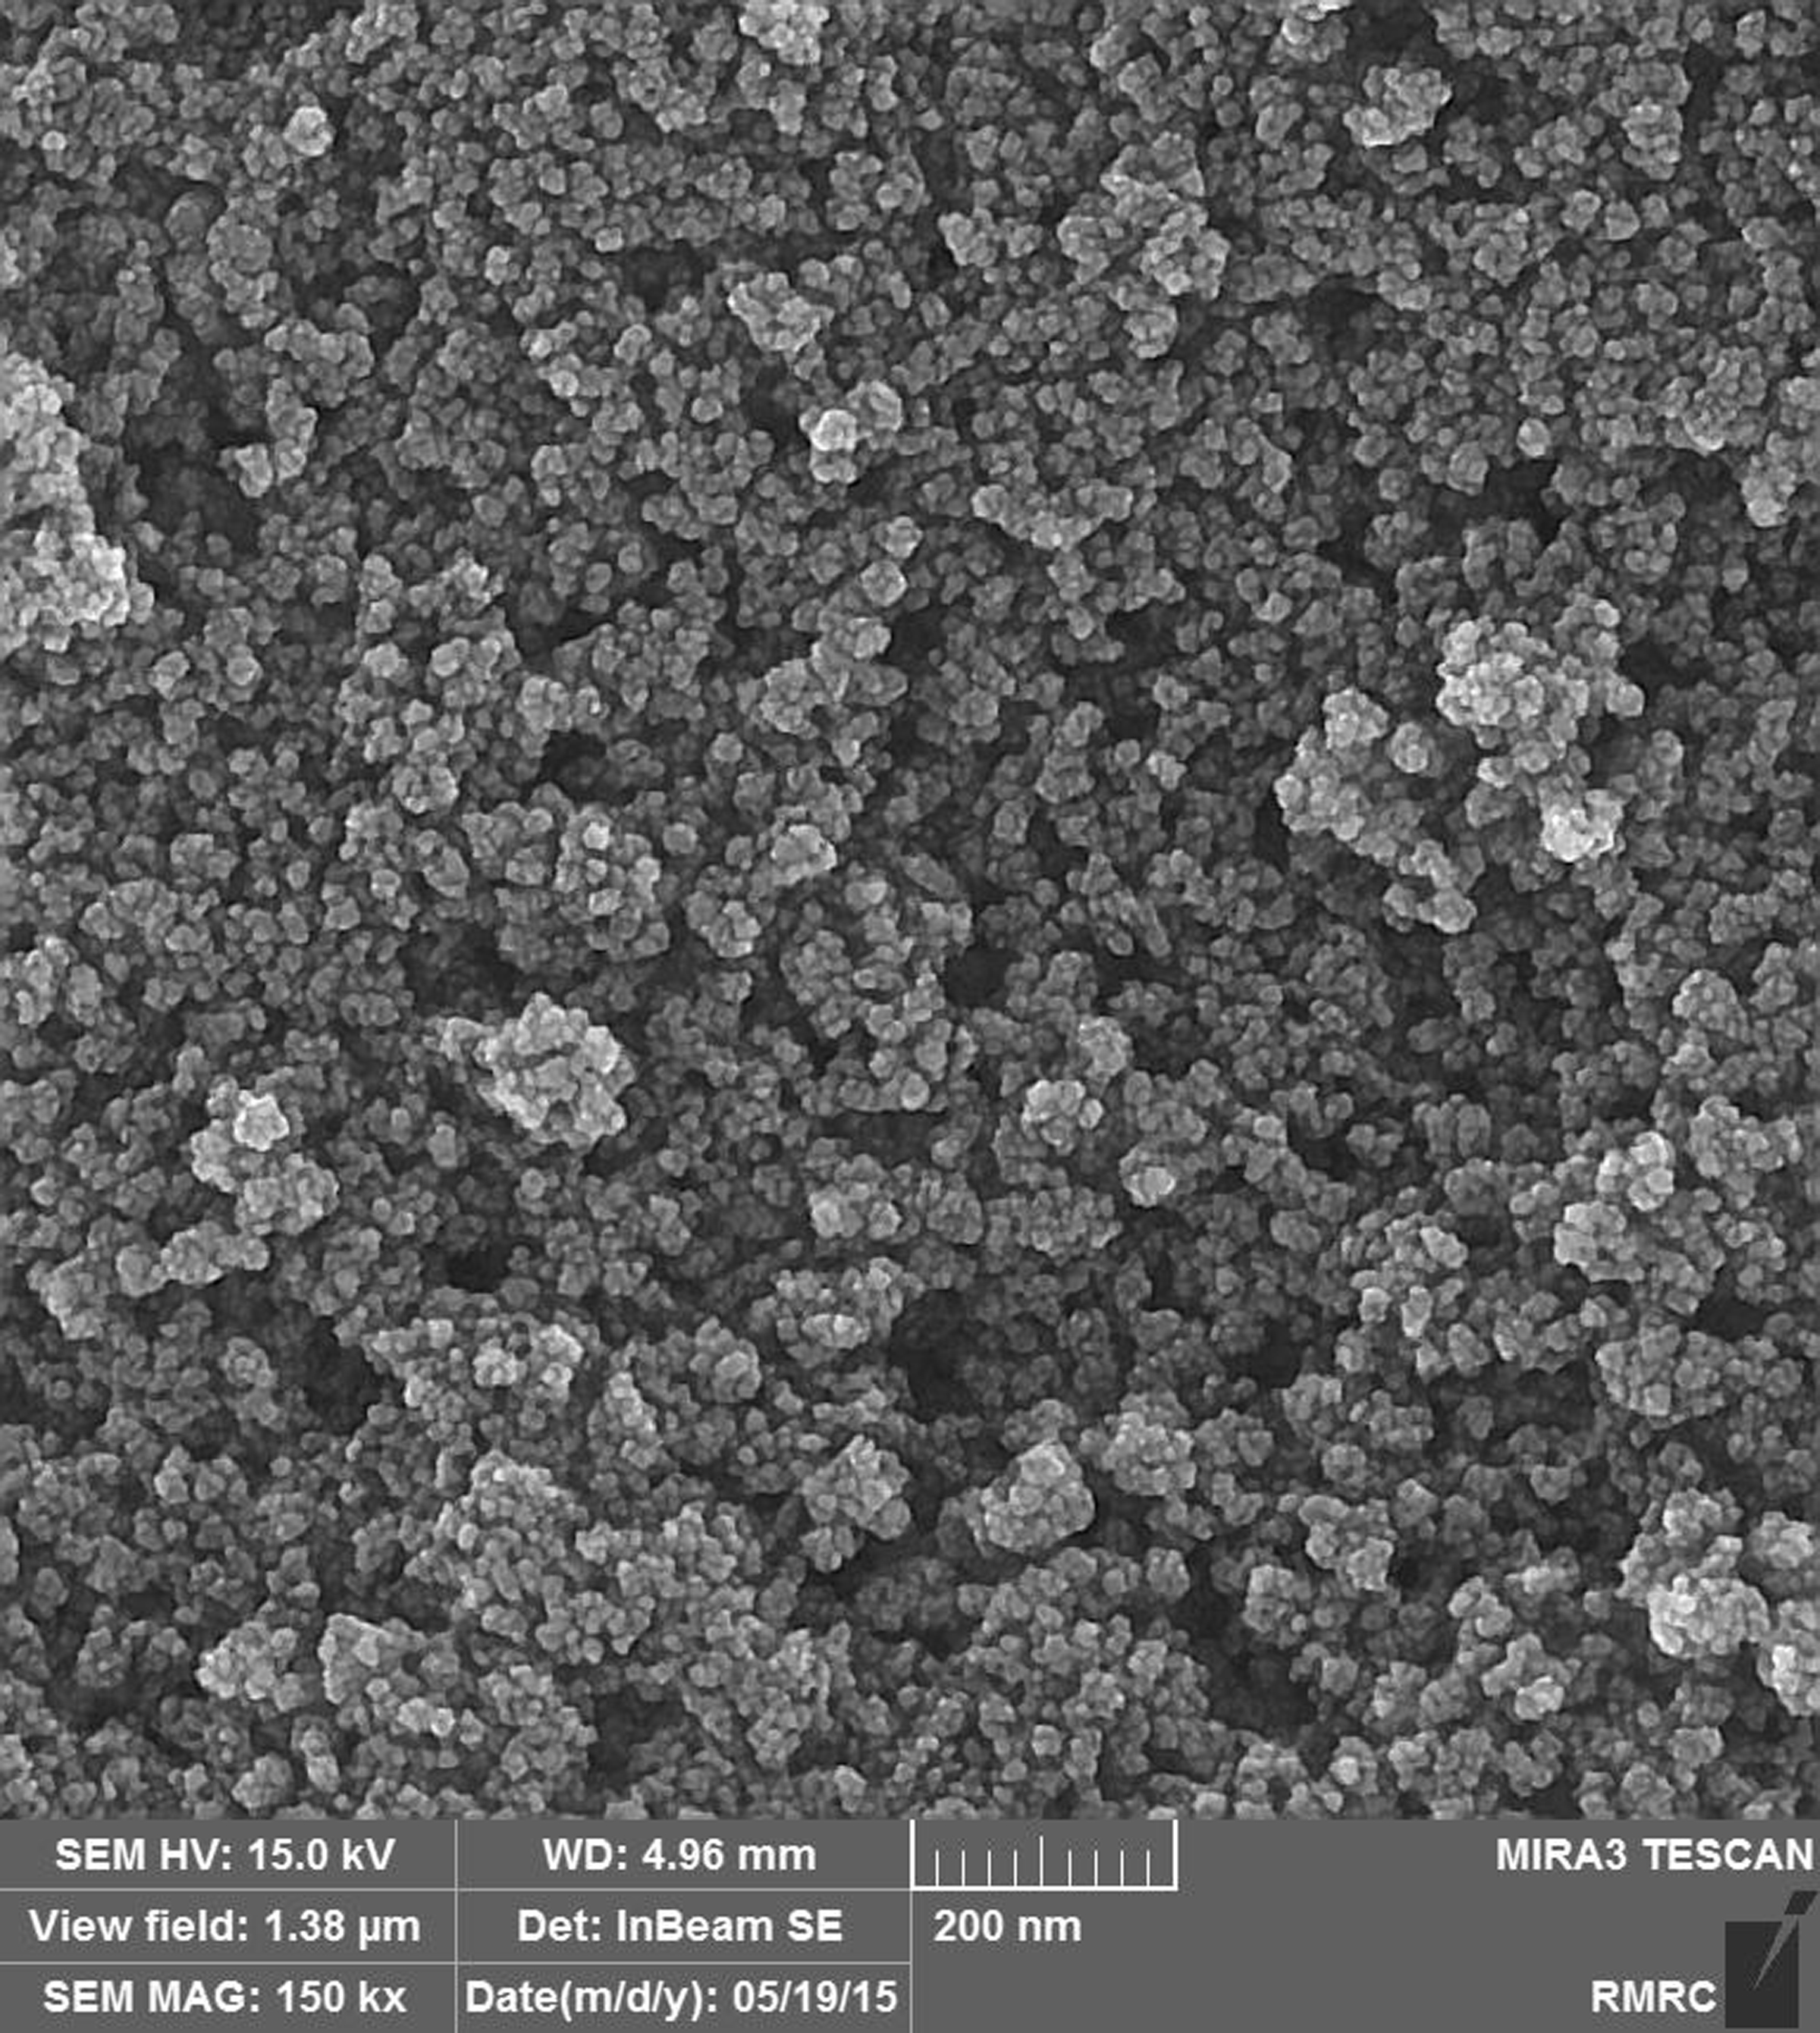
Figure 1. FE-SEM image of Fe₃O₄@SiO₂-OSO₃H nanocomposite
Further information about the chemical structure of Fe₃O₄@SiO₂-OSO₃Hnanocomposite was obtained from FT-IR spectroscopy (Figure 2). The analysis indicated three strong absorption bond at 567 cm⁻¹ corresponding to the vibration of Fe-O in Fe₃O₄. The next strong peak at 1070 cm⁻¹ is attributed to the Si–O–Si bond stretching of Fe₃O₄@SiO₂-SO₃H. The weak intensity band at 830 cm⁻¹ can be ascribed to the stretching of non-bridging oxygen atoms in Si–OH bond. Therefore, silica coating on the surface of Fe₃O₄ was conﬁrmed by these absorption bonds. The presence of sulfonyl groups is proved by 1217cm⁻¹and 1124cm⁻¹bonds that were covered by a stronger absorption of Si-O bond at 1072 cm⁻¹. The last strong peak appeared at about 2600-3700 cm⁻¹ due to the stretching of OH groups in the SO₃H.
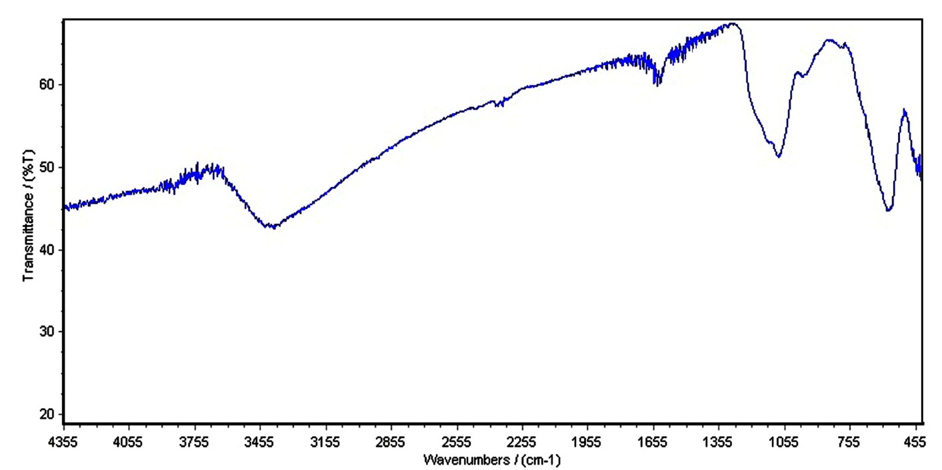
Figure 2. FT-IR spectrum of Fe₃O₄@SiO₂-OSO₃H nanocomposite
The chemical purity of the samples as well as their stoichiometry was tested by EDX study. The EDX spectrum of Fe₃O₄@SiO₂-OSO₃Hnanocomposite shows that the elemental compositions are (Fe, O, S and Si) which have posse's nanostructure (Figure 3).
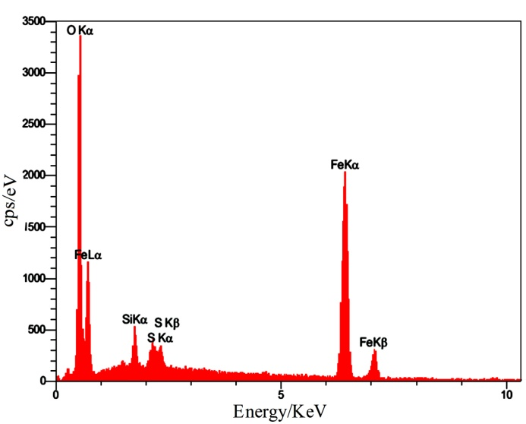
Figure 3. The EDX spectrum of Fe₃O₄@SiO₂-OSO₃H nanocomposite
Figure 4 shows the XRD pattern of the prepared Fe₃O₄@SiO₂-OSO₃H. All the XRD patterns show raising background which is attributed to X-ray fluorescence since Cu-Kα has been used as the X-ray source during the measurements.
The reflections of XRD pattern of Fe₃O₄@Silica sulfonic acid in Figure 4 confirm the synthesis of cubic normal spinel Fe₃O₄ (JCPDS file no. 79-0417). These results represent the stability of the crystalline phase of Fe₃O₄ nanoparticles during silica coating and surface sulfonic acid functionalization.
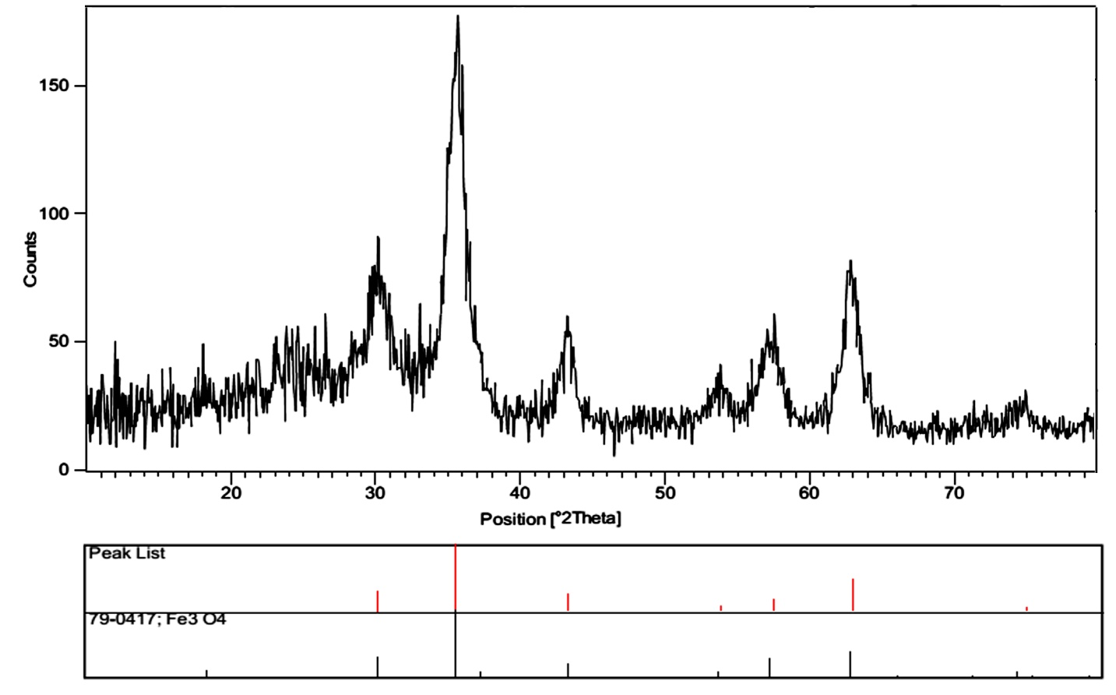
Figure 4. The XRD pattern of Fe₃O₄@SiO₂-OSO₃H nanocomposite
To optimize the reaction conditions the condensation of p-toluidine (1 mmol), dimethyl acetylenedicarboxylate (1 mmol), 4-chlorobenzaldehyde (1 mmol) and ethyl acetoacetate (1 mmol), as a model reaction, were studied in the presence of different amounts of Fe₃O₄@SiO₂-OSO₃H nanocomposite under solvent-free conditions (Scheme 3). The respective results in Table 1 indicate that the best results were attained when the reaction was performed by using 0.02g of the catalyst at 80 ^{º}C. To demonstrate that heat cannot thermodynamically promote the reaction in the absence of catalyst; the model reaction was examined at 80 ^{º}C under catalyst-free conditions. In these conditions, desired product was obtained in trace after 120 min. This observation indicated clearly that heat cannot promote the reaction without catalyst. Thus presence of catalyst is essential for this reaction.
Scheme 3. The model reaction for the synthesis of 1,4-dihydropyridine 5a
Table 1. The Effect of the catalyst amount and temperature on the model study
Entry | Catalyst (g) | Temp. (°C) | Time (min) | Yields(%) ª
1 | --- | 80 | 120 | trace
2 | 0.03 | 80 | 60 | 91
3 | 0.02 | 80 | 60 | 91
4 | 0.01 | 80 | 90 | 82
5 | 0.02 | 50 | 90 | 71
6 | 0.02 | 100 | 70 | 91
ª Isolated yield.

After optimization of the reaction conditions, the efficiency and scope of the catalyst were evaluated by the reaction of arylamines, dimethyl acetylenedicarboxylate, aryl aldehydes and ethyl acetoacetate by using 0.02 g of Fe₃O₄@SiO₂-OSO₃H nanocomposite at 80 ^{º}C. The corresponding results are summarized in Table 2. As it can be seen from Table 2, all reactions proceeded efficiently to afford the desired 1,4-dihydro-pyridines in high yields and short reaction times. Therefore, Fe₃O₄@SiO₂-OSO₃H nanocomposite was efficient to catalysis the one-pot four-component reactions.
The influence of electron-withdrawing and electrondonating substituents on the aromatic ring of aldehydes upon the reaction yields and times was investigated. The results in Table 2 show that the aromatic aldehydes bearing both electron-donating and electron-withdrawing groups presented excellent yield of desired products.
Table 2. The synthesis of 1,4-dihydropyridines using Fe₃O₄@SiO₂-SO₃H under solvent-free conditions at 80°C.
Entry | Ar | Ar/ | Product | Time (min) | Yield (%) | Lit. m.p (ºC) | M.p (ºC)
1 | 4-Cl-Ph | 4-CH₃-Ph | 5a | 60 | 91 | 132-133 | (133-135)²⁸
2 | 3-NO₂-Ph‎ | 4-CH₃-Ph | 5b | 60 | 89 | 137-138 | (135-137)²⁸
3 | 4-NO₂-Ph‎ | 4-OCH₃-Ph | 5c | 45 | 93 | 170-172 | ----
4 | 3-NO₂-Ph‎ | 4-OCH₃-Ph | 5d | 70 | 90 | 154-156 | (155-157)²⁸
5 | 4-Br-Ph | 4-OCH₃-Ph | 5e | 60 | 92 | 145-147 | ----
6 | 4-Br-Ph ‎ | 4-Cl-Ph | 5f | 70 | 85 | 127-129 | ----
7 | 4-Cl-Ph | 4-Cl-Ph | 5g | 60 | 85 | 131-133 | (132-134)²⁸
8 | 3-NO₂-Ph‎ | 4-Cl-Ph | 5h | 70 | 88 | 143-145 | (143-145)²⁸
9 | 4-Cl-Ph ‎ | 4-OCH₃-Ph | 5i | 50 | 87 | 128-130 | (129-131)²⁸
10 | 4-OCH₃-Ph | 4-CH₃-Ph | 5j | 80 | 83 | 109-112 | (110-112)²⁸
11 | 4-F-Ph ‎ | 4-CH₃-Ph | 5k | 60 | 90 | 105-107 | (104-106)²⁸
12 | 3-NO₂-Ph‎ | Ph | 5l | 70 | 88 | 153-155 | (151-153)²⁸
ªIsolated yield.

A plausible mechanism for the preparation of highly functionalized dihydropyridines using Fe₃O₄@SiO₂-OSO₃H nanocomposite has on the basis of our experimental results together with some literature²⁶ been shown in Scheme 3. It is likely that Fe₃O₄@SiO₂-OSO₃H MNPs acts as a Bronsted acid and increases the electrophilicity of the carbonyl groups of the aldehydes and intermediates. Firstly, the Knoevenagel condensation of aromatic aldehyde with ethyl acetoacetate is suggested to give the intermediate A, Then nucleophilic attack of arlymine to dimethyl acetylenedicaroboxylate leads to formation of intermediate B. Secondly, the Michael addition of β-enamino ester intermediate (B) to arylidenecyanoacetate (A) afforded the addition of intermediate (C). At last in intermediate(C), the intramolecularnucleophilic addition of amino group to carbonyl group formed the final 1,4- dihydropyridine(Scheme 4).
Scheme 4. Proposed reaction pathway for the synthesis of 1,4-dihydropyridines
3.1. Results of Antimicrobial activities:
3.1.2. Well diffusion method
Among the bacterial strains studied inhibition diameters of Staphylococcus aureus in the presence of 5-ethyl 2,3-dimethyl 1-(4-methoxyphenyl)-6-methyl-4-(4-nitrophenyl)-1,4-dihydropyridine-2,3,5-tricarboxylate (5c), 5-ethyl 2,3-dimethyl 4-(4-bromophenyl)-1-(4-methoxyphenyl)-6-methyl-1,4-dihydropyridine-2,3,5-tricarboxylate (5e), 5-ethyl 2,3-dimethyl 4-(4-bromophenyl)-1-(4-chlorophenyl)-6-methyl-1,4-dihydropyridine-2,3,5-tricarboxylate (5f)were 16, 15 and 17 mm respectively. But other bacterial strains showed no inhibition zone.
3.1.3. Determination of antibiotic susceptibility
The results of the antibiogram for Staphylococcus aureus strain showed that this bacterium is sensitive to Vancomycin antibiotic
3.1.4. Disc diffusion method
In this test, as well as well diffusion method inhibition diameters of Staphylococcus aureus in the presence of 5-ethyl 2,3-dimethyl 1-(4-methoxyphenyl)-6-methyl-4-(4-nitrophenyl)-1,4-dihydropyridine-2,3,5-tricarboxylate (5c), 5-ethyl 2,3-dimethyl 4-(4-bromophenyl)-1-(4-methoxyphenyl)-6-methyl-1,4-dihydropyridine-2,3,5-tricarboxylate (5e), 5-ethyl 2,3-dimethyl 4-(4-bromophenyl)-1-(4-chlorophenyl)-6-methyl-1,4-dihydropyridine-2,3,5-tricarboxylate (5f) was 15, 14, 16 mm respectively.
3.2. Recycling of the Catalyst
Reusability is one of the most significant properties of the prepared catalysts. The recyclability of MNPs-SO3H was studied for the model reaction. After completion of the reaction dichloromethane was added to the reaction mixture, the catalyst was insoluble in CH₂Cl₂ and it could therefore be recycled by a simple filtration. The nanocatalyst was then washed three to four times with methanol and dried at 80 ^{º}C for 7 h. The catalyst could be reused for five times with a minimal loss of activity (yields 91 to 85) (Table 3).
Table 3. Recycling of the Fe₃O₄@SiO₂-OSO₃H nanocatalyst
Number of cycle |  | Yield (%) ª
1 |  | 91
2 |  | 90
3 |  | 90
4 |  | 88
5 |  | 85
ª Yields refer to the isolated pure product

4. Conclusion
In conclusion, we have developed a simple and efficient approach for the synthesis of 1,4-dihydropyridines by one-pot four-component reaction of arylamine, dimethyl acetylenedicarboxylate, aromatic aldehyde and ethyl acetoacetate in the presence of Fe₃O₄@SiO₂-OSO₃H nanocatalyst under solvent-free conditions. The present methodology offers several advantages, such as good yields, short reaction times, ease of separation, recyclability of the magnetic nanocatalyst, simple purification and environmentally benign. These compounds showed high antibiotic properties and can be useful in other research and biomedical applications.
4.2. Acknowledgements
The author gratefully acknowledges the financial support of this work by the Research Affairs Office of the Islamic Azad University, Qom Branch, Qom, I. R. Iran [grant number 2014-13929].
5. References
- A. Nefzi, J. M. Ostresh, R. A. Houghten, Chem. Rev. 1997, 97, 449-472.
- K. K. Boroujeni, Z. Heidari, R. Khalifeh, Acta. Chim. Slov. 2016, 63, 602-608.
- R. Shan, C. Velazquez, J. Med. Chem. 2004, 47, 254-261.
- L. Ohberg, J. Wesman, Synlett, 2001, 8, 1296-1298.
- A. Dondoni, A. Massi, E. Minghini, V. Bertolasi, Tetrahedron, 2004, 60, 2311-2326.
- J. L. Donelson, R. A. Gibbs, S.K. De, J. Mol. Cat. A: Chem. 2006, 256, 309-311.
- S. J. Ji, Z. Q. Jiang, J. Lu, T. P. Loh, Synlett, 2004, 831-835.
- S. Ko, M. N. V. Sastry, C. Lin, C. F. Yao, Tetrahedron Lett. 2005, 46, 5771-5774.
- I. B. Dzvinchuk, N. A. Tolmacheva, Chem. Heterocycl. Comp. 2001, 37, 506-508.
- V. A. Chebanov, V. E. Saraev, K. M. Kobzar, S. M. Desenko, V. D. Orlov, E. A. Gura, Chem. Heterocycl. Comp. 2004, 40, 475-480.
- G. Sabitha, G. S. Reddy, C. S. Reddy, J. S. Yadav, Tetrahedron Lett. 2003, 44, 4129-4131.
- L. M. Wang, J. Sheng, L. Zhang, J. Han, Z. Y. Fan, H. Tian, C. Y.Qian, Tetrahedron, 2005, 61, 1539.
- S. Ko, C. F. Yao, Tetrahedron, 2006, 62, 7293-7299.
- M. A. Chariand, K. Syamasundar, Catal. Commun. 2005, 6, 624-626.
- S. H. Mashraqui, M. A.Karnik, Tetrahedron Lett. 1998, 39, 4895-4898.
- R. S. Varma, D. Kumar, Tetrahedron Lett. 1999, 40, 21-24.
- Y. Z. Mao, M. Z. Jin, Z. L. Liu, L. M. Wu, Org. Lett. 2000, 2, 741-742.
- N. Nakamichi, Y. Kawashita, M. Hayashi, Org. Lett. 2002, 4, 3955-3957.
- M. A.Ghasemzadeh, Acta. Chim. Slov. 2015, 62, 977-985.
- M. A. Ghasemzadeh, M. H. Abdollahi-Basir, M. Babaei, Green Chem. Lett. Rev. 2015, 8, 40-49.
- M. A. Ghasemzadeh, B. Mirhosseini-Eshkevari, M. H. Abdollahi-Basir, Comb. Chem. High. T. Scr. 2016, 19, 592-601.
- M. A. Ghasemzadeh, N. Ghasemi-Seresht, Res. Chem. Intermed. 2015, 41, 8625-8636.
- B. Jean, R. Franklin, A. Patricia, A. Janet, M. George, Approved standard–Tenthedition. 2015, 35, M07.
- D. M. Livermore, D. F. Brown, J. Antimicrob. Chemother. 2001, 48, 59-64.
- Y. Hu, Z. Zhang, H. Zhang, L. Luo, S. Yao, J. Solid State Electrochem. 2012, 16, 857-867.
- Y. H. Deng, D. W. Qi, C. H. Deng, X. M. Zhang, D. Y. Zhao, J. Am. Chem. Soc. 2008, 130, 28-29.
- A. R. Kiasat, J. Davarpanah, J. Mol. Catal. A-Chem. 2013, 373, 46-54.
- W. Ping, X. Er-Yan, S. Jing, Y. Chao-Guo, Chem. Res. Chinese Universities. 2012, 28, 652-655.

