Understanding the Inhibition of Mild Steel Corrosion by dianiline Schiff bases: a DFT investigation.
Salah Eddine Hachani*, Zelikha Necira, Djamel Eddine Mazouzi, Nadia Nebbache.
Laboratory of Applied Chemistry LCA, Faculty of Science, University of Biskra, B.P. 145, RP. 07000 BISKRA, ALGERIA.

*Corresponding author:
Phone number: +213791162887
E-mail address: salaho_hachani@yahoo.fr

Abstract:
Quantum chemical calculations using density functional theory (DFT) at B3LYP/6-31G level were used to correlate the inhibition of mild steel corrosion in 1 M H₂SO₄ by four dianiline Schiff bases namely N,N′-Bis(benzylidene)-4,4’-dianiline (DAA), N,N′-Bis (benzylidene)-4,4’-methylenedianiline (MDAA), N,N′ Bis(benzylidene)-4,4’-sulphonyldianiline (SDAA) and N,N′-Bis(benzylidene)-4,4’-oxydianiline (ODAA) with their electronic and structural properties. Quantum chemical parameters such as the E_{HOMO}, E_{LUMO}, energy gap (ΔE), dipole moment (µ), global softness (σ), and global hardness (η) were calculated and discussed to provide valuable explanations for the reactivity and selectivity of the studied inhibitors. Both experimental and theoretical data showed a certain relationship to the calculated quantum parameters confirming that DAA has the highest inhibition efficiency.
Keywords: dianiline Schiff bases, corrosion, inhibition, mild steel, 1 M H₂SO₄, DFT.

- Introduction:
The prevention of mild steel against corrosion has attracted great attention from both academia and industry considering its important role in several industrial applications such as storage and transportation of various chemical solutions.¹ Mild steel equipment must be regularly cleaned to prevent damage and maintain the application efficiency. Acid solution is extensively used in chemical cleaning of mild steel which leads, after a certain time, to corrode its surfaces.^{2,3}
The protection of mild steel using corrosion inhibitors is one of the most practical processes particularly used in acidic media.⁴ Organic compounds containing heteroatoms with lone pairs of electrons (oxygen, sulfur, nitrogen and phosphorus), aromatic rings and π-electrons in triple or conjugated double bonds are considered to be excellent corrosion inhibitors.⁵ The corrosion inhibitory of such organic compounds is closely related to their adherence on metal surfaces via a physical adsorption (physisorption) which arise from electrostatic interactions between the inhibitor and the metallic surface or via chemical adsorption (chemisorption) by coordination bonds.^{6,7}
Schiff bases are organic compounds with the general chemical structure R₂C=NR’ obtained from the condensation of carbonyls and amines. This type of compounds has a well-known popularity in the field of materials science due to their potential advantages such as easy synthetic route, high purity, low toxicity, and their eco-friendly nature.⁸⁻¹⁰ The studies on corrosion inhibitors have demonstrated that Schiff base molecules can be used as effective corrosion inhibitors in different aggressive media.¹¹
Experimental techniques such as weight loss measurements, potentiodynamic polarization and electrochemical impedance spectroscopy are useful in understanding the corrosion inhibition mechanisms but they are expensive and time-consuming. ^{12,13} Computer hardware and software developments motivated scientists towards the exploitation of theoretical chemistry in corrosion inhibition research thanks to the significant relationship between the corrosion activity of an inhibitor and its electronic and molecular structure properties.
Quantum chemical calculations have proved to be a technique of choice used to elucidate the ambiguities of experimental corrosion inhibition observations.¹⁴ The corrosion inhibitory of a molecule is strongly related to quantum chemical parameters such as the energies of the highest occupied molecular orbital (HOMO) and lowest unoccupied molecular orbital (LUMO), energy difference HOMO–LUMO (ΔE), electronegativity (χ), proton affinity (A), potential ionization (I), global hardness (η), and softness (σ).
In a study,¹⁵ the inhibition of mild steel corrosion in sulfuric acid media by dianiline Schiff bases namely N,N′-Bis(benzylidene)-4,4’-dianiline (DAA), N,N′-Bis(benzylidene)-4,4’-methylenedianiline (MDAA), N,N′-Bis(benzylidene)-4,4’-sulphonyldianiline (SDAA) and N,N′-Bis(benzylidene)-4,4’- oxydianiline (ODAA) (Fig.1) was investigated. Although a good inhibition activity is reported for the four compounds, the relationship between experimental protection efficiencies of the concerned inhibitors and their molecular and electronic properties has not been investigated yet.
Figure 1: Chemical molecular structures of the studied dianiline Schiff bases inhibitors.
This theoretical investigation aims to provide supportive explanations for the observed results. Various quantum chemical parameters including the energies of frontier orbitals (E_{HOMO} and E_{LUMO}), energy gap (ΔE), dipole moment (µ), hardness (η), softness (σ), the fraction of electrons transferred (ΔN) and total energy (TE) were calculated and discussed.
- Computational details:
Density functional theory (DFT) method is theoretical approach widely applied to predict the chemical reactivity of molecules thanks to its ability to give accurate geometries and electronic properties of the studied organic compounds.¹⁶ In the present study, quantum chemical calculations were performed using density functional theory (DFT) with the Beck’s three parameter exchange functional along with the Lee-Yang-Parr non local correlation functional (B3LYP) with 6-31G basis set¹⁷ at the neutral forms of the investigated molecules. The input files of the studied dianiline Schiff bases were built using Gauss View 5.0.8¹⁸ and all calculations were carried out using Gaussian 03W program package.¹⁹
The optimized geometry of all studied molecules was determined at minimum energy level. The energies of frontier molecular orbitals (E_{HOMO} and E_{LUMO}) are reported and used to elucidate the reactivity of the studied inhibitors. According to the Koopmans’ theorem,²⁰ the ionization potential (I) and electron affinity (A) are related to E_{HOMO} and E_{LUMO} of the inhibitor molecule and they are given by the relations 1 and 2:
$I=-E_{HOMO}$ (1)
$A=-E_{LUMO}$ (2)
According to Pearson,²¹ the electronegativity ($χ$), global hardness ($η$) and global softness (the inverse of global hardness) can be calculated from the ionization potential and electron affinity by the following equations:
$χ=(I+A)/2$ (3)

$η=(I-A)/2$ (4)
$=1/η$ (5)

The fraction of electrons transferred ($N)$ from the chemical species to the metal surface is calculated using Pearson’s equation²² :
$N=\left(χ_{Fe}-χ_{Inh}\right)/2(η_{Fe}+η_{Inh})$ (6)
Knowing that $χ_{Fe}$ and $χ_{Inh}$ are the absolute electronegativity of iron and inhibitor molecule respectively, $η_{Fe}$and $η_{Inh}$ are the absolute hardness of both iron and the inhibitor molecule respectively. In the present work, we take $χ_{Fe}$= 7 eV and $η_{Fe}=$ 0 eV to compute the fraction of electrons transferred$(N$) of each studied inhibitor.²³
- Results and discussions:
The inhibition of a mild steel corrosion using dianiline Schiff bases in 1.0 M H₂SO₄ solution was experimentally investigated by Chitra et al¹⁵ using different techniques such as weight loss, electrochemical techniques (polarization measurement, electrochemical impedance spectroscopy). It was found that the four investigated compounds are good inhibitors and DAA is the best one, their inhibitory role is greatly marked at higher molar concentration. The inhibition efficiency followed the sequence: MDAA ≈ DAA > SDAA > ODAA.¹⁵
In this contribution, quantum chemical calculations were used to find the relationship between the molecular electronic features of the studied inhibitors and their inhibition efficiencies to explain the experimental observations. The optimized molecular structures of the studied dianiline inhibitors are represented in Figure 2.
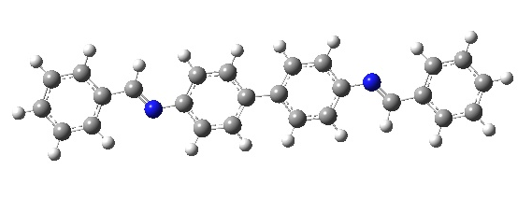
DAA
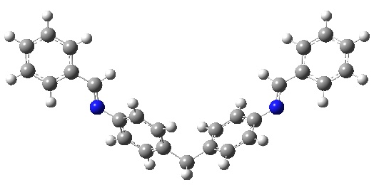
MDAA
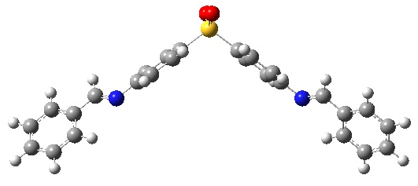
SDAA
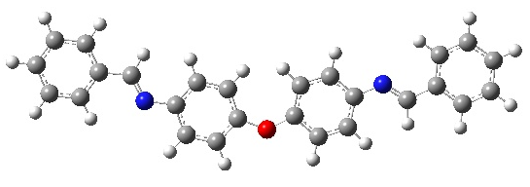
ODAA
Figure 2: Optimized molecular structures of dianiline inhibitors at B3LYP/6-31 G level.

The inhibitor molecular geometry is a critical parameter influencing the adsorption on metal surface; molecules with planar molecular structure have a greater tendency to adsorb on metal surface than molecules having less planar geometry.²⁴ The planarity level of the optimized studied structures is described in Figure 3. The comparison between the different molecular geometries of the studied inhibitors shows that DAA and ODAA are highly planar so they can cover the mild steel surface while MDAA and SDAA are no planar. The order of inhibitor adsorbability on the metal surface would probably be as following DAA ≈ ODAA > SDAA ≈ MDAA which confirms that DAA is the best inhibitor among the four studied.
Figure 3: Geometry planarity of the studied dianiline Schiff base inhibitors.
Beside the previous molecular geometries, Quantum chemical parameters as E_{HOMO,} E_{LUMO}, ΔE, global softness (σ), global hardness (η) and other parameters are efficient for finding which inhibitor molecule has greater ability to donate electrons, receive electrons from the metal or bind more strongly to the metallic surface to act as suitable corrosion inhibitor.
The calculated quantum properties are summarized in Table 1. Regarding to the total energy values corresponding to the studied compounds, it can be seen that the best corrosion inhibitor (DAA) has the highest total energy (-30260.1092 eV) among the four studied molecules which confirms its higher chemical reactivity toward the metal surface.
Table 1: Calculated quantum chemical parameters of the dianiline Schiff bases using B3LYP/6-31G.
Compound | DAA | MDAA | SDAA | ODAA
TE (eV) | -30260.1092 | -31329.6100 | -45182.0792 | -32305.6070
µ (D) | 0 | 2.2011 | 7.1350 | 1.0153
E_{HOMO} | -5.4975 | -5.7291 | -6.3688 | -5.4815
E_{LUMO} | -2.0762 | -1.6443 | -2.1325 | -1.8293
ΔE (eV) | -3.4213 | -4.0848 | -4.2363 | -3.6522
I (eV) | 5.4975 | 5.7291 | 6.3688 | 5.4815
A (eV) | 2.0762 | 1.6443 | 2.1325 | 1.8293
χ (eV) | 3.79 | 3.69 | 4.25 | 3.65
η (eV) | 1.71 | 2.04 | 2.12 | 1.83
σ (eV⁻¹) | 0.585 | 0.490 | 0.472 | 0.546
ΔN | 0.938 | 0.811 | 0.648 | 0.915

HOMO and LUMO orbitals distribution in the studied dianiline Schiff bases are shown in Figure 4. It is well known that the activity of an inhibitor is closely related to its adsorption on metal surface. According to Fukui’s frontier molecular orbital theory, both HOMO and LUMO energies are very useful in interpreting the adsorption reactivity of a molecule.²⁵ E_{HOMO} is associated with the electron-donating ability of the inhibitor molecule; higher E_{HOMO} indicates a greater ease of donating electrons to the unoccupied d orbital of metal. E_{LUMO} is associated to electron-accepting ability of inhibitor molecules; a lower E_{LUMO} indicates a bigger electron-accepting ability of the inhibitor. It can be observed from Table 1 that the E_{HOMO} values increased in the order of SDAA < MDAA < DAA < ODAA, which means that the ability to give an electron from the studied inhibitors to mild steel surfaces follows the order of ODAA > DAA > MDAA > SDAA. This order is not in agreement with the reported experimental results of inhibition efficiency.

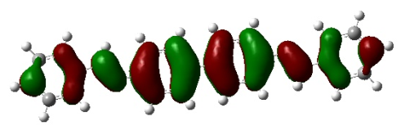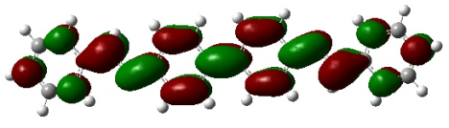
DAA HOMO DAA LUMO
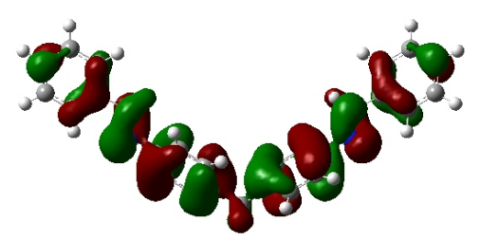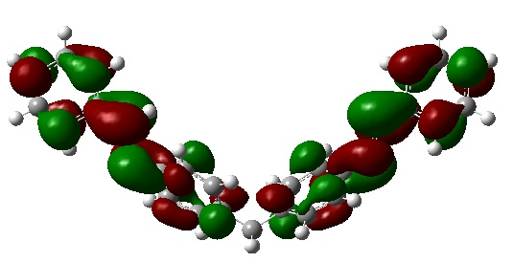
MDAA HOMO MDAA LUMO
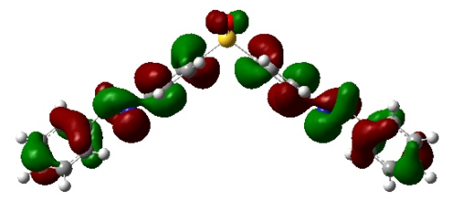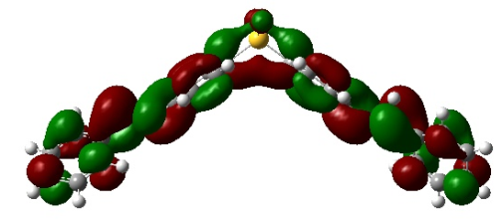
SDAA HOMO SDAA LUMO
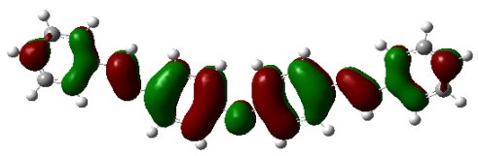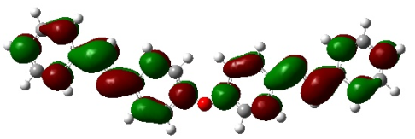
ODAA HOMO ODAA LUMO
Figure 4: HOMO and LUMO orbitals of DAA, MDAA, SDAA and ODAA molecules at B3LYP/6-31G level.
The energy gap (ΔE): the energy difference between HOMO and LUMO is also an important parameter can be used to predict the inhibitor reactivity towards the metal surface.²² As ΔE decreases, the chemical reactivity increases leading to an increase in the adsorption of the inhibitor molecules on the metallic surface.²⁶ Here, the trend for the ΔE values (Table 1) follows the order DAA > ODAA > MDAA > SDAA. This trend is not in agreement with the experimental findings.
Electronegativity (χ) is a chemical property that describes the molecule capability to attract electrons. Molecules having higher electronegativity would strongly interact with the metal surface. As consequence, higher inhibition effectiveness is expected.²⁷ The electronegativity values of the four inhibitor molecules follows the sequence SDAA > DAA > MDAA > ODAA. This trend does not correlate with the reported experimental results.
Global hardness (η) is a measure of molecule resistance towards electron cloud polarization or deformation of molecules under small perturbations of the chemical reaction.²⁸ The inhibitor with the least value of global hardness is expected to have the highest inhibition efficiency.²⁹ In our study, DAA has the lowest global hardness among the four studied inhibitors molecules which points to the fact that DAA has the highest inhibition efficiency.
Global Softness ($σ$) is also an important quantum parameter used to explain chemical reactivity of the molecule. The adsorption on metal surface occurs at the part of the molecule where softness has the highest value.³⁰ It can be seen from Table 1 that the calculated softness values of the inhibitors are increasing in the order of SDAA < MDAA < ODAA < DAA, which supports a better adsorption capability of DAA on the metallic surfaces.
The fraction of electrons transferred (ΔN) from the inhibitor molecule to the metallic surface is calculated using Pearson’s formula (Eq.6). According to Lukovits et al.³¹ the inhibition activity increases with increasing of electron-donating ability of the molecule to the metal surface if ΔN < 3.6. From Table 1, it can be seen that all ΔN values are positive and less than 3.6 indicating that the four dianiline Schiff bases are able to give their electrons to the poor d-orbital of metal. The ΔN of DAA compound is the highest among the four molecules which confirms its highest electron-donating ability to mild steel surfaces which agrees with the experimental results.
The dipole moment (µ) results from non-uniform distribution of charges on the various atoms in the molecule.³² High dipole moment is required to ensure a better molecule adsorption on metal surfaces.³³ The dipole moment values (Table 1) follow the trend SDAA > MDAA > ODAA > DAA. This trend does not correlate well with the reported inhibition efficiencies. Similar irregularities in the correlation of dipole moment with the inhibition efficiency have also been reported.³⁴
- Conclusion:
This study aims to bridge the gap between the corrosion inhibition efficiencies of four dianiline Schiff bases and their electronic and molecular properties. DFT calculations at B3LYP functional with 6-31G basis set were employed at the neutral forms of the studied molecules. It was concluded from this study that:
- The total energy of the best inhibitor (DAA) is the highest among the studied dianiline Schiff bases.
- Quantum parameters such as global hardness$(η)$, global softness ($σ$) and the fraction of electrons transferred ($N$) confirm the highest inhibition efficiency of DAA.
- No direct relationship between the experimental observations and both gap energy (ΔE), electronegativity (χ) and dipole moment (µ).
Acknowledgment: The authors would like to thank Professor Bachir Abdelmalik from the department of computer science, University of Biskra-Algeria for his English skills.
Funding: This research did not receive any specific grant from funding agencies in the public, commercial, or not-for-profit sectors.
References:
1. Y. Liang, C. Wang, J.S. Li, L.J Wang, J.J. Fu, Int. J. Electrochem. Sci. 2015, 10, 8072-8086.
2. S.A.A. El-Maksoud, A.S. Fouda, Mater. Chem. Phys. 2005, 93, 84-90.
3. H. Keles, M. Keles, I. Dehri, O. Serindag, Mater. Chem. Phys. 2008, 12, 173–179.
4. L. Guo, X. Ren, Y. Zhou, S. Xu, Y. Gong, S. Zhang, Arab. J. Chem. 2017, 10, 121-130.
5. N.O. Eddy, Port. Electrochim. Acta. 2009, 27, 579-589.
6. R. Solmaz, E.A. Sahin, A. Doner, G. Kardas, Corros. Sci. 2011, 53, 3231-3240.
7. O.K. Abiola, N.C. Oforka, Mater. Chem. Phys. 2004, 83, 315-322.
8. H.D. Lece, K.C. Emregul, O. Atakol, Corros. Sci. 2008, 50, 1460-1468.
9. S. Issaadi, T. Douadi, A. Zouaoui, S. Chafaa, M.A Khan, G. Bouet, Corros. Sci. 2011, 53, 1484-1488.
10. K.R Ansari, M.A. Quraishi, A. Singh, Corros. Sci. 2014, 79, 5-15.
11. M. Behpour, S.M. Ghoreishi, N. Soltani, M. Salavati-Niasari, Corros. Sci. 2009, 51, 1073-1082.
12. M.G.V. Satyanarayana, V. Himabindu, Y. Kalpana, M.R Kumar, K. Kumar, J. Mol. Struct.(THEOCHEM). 2009, 912, 113-118.
13. T.H. Muster, A.E. Hughes, S.A. Furman, T. Harvey, N. Sherman, S. Hardin, P. Corrigan, D. Lau, F.H. Scholes, P.A. White, M. Glenn, S.J. Garcia, J.M.C. Mol, Electrochim. Acta. 2009, 54, 3402-3411.
14. S.K. Saha, P. Banerjee, RSC Adv. 2015, 5, 71120-71130.
15. S. Chitra, K.S. Parameswari, Int. J. Electrochem. Sci. 2010, 5, 1675-1697.
16. C.O. Gretir, B. Mihci, G. Bereket, J. Mol. Struct. (THEOCHEM). 1999, 488, 223-231.
17. S.G. Zhang, W. Lei, M.Z. Xia, F.Y. Wang, J. Mol. Struct. (THEOCHEM). 2005, 732, 173-182.
18. I.B. Obot, S. Kaya¸ C. Kaya, B. Tuzun, Res Chem Intermed. 2016, 42, 4963-4983.
19. A. Zarrouk, I. El Ouali, M. Bouachrine, B. Hammouti, Y. Ramli, E.M. Essassi, I. Warad, A. Aouniti, R .Salghi, Res Chem Intermed. 2013, 39, 1125-1133.
20. T. Koopmans, Physica E. 1934, 1, 104-113.
21. R.G. Pearson, Inorg. Chem. 1988, 27, 734-740.
22. R.G. Pearson, J. Chem. Edu. 1987, 164, 561-567.
23. S.K. Saha, P. Ghosh, A. Hens, N.C. Murmu, P. Banerjee, Physica E. 2015, 66, 332-341.
24. E.E Ebenso, M. M.Kabanda, T. Arslan, M. Saracoglu, F. Kandemirli, L.C. Murulana, K.A. Singh, K.S. Shukla, B. Hammouti, K.F. Khaled, M.A. Quraishi, I.B. Obot, N.O. Eddy, Int. J. Electrochem. Sci. 2012, 7, 5643-5676.
25. K. Ramya, K.K. Anupama, K.M. Shainy, Egypt. J. Petrol. 2017, 26, 421–437.
26. I.B. Obot, Z.M. Gasem, Corros. Sci. 2014, 83, 359-366.
27. A. Dutta, S.K. Saha, P. Banerjeeb, D. Sukul, Corros. Sci. 2015, 98, 541-550.
28. N.O. Obi-Egbedi, I.B. Obot, M.I. El-Khaiary, S.A. Umoren, E.E. Ebenso, Int. J. Electrochem. Sci. 2011, 6, 5649-5675.
29. E.E. Ebenso, D.A. Isabirye, N.O. Eddy, Int. J. Mol. Sci. 2010, 11, 2473-2498.

30. R. Hasanov, M. Sadikoglu, S. Bilgic, Appl. Surf. Sci. 2007, 253, 3913-3921.
31. I. Lukovits, E. Kalman, F. Zucchi, Corrosion. 2001, 57, 3-8.
32. O. Kikuchi, Quant. Struct-Act. Relat. 1987, 6, 179-184.
33. X. Li, S. Deng, H. Fu, T. Li, Electrochim. Acta. 2009, 54, 4089-4098.
34. A. El Assyry, B. Benali, B. Lakhrissi, M. El Faydy, M. Ebn Touhami, R. Touir, M. Touil, Res Chem Intermed. 2015, 41, 3419-3431.

