A comparative study on the methylene blue decolorization through homogeneous and heterogeneous Fenton oxidation systems
SHIMA RAHIM POURAN ¹*, ABOLFAZL BAYRAMI ², MOHAMMAD SALEH SHAFEEYAN ³, ABDUL AZIZ ABDUL RAMAN ⁴ and WAN MOHD ASHRI WAN DAUD ⁴
¹ Research Laboratory of Advanced Water and Wastewater Treatment Processes, Department of Applied Chemistry, Faculty of Chemistry, University of Tabriz, 51666-16471 Tabriz, Iran.
²Department of Biology, Faculty of Science, University of Mohaghegh Ardabili, Ardabil, Iran.
³School of Chemical Engineering, College of Engineering, University of Tehran, 11155/4563, Tehran, Iran.
⁴ Chemical Engineering Department, Faculty of Engineering, University of Malaya, 50603 Kuala Lumpur, Malaysia.

Abstract: Oxidative treatment of methylene blue solution was investigated using magnetite nanoparticles and goethite in heterogeneous Fenton-like reaction, and ferrous ions in homogeneous Fenton-reaction. The aim was to compare the degradation efficiencies of the studied catalysts for decolorization of methylene blue solution as a model organic pollutant. Response surface methodology (RSM) was applied to determine the optimal operational conditions for magnetite/H₂O₂ and goethite/H₂O₂ systems. The [H₂O₂] of 0.2 M, catalyst dosage of 1 g L⁻¹, pH 9.0 and reaction time of 5h were chosen by RSM. The pH value of 3.0 was used in the case of Fe⁺² / H₂O₂ system. The experimental results showed that homogeneous Fenton oxidation system was the most effective system under both acidic and neutral conditions but decreased at pH value of 9.0 due to the decrease in available Fe²⁺ ions in the solution and generation of ferric hydroxide sludge. Fe₃O₄/ H₂O₂ system represented better removal efficiency than FeO (OH) / H₂O₂ system that could be attributed to the presence of FeII cations in magnetite structure and its larger surface area.

Keywords: Heterogeneous Fenton; response surface methodology; magnetite nano-particles; goethite

METHYLENE BLUE DECOLORIZATION THROUGH FENTON OXIDATION
INTRODUCTION
Tones of synthetic dyes are produced universally due to their wide applications in many industries, especially textiles. Since dyes are considered as one of the severe environmental pollutants, a large number of studies were opened to minimize their impact on human health and the environment.¹⁻⁴ Advanced oxidation processes (AOPs) are amongst the most accepted treatment methods for removal of dyes and pigments. The generation of highly actives species is the key factor for effective decomposition of organic pollutants through AOPs. Fenton reaction has attracted considerable attention amongst these processes due to its simple equipment, ease of operation and higher efficiency.⁵⁻⁷ In this reaction, catalytic action of iron species leads to H₂O₂ breakdown to highly active hydroxyl radicals (Eq.1):
There are large numbers of studies on Fenton treatment of various industrial wastewaters and synthetic solutions at laboratory or pilot plant scales.⁸ Fenton treatment of synthetic dye solutions such as Alizarin red S dye (C.I. 58005),⁹ Acid Blue 193 and Reactive Black 39,¹⁰ C.I. Basic Red 46 (BR46),¹¹ and C.I. Acid Red 14 azo dye,¹² are number of the examples reported in literature. In conventional Fenton reaction, using iron salts (Fe²⁺ and Fe³⁺ ions), due to the availability of the reactants in the reaction solution, the degradation rate is high and under the optimal condition, decolorization occurs within a short reaction time. However, this reaction is effective only at acidic condition of pH 3.0 and at higher pH conditions; the soluble iron is precipitated as ferric hydroxide resulting in catalyst withdrawal from the reaction medium. Accordingly, the catalyst recovery is also impracticable. In light of this, a number of solutions have been proposed to overcome the shortcomings of homogeneous Fenton reaction. Application of chelating agents,⁸ and heterogeneous catalysts,^{8,13} are examples to stabilize the iron in the solution and expand the pH range of the reaction. Large numbers of heterogeneous iron compounds such as zero-valent iron (ZVI),¹⁴ clays, silica, zeolites,¹⁵ and iron minerals,¹³ have been studied for dye wastewater treatment through Fenton reaction. In heterogeneous catalysts, iron is fixed in the structure and activates the reaction over broad range of pH (Eq.2). In addition, it can be simply separated from the solution by magnet or filtering.

In the present study, magnetite and goethite were chosen for heterogeneous Fenton treatment of synthetic MB wastewater. Methylene blue (MB) was selected as a model dye pollutant because of its extensive application in textile industry and recalcitrant nature. Central composite design (CCD) was used to optimize the Fenton-like reactions. The main objective of this study was to assess the efficiency of Fenton reaction catalysed by magnetite nanoparticles and goethite as heterogeneous catalyst. In addition, the decolorization efficacies of studied heterogeneous catalysts were compared with homogeneous Fenton under various pH conditions.

EXPERIMENTAL
Chemicals
All the chemicals were of reagent grade and used without further purification. Catalase (10,000–40,000 units/mg protein), magnetite (Fe₃O₄) and goethite (HFeO₂) were purchased from Sigma Aldrich. Methylene blue (MB), Hydrogen peroxide (H₂O₂, 30% w/w), Ferrous sulphate (FeSO₄·7H₂O), Sodium hydroxide (NaOH) and Sulfuric acid (H₂SO₄) were purchased from Merck. The ferrous (Fe²⁺) catalyst was prepared by dissolving FeSO₄ in distilled water and was used immediately to avoid the rapid oxidation of Fe²⁺.

Homogeneous Fenton Experiments
Fenton experiments were carried out in batch using a 250 mL borosilicate glass beaker with 100 mL of MB solution at the initial pH of 3.0±0.1 (known as the optimum pH,¹⁶ and temperature of 25°C. The MB solution was acidified using sulphuric acid that was monitored using a Cyber Scan pH meter (Eutech, Thermo Fisher Scientific). Subsequently, a fixed amount of Fe²⁺ was added and Fenton reaction was initiated by addition of predetermined amount of H₂O₂ solution under constant magnetic stirring to homogenize the mixture.⁸ At the end of the stipulated time period, the pH was readjusted to 10.0 ± 0.5, leading to reaction termination. The residual H₂O₂ was removed from the solution using a few drops of catalase enzyme (10 V/V). A 0.22 µm Millipore filter was used to remove the ferric hydroxide precipitate before the remnants of the MB concentration was monitored. Prior to the measurement, a calibration curve was obtained using standard MB solutions with known concentrations. The following equation (Eq.3) was used to calculate the percentages of color removal:
where, X₀ is the initial value of color and Xi is the measured value of color after defined reaction time. The reaction was repeated at pH 7.0±0.1 to assess the effectivity at neutral condition and at pH 9.0±0.1. The measurements were done at least in duplicate and the results were expressed as mean values of the measurements with an experimental error below 5%.

Heterogeneous Fenton Experiments
The MB degradation studies by nano-magnetite and goethite samples were carried out in a batch system at 25°C. The initial pH of the dye solution was adjusted to 9.0 by using NaOH solutions. Predetermined amount of each sample was added to dye solution (50 mg L⁻¹) and constantly stirred mechanically at 170 rpm for 60 min, to achieve sorption equilibrium. Then, depending on the experimental design, 0.1-0.3 mol L⁻¹ H₂O₂ was added to solutions to initiate Fenton reaction. After 300 min, the catalyst particles were separated from the solution by centrifugation at 3500 rpm for 5 min and the equilibrium concentration of MB was determined by a UV–vis spectrophotometer (Spectroquant® Pharo 300) at λmax 664 nm using Eq. (3). The experiments were repeated at pH 7.0±0.1 using 1 g L⁻¹ of each sample and 0.2 mol L⁻¹ H₂O₂ (optimum values) to assess the efficiency at neutral condition.

Design of Experiments (DOE)
Design Expert Software (version 9.0.3) was used for the statistical design of experiments, development of regression models, data analysis and optimization of Fenton-like reactions. Response surface methodology (RSM) was employed to assess the individual and interactive effects of two independent variables: (A) H₂O₂ and (B) catalyst concentrations on color removal efficiencies (%) of both hetero-catalysts. For the both catalysts, a face centred CCD that consists of 4 factorial points, 4 axial points and 3 replicates at the centre points were applied. The centre points are used to estimate the experimental error and the duplicability of the data. The ranges between 0.1 ‒ 0.3 mol L⁻¹ for [H₂O₂] and 0.5 ‒ 1.5 g L⁻¹ for catalysts concentration and over oxidation reaction time of 300 min were chosen based on the preliminary studies and the literatures.^{17,18}
A total of 11 experiments were performed for each hetero-catalyst in which three of them were at the centre point: (A) = 0.2, (B) = 1. The following second order polynomial equation (Eq.4) was used to predict the studied variable factors as a function of independent variables and the interaction among them:
Where, Y is the predicted dependent variable, b0 is constant coefficient, bi , bii and bij are regression coefficients, i and j are index numbers, k is number of patterns, Xi´s are independent variables and ɛ is the random error. The analysis of variance (ANOVA) was used to assess the significance and adequacy of the model. The fitness of the polynomial models was expressed by the coefficients of determination, R², R²_{adj} and R²_{pred}. The main indicators that were used to show the significance of the model were Fisher variation ratio (F-value), probability value (Prob > F) with 95% confidence level and adequate precision. The final model for each response was obtained after elimination of insignificant terms (p > 0.05) based on F‒test and the 3‒D plots were presented. Furthermore, the optimum values for independent variables were identified and further experiments were performed to verify the regression models.

RESULTS AND DISCUSSION
Experimental Design and ANOVA Analysis
Table 1 presents the results obtained from the heterogeneous Fenton experiments for the magnetite and goethite catalysed reactions.

TABLE I. Experimental Design Matrix and Response for Magnetite and Goethite
Run No. | A:catalyst / g L⁻¹ | B:H₂O₂ / mol L⁻¹ | Color removal / %
 |  |  | magnetite | goethite
1 | 1 | 0.2 | 68 | 63
2 | 1 | 0.2 | 67 | 64
3 | 0.5 | 0.1 | 59 | 56
4 | 1.5 | 0.3 | 74 | 71
5 | 1.5 | 0.1 | 61 | 59
6 | 1 | 0.2 | 67 | 63
7 | 0.5 | 0.2 | 64 | 60
8 | 1 | 0.1 | 62 | 59
9 | 1.5 | 0.2 | 69 | 65
10 | 0.5 | 0.3 | 65 | 62
11 | 1 | 0.3 | 69 | 67

Two quadratic models were proposed to describe the color removal efficiencies through Fenton catalyzed by magnetite and goethite (Eqs. 5 and 6):

Magnetite:
Goethite:

In these equations, the positive and negative symbols signify the synergistic or antagonistic effects respectively. Analysis of variance (ANOVA) was performed to evaluate the “goodness of Fit” of the proposed models. The results of ANOVA for both catalysts are given in Table 2. From the results, the p-values of both catalysts for the studied response were less than 0.05 (< 0.0001 and 0.0002) that shows the models were significant and could be used for prediction of the studied response. Furthermore, in order to assess the quality of the equations, regression coefficients of R², adjusted R² and predicted R² were used. The closeness of R² values to 1.00 showed that the models were highly reliable regarding experiments repetition. The values obtained for magnetite and goethite were respectively R²: 0.98 and 0.99, Adj R²: 0.97 and 0.98 and Pred R²: 0.87 and 0.95 that showed the significance of the models to predict the studied response. The difference less than 0.2 between pred-R² and adj-R² indicates a good agreement in the results for both catalysts.
Moreover, the results for adequate precision (the ratio of signal to noise) were 25.162 and 37.337 that were much greater than the required value of 4.0. This shows an acceptable signal and demonstrates that the models could navigate the design space. On the other hand, the lack of fit values for both hetero-catalysts were not significant that is the satisfactory result for the proposed models because it implies the models were fit to predict the amount of decolorization within the studied range of variables.¹⁹

TABLE II. Analysis of Variance (ANOVA) Results for Magnetite and Goethite
Source | Sum of squares | Degrees of freedom | Mean square | F-value | p-value  (Prob > F)
Magnetite
Model | 180.07 | 5 | 36.01 | 63.46 | 0.0002
Residual | 2.84 | 5 | 0.57
Lack of Fit | 2.17 | 3 | 0.72 | 2.717 | 0.3308
Pure Error | 0.67 | 2 | 0.33
Cor Total | 182.91 | 16
Goethite
Model | 173.19 | 5 | 34.64 | 128.21 | <0.0001
Residual | 1.35 | 5 | 0.27
Lack of Fit | 0.68 | 3 | 0.23 | 0.68 | 0.6395
Pure Error | 0.67 | 2 | 0.33
Cor Total | 174.55 | 10

Optimized Condition
The optimal conditions for heterogeneous Fenton reactions were obtained by design expert software. The condition proposed for both catalysts were [Catalyst] 1 g L⁻¹ and [H₂O₂] 0.2 mol L⁻¹ at predetermined pH and reaction time of 9 and 300 minutes. This condition was chosen based on the “maximum” color removal while using “in range” values of Fenton reagents. The color removal (%) of 67.32 and 63.37 were predicted by software at optimum values for magnetite and goethite catalyzed Fenton reactions respectively. The predicted values were in very close agreement with experimental values by deviation errors less than 0.1% that indicates the developed models can correlate the amount of catalyst and hydrogen peroxide to decolorization (%) with high accuracy.

Effects of the Fenton Reagents on Decolorization Efficiency
The effects of initial concentrations of H₂O₂ and the hetero-catalysts on decolorization efficacy are shown in Fig. 1a-b.

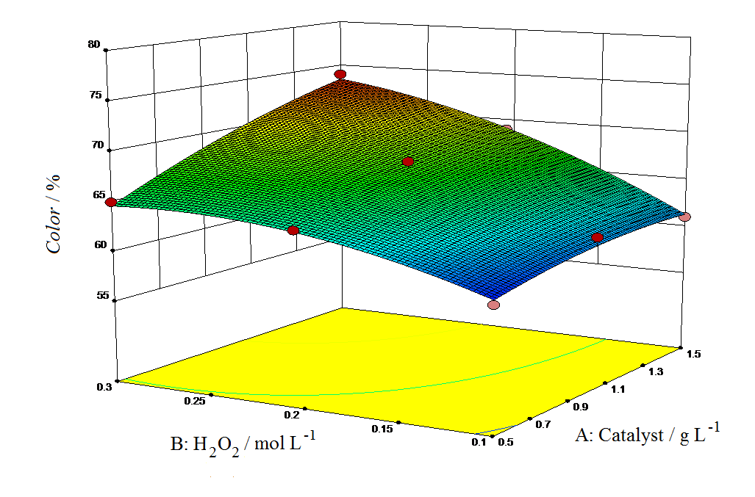
a)
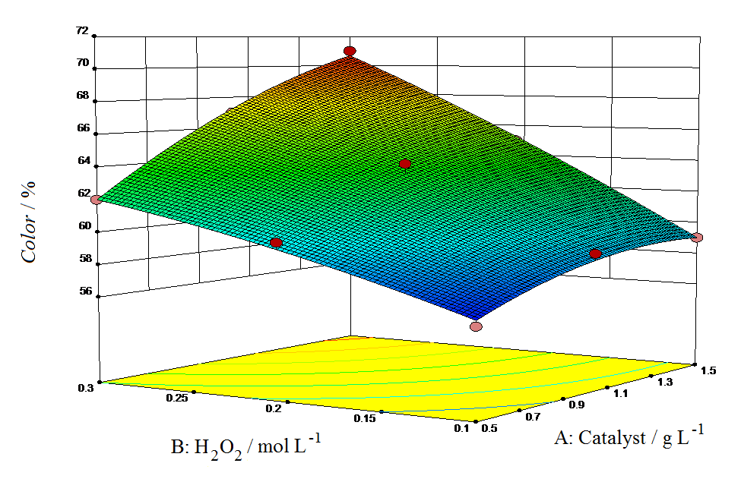
b)

Fig 1. The 3-D response surface of the effect of catalyst and [H₂O₂] on colour removal (%) using (a) nano-magnetite and (b) goethite in Fenton-like reaction

As can be seen in the graphs, the increase in H₂O₂ concentration was favored for decolorization in both catalysts. This is due to the generation of sufficient amount of •OH radicals. However, when the amount of H₂O₂ exceeded up to 0.3 mol L−1, the efficiency decreased due to the •OH scavenging effects of H₂O₂ (Eq. 7) that leads to the generation of perhydroxyl radical (HO₂•). HO₂• radicals are relatively less active than •OH radicals and also lead to a further decline in •OH availability in reaction solution as shown in Eq. (8):
Similarly, higher concentrations of both catalysts resulted in higher removal efficiencies when appropriate amount of H₂O₂ was available in reaction medium. It is worth noting that in heterogeneous catalysis, adsorption of the probe molecule on the surface of the catalyst plays a critical role in degradation reaction where the degradation occurs on the surface of the catalyst. To achieve this, there should be an interaction between the catalyst surface and the pollutant molecules. For this, one of the main surface characteristics that should be considered is the point of zero charge (pH_{pzc}) of the employed catalysts. The pH_{pzc} is a pH value that the surface of the catalyst is neutral. The surface is acidic at pH values below pH_{pzc} and is basic at pH values above pH_{pzc}. Since, methylene blue is a cationic dye, it attracts to the surface at pH > pH_{pzc}. The pH_{pzc} of magnetite and goethite are 6.0-6.8 and 7.4-8.2, respectively.²⁰
Therefore, the pH value of 9 was chosen in present study as optimum value to increase the adsorption of MB on the surface of the both hetero-catalysts.
On the other hand, the experiments were carried out at pH 7 to assess the decolorization effectiveness of the employed catalysts at neutral condition and under the optimum concentrations of Fenton reagents. As explained earlier, the pH_{pzc} of the magnetite is less than 7, thus MB adsorbed on its surface and resulted in accelerated color removal. However, the removal efficiency at pH 7 was less than pH 9. On the contrary, there was no adsorption of MB on the surface of goethite at pH< pH_{pzc} due to electrostatic repulsions between the cationic dye molecules and positively charged surface of goethite. Accordingly, the decolorization rate decreased below 10%.

Comparison between Homogeneous and Heterogeneous Processes
In order to compare the effectiveness of the heterogeneous Fenton process with homogeneous reaction, a set of experiments were conducted with soluble iron under the same optimized Fenton reagents with varying pH conditions of 3 (optimal value for homogeneous reaction), 7 and 9. The color of MB solution was immediately disappeared under the studied condition with pH 3. Under neutral condition, although, much of the soluble iron was precipitated as ferric hydroxide, still the decolorization rate was much higher than heterogeneous process in which MB degradation was accomplished within a minute. This was because the amount of used soluble iron for degradation of 50 ppm MB was higher than required amount. Similar trend was observed at pH 9 but degradation process took longer time of about 25 min.
Since, there is no mass transfer limitation in homogeneous reaction; the amount of utilized Fenton reagents in heterogeneous reaction was much higher than the amount required for homogeneous reaction. On this basis, the Fenton reagents concentrations decreased 10 times and additional experiments were carried out using [Fe²⁺] 0.1 g L⁻¹ and [H₂O₂] 0.02 mol L⁻¹ at pH 3, 7 and 9. Comparatively, very fast decolorization was observed at pH 3. At neutral condition, despite of ferric hydroxide generation, MB degradation was completed within a few minutes. In contrast, it took about 15 h to remove 85% of color at pH 9.
Although, homogeneous Fenton represented significantly higher removal efficacies over a short reaction time, the generated sludge is an important issue that should be addressed; especially for treatments at large scales. In addition, to attain complete mineralization of pollutant, acidification of the neutral or basic wastewaters is required. Moreover, the catalyst is not recoverable. In contrast, in heterogeneous reaction, the iron oxides could be simply separated from the solution by magnet and reused for several runs with inconsiderable decrease in their efficiency. In light of this, future studies should focus on production of new heterogeneous catalysts that not only overcome homogeneous Fenton shortcomings but activating Fenton reaction effectively.

CONCLUSION
In this study, two iron oxides, nano-magnetite and goethite, were used in Fenton-like degradation of a synthetic dye wastewater. The heterogeneous reactions were designed by CCD and the optimized values of [catalyst] 1 g L⁻¹ and [H₂O₂] 0.2 mol L⁻¹ were established by software. The color removal efficiencies of 67% and 63% were obtained at pH 9 and over 300 minutes by magnetite and goethite catalyzed Fenton reactions. The comparative studies between heterogeneous and homogeneous Fenton reactions revealed the effectiveness of homogeneous Fenton with significantly lower Fenton reagents (upto 10 times) and higher reaction rate at acidic and neutral condition. However, at basic condition, the degradation efficiency decreased and ferric hydroxide precipitated. Acceptable degradation efficiency at neutral condition along with easier catalyst recovery and reuse make magnetite as a potential solution to prevail the inconveniences accompanied homogeneous Fenton reaction. However, future work in this field should emphasis on modification in magnetite structure to increase its activity in Fenton reaction and the rate of pollutant degradation.

REFERENCES
- A. Török, E. Buta, C. Indolean, S. Tonk, L. Silaghi-Dumitrescu, C. Majdik, Acta Chim. Slov. 2015, 62, 452-461.
- S. T. Ong, H. Y. Gan, L. E. Leow, Acta Chim. Slov. 2017, 64, 144-158.
- W. Anku, S. O. B. Oppong, S. K. Shukla, P. P. Govender, Acta Chim. Slov. 2016, 63, 380-391.
- T. Jerič, R. J. M. Bisselink, W. van Tongeren, A. M. Le Marechal, Acta Chim. Slov. 2013, 60, 666-672.
- M. Strlič, J. Kolar, V. S. Šelih, D. Kočar, B. Pihlara, Acta Chim. Slov. 2003, 50, 619-632.
- A. Žgajnar Gotvajn, J. Zagorc-Končan, Acta Chim. Slov. 2005, 52, 131-137.
- J. Malešič, J. Kolar, M. Strličb, S. Polanc, Acta Chim. Slov. 2006, 53, 450-456.
- S. Rahim Pouran, A.R. Abdul Aziz, W.M.A. Wan Daud, J.Indust. Eng. Chem. 2015, 21, 53-69.
- C.V. dos Santos Allan, C. Masini Jorge, Talanta 2009, 77, 1081-1086.
- I. Arslan-Alaton, G. Tureli, T. Olmez-Hanci, J. Photochem. Photobiol. 2009, 202, 142-153.
- A.R. Khataee, M. Zarei, L. Moradkhannejhad, Desalination 2010, 258, 112-119.
- A. Aleboyeh, N. Daneshvar, M.B. Kasiri, Chem. Eng. Process. Process Intensif. 2008, 47, 827-832.
- S. Rahim Pouran, A.A. Abdul Raman, W.M.A. Wan Daud, J. Clean. Product. 2014, 64, 24-35.
- I. Grčić, S. Papić, K. Žižek, N. Koprivanac, Chem. Eng. J. 2012, 195-196, 77-90.
- S. Navalon, M. Alvaro, H. Garcia, Appl. Catal. B, 2010, 99, 1-26.
- F.J. Rivas, F.J. Beltrán, O. Gimeno, J. Frades, J. Agricult. food chem. 2001, 49, 1873-1880.
- A.R. Abdul Aziz, W.M.A.W. Daud, Chem. Eng. Res. Design 2012, 90, 298-307.
- D.B. Hasan, S.R. Pouran, A.A.A. Aziz, S.M. Nashwan, W.M.A.W. Daud, M.G. Shaaban, J. Indust. Eng. Chem. 2015, 25, 186-191.
- A. Arami-Niya, W.M.A.W. Daud, F.S. Mjalli, F. Abnisa, M.S. Shafeeyan, Chem. Eng. Res. Design 2012, 90, 776-784.
- C. Appel, L.Q. Ma, R.D. Rhue, E. Kennelle, Geoderma 2003, 90, 77-93.

*Corresponding author. E-mail: rahimpooran@yahoo.com Tel.: +98 41 33393165; Fax: +98 41 33340191.

