Supplementary Material

Synthesis and in vitro bio-activity evaluation of N4-benzyl substituted 5-chloroisatin 3-thiosemicarbazones as urease and glycation inhibitors
Humayun Pervez,^{*,a} Nazia Khan,ª Jamshed Iqbal,^{b} Sumera Zaib,^{b} Muhammad Yaqub,ª Muhammad Moazzam Naseer^{*, c}
ªInstitute of Chemical Sciences, Organic Chemistry Division, Bahauddin Zakariya University, Multan 60800, Pakistan
^{b}Centre for Advanced Drug Research, COMSATS Institute of Information Technology, Abbottabad 22060, Pakistan
^{c}Department of Chemistry, Quaid-i-Azam University, Islamabad 45320, Pakistan

Table of Contents

1) Molecular docking protocol
2) Copies of representative ¹H NMR, ¹³C NMR and Mass spectra

1. Molecular docking protocol
In order to perform docking studies, the crystallographic structure of Jack bean urease (PDB ID: 3LA4) was obtained from the RCSB PDB database¹ and prepared. Prior to docking experiments, the enzyme structure was protonated with the Protonate3D² algorithm implemented in the molecular modeling tool MOE.³ The structure was energy minimized using Amber99 force ﬁeld including all crystallographic solvent molecules. The backbone atoms were restrained with a small force in order to avoid collapse of the binding pockets during energy minimization calculations and then, the water molecules and co-crystallized bound compounds were removed. Similarly, 3D structural coordinates of the compounds were generated for all the compounds using MOE followed by assignment of protonation and ionization states in physiological pH range by using the ‘wash’ module. Afterwards, the compounds’ structures were energy minimized with the MMFF94x force ﬁeld for docking studies.³ Docking studies of all the compounds were performed using LeadIT from BioSolveIT, GmbH Germany.⁴ Receptor was loaded by Prepare Receptor utility of the LeadIT software, while selecting the metal ions as part of the receptor. The binding site for Jack bean urease was deﬁned in 7.5 Å spacing of the amino acid residues surrounding the bound phosphate. Using FlexX utility of LeadIT, docking of compounds was performed keeping default docking parameters and top 30 highest scoring docked poses were kept for further analysis. The Discovery studio visualizer v4, was used for visualizing the results.⁵ Using HYDE visual afﬁnity⁶ program of LeadIT, the binding mode analyses of the docked poses were evaluated. Binding free energy, i.e., ∆G was determined for each pose.

2. Copies of representative ¹H NMR, ¹³C NMR and Mass spectra

¹H-NMR spectrum of 5b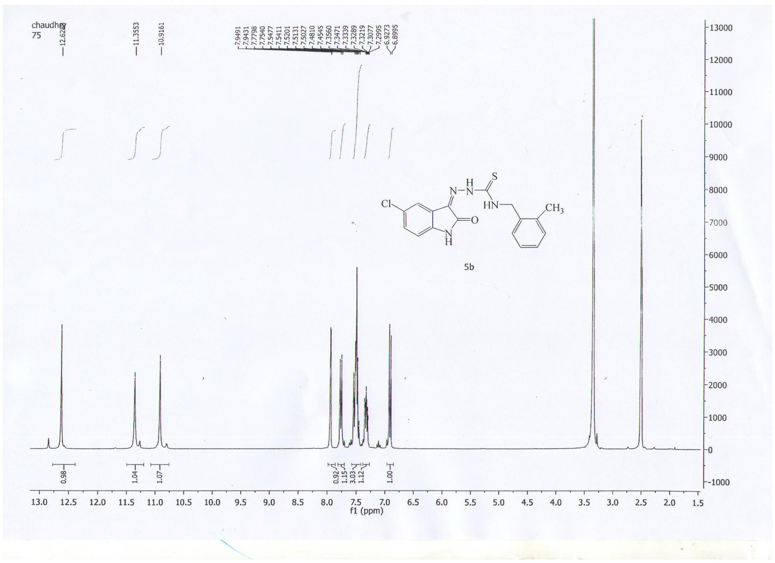

¹H-NMR spectrum of 5e
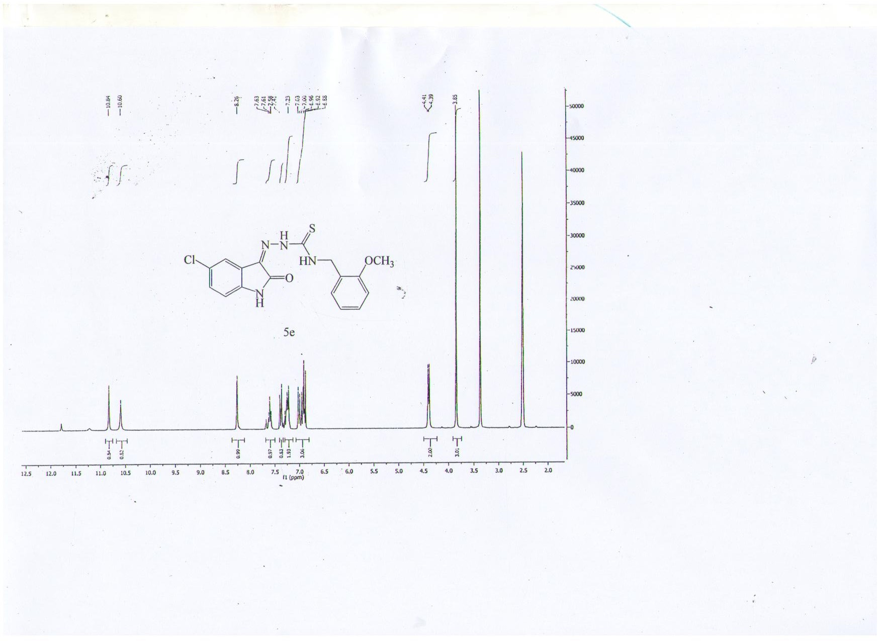

¹H-NMR spectrum of 5h
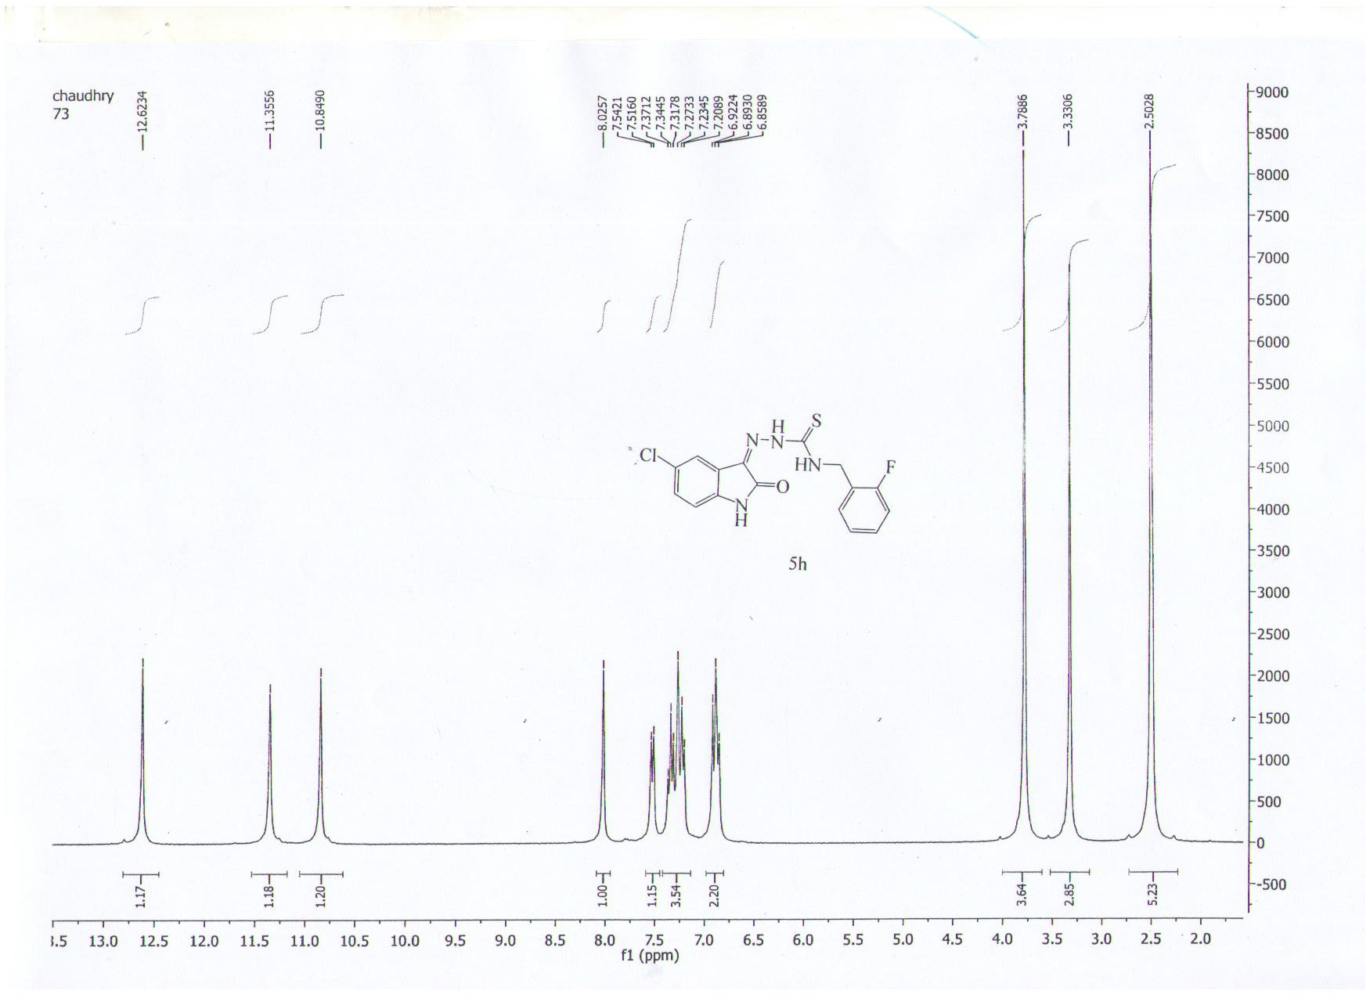

¹H-NMR spectrum of 5k
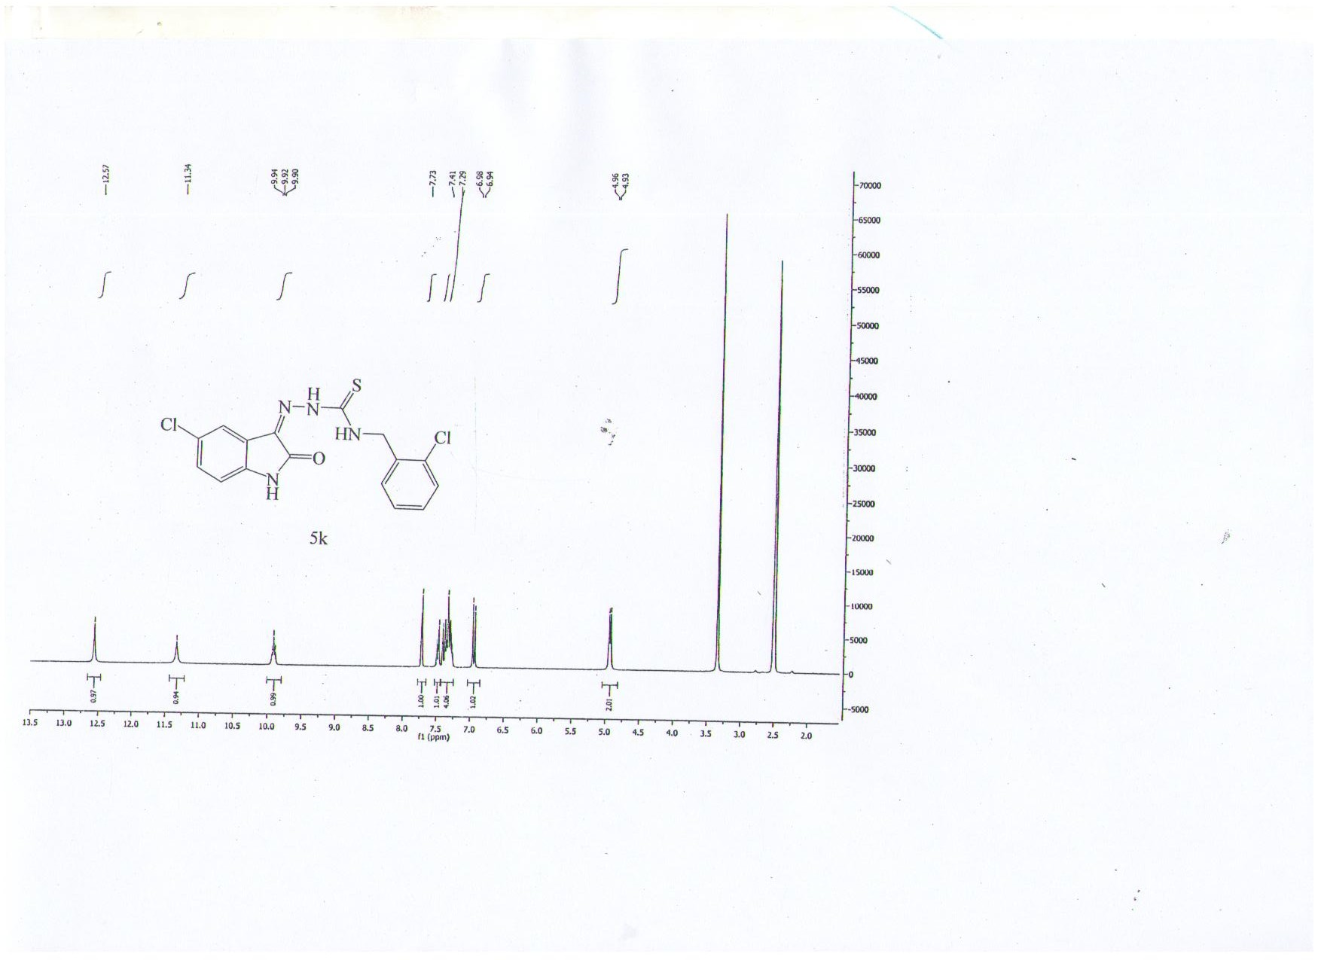

¹H-NMR spectrum of 5l
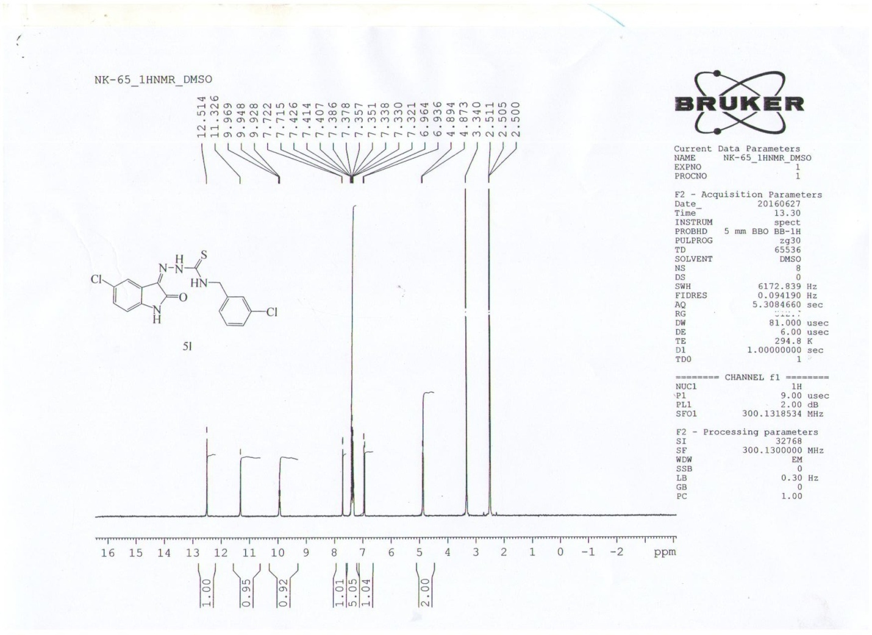

¹H-NMR spectrum of 5n
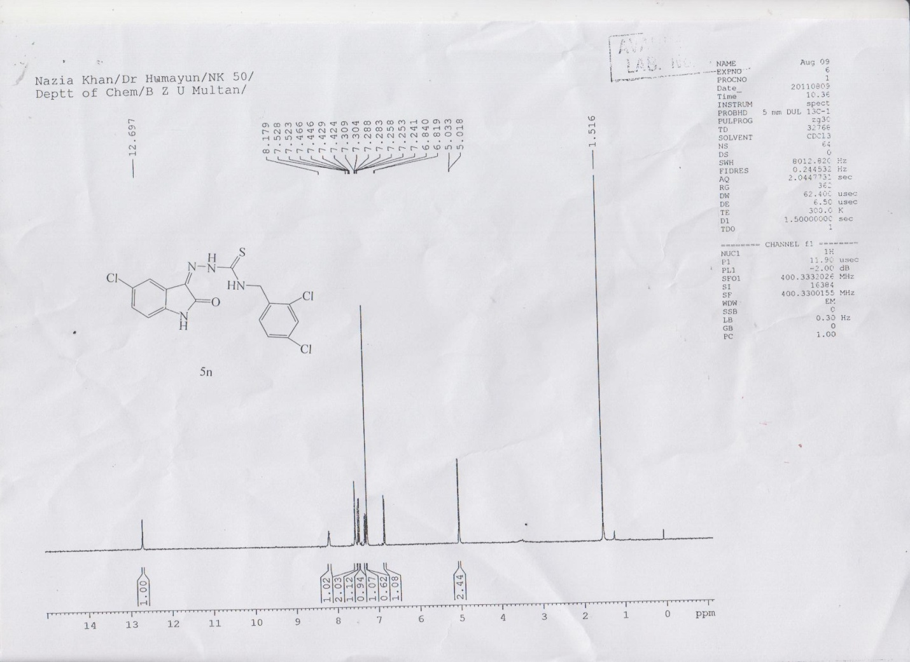

¹H-NMR spectrum of 5o
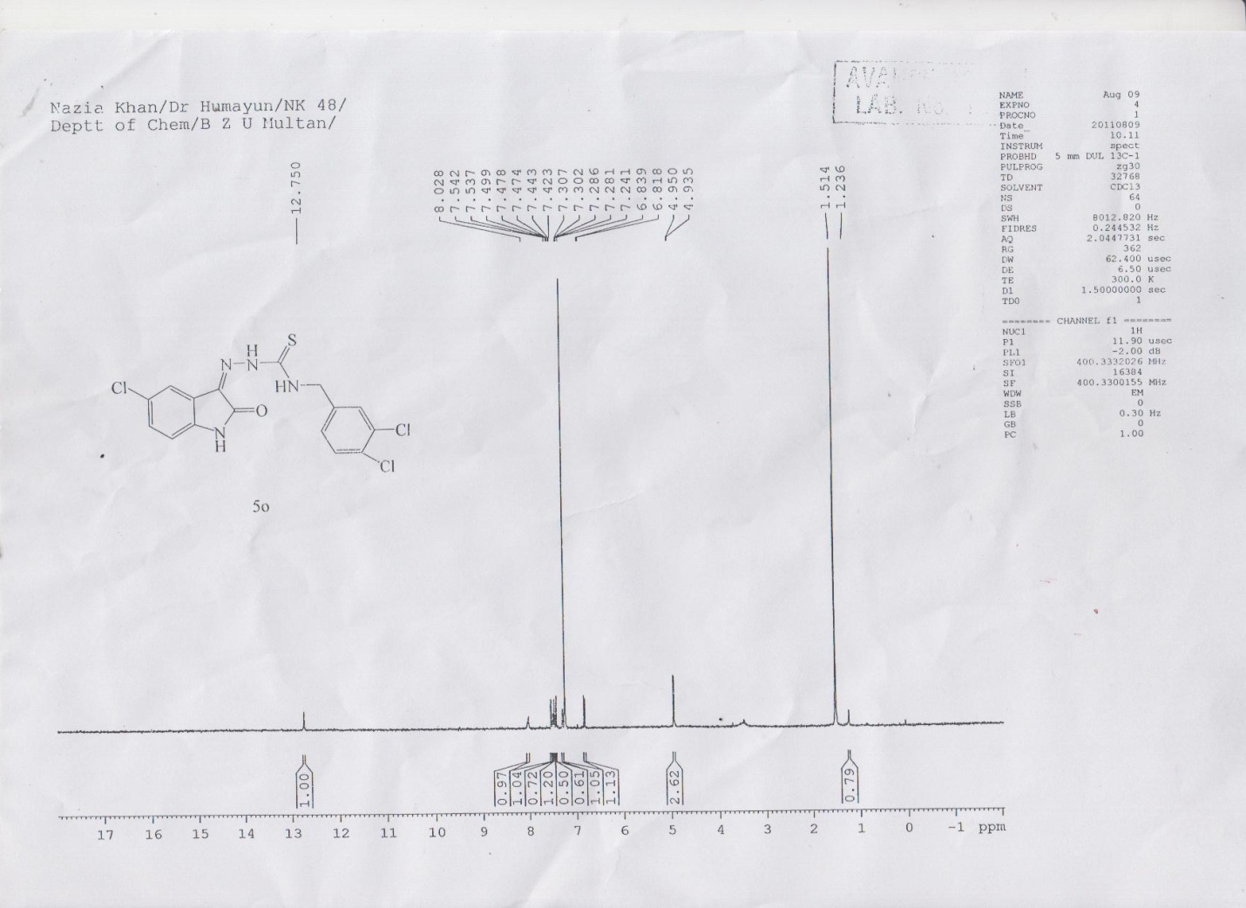

¹³C-NMR spectrum of 5b
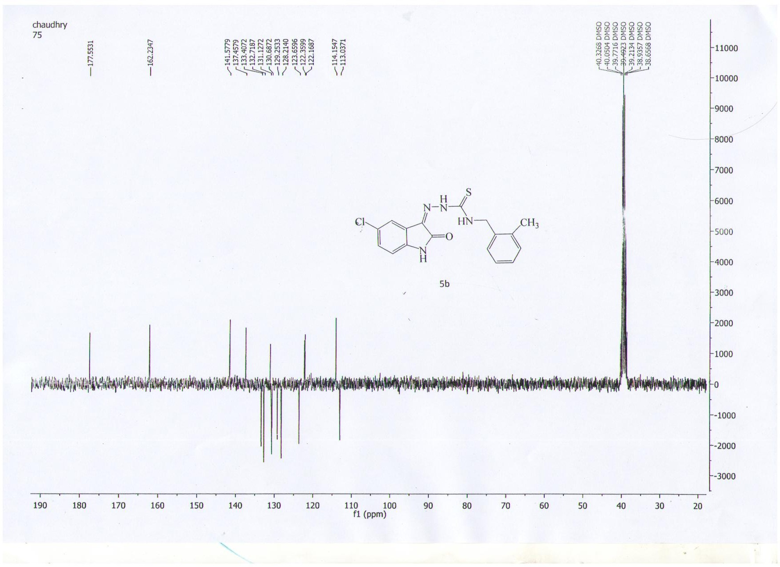

¹³C-NMR spectrum of 5e
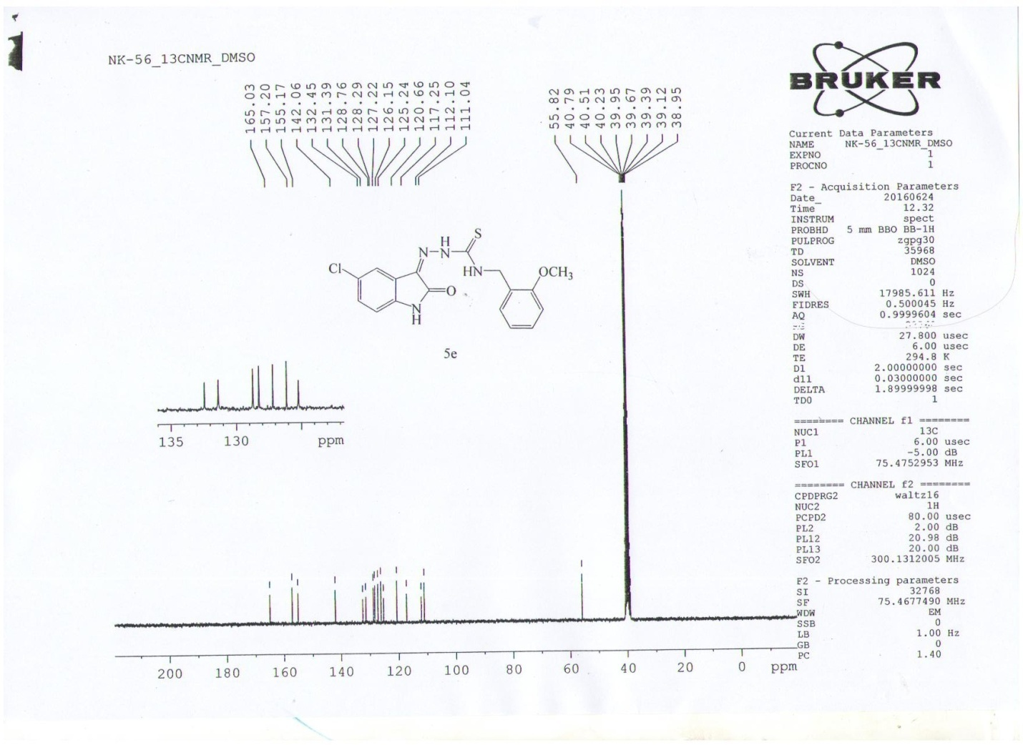

¹³C-NMR spectrum of 5h
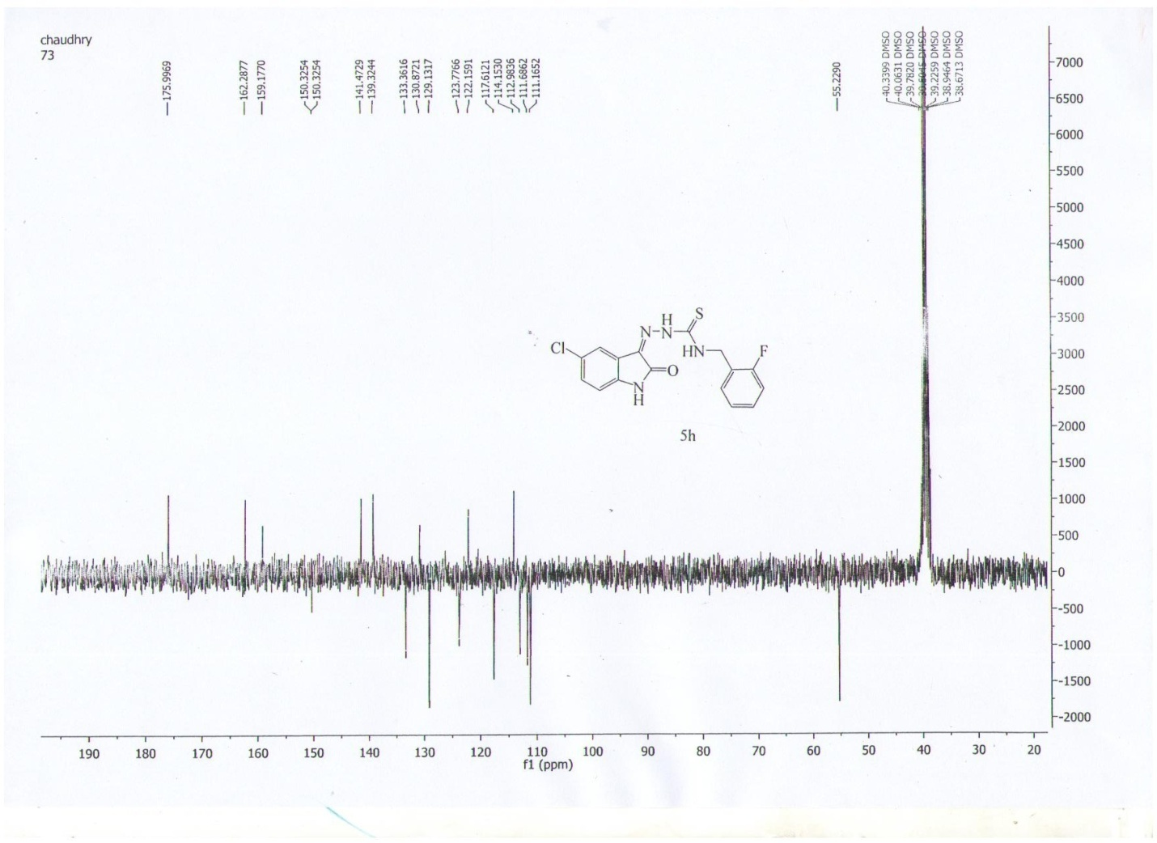

¹³C-NMR spectrum of 5k
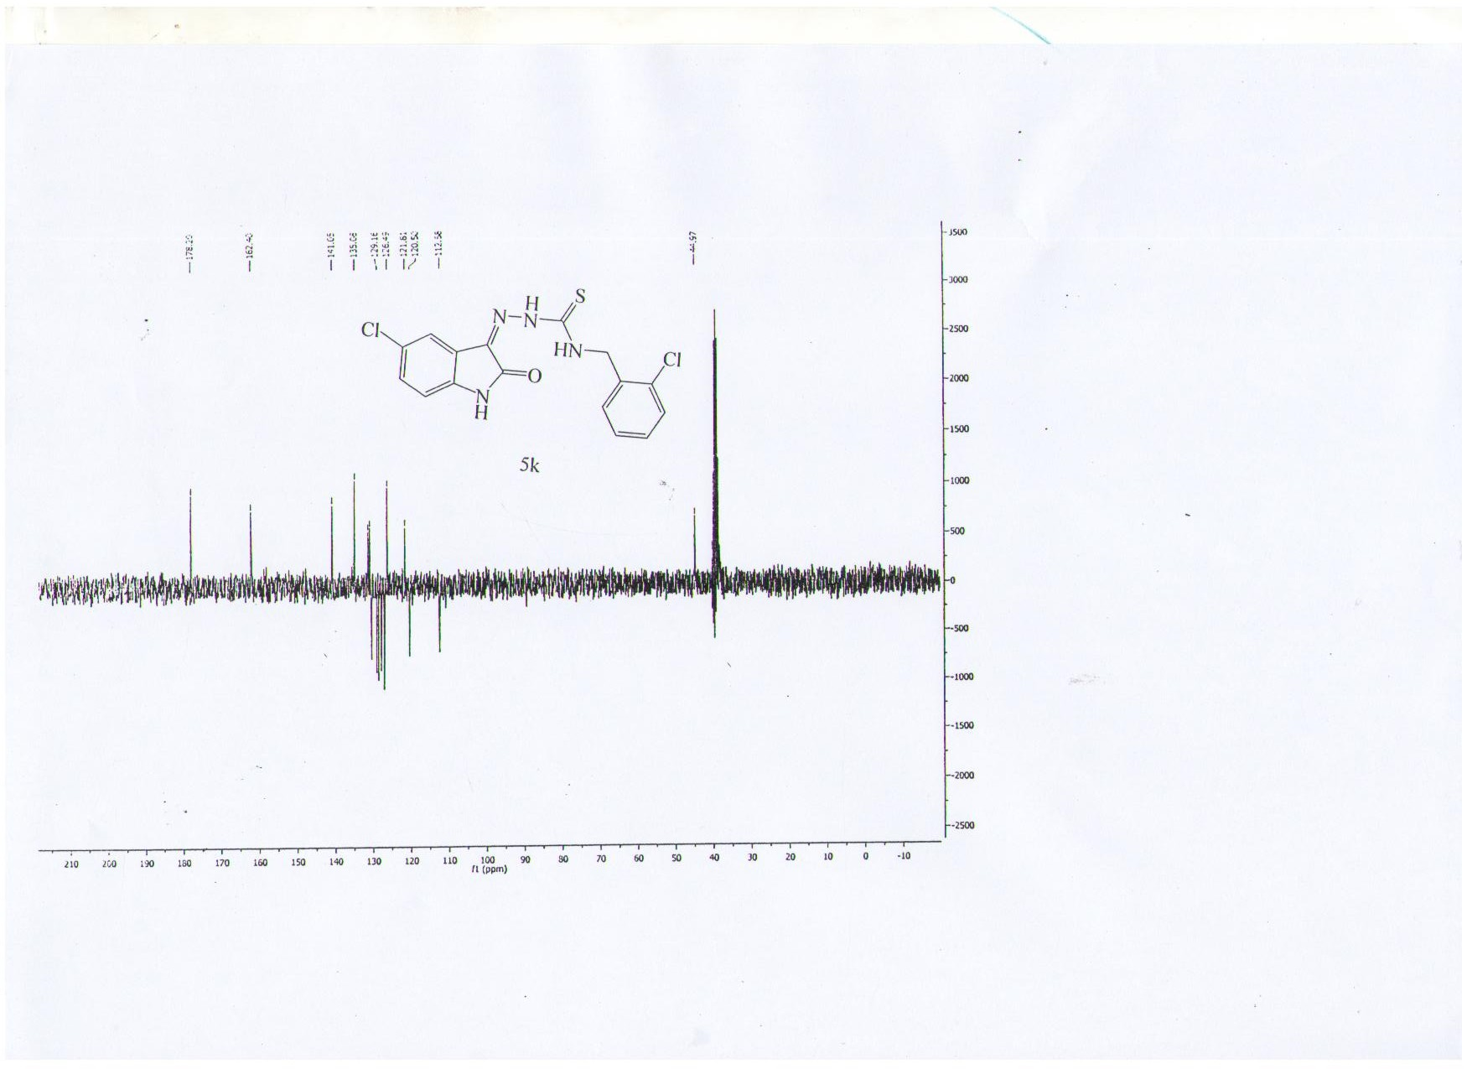

¹³C-NMR spectrum of 5l
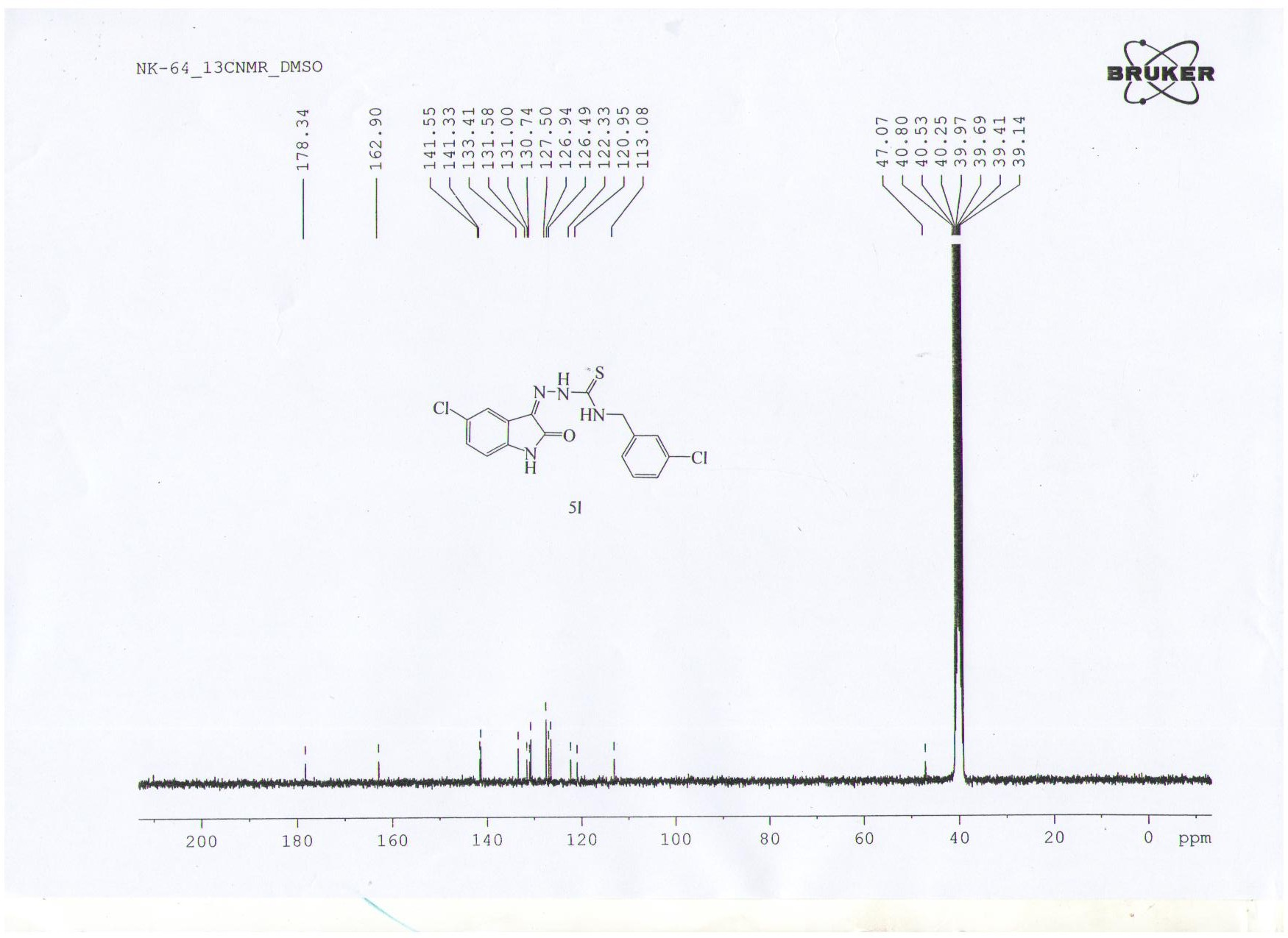

¹³C-NMR spectrum of 5n
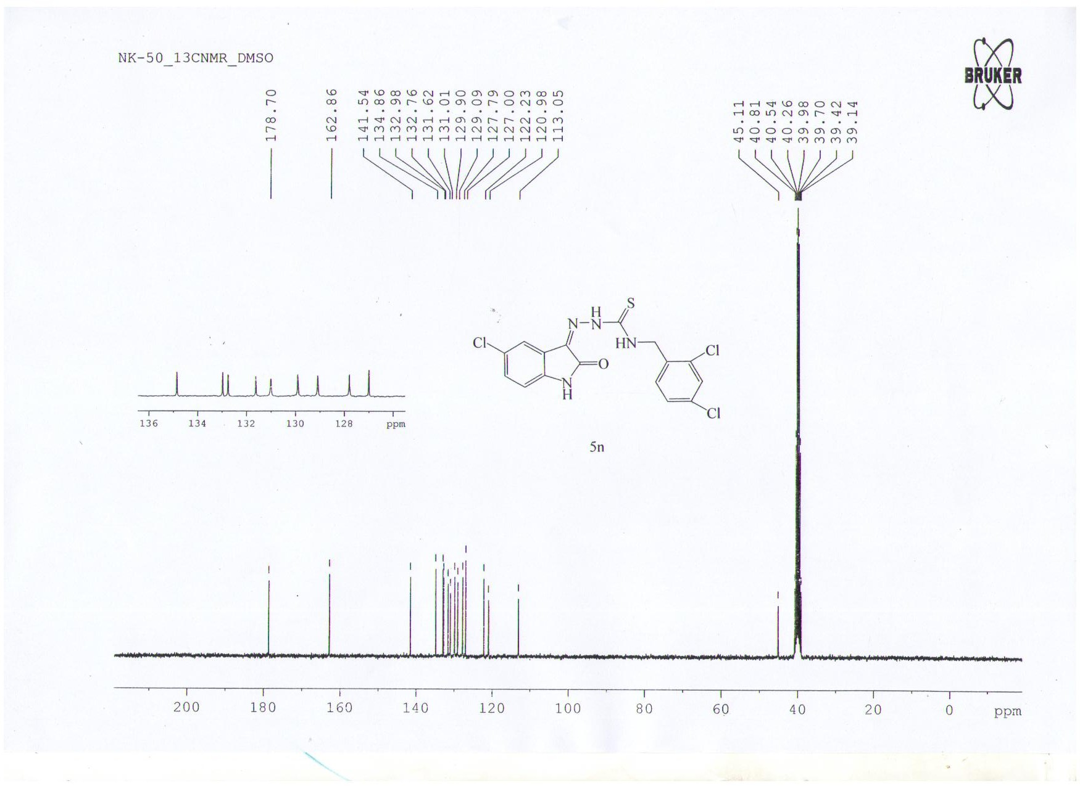

¹³C-NMR spectrum of 5o
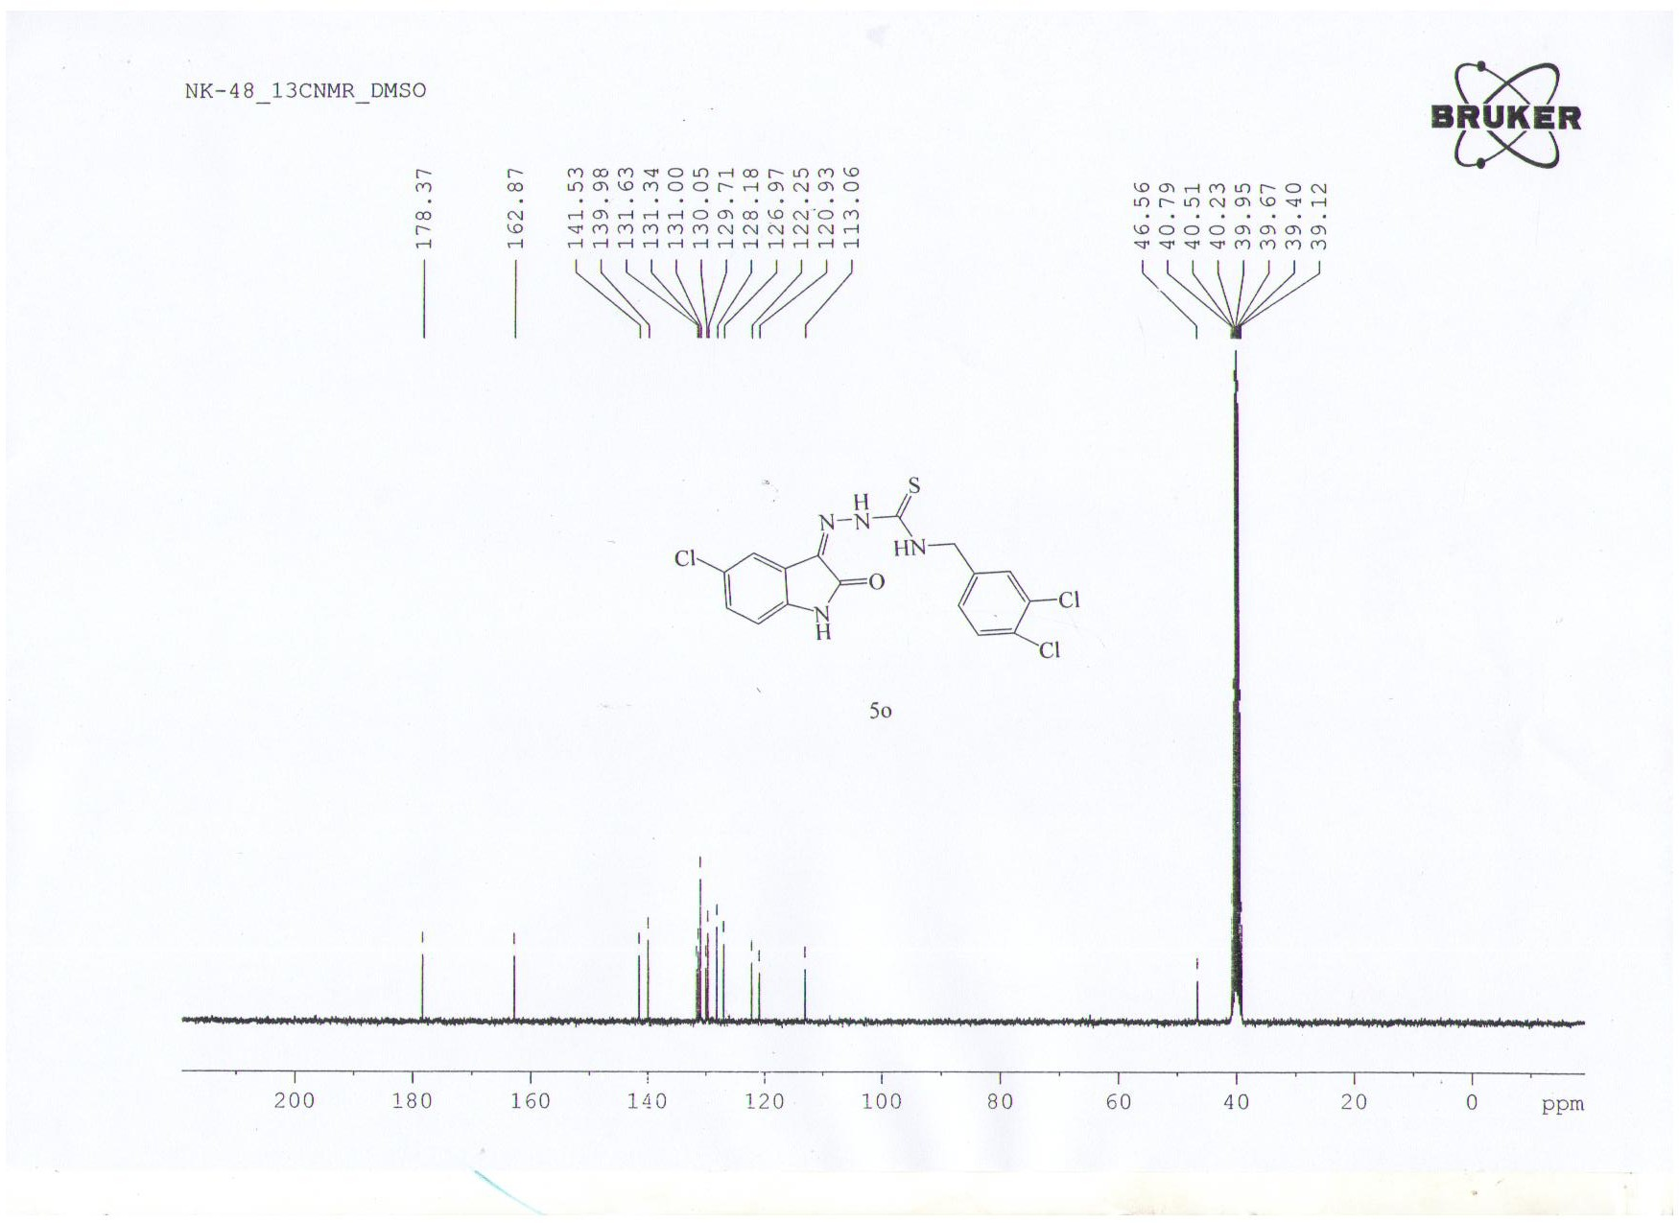

Mass spectrum of 5b
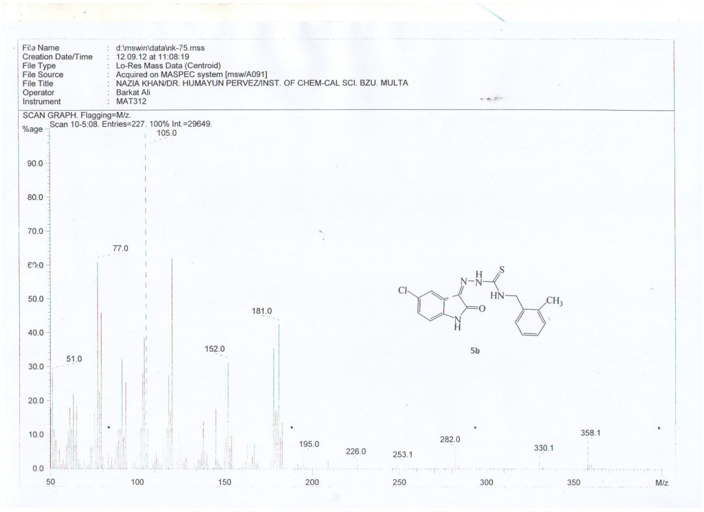

Mass spectrum of 5e
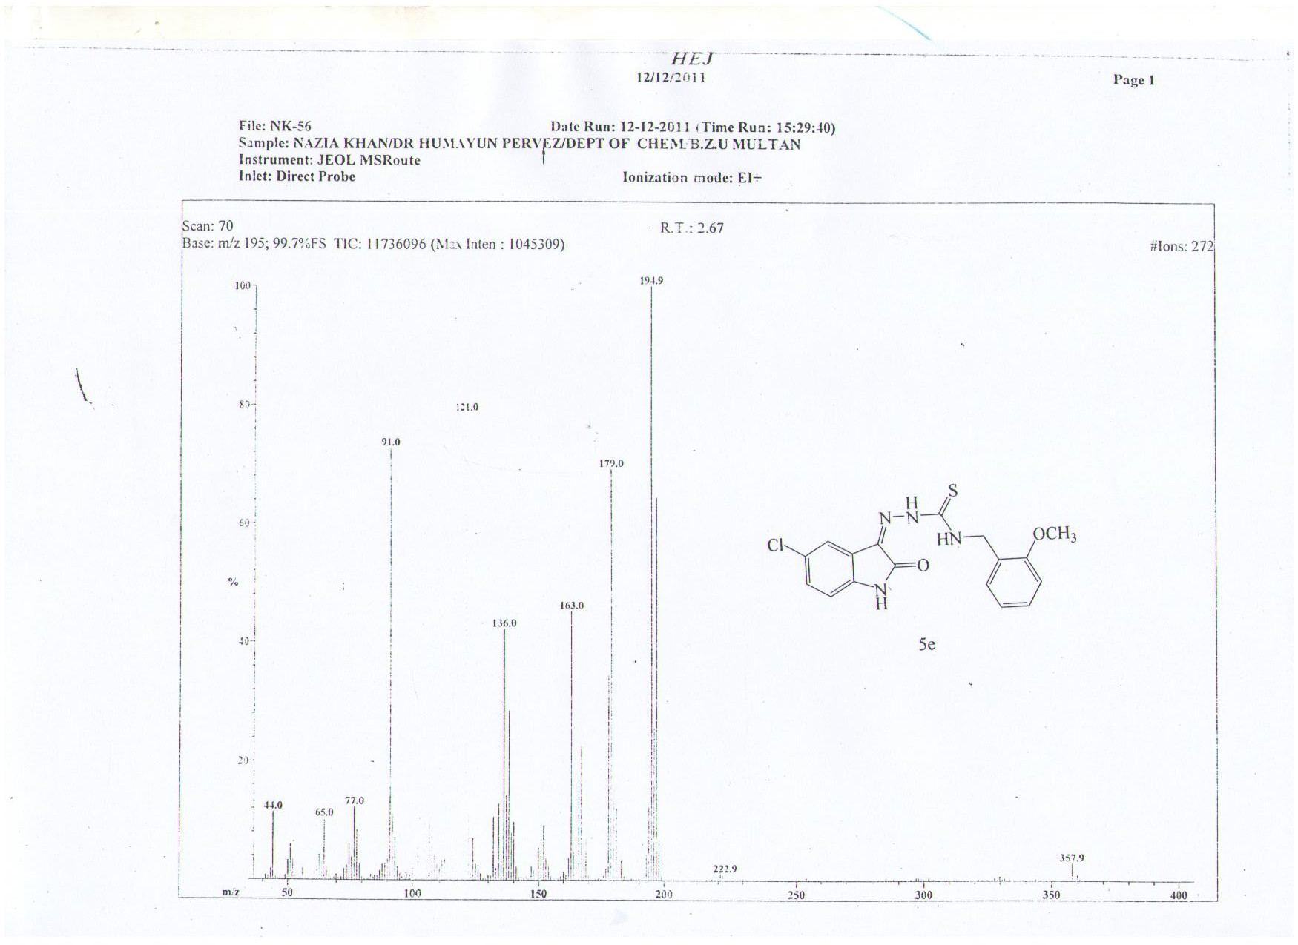

Mass spectrum of 5h
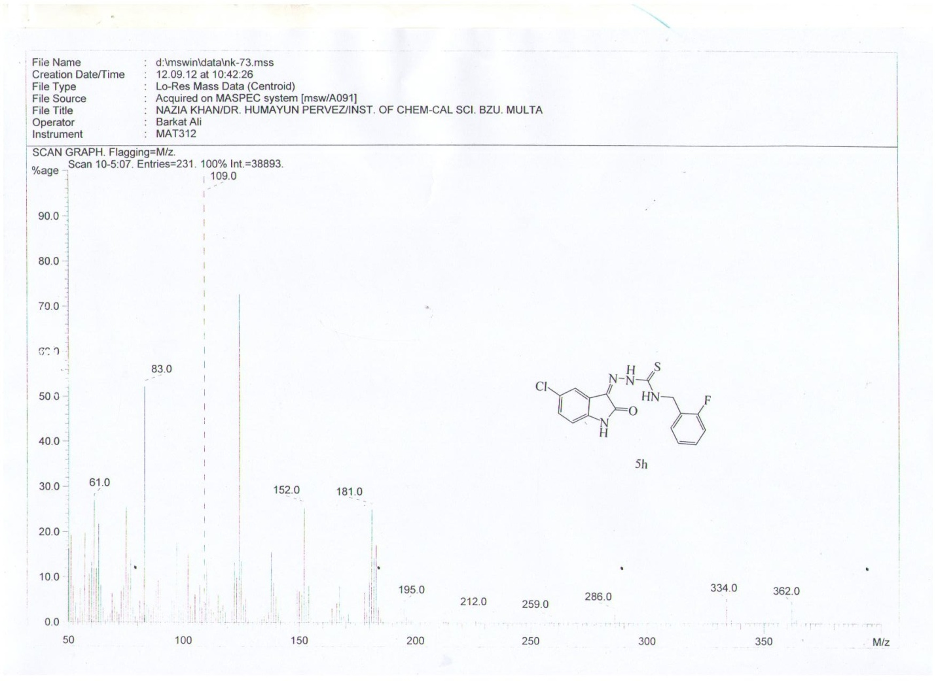

Mass spectrum of 5k
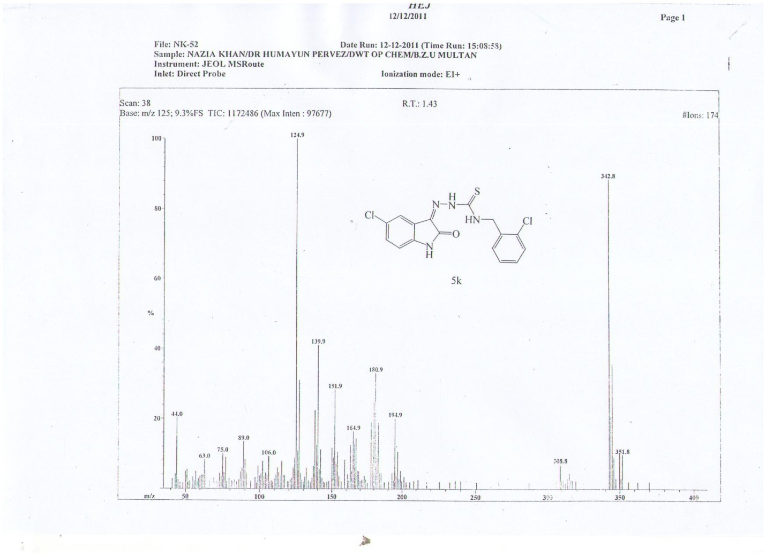

Mass spectrum of 5l
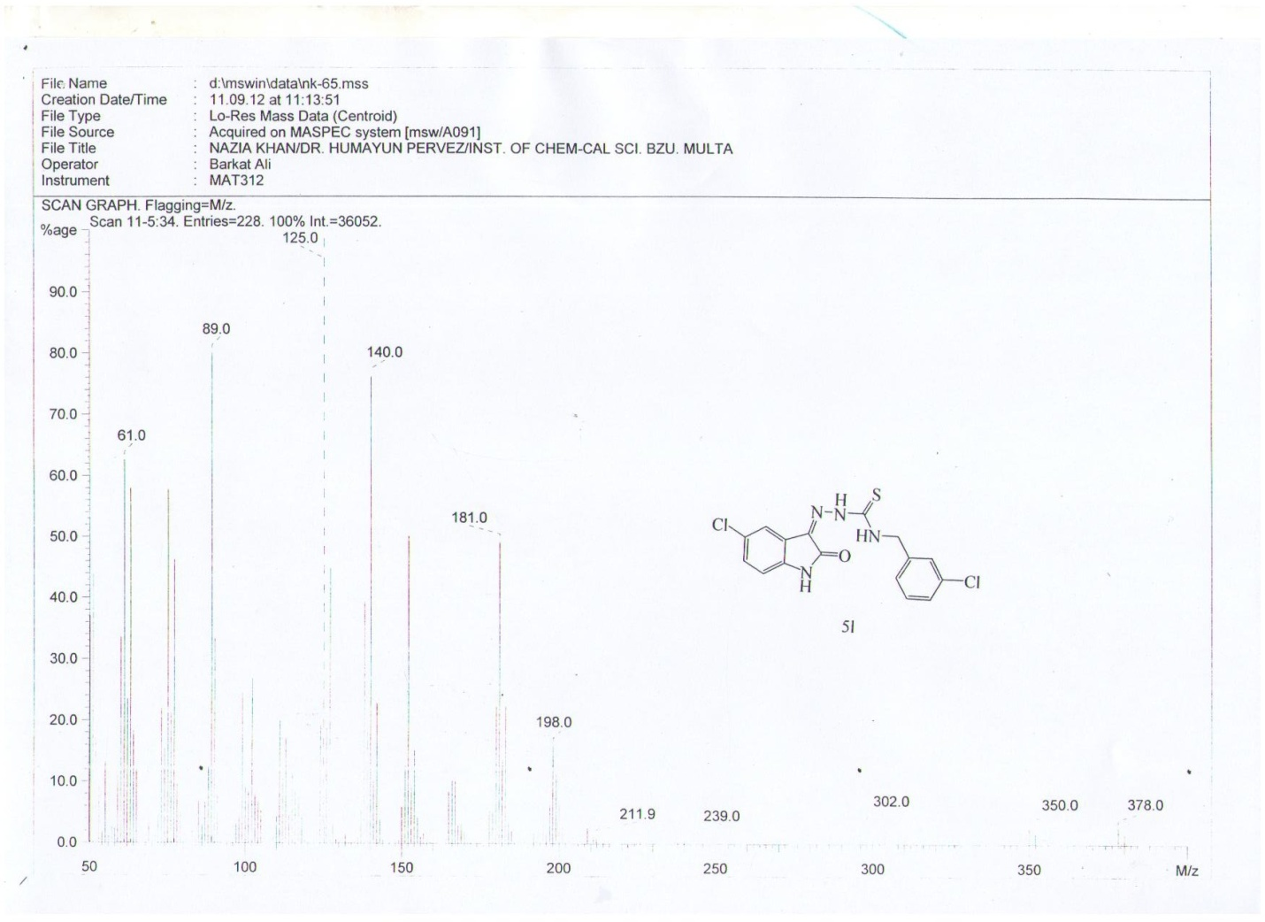

Mass spectrum of 5n
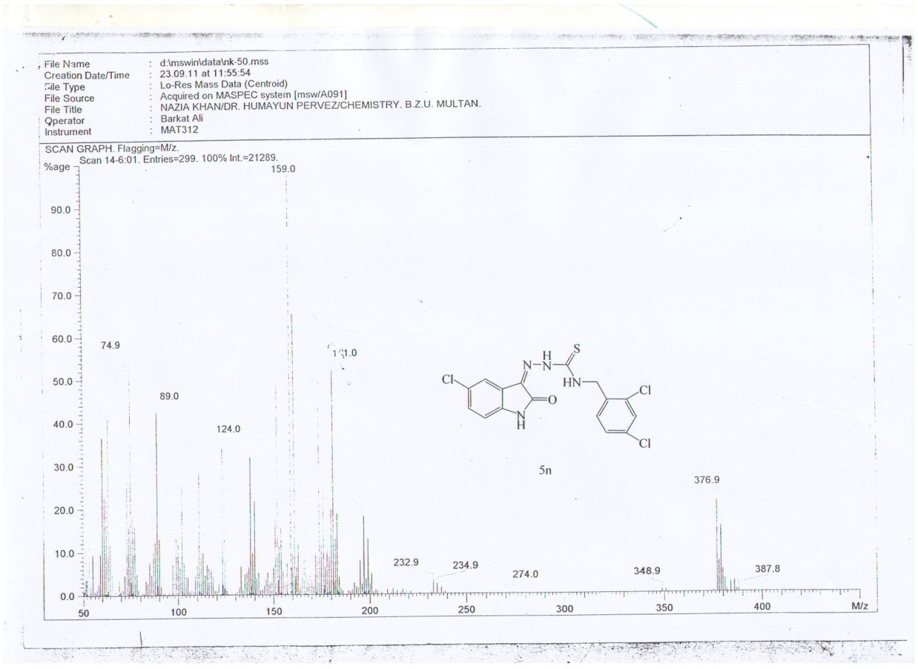

Mass spectrum of 5o
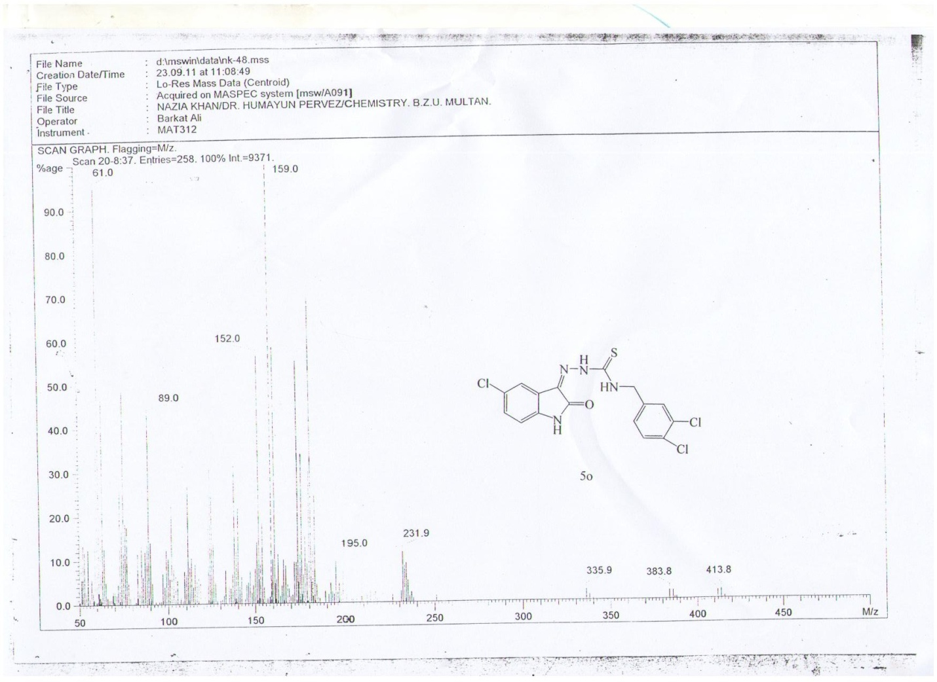

References
1. Balasubramanian, A.; Ponnuraj, K. Crystal structure of the first plant urease from jack bean: 83 years of journey from its first crystal to molecular structure. Journal of Molecular Biology, 2010, 400(3), 274-283.
2. P. Labute, Protonate 3D; Chemical Computing Group, 2007. http://www.chemcomp.com/journal/proton.htm.
3. MOE (The Molecular Operating Environment) Version 2014.0901. Chemical Computing Group, (CCG) http://www.chemcomp.com/MOEMolecular_Operating_ Environment.htm.
4. LeadIT, 2014, at http://www.biosolveit.de/LeadIT/.
5. Accelrys Software Inc. Discovery Studio Modeling Environment, Release 4.0; Accelrys Software: San Diego, CA, 2013.
6. Schneider, N.; Lange, G.; Hindle, S.; Klein, R.; Rarey, M. A consistent description of HYdrogen bond and DEhydration energies in protein-ligand complexes: methods behind the HYDE scoring function. Journal of Computer-Aided Molecular Design, 2013, 27(1), 15-29.

