Graphical Abstract

Synthesis and in vitro bio-activity evaluation of N4-benzyl substituted 5-chloroisatin 3-thiosemicarbazones as urease and glycation inhibitors
H. Pervez, N. Khan, J. Iqbal, S. Zaib, M. Yaqub, M. M. Naseer

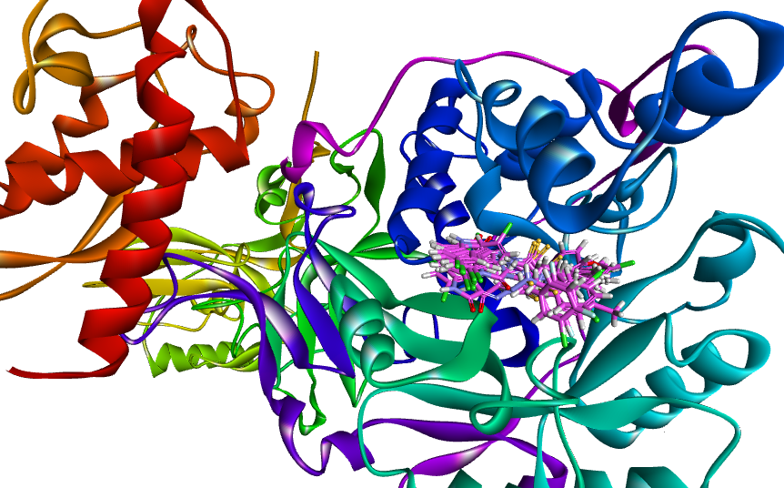
Common binding modes of all the inhibitors inside the active site pocket of the urease enzyme

