Graphene Oxide/Co₃O₄ Nanocomposite: Synthesis, Characterization, and Its Adsorption Capacity for Removal of Organic Dye Pollutants from Water

Kolsoum Pourzare, Saeed Farhadi*, Yaghoub Mansourpanah
ªDepartment of Chemistry, Lorestan University, Khoramabad68151-44316, Iran
*Corresponding author: Tel: +98 06633120611, fax: +98 06633120618.
Email address: sfarhadi1348@yahoo.com (S. Farhadi)
___________________________________________________________________________
Abstract
In this work, graphene oxide/Co₃O₄nanocompositehas been synthesized via hydrothermal decomposition of the [Co(en)₃](NO₃)₃complex onto graphene oxide nanosheets. The as-prepared nanocomposite (denoted as GO/Co₃O₄)was structurally characterized by X-ray diffraction (XRD), Fourier transform infrared spectroscopy (FT-IR),Raman spectroscopy, energy dispersive X-ray spectroscopy (EDS), transmission and scanning electron microscopies (TEM and SEM) and magnetic measurements. The results demonstrated the successful immobilization of Co₃O₄ nanoparticles with an average diameter size of around 12 nm on the surface of graphene oxide nanosheets. The adsorption performance of GO/Co₃O₄nanocomposite was investigated towards different organic dyes in aqueous solutions. The results displayed that the adsorption rate of the GO/Co₃O₄nanocompositecan be achieved up to 98% for methylene blue (MB) within 12 min, and 66% and 45% for Rhodamine B (RhB) and methyl orange (MO) within 40 min. The effect of various important parameters including adsorbent dosage, contact time, pH, and temperature on the adsorption process were investigated in detail. The equilibrium adsorption data was better fitted by Langmuir isotherm. Besides, adsorption kinetics is well-modeled using pseudo-second-order model. Different thermodynamic parameters indicated that the adsorption process was physisorption and spontaneous. The findings of the present work highlight the fast and facile fabrication of GO/Co₃O₄ and its application for the efficient removal of MB from wastewater.
Keywords: Graphene oxide nanosheets, Co₃O₄ nanoparticles, Hydrothermal decomposition, Nanocomposite, Adsorption performance, Organic dyes.
___________________________________________________________________________
- Introduction
Many chemical industries such as paper, plastics, cosmetics, leather, printing, food, textile and so forth use dyes for coloring their products and release the various types of dye into water bodies, which preventing the penetration of sunlight, retarding photosynthetic reactions, and affecting aquatic life.¹⁻⁴ Most dye molecules have an aromatic ring in their structure, which makes them highly toxic, nonbiodegradable, carcinogenic, and mutagenic to both human beings and aquatic life.⁵ Hence, it is essential to remove or to minimize dyes to permissible levels, without disturbing the quality of water to can be used again them for diverse industrial and agricultural applications.⁶ A wide array of wastewater treatment techniques including membrane filtration, centrifugation, photodegradation, chemical coagulation, and adsorption have been developed for separation of dyes from wastewater.
Among these technologies, adsorption is the most widely used method due to its versatility, wide applicability, and economic feasibility.⁷Activated carbon, clays, zeolites, polymeric materials, and etc., have been applied to adsorb dyes from wastewater. However, these adsorbents suffer from either low adsorption capacities or separation trouble. Hence, the adsorbent with both characters is immensely expected in both science and technology societies.⁸ In material science research, a great deal of attention has been focused on graphene, a carbon allotrope with a two-dimensional sheet-like structure which possesses many unique features such as high electrical conductivity, mechanical flexibility, chemical and thermal stability, high surface functionality, and large surface area.⁷ Due to strong more interplane interactions, graphene, and its derivatives tend to aggregate in a layer-by-layer manner which as a result, a significant part of their surface area will be lost. The use of the dispersion of single-layered GO as an absorbent allows one to utilize the surface area to the utmost extent, but these GO sheets are difficult to collect from water.⁹This problem can be solved via chemical modification graphene by the process of attaching organic groups or inorganic particles onto graphite oxide (GO) surfaces which can result not only in physical separation of the resultant functionalized graphene sheets but also in possible formation of a stable dispersed phase of graphene in the synthesis process¹⁰⁻¹² and keep the surface area and pore volume at a high level which is required for applications such as adsorption processes and photocatalysis.¹³ Recently, many types nanoparticles have been deposited on GO sheets such as Fe₂O₃, ZnO, Fe₃O₄, TiO₂, etc. For instance, Amino-functionalized Fe₃O₄ (NH₂-Fe₃O₄) particles were deposited on the graphene oxide sheets and were used to adsorb Methylene Blue (MB) and Neutral Red (NR) from aqueous solution by Xie et al.¹⁴The adsorption test of dyes demonstrated that it only takes 30 min for MB and 90 min for NR to attain equilibrium. Luo's group fabricated magnetic cyclodextrin/graphene oxide (MCGO) materials and investigated their application as excellent adsorbents for methylene blue.¹⁵The MCGO demonstrate extremely fast MB-removal from wastewater with high removal efficiency within 50 min. Li et al. prepared a magnetic CoFe₃O₄-functionalized graphene sheet (CoFe₃O₄-FGS) nanocomposite via a facile hydrothermal method and used it to adsorb methyl orange.¹⁶ The observed maximum adsorption capacity at 10 mg L⁻¹ initial concentration was 71.54 mg g⁻¹. In another study, Fan et al. prepared a magnetic chitosan–GO (MCFO) nanocomposite through the covalent bonding of chitosan to the surface of Fe₃O₄ nanoparticles followed by covalent functionalization of GO with magnetic chitosan and acted as a good adsorbent to adsorb MB from aqueous solutions.¹⁷Yao's group also fabricated Fe₃O₄/SiO₂/GO nanocomposite through a covalent bonding technique and served as an adsorbent for the removal of MB from aqueous solution.¹⁸The maximum MB adsorption capacities were 97, 102.6, and 111.1 mg g⁻¹at 25, 45, and 60 ^{º}C, respectively.
Spinel-type cobaltoxide (Co₃O₄) is an important magnetic p-type semiconductor oxide and its synthesis and properties have attracted considerable attention owing to prominent applications in heterogeneous catalysis, energy storage and conversion, sensors, and devices, etc.¹⁹⁻²⁵For this reason, various nanostructures of Co₃O₄ such as nanoparticles, nanoplates, nanorods, nanotubes, nanocubes, nanodiscs, nanoflowers and hollow microspheres structures have been prepared by using different synthesis methods.²⁶⁻³²To the best of our knowledge, the investigation of adsorption properties of GO/Co₃O₄nanocomposites have not been reported. In this study, we present a solvothermal approach for production of GO/Co₃O₄nanocomposites. The resulting products are characterized by IR, FESEM, EDS, TEM, XRD and VSM and their adsorption properties were investigated for removing dye molecules from aqueous solutions.
2. Experimental
2.1. Materials
Methyl orange (C₁₄H₁₄N₃NaO₃S, abbreviated as MO), methylene blue (C₁₆H₁₈ClN₃S, abbreviated as MB), and Rhodamine B (C₂₈H₃₁ClN₂O₃, abbreviated as RhB), Cobalt (II)-chlorid hexahydrate, and all other materials and solvents were purchased from Merck comical Co. All chemical materials were analytical grade and used as received without further purification.
2.2. Synthesis of Co₃O₄Nanoparticles.
First, the [Co(en)₃](NO₃)₃ complex was prepared via a simple reaction of an aqueous solution of [Co(en)₃]Cl₃ with concentrated nitric acid according to the reported method.³³ To prepare Co₃O₄ nanoparticles, the [Co(en)₃](NO₃)₃complex was decomposed at 250 ºC for 1 h in an electric furnace under ambient air. The decomposition product was collected for characterization.
2.3. Synthesis of Graphene Oxide/Co₃O₄ Nanocomposite (GO/Co₃O₄)
Graphene oxide (GO) was prepared by the oxidation of graphite powder under acidic conditions according to the modified Hummers method using a mixture of H₂SO₄, NaNO₃, and KMnO_{4.} ^{34, 35}For the synthesis of GO/Co₃O₄nanocomposite, 50 mg GO was dispersed into 20 mLof deionized water by sonication for 1 h to achieve uniform dispersion GO. 100 mg of the as-prepared Co₃O₄ nanoparticles were dispersed in deionized water for 15 min and it was gradually added to the GO suspension. The mixture was sonicated for 30 min and transferred into an autoclave for hydrothermal treatment at 180 °C for 24 h. The resultant product was separated by centrifugation and washed with deionized water and dried in an oven at 60 ˚C for 12 h.
2. 4. Methods of Characterization
Fourier-transform infrared spectra were obtained on Shimadzu FT-IR 8400S (Japan) with temperature controlled high sensitivity detector (DLATGS detector) in the scan range of 500–4000 cm⁻¹ using KBr pellet. The XRD patterns were obtained on a Rigaku D-max C III, X-ray diffractometer using Ni-filtered Cu Ka radiation (λ = 1.5406 Å) and the scanning angle ranged from 15º to 85º of 2θ for the phase determination samples. Optical absorption spectra of dyes were obtained from a Cary 100 UV-Vis spectrophotometer in the wavelength range of 200-800 nm. A vibrating sample magnetometer (VSM, Magnetic Daneshpajoh Kashan Co., Iran) was employed to measure the magnetic parameter at room temperature. The particle size was observed by a transmission electron microscope (Philips CM10) at the accelerating voltage of 100 kV. SEM images were obtained from MIRA3 TESCAN Field Emission Scanning Electron Microscope equipped with Energy Dispersive X-ray analyzer (EDX) for the elemental analysis of the sample.
2.5. Adsorption Tests
Adsorption experiments were performed by using 30 ml solution of known MB concentration and varying the amount of GO/Co₃O₄ as the adsorbent from 10 to 30 mg in 40 min. The initial pH of MB solution was adjusted to values in the range of 4-12 by dropwise adding 0.1 mol/L NaOH or 0.1 mol/L HCl solutions. After adsorption, the solution was separated from the precipitate by centrifuge at 5000 rpm for 5 min. The concentrations of the dye in the solutions after different time intervals were determined with a UV-visible spectrophotometer at the wavelength of 664 nm (λ_{max}). The amount of MB adsorbed onto the GO/Co₃O₄nanocomposite (qt) and its removal rate (R%) were calculated by the following equations:
q_{t} = (C₀ − C_{t})V/m, R% = (C₀ – C_{t})100/C₀ = (A₀ – A_{t})100/A₀
where C₀ and C_{t} (mg/L) are the liquid-phase concentrations of dye at initial and at time t, respectively, V (L) is the volume of the solution and m (g) is the mass of the used adsorbent.
A₀ and A_{t} represented the absorbance of MB before and after the adsorption.
3. Results and Discussion
3.1. Characterization of the GO/Co₃O₄ Nanocomposite
The FT-IR spectra of samples are shown in Figure 1. For the starting [Co(en)₃](NO₃)₃complex, the characteristic stretching bands of NH₂, CH₂, NO₃ are appeared at about 3100–3400, 2951 and 1380 cm⁻¹.^{36,37} As can be seen in the spectrum of Co₃O₄ (Figure 1(b)), all the bands associated with the complex obviously disappeared when the complex is decomposed at 250 ^{º}C and only two strong bands at 569 and 663cm⁻¹ were observed which confirm the spinel structure of Co₃O₄. The later band is attributed to the stretching vibration mode of Co(III)–O and later band can be assigned to the CO(II)–O bond.³⁸In the GO spectrum (Figure 2(c)), the obvious characteristic peaks of GO can be seen, including the C=O stretching vibrations of COOH groups (1726 cm⁻¹), graphitic C=C bonds stretching vibrations (1618 cm⁻¹), O-H deformation vibrations of tertiary C-OH (1398cm⁻¹), and C-O stretching vibrations of epoxy/alkoxy groups (1026cm⁻¹).^{37,43} Additionally, the broad absorption at 3100-3700 cm⁻¹ is attributed to the O-H stretching vibration.⁴³ However, as can be seen in Figure 2(d), the peak of C=O disappears and the peak intensity of O-H and C-O decreases after hydrothermal treatment, which indicates the removal of oxygen-containing functional groups and the partial reduction of GO, leading to the formation of reduced graphene oxide (rGO) in the composite, indicating the restoration of a graphitic structure in graphene.³⁹ Moreover, the two strong absorption peaks in the spectrum of the GO/Co₃O₄ sample at lower frequencies (in the 400-600 cm⁻¹ range) can be assigned to the stretching vibrations of the Co-O bonds of Co₃O₄ phase.³⁷ This result confirms the formation of the GO/Co₃O₄nanocomposite.

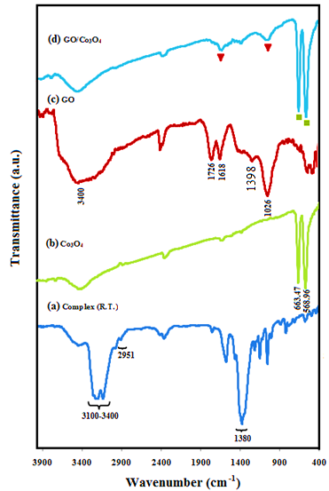
Figure 1.FT-IR spectra of (a) the [Co(en)₃](NO₃)₃ complex, (b) Co₃O₄, (c) GO, and (d) GO/Co₃O₄.

In order to further identify the chemical composition and structure of the prepared samples, powder X-ray diffraction (XRD) was conducted. Figure 2 displays the XRD patterns of the Co₃O₄and GO/Co₃O₄nanocomposite.The diffraction patterns in Figure2(a) and (b) are similar and can be indexed to the Co₃O₄phase (JCPDS No. 78-1970).Moreover, no characteristic diﬀraction peaks for GO are observed in the pattern indicating that the GO nanosheets do not stack during the synthesis process. The reason can be attributed to that the Co₃O₄nanoparticles anchored on the surfaces of GO prevent the exfoliated GO nanosheets from restacking. However, a broad characteristic peak for grapheme nanosheets at about 2θ =23° appeared, suggesting that the GO are reduced to graphene during the formation of nanocomposite.³⁴The average domain size ofCo₃O₄ nanoparticles was calculated to be approximately 15 nm by the Scherrer formula: ⁴⁰ D_{XRD} = 0.9λ/(β cos θ), where D_{XRD} is the average crystalline size, λ, β, and θ are the wavelength of Cu Kα radiation, the full width at half maximum of the diffraction peak, and the Bragg angle, respectively.
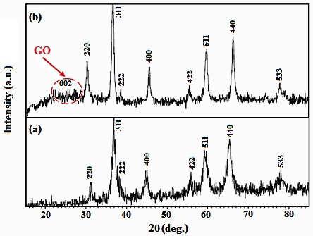
Figure 2. XRD patterns of (a) Co₃O₄and (b) GO/Co₃O₄nanocomposite.

Raman spectroscopy is a powerful tool to characterize the significant structural changes of GO during the composite synthesis. Figure 3 presents the Raman spectra of GO and GO/Co₃O₄nanocomposite. According to the Raman spectrum of GO in Figure 3(a), the obvious peaks at 1318 and 1584 cm⁻¹ can be attributed to the disordered structure (D band, sp³ carbon atoms of disorders and defects) and graphite structure (G band, sp² carbon atoms in graphitic sheets) of GO, respectively.^{32,33}In the spectrum of GO/Co₃O₄, the D and G peaks still exist, while another two obvious peaks at 477 and 683cm⁻¹ can be attributed to Co₃O₄.⁴¹ Compared to GO, it is clear that D and G bands of GO/Co₃O₄are down shifted by 10 cm⁻¹.The red shifts of the D and G bands for GO/Co₃O₄ provide evidence for the charge transfer between GO and Co₃O₄, which shows a strong interaction between GO and Co₃O₄.³⁴ The Raman spectra further confirm the successful synthesis of GO/Co₃O₄ composite.
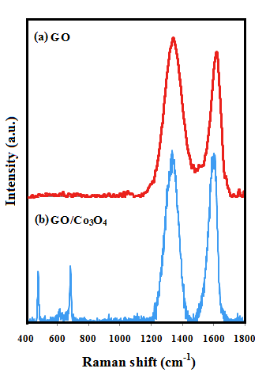
Figure 3.Raman spectra of (a) GO and (b) GO/Co₃O₄nanocomposite.
SEM images indicating the microstructural features of GO, Co₃O₄, GO/Co₃O₄nanocompositeare shown in Figure4. SEM image of pure GO in Figure 4(a) shows layered structure of GO having large stacks, possibly consisting of hundreds of grapheme oxide nanosheets. It should also be noted that the surfaces of the GO sheets are quite flat and smooth. Figure4(b) shows SEM micrograph of sphere-like Co₃O₄ nanoparticles. The SEM images of GO/Co₃O₄in Figure4(c)-(f) clearly shows graphene oxide nanosheets were successfully decorated with the Co₃O₄ nanoparticles consisting of small and elongated grains. It was found that the size of Co₃O₄ nanoparticles was in the range of 20–30 nm.As can be seen, Co₃O₄ nanoparticles deposited on the surfaces of large graphene sheets. It should also be noted that the micropores between the graphene sheets were evenly filled up with theCo₃O₄ nanoparticles as clearly seen in the images of stack edges given in Figure4(c)-(f). In opposite of pure GO, the surfaces of GO nanosheets in the nanocomposite are rough, and the edges are highly crumpled. Moreover, the graphene oxide nanosheets can prevent the aggregation of Co₃O₄ nanoparticles to a certain extent, which can be the great benefit to its adsorption ability.
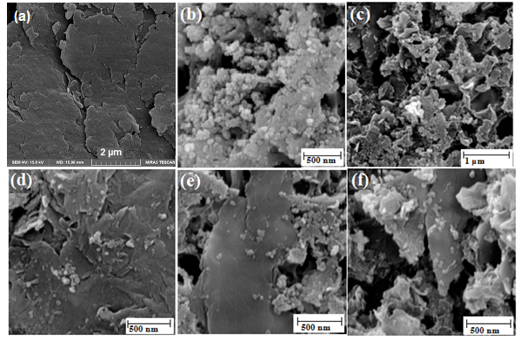
Figure 4.SEM images of (a) GO, (b) Co₃O₄, and (c)-(f) GO/Co₃O₄.

Further investigation was carried out by energy dispersive X-ray spectroscopy (EDX) to characterize the composition of the as-prepared GO/Co₃O₄nanocomposite as shown in Fig. 5. The presence of C, O and Co elements in the composites can be proved by the EDX elemental spectrum of GO/Co₃O₄. The inset of Figure 5 shows a representative SEM image of the nanocomposite with corresponding EDX elemental mappings. As presented in the inset of Fig. 5, the corresponding elemental mappings distribution shows the existence of C, O and Co. From the maps, it can be seen that the elements are uniformly distributed over the nanocomposite, confirming the homogeneity of the sample. The results further indicate that the Co₃O₄nanocrystals have been successfully grown on the surface of the GO.
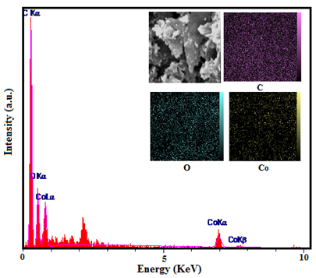
Fig. 5.EDX spectrum of the GO/Co₃O₄nanocomposite.The inset shows a representative SEM image of the nanocomposite with corresponding EDX elemental mappings

The magnetization curves of the Co₃O₄ and GO/Co₃O₄ were measured at room temperature, as shown in Figure 6. The magnetic hysteresis loop of Co₃O₄ is an S-like curve and depicts ferromagnetic behavior. The fine hysteresis loop of GO/Co₃O₄nanocomposite exhibits typical weak ferromagnetic behavior at room temperature. At 300 K the saturation magnetization (Ms), coercivity (Hc), a remanent magnetization (Mr) and squareness (Mr/Ms) for the as-received Co₃O₄nanoparticles are 1.3 emu gr⁻¹, 240 Oe, 0.2 emu gr⁻¹ and 0.153, respectively. The specific saturation magnetization (Ms) is 0.18 emu g⁻¹ for GO/Co₃O₄. The Msvalues are found to be lesser than that of pure Co₃O₄ as a result of the presence of non-magnetic GO component diluting the magnetic property.¹⁴
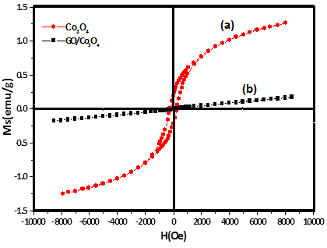
Figure 6.Magnetic hysteresis loops of (a) Co₃O₄ nanoparticles and (b) GO/Co₃O₄nanocomposite.

3.2. Adsorption Studies
The adsorption activity of GO/Co₃O₄was examined by dispensing composite powder (30 mg) into an aqueous solution (30 ml, 25 mg L⁻¹) organic dye(MB, RhB, and MO), and determining the concentrations of dye solution at given intervals by the UV-vis absorption spectra. From Figure 7, it can be clearly seen that GO/Co₃O₄ has different adsorption ability towards MB, RhB, and MO. The removal percentage of MB can be achieved to 98% in 12 min, while only 66% and 45% of RhB and MO can be removed within 40 min. To better understand adsorption ability of composite, MB was chosen as the removal target to study the adsorption performance in detail, including adsorption kinetic parameters, adsorption isotherm, and thermodynamic parameters.
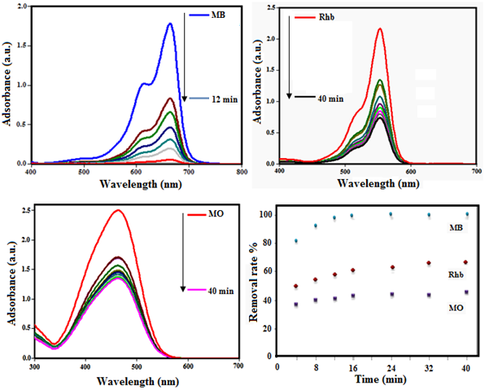
Figure 7. The adsorption capability of hybrid toward different dyes: (a) MB; (b) RhB; (c) MO. (d) The removal efficiency of MB, RhB, and MO dyes.

3.3. Kinetic studies and effects of contact time
Figure 8(a) and (b) shows UV–vis spectra of the adsorbed dye at various times and the effect of GO/Co₃O₄ adsorbent dosage on the removal of MB. It is obvious that the percentage of dye removed by the adsorbent increase during the initial stage due to most available vacant surface sites and then be slow for all the samples until a state of equilibrium is acquired after 12 min. It was also observed from Figure 8(b) that the percentage of the adsorbed dye at equilibrium increased sharply from 43% to 98% with increasing adsorbent dosage from 10 to 30 mg that it can be attributed to increase the contact area and availability more adsorption sites.
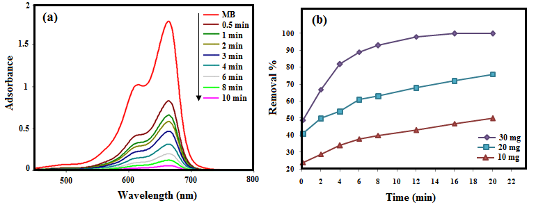
Figure 8.The adsorption rate of GO/Co₃O₄ toward MB (a), the effect of adsorbent dosege on the removal percent of MB with different dosages GO/Co₃O₄ (b).

Meanwhile, to further investigate the adsorption behavior, pseudo-second-order kinetics model was applied. The pseudo-second-order kinetic model is expressed by the following equation:
t/q_{t} = 1/k₂q_{e}² + t/q_{e}

where k₂ is rate constant of the pseudo-second-order model (g mg⁻¹ min⁻¹), q_{e} and q_{t} (mg g⁻¹) are the amounts of the dye adsorbed at equilibrium and at various times t (min), respectively. The values of k₂ and q_{e} at different amount of adsorbent can be determined from the intercept and slope of plots of t/q_{t} versus t (Figure 9) and results are given in Table 1. It is observed that the experimental adsorption capacity (q_{e,exp}: 24.63) value is close to the calculated adsorption capacity (q_{e,cal}: 26.31).Also, the large correlation coefficients (R² = 0.998) suggest that the adsorption kinetic followed the pseudo-second-order model. The values of q_{e,cal} increased from 26.31 to 38.46 mg g⁻¹, when the initial amount of adsorbent decreased from 30 mg to 10 mg, due to the affinity for the adsorption surface sites at lower adsorbent concentration.³⁹
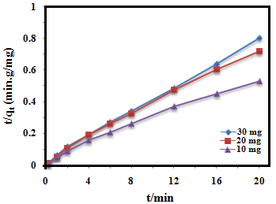

Figure 9.Pseudo-second-order kinetics plot of MB adsorption on the GO/Co₃O₄nanocomposite.

Table 1.Adsorption kinetic parameters for the adsorption of MB onto the GO/Co₃O₄.
Amount of adsorbent (mg) | k₂ (g mg⁻¹ min⁻¹)ª | q_{e}(mg g⁻¹) | R²
30 | 0.05159 | 26.31 | 0.998
20 | 0.0371 | 28.57 | 0.994
10 | 0.0193 | 38.46 | 0.989
ªPseudo-second-order kinetics

The comparative removal efficiency of MB onto the different adsorbents in the aqueous medium is presented in Table 2. It is observed that in term ofRemoval efficiency (%) and contact time, the GO/Co₃O₄nanocomposite is the most efficient adsorbent (98 % adsorption of methylene blue) compared to the other reported adsorbents. This may be due to the fact that, in the case of GO/Co₃O₄nanocomposite, the main driving force for adsorption is electrostatic forces of attraction between cationic MB moleculesand negatively charged oxygen-containing surface groups along with π–π interaction between the localized π electrons in the conjugated aromatic rings of the adsorbent and adsorbate which is comparatively stronger than the π−π interaction, electrostatic attraction, van der Waals interaction, and hydrogen bonding alone.^{42,43}
Table 2.The comparative removal efficiency of MB onto different adsorbents.
Entry | Adsorbent material | Removal efficiency (%) | C_{MB} (mg L⁻¹) | Time (min) | Ref.
1 | G–CNT hybrid | 97 | 10 | 180 | [39]
2 | (4-Hap)₄[Mo₈O₂₆]hybrid | 100 | 10 | 120 | [53]
3 | M-MWCNTs | 82 | 20 | 120 | [50]
4 | H₆P₂W₁₈O₆₂/MOF-5 | 97 | 10 | 10 | [48]
5 | H₃PW₁₂O₄₀@MIL-101 | 97.5 | 20 | 30 | [54]
6 | GO/Co₃O₄ nanocomposite | 98 | 25 | 12 | This work

3.4. Adsorption isotherm
An adsorption isotherm declares the relationship between the mass of dye adsorbed at a given temperature under equilibrium conditions per unit mass of adsorbent (qe, mg g⁻¹) and the liquid phase dye concentration (Ce, mg L⁻¹).⁴⁴In this study, to investigate the nature of electrostatic interaction of the dye molecule with GO/Co₃O₄nanocomposite, the Langmuir and Freundlich models were applied, in which the experiments were conducted by varying the amount of adsorbent from 10 to 25 mg at 25 °C while keeping the concentration of methylene blue solution constant ( 25 mg L⁻¹). The Langmuir adsorption model supposes that maximum adsorption occurs on a saturated monolayer of solute molecules and all adsorption sites on the adsorbent surface are homogeneous ⁴⁵ and is given by the following equation:
c_{e}/q_{e} = 1/k_{L}q_{m +} c_{e}/q_{m}
wherek_{L} is the Langmuir adsorption constant, Ce, q_{e}, and q_{m}, are the MB concentration at equilibrium (mg L⁻¹), the amount of MB adsorbed at equilibrium (mg g⁻¹), and the maximum adsorption capacity (mg g⁻¹), respectively. The values of q_{m} and k_{L} are computed from the slope and intercept of the linear plot of c_{e}/q_{e} versus c_{e}. The separation factor (R_{L}) is used to evaluate the favorability adsorption on the adsorbent, which is defined by the following equation:^{15, 46}
R_{L} = 1/(1+ K_{L}C₀)
The parameter can show that the isotherm is irreversible (R_{L} = 0), favorable (0 < R_{L}< 1), linear (R_{L} = 1) or unfavorable (R_{L}> 1). In this work, the value of R_{L} calculated for the initial concentrations of MB was 0.11, which illustrated that the adsorption of MB onto GO/Co₃O₄was favorable. Freundlich model is based on the assumption that the multilayer of the adsorption process occurs on a heterogeneous surface and is given by the following equation:⁴⁶
logq_{e} = 1/n log c_{e} + log k_{f}
where, K_{F}is a Freundlich constant and n is the heterogeneity factor. The isotherms based on the experimental data are shown in Figure 10(a) and (b), and the parameters obtained from linear regression were summarized in Table 3. According to the obtained data, the correlation coefficient R² in Langmuir model (0.973) is higher than that of Freundlich model (0.910), which exhibits that the Langmuir model is suitable for describing the adsorption equilibrium of MB onto GO/Co₃O₄ nanocomposite.
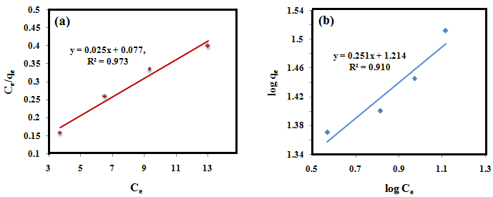Figure 10. Adsorption isotherm plots for the adsorption MB onto the GO/Co₃O₄ hybrid: (a) the Langmuir isotherm, (b) the Freundlich isotherm.

Table 3. Isotherm parameters for the adsorption of MB onto the GO/Co₃O₄.
Langmuir |  |  |  |  | Freundlich
K_{L} (L mg⁻¹) | q_{m} (mg g⁻¹) | R_{L} | R² |  | K_{F} (mg g⁻¹ (L mg⁻¹)^{1/n}) | n | R²
0.32 | 40 | 0.11 | 0.973 |  | 16.36 | 3.98 | 0.910

3.5. Effect of pH
The effect of pH on the adsorption process of the dyes is important because industrial dye wastewater is discharged at a pH that varies from the environmental pH.⁴⁷ In general, the solution pH can affect the surface charge of the adsorbent, the degree of ionization/ dissociation of dye molecules as well as dissociation of the functional groups on the active sites of the adsorbent. ^{48,49} Figure 11 shows the effect of initial solution pH on MB adsorption onto GO/Co₃O₄. The adsorption capacity and removal rate of MB were both becoming major with increasing solution pH from 4 to 12. This phenomenon can be explained that at higher pH, the surface of the GO/Co₃O₄ may become negatively charged, which enhances the positively charged MB cations through electrostatic forces of attraction. A similar trend was observed for adsorption of methylene blue onto magnetite-loaded multi-walled carbon nanotubes⁵⁰,polydopamine microspheres,⁴⁶ and magnetic cyclodextrin/graphene oxide¹⁵ or magnetic graphene oxide.⁵¹
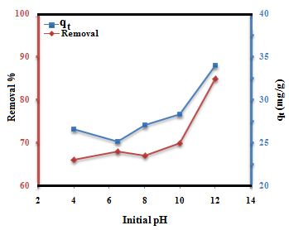
Figure 11. Effect of initial pH on adsorption capability and removal of MB onto the GO/Co₃O₄nanocomposite.

3.6. Thermodynamic parameters
Thermodynamics studies for adsorption of MB on GO/Co₃O₄ were carried out at different temperatures. The thermodynamic parameters, namely, Gibbs free energy (ΔG°), enthalpy (ΔH°) and entropy (ΔS°) are calculated using the following equation:
lnK_{L} = -∆Hº/(RT) + ∆S^{º}/R
∆G^{º}= -RT lnK_{L}
Where K_{L} (L/g) is the Langmuir constant, R is the universal gas constant (8.314 J mol⁻¹ K) and T is the absolute temperature (in Kelvin). Plotting lnK_{L} versus 1/T gives a straight line with slope and intercept equal to -∆H^{º}/R and ∆S^{º}/R, respectively (Figure 12). The positive value of ∆Hº (Table 4) shows endothermic nature of adsorption process that it is in accord with the increasing adsorption capacity collaborated with the increase of temperature.The negative value of ∆Gº for different temperatures shows the feasibility and the spontaneous nature of the adsorption. The activation energy, E_{a}, is calculated by using the Arrhenius equation:
lnk = ln A - E_{a}/RT
where k is pseudo-second-order rate constant, E_{a}, A, R, and T are activation energy, Arrhenius factor, the universal gas constant, and temperature in Kelvin, respectively. The linear plot of lnk against 1/T provides of slope equal to -E_{a}/R. The value of E_{a} ranging from 5 to 40 kJ mol⁻¹ are characteristics for physisorption while ranging from 40 to 800 kJ mol⁻¹ indicates chemisorptions.⁵² The activation energy for the adsorption of MB onto GO/Co₃O₄nanocomposite was found to be 7.37 kJ mol⁻¹, which indicates the process is governed by physical adsorption.
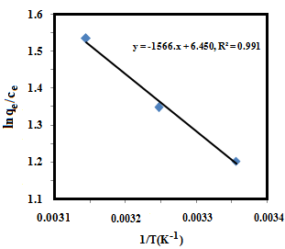
Figure 12.Van’t Hoff plots for the adsorption of MB onto the GO/Co₃O₄.

Table 4. Thermodynamic parameters for the adsorption of MB onto the GO/Co₃O₄.
T (K) | ∆Gº (KJ/mol) | ∆H^{º} (KJ/mol) | ∆S^{º} (J/mol k)
298 | -2.96 | 13.01 | 53.62
308 | -3.49 | — | —
318 | -4.03 | — | —

3.6. Recyclability of the GO/Co₃O₄nanocomposite
Recovery and regeneration ability of the adsorbent that can reduce the cost of the treatment process is crucial for its practical application. For this purpose, the used adsorbent was regenerated with ethanol solution, and the absorption-desorption cycle was repeated four times, the results are shown in Figure 13. In the first three cycles, the removal efficiencies were 98%, 95%, and 93%, respectively and then remained at 90% at the fourth cycle. These results show that the adsorbent has the potential for reusability.
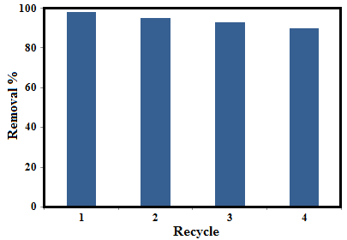
Figure 13. Effect of recycle times of GO/Co₃O₄ on the MB removal rate.
4. Conclusion
The GO/Co₃O₄ nanocomposites have been synthesized successfully using a solvothermal method by using the [Co(en)₃](NO₃)₃ complex as a new precursor. The results of XRD, FTIR, FESEM, and EDS showed that the Co₃O₄ nanoparticles were deposited onto GO nanosheets. Compared with Co₃O₄ nanoparticles, the GO/Co₃O₄nanocomposite shows weak ferromagnetic behavior. The results revealed that the GO/Co₃O₄nanocomposite demonstrated rapid uptake of cationic methylene blue (MB) and the adsorption process followed pseudo-second-order kinetic model as well as Langmuir isotherms. The rapid adsorption rate is mainly attributed to the electrostatic interaction of oppositely charged adsorbate−adsorbent species along with the π−π interaction. The thermodynamic parameters showed that the adsorption is spontaneous. The recyclability tests indicated that the GO/Co₃O₄nanocomposite can be recycled and utilized several times without losing the adsorption capacity.
5. Acknowledgements
The authors gratefully acknowledge the Lorestan University Research Council and Iran Nanotechnology Initiative Council (INIC) for their financial supports.
6. References
1. C. A. Demarchi, M. Campos and C. A. Rodrigues, J. Environ. Chem. Eng.2013, 1, 1350-1358.
2. J. Wang, C. Zheng, S. Ding, H. Ma and Y. Ji, Desalination. 2011, 273, 285-291.
3. F. Marahel, M. A. Khan, E. Marahel, I. Bayesti and S. Hosseini, Desalination Water Treat. 2015, 53, 826-835.
4. N. Muhd Julkapli, S. Bagheri and S. Bee Abd Hamid, Scientific World J.2014, 2014.
5. H. Hou, R. Zhou, P. Wu and L. Wu, Chem. Eng. J.2012, 211, 336-342.
6. A. K. Sarkar, A. Pal, S. Ghorai, N. Mandre and S. Pal, Carbohydr. Polym.2014, 111, 108-115.
7. M. Yusuf, F. Elfghi, S. A. Zaidi, E. Abdullah and M. A. Khan, RSC Adv.2015, 5, 50392-50420.
8. L. Zhou, C. Gao and W. Xu, ACS Appl. Mater. Interfaces. 2010, 2, 1483-1491.
9. Y. Chen, L. Chen, H. Bai and L. Li, J. Mater. Chem. A. 2013, 1, 1992-2001.
10. S. Park and R. S. Ruoff, Nat. nanotechnol. 2009, 4, 217-224.
11. X. Wang, X. Li, L. Zhang, Y. Yoon, P. K. Weber, H. Wang, J. Guo and H. Dai, Sci. 2009, 324, 768-771.
12. T. Ramanathan, A. Abdala, S. Stankovich, D. Dikin, M. Herrera-Alonso, R. Piner, D. Adamson, H. Schniepp, X. Chen and R. Ruoff, Nat. Nanotechnol.2008, 3, 327-331.
13. B. Li and H. Cao, J. Mater. Chem.2011, 21, 3346-3349.
14. G. Xie, P. Xi, H. Liu, F. Chen, L. Huang, Y. Shi, F. Hou, Z. Zeng, C. Shao and J. Wang, J. Mater. Chem.2012, 22, 1033-1039.
15. L. Li, L. Fan, H. Duan, X. Wang and C. Luo, RSC Adv.2014, 4, 37114-37121.
16. N. Li, M. Zheng, X. Chang, G. Ji, H. Lu, L. Xue, L. Pan and J. Cao, J. Solid State Chem.2011, 184, 953-958.
17. L. Fan, C. Luo, X. Li, F. Lu, H. Qiu and M. Sun, J. Hazard. Mater.2012, 215, 272-279.
18. Y. Yao, S. Miao, S. Yu, L. P. Ma, H. Sun and S. Wang, J. Colloid Interface Sci.2012, 379, 20-26.
19. F. Jiao and H. Frei, Angew. Chem.2009, 121, 1873-1876.
20. H. Sun, H. Tian, Y. Hardjono, C. E. Buckley and S. Wang, Catal. Today. 2012, 186, 63-68.
21. J. A. Koza, Z. He, A. S. Miller and J. A. Switzer, Chem. Mater.2012, 24, 3567-3573.
22. Z. Wang and L. Zhou, Adv. Mater.2012, 24, 1903-1911.
23. G. Wang, H. Liu, J. Horvat, B. Wang, S. Qiao, J. Park and H. Ahn, Chem. Eur. J.2010, 16, 11020-11027.
24. T. Zhu, J. S. Chen and X. W. Lou, J. Mater. Chem.2010, 20, 7015-7020.
25. L. Jin, X. Li, H. Ming, H. Wang, Z. Jia, Y. Fu, J. Adkins, Q. Zhou and J. Zheng, RSC Adv.2014, 4, 6083-6089.
26. S. Farhadi and K. Pourzare, Mater. Res. Bull.2012, 47, 1550-1556.
27. S. Farhadi, K. Pourzare and S. Bazgir, J. Alloys Compd.2014, 587, 632-637.
28. L. Wang, J. Deng, Z. Lou and T. Zhang, Sens. Actuators B Chem.2014, 201, 1-6.
29. J. Xu, L. Gao, J. Cao, W. Wang and Z. Chen, Electrochim. Acta. 2010, 56, 732-736.
30. D. Vickers, L. Archer and T. Floyd-Smith, Colloids Surf. A Physicochem. Eng. Aspects, 2009, 348, 39-44.
31. J. S. Chen, T. Zhu, Q. H. Hu, J. Gao, F. Su, S. Z. Qiao and X. W. Lou, ACS appl. mater. interfaces. 2010, 2, 3628-3635.
32. S. Farhadi, Z. Heydari-Chegeni and M. Mousavi, J. Alloys Compd.2017, 692, 923-933.
33. W. C. Fernelius, 1939.
34. Y. Yao, Z. Yang, H. Sun and S. Wang, Ind. Eng. Chem. Res. 2012, 51, 14958-14965.
35. P. Bradder, S. K. Ling, S. Wang and S. Liu, J. Chem. Eng. Data. 2010, 56, 138-141.
36. K. Nakamoto, Infrared and Raman spectra of inorganic and coordination compounds, Wiley Online Library, 1986.
37. I. Kanesaka, H. Nishimura, K. Kanamori, K. Kawai, K. Ichimura and K. Watanabe, Spectrochim. Acta Mol. Spectrosc.1987, 43, 817-821.
38. B. Pejova, A. Isahi, M. Najdoski and I. Grozdanov, Mater. Res. Bull.2001, 36, 161-170.
39. L. Ai and J. Jiang, Chem. Eng. J.2012, 192, 156-163.
40. H. P. Klug and L. E. Alexander, X-ray diffraction procedures, Wiley New York. 1954.
41. Y. Zhao, S. Chen, B. Sun, D. Su, X. Huang, H. Liu, Y. Yan, K. Sun and G. Wang, Sci. rep.2015, 5, 7629-7635.
42. P. Sharma and M. R. Das, J. Chem. Eng. Data. 2012, 58, 151-158.
43. Y. Li, Q. Du, T. Liu, X. Peng, J. Wang, J. Sun, Y. Wang, S. Wu, Z. Wang and Y. Xia, Chem. Eng. Res. Des.2013, 91, 361-368.
44. L. Sun, S. Hu, H. Sun, H. Guo, H. Zhu, M. Liu and H. Sun, RSC Adv.2015, 5, 11837-11844.
45. L. Yao, S. K. Lua, L. Zhang, R. Wang and Z. Dong, J. Hazard. Mater.2014, 280, 428-435.
46. J. Fu, Z. Chen, M. Wang, S. Liu, J. Zhang, J. Zhang, R. Han and Q. Xu, Chem. Eng. J.2015, 259, 53-61.
47. X. Rong, F. Qiu, C. Zhang, L. Fu, Y. Wang and D. Yang, Powder Technol.2015, 275, 322-328.
48. X. Liu, W. Gong, J. Luo, C. Zou, Y. Yang and S. Yang, Appl. Surf. Sci.2016, 362, 517-524.
49. Z. Chen, J. Zhang, J. Fu, M. Wang, X. Wang, R. Han and Q. Xu, J. Hazard. Mater.2014, 273, 263-271.
50. L. Ai, C. Zhang, F. Liao, Y. Wang, M. Li, L. Meng and J. Jiang, J. Hazard. Mater.2011, 198, 282-290.
51. J. H. Deng, X.-R. Zhang, G.-M. Zeng, J.-L. Gong, Q.-Y. Niu and J. Liang, Chem. Eng. J.2013, 226, 189-200.
52. A. Farghali, M. Bahgat, W. El Rouby and M. Khedr, J. Alloys Compd.2013, 555, 193-200.
53. Y. Q. Zhang, C.-C. Wang, T. Zhu, P. Wang and S.-J. Gao, RSC Adv.2015, 5, 45688-45692.
54. T. T. Zhu, Z.-M. Zhang, W.-L. Chen, Z.-J. Liu and E.-B. Wang, RSC Adv.2016, 6, 81622-81630.

