Preparation and characterization of Chromium-Doped
Ni-Cu-Zn Nano Ferrites
B. L. Shinde ¹, L. A. Dhale ², V. S. Suryavanshi ³, K. S. Lohar ^{2*}
¹ Department of Chemistry, Waghire College, Saswad Dist: Pune, 412301 (M.S.) India
² Department of Chemistry, Shrikrishna Mahavidyalaya, Gunjoti, 413606, Dist: Osmanabad (M.S.) India
³ Department of Chemistry, Shri Chatrapati Shivaji College,Omerga, Dist: Osmanabad 413 613 (M.S.) India
*Corresponding author: E-mail: kslohar@rediffmail.com
Abstract:
Cr³⁺ doped Ni-Cu-Zn ferrites with composition Ni_{0.2}Cu_{0.2}Zn_{0.6}Fe_{2-x}Cr_{x}O₄ (x = 0.0, 0.2, 0.4, 0.6, 0.8 and 1.0) were prepared by sol-gel auto combustion method. Thermal analysis of precursors carried using TGA-DTA to study the decomposition pattern of precursors. The EDAX patterns confirmed the desired composions of elements. XRD revealed that all samples possess single cubic spinel structure. Lattice constant, crystalline size and hopping length deceases are with increasing Cr³⁺ concentration. The IR spectra show two major absorption bands. High frequency bands (560 - 610 cm⁻¹) assigned to the tetrahedral and low frequency bands (388 - 491 cm⁻¹) assigned to the octahedral complex. The microstructures of the prepared samples were studied by SEM and TEM.
Key-words: Spinel ferrites, Sol-gel auto combustion, TGA, SEM, TEM.
1. Introduction
Nano ferro spinels are of great interest for addressing relationship between physical properties and their crystal structure. Due to their reduced sizes, these nanoparticles may possess novel and/or improved properties in comparison to the bulk materials. This has renewed interest to study different properties of pure and mixed spinel ferrite systems in nanocrystalline regime. The polycrystalline ferrites such as Ni-Cu-Zn ferrites have very important structural, magnetic and electrical properties dependent on several factors such as method of preparation, substitution of cations, sintering temperature, sintering time, sintering atmosphere, porosity and microstructure. Multilayer chip inductors (MLCIs) are applied in large quantity in various electronic circuits and they have greatly benefited the miniaturization of many latest electronic products, including mobile phones, notebook computers and video cameras. Ni-Cu-Zn ferrites were considered as one of the most versatile magnetic materials to manufactured MLCI mainly because of their high electrical resistivity, low sintering temperature and high permeability.^{1,2} These oxides can be sintered at relatively low temperatures with a wide range of compositions. Recently, several methods were used to synthesize highly crystalline and uniformly sized magnetic nanoparticles of cobalt ferrite.³⁻⁷ Most of these methods cannot be applied to a large scale and economic production because they require expensive and toxic reagents, complicated synthetic steps, high reaction temperature and long reaction time. Among these methods, the sol-gel method has gained scientific and technological importance during the last three decades. This process offers many advantages compared to the conventional powder route such as low temperature processing and/or better homogeneity for the synthesis of multi-component materials.
2. Experimental
2.1. Materials and Synthetic Procedure
Nanocrystalline Cr³⁺ substituted NiCuZn ferrites, with composition Ni_{0.2}Cu_{0.2}Zn_{0.6}Fe_{2-x}Cr_{x}O₄ (x = 0.0, 0.2, 0.4, 0.6, 0.8 and 1.0) were synthesized by the sol-gel auto-combustion method. Analytical reagent grade citric acid (C₆H₈O₇·H₂O), nickel nitrate (Ni(NO₃)₂·6H₂O), copper nitrate (Cu(NO₃).6H₂O), zinc nitrate (Zn(NO₃)₂·6H₂O), chromium nitrate (Cr(NO₃)₃·9H₂O) and iron nitrate (Fe(NO₃)₃·9H₂O) were used for synthesis. The reaction procedure was carried out in an air atmosphere without the protection of inert gases. The molar ratio of metal nitrates to citric acid was 1:3. The metal nitrates were dissolved in stoichiometric proportions together in the minimum amount of double-distilled water to obtain a clear solution. An aqueous solution of citric acid was mixed with the metal-nitrate solution, and ammonia solution was slowly added to adjust the pH ≈ 7. The mixed solution was placed on a hot plate with continuous stirring at 90 °C. During evaporation, the solution formed a very viscous brown gel. When all of the water molecules were removed from the mixture, the viscous gel began to froth. After few a minutes, the gel ignited and burnt with glowing flints. The decomposition reaction continued until the entire citrate complex was consumed. The auto-combustion was completed within a minute, yielding brown-colored ashes referred to as the precursor. Sintering temperature is determined from TGA / DTA and prepared powders of all the precursor samples were sintered at 500 °C for 4 h to obtain the final product.
2.2. Characterization of Samples
In the present work simultaneous thermo gravimetric (TG) and differential thermal analysis (DTA) of precursors were carried on SDT Q600 V20.9 Build 20 instrument in air atmosphere at heating rate 10⁰ C / min, within temperature range 25 ⁰C to 800 ⁰C. The composition was determined by energy dispersive X-ray spectroscopy (EDAX, Inca Oxford, attached to the SEM). The crystallographic structures were identified by X-ray powder diffraction with Cu-K_{α} radiation (λ=1.5405 Å) by Phillips X-ray diffractometer (Model 3710) The infrared spectra of all the samples were recorded at room temperature in the range 300 to 800 cm⁻¹ using Perkin Elmer infrared spectrophotometer. Morphology and structure of the powder samples were studied on JEOL-JSM-5600 N Scanning Electron Microscope (SEM) and on Philips (model CM 200) Transmission Electron Microscope (TEM).
3. Results and discussion
3.1. Thermal Analysis (TGA / DTA)
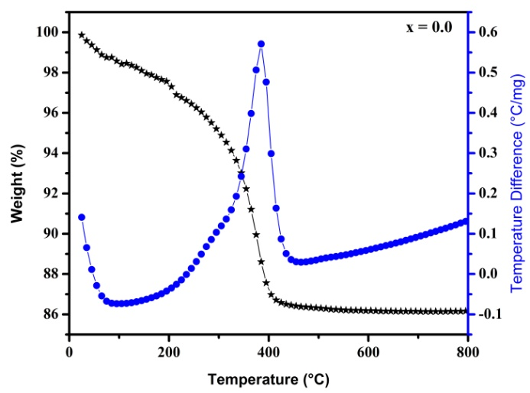
Figure 1: TGA-DTA plot for precursor of Ni_{0.2}Cu_{0.2}Zn_{0.6}Fe_{2- x}Cr_{x}O₄ (x = 0.0)
The typical TGA/DTA curves of Ni0.2Cu0.2Zn0.6Fe2_{- x}Cr_{x}O₄ (x = 0.0; Figure 1) and (x=1.0; Figure 2), illustrates two weight loss steps. The first weight loss step in the temperature range of 30-100 °C, corresponding to endothermic peak around 80 ºC, which is due to the loss of coordination water in the precursor. The second weight loss step observed in the temperature range of 310-425 °C corresponding to the exothermic peak around 380 °C, is as a result of the decomposition of unreacted starting citric acid remained after combustion. The released heat in the process of exothermic decomposition has been observed to be sufficient for complete conversion of the metal precursors to metal oxides.⁸
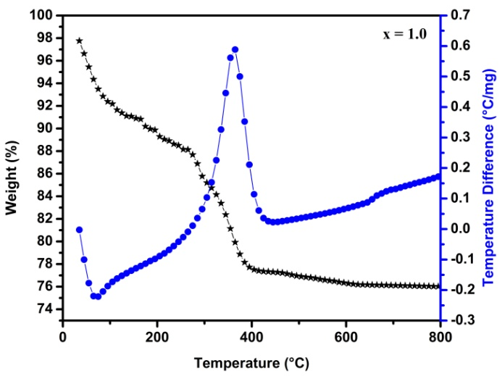
Figure 2: TGA-DTA plot for precursor of Ni_{0.2}Cu_{0.2}Zn_{0.6}Fe_{2- x}Cr_{x}O₄ (x = 1.0)
Almost no weight loss was observed above 425 °C, representing the presence of only Ni_{0.2}Cu_{0.2}Zn_{0.6}Fe_{2-x}Cr_{x}O₄ ferrites in this temperature range. Thus, the synthesized all the precursor samples were sintered at 500 °C for 4 hour to obtain the final product.
3.2. Structural Analysis
3.2.1. Elemental Analysis
The chemical compositions of Ni_{0.2}Cu_{0.2}Zn_{0.6}Fe_{2-x}Cr_{x}O₄ ferrite nanoparticles have been determined by EDAX.
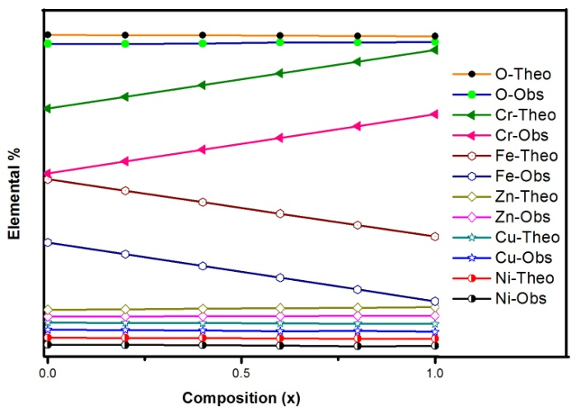
Figure 3. Plots of Observed and Theoretical elemental % versus composition (x)
The EDAX confirmed the homogeneous mixing of the Fe, Ni, Cu, Zn, Cr and O atoms in pure and doped ferrite samples. Figure 3 shows the plots of observed and theoretical percentage of Fe, Ni, Cu, Zn, Cr and O values versus composions (x). The observed % values and theoretical % values of element do not match perfectly because solid state reactions are not stoichiometric reactions.⁹
3.2.2. X-ray diffraction
X-ray diffraction (XRD) patterns of the Ni_{0.2}Cu_{0.2}Zn_{0.6}Fe_{2-x}Cr_{x}O₄ spinel ferrite system with x = 0.0 to 1.0, in the steps of 0.2 are shown in Figure 4. The XRD patterns confirmed the formation of cubic spinel structure of single phase without additional peaks corresponding to any other phases. The crystal structures of Ni-Cu-Zn ferrite are identified as cubic spinel (space group: fd³m) with the corresponding (220), (311), (222), (400), (422), (333) and (440) planes.
Lattice parameter (a) of all the samples was determined by using the following equation:¹⁰
(1)
Lattice constant values with an accuracy of ±0.002 Ǻ were calculated for each sample using XRD pattern and are listed in Table 1. The decrease in the lattice constant is related to the difference in ionic radii of Fe³⁺ and Cr³⁺. In the present ferrite system Fe³⁺ ions (0.67 Ǻ) ions are replaced by the relatively small Cr³⁺ ions (0.64 Ǻ).¹¹
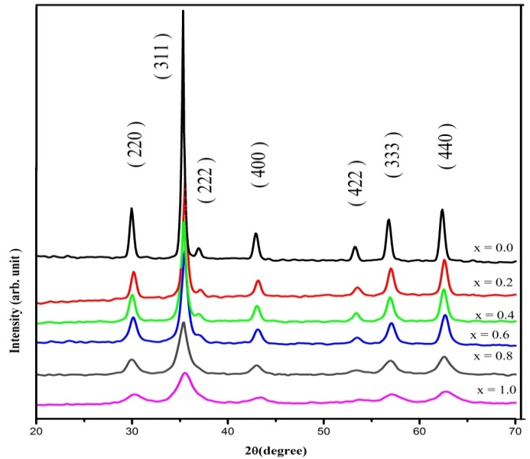
Figure 4. The XRD patterns for Ni_{0.2}Cu_{0.2}Zn_{0.6}Fe_{2-x}Cr_{x}O₄
The X-ray density of all the samples was obtained by the following relation:
(2)
Where, 8 is formula unit, M is molecular weight, N is Avogadro’s number, a is lattice constant. The values of X-ray density are presented in table 1. It is seen from Table 1 that like lattice parameter, X-ray density also decreased with increasing Cr³⁺ content x. The decrease in X-ray density is attributed to decrease in lattice constant. It is observed that X-ray density increase for x = 1.0. This may be related to the molecular weight of the sample overtakes the volume (a³).
The average crystallite diameter ‘D_{XRD}’ of powder estimated from the most intense (311) peak of XRD and using the Debye-Scherrer method,¹⁰
(3)
Where, β_{1/2} is the full width of half maximum in (2θ), θ is the corresponding Bragg angle and C = 0.9. The values of the crystallite size are given in Table: 1. The crystallite size is decreases from 30.3 nm to 8.9 nm with increasing Cr³⁺ substitution.
The percentage porosity ‘P’ of all the samples was calculated using the values of X-ray density and bulk density:
(4)
Where, d_{B} and d_{x} are the bulk and X-ray densities respectively.

Table 1: Lattice constant (a), X-ray density (d_{x}) and hopping lengths (L_{A}) and (L_{B}), particle size (D_{xrd}) and porosity (P) of Ni_{0.2}Cu_{0.2}Zn_{0.6}Fe_{2-x}Cr_{x}O₄
Composition  ‘x’ | ‘a’  (Å) | ‘d_{x}’  (g/cm³) | L_{A}  (Å) | L_{B}  (Å) | P  (%) | Particle size (nm)
 |  |  |  |  |  | D_{xrd} | TEM
0.0 | 8.418 | 5.329 | 3.645 | 2.976 | 25.4 | 30.3 | 30.6
0.2 | 8.415 | 5.316 | 3.644 | 2.975 | 26.1 | 24.9 | 25.2
0.4 | 8.406 | 5.317 | 3.640 | 2.972 | 27.7 | 19.1 | 19.5
0.6 | 8.394 | 5.323 | 3.634 | 2.967 | 28.7 | 16.4 | 15.9
0.8 | 8.389 | 5.314 | 3.632 | 2.966 | 28.4 | 12.6 | 12.8
1.0 | 8.367 | 5.339 | 3.623 | 2.958 | 32.0 | 8.9 | 9.5
As evidenced from Table 1 that porosity increased from 25.4 (x = 0.0) to 32 (x = 1.0) with the Cr³⁺ substitution. In the present series of Ni_{0.2}Cu_{0.2}Zn_{0.6}Fe_{2-x}Cr_{x}O₄, both the molecular weight and the volume of the unit cell decrease with increasing Cr³⁺ substitution, but the rate of the decrease of molecular weight is more than that of volume. Therefore, the density decreases with Cr³⁺ substitution, this resulted in increase in porosity. Apart from this, the increase in porosity is mainly attributed to decrease in crystallite size, which increases the grain boundaries of the particle and accordingly the porosity.
The distance between the magnetic ions i.e. hopping lengths (L_{A} and L_{B}) in the tetrahedral A-site and octahedral B –site was calculated using following relation:¹²
(5)
(6)
It has been observed from Table 1 that the hopping lengths (L_{A} and L_{B}) decreased with Cr³⁺ substitution. The decrease in both the hopping lengths with Cr³⁺ substitution is due to the decrease in lattice constant.
3.2.3. Infrared spectroscopy
The infrared spectroscopy is an important tool to probe various ordering phenomena that provide information on the position of the ions and the vibrational modes of crystals. The substitution of metal ion in ferrites may give rise to structural change within the unit cell without affecting the structure as a whole. Such structural changes brought about by metal ions strongly influence the lattice vibrations.¹⁹ The IR spectra as shown in Figure 5, were recorded at room temperature in the frequency range 300-800 cm⁻¹. For ferrites, generally it is found two assigned absorption bands appear around 600 cm⁻¹: ν₁, which is attributed to stretching vibration of tetrahedral groups Fe³⁺-O²⁻ and around 400 cm⁻¹: ν₂, which is attributed to the octahedral groups complex Fe³⁺-O²⁻. It is observed from Table 2 and Figure 6 that the higher frequency band (ν₁) is appeared in the range of 568–610 cm⁻¹ whereas lower frequency band (ν₂) is appeared in the range of 388-491 cm⁻¹. These bands are characteristics features of spinel structure. It explains that the normal mode of vibration of tetrahedral cluster is higher than that of octahedral cluster. It should be attributed to the shorter bond length of tetrahedral cluster and longer bond length of octahedral cluster.¹⁹
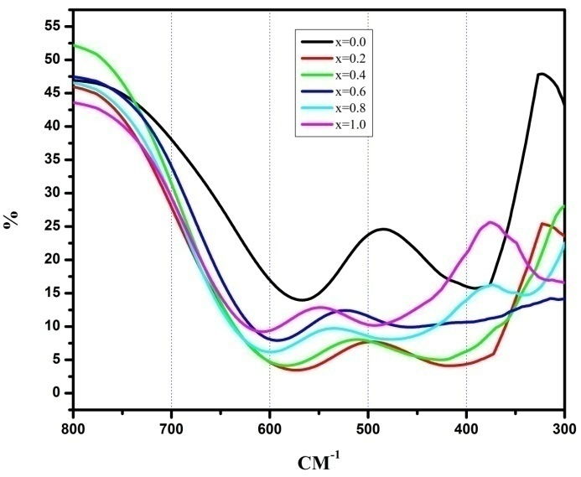
Figure 5: IR spectra for the series Ni_{0.2}Cu_{0.2}Zn_{0.6}Fe_{2-x}Cr_{x}O₄
The differences in band position and intensity with Cr³⁺ substitution may be related to; the decrease in the -intermolecular distance increases the metal-oxygen vibrational energies, which arises from the decrease in the number of Fe³⁺- complexes caused by the increase of the number of Cr³⁺- complexes¹⁹ and, formation of Me²⁺- at A and B sites (Me = Ni²⁺, Cu²⁺, Zn²⁺).
Table 2: Band position (ν₁ and ν₂), Force constant (K₀ and K_{t}) and Bond length (R_{A} and R_{B}) of system Ni_{0.2}Cu_{0.2}Zn_{0.6}Fe_{2-x}Cr_{x}O₄
Comp.  ‘x’ | Band positions |  | Force constants |  | Bond lengths
Comp.  ‘x’ | ν₁ (cm⁻¹) | ν₂ (cm⁻¹) | K_{O} × 10⁵ (dyne/cm ) | K_{t} × 10⁵  (dyne/cm) | R_{A}(Å) | R_{B}(Å)
0.0 | 568.1 | 388.9 | 0.9380 | 1.6075 | 3.864 | 3.065
0.2 | 574.6 | 418.1 | 1.0834 | 1.8388 | 3.862 | 3.064
0.4 | 585.8 | 424.7 | 1.1182 | 1.8978 | 3.861 | 3.063
0.6 | 597.2 | 447.2 | 1.2399 | 2.0884 | 3.859 | 3.063
0.8 | 603.9 | 474.2 | 1.3937 | 2.3203 | 3.857 | 3.062
1.0 | 610.5 | 491.9 | 1.4999 | 2.4789 | 3.855 | 3.061
The force constants corresponding to the tetrahedral and octahedral complexes are calculated by using the standard formulae given below: ¹⁷
$K_{t}=7.62×M_{1}×υ_{1}^{2}× {10}^{-2}$ (12)
$K_{o}=10.62×\frac{M_{2}}{2}×υ_{2}^{2}× {10}^{-2}$ (13)
Where, K_{O} is the force constant on octahedral site, K_{t} is the force constant on tetrahedral site, M₁ molecular weight of tetrahedral site, M₂ molecular weight of octahedral site, ν₁ the corresponding center frequency on tetrahedral site, and ν₂ the corresponding center frequency on octahedral site.
The molecular weights M₁ and M₂ for each sample are calculated from the cation distribution. The force constant is the second derivative of the potential energy with respect to the site radius with the other independent parameters kept constant. The bond lengths R_{A} and R_{B} have been calculated using the formula given by Gorter²¹. The molecular weights of the tetrahedral M₁ and octahedral M₂ sites have been calculated using the cation. The values of R_{A}, R_{B} and the force constants K_{t} and K_{O} are listed in Table: 2.
3.2.4. Scanning electron microscopy (SEM)
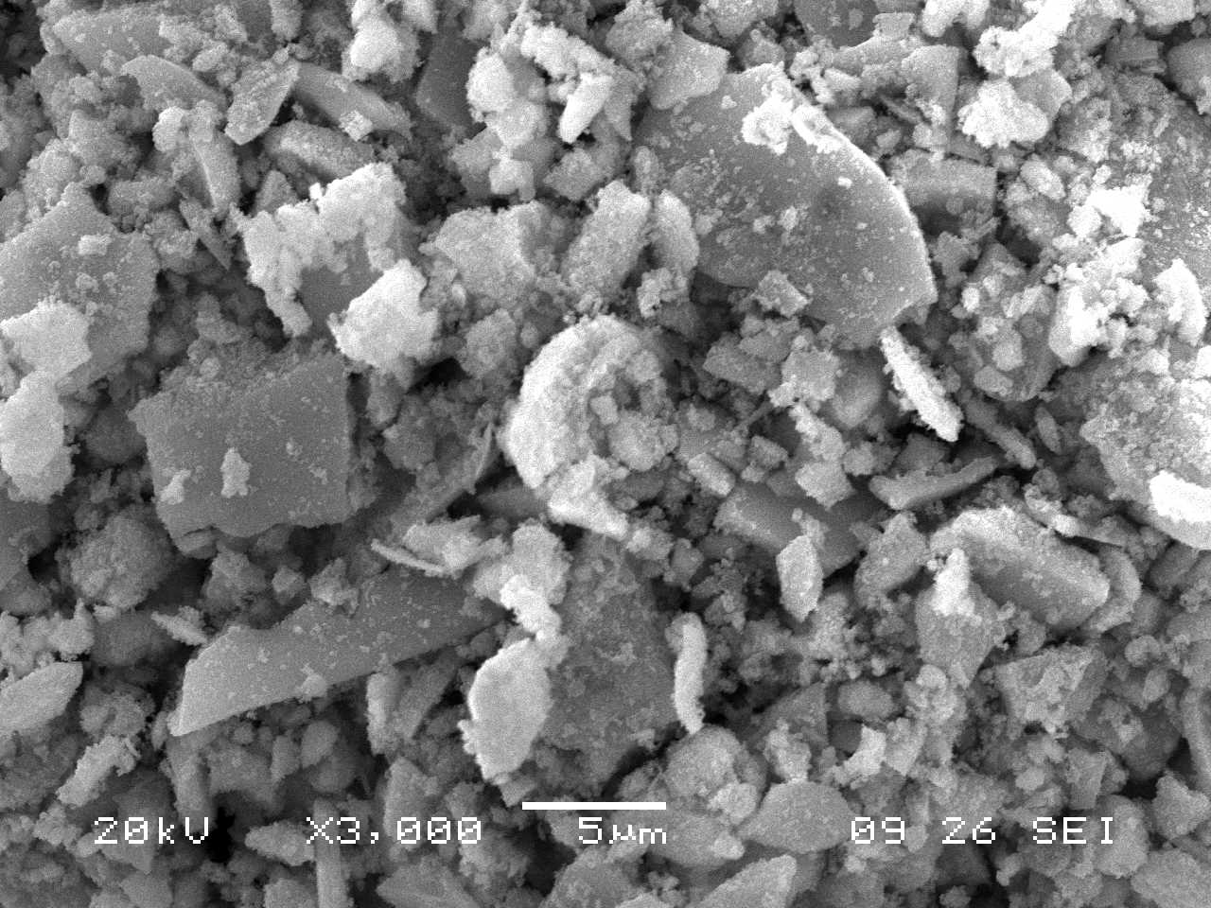
Figure 6: Scanning electron micrograph of Ni_{0.2}Cu_{0.2}Zn_{0.6}Fe_{2- x}Cr_{x}O₄ (x=0.6)
Typical Scanning electron micrograph (SEM) of the sample x=0.6 is shown in Figure 6. Each composition is characterized by a typical porous structure and small rounded grains. It is observed from SEM images that the structure is affected by the Cr³⁺ substitutions. It can be observed from the SEM images that the prepared samples are amorphous and porous in nature. The decrease in the grain size and an increase in porosity is observed with increasing Cr³⁺ substitutions. The observed changes in grain size suggest that the substitution of Cr³⁺ in NiCuZn ferrite solid solution occurs during sol-gel combustion process which enables a better homogeneity in the powders and, hence, a more controlled microstructure is obtained.
3.3.5. Transmission Electron Microscopy (TEM)
TEM image of the typical sample x = 0.4 is presented in Figure 7.
Figure 7: TEM image and SAED pattern for Ni_{0.2}Cu_{0.2}Zn_{0.6}Fe_{2- x}Cr_{x}O₄ (x=0.4)
Figure 8: SAED pattern for Ni_{0.2}Cu_{0.2}Zn_{0.6}Fe_{2- x}Cr_{x}O₄ (x=0.4)
The particles were well distributed and slightly agglomerated. The agglomeration is the indication of high reactivity of the prepared sample with the heat treatment and it may also be come from the magnetostatic interaction between particles. Since Cr³⁺ ions provide stability to the Ni-Cu-Zn lattice; it is believed that they also inhibit the process of grain growth through coagulation at the stage where the sol-gel is formed and hence samples of small particle size are produced.¹³ Selected area electron diffraction (SAED) patterns of the respective TEM image is also shown in Figure 8.
The Bragg’ rings observed in these SAED patterns corresponding to specific ‘d’ values and that match perfectly with the ‘d’ values calculated from XRD. The superimposition of the bright spot with Debye ring pattern indicates polycrystalline nature of the sample which is in accordance with XRD. As like XRD; SAED also confirmed that the sample does not possess any type of impurity or second phase.
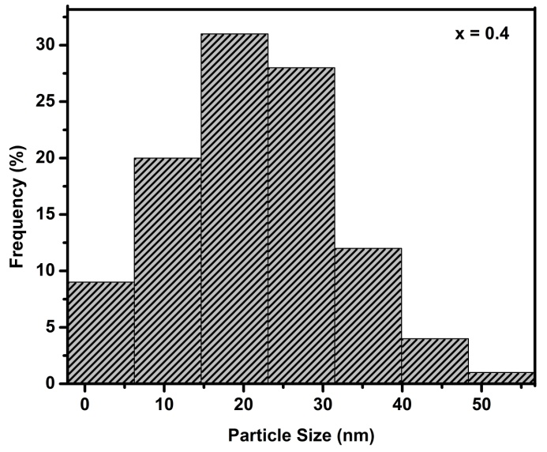
Figure 9: Particles size distribution for Ni_{0.2}Cu_{0.2}Zn_{0.6}Fe_{2- x}Cr_{x}O₄ (x=0.4) (based on TEM micrograph, Figure 7)
Particles size distributions for Ni_{0.2}Cu_{0.2}Zn_{0.6}Fe_{2- x}Cr_{x}O₄ (x=0.4) shown in figure 9. Nanocrystalline particles observed were in the range 6-55 nm. Particles with size between 10-30 nm were most abundant (more than 70%)
4. Conclusion
Ni_{0.2}Cu_{0.2}Zn_{0.6}Fe_{2-x}Cr_{x}O₄ (x = 0.0, 0.2, 0.4, 0.6, 0.8 and 1.0) spinel ferrites synthesized by sol gel auto combustion method. The EDAX pattern confirmed the homogeneous mixing of the Fe, Ni, Cu, Zn, Cr and O atoms in pure and doped ferrite samples with desired composition. The XRD patterns confirmed the formation of cubic spinel structure of single phase Ni_{0.2}Cu_{0.2}Zn_{0.6}Fe_{2-x}Cr_{x}O₄ ferrites without additional peaks corresponding to any other phases. The crystal structures of NiCuZn ferrite are identified as cubic. Lattice constant and X-ray density decreased with Cr³⁺ substitution. The crystallite size is observed in the range of 8.9-30.3 nm confirmed from TEM. It is concluded from IR spectra that higher frequency band (ν₁) is appeared in the range of 568–610 cm⁻¹ whereas lower frequency band (ν₂) is appeared in the range of 388-491 cm⁻¹ confirming characteristics features of spinel structure. It is observed from SEM that the prepared samples are amorphous and porous in nature. TEM images of the typical samples confirmed the particle size of obtained ferrite samples is in nm dimensions. The Bragg’ rings observed in these SAED patterns corresponding to specific ‘d’ values and that match perfectly with the ‘d’ values calculated from XRD.
5. References
- T. Nakamura, J. Magn. Magn. Mater., 1997, 168, 285-291.
- R. Lebourgeois, S. Duguey, J.P. Ganne, J.M. Heintz, J. Magn. Magn. Mater., 2007, 312, 328-330.
- M.A. Gabal, Y.M. Al Angari, A.Y. Obaid, Advanced Powder Technology, 2014, 25, 457-461.
- M. Epifani, E. Melissano, G. Pace, M. Schiopa, J. Europ. Ceram. Soc., 2007, 27, 115-123.
- N.L. Freitas, J.P. Continho, M.C. Silva, H.L. Lira, et al., Materials Science Forum, 2010, 660, 943-947.
- Tiago Pinheiro Braga, Bárbara Maria Campos Sales, et al., Catal. Sci. Technol., 2011, 1, 1383-1392.
- Y. Ahn, E.J. Choi, S. Kim, H.N. Ok, Mater. Lett., 2001, 50 (1), 47-52.
- A. Mali, A. Ataie, Ceramics International, 2004, 30, 1979-1983.
- K. S. Lohar, S. M. Patange, S. E. Shirsath et al., Int. J. of Modern Phy. B, 2011, 25-16, 2157-2166.
- B. D. Cullity, “Elements of X-ray diffraction”, (Addison-Wesley Publ. Comp. Inc., Reading, Massachusetts, U.S.A.), 1956, pp. 99.
- S. M. Patange, Sagar E Shirsath, et al., Appl. Phys. A: Mater Sci. Proces, 2009, A95, 429-434.
- B. Vishwanathan and V. R. K. Murthy, Ferrite Material Science and Technology, New Delhi: Narsoa Publishing House, 1990, pp. 15-61.
- Muhammad Javed Iqbal, Barkat-ul-Ain, Mater. Sci. Engg. B, 2009, 164, 6-11.
- L. Weil, E. F. Bertaut, L. Bochirol, J. Phys. Radium, 1950, 11, 208-212.
- A. Tomas, P. Laruelle, J. L. Dormann, M. Nouges, Acta Crystallogr., 1983, C39, 1615-1617.
- M. A. Amer, Hyp. Interact., 2000, 131, 29-42.
- A. A. Yousef, M. E. El-Zain, S. A. Mazen, et al., J. Phys. Condens. Matter, 1994, 6(29), 5717-5724.
- R.D. Waldron, Phys. Rev., 1955, 99, 1727-1735.
- S.S. Bellad, R.B. Pujar, B.K. Chougule, Indian J. Pure Appl. Phys., 1998, 36, 598-601.
- O. Hemeda, M.A. Amer, S. Aboul Enein and M.A. Ahmed, Phy. Stat. Sol. (A), 1996, 156, 29-38.
- E.W. Gorter, Philips Res. Rep., 1954, 9, 295-320.

