Polythiacalix[4]amides as a novel category of macromolecules; Synthesis, Antibacterial evaluation and Investigation on their Spectral and Thermophysical Characteristics
Hamed Tashakkorian¹, Moslem Mansour Lakouraj^{†, 2}, Rahimeh Maldar², Zahra Moulana³

¹Cellular and Molecular Biology Research Center (CMBRC), Health Research Institute, Babol University of Medical Sciences, Babol, 4717641367, Iran
²Department of Polymer Chemistry, Faculty of Chemistry, University of Mazanadaran, Babolsar, 47416 95447, Iran
³Infectious Diseases & Tropical Medicine Research Center, Babol University of Medical Sciences, Babol, 47176 41367, Iran

† Corresponding Author: Moslem Mansour Lakouraj
E-mail: lakouraj@umz.ac.ir
TelFax: (+) 98-1135302350

Abstract
Polythiacalix[4]amides as a novel category of polyamides, with high sorption capability towards some environmentally hazardous metal cations especially Hg2+, have been synthesized via direct polycondensation protocol using a thiacalix[4]arene dicarboxylic acid and commercial diamines. The polyamides were obtained in high yields and possessed inherent viscosities in the range of 0.55-0.75 dl/g. The photophysical characteristic was studied by looking for the maximum wavelength of each polymer using UV absorption spectroscopy. Thermogravimetric analysis displayed high thermal stability for these polyamides in range of 337 to 346°C at the point of 10% weight loss, and their char yields were about 32.9-58.5% at 600°C. Also, glass transition temperatures were between 157 and 178°C. To survey on possible sorption capability of these polythiacalixamides, solid-liquid extraction of some risky transition metal cations such as Cu²⁺, Co²⁺, Cd²⁺, Pb²⁺ and Hg²⁺ from wastewater was performed. Antibacterial evaluation was conducted using gram positive and negative bacteria strains and some reliable results have been obtained. The results showed some promising features of their ability for being employed as possible ingredients of industrial antibacterial membranes.

Keywords: Supramolecular chemistry; Thiacalixarene; Antibacterial evaluation; Sorption capability; Thermal Stability; Polyamide

- Introduction:
In the last decade, scientists in the field of supramolecular chemistry have designed novel architectures of host molecules with which receptors area in chemistry have been developed.¹⁻⁴ Supramoleculs such as cyclodextrins and crown ethers, calixarene and theirs derivatives including polycalixarenes have been employed widely in catalysis,⁵⁻⁸ molecular recognition or ion separation^{9,10} and sensors¹¹⁻¹³ during recent years. Calixarenes structure provides interesting platforms for improving the reception capability of material by special modification. Smart functionalization at the both upper and/or lower rim with specific complexing groups as well as replacement of CH₂ bridge by oxygen or sulfur, can improve the ionic and molecular binding properties and will increase the chance for recognition and separation of the target rare or toxic guests which is essential from economic and environmental point of view. One of the particular compounds of this family called as thiacalixarene, which has sulfur atoms instead of common methylene bridges shows some surprising features of these macrocycles. Thiacalixarene and its derivatives introduced some unique properties which led them to be applied in different applications from host-guest to supramolecular chemistry and also in molecular receptors.¹⁴⁻²² Based on the reported findings, these sulfur containing structures have attracted much attention in calixarene chemistry because of their usage in selective extraction of more polarizable transition metal ions instead of hard metal ions such as alkali, alkaline earth cations.²³⁻²⁸
In macromolecular science, it has been proved that calixarene based ionophores has a great acceptability in modern chemistry because of their extreme capability in functionalization from bridge position up to both side of the rims. As well, polymer scientists took advantage of these structures for preparation of ions-selective polymers or in producing efficient metal cations absorbent membranes. Also researchers who are studying in the field of polymers focused their attentions on the growing demands for novel antimicrobial compounds as major concerns for improving the standards of public health. Numerous strategies have been established to overcome the existence of medical device related infections. Therefore, preparations of polymeric materials containing antimicrobial moieties attracted much interest in recent years ^{29,30} and are commercially available in the forms of sutures, tubing, containers, films, dental implants, and catheters. As a part of our continuing study on the synthesis and physical properties of calixarene based polymers, ³¹⁻³⁴ the main goal of this research is to combine the extraction abilities towards heavy metal ions with antimicrobial properties by using thiacalixarene to introduce a novel type of polythiacalixamides. These high performance polyamides possess moieties with unique cavity size, thermal stability and also having such acceptable antibacterial activities. We wish these polymers can be applied in polymeric antibacterial membranes which are being incorporated in environmental applications and also in medical devices.

- Experimental
2.1. Apparatus and materials
Melting points were determined on an Electro Thermal 9100 apparatus in a sealed capillary and are uncorrected.¹H NMR spectra were recorded on a BrukerAvance III 400 MHz spectrometer in CDCl₃ and DMSO with TMS as internal standard. IR spectra were recorded on a Bruker FTIR spectrometer as KBr pellets. For ultraviolet-visible (UV-Vis) measurements, Cecil®UV-Visible spectrophotometer was applied. Inherent viscosities of polymers were determined by using an Ostwald viscometer. Elemental analyses were performed by a CHN-O-Rapid Heraeus elemental analyzer (Wellesley, MA). Differential scanning calorimetry (DSC) and thermogravimetric analysis (TGA) were recorded on a Perkin-Elmer Pyris Diamond and Pyris 6 TGA Consumables, respectively. Thermo Fisher Scientific ICE 3300 Atomic Absorption Spectrometer (AAS) was employed for determination of the metal ions. All materials and reagents were of standard analytical grade, purchased from Fluka or Merck companies, and used without further purification. Commercial grade solvents such as acetone, acetonitrile, methanol, toluene and n-Hexane were dried and stored over 4A˚ molecular sieves.³⁵
  - Synthesis
The thiacalixarene dicarboxylic acid (3) and its precursors, compounds 1 and 2 were synthesized according to the literature procedures.³⁶⁻³⁸ The FT-IR, ¹HNMR, and ¹³CNMR spectral data and melting points of the prepared compounds were compared with the original data given in the corresponding articles. As illustrated in scheme 2, the thiacalixarene-based polyamides (A-D) employed in this study were synthesized from condensation polymerization of thiacalixarene dicarboxylic acid with commercial diamines.

General procedure for polymerization of 5,11,17,23-tetra-tert-butyl-25,27-bis-[carboxylmethoxy]- 26,28-dihydroxy-2,8,14,20-tetrathiacalix[4]arene (3) with commercial diamines

A 25 ml Two-necked, round-bottomed flask equipped with a reflux condenser, magnetic stirrer and gas inlet was charged with 1.2 mmol of triphenylphosphite, 1 mmol pyridine and 5 ml of dry NMP. The solution was agitated at room temperature for 15 min under nitrogen atmosphere. Then, 1 mmol of thiacalix[4]arene dicarboxylic acid (3) was added to the solution. After a few minutes, 1 mmol of commercial diamine was dissolved in the reaction mixture. The temperature was raised to 110°C and the solution stirred for 14h. Polythiacalixamide was produced during direct phosphorylation polymerization and precipitated by pouring the flask content into the cold methanol. After stirring for half an hour, it was filtered using Buchner funnel and washed with hot water and methanol respectively. All of the polythiacalixamides mentioned in this work were prepared using the same procedure. The synthesized polymers were then, dried overnight under vacuum at 120 °C to afford corresponding polymers in 70-85% yields. The characteristic physical and spectral data of polythiacalixamides (A-D) were given in Tables 1-3.
2.3. Survey on Transition Metal Removal using pTCAs
Investigation on sorption behavior of pTCAs was carried out based on the following batch wise procedure. Polythiacalixamides (25×10⁻³g) were added to 10 mL aliquot solution of the corresponding metal nitrate (10×10⁻³) molL⁻¹. Then to have a precise comparison with our previously reported polycalixarenes (PCA), they were immersed in the test solutions and stirred at 25°C for 3 h. After the specified time, pTCAs were filtered off and the concentrations of the remaining metal ions in the aqueous phase (Ce) were determined using atomic absorption spectroscopy. The percent sorption of ions (S%) and distribution coefficient (K_{d}) were calculated as:
S% = (C_{i} – C_{e}/C_{i}) × 100
C_{i}: Initial metal ion concentration
K_{d} = (A / g of dry resin) / ( B/ mL of solution )
A: Amount of ion absorbed by resin
B: Amount of metal remaining in solution

2.4. Experimental section for determination of antibacterial activity
Synthesized polymers and monomers containing 1,2,4-triazole units were evaluated for their anti-bacterial activity against microorganisms including the two Gram-positive bacteria Staphylococcus aureus (ATCC 259230 and Bacillus subtilis (PTCC 1156) and three Gram-negative bacteria; Escherichia coli (PTCC 1533), Pseudomonas aeruginosa (PTCC 1707) and Klebsiella Pneumoniae (ATCC 11296). These common gram positives and gram negatives bacteria were investigated at different concentrations of the tested compounds using broth microdilution procedure. The compounds sensitivity of the strains was assayed for positive or negative growth after 24–48 h. The MIC test was repeated at least three times for each antimicrobial agent. Then antibacterial activities of the compounds were compared with known and effective antibiotics Penicillin, Ciprofloxacin, and Gentamicin at the same concentration.

2.4.1. Minimum Inhibitory Concentration (MIC)
MIC is the lowest concentration, which can cause complete growth inhibition. The broth microdilution method was applied to evaluate the MIC³⁹ 100 µl of Muller- Hilton broth, containing 10⁵ CFU ml⁻¹ of each bacterium, was added to each well. 100 µl of polythiacalix amide solutions with the maximum starting concentrations 500 µg/ml were poured in the first well of 96 sterilized well micro plates and then diluted to half concentrations in the next wells respectively. After dilution micro plates were incubated at 37 ºC for 24 h. The first well, which was completely transparent and had no bacterial growth, was considered for MIC. Each concentration was tested three times and the results were averaged.

2.4.2. Minimum Bactericidal Concentration (MBC)
The minimum bactericidal concentration (MBC) is the lowest concentration at which an antimicrobial agent will kill a particular microorganism. The MBC is determined from broth dilution MIC tests by sub-culturing to agar plates that do not contain the test agent. The MBC is identified by determining the lowest concentration of antibacterial agent that reduces the viability of the initial bacterial inoculum by ≥99.9%. 10 µL of the content without turbidity wells was cultivated on the Muller-Hilton plate. The number of colonies was counted after 24 h at 37 ºC. The first well, which had equal or less than 3 colonies, was regarded as MBC. Antibacterial agents are usually regarded as bactericidal if the MBC is no more than three times of the MIC concentration.

- Results and Discussion
  - Characterization and discussion:
In developing countries, water pollution, especially industrial and agricultural effluents with high levels of toxicity have been a serious concern. The progressive increase in environmental pollutants emerged the global search for novel, efficient and applicable compounds with high sorption capability. In the last decade macrocyclic supramolecules specially calixarene family, were introduced as a potential sensor for recognition and separation of toxic elements including Pb²⁺, Cd²⁺ and Hg²⁺.⁴⁰⁻⁴² Among them, thiacalixarene and its derivatives having sulfur as an excellent auxiliary chelating agent in their structure have an effective interaction with transition metal cations. Incorporation of thiacalixarene in backbone of the polymeric materials could help us to prepare such an interesting membrane with great applicability. Therefore, preparation of novel thermally stable polythiacalixamides (pTCAs) having flexible chelating cavity in their backbone and studying their potential capability in the extraction of transition metal ions particularly Hg²⁺ as hazardous cation was disclosed in this research. To have some reliable polymers with excellent cation extraction ability and high thermal stability, we decided to prepare polyamide with promising properties using p-tert-butyl-thiacalixarene dicarboxylic acid and commercial diamines. To achieve this goal, at first parent thiacalixarene was synthesized as revealed in the material section, using p-tertbutylphenol and sulfur. Then it was functionalized with bromoethylacetate to obtain the corresponding diester derivative and consequently the product was hydrolyzed using potassium hydroxide to give thiacalix[4]arene dicarboxylic acid as a functionalized monomer (Scheme 1). Then polythiacalixamides, pTCA(A-D) were obtained via direct polycondensation reaction of thiacalix[4]arene dicarboxylic acid (3) with various commercially available aromatic diamines using triphenylphosphite (TPP) and pyridine as condensing agents (Scheme 2). All the polymerization reactions afforded clear solutions which were cooled down and poured in to the cold methanol while being stirred.

Scheme 1. Synthesis of thiacalix[4]arenedicarboxylic acid
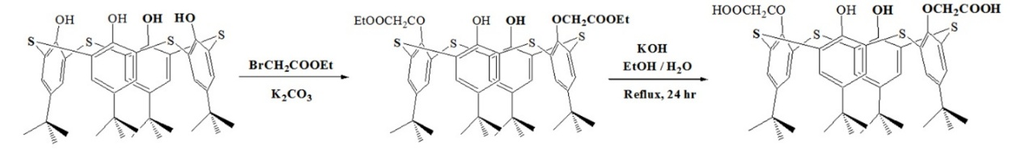

Scheme 2. Synthesis of polythiacalixamides
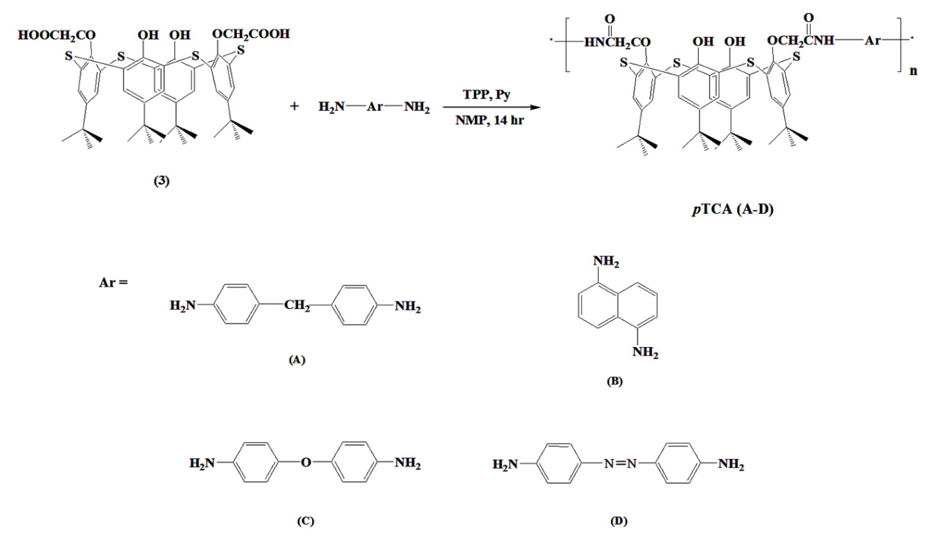

The structure and composition of the synthesized polyamides were characterized by a number of physical–chemical methods, i.e., ¹HNMR, IR, UV spectroscopy and elemental analysis. Also thermal stability and sorption capability of the pTCA(A-D) were determined and detailed completely in this article. ¹H-NMR spectra of all the prepared compounds clearly corresponded to the ascribed structures including monomer and polyamides by the number of signals and their multiplicities. Characteristic physical data of synthesized polymers were inserted in Tables (1-3) and explained here in details. Specified peaks in IR spectra of the polyamides at 1685, 1695, 1682 and 1686 cm⁻¹, respectively indicate the characteristic stretching vibration of amidic carbonyl bonds of pTCA(A-D). Amide proton (N-H) was also observed in ¹H-NMR spectra of polyamides (A-D) around δ = 12.4 ppm. The IR and ¹HNMR spectral data of the polythiacalixamides were summarized in Table 1.

Table 1. FTIR and ¹HNMR spectral data for the synthesized polythiacalixamides
Polymer | FTIR (Absorption peaks) cm⁻¹ |  |  | ¹HNMR (Chemical shift) ppm
Polymer | C=O | N-H | important  peaks | N-H  (amide proton) | CH₂  (Aliphatic) | Ar-H  (Aromatic  Proton)
pTCA (A) | 1685 | 3360 | -------- | 12.75 | 4.58 | 6.90-7.88
pTCA (B) | 1695 | 3355 | -------- | 12.10 | 4.97 | 7.05-7.95
pTCA (C) | 1686 | 3368 | 1597 (N=N) | 12.47 | 4.56 | 7.08-7.95
pTCA (D) | 1682 | 3351 | -------- | 12.31 | 4.63 | 7.11-7.86

Table 2. Elemental analysis (CHN) of polythiacalixamides

Polymer | Calculated (%) |  |  | Found (%)
Polymer | C | H | N | C | H | N
pTCA(A)  pTCA(B)  pTCA(C)  pTCA(D) | 70.35  68.94  66.77  68.11 | 6.19  5.92  5.72  5.84 | 4.68  5.02  9.16  4.67 | 70.02  68.61  66.21  67.86 | 6.01  5.72  5.54  5.57 | 4.72  4.98  8.90  4.43

The study on photophysical characteristic of polythiacalixamides (A-D) was performed by UV-absorption spectroscopy and results displayed as curves in Figure (1). The maximum of absorption wavelengths (λ_{max}) were observed at 270, 281, 323 and 262 nm for pTCA(A-D), respectively. pTCA(C) has a noticeable 53 nm red shift compared to the other polymers due to the conjugation of (N=N) group with phenyl rings in polymer chain.

Fig. 1. UV Spectra of polythiacalixamides
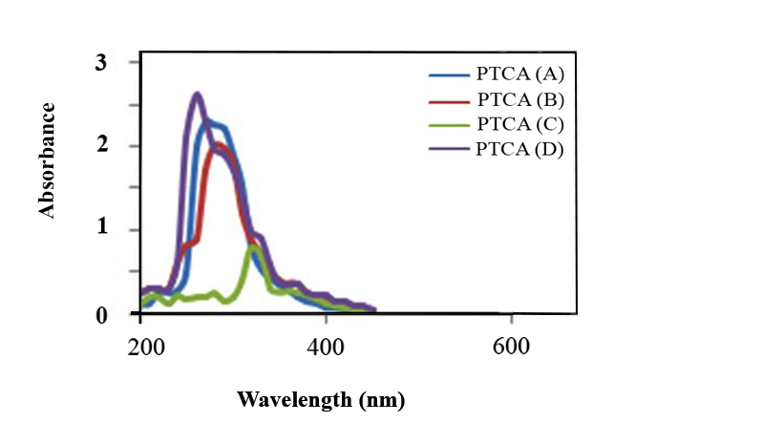

To study on their applicability as a membrane in industry, considering the solubility in industrial solvent is essential. So, the solubility of the pTCA(A-D) were investigated in variety of solvents and the results are represented in Table 3. The synthesized polyamides were soluble in aprotic polar solvent such as NMP, DMF, DMSO, DMAc and in dioxane on heating. Existence of bulky thiacalixarene macrocycle in the backbone and creating free space between polymeric chains, improved the solubility parameter relative to traditional polyamides. These polyamides were synthesized in high yields, with inherent viscosities in the range of 0.55- 0.75 dL/g at 25°C in NMP, which are summarized in Table 3.

Table 3. Solubility behavior and inherent viscosity of polythiacalixamides
Polymer | DMF | DMAc | NMP | DMSO | Dioxane | Tetralin | η (dL/g)ª
pTCA(A) | +h | + | + | + | +h | - | 0.57
pTCA(B) | +h | + | + | + | + | - | 0.75
pTCA(C) | +h | + | + | + | +h | - | 0.55
pTCA(D) | +h | + | + | +h | +h | - | 0.61

+, soluble at room temperature, +h, soluble on heating; -, insoluble; DMF, N,N- dimethylformamide; DMAc, N,N-dimethylacetamide; NMP, N-methyl-2-pyrrolidone; DMSO, dimethyl sulfoxide; Dioxan,Tetralin:1,2,3,4-tetrahydronaphthalene.
ª Inherent viscosity was measured at a concentration of 0.5 dL/g in NMP at 30°C.

3.2. Sorption of heavy metal cations
Functionalization of thiacalix[4]arene especially at the lower rim makes it more effective as extractant. ^{43-45,38} Hence, we investigated the preparation of a thiacalixarene derivative which has been functionalized at the lower rim and employed it in the backbone of polymeric chain. Then we evaluated the transition metal ions sorption capability of these polymers by solid-liquid extraction procedure. Therefore, some metal cations with great importance from environmental view, such as Cu²⁺, Co²⁺, Cd²⁺, Pb²⁺ and Hg²⁺ were chosen and their aqueous solutions were treated with pTCAs (A-D). The results including sorption percentage (S%) and distribution coefficients (K_{d}) are illustrated in Tables 4-5. From the results given in Table 4 and 5, it has been observed that pTCAs(A-D) have excellent extraction ability for Hg²⁺, Pb²⁺, Cd²⁺ and Co²⁺ from aqueous solution while exhibit some less promising capability toward Cu²⁺. In comparison with our recent studies on polycalixarenes (PCA) [31-33], it is clear that the presence of four sulfur atoms at the bridge position enhances the complexation of thiacalixarene moieties with the larger size metal cations and results in reasonable higher sorption ability. Exact cavity size and tight complexation of thiacalixarene macrocycle with metal cations are the key factors for the observed higher efficiency (Scheme 3). The above mentioned parameters can also play an important role in the lower sorption capabilities of unfunctionalized monomeric calix and thiacalixarene as well as previously prepared polycalixarenes, relative to pTCAs (A-D).

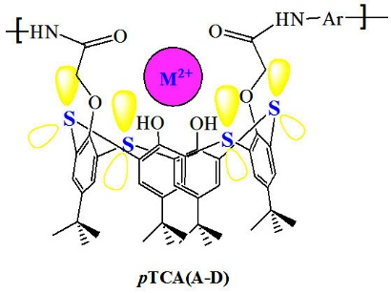
Scheme 3.polythiacalixamidecomplexation with large cations

Table 4. Sorption percentage (S %) of heavy metal cations by pTCAs
Polymer | Hg²⁺ | Pb²⁺ | Cd²⁺ | Co²⁺ | Cu²⁺
PTCA (A) | 93.2 | 92.2 | 91.2 | 85.8 | 30.4
PCA (CH₂) | ------ | ------ | 41.8 | 40.9 | 53.7
PTCA (B) | 90.0 | 89.5 | 93.2 | 80.0 | 57.3
PCA (Naph.) | ------ | ------ | 38.7 | 36.3 | 36.7
PTCA (C) | 93.3 | 92.3 | 90.0 | 83.1 | 59.3
PCA (Azo) | ------ | ------ | 36.4 | 44.2 | 48.0
PTCA (D) | 91.1 | 89.2 | 91.1 | 84.6 | 55.1
PCA (Oxy) | ------ | ------ | 39.4 | 38.3 | 51.8

Table 5. Distribution coefficients (K_{d}) of heavy metal cations by pTCAs
Polymer | Hg²⁺ | Pb²⁺ | Cd²⁺ | Co²⁺ | Cu²⁺
pTCA (A) | 5314.4 | 4728.2 | 4044.4 | 2416.9 | 174.6
pTCA (B) | 3600.0 | 3409.5 | 5314.4 | 1600.0 | 536.7
pTCA (C) | 5314.4 | 4600.1 | 3600.0 | 1966.8 | 582.8
pTCA (D) | 4044.4 | 3303.7 | 4094.3 | 2197.4 | 488.9

3.2.1. Sorption of transition metal cations in different pH
To evaluate the effect of pH on the sorption efficiency of pTCAs toward transition metal cations, some experiments have been performed in the pH range of 1.0 to11. It is found that at lower pH (up to pH 4.0), cationic ions especially Hg(II) was in the free ionic form,⁴⁶ and the existing hydrogen cations (H⁺) will strongly compete with the transition metal ions for binding with unoccupied sites of pTCAs. Since, the active sites of pTCA, which consists of sulfur, hydroxyl and amidic groups, are protonated in the presence of hydrogen cations. The strong electrical repulsion prevents the metal cations to reach the complexation sites and will cause in lower adsorption results. So, the lower adsorption efficiencies of pTCAs in strong acidic media were expected. Surprisingly the removal efficiency increased at pH about 5 to 7 and decreased slightly at pH greater than 9. Maximum sorption efficiency in the pH range 5–7 for pTCA can be attributed to the more polarizabale characteristics of chelating groups of pTCAs. In this regard, the larger flexible thiacalixamide macrocyclic units can form more effective complexes with metal cations particularly the larger ones such as Hg (II) and Pb (II). It is worthy to mention that metal cations may precipitate with hydroxide ions at higher pH (≥9) and therefore slightly decreases in the adsorption results were normal. Therefore, neutral conditions were preferred for heavy metal removal experiments.

3.3. Thermal stability
To explore the thermal stability of polythiacalixamides, thermal analyses including DSC and TGA were performed. The results, especially initial decomposition temperatures (IDTs) of pTCA (A-D) show that these polymers have considerable thermal stability. IDT data and other thermal properties such as T_{g}, T_{Max}, Char yields of the pTCAs (A-D) are also summarized in Table 6. The pTCAs showed glass transition temperatures (Tg), in the range of 157-178 °C by DSC, which are meaningful owing to such bulky pendent groups. The increasing order of Tg are corresponds to the increase in the order of rigidity and polarity of the polymer backbones. The relatively higher Tg value (178°C) of pTCA(B) may be as a result of structural stiffness caused by interchain forces between naphthalene units which solidify the polymer backbone and help polymer packing. The more solidity and better packing means the more rotation barrier and less flexibility. The thermal stability of polyamides was evaluated by TGA in nitrogen atmosphere. The figure 2 inset depicts a typical set of TGA curves for polyamide pTCA (A-D) in nitrogen. The decomposition temperatures (T_{d}) at 10% weight loss in nitrogen atmosphere were taken from the original TGA thermograms and are summarized in table 6. All the polythiacalixamides exhibited good thermal stability. As evident in table 6, the 10% weight loss of pTCA (A-D) was in the range of 337-346°C. The amounts of carbonized residues, char yields, were in the range of 39.1- 58.5 wt% at 700°C in nitrogen. The high char yields of these polyamides can be attributed to their high aromatic content. To survey more on the thermal characteristics of these polymers and to see the effect of sulfur atom on the thermal stability, comparison with the previously prepared PCA [31] was performed. By considering the results mentioned in table 6, the thermal stability parameters (e.g. IDTs) of the synthesized polythiacalixamides relative to that of reference polyamides show negligible differences between these two series of polyamides. Polythiacalixamides showed slightly higher T_{g} values owing to unique feature of sulfur atoms. Phenolic structures can rotate through the low energy barrier sulfur atoms to create different conformers prior to polymerization. So, as a result of low bulkiness of thiacalixarene, polythiacalixamides relative to polycalixamides with fixed methylene bridge groups and fixed cylindrical calixarene structures create less interchain cavity sizes and therefore more interchain forces will form. Thus, it is noteworthy to emphasize that polythiacalixamides due to the existence of polar coordinating sulfur atoms and adjustable conformers, represented high sorption capability, good solubility in industrial solvents and together with their significant thermal properties offer processability and applicability as a membrane.
Table 6. Thermophysical properties of polythiacalixamides
Polymer | T_{g}ª | T_{ini}^{b} | T_{10%}^{b} | T_{Max}^{c} | C yield (wt %)^{d}
PTCA (A) | 160 | 276 | 337 | 385 | 58.5
PCA (CH₂) | 155 | 285 | 340 | 363 | 46
PTCA (B) | 178 | 317 | 341 | 358 | 39.1
PCA (Naph.) | 162 | 302 | 323 | 356 | 56.2
PTCA (C) | 157 | 310 | 340 | 356 | 46.3
PCA (Azo) | 157 | 312 | 353 | 369 | 49.9
PTCA (D) | 161 | 324 | 346 | 354 | 32.9
PCA (Oxy) | 152 | 328 | 352 | 368 | 47.8

Fig. 2. TGA curves for polythiacalixamides
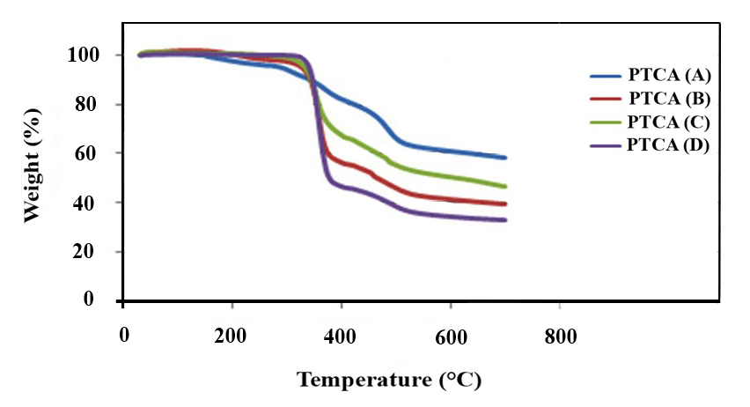

3.4. Overview on Mercury removal
Contamination of the environment with mercury which is naturally occurring in the earth’s crust and released with volcanic activity as well as industrial activities such as the burning of fossil fuels, ore processing, medical and municipal waste incineration, and the use of dental amalgams is a serious concern. Because of the hazardous characteristic of mercury such as a high toxicity, non-biodegradability and having very low permissible limit (0.001 ppm) in drinking water, even trace amounts of Hg ions must be removed from aquatic systems. During last decades different methods have been developed to eliminate mercury in all forms involving elemental, inorganic and organic compounds. Different kinds of sorbent have been applied to meet this need and some of the recent and important sorbents are cited in Table 7. Most of them have some limitation including temperature dependence, working pH, time of contact and etc. Herein, we introduced Polythiacalix[4]amides as novel functionalized polyamides which have shown some promising applicability toward removal of some hazardous heavy metals especially Hg(II) ion. As a result of acceptable thermal property and solubility as well as excellent sorption capability, pTCA can be employed in membrane technologies which focused on the reduction of mercury via recycling of Hg²⁺ from aqueous wastes and also reducing emissions from industrial activities.

Table 7. Comparison of sorption efficiency of p-TCA (A) with some of those reported in removal of Mercury (Hg²⁺)
Entry | Absorbents | Quantity of sorbent | Concentration  of Hg²⁺ | Time | Sorption capability (%) | Ref
1 | FeS₂ (Pyrite), N₂ atmosphere | 2 g/L | 2 mg L⁻¹ | (pH:4.1) 7 d  (pH:6.4) 2 d  (pH:10.4) 2 h | 95 | [47]
2 | Aluminum electrode (Electrocoagulation Method) | 4 cm×1 cm | 2× 10⁻⁵ M | (pH:7) 15 min | 99.85 | [48]
3 | Iron electrode  (Electrocoagulation Method) | 4 cm×0.8 cm | 2× 10⁻⁵ M | (pH:7) 15 min | 99.95 | [48]
4 | Thiacrown polymer | 20 mg/5 mL | 4-200 mg L⁻¹ | (pH:1.5 to 6.2) 30 min | ˃95 | [49]
5 | Bamboo leaf powder | 4 g/L | 100 mg L⁻¹ | (pH≈7) 60 min | 80 | [50]
6 | Activated carbon prepared  from c. pentandra hulls | 200 mg/50 mL | 40 mg L⁻¹ | (pH 6.0) 90 min | 99.7 | [46]
7 | Activated carbon prepared  from P. aureus hulls | 225 mg/50 mL | 40 mg L⁻¹ | (pH 7.0) 100 min | 98 | [46]
8 | Activated carbon prepared  fromc. arietinum waste | 300 mg/50 mL | 40 mg L⁻¹ | (pH 7.0) 110 min | 96.29 | [46]
9 | Thio chelating resin  (GMA–DVB) | 100 mg/100 mL | 5×10⁻³ M | (pH 5.8) 80 min | ≈100 | [51]
10 | Thiol chelating resin (Polystyrene) | 100 mg/20 mL | 400 mg L⁻¹ | (pH 1.5) 8 h | ≈100 | [52]
11 | Bayberry tannin-immobilized  collagen fiber | 100 mg/100 mL | 200.0 mg/L | (pH 7.0) 24 h | 98.34 | [53]
12 | Hydrous manganese oxide | 100 mg/10 mL | 1.0 × 10⁻⁸ mol dm⁻³ | (pH 2.2) 30 min | 96.1 | [54]
13 | Hydrous tin oxide | 100 mg/10 mL | 1.0 × 10⁻⁸mol dm⁻³ | (pH 2.2) 60 min | 93.1 | [54]
14 | Hydrous ferric oxide | 100 mg/10 mL | 1.0 × 10⁻⁵mol dm⁻³ | (pH = 8. 68) 65 min | 62 | [55]
15 | Hydrous tungsten oxide | 100 mg/10 mL | 1.0 × 10⁻⁵mol dm⁻³ | (pH = 4.42) 95 min | 93.5 | [56]
16 | Carbonaceous sorbent  Fromrice husk | 75 mg/100 mL | 200 mg/L | (pH = 6) 120 h | ˃90 | [57]
17 | Chitosan-coated cotton fibers | 100 mg/25 mL | 0.008 mol L⁻¹ | (pH = 5) 20 h | ≈ 99 | [58]
18 | Manganese dioxide nano-whiskers | 10 mg/100 mL | 10 mg L⁻¹ | (pH=5.5) 1 h | ≈ 99 | [58]
19 | Poly(acrylic acid) modified  seed gum | 100 mg/20 mL | 100 mg L⁻¹ | (pH = 6) 4 h | 92.36 | [59]
20 | Polythiacalix[4]amides | 25 mg/10 mL | 10×10⁻³ M | (pH=7) 3h | 93.2 | -

3.5. Antibacterial evaluation
The in vitro antibacterial activity of the synthesized polythiacalixamides against clinical isolates of Gram-positive and Gram-negative pathogens such as Escherichia coli (ATCC 25922), Staphylococcus aureus (ATCC 25923), Klebsiella Pneumoniae (NCTC 5056), Pseudomonase aeruginosa (1561) and Bacillus subtilis 1715 (PY79) bacterial strains was tested and compared with Penicillin, Ciprofloxacin and Gentamicin as reference antibacterials. In these experiments, minimum inhibitory concentrations (MICs) and minimum bactericidal concentration (MBC) were determined and their activities were interrelated by the known antibiotics penicillin, ciprofloxacin and gentamicin as known standards. The evaluation of the antibacterial studies declared that the polymers showed acceptable inhibition capabilities at different levels which was necessary for being incorporated in food and medical industeries. The MIC was the lowest concentration with no visible growth. The growth of bacteria was observed in the cells with lower concentrations than MIC. The solutions with no visible growth were then spread on agar plates and incubated at 37°C for 24 h to obtain MBC values.
The good activity can be attributed to the presence of pharmacologically active thiacalixarenes which are directly employed in the polymeric backbone. Also this result was probably ascribed to the nucleophilic characteristic of high value sulfur atoms which could modify the electronic density in the polymeric chains and thereby influence the absorption, distribution and metabolism of the bioactive molecules.
The mentioned antibiotics were evaluated for their antibacterial activity against standard bacteria strains according to table CLSI (2011). Results have been presented in table 8. As can be seen, all of the standard samples were very sensitive against ciprofloxacin antibiotic. The Lowest MIC was recorded for E.Coli which was about 0.015μg/mL. However, Bacillus subtilis and Staphylococcus aureus were sensitive toward gentamicine and penicillin antibiotics according to antimicrobial measurements data given in table (8). The MBC results state that examined antibiotics were so much effective toward the mentioned microorganisms. Antibacterial experiments indicated that these polymers have displayed some reliable bactericidal efficiency in high concentrations. In the other hand, in vitro antibacterial assay of the synthesized polycalixamides (A-C) exhibited acceptable activities against all the Gram-positive and Gram-negative strains tested. PTCA-D removed from these experiments due to low solubility which was necessary for micro dilution procedure. However, the synthesized PTCA (A-D) were not in the range of the known commercial antibiotics mentioned above, but we can still achieve some antibacterial applicability with using these polymers in the next generation of industrial food and medical appliances or in coating equipments which need high thermal stability, acceptable solubility for processing, and reliable antimicrobial characteristic at the same time.

Table 8: Comparison of in vitro antibacterial activities of the synthesized polyamers, monomers and known antibiotics after 24-48 h, conc. μg/mL
Bacteria  Polymer | Gram Negative |  |  |  |  |  | Gram Positive
Bacteria  Polymer | Escherichia coli |  | Pseudomonase aeruginosa |  | Klebsiella Pneumoniae |  | Bacillus subtilis |  | Staphylococcus aureus
 | MIC | MBC | MIC | MBC | MIC | MBC | MIC | MBC | MIC | MBC
PTCA-A | 125 | 250 | 250 | >250 | 250 | >250 | 31.2 | 125 | 62.5 | 125
PTCA-B | 187.5 | 375 | >375 | ----- | 187.5 | >375 | 375 | >375 | 375 | >375
PTCA-C | >250 | ----- | >250 | ----- | >250 | ----- | >250 | ----- | 250 | >250
Penicillin | 8 | >8 | >8 | ----- | >8 | ----- | 0.125 | 0.5 | 0.062 | 0.125
Ciprofloxacin | 0.015 | 0.062 | 0.062 | 0.125 | 0.031 | 0.062 | 0.031 | 0.125 | 0.031 | 0.062
Gentamicin | 4 | 8 | >128 | ----- | >128 | ----- | 4 | 8 | 0.5 | 1

4. Conclusions
In macromolecular science, it has been proved that calixarene based ionophores have great acceptability in modern chemistry because of their extreme capability in functionalization from bridge position up to the rims. Therefore, we have taken the advantage of these structures for preparation of ion-selective as well as antibacterial polymers to suggest novel formulation for producing antibacterial membranes. Hence, the main goal of this work is to achieve polyamides with potential great sorption capability which being applied in polymeric sorbents and membranes. Moreover, preparation of antibacterial polyamides which have both antibacterial characteristics and also high temperature bearing capacity was the other goals of this study. So, these ambitions were accomplished by incorporation of thiacalixarene moiety into the polyamide chains via polycondensation of thiacalixarene dicarboxylic acid with commercial diamines. The performed experiments demonstrated the characteristic features such as organo-solubility, photophysical behavior, thermal stability and sorption capabilities of polythiacalixamids, besides their reliable and valuable antibacterial properties. Among them, high extraction efficiencies toward Hg²⁺, Pb²⁺, Cd²⁺ and Co²⁺ was exceptional and seem to be good choices for additional sorption studies in the future. These polyamides bearing unique structure of thiacalixarene with precisely oriented amidic functionality and sulfur atoms, provide excellent complexation site for the cations and of course for interaction with cell walls of gram positive and negative pathogens. Moreover, their intrinsic thermal stability and favorable solubility makes it potentially applicable for advanced industrial purposes and in fabricating medical appliances.

5. Acknowledgments
The financial supports by Babol University of medical sciences as well as Research Council of Mazandaran University are gratefully acknowledged. Also we should appreciate Fariba asgharpour (M.Sc.) for helping us in the evaluation of antibacterial characteristics.

6. References:
1. J. Luo, Y. S. Zheng, Curr. Org. Chem., 2017, 16, 483-506.
2. K. Gloe, Macrocyclic chemistry (Current trends and future perspectives), Kluwer Academic Publishers, Dordrecht, 2005.
3. W.Walkowiak, C.A. Kozlowski, Desal. 2009, 240, 186-197.
4. J. W. Steed, J. L. Atwood, Supramolecular Chemistry second ed. Wiley, New York, 2009.
5. O. H. Rubio, R. Taouil, F. M. Muñiz, L. M. Monleón, L. Simón, F. Sanz, J. R. Morán, Org. Biomol. Chem., 2017, 15, 477-485.
6. S.B. Maamar, N. Jadambaa, F. Vocanson, F. Meganem, C. Felix, I. Dumazet-Bonnamour, J. Supramol. Chem. 2009, 21, 450-454.
7. S. Sayin, F. Ozcan, M. Yilmaz, Desal. 2010, 262, 99-105.
8. R. Ebdelli, A. Rouis, J. Davenas, I. Bonnamour, H. Ben Ouada, Sensor Lett. 2011, 9, 2241-2244.
9. S. Sayin, M. Yilmaz, Desal. 2011., 276, 328-335.
10. I. Akin, S. Erdemir, M. Yilmaz, M. Ersoz, J. Hazard. Mat. 2012, 223-224, 24-30.
11. J. W. Steed, P.A. Gale, Supramolecular chemistry: from molecules to nanomaterials, John Wiley & Sons, Ltd. New York, 2012.
12. S. M. Baghbanian, Y. Babajani, H. Tashakkorian, S. Khaksar, M. Farhang, Comptes Rendus Chimie, 2013, 16, 129–134.
13. M. M. Lakouraj, H. Tashakkorian, M. Rouhi, Chem. Sci. Trans. 2013, 2, 739-748.
14. M. D. Shah, Y. K. Agrawal. Calixarene: A new architecture in the pharmaceuticals, J. Sci. Indust. Res. 2012, 71, 21-26.
15. D. Reinhoudt, Supramol. Chem. 2016, 28, 342-350.
16. Stefan L. Debbert, Bradley D. Hohand, David J. Dulak, J. Chem. Educ. 2016, 93, 372–375.
17. F. Zhang, Y. Sun, D. Tian, W. S. Shin, J. S. Kim, H. Li, Chem. Commun. 2016, 52, 12685-12693.
18. R. Lamartine, C. Bavoux, F. Vocanson, A. Martin, G. Senlis, M. Perrin, Tetrahedron Lett. 2001, 42, 1021-1024.
19. S. Bouhroum, F. Arnaud-Neu, Z. Asfari, J. Vicens, J. Supramol. Chem. 2005, 17, 629-635.
20. Y. K. Agrawal, J. P. Pancholi, Ind. J. Chem. 2007, (A) 46, 1373-1382.
21. A. Zaghbani, R. Tayeb, M. Dhahbi, M. Hidalgo, F. Vocanson, I. Bonnamour, P. Seta, C. Fontàs, Sep. Purif. Technol. 2007, 57, 374-379.
22. Y. Li, X. Hu, X. Song, T. Sun, Environ. Poll. 2012, 167, 93-100.
23. A. Akdoğan, M. Deniz, S. Cebecioglu, A. Sen, H. Deligöz, Sep. Sci. Technol. 2002, 37, 973-980.
24. E. A. Shokova, V. V. Kovalev, Russ. J. Org. Chem. 2002, 39, 1-28.
25. H. Deligöz, J. Incl. Phenom., 2006, 55, 197.
26. M. H. Patel, V. B. Patel, P. S. Shrivastav, Tetrahedron, 2008, 64, 2057.
27. M. Tabakci, M. Yilmaz, Bioresour. Technol. 2008, 99, 6642-6655.
28. H. Deligöz, S. Memon, Pak. J. Anal. Environ. Chem. 2011, 12, 1-24.
29. B. Dizman, M. O. Elasri, L. J. Mathias, J. appl. polym. sci. 2004, 94, 635-642.
30. G. Thenmozhi, D. Jaya Kumar, Mohanraj Gopalswamy, R. Jaya Santhi, Der Pharma. Chem. 2011, 3(6), 325-333.
31. M. M. lakouraj, H. Tashakkorian, J. Macromol. Sci. Part A, 2012, 49, 806-813.
32. M. M. lakouraj, H. Tashakkorian, J. Macromol. Sci. Part A, 2013, 50, 310-320.
33. M. M. lakouraj, H. Tashakkorian, J. Supramol. Chem. 2013, 25, 221-232.
34. V. Hasantabar, M. M. lakouraj, H. Tashakkorian, M. Rouhi, Des. Monomer. Polym. 2016, 19, 607-618.
35. D. D. Perrin, W. L. F. Armarego, Purification of laboratory chemicals, Pergamon Press plc. Oxford, UK. 1988.
36. H. Kumagai, M. Hasegawa, S. Miyanari, Y. Sugawa, Y. Sato, T. Hori, S. Ueda, H. Kamiyama, S. Miyano, Tetrahedron Lett. 1997, 38, 3971-3972.
37. T. Sone, Y. Ohba, K. Moriya, H. Kumada, K. Ito, Tetrahedron, 1997, 53, 10689-10698.
38. B. Masci, Z. Asfari, V. Böhmer, J. Harrowfield, J. Vicens, Calixarenes 2001, Kluwer Academic Publishers, Dordrecht, Netherlands, 2001, PP. 235-249.
39. C. R. Mahon, D. C. Lehman, G. Jr. Manuselis, Textbook of diagnostic microbiology, Elsevier Health Sciences, London, 2014.
40. A. F. Danil De Namor, W.B. Aparicio-Aragon, M. T. Goitia, A. R. Casal, J. Supramol. Chem, 2004, 16, 423-433.
41. V. Arora, H. M. Chawla, S. P. Singh, Arkivoc, 2007, 172-200.
42. I. I. Abbas, J. K. Chaaban, J. Supramol. Chem. 2012, 24, 213-219.
43. C. Wieser, C. B. Dieleman, D. Matt, Coord. Chem. Rev. 1997, 165, 93-161.
44. C. D. Gutsche, Calixarenes revisited, Royal Society of Chemistry, Cambridge, 1998.
45. D. M. Roundhill, H. F. Koch, Chem. Soc. Rev. 2002, 31, 60-67.
46. M. M. Rao, Reddy D. H. K. Kumar, P. Venkateswarlu, K. Seshaiah, J. Environ. Manage. 2009, 90, 634-643.
47. J. Bower, K. S. Savage, B. Weinman, M. O. Barnett, W. P. Hamilton, W. F. Harper, Environ. Pollut. 2008, 156, 504-514.
48. C. P. Nanseu-Njiki, S. R. Tchamango, P. C. Ngom, A. Darchen, E. Ngameni, electrodes, J. Hazard. Mat. 2009, 168, 1430-1436.
49. T. F. Baumann, J. G. Reynolds, G. A. Fox, React & Funct. Polym. 2000, 44, 111-120.
50. D. K. Mondal, B. K. Nandi, M. K. Purkait, J. Environ. Chem. Eng. 2013, 1, 891-898.
51. A. A. Atia, A. M. Donia, A. M. Yousif, React &Funct. Polym. 2003, 56, 75–82.
52. L. Joseph, V. N. S. Pillai, Environ. Pollut. 1987, 48, 213-222.
53. X. Huang, X. Liao, B. Shi, J. Hazard. Mat. 2009, 170, 1141–1148.
54. S. P. Mishra, S. S. Dubey, D. Tiwari, J. Colloid and Interface Sci. 2004, 279, 61–67.
55. S. P. Mishra, (Miss) Vijaya, J. Colloid and Interface Sci. 2006, 296, 383–388.
56. E. I. El-Shafey, J. Hazard. Mat. 2010, 175, 319–327.
57. R. Qu, C. Sun, F. Ma, Y. Zhang, C. Ji, Q. Xu, C. Wang, H. Chen, J. Hazard. Mat. 2009, 167, 717–727.
58. K. P. Lisha, S. M. Maliyekkal, T. Pradeep, Chem. Engin. J. 2010, 160, 432–439.
59. V. Singh, S. K. Singh, S. Maurya, Chem. Engin. J. 2010, 160, 129–137.

