A 26-Membered Macrocycle Obtained by a Double Diels–Alder Cycloaddition Between Two 2H-Pyran-2-one Rings and Two 1,1'-(Hexane-1,6-diyl)bis(1H-pyrrole-2,5-dione)s

Bor Lucijan Turek, Marijan Kočevar, Krištof Kranjc,* Franc Perdih*
Faculty of Chemistry and Chemical Technology, University of Ljubljana, Večna pot 113, SI-1000 Ljubljana, Slovenia
E-mail: franc.perdih@fkkt.uni-lj.si; kristof.kranjc@fkkt.uni-lj.si
Dedicated to Professor Emeritus Miha Tišler, University of Ljubljana, on the occasion of his 90th birthday.

Abstract
With the application of a double dienophile 1,1'-(hexane-1,6-diyl)bis(1H-pyrrole-2,5-dione) for a [4+2] cycloaddition with a substituted 2H-pyran-2-one a novel 26-membered tetraaza heteromacrocyclic system 3 was prepared via a direct method under solvent-free conditions with microwave irradiation. The macrocycle prepared is composed of two units of the dienophile and two of the diene. The structure of the macrocycle was characterized on the basis of IR, ¹H and ¹³C NMR and mass spectroscopy, as well as by the elemental analysis and melting point determination. With X-ray diffraction of a single crystal of the macrocycle we have determined that the two acetyl groups (attached to the bridging double bond of the bicyclo[2.2.2]octene fragments) are oriented towards each other (and also towards the inside of the cavity of the macrocycle), therefore, mostly filling it completely.

Keywords: Macrocycles, 2H-Pyran-2-ones, [4+2] Cycloaddition, Crystal structure, Hydrogen bonds, Polymorphs

1. Introduction
Macrocycles are privileged molecule structures that are of paramount importance in many areas of chemistry, including drug development,¹ formation of coordination compounds and metal-organic frameworks.² Generally they possess properties (structural, chemical, physical and biological) that set them apart from their linear or small-ring analogues, the reason being that they can often provide sufficient flexibility for interactions with other molecules (e.g. for binding to an enzyme's active site or for a coordination to a guest ion during phase catalysis) combined with the advantages brought by the fact that they often contain more than one binding motif. This means that all of the interactions between the host (or enzyme) and the macrocycle are taking place between two molecules only and consequently the enthropy of the interaction is not so unfavourable as would be in the case where more (smaller) ligands interact simultaneously with the host.
Even though the synthesis of macrocycles has achieved some remarkable successes, there is still a lack of general approach towards them.³ There were many successful attempts towards the preparation of macrocycles, one of the most-often used being dilution techniques triggering the macrocyclization via lactonization, lactamization, metathesis reaction etc. (that were recently used for the first asymmetric total synthesis of aspergillide D⁴ or for the total synthesis of mandelalide A).⁵ Other options include the template-induced cyclization (around the host ion)⁶ and cyclization on a solid support (like Merrifield-based synthesis of cyclic peptides or such inspired by non-ribosomal peptide aldehydes).⁷ More contemporary approaches are based on multi multicomponent macrocyclizations (MiBs)⁸ that include various bifunctional building blocks. However, neither of the above mentioned approaches can be applied universally. So there is still place for new routes. Recently, a lot of effort was devoted to multicomponent reactions that efficiently offer access to various macrocycles, including the possibility to incorporate points of diversity, which are, nevertheless, generally introduced before or after the key cyclization step.⁹ However, even this approach is generally applied just to obtain the requisite linear precursors that are latter assembled via a suitable ring-closing reaction into the final macrocyclic target.^{10–14} Of interest are also preparations of calix[4]arene systems linked with 1,2,4-triazole and 1,3,4-oxadiazole derivatives,¹⁵ as well as other tetraaza macrocycles applied as ligands in various coordination compounds.¹⁶
Herein we present another approach, where two double Diels–Alder cycloadditions between two molecules of the substituted 2H-pyran-2-ones (each acting as a "double" diene)¹⁷ and two molecules of the double dienophile provide a 26-membered tetraaza macrocyclic system. This strategy can be termed a multicomponent reaction (as four molecules react to form the macrocycle) with four individual [4+2] pericyclic reactions representing the crucial ring-closing steps.

2. Experimental
2.1. Materials and Measurements
Melting points were determined on a micro hot stage apparatus and are uncorrected. ¹H NMR spectra were recorded at 29 °C with a Bruker Avance III 500 spectrometer at 500 MHz using Me₄Si as an internal standard. ¹³C NMR spectra were recorded at 29 °C with a Bruker Avance III 500 spectrometer at 125 MHz and were referenced against the central line of the solvent signal (CDCl₃ triplet at 77.0 ppm or DMSO-d₆ septet at 39.5 ppm). The coupling constants (J) are given in Hertz. IR spectra were obtained with a Bruker Alpha Platinum ATR FT-IR spectrometer on a solid support as microcrystalline powder. MS spectra were recorded with an Agilent 6624 Accurate Mass TOF LC/MS instrument (ESI ionization). Elemental analyses (C, H, N) were performed with a Perkin Elmer 2400 Series II CHNS/O Analyzer. TLC was carried out on Fluka silica-gel TLC-cards.
The starting 2H-pyran-2-one 1 was prepared by the method devised by Kepe, Kočevar et al.¹⁸ as follows: from acetylacetone, N,N-dimethylformamide dimethyl acetal (DMFDMA) and hippuric acid by heating in acetic anhydride according to the published procedure 5-acetyl-3-benzoylamino-6-methyl-2H-pyran-2-one was obtained; followed by the removal of the benzoyl group (in concentrated H₂SO₄ upon heating) analogously as previously described^{19,20} and subsequent derivatization of the free 3-amino group with acetyl chloride the 2H-pyran-2-one 1 was obtained.²¹ Dienophile 2 was prepared by a modification of the procedures published by Cava et al.²² All other reagents and solvents were used as received from commercial suppliers.
Microwave reactions were performed in air using a focused microwave unit (Discover by CEM Corporation, Matthews, NC, USA). The machine consists of a continuous, focused microwave power-delivery system with an operator-selectable power output ranging from 0 to 300 W. Reactions were conducted in darkness in glass vessels (capacity 10 mL) sealed with rubber septum. The pressure was controlled by a load cell connected to the vessel via the septum. The temperature of the reaction mixtures was monitored using a calibrated infrared temperature controller mounted below the reaction vessel and measuring the temperature of the outer surface of the reaction vessel. The mixtures were stirred with a Teflon-coated magnetic stirring bar in the vessel. Temperature, pressure, and power profiles were recorded using commercially available software provided by the manufacturer of the microwave unit.

Synthesis of 1,1'-(Hexane-1,6-diyl)bis(1H-pyrrole-2,5-dione) (2)²²
To a clear solution of maleic anhydride (2.03 g, 20 mmol) in diethyl ether (30 mL) a separately prepared mixture of hexane-1,6-diamine (2.07 g, 10 mmol) in diethyl ether (10 mL) is added dropwise at room temperature. The viscous suspension is further stirred at room temperature for 1 h and thereafter cooled on ice. Precipitated product is isolated by vacuum filtration and used in the next step without drying or additional purification.
The entire obtained solid is slowly added to a mixture of sodium acetate (0.66 g, 8 mmol) and acetic anhydride (8 mL) in an Erlenmayer flask while vigorously stirring at room temperature. After the completion of the addition, the reaction mixture is heated on water bath (approx. 100 °C) for 1 h, cooled to room temperature and poured onto ice–water mixture (30 g). The precipitated product is isolated by vacuum filtration, rinsed 3 times with distilled water and once with a few mL of petroleum ether yielding crude 2 (0.56 g, 20%) that is further crystallized from ethanol.
M.p. 139–141 °C (EtOH), m.p. (lit.)²³ 139–141 °C (EtOH). IR (ATR) 3104, 3087, 2936, 2856, 1686, 1453, 1418, 1372, 1327, 1240, 1129 cm^{–1}. ¹H NMR (500 MHz, CDCl₃): δ 1.29 (m, 4H, 2 × NCH₂CH₂CH₂), 1.59 (m, 4H, 2 × NCH₂CH₂CH₂), 3.51 (t, 4H, 2 × NCH₂CH₂CH₂), 6.69 (s, 4H, 4 × CH). ¹³C NMR (125 MHz, CDCl₃): δ 25.6, 27.8, 36.9, 124.4, 171.1. MS (ESI+) m/z 277 (MH⁺). HRMS calcd. for C₁₄H₁₆N₂O₄: 277.1183. Found: 277.1181. Anal. calcd. for C₁₄H₁₆N₂O₄·0.1 H₂O: C, 60.47; H, 5.87; N, 10.07. Found: C, 60.43; H, 5.89; N, 9.95.

Synthesis of the Macrocycle 3
A 10 mL quartz microwave vessel is loaded with 2H-pyran-2-one 1 (105 mg, 0.5 mmol), dienophile 2 (152 mg, 0.55 mmol) and n-butanol (100 mg). A stirring bar is added and the vessel closed with the rubber septum. The reaction mixture is irradiated with microwaves (150 W) at 150 °C for 45 min. Thereafter, the reaction mixture is cooled to room temperature and diisopropyl ether is added (0.5 mL). The precipitated product is collected by vacuum filtration providing crude macrocycle 3 (150 mg, 34%) that is further crystallized from DMF.
M.p. 255–257 °C (DMF). IR (ATR) 3368, 2940, 2860, 1766, 1698, 1548, 1437, 1399, 1367 cm^{–1}. ¹H NMR (500 MHz, DMSO-d₆): δ 1.03 (m, 8H, 2 × NCH₂CH₂CH₂CH₂CH₂CH₂N), 1.23 (m, 8H, 2 × NCH₂CH₂CH₂CH₂CH₂CH₂N), 1.85 (s, 6H, 2 × Me), 1.95 (s, 6H, 2 × NHCOCH₃), 2.02 (s, 6H, 2 × COMe), 3.00 (d, J = 7.5 Hz, 4H, 2 × 3a-H, 4a-H), 3.18 (m, 8H, 2 × NCH₂CH₂CH₂CH₂CH₂CH₂N), 4.11 (d, J = 7.5 Hz, 4H, 2 × 7a-H, 8a-H), 6.82 (s, 2H, 2 × CH), 8.43 (s, 2H, 2 × NH). ¹³C NMR (125 MHz, DMSO-d₆): δ 18.2, 23.5, 25.8, 27.0, 27.4, 37.7, 41.2, 42.9, 48.8, 57.2, 138.2, 142.7, 170.3, 174.1, 175.3, 195.8. MS (ESI+) m/z 884 (MH⁺). HRMS calcd. for C₄₆H₅₄N₆O₁₂: 883.3872. Found: 883.3844. Anal. calcd. for C₄₆H₅₄N₆O₁₂·0.8 H₂O: C, 61.57; H, 6.24; N, 9.37. Found: C, 61.57; H, 6.36; N, 9.27.

2.2. Crystallography
Single-crystal X-ray diffraction data were collected at room temperature on a Nonius Kappa CCD diffractometer using graphite monochromated Mo-Kα radiation (λ = 0.71073 Å). The data were processed using DENZO.²⁴ Structures were solved by direct methods implemented in SIR97²⁵ and refined by a full-matrix least-squares procedure based on F² with SHELXL-2014.²⁶ All non-hydrogen atoms were refined anisotropically. Hydrogen atoms were readily located in a difference Fourier maps and were subsequently treated as riding atoms in geometrically idealized positions, with C–H = 0.93 (aromatic), 0.98 (methine), 0.97 (methylene) or 0.96 Å (CH₃), N–H = 0.86 Å and with U_{iso}(H) = kU_{eq}(C or N), where k = 1.5 for methyl groups, which were permitted to rotate but not to tilt, and 1.2 for all other H atoms. To improve the refinement results, two reflections in the case of 2a, eleven reflections in the case of 2b and twenty eight reflections in the case of 3∙2DMF with too high values of δ(F²)/e.s.d. and with F_{o}² < F_{c}² were deleted from the refinement. In 2b a proposed twin law has been applied according to Platon analysis and the R₁ factor has improved from 8.13% to 7.75%, however, instead of estimated BASF 0.19 the refined BASF was found to be 0.00939. In the crystal structure of 3∙2DMF a solvate DMF molecule is disorder over two positions with refined ratio 0.82:0.18 and ISOR instruction was used for the refinement of C25B atom in DMF. Crystallographic data are listed in Table 1. X-Ray powder diffraction data were collected at room temperature using a PANalytical X’Pert PRO MPD diffractometer with θ–2θ reflection geometry, primary side Johansson type monochromator and Cu-Kα1 radiation (λ = 1.54059 Å).

Table 1. Crystal data and refinement parameters for the compounds 2a, 2b and 3∙2DMF.
Compound | 2a | 2b | 3∙2DMF
CCDC | 1547701 | 1547702 | 1547703
Molecular formula | C₁₄H₁₆N₂O₄ | C₁₄H₁₆N₂O₄ | C₅₂H₆₈N₈O₁₄
Molecular weight | 276.29 | 276.29 | 1029.14
Crystal system | Triclinic | Monoclinic | Orthorhombic
Space group | P –1 | P 2₁/a | P c a n
a (Å) | 4.5975(2) | 8.4999(3) | 10.4260(10)
b (Å) | 5.5190(3) | 6.6347(2) | 17.5217(2)
c (Å) | 14.1680(10) | 12.6120(5) | 27.8937(4)
α (°) | 93.956(3) | 90 | 90
β (°) | 97.222(4) | 98.295(2) | 90
γ (°) | 97.692(4) | 90 | 90
V (Å³) | 352.08(4) | 703.80(4) | 5095.7(5)
Z | 1 | 2 | 4
D_{calc} (g cm^{–3}) | 1.303 | 1.304 | 1.341
μ (mm^{–1}) | 0. 097 | 0.097 | 0.098
F(000) | 146 | 292 | 2192
Crystal dimensions (mm) | 0.60 × 0.35 × 0.05 | 0.60 × 0.50 × 0.05 | 0.28 × 0.13 × 0.08
Reflections collected | 2464 | 3070 | 11000
Data / restraints / parameters | 1540 / 0 / 91 | 1566 / 0 / 93 | 5819 / 6 / 369
R_{int} | 0.0227 | 0.0204 | 0.0320
R₁, wR₂ [I > 2σ(I)]ª | 0.0444, 0.1231 | 0.0775, 0.2475 | 0.0486, 0.1157
R₁, wR₂ (all data)^{b} | 0.0580, 0.1343 | 0.0854, 0.2540 | 0.0855, 0.1335
Goodness of fit on F², S^{c} | 1.039 | 1.097 | 1.010
Extinction coefficient | - | 0.62(15) | -
Δρ_{max}, Δρ_{min} (e Å^{–3}) | 0.128, –0.150 | 0.226, –0.229 | 0.263, –0.306
ª R = ∑||F_{o}| – |F_{c}||/∑|F_{o}|. ^{b} wR₂ = {∑[w(F_{o}² – F_{c}²)²]/∑[w(F_{o}²)²]}^{1/2}. ^{c} S = {∑[(F_{o}² – F_{c}²)²]/(n/p)}^{1/2} where n is the number of reflections and p is the total number of parameters refined.

3. Results and Discussion
3.1. Synthesis
The strategy for the synthesis of the macrocycle 3 was based on our previous experiences with the [4+2] cycloadditions of variously substituted 2H-pyran-2-ones and appropriate dienophiles, including N-substituted maleimides.^{27–31} Namely, it was already observed that 2H-pyran-2-ones can act as "double" dienes, reacting in two consecutive Diels–Alder reactions with two distinctive molecules of the dienophiles, yielding bicyclo[2.2.2]octenes.³⁰ The initial cycloaddition step leads to the formation of CO₂-bridged oxabicyclo[2.2.2]octenes that in the next step eliminate a molecule of CO₂ (via a retro-hetero-Diels–Alder reaction) providing cyclohexadiene systems that act as new dienes for another molecule of dienophile finally providing the double cycloadducts. On the other hand, if the two molecules of the dienophile would be connected by a suitable tether, it would be possible to expect that the second cycloaddition step would take place intramolecularly. At least in theory, the smallest possible cyclic product would consist of just one bicyclo[2.2.2]octene fragment (formed out of one 2H-pyran-2-one ring) and one molecule of the double dienophile. Related examples were already described by the application of cycloocta-1,4-diene.³² Of course, it could be also possible that larger cycles would be obtained, for example such that contain two bicyclo[2.2.2]octene moieties and two molecules of the double dienophile.
Here, we have focused our attention to a 3-acetylamino-6-methyl-2H-pyran-2-one (1) and 1,1'-(hexane-1,6-diyl)bis(1H-pyrrole-2,5-dione) (2) as the double dienophile (Scheme 1). In this case one could expect the formation of various cyclic systems, the simplest one consisting of one bicyclo[2.2.2]octene fragment and one fragment stemming from 2. The other possibility would be the formation of the macrocyclic ring from two dienes 1 and two molecules of 2. Even larger systems that could form theoretically, however, were not expected (as their formation is entropically less likely); on the other hand, the formation of a linear polymer containing bicyclo[2.2.2]octene fragments (stemming from 1) alternating with the dienophile parts (from 2) could not be excluded.

Scheme 1. Reaction sequence leading to the macrocycle 3.

The preparation of the double dienophile 2 was carried out according to the literature procedure²² starting from the commercially available maleic anhydride and hexane-1,6-diamine in diethyl ether at room temperature. After the first reaction step (i.e. the formation of an open-ring intermediate consisting of a terminal carboxylic acid group―formed by the opening of the anhydride ring―and a new amide fragment arising from the reaction between the remaining carbonyl group and the amine group of the hexane-1,6-diamine. This intermediate is in the next reaction step mixed with the solution of sodium acetate in acetic anhydride and upon heating to 100 °C re-cyclized into the new maleimide ring. Of course, because the starting hexane-1,6-diamine is a bi-functional compound containing two suitable amine groups, the above described reaction sequence takes place on both sides of the diamine, therefore furnishing the desired double dienophile 2.
2H-Pyran-2-one derivative 1, applied in this synthetic approach, can be straightforwardly accessed via a one-pot synthesis starting from the simple commercially available precursors: a carbonyl compound containing an activated CH₂ group (i.e. acetylacetone), a C₁-synthon such as N,N-dimethylformamide dimethyl acetal (DMFDMA) and hippuric acid (2) as an N-acylglycine derivative as previously described by Kepe, Kočevar and co-workers.¹⁸ The synthesis takes place under heating (approx. 65–70 °C) in acetic anhydride (or in a mixture with acetic acid) as the solvent yielding the substituted 3-benzoylamino-2H-pyran-2-one. To convert this into the desired 3-acylamino derivative 1, cleavage of the amide bond is executed (in conc. H₂SO₄ at approx. 80 °C), the product containing a free NH₂ group is isolated by the extraction in CH₂Cl₂ (after addition of water and neutralization with sodium hydrogen sulfate)¹⁹ and further acetylated with acetyl chloride at room temperature in CH₂Cl₂ with the addition of pyridine as the base.²¹
Compound 2 was in the next step applied as the double dienophile in the Diels–Alder reaction with 5-acetyl-3-acetylamino-6-methyl-2H-pyran-2-one (1) as the diene component. Because 2H-pyran-2-one skeletons can in general participate in two separate Diels–Alder reactions, the combination of the double dienophile 2 and the 2H-pyran-2-one derivative 1 was deemed appropriate for the preparation of a macrocyclic system. We assumed that the most probable outcome would be the reaction of two molecules of the dienophile 2 with two molecules of 2H-pyran-2-one 1. In this way the former 2H-pyran-2-one skeleton would be transformed into a new bicyclo[2.2.2]octene moiety (as described above), however due to the bifunctional nature of the dienophile 2, both bicyclo[2.2.2]octenes would be connected with two –[CH₂]₆– tethers.
The cycloaddition between dienophile 2 and 2H-pyran-2-one derivative 1 was carried out employing microwave irradiation³³ at 150 °C in closed vessel and under solvent-free conditions, just with a small addition of n-BuOH (100 mg for a 10 mL vessel). Its function was to prevent the deposition of the dienophile 2 on the upper (colder) parts of the reaction vessel as a consequence of its sublimation, as we have devised previously.³⁴
Indeed, after the cooling of the reaction mixture and addition of diisopropyl ether, product 3 was isolated and further crystallized from DMF. According to the ¹H NMR analysis of 3 it was clear that a macrocyle was obtained, composed of two –[CH₂]₆– chains (multiplets at δ 1.03, 1.23 and 3.18 ppm each integrated for 8H, belonging to the two central γ-CH₂ groups of the chain, to the two β-CH₂ units and to the two α-CH₂ groups, respectively), two methyl groups (singlet at δ 1.85 ppm integrated for 6H), two acetylamino groups (singlet at δ 1.95 ppm integrated for 6H) and two acetyl groups (singlet at δ 2.02 ppm integrated for 6H). Furthermore, two most characteristic doublets (each for 4H) were observed at δ 3.00 and 4.11 ppm, each corresponding to the two sets of protons on the bicyclo[2.2.2]octene fragment. According to our experiences with NMR spectra of such systems, from the existence of only two doublets and from the coupling constant observed (i.e. 7.5 Hz), we can conclude that the bicyclo[2.2.2]octene fragment is of the symmetric exo,exo structure, also consistent with our previous results.³⁰ Furthermore, a singlet at δ 6.82 (for 2H) corresponding to both protons attached to the double bond of the bicyclo[2.2.2]octene fragments and a singlet at δ 8.43 (for 2H) for the two NH groups were also observed in ¹H NMR. In the IR spectrum of 3 bands corresponding to the NH group at 3368 cm^{–1} and carbonyl group at 1698 cm^{–1} were observed. These data were further corroborated by the ¹³C NMR and mass spectroscopy, as well as elemental analysis, establishing the structure of 3 as a novel 26-membered tetraaza heteromacrocyclic system.

3.2. Crystal Structures
X-Ray crystal structures of 2 and 3 were determined, where two polymorphs of 1,1'-(hexane-1,6-diyl)bis(1H-pyrrole-2,5-dione) (2) were observed. All bond lengths of 2a, 2b and 3 are within normal ranges.³⁵ Conventional re-crystallization of 2 from ethanol, followed by cooling to 5 °C provided a crystalline form 2a. On the other hand, slow precipitation of 2 from its mixture with starting 1 in toluene (i.e. a reaction mixture remaining after an unsuccessful attempt to prepare 3) upon evaporation of the solvent at 5 °C provided a different polymorph 2b. Polymorph 2a crystallizes in triclinic P –1 space group and polymorph 2b in monoclinic P 2₁/a space group (Figure 1a,b). In both polymorphs asymmetric unit is composed of a half of molecule 2 due to the inversion center in the middle of C7–C7^{i} bond.

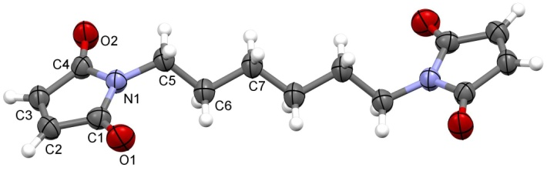
a)
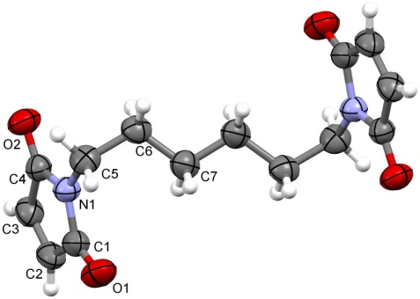
b)
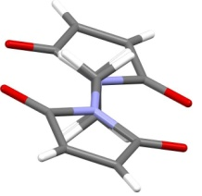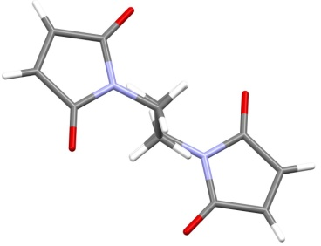
c)
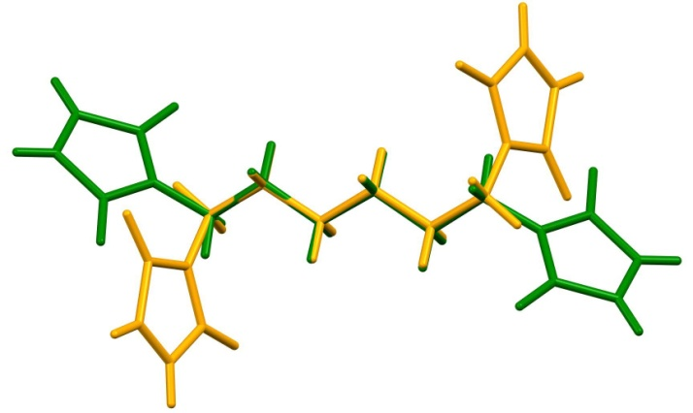
d)
Figure 1. Molecular structure and atom numbering scheme for a) 2a and b) 2b. Probability ellipsoids are drawn at the 50% level. c) View along C₆ chain for 2a (left) and 2b (right). d) Molecular overlay of polymorphs 2a (green) and 2b (orange).

In 2a and 2b the 1H-pyrrole-2,5-dione ring is planar. The maximum deviation from the mean plane described by the ring atoms is +0.004(1) and –0.004(1) Å for the C4 and N1 atoms in 2a and a negligible deviation in the range +0.001(1) to –0.001(1) Å for the C1 and C3 and N1 and C2 atoms in 2b. Such small deviations from planarity were observed also in two known polymorphs of 1H-pyrrole-2,5-dione (maleimides).^{36,37} The main difference in the molecular geometry between the polymorphs of 2 is in the N1–C5–C6–C7 torsion angle being –175.71(13)° in the form 2a (where CH₂ hydrogens are eclipsed over the succinimide ring) and 68.4(3)° in 2b (where CH₂ hydrogens are eclipsed over themselves only and not over the succinimide ring) (Figure 1c,d).
In the crystal structure 2a centrosymmetric hydrogen-bonded dimers formation is facilitated by C3–H3···O2 hydrogen bonding between adjacent pyrrole-2,5-dione moieties with the graph set motif³⁸ R²₂(8) and centrosymmetric hydrogen-bonded tetramers are formed via C2–H2···O2 and C3–H3···O2 hydrogen bonding between adjacent pyrrole-2,5-dione moieties with the graph set motif R²₄(10) generating infinite 2D layer (Table 2, Figure 2). Wavy 2D layers are present also in 2b, however, hydrogen-bonded trimers formation is facilitated by C2–H2···O2 and C3–H3···O2 hydrogen bonding between adjacent pyrrole-2,5-dione moieties with the graph set motif R²₃(9) (Table 2, Figure 3). The experimental PXRD patterns of 2a and 2b correspond well with the simulated data based on the single-crystal diffraction thereby supporting reasonable phase purities (Figure 4). Differences observed between experimental and simulated PXRD patterns are due to preferential orientations.

Table 2. Hydrogen bond geometry of 2a, 2b and 3∙2DMF (Å and °).
D–H···A | D–H (Å) | H···A (Å) | D···A (Å) | D–H···A (°) | Symmetry code
2a
C2–H2···O2 | 0.93 | 2.38 | 3.2650(17) | 159.0 | x – 1, y – 1, z
C3–H3···O2 | 0.93 | 2.51 | 3.4057(17) | 161.3 | –x + 1, –y, –z + 1
2b
C2–H2···O2 | 0.93 | 2.42 | 3.341(4) | 172.9 | x, y – 1, z
C3–H3···O2 | 0.93 | 2.45 | 3.369(4) | 167.7 | –x – ½, y – ½, –z + 1
3∙2DMF
N3–H3···O4 | 0.86 | 2.17 | 3.0207(18) | 168.1 | x, –y, –z + ½
C1–H1···O6 | 0.98 | 2.44 | 2.982(2) | 114.7 | x, y, z
C2–H2···O7 | 0.98 | 2.60 | 3.384(2) | 137.3 | x, y, z
C4–H4···O7 | 0.98 | 2.44 | 3.317(3) | 149.4 | x, y, z
C5–H5···O3 | 0.98 | 2.54 | 3.374(2) | 142.8 | x – ½, –y + ½, z
C5–H5···O6 | 0.98 | 2.56 | 3.125(2) | 116.8 | x, y, z
C15–H15A···O6 | 0.96 | 2.53 | 3.382(2) | 147.5 | x + 1, y, z
C17–H17B···O4 | 0.96 | 2.60 | 3.443(3) | 146.4 | x, –y, –z + ½
C17–H17C···O5 | 0.96 | 2.44 | 3.314(3) | 150.8 | x – 1, y, z

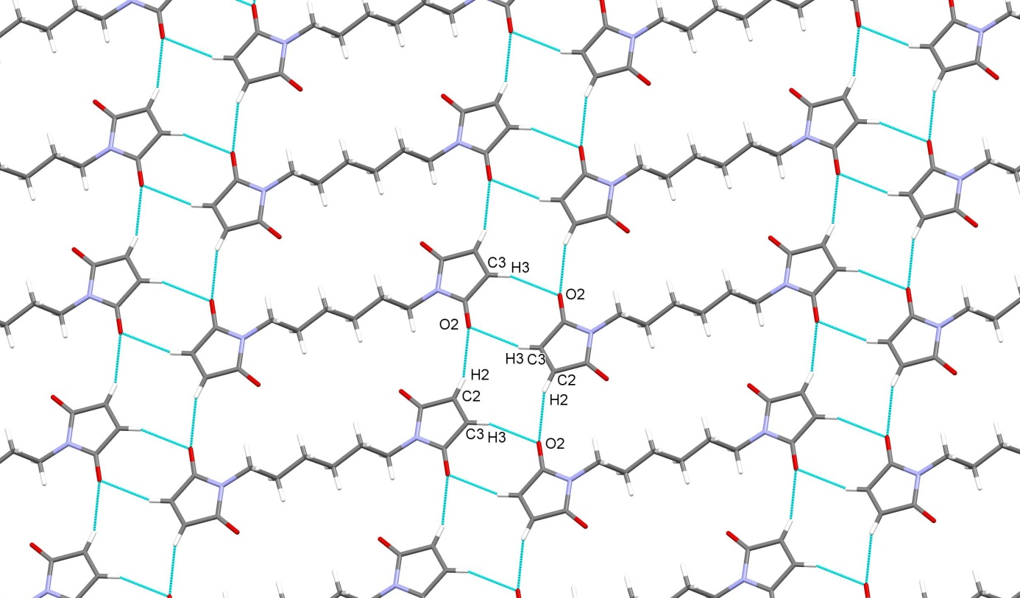

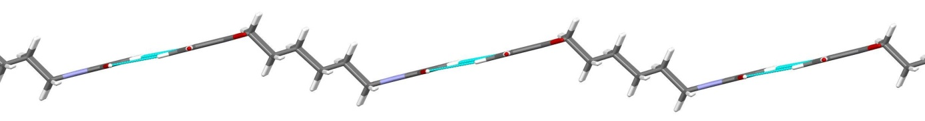
Figure 2. 2D layer formation in 2a generated by C–H···O hydrogen bonding (blue dashed lines) with graph set motifs R²₂(8) and R²₄(10) (top). View along the layer (bottom).

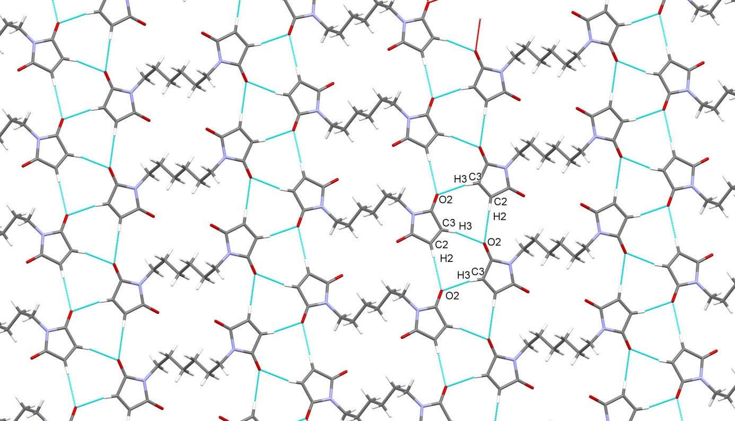
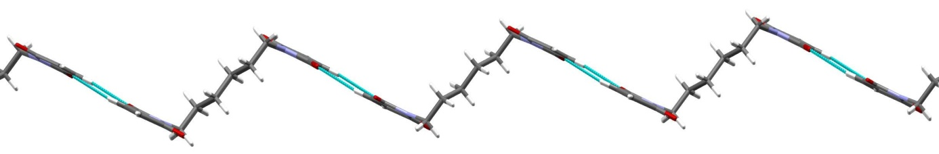
Figure 3. 2D layer formation in 2b generated by C–H···O hydrogen bonding (blue dashed lines) with graph set motif R²₃(9). (top). View along the layer (bottom).

Figure 4. Calculated and experimentally determined PXRD patterns of polymorphs 2a and 2b.

X-Ray analysis of the product 3 has confirmed the results of NMR analysis, namely that this is a 26-membered tetraaza macrocyclic system, being composed of two bicyclo[2.2.2]octene moieties, each of them fused with two succinimide rings; both these fragments are additionally connected with two –[CH₂]₆– tethers into the macrocyclic structure 3 (Figure 5). Macrocycle 3∙2DMF crystallizes in orthorhombic P c a n space group and the asymmetric unit is composed of half of the macrocyclic molecule 3 (due to a 2-fold axis positioned in the middle of the macrocycle) and one solvate DMF molecule.

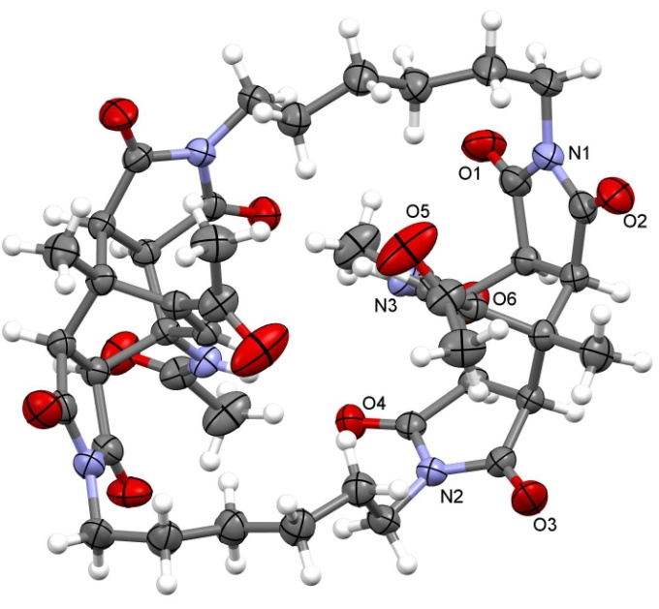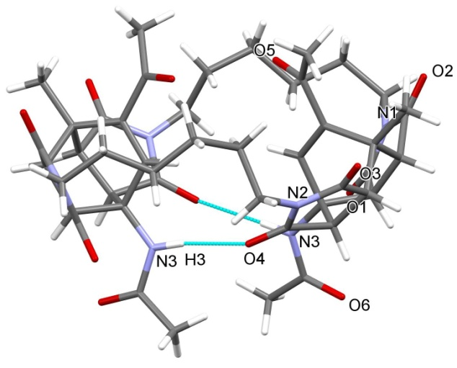
Figure 5. Molecular structure of 3. Probability ellipsoids are drawn at the 50% level (left). Solvate molecules have been removed for clarity. Intramolecular N–H∙∙∙O hydrogen bonding indicated by blue dashed lines (right). Hydrogen atoms not involved in the motif shown have been omitted for clarity.

The two acetyl groups (attached to the bridging double bond of the bicyclo[2.2.2]octene fragments) are oriented towards each other (and also towards the interior of the cavity of the macrocycle 3) therefore mostly filling it completely and thus presumably disabling the ability of 3 to be involved in the host–guest interactions. Furthermore, the bowl-like shape macrocycle 3 is stabilized by two intramolecular N3–H3···O4 hydrogen bonds between the amide hydrogen of the acetylamino group attached to one bicyclo[2.2.2]octene fragment and one of the carbonyl groups of the succinimide ring fused to the other bicyclo[2.2.2]octene fragment with the graph set motif R²₂(12). Additionally, in the crystal structure 3∙2DMF macrocyclic molecule is linked via C2–H2···O7 and C4–H4···O7 hydrogen bonding to DMF solvate molecule generating the graph set motif R¹₂(6). Infinite 2D layer is formed due to C5–H5···O3, C15–H15A···O6 and C17–H17C···O5 hydrogen bonding with six adjacent macrocycle molecules generating the graph set motifs C(5), C(15), R²₂(8) (Table 2, Figure 6).

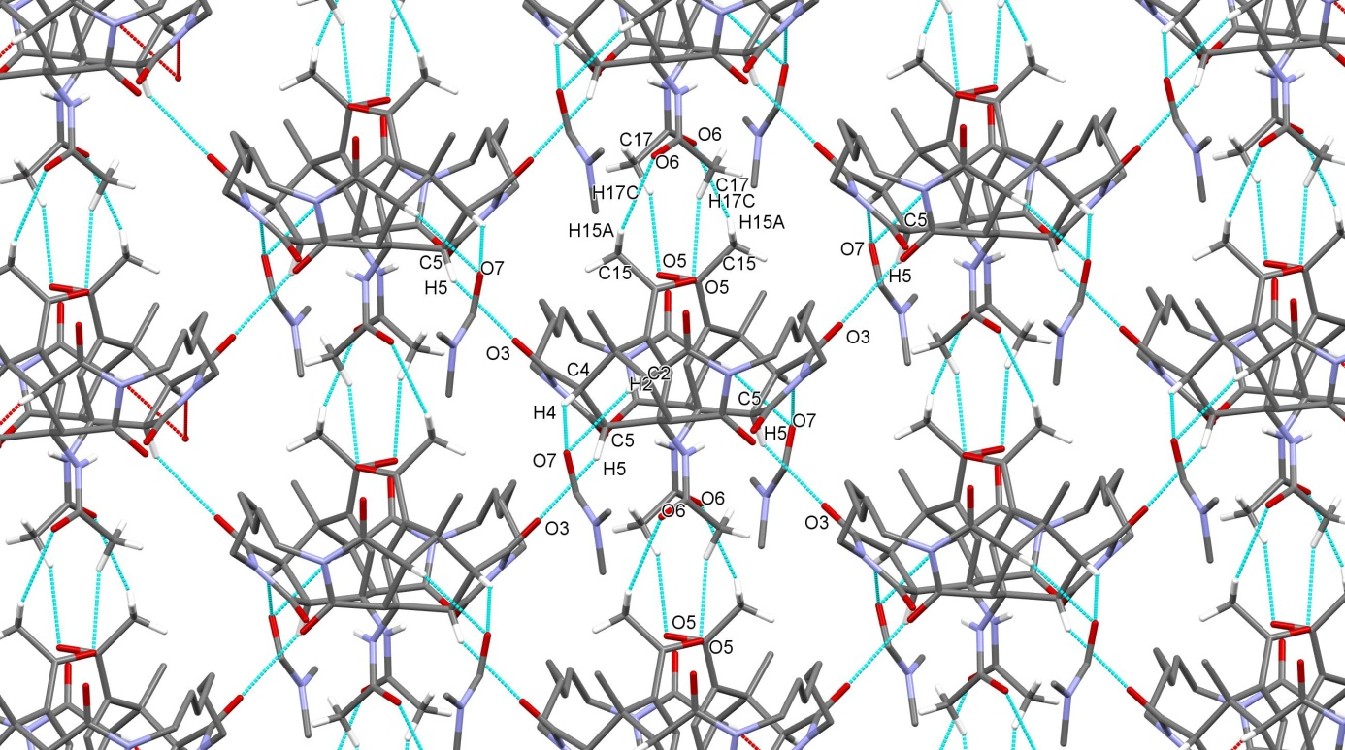
Figure 6. 2D layer formation in 3 generated by C–H···O hydrogen bonding (blue dashed lines). Hydrogen atoms not involved in the motif shown have been omitted for clarity.

4. Conclusion
Herein we describe a preparation of a novel 26-membered tetraaza heteromacrocyclic system 3 that was obtained via a direct method under solvent-free conditions with microwave irradiation starting from a substituted 5-acetyl-3-acetylamino-6-methyl-2H-pyran-2-one (1) and 1,1'-(hexane-1,6-diyl)bis(1H-pyrrole-2,5-dione) (2) acting as a double dienophile for the Diels–Alder cycloaddition. Single-crystal X-ray diffraction patterns of the dienophile 2 and macrocycle 3 were measured and have provided an important insight into their solid state structure. For compound 2 we have found two different polymorphic structures; for both the mode of packing and crystal architecture were determined. 2D layers are formed in both polymorphs facilitated by C2–H2···O2 and C3–H3···O2 hydrogen bonding between adjacent pyrrole-2,5-dione moieties with the graph set motifs R²₂(8) and R²₄(10) in 2a and graph set motif R²₃(9) in 2b. Also for the macrocycle 3 we were able to confirm the other spectroscopic results therefore concluding that 3 is a 26-membered tetraaza macrocyclic system, composed of two bicyclo[2.2.2]octene fragments (each of them fused with two succinimide rings); both such units are connected into the heterocyclic ring via two –[CH₂]₆– tethers. Additionally, it was shown that both double-bond bridges of the two bicyclo[2.2.2]octene fragments are oriented towards the interior of the macrocycle's cavity, therefore presumably disabling the possibility for the host–guest interactions of 3. The two bicyclo[2.2.2]octene parts of the bowl-like shaped macrocycle 3 are stabilized by two intramolecular N3–H3···O4 hydrogen bonds between the amide hydrogen of the acetylamino group attached to one bicyclo[2.2.2]octene fragment and one of the carbonyl groups of the succinimide ring fused to the other bicyclo[2.2.2]octene fragment. Infinite 2D layer is formed due to C5–H5···O3, C15–H15A···O6 and C17–H17C···O5 hydrogen bonding with six adjacent macrocycle molecules.

5. Supplementary Material
Crystallographic data of 2a, 2b and 3 were deposited in the Cambridge Crystallographic Data Center under the number CCDC 1547701–1547703. CIF files containing complete information on the studied structures may be obtained free of charge from the Director, CCDC, 12 Union Road, Cambridge, CB2 1EZ, UK, fax +44-1223-336033; e-mail: data_request@ccdc.cam.ac.uk or from the following web site: www.ccdc.cam.ac.uk/data_request/cif.

6. Acknowledgement
The authors thank the Ministry of Education, Science and Sport of the Republic of Slovenia and the Slovenian Research Agency for financial support (grant Nos. P1-0230-0103 and P1-0230-0175).

7. References
1. K. Josephson, A. Ricardo, J. W. Szostak, Drug Discov. Today 2014, 19, 388–399.
2. H. Zhang, R. Zou, Y. Zhao, Coord. Chem. Rev. 2015, 292, 74–90.
3. S. Collins, S. Bartlett, F. L. Nie, H. F. Sore, D. R. Spring, Synthesis 2016, 48, 1457–1473.
4. B. K. Jena, G. S. Reddy, D. K. Mohapatra, Org. Biomol. Chem. 2017, 15, 1863–1871.
5. T. M. Brutsch, P. Bucher, K. H. Altmann, Chem. Eur. J. 2016, 22, 1292–1300.
6. N. Uchida, R. X. Zhi, J. Kuwabara, T. Kanbara, Tetrahedron Lett. 2014, 55, 3070–3072.
7. L. R. Malins, J. N. deGruyter, K. J. Robbins, P. M. Scola, M. D. Eastgate, M. R. Ghadiri, P. S. Baran, J. Am. Chem. Soc. 2017, 139, 5233–5241.
8. L. A. Wessjohann, D. G. Rivera, O. E. Vercillo, Chem. Rev. 2009, 109, 796–814.
9. E. M. Driggers, S. P. Hale, J. Lee, N. K. Terrett, Nat. Rev. 2008, 7, 608–624.
10. B. Beck, G. Larbig, B. Mejat, M. Magnin-Lachaux, A. Picard, E. Herdtweck, A. Dömling, Org. Lett. 2003, 5, 1047–1050.
11. J. K. Sello, P. R. Andreana, D. Lee, S. L. Schreiber, Org. Lett. 2003, 5, 4125–4127.
12. T. Pirali, G. C. Tron, J. Zhu, Org. Lett. 2006, 8, 4145–4148.
13. C. Hebach, U. Kazmaier, Chem. Commun. 2003, 596–597.
14. S. A. Dietrich, L. Banfi, A. Basso, G. Damonte, G. Guanti, R. Riva, Org. Biomol. Chem. 2005, 3, 97–106.
15. Z. D. Ghezelbash, K. A. Dilmaghani, Acta Chim. Slov. 2016, 63, 790–797.
16. R. Vafazadeh, G. Zare-Sadrabadi, Acta Chim. Slov. 2015, 62, 889–894.
17. For a review on Diels–Alder reactions of 2H-pyran-2-one derivatives, see: K. Kranjc, M. Kočevar, Arkivoc 2013, (i), 333–363.
18. V. Kepe, M. Kočevar, S. Polanc, B. Verček, M. Tišler, Tetrahedron 1990, 46, 2081–2088.
19. F. Požgan, K. Kranjc, V. Kepe, S. Polanc, M. Kočevar, Arkivoc 2007, (viii), 97–111.
20. M. Kočevar, Acta Chim. Slov. 1996, 43, 143–152 (Chem. Abstr. 1996, 125, 576047).
21. F. Požgan, M. Krejan, S. Polanc, M. Kočevar, Heterocycles 2006, 69, 123–132.
22. M. P. Cava, A. A. Deana, K. Muth, M. J. Mitchell, Org. Synth. 1961, 41, 93–95.
23. S. Doi, Y. Takayanagi: Ion exchange resin catalysts for bismaleimide manufacture. JP 62221668 A, September 29, 1987.
24. Z. Otwinowski, W. Minor, Methods Enzymol. 1997, 276, 307–326.
25. A. Altomare, M. C. Burla, M. Camalli, G. L. Cascarano, C. Giacovazzo, A. Guagliardi, A. G. G. Moliterni, G. Polidori, R. Spagna, J. Appl. Cryst. 1999, 32, 115–119.
26. G. M. Sheldrick, Acta Cryst. 2015, C71, 3–8.
27. L. Kukuljan, K. Kranjc, F. Perdih, Acta Chim. Slov. 2016, 63, 905–913.
28. J. Suljagić, A. Juranovič, M. Krivec, K. Kranjc, M. Kočevar, J. Heterocycl. Chem. 2017, 54, 457–464.
29. M. Krivec, M. Gazvoda, K. Kranjc, S. Polanc, M. Kočevar, J. Org. Chem. 2012, 77, 2857–2864.
30. K. Kranjc, F. Perdih, M. Kočevar, J. Org. Chem. 2009, 74, 6303–6306.
31. K. Kranjc, M. Kočevar, F. Iosif, S. M. Coman, V. I. Parvulescu, E. Genin, J.-P. Genêt, V. Michelet, Synlett 2006, 1075–1079.
32. M. Eto, K. Harano, T. Hisano, J. Chem. Soc., Perkin Trans. 2 1993, 963–966.
33. K. Kranjc, M. Kočevar, Curr. Org. Chem. 2013, 17, 448–456.
34. K. Kranjc, M. Kočevar, Collect. Czech. Chem. Commun. 2006, 71, 667–678.
35. F. H. Allen, O. Kennard, D. G. Watson, L. Brammer, A. G. Orpen, R. Taylor, J. Chem. Soc., Perkin Trans. II 1987, S1–S19.
36. P. J. Cox, S. F. Parker, Acta Cryst. 1996, C52, 2578–2580.
37. M. E. Light, I. E. D.Vega, P. A. Gale, CSD Communication (Private Communication), 2007, refcode: TEKQAB01.
38. J. Bernstein, R. E. Davis, N. L. Shimoni, N.-L. Chang, Angew. Chem., Int. Ed. 1995, 34, 1555–1573.

Povzetek
Z uporabo dvojnega dienofila 1,1'-(heksan-1,6-diil)bis(1H-pirol-2,5-diona) za [4+2] cikloadicijo s substituiranim 2H-piran-2-onom smo z neposredno metodo brez uporabe topil pod pogoji obsevanja z mikrovalovi pripravili nov 26-členski tetraaza heteromakrociklični sistem 3. Pripravljeni makrocikel je sestavljen iz dveh enot dienofila in dveh dienskih enot. Strukturo makrocikla smo ugotovili s pomočjo IR, ¹H in ¹³C NMR ter masne spektroskopije, kot tudi z elementno analizo in določitvijo temperature tališča. Z rentgensko difrakcijo monokristala makrocikla smo ugotovili, da sta dve acetilni skupini (vezani na mostovno dvojno vez biciklo[2.2.2]oktenskega fragmenta) v prostoru orientirani ena proti drugi (in hkrati tudi proti osrčju votline makrocikla) ter jo s tem bolj ali manj v celoti zapolnjujeta.

Ključne besede: makrocikli, 2H-piran-2-oni, [4+2] cikloadicija, kristalna struktura, vodikove vezi, polimorfi.

