Graphical Abstract
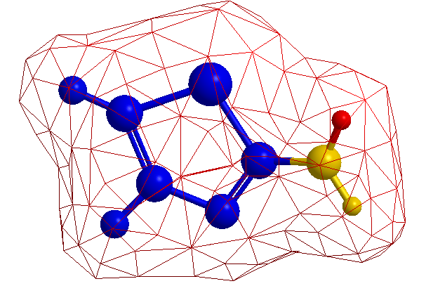
2-Aminothiazole

