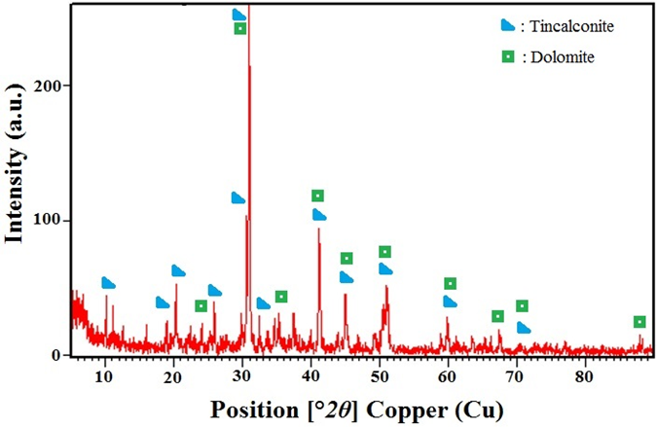

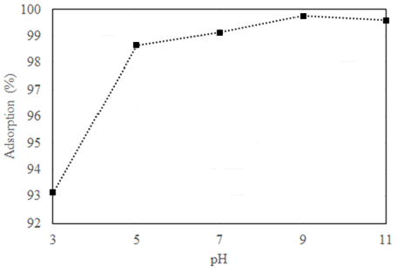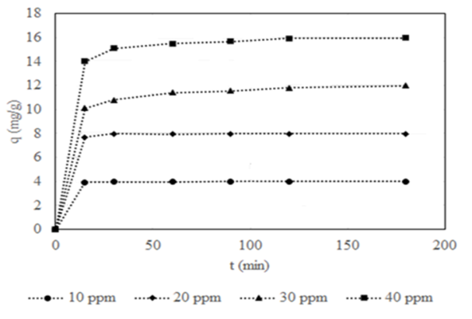

Adsorbent | Freundlich |  |  | Langmuir
Adsorbent | K_{F} | n | R² | q_{max} (mg/g) | K_{L} | R_{L} | R²
Borax waste | 41.4588 | 2.5452 | 0.7876 | 24.0964 | 41.5000 | 0.0006 | 0.8320

T (K) | ΔH (kJ/mol) | ΔS(kJ/molK) | ΔG (kJ/mol)
293 | 69.395 | 0.276 | -11.619
303 | 69.395 | 0.276 | -14.384
313 | 69.395 | 0.276 | -17.149
323 | 69.395 | 0.276 | -19.914

