ADSORPTION OF Cr(III) FROM AQUEOUS SOLUTION BY BORAX SLUDGE
Fatma Tugce Senberber¹, Meral Yildirim², Nevin Karamahmut Mermer²,
Emek Moroydor Derun²,*
¹ Programme of Occupational Health and Safety, Atasehir Adiguzel Vocational School, Turkey
² Department of Chemical Engineering, Yildiz Technical University, Turkey
Running head: adsorption of Cr (III) by borax sludge

Abstract
Borax sludge is the trommel sieve waste of borax production process and was used as adsorbent for Cr(III) removal. Effects of various parameters including pH, initial Cr(III) concentration, and contact time were investigated for batch adsorption of Cr(III). The obtained experimental results were applied different adsorption isotherms and kinetic models.
The results indicated that Langmuir isotherm (R²=0.8320) was more suitable to explain the adsorption characteristics of borax sludge. The overall kinetic data fitted the pseudo-second order rate model (R²=0.9990).
According to thermodynamic studies, which carried out for different temperatures, changes of enthalpy (ΔH) and entropy (ΔS) values for Cr(III) adsorption borax sludge were determined as 69.40 kJ/mol and 0.276 kJ/molK, respectively. The study implies that borax sludge could be used as an alternative adsorbent in adsorption of Cr(III) from aqueous solutions.

Keywords: Adsorption kinetic, borax sludge, Cr (III), thermodynamic
* Corresponding author: Emek Moroydor Derun
e-mail address: moroydor@gmail.com, moroydor@yildiz.edu.tr, telephone number: +90-212 3834776, fax number: +90-212 3834725
1. Introduction
The main types of pollution according to environmental factors are classified as water pollution, air pollution, soil pollution, radioactive contamination and microbiological contamination.¹ Water pollution, which can be caused by sewage, solid wastes, radiation, toxic chemicals and pesticides etc., is a natural imbalance of water environment which is one of the major environmental hazards for the entire world.² Heavy metal contamination is a permanent toxic chemical pollution and has adverse effects for human health and environment.³
Being one of water contaminating metal, chromium is ubiquitous in nature that exists approximately 0.1 mg/m³ in air and 1 mg/L in unpolluted water.⁴ Therefore, exposing to chromium in high concentration have negative effects on fertility, inhale system and also can cause cancer.⁴⁻⁷ Removing chromium ions from aqueous mediums is significant for both human health and environment. Thus, many researchers applied various methods including ion exchange, osmosis, foam flotation, electrolysis, and surface adsorption to reduce chromium concentration under Minimal National Standards (MINAS) upper limit in industrial wastewater which is 0.1 mg/L.^{8,9} Adsorption is an attention getting process for removal of heavy metals due to its facilities, economic and efficiency advantages.
In literature, various adsorbents were used for removal of two main types of chromium ions (Cr(VI), Cr(III)) by changing adsorption parameters such as chromium concentration, adsorbent dose, pH, temperature and agitation time. Various researches have been reported for chromium removal from aqueous medium using chemical, biological and industrial waste materials as adsorbents. During biosorption processes, performances of different biological adsorbents such as chitosan, thuja oriantalis, activated rice husk carbon, neem leaves, activated red mud, hazelnut shell activated carbon, agave lechuguilla biomass, and soya cake were investigated for chromium adsorption.¹⁰⁻¹⁷ In many adsorption processes, layered double hydroxide, Turkish brown coals, ozonised activated carbon, acrylate-based magnetic beads and bentonite clay were studied as chemical adsorbents.¹⁸⁻²³ Besides these studies some industrial wastes such as fly ash, saw dust and timber of Indian Rosewood were preferred because of their economically usage.^{24,25}
Evaluation of borax sludge is highly important, due to emerging amount of boron waste in Turkey, which is 600000 tons per year.^{26,27} It is envisaged that this amount will increase in the coming years depending on the consumption of boron sources, regarding to the usage of waste boron in different production processes. Storage problems and storage costs will be reduced and the polluting elements will be minimized by using boron wastes in industrial applications such as adsorption studies.
Usage of waste materials as low-cost adsorbents is attractive due to their contribution in the reduction of costs for waste disposal. Even though the variety of adsorption studies performed on boron waste; chromium adsorption on boron waste has not yet been investigated.²⁸ In the literature, boron waste was used as an adsorbent for the adsorption studies of dye, cadmium (II) and zinc (II).^{29,30}
The purpose of this study is to investigate the usage possibility of borax sludge as a low cost adsorbent for chromium adsorption. Adsorption performances of borax sludge were studied by varying parameters such as the contact time, the initial Cr(III) concentration. In this study, the adsorption of Cr(III) from aqueous solutions under different kinetic and equilibrium conditions was investigated in detail.

2. Experimental
2.1 Raw material preparation
Borax sludge, which was used as adsorbent for removing Cr(III) ions from aqueous medium, was supplied from Eti Mine Bandirma Boron Works (Balikesir, Turkey). Before using in experimental studies, the adsorbent was dried in an incubator (Ecocell 111, Germany) at 105°C for 2 hours to eliminate their moisture contents. The dried adsorbent was grounded with agate mortar and sieved by vibratory sieve-shaker (Fritsch, Germany) to access a particle size of below 90 µm. Following preparation step, the identification studies were carried out by Philips PANalytical Xpert Pro (PANalytical B.V., The Netherlands) X-ray diffractometer (XRD) with Cu- Kα tube and parameters of 45 kV and 40 mA. The composition of adsorbents were determined by Philips PANalytical Minipal X-ray fluorescence (XRF) (PANalytical B.V., The Netherlands). The BET surface areas of adsorbents were measured on a Micromeritics ASAP 2020 instrument using N₂ adsorption after degassing adsorbent at 300°C for 8 hours.
A stock solution of Cr (III) was prepared by dilution of Chromium standard solution (from Cr(NO₃)₃, Merck KGaA, Darmstadt, Germany) with double distilled water.

2.2 Adsorption experiments
With the aim of determining the effect of pH on the removal of Cr(III), batch adsorption studies were carried out by varying the pH of solution between 3-11 and contact time and initial Cr(III) concentration were set to 180 min and 40 mg/L, respectively. 1 M NH₃ and HCl were used to adjust the pH of the solutions as required.
For isotherm studies and kinetic investigations, 0.05 g of borax sludge was added to 50 mL of Cr(III) solution with altering initial Cr(III) concentration (10 – 40 mg/L) and mixing was carried out for different contact times (15 – 180 min) at a speed of 200 rpm. The adsorption temperature was set to 20°C. At the end of each adsorption period, the adsorbents were filtered through filter paper (Blue ribbon, Chmlab) and the residual Cr(III) concentration was analyzed by Inductively Coupled Plasma - Optical Emission Spectrometer (ICP-OES) (Optima DV 2100, Perkin Elmer, USA). The amount of adsorbed Cr(III) after pre-determined contact time was calculated by following expression Eq. (1),
(1)
where q is the removal capacity of adsorbent at equilibrium (mg/g), V is the volume of suspension (mL), m is the weight of adsorbents (g), C_{i} and C_{f} are initial and final concentration of Cr (III) (mg/L), respectively.³¹
For thermodynamic studies, experiments were carried out at various adsorption temperatures (20°C, 30°C, 40°C, and 50°C) and equilibrium adsorption parameters.

2.3 Isothermal analysis and kinetic studies
Two well-known adsorption isotherms, Langmuir and Freundlich, which give information about the adsorption process and explain the equilibrium relation between the uptake amount of adsorbed sample and concentration at a constant temperature were applied to find out the effects of different initial concentrations, times related to the usage of borax sludge.^{32,32}
Langmuir isotherm, which neglects the lateral interactions, was fitted to obtain experimental quantities (Eq. (2)),
(2)
where q_{e} (mg/g) is amount of Cr (III) adsorbed per unit mass of adsorbent, q_{max} maximum adsorption capacity of adsorbent (mg/g), C_{e} is concentration of Cr (III) in suspension at equilibrium (mg/L) and K_{L} is Langmuir constant related to the affinity of the binding sites.^{24,34} When a linear plot of 1/q_{e} versus 1/C_{e} is drawn, the values of K_{L} and q_{max} can be obtained from slope and intercept of the plot, respectively. In Langmuir isotherms, separation factor of R_{L} is used to indicate the essential features of the isotherm. When R_{L} is between 0 and 1, it expresses that the adsorption is favorable Eq. (3).³⁵
(3)
Freundlich isotherm is expressed as Eq. (4),
(4)
where K_{F} is an approximate indicator of adsorption capacity, n is a constant about intensity of adsorption. The values of K_{F} and n can be determined from the plot of Inq_{e} versus InC_{e} which are obtained from linearized Eq. (4).^{31,36}
Lagergren pseudo-first order kinetic model, pseudo-second order kinetic model, Intraparticle diffusion and Natarajan and Khalaf were fitted to experimental data for investigation kinetic parameters and mechanism of Cr (III) adsorption. Lagergren pseudo-first order kinetic model can be expressed as the form of Eq. (5),
(5)
where k₁ is the pseudo-first order rate constant (min⁻¹), q_{t} and q_{e} are amounts of absorbed Cr (III) per unit mass of adsorbent at time t and equilibrium time (mg/g), respectively.
Pseudo-second order kinetic model is given in Eq. (6),
(6)
and k₂ is the pseudo-second order rate constant (g/mg.min).
The intraparticle diffusion kinetic model which gives information about the adsorption mechanism is formulated as Eq. (7).
(7)
In Eq. (7), q_{t} is amount of absorbed Cr (III) per unit mass of adsorbent at time t (mg/g), t is contact time (min), k_{id} is the intraparticle diffusion rate constant (mg/g.min^{1/2}) and A is a constant.
Natarajan and Khalaf explained the relation between the initial concentration and the concentration at the time of t. The linearized equation for Natarajan and Khalaf first order model is given Eq. (8).³⁷
log (8)
The appropriate kinetic model which explains kinetics and mechanisms of Cr (III) adsorption can be determined by drawing linear plots for each kinetic model and calculation correlation coefficient of R² for each model.
2.4 Thermodynamic studies
Different adsorption temperatures (20°C, 30°C, 40°C, 50°C) were attempted to predict thermodynamic parameters such as Gibbs free energy (ΔG), enthalpy (ΔH) and entropy (ΔS) by using following equations,
(9)
(10)
(11)
In equations, K_{d} is distribution coefficient of adsorbent (C_{e}/q_{e}), R is gas constant (8.314 J/mole.K), T is adsorption temperature (K). From the plot between lnKd and 1/T, ΔH and ΔS can be calculated.

3. Results and Discussion
3.1 Characterization results of adsorbent
XRD pattern of borax sludge was given in Fig. 1. According to XRD results, borax sludge was identified as the mixture of dolomite (pdf. no: 00-005-0622; CaMg(CO₃)₂) and tincalconite (pdf. no: 00-008-0049; Na₂B₄O₇5H₂O) phases.
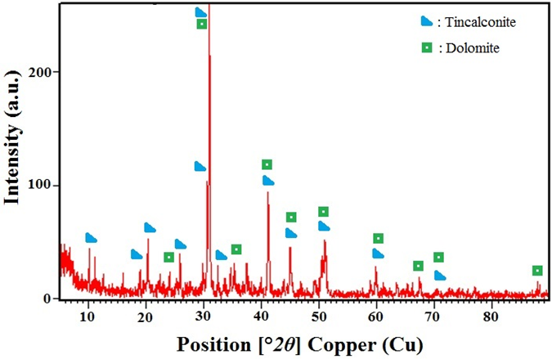
Fig. 1: XRD pattern of borax sludge
According to XRF results, borax sludge had the content of CaO 57.3%, MgO 22%, SiO₂ 20% and K₂O 0.95%. Although having boron compounds in content, XRF showed inability to measure boron amount because of its low molecular weight.
BET surface areas of borax sludge was determined as 5.54 m²/g. From the characterization results of adsorbents, it can be seen that borax sludge have the similar chemical composition and features with the pure dolomite mineral.³⁸
3.2 Adsorption results
The adsorbed Cr(III) percentage is presented in Fig. 2. for various pH values. The pH of original solution was 2, and the removal efficiency of Cr(III) showed increase as the pH increased to 9. The increase of adsorbed amount of Cr(III) in alkaline environment indicated that pH value had major effects on the adsorption mechanism.
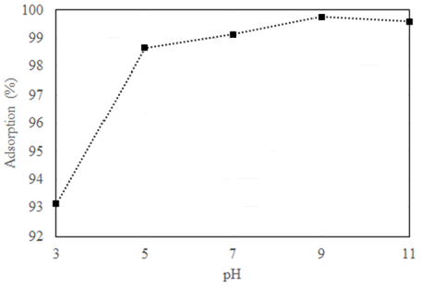
Fig. 2: Adsorption of Cr(III) given for various pH values

The increase in removal percentage at higher pH can be explained by precipitation of Cr(OH)₃ on borax sludge with surface adsorption.⁹ The probable removal mechanism of Cr(III) by borax sludge could be explained by three steps which are (1) the dissolution of dolomite and tincalconite in borax sludge and formation of Ca²⁺, Mg²⁺ and Na⁺ cations; (2) the formation of Cr(OH)₃ precipitate; (3) the cations on the adsorbent (Ca²⁺, Mg²⁺ and Na⁺) exchanged with Cr³⁺. According to adsorption results, the steps of waste dissolution and Cr(OH)₃ precipitation progress successfully in the experiments by increasing pH values. This indicates that adsorption mechanism proceeds accomplishedly in alkaline environment.
The results of adsorption experiments were given in Fig. 3 at the plot of q values to t. The removal of Cr(III) increased with the increasing time. In the adsorption experiments, there was a strong increase in adsorbed amount of Cr(III) ions between 15 and 60 min. Maximum adsorption amounts were obtained at 120 min and minor changes were observed at further contact times. Hence, the 180 min were assumed as the required contact time for its equilibrium state. The changes in q values at the experiments for borax sludge adsorption can be explained with the minor differences in chemical composition of borax sludge. The highest q value was found as 15.986 mg/g.
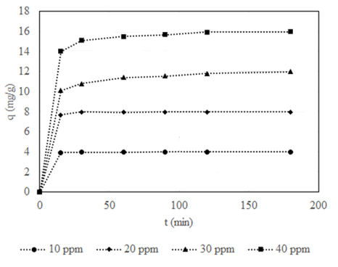
Fig. 3: Removal of Cr(III) depending on contact time

3.3 Results of isothermal analyses and kinetics
The adsorption results for equilibrium state (contact time of 180 min and pH value of 9) each initial concentrations were applied to isothermal methods of Freundlich and Langmuir. The results for the isothermal analysis are given in Table 1. In comparison of isotherm results, higher correlation factors were obtained for Langmuir isotherm method. K_{L} constant and q_{max} were found as 41.500 and 24.096 mg/g. The values of R_{L} were determined lower than 1, which suggests that the adsorption is favorable. From the isotherm results of Freundlich method, K_{F} values for the borax sludge were found as 41.459.

Table I. Freundlich and Langmuir parameters for the adsorption
Adsorbent | Freundlich |  |  | Langmuir
Adsorbent | K_{F} | n | R² | q_{max} (mg/g) | K_{L} | R_{L} | R²
Borax sludge | 41.4588 | 2.5452 | 0.7876 | 24.0964 | 41.5000 | 0.0006 | 0.8320

Results of applied kinetic models are given in Table 2. The highest correlations factors were determined in Pseudo-second order kinetic model. K and q_{e} values were calculated from the relationship of t/qt vs time, can be presented in Fig. 4. K constants were found in the range of 4.0700 – 0.2902 for borax sludge. Obtained q_{e} values for borax sludge (16.000 – 4.001 mg/g) were in compatible with previous study which calculated q_{max} value of dolomite for Cr(III) removal as 10.01 mg/g (20°C).
Table II. Kinetic results for the adsorption process
Kinetic Model | C₀ (ppm) | 10 | 20 | 30 | 40
Lagergren Pseudo first order | q_{e} | 0.1002 | 0.1814 | 15.7797 | 2.0305
Lagergren Pseudo first order | K | 0.0405 | 0.0244 | 0.0302 | 0.0368
Lagergren Pseudo first order | R² | 0.8383 | 0.5940 | 0.9848 | 0.9506
Pseudo-second order | q_{e} | 4.0012 | 8.0192 | 11.7239 | 16.0000
Pseudo-second order | K | 4.0700 | 2.1353 | 0.0107 | 0.2902
Pseudo-second order | R² | 0.9990 | 0.9998 | 0.8606 | 0.9903
Intraparticle diffusion | K_{id} | 0.0054 | 0.0322 | 1.0218 | 0.0961
Intraparticle diffusion | A | 3.9317 | 7.6236 | 0.0328 | 14.7630
Intraparticle diffusion | R² | 0.8839 | 0.7958 | 0.8232 | 0.8877
Natarajan and Khalaf | K_{n} | 0.0387 | 0.0514 | 0.0926 | 0.0454
Natarajan and Khalaf | R² | 0.8216 | 0.7816 | 0.9563 | 0.9398

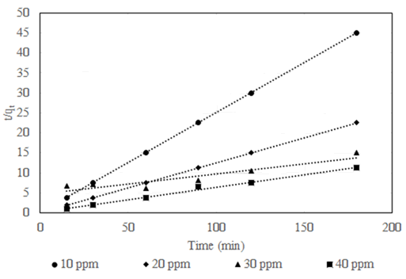
Fig. 4: Pseudo – second order kinetic plots

3.4 Results of thermodynamic studies
The thermodynamic studies were experimented on the equilibrium state (contact time of 180 min and pH value of 9). According to the results of thermodynamic experiments for Cr(III) adsorption, the plot of lnK_{d} versus 1/𝑇 is shown in Fig. 5. Based on the equations (9) – (11), enthalpy (ΔH) value was determined as 69.40 kJ/mol for borax sludge which indicated that the endothermic behavior of the adsorption process. Entropy (ΔS) value of borax sludge was found as 0.276 kJ/molK.
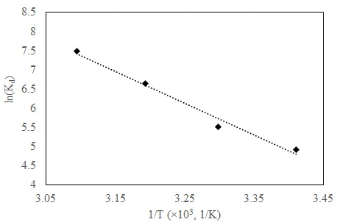
Fig. 5: Plot of lnK_{D} versus 1/𝑇 for Cr (III) adsorption by borax sludge
The Gibbs free energy change (ΔG) showed minor changes and were negative for the experimental range of the temperatures. The negative values of the ΔG showed adsorption of Cr(III) onto borax sludge is spontaneous and the degree of spontaneity increases with the increasing adsorption temperature.³⁰ Thermodynamic parameters for the adsorption process are given in Table 3.
Table III. Thermodynamic parameters for the adsorption process
T (K) | ΔH (kJ/mol) | ΔS(kJ/molK) | ΔG (kJ/mol)
293 | 69.395 | 0.276 | -11.619
303 | 69.395 | 0.276 | -14.384
313 | 69.395 | 0.276 | -17.149
323 | 69.395 | 0.276 | -19.914

4. Conclusion
In this study borax sludge was used as an adsorbent for the removal of Cr(III) from waste water. To investigate the potential use of borax sludge varying parameters such as the contact time, the initial Cr(III) concentration, pH and adsorption temperature have been worked. Langmuir and Freundlich adsorption isotherms were used to describe the observed adsorption phenomena. Lagergren pseudo-first order kinetic model, pseudo-second order kinetic model, Intraparticle diffusion and Natarajan and Khalaf were used for investigation of kinetic parameters and mechanism of Cr(III) adsorption. Gibbs free energy (ΔG), enthalpy (ΔH) and entropy (ΔS) values were calculated by using of kinetic data.
This study showed that the borax sludge has been evaluated as possible adsorbent for removal of Cr(III) from waste water. An initial pH of 9 was found to be optimum for maximum Cr(III) adsorption which has major effects on the adsorption mechanism. The adsorption is described by Langmuir isotherm model while the adsorption mechanisms were explained with the Pseudo-second order kinetic model. ΔH and ΔS values were calculated 69.40 kJ/mol and 0.276 kJ/molK for borax sludge respectively. The negative ΔG values were obtained from thermodynamic calculations that confirm the feasibility of the adsorption. In conclusion, borax sludge can be used as potential adsorbent for removal of Cr(III) from waste water which is readily available in Turkey.

References

- M.W. Holdgate, Cambridge University Press, 1979.
- S. Kolemen, N.B. Acarali, N. Tugrul, E.M. Derun and S. Piskin, Water, Air, Soil Pollut.,2013, 224, 1367.
- C. Bolognesi, E. Landini, P. Roggieri, R. Fabbri and A. Viarengo, Environ. Mol. Mutagen., 1999, 33, 287-292.
- O. Kahvecioglu, G. Kartal, A. Guven and S. Timur, Metallurgy, 2004, 136, 47–53.
- A.H. Smith and C.M. Steinmaus, Annu. Rev. Publ. Health, 2009, 29, 107–122.
- A. Elbetieha and M.H. Al-Hamood, Toxicology,1997, 116, 39-47.
- W. Mertz, J. Nutr.,1993, 123, 626-633.
- S. Rengaraj, K.H. Yeon and S.H. Moon, J. Hazard. Mater., 2001, 87, 273-287.
- S. Debnath and U.C. Ghosh, J. Chem. Thermodyn., 2008, 40, 67–77.
- S.P. Ramnani and S. Sabharwal, React. Funct. Polym., 2006, 66, 902–909.
- E. Oguz, Colloids Surf., A, 2005, 252, 121–128.
- N.R. Bishnoi, M. Bajaj, N. Sharma and A. Gupta, Bioresour. Technol.,2004, 91, 305–307.
- B.V. Babu and S. Gupta, Adsorption, 2008, 14, 85–92.
- J. Pradhan, S.N. Das and R.S. Thakur, J. Colloid Interface Sci., 1999, 217, 137–141.
- M. Kobya, Adsorpt. Sci. Technol., 2004, 22, 52-64.
- J.R. Gonzalez, J.R.P. Videa, E. Rodrıgueza, S.L. Ramirez and J.L.G. Torresdey, J. Chem. Thermodyn., 2005, 37, 343–347.
- N. Daneshvar, D. Salari and S. Aber, J. Hazard. Mater., 2002, B94, 49–61.
- R.L. Goswamee, P. Sengupta, K.G. Bhattacharyya and D.K. Dutta, Appl Clay Sci., 1998, 13, 21–34.
- N.N. Das, J. Konar, M.K. Mohanta and S.C. Srivastava, J. Colloid Interface Sci.,2004, 270, 1–8.
- F. Gode and E. Pehlivan, Fuel Process. Technol.,2005, 86, 875–884.
- J.R. Utrilla and M.S. Polo, Water Res., 2003, 37, 3335–3340.
- G. Bayramoglu and M.Y. Arica, Chem. Eng. J., 2008, 139, 20–28.
- S.S. Tahir and R. Naseem, Sep. Purif. Technol., 2007, 53, 312–321.
- A.K. Bhattacharya, T.K. Naiya, S.N. Mandal, S.K. Das, Chem. Eng. J., 2008, 137, 529–541.
- V.K. Garg, R. Gupta, R. Kumar and R.K. Gupta, Bioresour. Technol., 2004, 92, 79–81.
- F. Oruc, E. Sabah and Z.M. Erkan, 2nd International Boron Symposium, 2004.
- Y. Erdogan and T.A. Baydır, Journal of Science and Technology of Dumlupinar University, 2013, 31, 39-46.
- A. Bhatnagara and M. Sillanpaa Chem. Eng. J.,2010, 157, 277–296.
- A. Olgun and N. Atar, J. Hazard. Mater., 2009, 161, 148–156.
- N. Atar, A. Olgun and S. Wang, Chem. Eng. J., 2012, 192, 1–7.
- G. Qiu, Q. Xie, H. Liu, T. Chen, J. Xie and H. Li, Appl Clay Sci., 2015, 118, 107–115.
- R.I. Masel, first ed. John Wiley and Sons, 1996.
- A. Dabrowski, Adv. Colloid Interface Sci., 2001, 93, 135-224.
- A.V. Tvardovskiy, first ed. Elsevier, 2007.
- A. Ghaemi, M. Torab-Mostaedi and M.Ghannadi-Maragheh, J. Hazard. Mater., 2011, 190, 916–921.
- A.B. Albadarin, C. Mangwand, A.H. Al-Muhtaseb, G.M. Walker, S.J. Allen and M.N.M. Ahmad, Chem. Eng. J.,, 2012, 179, 193–202.
- V. Srihari and A. Das, Desalination, 2008, 225, 220–234.
- I.Y. Elbeyli, Turkish Journal of Engineering and Environmental Sciences, 2004, 28, 281 – 287.

