For Reviewers only

a)
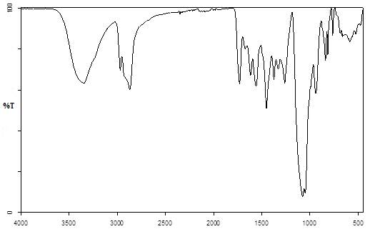
b)
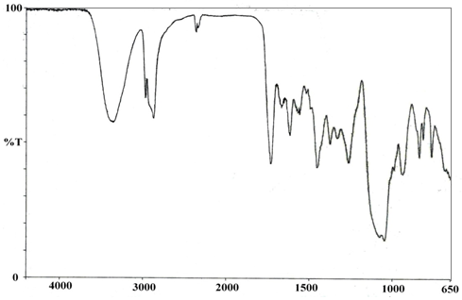

Rev. Fig. 1. IR spectrum of oligoetherols obtained in MOPR (a) and two-step reaction (b)
in molar ratio MEL:GL:PC = 1:8:12

