Evaluation of Jeffamine® core PAMAM dendrimers for simultaneous removal of divalent heavy metal ions from aqueous solutions by polymer assisted ultrafiltration
Ali Serol Ertürk,^{1*} Mustafa Ulvi Gürbüz,² Metin Tülü,² Abdürrezzak Emin Bozdoğan²
¹Department of Basic Pharmaceutical Sciences, Faculty of Pharmacy, Adıyaman University, 02040, Adıyaman, Turkey
²Department of Chemistry, Faculty of Arts and Sciences, Yıldız Technical University, 34210, Esenler, Istanbul, Turkey
* Corresponding author: Ali Serol Ertürk
Tel: +90 (416) 223 38 00 /2760; fax: +90 (416) 223 3809; E-mail: aserturk@gmail.com, aserturk@adiyaman.edu.tr

SUPPLEMENTARY MATERIAL

Table of Contents
General Experimental 2
Synthesis of Jeffamine® core PAMAM-NH₂ dendrimers 3
Potentiometric titrations and determination of the pKa values of PAMAM-NH₂ dendrimers 5
Protonation of Jeffamine® core PAMAMs in aqueous solutions 8
References 10

General Experimental
Potentiometric titrations were carried out automatically by using TitroLine® 7000 (SI Analytics GmbH, Hattenbergstraße, Germany) autotitrator and thermostated titration vessel under nitrogen media. Temperature was kept at room temperature (25 ± 0.1 ºC) using Polyscience® digital temperature controller circulating bath (Polyscience, Illinois, USA). Titrator was controlled by a personal computer with Schoot Instruments, Titrisoft® 2.73 software. pH data were collected with IoLine ultra precise glass electrode with an iodine/iodide reference system. Glass electrode was calibrated with Merck pH 4.0, 7.0, 11.0 buffer solutions.

Synthesis of Jeffamine® core PAMAM-NH₂ dendrimers
JCPDs were synthesized by following the procedure we have reported in our recent studies.^{1, 2} The synthesis involves two consecutive reactions, which are Micheal addition and amidation reaction, respectively. Micheal addition of excess methyl acrylate (2.5 M eq. per terminal amine) to Jeffamine® core in methanol gives the ester terminated half-generation dendrimers, Gn.5, where n refers to generation number. The successive amidation reaction of ester-terminated poly(amidoamine) PAMAM dendrimers (PAMAMs) (PAMAM.OCH₃) with excess ethylene diamine (EDA) (10 M eq. of EDA per ester branched half-generation) in methanol under appropriate microwave irradiation produces amine-terminated full generation PAMAMa (PAMAM.NH₂) referred to as Gn-NH_{2.} Repetition of Micheal addition and amidation reactions gives next higher generations. By repeating the Micheal addition and amidation reactions, we synthesized both ester terminated (G0.5-G3.5) and amine terminated (G1-NH₂-G4-NH₂) PAMAMs (Scheme 1). Purifications of both PAMAM.OCH₃ and PAMAM.NH₂ dendrimers were carried out by using 1-3 kDA dialysis membranes in methanol-water (1:1) depending on the relative molecular weight of Gn.5 and Gn-NH₂ by using liquid phase polymer retention technique (LPR). While resulting pure PAMAM-OCH₃ dendrimers were water insoluble, PAMAM-NH₂ dendrimers were water-soluble. Thus, highest generation G3.NH₂ and G4-NH₂, which has the highest number of available amino groups for binding with Co(II) ions were used in the complexation studies.
Scheme S1. Synthesis and structure development of G1-NH₂-G4-NH₂ PAMAMs, (a) Micheal addition step and (b) amidation step¹

Potentiometric titrations and determination of the pKa values of PAMAM-NH₂ dendrimers
Acid base titrations of JCPDs were conducted according to literature.^{3, 4} The general procedure was as follows. Appropriate amount of PAMAM-NH₂ (G3-NH₂ (62.68 mg) and G4-NH₂ (56.10 mg)) was weighted and diluted to 60.0 mL with 0.10 M NaCl solution. Resulting solution was transferred into a 100 mL thermostated vessel, and temperature was kept at 25 ± 0.1 ºC. Titrations were carried out by using 0.258 M HCl (forward titration) and 0.248 M NaOH (back titration) (standardized against to KHP). First of all, amine groups of dendrimers were protonated by forward acid titrations up to pH ~ 2.0. Afterwards, the investigation of the deprotonation pH ranges of the tertiary and primary amine groups was performed by back titrations up to pH ~12.0.
Tertiary and primary amine groups of PAMAMs are Lewis bases, and they can bind most metals simultaneously (Table 1). However, primary amines of dendrimers cannot bind metal ions depending on the pH characteristic of the media when extent of protonation (EOP) of amine groups is out of the pH range of metal binding or all amine groups are protonated. Therefore, they are not available for metal ion coordination depending on the pH of the aqueous media.⁵ The potentiometric titration curves of dendrimers used in this study are shown in Fig. S1-S2 at supporting information. Both of the titration curves displayed three end points in accordance with the literature.⁶ Starting from the low pH 2, the first one is for excess acid added to dendrimer solution during direct titration. Other two are for tertiary and primary amines, respectively. First derivative of the back titration curves was taken by the software of the autotitrator and overlapped with the back titration curve. Maximum points on the derivative curve revealed the exact position of the end points for the tertiary and primary amines of G3-NH₂ and G4-NH₂. Diallo et al.⁷ accepted the maximum points as the inflection points referring to pKa values of the tertiary and primary amines of PAMAMs. By using the same approach, we calculated the pKa values of tertiary and primary amine groups of dendrimers (Table S1). Inspection of Table S1 shows that the pKa values we observed were in good agreement with the literature.
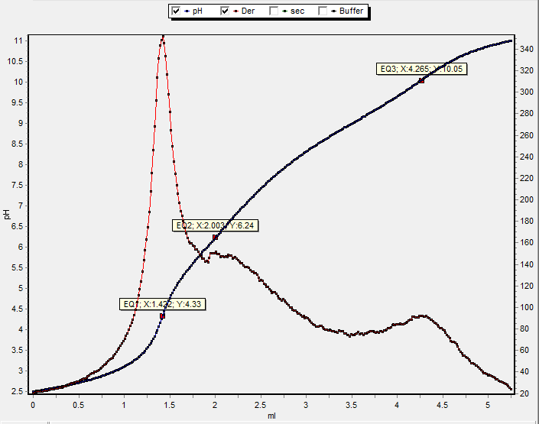
Figure S1. Potentiometric titration of G3.NH₂. Titration curve reveals pH 6.24 for end point of tertiary amines and pH 10.05 for primary amine groups.

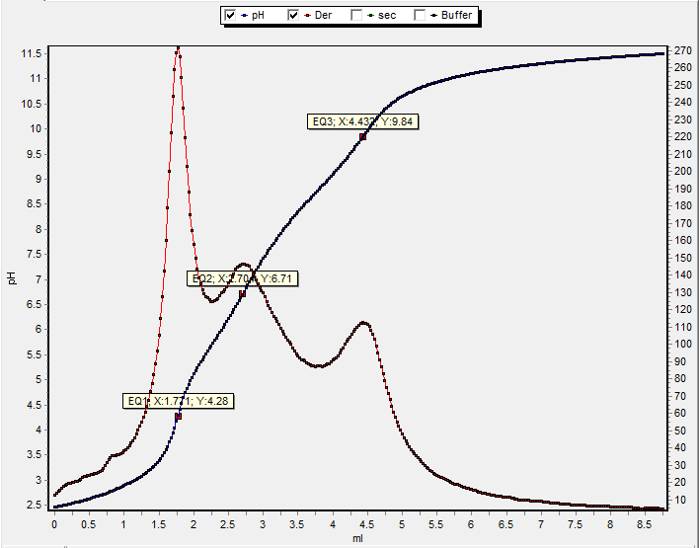
Figure S2. Potentiometric Titration of G4-NH₂. Titration curve reveals pH 6.71 for end point of tertiary amines and pH 9.84 for primary amine groups.

Table S1. pKa values for the tertiary and primary amine groups of JCPDs.
Dendrimer | pKa of tertiary N groups | pKa of terminal amine groups | pKa of tertiary N groups (literature) | pKa of terminal amine groups (literature)
G3-NH₂ | 6.24 | 10.05 | 6.52ª-6.70^{b}-6.30^{c} | 9.90ª-9.00^{b}-9.23^{c}
G4-NH₂ | 6.71 | 9.84 | 6.85ª-6.70^{b}-6.30^{c} | 10.29ª-9.00^{b}-9.23^{c}
ª Data taken from Diallo et al.⁷ ^{b} Data taken from Cakara et al.⁸ ^{c} Data taken from Niu et al.⁹ pKa values were calculated by taking the inflection points of the second derivative of titration curves as it is stated in the study of Diallo et al.⁷ Acid base titration of the aqueous solutions of the G4-NH₂ can be seen in Fig. S1-S2

Protonation of Jeffamine® core PAMAMs in aqueous solutions
Fig. S3 shows the predicted extent of protonation (α) values of tertiary (αN³) and primary amine groups (αN¹) of JCPDs in aqueous solutions within the pH range of 2-12. These values were calculated by using Hendersen-Hasselbech equation (1) by using the pKa values derived from Table S1.¹⁰
$log\frac{α}{1-α}={pK}_{a}-pH$ (1)
where, α is extent of protonation, pKa is the acidity constant for tertiary and primary amine groups, and pH is the measurement of the hydronium ion concentration of the aqueous media.
Figure S3. Extent of protonation (α) of primary and tertiary amine groups of JCPDs.

Table S2 presents the fraction of protonated tertiary (αNR₃) and primary amine (αNH₂) groups of G3-NH₂ and G4-NH₂ PAMAMs. Investigation of the Table S2 reveals that all of the amine groups of JCPDs become protonated at low pH (≤5) whereas at neutral pH (~7.0), only their tertiary amine groups remain unprotonated. On the other hand, at higher pH 9, the tertiary amine groups just remained deprotonated. These results are correlated with those reported by Diallo et al.⁷ and Cakara et al.⁸ (Table S1) and suggest that tertiary and primary amine groups of JCPDs protonate independently, and the dendrimer generation number do not have a significant effect on the extent of protonation of tertiary and primary amine groups of JCPDs. In addition, it could be easily seen from Fig. S3 that decrease in pH towards the low pH decreases the available binding sites (¹N and ³N) as they are blocked by protonation.
Table S2. Extent of protonation (EOP) values of tertiary and primary amine groups of JCPDs as a function of pHª.
A. Fraction of protonated tertiary amine groups
Dendrimer | pH 3 | pH 5 | pH 7 | pH 9
G3-NH₂ | 0.999 | 0.945 | 0.148 | 0.001
G4-NH₂ | 0.999 | 0.980 | 0.339 | 0.005
B. Fraction of protonated primary amine groups
Dendrimer | pH 3 | pH 5 | pH 7 | pH 9
G3-NH₂ | 0.999 | 0.999 | 0.999 | 0.918
G4-NH₂ | 0.999 | 0.999 | 0.998 | 0.873
ªData obtained from the EOP graphs of G3-NH₂ and G4-NH₂ (Fig. S3)

References
1. A. S. Ertürk, M. Tülü, A. E. Bozdoğan and T. Parali, European Polymer Journal 2014, 52, 218-226.
2. A. S. Erturk, M. U. Gurbuz, M. Tulu and A. E. Bozdogan, RSC Advances 2015, 5, 60581-60595.
3. I. J. Majoros, B. Keszler, S. Woehler, T. Bull and J. R. Baker, Macromolecules 2003, 36, 5526-5529.
4. I. J. Majoros, T. P. Thomas, C. B. Mehta and J. R. Baker, Journal of Medicinal Chemistry 2005, 48, 5892-5899.
5. F. Zeng and S. C. Zimmerman, Chem. Rev. (Washington, D. C.) 1997, 97, 1681-1712.
6. X. Shi, I. Bányai, M. T. Islam, W. Lesniak, D. Z. Davis, J. R. Baker Jr and L. P. Balogh, Polymer 2005, 46, 3022-3034.
7. M. S. Diallo, S. Christie, P. Swaminathan, L. Balogh, X. Shi, W. Um, C. Papelis, W. A. Goddard, III and J. H. Johnson, Jr., Langmuir 2004, 20, 2640-2651.
8. D. Cakara, J. Kleimann and M. Borkovec, Macromolecules 2003, 36, 4201-4207.
9. Y. Niu, L. Sun and R. M. Crooks, Macromolecules 2003, 36, 5725-5731.
10. V. Kabanov, A. Zezin, V. Rogacheva, Z. G. Gulyaeva, M. Zansochova, J. Joosten and J. Brackman, Macromolecules 1998, 31, 5142-5144.

